技术英语中冠词的用法

Task Topic
Task topic中，涉及具体的物体，通常都需要使用冠词。
典型用法：
1. 界面元素，如窗口、页签、菜单、选项、按钮（称之为属性词）等，在其名称前需加冠词，通常加the。如果只有名称，但无属性词，则不加冠词。
如the XXX window/page/button/field/box
例：
To configure a default gateway
1. Open Network Connections by clicking the Start button, clicking Control Panel, clicking Network and Internet, clicking Network and Sharing Center, and then clicking Manage network connections.
2. Right-click the network adapter that you want to configure a default gateway for, and then click Properties. If you are prompted for an administrator password or confirmation, type the password or provide confirmation.
3. Click the Networking tab.
• Under This connection uses the following items, click either Internet Protocol Version 4 (TCP/IPv4) or Internet Protocol Version 6 (TCP/IPv6), and then click Properties.
• Select either Obtain an IP address automatically or Use the following IP address.
If you configure the network adapter to obtain an IP address automatically, the default gateway is assigned by the DHCP server. If you specify an alternate configuration (IPv4 only), the default gateway is the IP address in the Default gateway box on the Alternate Configuration tab. You can only specify one default gateway.
If you manually specify an IP address configuration, the default gateway is the IP address in the Default gateway box on the General tab.
[windowshelp.microsoft.com]

A message box appears with the following text: ...
[support.microsoft.com]

- 具体所指的事物
例：
2. Right-click the network adapter that you want to configure a default gateway for, and then click Properties.
If you are prompted for an administrator password or confirmation, type the password or provide confirmation.
If you configure the network adapter to obtain an IP address automatically, the default gateway is assigned by the DHCP server.
- 物质名称+属性
如：a/the XXX system, a/the XXX server, a/the XXX network

例：
To prevent the AS/400 system from connecting through the SOCKS server, the directly connected network should be defined.
[www.redbooks.ibm.com]

If the wizard still can't find a projector, try refreshing the Domain Name System (DNS) server. The DNS server is the service that assigns network addresses.
[windowshelp.microsoft.com]

Concept Topic
涉及具体事物，或具体所指，需要使用冠词。
例：
Clusters
A cluster is a set of Cisco CallManagers that share the same database.
When you install the Cisco CallManager software on a server, you specify which servers and which Cisco CallManagers belong to the same cluster. You also specify which server is the publisher of the master database for the cluster. The other servers in the cluster are all subscribers to the master database, but they also maintain their own backup copies of the master database. Figure 1-1 illustrates a simple cluster containing three Cisco CallManagers.
During normal operation, all of the Cisco CallManagers in the cluster read data from and write data to the master database. Periodically, the backup copies of the database are updated automatically from the master. If the master database becomes unavailable for any reason (for example, if the network connection is broken), the various Cisco CallManagers in the cluster can continue to operate from their local backup copies of the database. When the master database is restored, normal operation resumes.
[Cisco CallManager Administration Guide, Release 3.0, Part 1, System Description]

信令消息流程
SIP（Session Initiation Protocol，会话初始协议）是由IETF（Internet Engineering Task Force，因特网工程任务组）制定的多媒体通信协议。它是一个基于文本的应用层控制协议，用于创建、修改和释放一个或多个参与者的会话。广泛应用于CS（Circuit Switched，电路交换）、NGN（Next Generation Network，下一代网络）以及IMS（IP Multimedia Subsystem，IP多媒体子系统）的网络中，可以支持并应用于语音、视频、数据等多媒体业务，同时也可以应用于Presence（呈现）、Instant Message（即时消息）等特色业务。可以说，有IP网络的地方就有SIP协议的存在。^{[1-2]}
- SIP是类似于HTTP。SIP可以减少应用特别是高级应用的开发时间。由于基于IP协议的SIP利用了IP网络，固定网运营商也会逐渐认识到SIP技术对于他们的远意义。



书名
For more information about the EMS GUI, see the EMS User's Guide, 401-710-110. [Lucent]

For information on accessing the EMS GUI from a PC or workstation browser, see Flexent® MobilityManager Application Processor Cluster (FMM-APC) Operations,
Administration, and Maintenance (OA&M) (401-710-201). Refer to OMP-FX Operation, Administration, and Maintenance (OA&M) (401-662-102) for more information about the OMP-FX.
[Lucent]

The Flexent® Wireless Networks Radio Cluster Server and Flexent® Mobility Manager Radio Cluster Server Operations, Administration, and Maintenance is
hereafter referred to as the RCS and FMM-RCS OA&M.
[Lucent]

See Softkey Template Configuration in the Cisco CallManager Administration Guide.
[Cisco]

标题

con[计] 配置器，配置程序
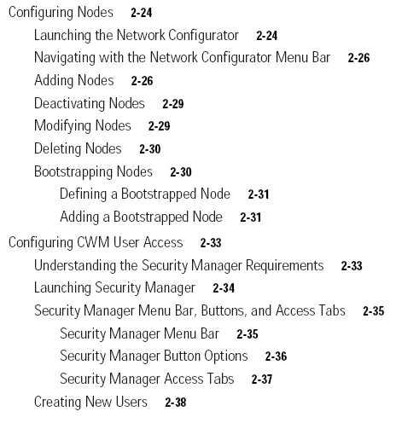
[Cisco]

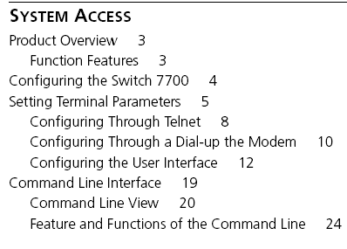
[from 3com]

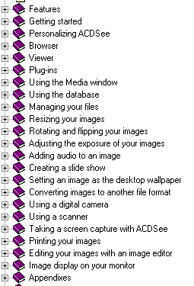
[from ACDSee]

消息
Password does not match the confirm password. [Microsoft Windows]
Access Denied
WINSOCK Error: Socket is not connected.

Error Message:
Invalid Server Name
Explanation:
The server name that you have entered is not valid. [Microsoft Windows]

Workstation Logon
Your password expires today. Do you want to change it now?
The full domain list can not be generated at this time. Some domains may be missing from the list.
The passwords you typed do not match. Type the new password in both text boxes.
The system cannot log you on now because the domain name is not available....
Your system is running without a properly sized paging file. Please use the...
Unable to log you on because the netlogon service is not running on this machine....
Your new password does not meet the minimum length or password history requirements of the domain....
Your password is number days old, but it must be number days old before it can be changed....
This screen saver has no options that you can set....
Unable to change your password because the computer you selected is not the...
The password is incorrect. Please retype your password. Letters in password...
Your password must be at least text characters long. Your new password c...
Unable to log you on because of insufficient memory, please contact your administrator....
The system can not log you on ( computer name ). Please try again or consult your system administrator....
Your account is configured to prevent you from using this workstation. Please try another workstation....
The system cannot change your password now because the domain name is not available....
Unable to change the password on this account ( account ). Please consult your system administrator....
Your password will expire in text days. Do you want to change it now?... [Microsoft Windows]

产品名
The “System configuration application” (31) section explains how to use the System Configuration application of the LMT software to configure the server cluster complex local area network (LAN). That section also describes the FMS- and FWR-based platforms that the LMT supports. [Lucent]

These release notes cover information relating to the Cisco IP/VC 3510 Multipoint Control Unit (MCU) Release 1.0. [Cisco]

About the Cisco IP/VC 3510 Multipoint Control Unit (MCU)
The Cisco IP/VC 3510 MCU includes an MCU and a gatekeeper integrated in one box. The MCU can also be used with an external gatekeeper. [Cisco]

Because Cisco IPMA is installed automatically on the same server with Cisco CallManager, you do not require an additional server. [Cisco]

典型用例
  - System (with article)

  - Command (with article)

  - Following (with or without article)
Observe the following instructions to avoid exposing yourself and others to risk:
[Lucent]
Following are the two types of XNS access lists that you can use to filter routed traffic: [Cisco]

  - Current (with article)
You might perform this task to back up a current configuration file to a server before changing its contents... [Cisco]
To restore the current phone system settings, you need.... [Cisco]
  - Corresponding (with article)
For the Cisco SLT and the Cisco LAN switches, each trap has a corresponding Cisco MGC Node Manager alarm.

  - Specified (with article)

  - Same (with article)

This can be a statement number, sequence number, or source line number.
publib.boulder.ibm.com

有无冠词的区别
Modify the user and the user group to which the directory belongs

无冠词
  - status
Ensure the working and protect cards are in normal status. [Cisco]
  - mode
In administrator mode, you can deploy and maintain applications. [Microsoft]
  - format
This contains ten files in .xls format.
对比：
enter the year in a four-digit format
Date to search for in the format of YYYYMMDD or blanks [ibm]

