技术英语冠词用法详解
蒋创新

概述
冠词的用法包括使用冠词（包括定冠词和不定冠词）和不需要使用冠词（零冠词）。
定冠词和不定冠词的用法，仅针对需要使用冠词的情况，不包括零冠词的情况。
在语法概念中，冠词的应用场景有很多，本文只讨论通信技术英语中的用法，尤其是我们手册翻译中涉及的情况。

定冠词和不定冠词

Rule 1：单数可数名词在表示具体事物时必须使用冠词
通用规则：大多数情况下，单数可数名词用以表示具体事物，必须使用冠词。单数可数名词在正文中表示概念或类别名称时不使用冠词，参见零冠词用法。

Rule 1-1：非特定的单数可数名词首次出现时使用不定冠词，再次出现时使用定冠词
例：
Pushing a Web Page to an Agent
You can coach an agent by pushing a web page to that agent’s Agent Desktop integrated browser.

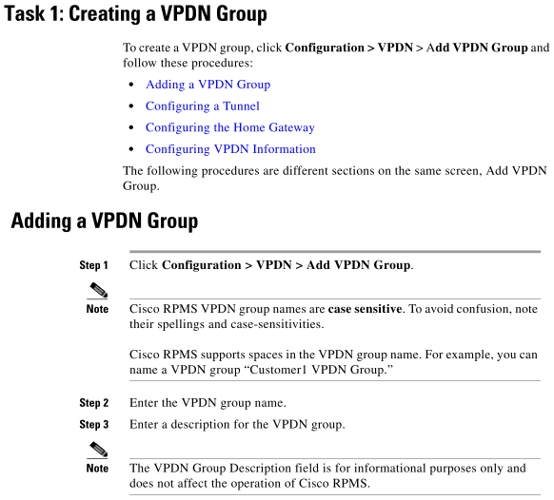

Rule 1-2：特定的单数可数名词使用定冠词
特定的名词包括上文已经提及的、带定语从句的或上下文中明确的对象。
例：
To push a web page to an agent:
1. Select the agent in the Agent tree, and then select Intervention > Coach by pushing a page. The Push URL to Agents dialog box is displayed, see Figure 20.

Rule 2：复数名词在强调全部时加定冠词
When a desktop is using network address translation (NAT) due to a firewall or router, then virtual private network (VPN) software must be used on the desktop to ensure full bi-directional network connectivity between the contact center servers and the desktop.

Rule 2-1：带定语的复数名词也加定冠词
例：
For each card, you can assign a card SCT that defines the connection characteristics between the card and the switch bus.
Table 8-1 lists the modules that comprise the CWM Statistics Collection Manager (SCM).
Table 2-10 lists the features and descriptions for the base modules and their variants, and Table 2-11 lists the physical and environmental specifications for the base modules and their variants.

Rule 3：产品名称前使用冠词

Rule 3-1产品名称使用定冠词或不定冠词
例：
the ZXMP S385
the ZXME MCAS system
a CDR server

比较：
a PPC module （存在多个，指某一个）
the PPC module （指特定的一个；或这一类，与其他模块并论）

Rule 3-2：环境中仅存在一个，使用定冠词
例：
Configuring the AAA server
the NMS

Rule 4：界面元素+属性词使用冠词
属性词是指该界面名称的性质，如ACB window，其中ABC是界面的名称，window表示该界面的性质是一个窗口。
界面元素+属性词的结构通常使用定冠词。
例：
The Device Management window is displayed, see Figure 1-1.
Click the Activate button
A confirmation dialog box is displayed.

注：不带属性词的名称不使用冠词，比较：
正确：Click the Apply button.
正确：Click Apply.
错误：Click the Apply.

Rule 5：手册名称前使用定冠词
例：
Refer to the ZXSDR OMMB (V12.12.30) General Operation Guide

Rule 6：缩略语当作名词不特别省略冠词
缩略语根据其全称的词性，分为可数名词和不可数名词，适用普通名词的通用冠词用法规则，除适用零冠词的情况外，不省略冠词。

This happens when the MSC's bootflash gets full.
The STP recognizes the 800 query and routes it to an appropriate database via an SCP.

Rule 7：标题中不省略冠词
标题中冠词的用法与正文中相同。
例：
Configuring the Service Processing Server
Deleting a Service Node
Global Configuration of the OPP System

Rule 8：在following, current, corresponding, specified, same 等词之前，一般需要使用定冠词
例：
Perform the following steps to create a service account:
The current user cannot be deleted.
LDP makes the corresponding FIB entries unlabeled at LC removal.
Use the same procedure to add more devices.
The following tables list the toolbar buttons and shortcut keys that you can use to navigate Supervisor Desktop.
注：其中following在句首时可以省略。
Following is a list of the primary subsystems responsible for call session processing.

Rule 9：与特定词（mode, format，type）搭配时使用不同的冠词或不用冠词
例：
in global configuration mode （名称本身就是一种模式）
Each command you enter while you are in interface configuration mode with the interface range command is executed as it is entered. The commands are not batched together for execution after you exit interface configuration mode. If you exit interface configuration mode while the commands are being executed, some commands might not be executed on some interfaces in the range.
in privilege mode（名称本身就是一种模式）
in the administration mode （名称本身不是一种模式，只作定语）
in Normal status （名称本身就是一种状态）
Date to search for in the format of YYYYMMDD or blanks
This contains ten files in .xls format.
in the Text format
in 24-hour format
a type of device （一类设备）
They seek a kind of relationship, in addition to the outcomes of that relationship.
For an up-to-date list of supported transceivers, refer to your transceiver compatibility matrices at the following URL.

Rule 10：不同用法，不同含义
the type of device 设备类型 the type of the device该设备的类型
the current version of device当前版本的设备 the current version of the device该设备的当前版本
The current version of Device Installer does not support Linux based Device Servers
To check the current version of the device, select the Setup button.
Provide the username, password, and a name for the default database catalog.

零冠词

Rule 11：不可数名词前通常不加冠词
不可数名词前通常不加冠词。
例：
To ensure normal system operation, plan your site configuration and prepare your site before installation^{[1]}.

注[1]：installation: [mass noun]the action or process of installing someone or something, or of being installed
例：the use of the system could be followed by installations on other vehicles.
使用本系统后可进行其他车辆的装配。
[新牛津英汉双解大词典]

Rule 12：抽象概念名词前通常不加冠词
如表示类别、选项、参数名称等名词。
例：
Cisco Networking Services messages are classified into three message types: request, response and notification.
Search options include last name, first name, department, extension, job title, and location, and they can be customized within each attendant console client.

Rule 13：复数名词（表示类别时）不加冠词
例：
GlobalCall alarms are classified as either blocking or non-blocking.
This section describes ACL concepts.
Masks are used with IP addresses in IP ACLs to specify what should be permitted and denied.
It provides supervisors with powerful tools to increase productivity and improve customer satisfaction.

例：
Graphical displays of the information consist of bar charts with agent names on the Y axis.
Features that are not listed here are in all three feature levels.

Rule 14：各类标题（title）句首名词前不加冠词
Do not use the to begin any of the following items:
- Manual titles
- Chapter titles
- Headings
- Figure captions
- Table captions
- Callouts
例：
System Description

Rule 15：名词后接数词表示顺序时通常用零冠词
例：
module No. 3
Subscriber A originiates a call to subscriber B.

比较：
The A interface （A接口，A为接口类型）
The No.3 module

Rule 16：两个或以上同类名词并列时后面的名词省略冠词，不同类的名词使用冠词
The information includes the name and address of the system call, the thread or process which made the system call, and …
310-byte area with DOMIP6 in the first six bytes, where GTTERM will return the domain name, terminal name, IP address, port number, and zone identifier if requested.
When a CIMOM is discovered or manually added, you must provide access information for it, including the username, password, and location of the TrustStore ...
This section describes the requirements and the procedure for installing Customer Center SDK on Windows.
Provide the username, password, and a name for the default database catalog.
you still have the opportunity to modify scan target settings, including the IP address, user credentials, scan directories, and the type of scan.

Rule 17：消息类句子中的名词可省略冠词
File cannot be deleted.
Error reading input stream.
Currency symbol "current symbol" is not valid.

Rule 18：用介词by构成的表方式的短语通常用零冠词
by plane / by air乘飞机（表示使用交通）
注：by避免滥用。
例：
误：By (the) device management function, you can create devices as needed.
正：By using the device management function, you can create devices as needed.
误：Fix one side of the cable tray to tower by U-bolt.
正：Fix one side of the cable tray to the tower by using U-bolts.

Rule 19：有些短语用零冠词和定冠词均可，但含义不同
in charge of 负责，管理，主管 in the charge of 在…的管理(负责)之下
（可能还存在其他，没有收集到）

Rule 20：有时定冠词和零冠词的选择与英美英语的不同习惯有关
go to university (英)上大学 go to the university (美)上大学
IP Address (The) IP address of the SNMP server

不确定或都可以
Save the file in XLS format.
Save the file in the XLS format.

When you tap the plus button, a page for creating a new employee form is displayed.
[IBM]

A page for modifying definitions is displayed.
[developers.sun.com]

In the Reporting Services Configuration tool, click Report Manager URL to open the page for configuring the URL.
technet.microsoft.com

Search result description: The page for setting filtering options is displayed.
[public.dhe.ibm.com]

应用场景

名词解释
Dry contact
From Wikipedia, the free encyclopedia
Jump to: navigation, search
Dry contact may mean any of the following in electronics:
No current: Dry contact can refer to a secondary set of contacts of a relay circuit which does not make or break the primary current being controlled by the relay. Usually some other contacts or device have the job of starting or stopping the primary current being controlled. For example, a reed relay matrix switch is normally switched with all contacts dry. After the contacts are all connected, a wire spring relay is energized and connects a supervisory scan point, or main switch, through which the primary current being controlled then flows. Dry contacts are primarily employed in 49 volt or less (low voltage) distribution circuits. See also Contactor
No mercury: Wet contacts are mercury wetted, which gives certain operational advantages. Dry contacts means a relay that does not use mercury wetted contacts.
Dry joint: A dry contact can be confused with a dry joint, which is a type of badly soldered joint in which the solder failed to wet the metal. These are liable to fail electrically. The term dry joint is also used less precisely to mean any sort of unsatisfactorily soldered joint.

A SIP user agent (UA) is a logical network end-point used to create or receive SIP messages and thereby manage a SIP session.
[Wikipedia]

信令流程
Sample TCAP Database Query
This sample query describes how a dialed 800 number is processed using TCAP.
1. A subscriber goes off-hook and dials an 800 number. The end office switch (SSP) parses the digit string and sends an 800 query message to either of its STPs over its A-link.
2. The STP recognizes the 800 query and routes it to an appropriate database via an SCP.
3. The SCP receives the query, extracts the passed information and retrieves a real telephone number to which the call should be routed.
4. The SCP sends a response message with the information necessary to process the call to the originating SSP via an STP and an A-link.
5. The STP receives the response and routes it to the SSP.
6. The SSP receives the response and uses the information to route the call. It generates an IAM message and proceeds with ISUP call setup.

事件及机制描述
As with the MF address signaling, SF is sent switch to switch. A trunk is initially on-hook at both ends. One of the switches sends a forward off-hook (seizure) to reserve a trunk. The receiving switch indicates that it is ready to receive address digits, (after connecting a digit received by the line by sending a wink signal. When the originating switch receives the wink signal, it transmits the digits of the called party number. When a call is answered, the called parties switch sends an off-hook signal (answer). During the conversation phase, both ends at each trunk are off-hook. If the calling a party clears the call, it sends a clear-forward signal; likewise, when the called party hangs up, it sends a clear-backward signal.

When a desktop is using network address translation (NAT) due to a firewall or router, then virtual private network (VPN) software must be used on the desktop to ensure full bi-directional network connectivity between the contact center servers and the desktop.

功能描述
SIP invitations used to create sessions carry session descriptions that allow participants to agree on a set of compatible media types. SIP makes use of elements called proxy servers to help route requests to the user's current location, authenticate and authorize users for services, implement provider call-routing policies, and provide features to users. SIP also provides a registration function that allows users to upload their current locations for use by proxy servers. SIP runs on top of several different transport protocols.

参数解释
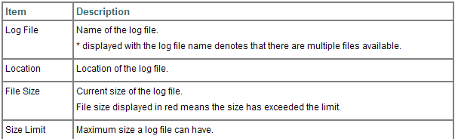

外观图
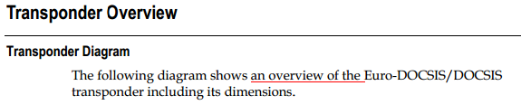

冠词与复数

Rule 21：consist of, is made up of后的名词通常使用不定冠词或复数
The diagram shows that SQL procedures can consist of one or more optionally atomic compound statements.
Search result description: A FARF4 address, shown in Figure 2, is made up of a universal format type (UFT), a format type indicator (FTI), an ordinal number, and control bits.
Each tab is made up of a left, middle, and right image.

Managing the Version vs Managing Versions
通常要管理的对象都是多个的。其他用复数的情况有如查询、批量操作等。
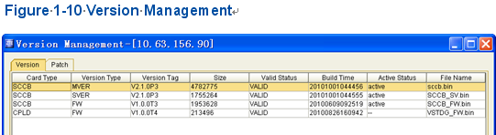

大标题中的单复数
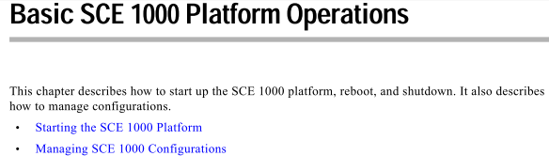

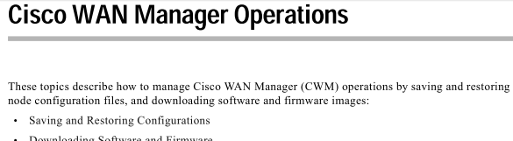

task topic标题中的复数
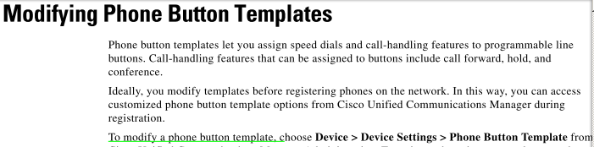

审核问题分析
The VoIP subnet is used for VoIP service.

the IP address is automatically set to IP address of the MG.

This manual provides the basic standards for the product series. 本手册只是本系列产品基本的规范。

Select a predefined task “Test BSS Board”.
The start time and end time for blocking a blacklist user.

When the sensors such as the smoke sensor and door access sensor detect abnormality

Handle the fault in accordance with hardware fault handling suggestion.

The CND network consists of the CDN Manager and the SCU.

In the single-control network, two GE network interfaces of the SCU are configures as “Bond” virtual interfaces which are shared by signaling and NM.

Single node supports the management of 1.5 million files or 200 million chunks with two default copies.

ID of the service function requested by a subscriber. (参数解释)

For menu statistics description, refer to Table 5-1.

The system delivers a menu to subscribers and requires subscribers to return a response message to indicate the selected menu item. Then the system operates based on the response.

A VC operator can lock a recharge card on the Operation and Maintenance Management (OMM) pages. After being locked, the recharge card cannot be used unless VC operators unlock it.

实例分析
（参考资料：操作类、概念类、参考类）

