Tic-Tac-Toe Game Test Plan

Overview
Tic-tac-toe is a game for two players who alternately occupy spaces in a 3x3 grid with their symbol, X and O. The player who successfully places three marks in a row (horizontal, vertical, or diagonal) wins the game. If no player wins while there is no place left to move then the game is a tie. Player X goes first.

Test Plan Objectives
- Test that only valid moves are allowed
- Validate that the game can correctly switch between players
- Test that the game can declare the end of the game

Features to be tested
- Basic game play
  - Only allow legal moves
  - Alternates between players
  - Players can place moves
- Ending the game
  - Can declare a winner
  - Can declare a tie

Features NOT to be tested
- Play with a larger game board

Test Cases

Alternate between Players
Scenario | Input | Expected Result | Actual Result | Limitations
Basic player switching | 1. X place at “A1”  2. Assert that it is now O’s turn  3. O gives an input of “B4”  4. Assert that it is invalid input and it is still O’s turn  5. Place ‘O’ at “B2”  6. Assert that it is now X’s turn | 1. The game control switches to the next player after each turn (assertions pass)  2. If it is invalid input, don’t switch player but keep asking until a valid input is given | Matches with the Expected Result  (Output shown as below) | Player would not switch until a legal move is made
Screenshot of output
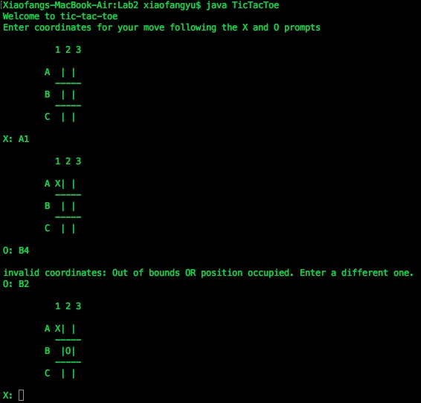

Validate Basic Moves (legal moves only)
Scenario | Input | Expected Result | Actual Result | Limitations
Basic moves validation | 1. X tries to place at “A1”  2. An X is placed at TopLeft  3. O tries to place at “B2”  4. An O is placed at Center  5. X tries to place at “A1”  6. X tries to place at “B2”  7. X tries to place at “B4”  8. X tries to place at “D1”  9. X tries to place at “A2B%@$” | For step 1 ~ 4, markers are present at expected positions (assertions pass);  Step 5, 6, 7, and 8 fail: error message displays and the player is not switched;  Step 9 passes and ‘X’ is added at “A2”. | Matches with the Expected Result  (Output shown as below) | 1. Out-of-bound input is illegal;  2. Position occupied by his opponent or himself is illegal;  3. Only check the first two characters of the input (same if you enter “A1” or “A1&%#$%^&&”).
Screenshot of output
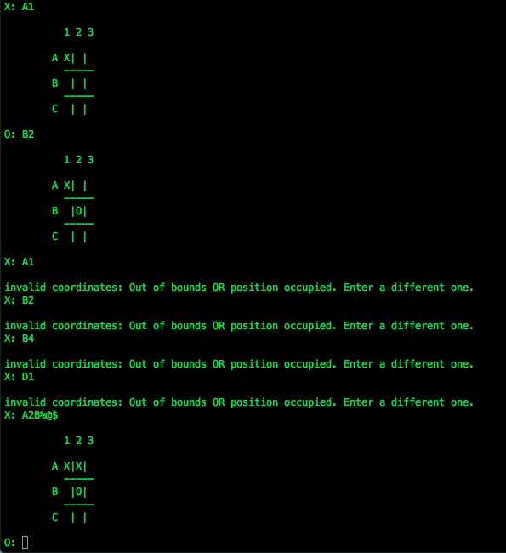

Declare the Winner or a Tie
Scenario | Input | Expected Result | Actual Result | Limitations | Screenshot (final step and result)
Horizontal win | X: A1  O: B2  X: A3  O: C1  X: A2 | X wins | Matches with the Expected Result | There are three cases (same row number) to get a horizontal win. | 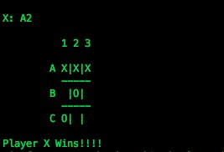
Vertical win | X: A1  O: A3  X: B2  O: C3  X: B1  O: B3 | O wins | Matches with the Expected Result | There are three cases (same column number) to get a vertical win. | ￼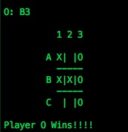
Diagonal win | X: B2  O: A3  X: A1  O: B3  X: C3 | X wins | Matches with the Expected Result | There are two cases to get a diagonal win:  A1,B2,C3  or  A3,B2,C1 | 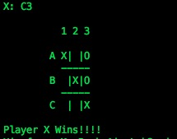
Stalemate | X: A1  O: A2  X: A3  O: B1  X: B3  O: B2  X: C1  O: C3  X: C2 | The game is declared a draw | Matches with the Expected Result | If no player wins while there is no place left to move then the game is a tie. | 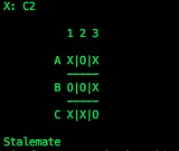

Open Issues
- The dev implements a win method (win when three in a row) for larger game board (> 3x3). This is not currently covered in the test plan.

