Test Plan: Weekly Employee Pay Report

Overview
A company pays its employees on a weekly basis. There are three types of employees:
1. Salaried employees: fixed weekly salary possibly with a 10% bonus;
2. Hourly employees: paid by number of hours, hourly pay rate is doubled if it’s beyond 40 hours/week;
3. Commissioned employees: 20% of the week's sales.

Test Plan Objectives

1. Test that the application requests the user to input the name, type, weekly salary/hourly rate/weekly sales; if it’s an hourly employee, request for hours worked for the week.

2. Test that, if it is beyond 40 hours/week, the hourly rate is doubled for hourly employees.

3. Test that the application request for whether a salaried employee will be rewarded by adding 10% to their salaries.
4. Test that the payment information is correctly printed for each employee.
5. Test that the header and footer are printed correctly. The total amount should be printed out below the table. And if there is/are salaried employee(s) awarded, a note stating bonus should be added below the total amount.

Test Cases

1. Salaried Without Bonus
Scenario | Input | Expected Result | Actual Result | Limitations
Salaried without bonus | Name: James Hogan  Type: Salaried  Salary: 3,300.00 | In the table: display the employee’s name, type, and salary ($3,300.00 without ‘*’ sign);  Below the table: only display the total amount ($3,300.00). | Matches with the Expected Result  (Output shown as below) | Empty name and invalid type are not accepted.
Screenshot of output
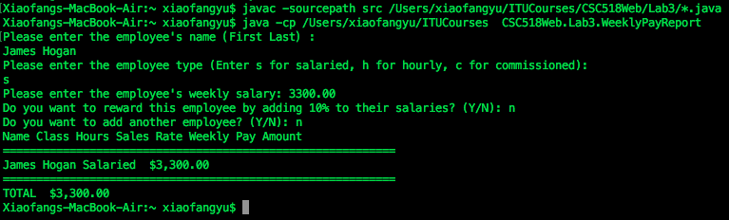

2. Salaried With Bonus
Scenario | Input | Expected Result | Actual Result | Limitations
Salaried with bonus | Name: James Hogan  Type: Salaried  Salary: 3,630.00 | In the table: display the employee’s name, type, and salary($3,630.00 with ‘*’ sign);  Below the table: display the total amount ($3,630.00) and the bonus status note. | Matches with the Expected Result  (Output shown as below) | Empty name and invalid type are not accepted.  Requested whether the employee is rewarded.
Screenshot of output
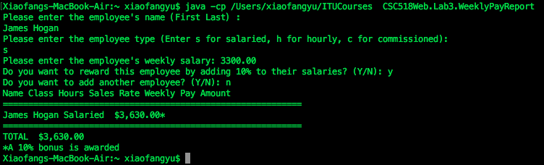

3. Hourly Within 40 Hrs
Scenario | Input | Expected Result | Actual Result | Limitations
Hourly within 40 hrs | Name: Jennifer Waltz  Type: Hourly  Hourly rate: 15.00  Hours: 30 | In the table: display the employee’s name, type, hours, and weekly salary($450.00);  Below the table: Only display the total amount ($450.00). | Matches with the Expected Result  (Output shown as below) | Empty name and invalid type are not accepted.
Screenshot of output
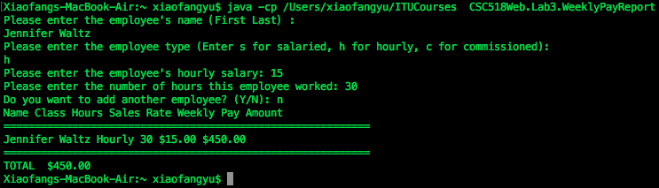

4. Hourly More Than 40 Hrs
Scenario | Input | Expected Result | Actual Result | Limitations
Hourly more than 40 hrs | Name: Jennifer Waltz  Type: Hourly  Hourly rate: 15.00  Hours: 45 | In the table: display the employee’s name, type, hours, and weekly salary ($750.00);  Below the table: Only display the total amount ($750.00). | Matches with the Expected Result  (Output shown as below) | Empty name and invalid type are not accepted.
Screenshot of output
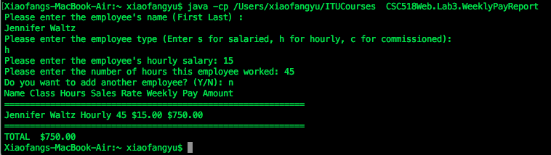

5. Commissioned
Scenario | Input | Expected Result | Actual Result | Limitations
Commissioned | Name: Marry Bulter  Type: Commissioned  Weekly sales: 10,000.00 | In the table: display the employee’s name, type, weekly sales, and weekly salary ($2,000.00);  Below the table: Only display the total amount ($2,000.00). | Matches with the Expected Result  (Output shown as below) | Empty name and invalid type are not accepted.
Screenshot of output
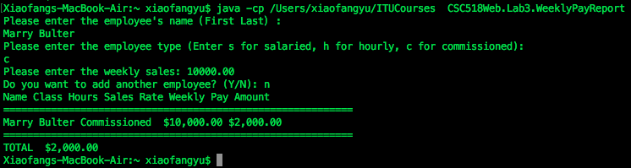

Multiple Employees
Scenario | Input | Expected Result | Actual Result | Limitations
Multiple Employees | Five employees show all the previous five test cases | In the table: display the five employees’ name, type, weekly sales, and weekly salary respectively;  Below the table: Only display the total amount and the bonus status note. | Matches with the Expected Result  (Output shown as below) | Empty name and invalid type are not accepted.  Once all the info for one employee requested, ask for whether or not add another employee.
Screenshot of output
