#!/bin/ksh

####################################################

# Written by Xiaofang Yu

# Oct. 23, 2017

# Purpose: This script is for CSC505 Weekend2_KSHChallenge assignment

####################################################

# Challenge #1

find . -name '*.sh' -exec ls -lhS {} \; | (head –n1; tail –n1)

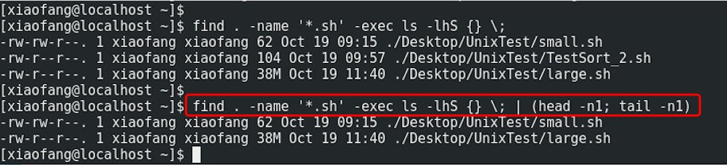

#Challenge #2

ps –e –o pid,comm,etime –sort=etime | (head –n2; tail –n1)

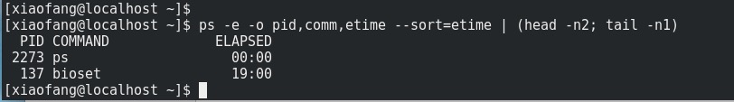

#Challenge #3