#!/bin/ksh

####################################################

# Written by Xiaofang Yu Nov. 7, 2017

# Purpose: This script is for CSC505 Weekend2_KSHChallenge assignment

####################################################

# Challenge #1

find . -name '*.sh' -exec ls -lhS {} \; | (head -n1; tail -n1)

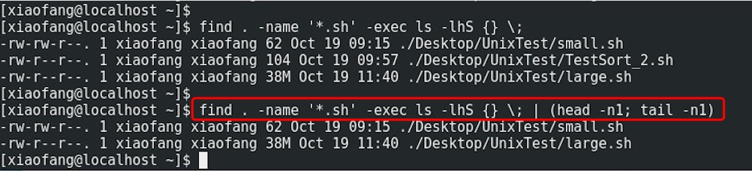

#Challenge #2

ps -e -o pid,comm,etime -sort=etime | (head -n2; tail -n1)

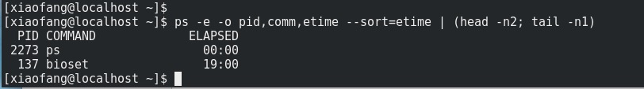

#Challenge #3

find / -exec ls -ldb {} \; | grep -v ‘^\-‘

