1、**创建一个类Point，有int类型的属性x, y。该类有四个方法setX(int)、setY(int)、getPoint()和movePoint(int,int)。setX(int)和setY(int)方法是设置成员变量x和y的值，getPoint()方法则获得由x, y构成的坐标点，movePoint(int,int)带两个int参数，用来修改x，y构成的坐标点。修改该类，可在该类增加main方法，也可在另外的类中实现main方法，实例化该Point类，通过设置x，y的值，并改变该值。输出结果。**

源代码：

public class Point {

    private int X;

    private int Y;

    Point(int x,int y) {

        X = x;

        Y = y;

    }

    public void movePoint(int x, int y) {

        this.X = x;

        this.Y = y;

    }

   public void setX(int x) {

        this.X = x;

    }

    public void setY(int y) {

        this.Y = y;

    }

    public int[] getPoint() {

        int[] xyArray = new int[2];

        xyArray[0] = this.X;

        xyArray[1] = this.Y;

        return xyArray;

    }

    public void showPoint(int[] xyPoint) {

        System.out.println("Get point: (" + xyPoint[0] + ", " + xyPoint[1] + ")");

    }

    public static void main(String[] args) {

        Point aPoint = new Point(0, 0);

        int[] xyPoint = aPoint.getPoint();

        aPoint.showPoint(xyPoint);

        aPoint.movePoint(9, 9);

        xyPoint = aPoint.getPoint();

        aPoint.showPoint(xyPoint);

        aPoint.setX(0);

        xyPoint = aPoint.getPoint();

        aPoint.showPoint(xyPoint);

        aPoint.setY(0);

        xyPoint = aPoint.getPoint();

        aPoint.showPoint(xyPoint);

    }

}

运行截图：

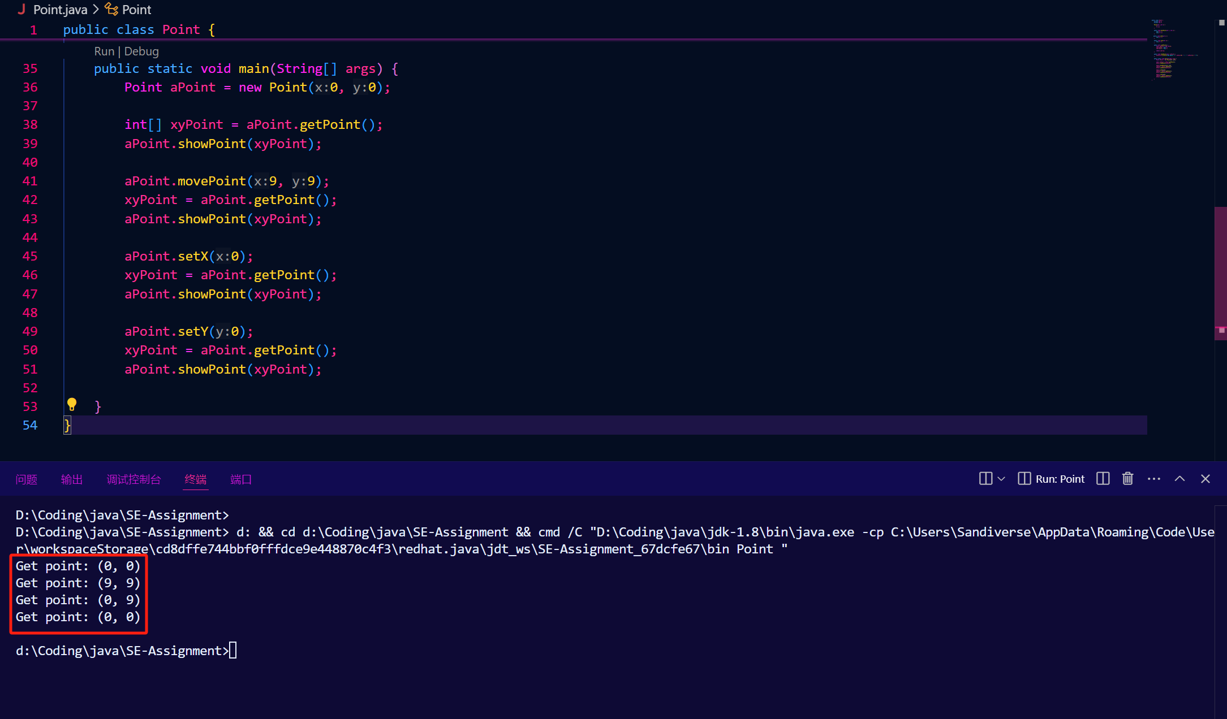

2、**修改上题程序，要求如下：**

**Point类有一个默认构造方法，为x, y设置原点值。**

**另一个类为TestPoint，有一个main()方法，用来对Point类的实例进行测试。要求为其实例设置(0,0)坐标点，再移动到(10, 20)坐标点上，并输出实例调用相应的方法的结果**

源代码：

public class Point {

    int X;

    int Y;

    Point() {

        X = 0;

        Y = 0;

    }

    public void movePoint(int x, int y) {

        this.X = x;

        this.Y = y;

        System.out.println("move point to (" + x + ", " + y + ")");

    }

   public void setX(int x) {

        this.X = x;

        System.out.println("set x to " + x);

    }

    public void setY(int y) {

        this.Y = y;

        System.out.println("set y to " + y);

    }

    public int[] getPoint() {

        int[] xyArray = new int[2];

        xyArray[0] = this.X;

        xyArray[1] = this.Y;

        return xyArray;

    }

    public void showPoint(int[] xyPoint) {

        System.out.println("Get point: (" + xyPoint[0] + ", " + xyPoint[1] + ")");

    }

}

class TestPoint {

    public static void main(String[] args) {

        Point testOnePoint = new Point();

        int[] xyPoint = {testOnePoint.X, testOnePoint.Y};

        testOnePoint.showPoint(xyPoint);

        testOnePoint.movePoint(10, 20);

        xyPoint[0] = testOnePoint.X;

        xyPoint[1] = testOnePoint.Y;

        testOnePoint.showPoint(xyPoint);

    }

}

运行截图：

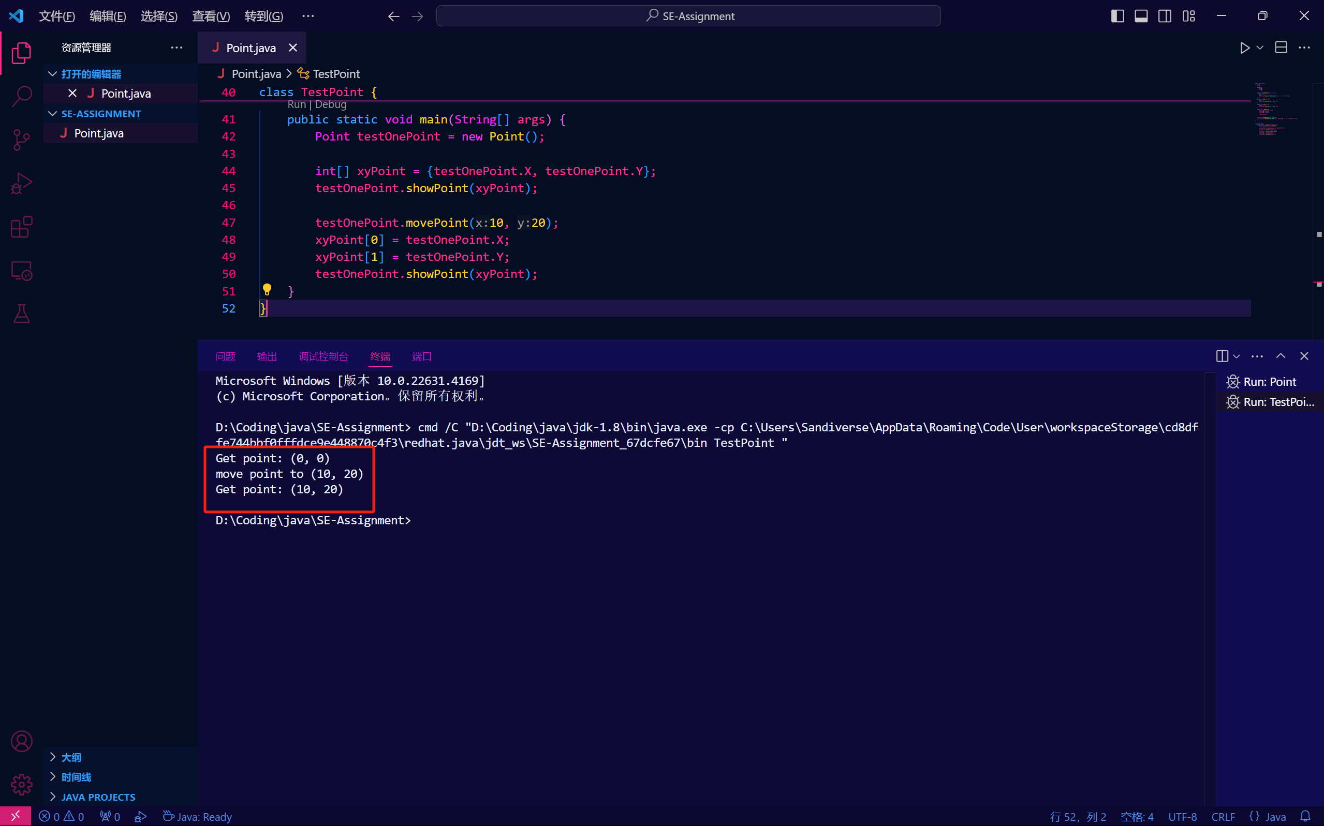

3、

**设计Student类，有姓名、学号、性别、年龄等属性，方法有获得姓名、学号、性别、年龄和修改年龄。**

**设置一个静态属性，学校名，再创建静态方法来修改和获得该属性值。**

**要求：**

**在该类中创建main方法，在方法中创建该对象并实例化，然后测试其功能。要求至少创建3个不同学生对象。针对静态属性，尝试不同的方法对其进行访问。**

**改写上面的程序，将学生类中的main方法移除。创建另外一个类（StudentTest），在其中创建main方法重做前面的工作**

**选做部分：尝试在本题完成程序的基础上，修改学生类属性的访问方式，诸如私有保护等等，测试访问限制，观测编译器的出错提示**

* 首先，创建3个不同学生对象，针对静态属性使用方法访问

源代码：

public class Student {

    String name;

    String ID;

    String gender;

    int age;

    static String universityName = "University of Electronic Science and Technology of China";

    Student(String name, String ID, String gender, int age) {

        this.name = name;

        this.ID = ID;

        this.gender = gender;

        this.age = age;

    }

    public void getName() {

        System.out.println("the name of the student is " + name);

    }

    public void getID() {

        System.out.println("the ID of the student is " + ID);

    }

    public void getGender() {

        System.out.println("the gender of the student is " + gender);

    }

    public void getAge() {

        System.out.println("the age of the student is " + age);

    }

    public void modifyAge(int age) {

        int prevAge = this.age;

        this.age = age;

        System.out.println("the previous age of the student is " + prevAge + ", now the age is " + age);

    }

    public static void modifyUniversity(String newUniversityString) {

        universityName = newUniversityString;

        System.out.println("University of the Student is modified to " + newUniversityString);

    }

    public String getUniversityName() {

        return universityName;

    }

    public static void main(String[] args) {

        Student A = new Student("Genshin", "2023090909000", "Helicopter", 114);

        Student B = new Student("MIT", "1919810", "Transformer", 514);

        Student C = new Student("Yuzusoft", "0721", "Ciallo", 721);

        A.getName();

        B.getGender();

        C.getID();

        C.modifyAge(1919);

        String universityNameOfTheStudent = C.universityName;

        System.out.println("university name is " + universityNameOfTheStudent);

        universityNameOfTheStudent = C.getUniversityName();

        System.out.println("university name is " + universityNameOfTheStudent);

    }

}

运行结果为：

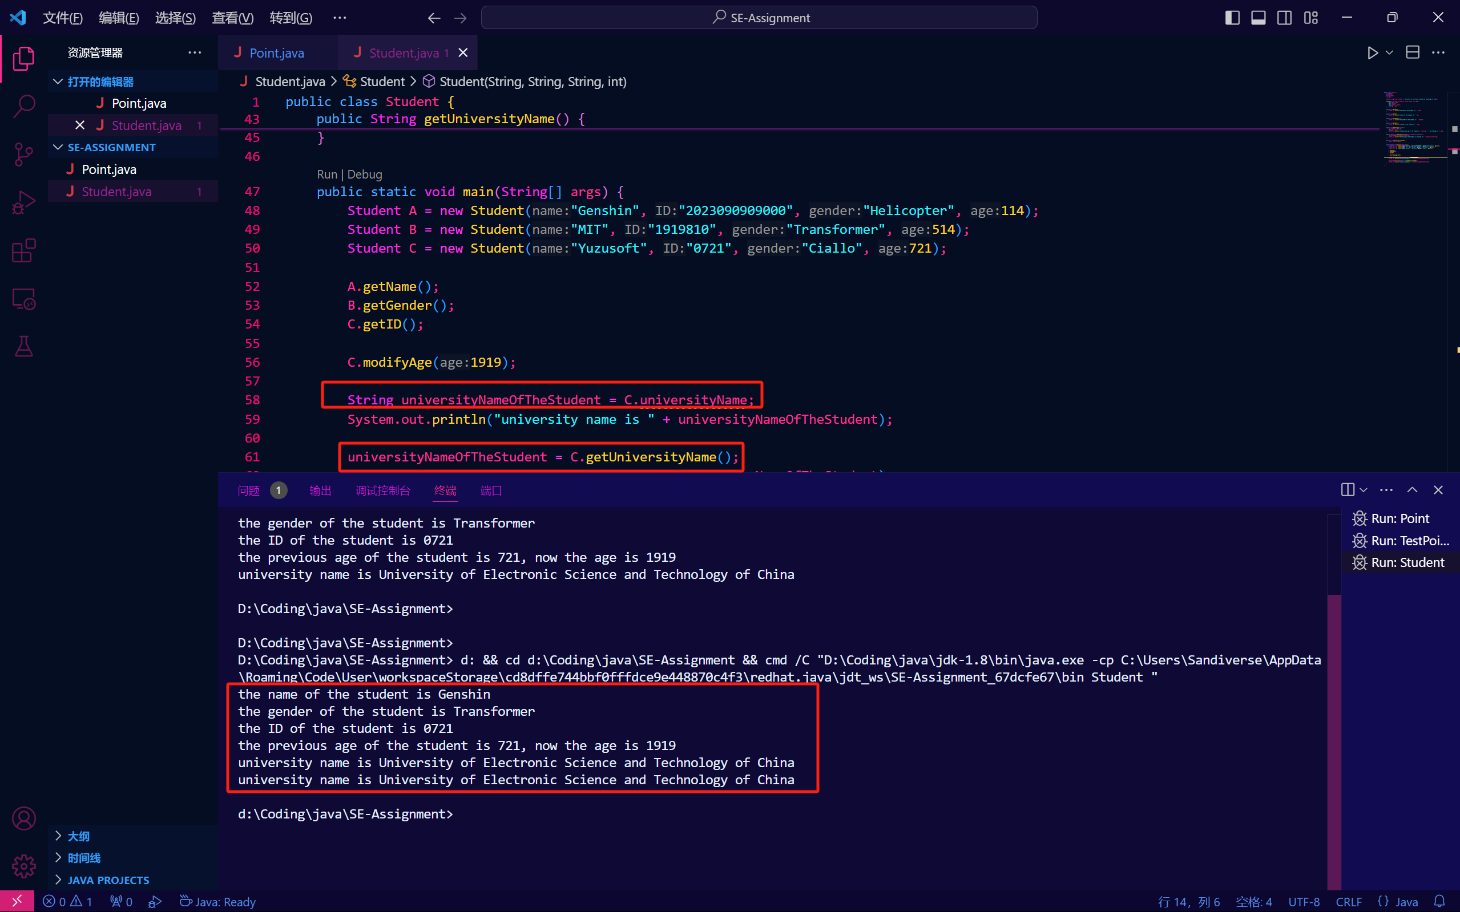

* 之后移除main方法并使用StudentTest重复操作

源代码：

public class Student {

    String name;

    String ID;

    String gender;

    int age;

    static String universityName = "University of Electronic Science and Technology of China";

    Student(String name, String ID, String gender, int age) {

        this.name = name;

        this.ID = ID;

        this.gender = gender;

        this.age = age;

    }

    public void getName() {

        System.out.println("the name of the student is " + name);

    }

    public void getID() {

        System.out.println("the ID of the student is " + ID);

    }

    public void getGender() {

        System.out.println("the gender of the student is " + gender);

    }

    public void getAge() {

        System.out.println("the age of the student is " + age);

    }

    public void modifyAge(int age) {

        int prevAge = this.age;

        this.age = age;

        System.out.println("the previous age of the student is " + prevAge + ", now the age is " + age);

    }

    public static void modifyUniversity(String newUniversityString) {

        universityName = newUniversityString;

        System.out.println("University of the Student is modified to " + newUniversityString);

    }

    public static String getUniversityName() {

        return universityName;

    }

}

*/\*\**

*\* StudentTest*

*\*/*

class StudentTest {

    public static void main(String[] args) {

        Student A = new Student("Genshin", "2023090909000", "Helicopter", 114);

        Student B = new Student("MIT", "1919810", "Transformer", 514);

        Student C = new Student("Yuzusoft", "0721", "Ciallo", 721);

        A.getName();

        B.getGender();

        C.getID();

        C.modifyAge(1919);

        String universityNameOfTheStudent = C.universityName;

        System.out.println("university name is " + universityNameOfTheStudent);

        universityNameOfTheStudent = C.getUniversityName();

        System.out.println("university name is " + universityNameOfTheStudent);

    }

}

运行截图：

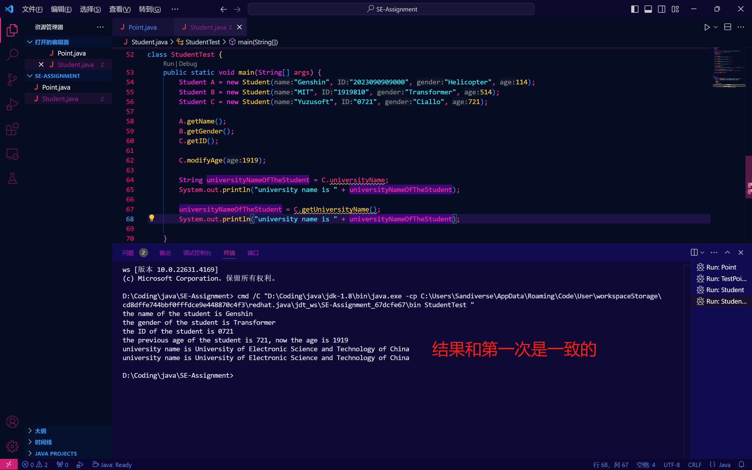

* 选做部分，修改类属性的访问方式

将ID修改为private，此时直接通过studentTest中main函数的实例B访问ID时出现报错：

