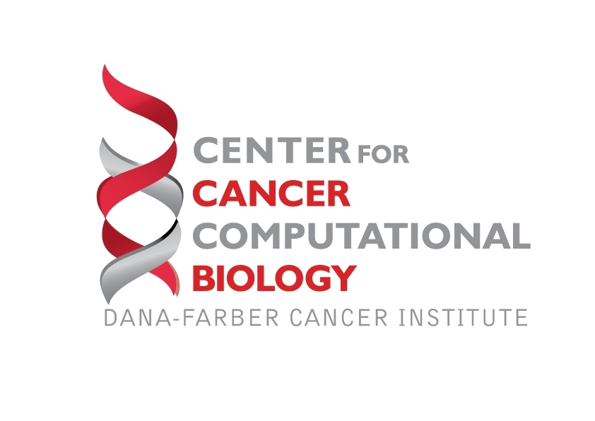

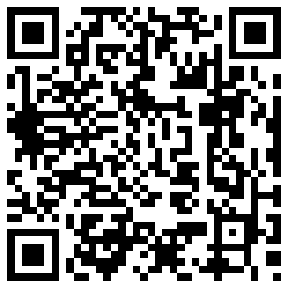
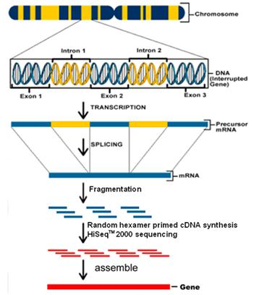
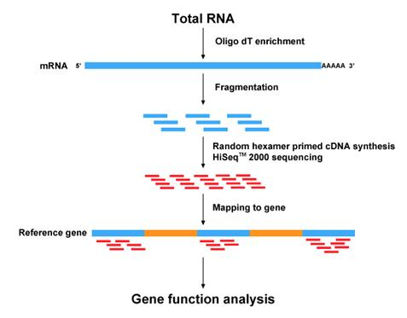
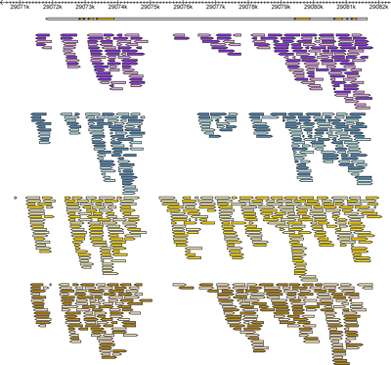
CCCB: From Data to Knowledge, Knowledge to Understanding
Center for Cancer Computational Biology presents
Computing Basics for Genomic Analysis
Monday, January 28th, 2013
Dana-Farber Cancer Institute, Department of Biostatistics and Computational Biology
Location: DFCI Yawkey Center, Room 306
High throughput technologies such as microarray and next generation sequencing (NGS) allow for the study of genomic changes with high resolution. However, managing and analyzing the Big Data generated from high throughput experiments presents a novel analytical challenge that requires computing knowledge. This course will introduce basic computing tools necessary to manipulate genomic data. The course will introduce the Linux operating system, shell scripting, and the R language in the context of high throughput data manipulation and visualization. The goal of this course is to enable participants having no prior programming experience to work with genomic data on a Linux server and to provide sufficient computation background for our Nex-Gen RNA-Seq Analytical Workshop.

Space is limited, registration required! http://cccbworkshopseptember.eventbrite.com
Visualizing

