About Using the ModelSim Software with the Quartus II Software
Author: Kerwin. Xie

ModelSim-Altera Design Flow（For Altera Version）
- Set up the ModelSim-Altera working environment
- Set up a project with the ModelSim-Altera software
- Perform a functional simulation with the ModelSim-Altera software
- Perform a timing simulation with the ModelSim-Altera software

ModelSim PE/SE Design Flow（For PE/SE Version）
- Set up the ModelSim working environment
- Set up a project with the ModelSim software
- Compile libraries and design files with the ModelSim software
- Perform a functional simulation with the ModelSim software
- Perform a timing simulation with the ModelSim software
目 录
ModelSim-Altera版本仿真流程 3
1、建立ModelSim-Altera工作环境 3
2、用ModelSim-Altera建立工程 3
3、用ModelSim-Altera执行功能仿真 3
4、用ModelSim-Altera执行时序仿真 4
ModelSim-PE/SE版本仿真流程 6
Performing a Functional Simulation with the ModelSim Software 6
Performing a Timing Simulation with the ModelSim Software 7
相关知识链接 9
ModelSim Precompiled Libraries（预编译库） 9
Altera Functional Simulation Libraries（功能仿真库） 12
Altera Post-Fit Libraries（后适配库） 21
Performing Power Analysis with the Quartus II Software and Other EDA Tools 30
使用QuartusII自动运行ModelSim仿真 37
1、配置NativeLink 37
2、运行仿真 39
3、产生Testbench 40

相关链接：ModelSim-Altera软件支持
谢银坤 Kerwin Xie
2010年1月20日

ModelSim-Altera版本仿真流程

1、建立ModelSim-Altera工作环境
1.1版本说明
ModelSim-Altera（OEM）version 6.4a
QuartusII version 9.0
该ModelSim版本支持所有QuartusII支持的Altera器件。
1.2要自动从Quartus II运行EDA设计输入、综合、仿真或者时序分析工具，您必须指定第三方EDA工具的可执行文件位置，通过单击Tools菜单上的Options供然后点击EDA Tool Options选项。

2、用ModelSim-Altera建立工程
2.1 如果要执行时序仿真，需要产生Verilog（.vo）或者VHDL（.vho）输出文件。
a. 选择EDA Tool Settings
b. 用QuartusII编译设计文件
注：如果已经编译过设计，要重新产生.vo、.vho和.sdo（标准延迟输出文件）的话，只需要运行Start EDA Netlist Writter即可。同时也可以用于产生.vcd文件。
如果要执行功耗估算，确保在Simulator Settings下的Settings对话框选择合适的参数。
2.2 启动Modelsim软件，选择工程目录：File—>Change Directory.
注：如果要执行功能仿真，工程目录就是包含设计文件的目录；
如果要进行时序仿真，工程目录务必设在包含.vo、.vho和.sdo的目录下。
2.3 创建新的工作库：
a. File—>New—>Library，出现创建新库的对话框
b. 在Create选项下，选择a new library and a logical mapping to it.
c．在Library Name中输入库的名称
注：如果你想要脱离QuartusII独立运行Modelsim，库文件名必须是work；如果是由QuartusII自动运行Modelsim，则库的名称被自动名为ModelSim_work，并且位于QuartusII的过程目录下。

3、用ModelSim-Altera执行功能仿真
3.1 编译Verilog或者VHDL文件和Test Bench文件（如果你使用testbench的话）
a. Compile menu, 点击Compile.
b. 在Library列表下选择work库
c. 选择需要的Verilog或者VHDL文件
注：如果选择.vo、.vho文件作为功能仿真的话，必须在下面操作前进行编译。
d. 执行编译
e. 重复上面操作，编译testbench文件
f. 点击done完成。
3.2 加载设计：
a. 在Simulate菜单中，点击Simulate.出现Simulate对话框
b. 如果要仿真Verilog HDL设计文件，指定ModelSim预编译库
i. 点击Libraries标签
ii．在Search Libraries (-L)中，点击Add选择适当的库
iii. 点击OK完成
c. 在Name 列表中，点击+展开work库，选择要仿真的顶层文件（一般是testbench）
d. 点击OK完成
3.3 在ModelSim中执行功能仿真

4、用ModelSim-Altera执行时序仿真
重要提示：强烈建议在进行RAM仿真时，将Time scale设置为飞秒ps级别！
4.1 编译Verilog或者VHDL输出文件和testbench文件，方法同功能仿真。
4.2 如果你的设计包含全局复位或者全局上电信号，并且还没这么做，可以在Verilog或者VDHL输出文件中建立这些信号。方法如下：
对于Verilog，在仿真前，将下列代码加到testbench文件中：
reg <device-wide reset>;
reg <device power up>;
initial
begin
<device power up> = 0;
#<time> <device power up> = 1;
对于VHDL，在仿真前运行下列命令：
force /<design>/<entity>/<device power up> 0 0 ns
force <design>/<entity>/<device power up> 1 <time> ns
force /<design>/<entity>/<device-wide reset> 1 0 ns
注： <device-wide reset> 是全局复位信号名称，<device power up> 是全局上电信号，<time> 是一个时间值，它介于0和实际开始仿真的时间之间。
4.3 在Simulate菜单中，点击Simulate.出现Simulate对话框
4.4 如果是仿真verilog语言，点击verilog标签，在Pulse Options中的Error Limit 和Rejection Limit中填入0.
4.5 如果仿真的是VHDL设计，指定.sdo标准延迟文件：
a. 点击SDF标签，点击ADD
b. 在Add SDF Entry对话框中，点击Browse，出现Select SDF File对话框
c. 选择标准延迟输出.sdo文件
注：如果使用的是test bench文件作为设计的激励，那么在Apply to region 框中，从顶层设计文件开始，将路径指向test bench中的instance
4.6 如果仿真的是verilog设计，要指定预编译库（ModelSim precompiled libraries）
a. 点击Library标签，在Search Libraries (-L)中，点击Add.
b. 指定目录\<ModelSim-Altera install directory>\altera\verilog\<device family>\，点击OK；
4.7 点击Design标签，在Name列表中，点击+展开work库，并选择标准延时输出文件对应的设计实体（entity），点击OK完成。
4.8 如果要仿真高速电路（包括HSSI, LVDS, PLLs等），点击Others标签，在Other vsim options中输入+transport_int_delays +transport_path_delays，点击OK完成；
4.9 要直接从ModelSim中生成.vcd（Value Change Dump File）文件用于QuartusII中PowerPlay Power Analyzer分析，可以在ModelSim中输入命令：
source <test bench or design instance name>_dump_all_vcd_nodes.tcl
4.10 Tcl脚本文件指示ModelSim-Altera监视Tcl脚本文件中的输出信号并在仿真过程中写入到.vcd文件中去。
4.11 在ModelSim-Altera进行时序仿真。
重要提示：强烈建议在进行RAM仿真时，将Time scale设置为飞秒ps级别！

ModelSim-PE/SE版本仿真流程

Performing a Functional Simulation with the ModelSim Software
1. If you have not already done so, set up a project with the ModelSim software.
2. To map the design libraries to your work library:
a. On the File menu, point to New and click Library (File menu). The Create a New Library dialog box appears.
b. Type lpm in the Library Name box, type the name of the work library in the Library Maps to box, and then click OK.
c. Repeat steps 2a and 2b to map altera_mf to the work library.
3. To compile the functional simulation libraries, Verilog HDL or VHDL Design Files, and test bench files (if you are using a test bench):
Important: If your design contains the altgxb megafunction or the alt2gxb megafunction, please refer to the appropriate megafunction topic for required settings information.
a. On the Compile menu, click Compile.
b. In the Library list of the Compile HDL Source Files dialog box, select the work library.
c. In the File name list, type the directory path and file name of the functional simulation libraries Or In the Files of Type list, select All Files (*.*), and in the Look in list select the Verilog HDL or VHDL Design File.
d. Click Compile.
Note: For VHDL designs that use the 220model.vhd library, turn on Use Explicit Declarations under Default Options in the Compile dialog box.
e. Repeat steps 4b to 4d to compile the Verilog HDL or VHDL Design File.
f. Repeat steps 4b to 4d to compile the test bench file(s).
g. Click Done.
4. To load the design:
a. On the Simulate menu, click Simulate. The Simulate dialog box appears.
b. In the Name list, click the + icon to expand the work directory.
c. Select the top-level design file to simulate.
d. Click Add.
e. Click Load.
5. Perform the functional simulation in the ModelSim software.

Performing a Timing Simulation with the ModelSim Software
1 If you have not already done so, compile libraries and design files with the ModelSim software.
2 If the design contains device-wide reset or device power-up signals, and if you have not already done so, set up the signals in the Verilog Output File or set up the signals in the VHDL Output File.
3 On the Simulate menu, click Simulate. The Simulate dialog box appears.
4 If you are simulating a Verilog HDL design, click the Verilog tab. Under Pulse Options, type 0 in the Error Limit and Rejection Limit boxes.
5 If you are simulating a VHDL design, to specify the Standard Delay Format Output File (.sdo):
a. Click the SDF tab.
b. Click Add.
c. In the Add SDF Entry dialog box, click Browse. The Select SDF File dialog box appears.
d. In the Files of type list, select All Files (*.*).
e. Select the Standard Delay Output File.
f. Click Open.
g. Click OK.
Note: If you are using a test bench file to provide simulation stimuli to the design, in the Apply to region box, specify the path to the design instance in the test bench, starting from the top-level design file.
6 Click the Design tab.
7 In the Name list, expand the work directory and select the design entity that corresponds to the Standard Delay Output File.
8 Click Add.
9 Select the top-level Verilog HDL or VHDL Output File or test bench.
10 Click Add.
11 If you are simulating high-speed circuits (including designs that use HSSI, LVDS, or PLLs):
a. Click the Other tab.
b. In the Other options box type：
+transport_int_delays and +transport_path_delays.
c. Click OK.
12 Click Load.
13 To direct the ModelSim software to generate a Value Change Dump File (.vcd) that you can then use to perform power analysis in the Quartus II PowerPlay Power Analyzer, type the following command at the ModelSim prompt:
source <test bench or design instance name>_dump_all_vcd_nodes.tcl
The Tcl Script File (.tcl) directs the ModelSim software to monitor and write the output signals contained in the Tcl Script File to a Value Change Dump File during simulation.
Perform the timing simulation in the ModelSim software.

相关知识链接

ModelSim Precompiled Libraries（预编译库）
The following libraries are the precompiled atom libraries for the Mentor Graphics ModelSim-Altera OEM version software.
For Verilog HDL or VHDL designs, the following libraries are located in the \<ModelSim-Altera system directory>\altera\<verilog | vhdl> directory for PCs and in the /<ModelSim-Altera system directory>/modeltech/altera/<verilog | vhdl> directory for Linux workstations:
Library | Description
apex20k | Precompiled atom library for APEX 20K designs
apex20ke | Precompiled atom library for APEX 20KC and APEX 20KE designs
apex20ke_87 | Precompiled atom library for VHDL 87-compliant APEX 20KC and APEX 20KE designs
apexii | Precompiled atom library for APEX II designs
arriagx | Precompiled atom library for Arria GX designs
arriagx_hssi | Library that contains functional simulation models for Arria GX devices with the alt2gxb megafunction
arriaii_hssi | Library that contains functional simulation models for Arria II GX devices with altgxb instantiations
arriaii_pcie_hip | Library that contains functional simulation models for PCI Express hard IP blocks
arriaii | Precompiled atom library for Arria II GX designs
cyclone | Precompiled atom library for Cyclone designs
cycloneii | Precompiled atom library for Cyclone II designs
cycloneiii | Precompiled atom library for Cyclone III designs
flex6000 | Precompiled atom library for FLEX 6000 designs
flex10ke | Precompiled atom library for FLEX 10K and ACEX 1K designs
hardcopyii | Precompiled atom library for HardCopy II designs
hcstratix | Precompiled atom library for HardCopy Stratix designs
max | Precompiled atom library for MAX 3000 and MAX 7000 designs
maxii | Precompiled atom library for MAX II designs
stratix | Precompiled atom library for Stratix designs
stratixgx | Precompiled atom library for Stratix GX designs
stratixgx_gxb | Library that contains timing simulation models for Stratix GX devices with the altgxb megafunction
stratixii | Precompiled atom library for Stratix II designs
stratixiigx | Precompiled atom library for Stratix II GX designs
stratixiigx_hssi | Library that contains functional simulation models for Stratix II GX devices with the alt2gxb megafunction
stratixiii | Precompiled atom library for Stratix III designs
stratixiv | Precompiled atom library for Stratix IV designs
stratixiv_hssi | Library that contains functional simulation models for Stratix IV devices with alt4gxb instantiations
stratixiv_pcie_hip | Library that contains functional simulation models for PCI Express hard IP blocks
220model | Library that contains functional simulation models for Altera library of parameterized modules (LPM) version 2 2 0
220model_87 | Library that contains VHDL 87-compliant functional simulation models for Altera library of parameterized modules (LPM) version 2 2 0
altera | Library that contains functional simulation models for Altera-specific primitives
altera_mf | Library that contains functional simulation models for Altera-specific megafunctions
altera_mf_87 | Library that contains VHDL 87-compliant functional simulation models for Altera-specific megafunctions
altgxb | Library that contains functional simulation models for Stratix GX devices with the altgxb megafunction
alt_vtl | Library that contains precompiled components for MAX+PLUS II designs

Altera Functional Simulation Libraries（功能仿真库）
The following directories are the functional simulation libraries, located in the <Quartus II installation directory>\eda\sim_lib directory:
Library | Description
220model.v  220model.vhd  220model_87.vhd | Libraries that contain simulation models for Altera library of parameterized modules (LPM) version 2 2 0.  For VHDL-93 compliant designs, use 220model.vhd. For VHDL-87 compliant designs, use 220model_87.vhd.
220pack.vhd | Libraries that contain VHDL Component Declarations for the 220model.vhd library.
altera_primitives.v  altera_primitives.vhd  altera_primitives_components.vhd | Libraries that contain primitives for Altera-specific megafunctions used in Block Design Files (.bdf), AHDL Text Design Files (.tdf), VHDL Design Files (.vhd), and Verilog Design Files (.v).
altera_mf.v  altera_mf.vhd  altera_mf_87.vhd | Libraries that contain simulation models for Altera-specific megafunctions.  For VHDL-93 compliant designs, use altera_mf.vhd. For VHDL-87 compliant designs, use altera_mf_87.vhd.
arriagx_hssi_atoms.v  arriagx_hssi_atoms.vhd | Libraries that contain simulation models for Arria GX designs that contain the alt2gxb megafunction.  For Verilog HDL designs, you must compile the 220model.v and sgate.v simulation model libraries (in that order) before compiling this library.  For VHDL designs, you must compile the 220pack.vhd, 220model.vhd, sgate_pack.vhd, and sgate.vhd simulation model libraries (in that order) and then compile the arriagx_hssi_components.vhd.
  Note: If you have not already done so, instantiate the alt2gxb megafunction in the MegaWizard Plug-In Manager. You must turn on the option to Generate simulation model in the Summary dialog box in order to generate a Verilog Output File (.vo) or VHDL Output File (.vho).
arriaii_hssi_atoms.v  arriaii_hssi_atoms.vhd | Libraries that contain simulation models for Arria II GX designs that contain the alt4gxb megafunction.  For Verilog HDL designs, you must compile the 220model.v and sgate.v simulation model libraries (in that order) before compiling this library.  For VHDL designs, you must compile the 220pack.vhd, 220model.vhd, sgate_pack.vhd, and sgate.vhd simulation model libraries (in that order) and then compile the arriaii_hssi_components.vhd.
stratixgx_mf.v  stratixgx_mf.vhd | Libraries that contain simulation models for Stratix GX designs that contain the altgxb megafunction.  For Verilog HDL designs, you must compile the 220model.v and sgate.v simulation model libraries (in that order) before compiling this library.  For VHDL designs, you must compile the 220pack.vhd, 220model.vhd, sgate_pack.vhd, and sgate.vhd simulation model libraries (in that order) before compiling these libraries.
stratixiigx_hssi_atoms.v  stratixiigx_hssi_atoms.vhd | Libraries that contain simulation models for Stratix II GX designs that contain the alt2gxb megafunction.  For Verilog HDL designs, you must compile the 220model.v and sgate.v simulation model libraries (in that order) before compiling this library.  For VHDL designs, you must compile the 220pack.vhd, 220model.vhd, sgate_pack.vhd, and sgate.vhd simulation model libraries (in that order) and then compile the stratixiigx_hssi_components.vhd.
  Note: If you have not already done so, instantiate the alt2gxb megafunction in the MegaWizard Plug-In Manager. You must turn on the option to Generate simulation model in the Summary dialog box in order to generate a Verilog Output File (.vo) or VHDL Output File (.vho).
stratixiv_hssi_atoms.v  stratixiv_hssi_atoms.vhd | Libraries that contain simulation models for Stratix IV GX designs that contain the alt4gxb megafunction.  For Verilog HDL designs, you must compile the 220model.v and sgate.v simulation model libraries (in that order) before compiling this library.  For VHDL designs, you must compile the 220pack.vhd, 220model.vhd, sgate_pack.vhd, and sgate.vhd simulation model libraries (in that order) and then compile the stratixiv_hssi_components.vhd.

Note:
- If your design contains the altgxb megafunction, you must set the value of the pll_areset signal to start high in the test bench or waveform file for the design. If the megafunction does not instantiate a GXB transmitter PLL, you must set the values of the rx_analogreset and rx_digitalreset signals to start high.
- If your design contains the alt2gxb megafunction or the altgx megafunction, Altera recommends that you set the value of the gxb_powerdown signal to start high in the test bench or waveform file for the design. If the instantiated alt2gxb or altgx megafunction does not use gxb_powerdown signal, Altera requires that you set the values of the tx_digitalreset, rx_analogreset, and rx_digitalreset signals to start high. Assert tx_digitalreset long enough so that it can be registered by tx_clkout and assert rx_digitalreset a few clock cycles longer than rx_analogreset so that it can be registered by rx_clkout. Altera requires that you apply the same reset sequence mentioned above after dynamic channel reconfiguration.
- If your design contains the alt4gxb megafunction, for a top-level design, you must connect reconfig_togxb[] to a reconfiguration controller because of silicon requirements. For functional simulation or module level simulation, you must assign reconfig_togxb[3:0] to a value of 4'b0010 if you do not have a reconfiguration controller in the same scope. If you do not connect ports and provide them with appropriate initial values, functional simulation fails: rx_analogreset is ignored and rx_pll may not function properly.

The following libraries are VITAL-Compliant functional simulation libraries for use with designs synthesized with the Synopsys Design Compiler software:
The \quartus\eda\synopsys\sim\vhdl\vital directory contains Altera-provided VHDL simulation models in VITAL 95 format. This library contains functional descriptions of all primitives that appear in Altera-specific technology libraries. These libraries allow you to perform a functional simulation that verifies the netlist structure generated by the Synopsys Design Compiler software. Altera provides the flex.cmp and flex.vhd files in the \quartus\eda\synopsys\sim\vhdl\vital directory.
Similarly, the \quartus\eda\synopsys\sim\verilog\altera directory contains Altera-provided Verilog HDL simulation models for all Altera devices supported by the Quartus II software.

Altera Post-Fit Libraries（后适配库）
Altera provides the following post-fit simulation model libraries and components, located in the \quartus\eda\sim_lib\ directory, for use with other EDA simulation tools:
Library | Description
apex20k_atoms.v  apex20k_atoms.vhd | Atom libraries for APEX 20K designs
apex20ke_atoms.v  apex20ke_atoms.vhd  apex20ke_atoms_87.vhd | Atom libraries for APEX 20KC and APEX 20KE designs.  For VHDL 93-compliant designs, use apex20ke_atoms.vhd. For VHDL 87-compliant designs, use apex20ke_atoms_87.vhd.
apexii_atoms.v  apexii_atoms.vhd | Atom libraries for APEX II designs
arriagx_atoms.v  arriagx_atoms.vhd | Atom libraries for Arria GX designs
arriagx_hssi_atoms.v  arriagx_hssi_atoms.vhd | Atom libraries for Arria GX designs that contain the alt2gxb megafunction.  For Verilog HDL designs, you must compile the compile the 220model.v and sgate.v simulation model libraries (in that order) before compiling this library.  For VHDL designs, you must compile the 220pack.vhd, 220model.vhd, sgate_pack.vhd, and sgate.vhd simulation model libraries (in that order), and then compile the arriagx_hssi_components.vhd library, before compiling this library.
arriaii_atoms.v  arriaii_atoms.vhd | Atom libraries for Arria II GX designs
arriaii_hssi_atoms.v  arriaii_hssi_atoms.vhd | Atom libraries for Arria II GX designs that contain the alt4gxb megafunction.  For Verilog HDL designs, you must compile the compile the 220model.v and sgate.v simulation model libraries (in that order) before compiling this library.  For VHDL designs, you must compile the 220pack.vhd, 220model.vhd, sgate_pack.vhd, and sgate.vhd simulation model libraries (in that order), and then compile the arriaii_hssi_components.vhd library, before compiling this library.
arriaii_pcie_hip_atoms.v  arriaii_pcie_hip_atoms.vhd | Atom libraries for Arria II GX designs that contain PCI Express hard IP blocks.  For Verilog HDL designs, you must compile the compile the 220model.v and sgate.v simulation model libraries (in that order) before compiling this library.  For VHDL designs, you must compile the 220pack.vhd, 220model.vhd, sgate_pack.vhd, and sgate.vhd simulation model libraries (in that order), and then compile the arriaii_pcie_hip_components.vhd library, before compiling this library.
cyclone_atoms.v  cyclone_atoms.vhd | Atom libraries for Cyclone designs
cycloneii_atoms.v  cycloneii_atoms.vhd | Atom libraries for Cyclone II designs
cycloneiii_atoms.v  cycloneiii_atoms.vhd | Atom libraries for Cyclone III designs
flex6000_atoms.v  flex6000_atoms.vhd | Atom libraries for FLEX 6000 designs
flex10ke_atoms.v  flex10ke_atoms.vhd | Atom libraries for FLEX 10K and ACEX 1K designs
hardcopyii_atoms.v  hardcopyii_atoms.vhd | Atom libraries for HardCopy II designs
hcstratix_atoms.v  hcstratix_atoms.vhd | Atom libraries for HardCopy Stratix designs
max_atoms.v  max_atoms.vhd | Atom libraries for MAX 3000 and MAX 7000 designs
maxii_atoms.v  maxii_atoms.vhd | Atom libraries for MAX II designs
stratix_atoms.v  stratix_atoms.vhd | Atom libraries for Stratix designs
stratixgx_atoms.v  stratixgx_atoms.vhd | Atom libraries for Stratix GX designs
stratixgx_hssi_atoms.v  stratixgx_hssi_atoms.vhd | Atom libraries for Stratix GX designs that contain the altgxb megafunction.  For Verilog HDL designs, you must compile the compile the 220model.v and sgate.v simulation model libraries (in that order) before compiling this library.  For VHDL designs, you must compile the 220pack.vhd, 220model.vhd, sgate_pack.vhd, and sgate.vhd simulation model libraries (in that order) before compiling this library.
stratixii_atoms.v  stratixii_atoms.vhd | Atom libraries for Stratix II designs
stratixiigx_atoms.v  stratixiigx_atoms.vhd | Atom libraries for Stratix II GX designs
stratixiigx_hssi_atoms.v  stratixiigx_hssi_atoms.vhd | Atom libraries for Stratix II GX designs that contain the alt2gxb megafunction.  For Verilog HDL designs, you must compile the compile the 220model.v and sgate.v simulation model libraries (in that order) before compiling this library.  For VHDL designs, you must compile the 220pack.vhd, 220model.vhd, sgate_pack.vhd, and sgate.vhd simulation model libraries (in that order), and then compile the stratixiigx_hssi_components.vhd library, before compiling this library.
stratixiii_atoms.v  stratixiii_atoms.vhd | Atom libraries for Stratix III designs
stratixiv_atoms.v  stratixiv_atoms.vhd | Atom libraries for Stratix IV designs
stratixiv_hssi_atoms.v  stratixiv_hssi_atoms.vhd | Atom libraries for Stratix IV designs that contain the alt4gxb megafunction.  For Verilog HDL designs, you must compile the compile the 220model.v and sgate.v simulation model libraries (in that order) before compiling this library.  For VHDL designs, you must compile the 220pack.vhd, 220model.vhd, sgate_pack.vhd, and sgate.vhd simulation model libraries (in that order), and then compile the stratixiv_hssi_components.vhd library, before compiling this library.
stratixiv_pcie_hip_atoms.v  stratixiv_pcie_hip_atoms.vhd | Atom libraries for Stratix IV designs that contain the alt4gxb megafunction.  For Verilog HDL designs, you must compile the compile the 220model.v and sgate.v simulation model libraries (in that order) before compiling this library.  For VHDL designs, you must compile the 220pack.vhd, 220model.vhd, sgate_pack.vhd, and sgate.vhd simulation model libraries (in that order), and then compile the stratixiv_pcie_hip_components.vhd library, before compiling this library.
Components |  | Description
apex20k_components.vhd |  | VHDL Component Declaration library for use with APEX 20K designs
apex20ke_components.vhd |  | VHDL Component Declaration library for use with APEX 20KC and APEX 20KE designs
apexii_components.vhd |  | VHDL Component Declaration library for use with APEX II designs
arriagx_componenets.vhd |  | VHDL Component Declaration library for use with Arria GX designs
arriagx_hssi_components.vhd |  | VHDL Component Declaration library for use with Arria GX designs that contain the alt2gxb megafunction
arriaii_components.vhd |  | VHDL Component Declaration library for use with Arria II GX designs
arriaii_hssi_components.vhd |  | VHDL Component Declaration library for use with Arria II GX designs that contain the alt4gxb megafunction
arriaii_pcie_hip_components.vhd |  | VHDL Component Declaration library for use with Arria II GX designs with PCI Express hard IP.
cyclone_components.vhd |  | VHDL Component Declaration library for use with Cyclone designs
cycloneii_components.vhd |  | VHDL Component Declaration library for use with Cyclone II designs
cycloneiii_components.vhd |  | VHDL Component Declaration library for use with Cyclone III designs
flex6000_components.vhd |  | VHDL Component Declaration library for use with FLEX 6000 designs
flex10ke_components.vhd |  | VHDL Component Declaration library for use with FLEX 10K and ACEX 1K designs
hardcopyii_components.vhd |  | VHDL Component Declaration library for use with HardCopy II designs
hcstratix_components.vhd |  | VHDL Component Declaration library for use with HardCopy Stratix designs
max_components.vhd |  | VHDL Component Declaration library for use with MAX 3000 and MAX 7000 designs
maxii_components.vhd |  | VHDL Component Declaration library for use with MAX II designs
stratix_components.vhd |  | VHDL Component Declaration library for use with Stratix designs
stratixgx_components.vhd |  | VHDL Component Declaration library for use with Stratix GX designs
stratixgx_hssi_components.vhd |  | VHDL Component Declaration library for use with Stratix GX designs that contain the altgxb megafunction
stratixii_components.vhd |  | VHDL Component Declaration library for use with Stratix II designs
stratixiigx_components.vhd |  | VHDL Component Declaration library for use with Stratix II GX designs
stratixiigx_hssi_components.vhd |  | VHDL Component Declaration library for use with Stratix II GX designs that contain the alt2gxb megafunction
stratixiii_components.vhd |  | VHDL Component Declaration library for use with Stratix III designs
stratixiv_hssi_components.vhd |  | VHDL Component Declaration library for use with Stratix IV designs that contain the alt4gxb megafunction
stratixiv_pcie_hip_components.vhd |  | VHDL Component Declaration library that contains functional simulation models for PCI Express hard IP blocks

Performing Power Analysis with the Quartus II Software and Other EDA Tools
You can use the Quartus II PowerPlay Power Analyzer to perform power analysis of a design after performing a simulation of the design in other EDA simulation tools. The EDA Netlist Writer generates a script file which you can run in an EDA simulation tool to generate a Value Change Dump File (.vcd). You can then use the Value Change Dump File as input to the power analyzer to perform power analysis. The Cadence NC-Verilog and NC-VHDL, the Synopsys VCS, and the Mentor Graphics ModelSim-Altera and ModelSim PE/SE software support this functionality.
To perform power analysis using the Quartus II software and other EDA simulation tools:
- To specify EDA tool settings in the Quartus II software:

  - On the Assignments menu, click Settings.
  - In the Category list, select Simulation under EDA Tool Settings.
  - In the Tool name list, select the name of the simulation tool.
  - To filter glitches in Verilog Output Files (.vo), VHDL Output Files (.vho), and the corresponding Standard Delay Format Output Files (.sdo), turn on Enable glitch filtering.
  - Turn on Generate Value Change Dump file script.
  - Under Script options, specify the type of output signals to include in the Value Change Dump File generation script and the name of the test bench instance for which you are performing the simulation.
- Compile the design with the Quartus II software.
Note: For ModelSim, NC-Verilog and NC-VHDL, the EDA Netlist Writer generates a Tcl Script File (.tcl) that you can source in the tool to generate the Value Change Dump File. For VCS, the EDA Netlist Writer generates a Verilog Design File (.v) that you can include in the simulation test bench file.
If you specified that the Quartus II software should run the simulation tool automatically after compilation, the Value Change Dump File is automatically generated during simulation.
If you have already compiled the design, and want to specify different EDA tools settings and generate a Verilog Output File (.vo), VHDL Output File (.vho), and Standard Delay Format Output File (.sdo) without recompiling the design, you can use the Start EDA Netlist Writer command.
You can also use the Start EDA Netlist Writer command to generate script files to generate Value Change Dump File in EDA simulation tools.
- Direct the EDA simulation tool to generate a Value Change Dump File during timing simulation and then perform a timing simulation. For more information, refer to the following topics:
  - Performing a Timing Simulation with the NCSim Software
  - Performing a Timing Simulation with the VCS Software
  - Performing a Timing Simulation with the ModelSim Software
  - Performing a Timing Simulation with the ModelSim-Altera Software
- After generating the Value Change Dump File, perform power analysis in the Quartus II software
个人使用心得
★RTL仿真
这个仿真过程最简单，不需要综合，也不需要经过布局布线，只需要编写好设计文件，和testbench文件直接导入ModelSim里边编译仿真即可。同时对于Verilog语言，需要选择相应的RTL仿真库。主要的RTL仿真库如下表：
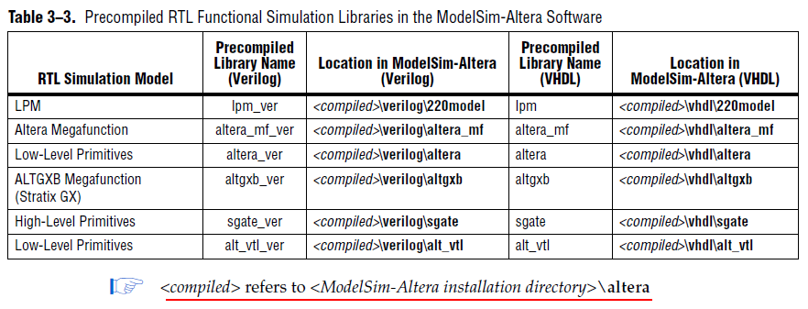
★综合后仿真（功能仿真）
注：此过程需要在综合后才能进行。需要的是Verilog输出文件，而不是设计文件！同时对于仿真库而言，用到的是门级仿真库，而不是RTL仿真库（也就是器件对应系列的仿真库）。常用的门级与编译仿真库如下：
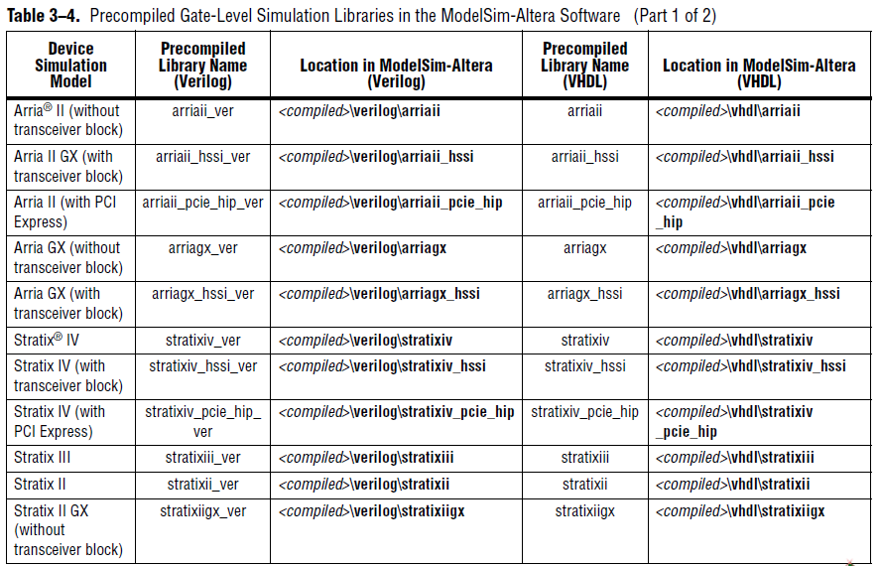
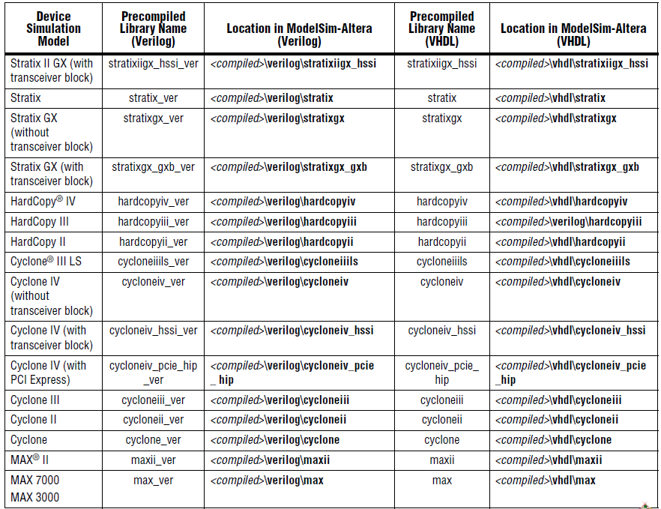
1、步骤：选目录—>建库—>编译—>仿真
1.1 目录选在QuartusII产生的EDA网表目录下，路径：<工程目录>\simulation\modelsim，这样做是为了方便文件的调用；
1.2 在此目录下建库。为了独立于QuartusII工作，库名必须是work；
1.3 编译文件。一般来说都使用testbench，因此可以使用(.vo+.vt)结合的方法进行仿真，.vo是verilog输出文件，.vt是verilog测试文件；若是VHDL则分别是.vho和.vht。编译顺序最好是先输出文件（.vo、.vho文件）再是测试文件（.vt、vht文件）
1.4 开始仿真。如果用到相关的LPM、MF或者IP等，要添加相应的预编译仿真库。在Library—>Search Libraries（-L）中点击Add添加。然后在Design—>Name—>work下选中仿真顶层文件，有testbench的话一般就选testbench。
2、关于QuartusII自动生成的testbench文件
QuartusII自动生成的testbench文件中包含一个全局寄存器eachvec，其包含一个语句@eachvec，记得把它注释掉，否则可能会因为它没有触发而导致仿真失败。
☆在QuartusII中自动生成仿真网表：Assignments->EDA Tool Settings
☆在QuartusII中自动生成TsetBench：Processing->Start->Start Test Bench Template Write
★门级仿真（时序仿真）
ModelSim的时序仿真跟功能仿真基本一致，但要注意下面几点区别：
1、如果包含全局复位或者全局上电信号，需做相应处理，具体看前文；
2、对Verilog程序进行仿真时，则无需添加.sdo文件，Verilog是通过添加预编译库自动调用.sdo文件的。同时，在Pulse Options中的Error Limit和Rejection Limit中输入0；
3、对VHDL文件进行时序仿真时，必须要添加.sdo文件，同时在Apply to region中将其指定到testbench中对应的模块；
关于testbench
在testbench中，每个连续的信号最好是用独立的always语句来描述，否则可能发生冲突导致仿真出错。

使用QuartusII自动运行ModelSim仿真
首先注意几点：
1、切记用Modelsim仿真时路径不能包含汉字！！！
2、要再次仿真时，确保前一次仿真的ModelSim程序已经退出，否则会报类似下面的错误！
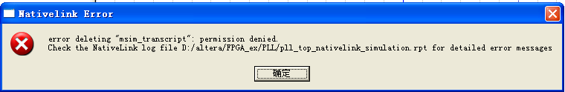
3、产生上面错误的原因也可能是使用了不支持RTL级仿真的IP核，但是不影响时序仿真。
4、用波形文件产生testbench文件时，最好只有输入信息，不要包含任何输出信息；
下面是操作方法：

1、配置NativeLink
1.1 进入EDA Tool Settings,在EDA Tool Settings中选择Simulation，如图：
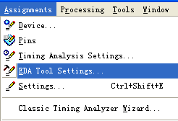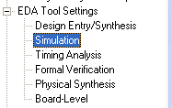
1.2 在simulation右侧对话框配置如下（Verilog）：
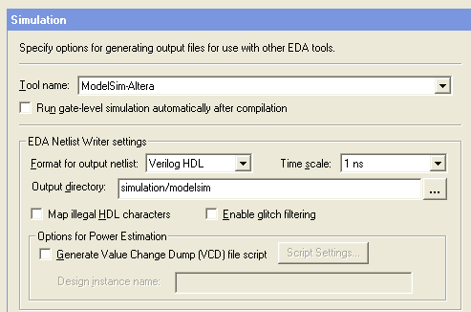
☆如果要编译后自动运行门级仿真，可以勾选Run gate-level simulation … after complilation.
1.3 编译testbench文件
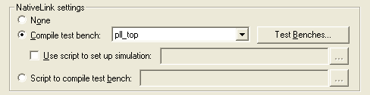
在NativeLink settings中点击Test Benches，出现对话框中点击New，出现如下对话框：
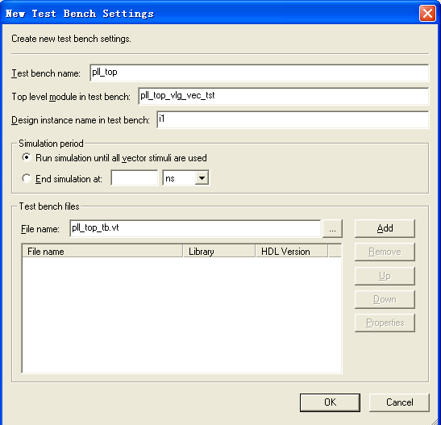
Testbench name中可以随便填一个名字，是指定当前Testbench文件的别名；
Top level module in test bench中填的是Testbench中要仿真的顶层模块；
Design instance name in test bench:填上Testbench中顶层模块对源程序的实例化名。
在Test bench files拦中添加对应的Testbench文件，点击Add添加，再点击OK完成配置。

2、运行仿真
如果要手动进行仿真，也可以在QuartusII中调用Modelsim，方法如下：
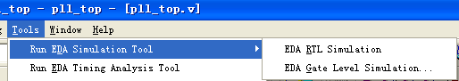
其中，RTL Simulation是寄存器传输级仿真，它是理想化的仿真，不包含任何延时信息，通常用作功能检验，也称作前仿真或功能仿真；
Gate-Level Simulation是门级仿真，通常也称为后仿真或时序仿真，它包含逻辑电路、布局布线等延时信息，是对真实电路情况的仿真。要仿真门级仿真，需要在Fitter之后进行。

3、产生Testbench
从QuartusII中产生Testbench，有两种方法：
（1）从波形文件导出，方法如下：
打开波形仿真文件，编辑输入信息，
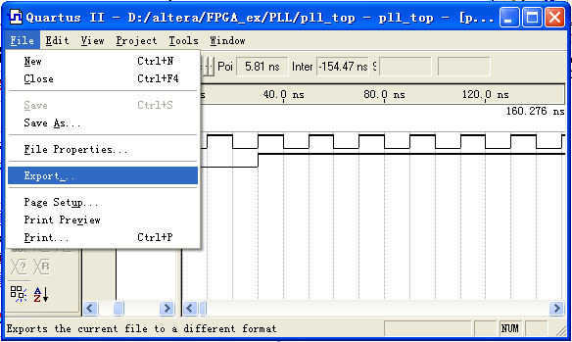
点击Flie—>Export，直接导出即可。
（2）也可以利用QuartusII产生Testbench模板，再自行输入测试信息。
