1. 打开 DarwinDumper，点击Choose，选择保存位置。可以将生成的文件保存到桌面

Open DarwinDumper, click Choose and select save location. You may save the generated file to Desktop.

1. 点击Deselect All Dumps,取消所有的选择项

Click Deselect All Dumps.

1. 勾选右侧的EDID

Find EDID on the right of the column and select it.

1. 点击Run按钮,生成EDID.BIN,保存于桌面生成的新目录中

Click Run to generate EDID.BIN and save it.

1. 打开FixEDID,点击Open EDID binary file,选择上面生成的EDID.BIN,这个文件位于~/Desktop/DarwinDumper143e

Double click FixEDID, click Open EDID binary file and find the EDID.BIN that was just generated. In my case the file is located in ~/Desktop/DarwinDumper143e (the number is subject to change)

1. 请选择打开EDID.bin

Choose EDID.bin

1. 根据自己的显示器的分辨率选择16:9或者16:10,我的显示器是15.6寸,分辨率为1920x1080,长宽比为16:9,所以我需要将插图中的16:10通过下拉菜单选择调整为16:9,（影响关于本机的显示器大小）

Choose the resolution ratio that suits your monitor. I have a 15.6 inch monitor with a resolution of 1920x1080 and a ratio of 16:9, thus I need to find a model that has that ratio. This affects the monitor size in About This Mac -> Displays.

1. 点击Make按钮,会自动在桌面生成一个新目录,比如我的目录为:DisplayVendorID-143e

Click Make and generate a new directory on your Desktop. The directory name should start with DisplayVendorID.

1. 用plistedit打开DisplayProductID-143e

Open the plist file with any plist editor you like. Editors that display hexes are preferred.

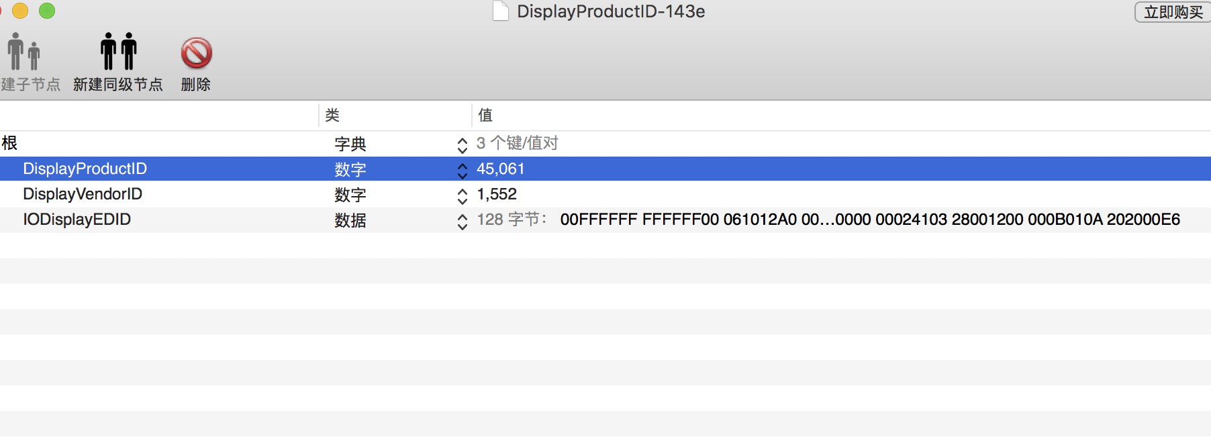

1. 把三个数据注入clover

Copy the value of IODisplayEDID and inject it in CLOVER as demonstrated. There should be no spaces within the hex.

1. 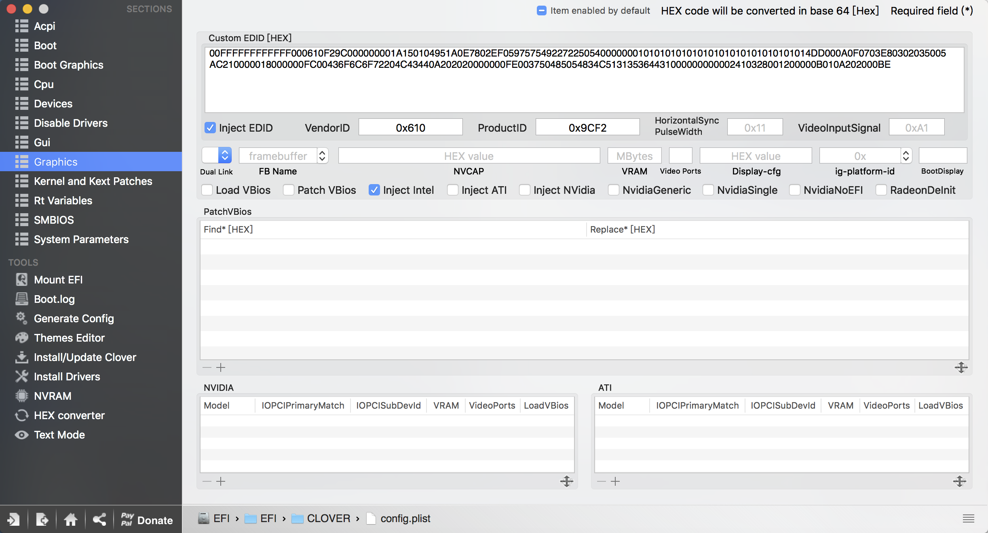

Edid需要去掉空格，另外两个转化为16进制的。