UCROO Platform QA Testing Document

Yash Parekh

**Purpose:** This document explains the various activities performed as part of Testing of the UCROO website.

**Application Overview:** Ucroo is an online community application for academic institutions. It helps to create a more connected college by implementing features for connection between students, peers, organizations, and staff at the given university or college. By encouraging these features through the platform, Ucroo creates a more connected college.

**Platform:** The following tests were run on a Windows 10 computer, on the Internet Explorer browser.

**Testing Scope:** This document tests the following functional aspects:

1. Posting
   1. Editing, deleting, reporting, pinning, images, files
2. Messaging
3. Group creation
   1. Viewing and posting in groups

**Testing Strategy:** For this test, the features will be manually tested.

**User 1: Admin**

**Unit testing:**

1. Posting

Posted “Test post for 12/14/17”

Changed to “Test post for 12/14/17 QA testing”

Reported Student’s post “Test post for 12/14/17 QA testing”

Message: Post reported successfully

Pinned post

Posted “Image posting test. Potato”

With image: potato.jpg

Poll “What’s the best vegetable?”

Option 1: “Potato”

Option 2: “More potatoes”

Option 3: “Ketchup”

Option 4: “Delete”

Deleted option 4

Posted poll

Voted “Ketchup”

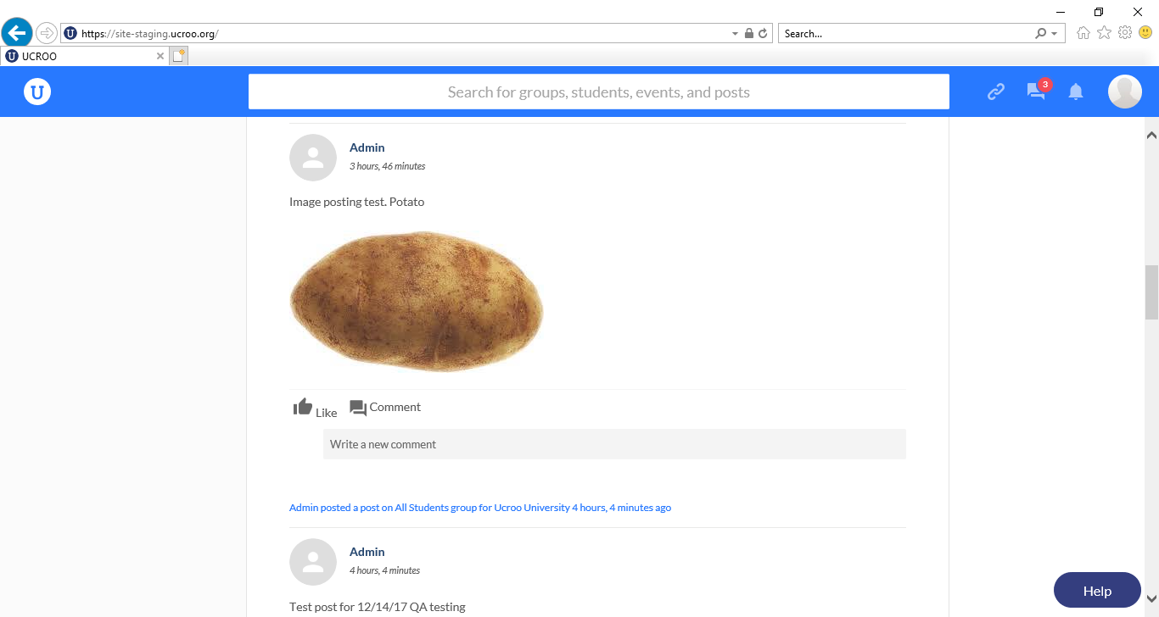

1. Messaging

Messaged back and forth with Dani using Friend account

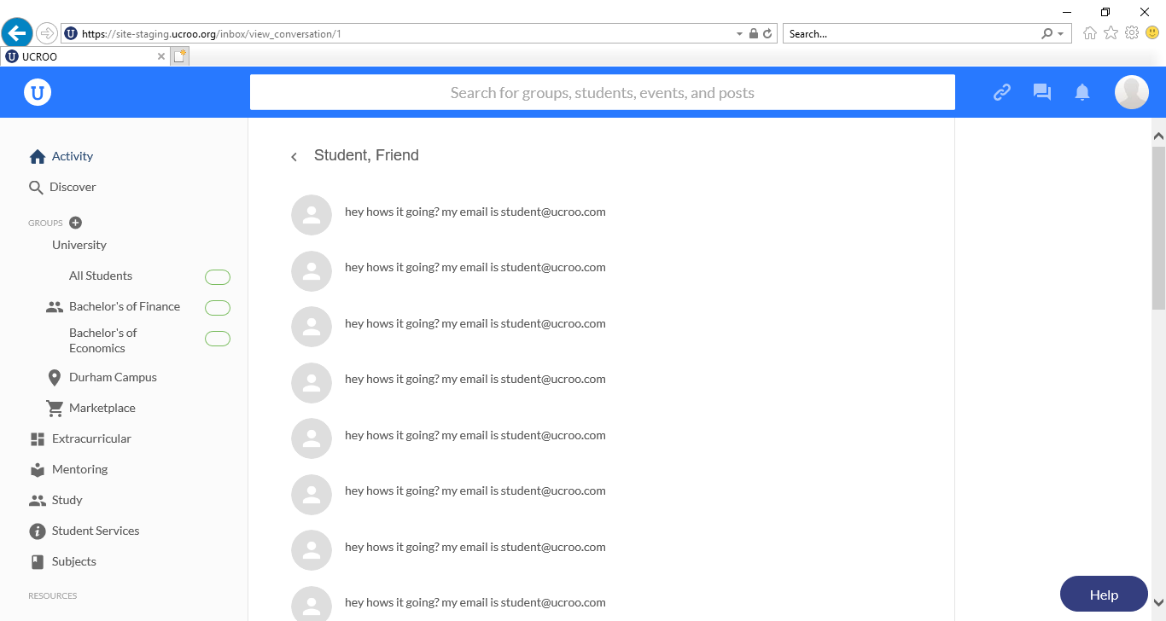

1. Group creation
   1. Group type does not populate – can’t proceed further in creating a group

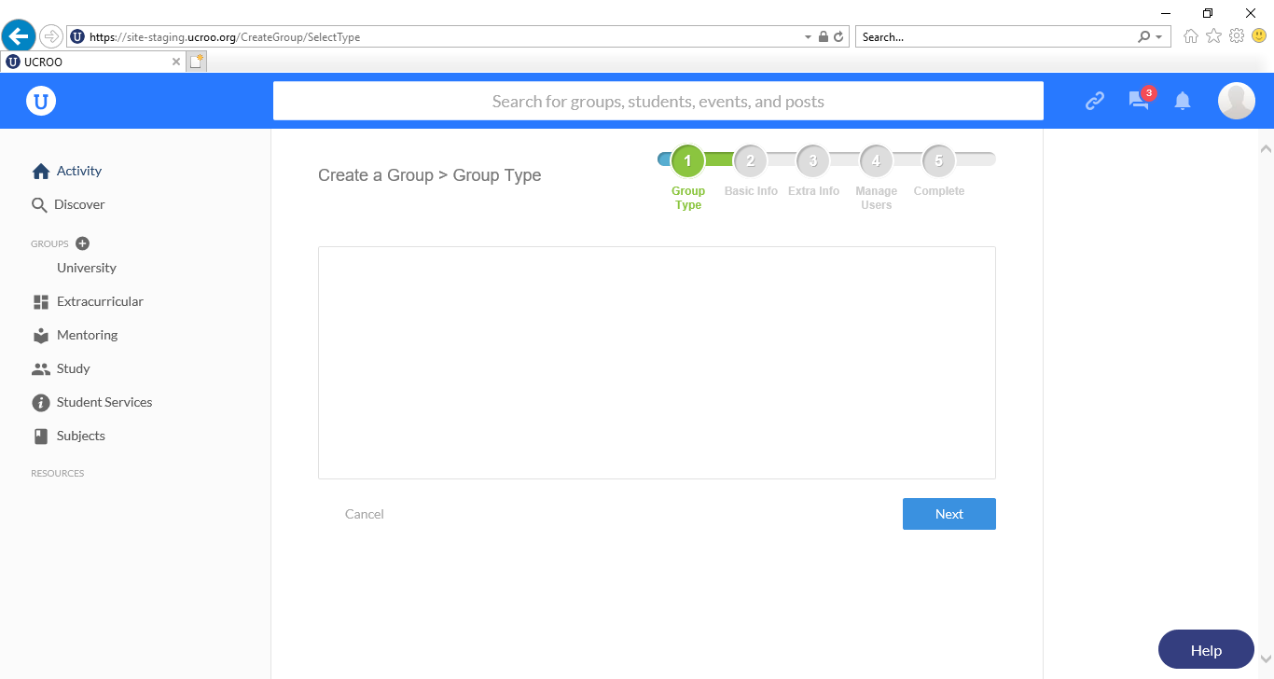

* 1. Viewing and posting in groups

Group: Bachelor’s of Finance

Events: Warning bubble pops up with no text

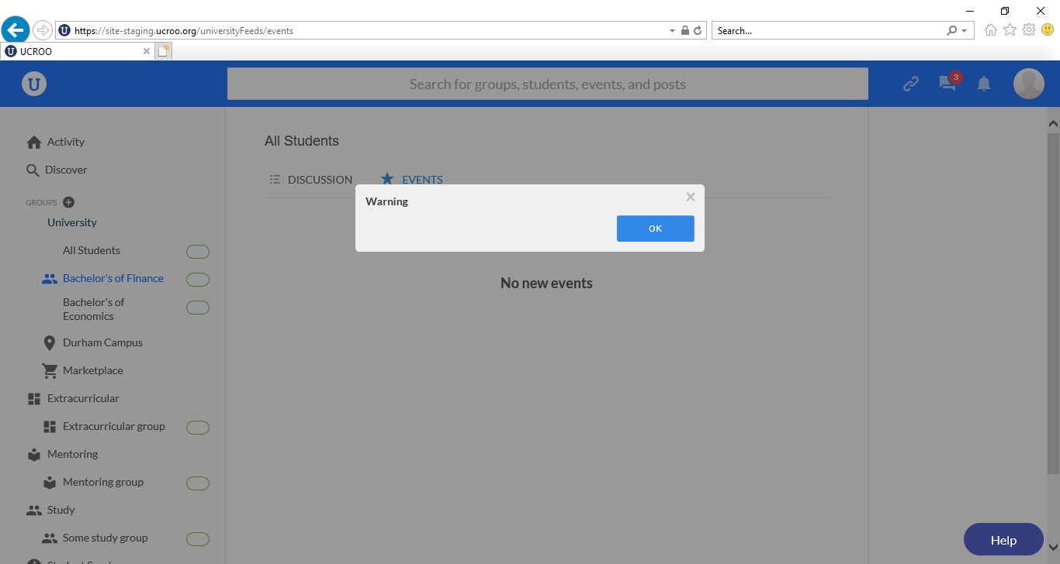

One thing that may be confusing:

-Admin posted, and then commented

-Then admin edited post

-Post: 28 minutes ago, comment 38 minutes ago. Is this confusing?

**User 2: Student**

**Unit testing:**

1. Posting

Posted “Test post for 12/14/17”

Once posted, have to refresh for post to show up

Changed to “Test post for 12/14/17 edited”

Reported Admin post “Test post for 12/14/17 QA testing”

Message: Post reported successfully

Posted “Image posting test. Potato.”

With image: potato.jpg

Poll “What is the best mode of transportation?”

Option 1: “Walking”

Option 2: “Flying”

Posted poll

Voted “Flying”

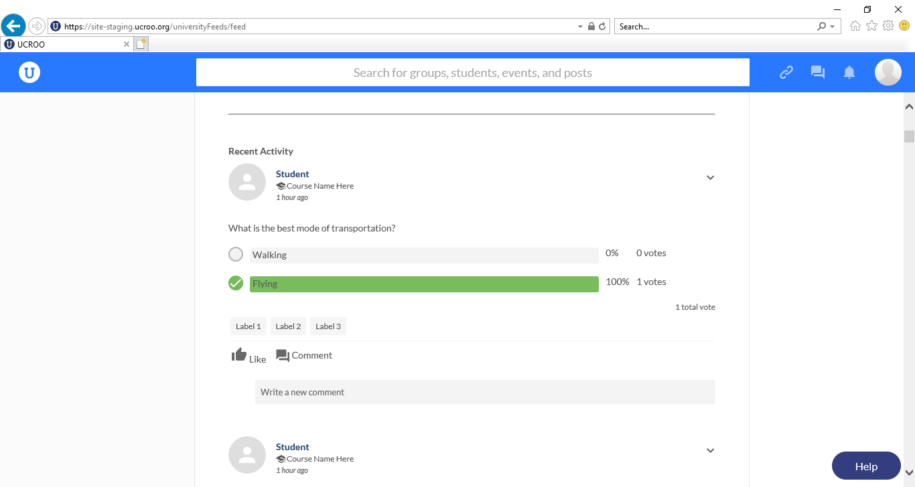

1. Messaging

Messaged “Hi Admin”

Message seemed to get lost

1. Group creation
   1. Group types do not populate – can’t proceed further in creating a group

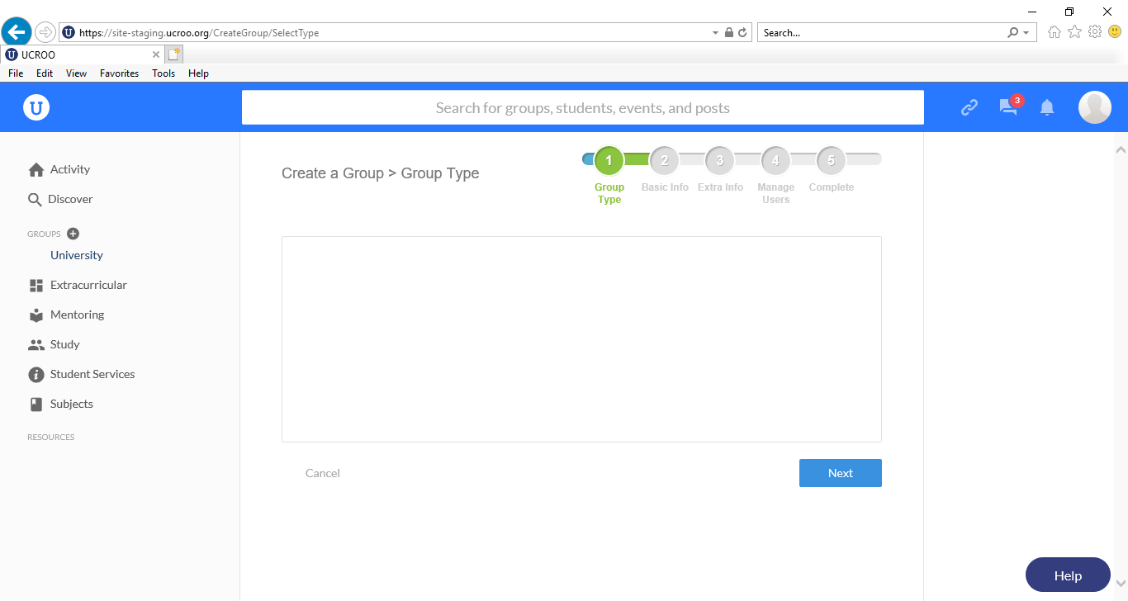

* 1. Viewing and posting in groups

Group: Bachelor’s of Finance

