UCROO Platform QA Testing Document

Yash Parekh

**Purpose:** This document explains the various activities performed as part of Testing of the UCROO website.

**Application Overview:** Ucroo is an online community application for academic institutions. It helps to create a more connected college by implementing features for connection between students, peers, organizations, and staff at the given university or college. By encouraging these features through the platform, Ucroo creates a more connected college.

**Platform:** The following tests were run on a Windows 10 computer, on the Google Chrome browser.

**Testing Scope:** This document tests the following functional aspects:

* 1. Event creation

**Testing Strategy:** For this test, the features will be manually tested.

**User 1: Admin**

**Unit testing:**

1. Group creation

Clicked plus icon next to GROUPS on right sidebar

1. Selected Study – Exam from group types

Group name – Manual QA Exam Study Group

Group description – This group is created to study manual QA practices.

Group privacy – Public

1. Images
   1. Click to upload a cover picture
      1. Clicked and option to select a file popped up
      2. Selected file “manual_qa_group_image_12_28_17.jpg”
      3. Clicked open
      4. Cover picture successfully uploads and is seen
   2. Drag to upload cover picture
      1. Dragged file “manual_qa_group_image_12_28_17.jpg” on to specified area
      2. Cover picture successfully updated
   3. Group picture - update
      1. Clicked update
      2. Selected file “manual_qa_group_image_12_28_17.jpg”
      3. Clicked open
      4. Group picture successfully uploads and is seen

Click “Next”

1. Group details – add labels
   1. Typed “QA”, hit enter
   2. Typed “Ghost inspector”, hit enter
   3. Typed “Selenium”, hit enter
   4. Clicked x next to Selenium to remove it from group details list

Click “Next”

1. User Management
   1. Download template CSV for bulk group members add
   2. Added to CSV: [yash@ucroo.com](mailto:yash@ucroo.com), [yash.parekh223@gmail.com](mailto:yash.parekh223@gmail.com) into cells A2, A3
   3. Clicked Upload CSV
   4. Selected “bulk_user_import.csv”
   5. Clicked “Open”
   6. Error message: Warning

*All of the conditions listed for Bulk Add Group Member were successfully met:

* The file format type must be **.csv** ([click here for help](https://support.office.com/en-us/article/Import-or-export-text-txt-or-csv-files-5250ac4c-663c-47ce-937b-339e391393ba?CorrelationId=8c4ffb10-2e14-4aac-9d3b-3f05488cb1ec&ui=en-US&rs=en-US&ad=US))
* Files must ONLY contain a **list of email addresses**
* Do not upload files with multiple columns
* You can upload a maximum of **1000 members at a time**
  1. Manually added users using Add Members text input area
     1. Friend
     2. Admin
     3. Academic
  2. Deleted Admin from list using trash icon
     1. Are you sure you want to remove this member? – Yes
     2. Successfully removed Admin from list
  3. Admin Management
     1. Added Academic as admin
  4. Created CSV file, bulk_user_import.csv with the following emails:
     1. [admin@ucroo.com](mailto:admin@ucroo.com)
     2. [student@ucroo.com](mailto:student@ucroo.com)
     3. [uniadmin@ucroo.com](mailto:uniadmin@ucroo.com)
  5. Clicked “Upload CSV”
  6. Clicked “Select File”
  7. Selected “bulk_user_import.csv”
  8. Clicked “Open”
  9. Error message: Warning

*All of the conditions listed for Bulk Add Group Member were successfully met:

* The file format type must be **.csv** ([click here for help](https://support.office.com/en-us/article/Import-or-export-text-txt-or-csv-files-5250ac4c-663c-47ce-937b-339e391393ba?CorrelationId=8c4ffb10-2e14-4aac-9d3b-3f05488cb1ec&ui=en-US&rs=en-US&ad=US))
* Files must ONLY contain a **list of email addresses**

Click “Submit”

Page froze when hit submit with submit button grayed out and loading circle above it

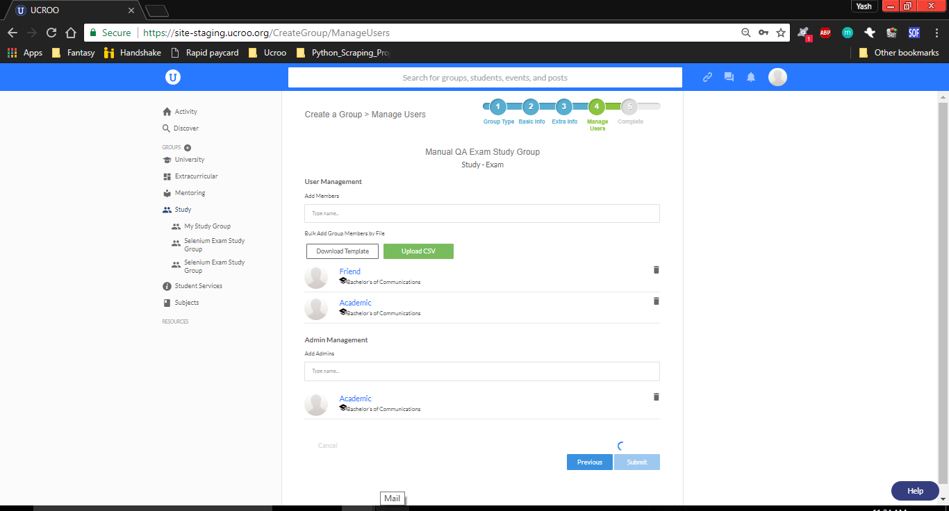

1. Event creation

Since there were some errors with the group creation, I decided to use another group to test Event creation.

Group name: Selenium Exam Study Group

1. Clicked “Create Event”
2. Name of Event: “Manual QA Study Session 1”
3. Event Type: “Group Type 0”
4. Uploaded event image: Ucroo logo
5. Event Description: “This event was created through manual QA testing”
6. Event Start Date: 28 Dec 2017, Event Start Time: 5 : 00 PM
7. Event End Date: 28 Dec 2017, Event End Time: 6 : 00 PM
8. Max # of Attendees: 10
9. Location: 3001 Brighton Boulevard, Denver, CO, United States
10. Room #: 416
11. Labels: Selenium, Python
12. Will attendees need tickets? Yes
13. Ticket URL: Cats – invalid
14. Ticket URL: google.com – valid

Clicked “Create Event”

Error: An event name is required

This error displayed although event name is provided.

Can’t click Events tab button from Selenium Exam Study Group (Group home page, Info and Admin buttons do work)