**Task 1 – Simulating SDE**

**1. Simulating Geometric Brownian motion**

We know that the general form of GBM is **µdt + σdBt**

Given **dS(t) = 0.1 dt + 0.26 dBt** and **S0 = 39.** So, we know that **µ = 0.1 and σ=0.26**

**# calculate theoretical expectation value for S(3)**

- E[S(t)] =

- E[S(3)] = 39 e 0.1 *3 = 52.6444935

- When using python to stimulate GBM, we import pylab which contains useful mathematical function and then the parameters was declare respectively.

- The equation was defined and the value was plug in respectively to find the expecte value

**# calculate theoretical variance for S(3)**

- Var[S(t)] =

- Var[S(t)] = ${ 39}^{2}e^{2* 0.1*3}\left(e^{{0.26}^{2}*3}-1\right)$ = 623.0964723

-when using python, the value of Var[S(3)] is calculated by typing in the formula into python and substitute the value into the equation to find the answer.

**#stimulating 1000 GBM for 0<t<3**

-Given 0 < t < 3, we set the partition [0,3] into 1000 equally spaced intervals by using p.linspace function. ( t = p.linspace(0,3,n+1)), where n = 1000

- Then, we used p.rand to create 1000-by1001 matrix of normally distributed random numbers. (p.randn(n_path, n+1) / p.sqrt(n/3))

- We set the first column of the matrix dB = 0. dB[:,0] = 0

-We do cumulative sum for all the elements in the same row by using function B = dB.cumsum(axis=1).

-To plot the 5 realizations of the GBM, we pick the first 5 rows by using S[0:5].

- Using p.plot,p.title,p.xlabel,p.ylabel, the graph could be created whith title and labeled axis. Then, using p.show, the graph could be shown. The graph generated with 5 realisation was shown below.

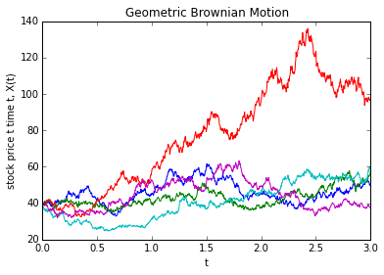

**#calculate expectation value of S(3)**

-the function np.mean was used in python to find expectation by using the mean.

**#calculate variance for S(3)**

-the function np.var was used to find variance of the values in array.

**# P[S(3)>39]**

-A ‘for loop’ was used and a variable count was implemented.

- when the value of S(3) exceed 39, the count will increased by 1 and stored.

- At the same time, new variable total was implemented to store what is the sum of all the values exceed 39.

-hence, the probability was calculated by total ount divided by the number of paths.

**#E[S(3)|S(3)>39]**

-By using the total generated just now, the conditional expectation was calculated by dividing the number of counts

**2. Stimulating mean reversal process**

- For given 0<t<1, we want to stimulate 1000 runs of above mean reversal process.

- with the given equation, dR(t) = [0.064 – R(t)] dt + 0.27R(t) dB(t); and R(0) = 3, we know that alpha=1,theta = 0.064, and sigma = 0.27.

- We import pylab. After that we declare all the variable.

- We creat browian path by using the function p.linspace(0,t,n+1)[:-1] and set a matrix dB = p.randn (n_path, n+1)* p.sqrt(dt). We also set the first column of each row as zero by dB[:,0] = 0

- We used function cumsum(axis=1) to find the cumulative sum of all elements in the same row.

- To find and plot the mean reversal process, we firstly create a zero matrix of R with same size with B and we set the first column of matrix R as 3.

- The 5 stimulation was run using a ‘for loop’. After that, the graph was plot by p.plot and modified by p,title, p.xlabel, p.ylabel. Finally, we show the graph using p.show. the graph generated was shown below.

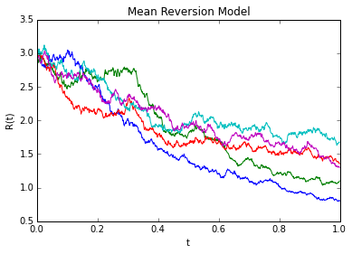

**# Find expected value of R(1)**

-We pick all the value from R(1) by R1 = R[: , -1] and the expected value was calculated by R1.sum() / n_path.

**# Find P[R(1)>2]**

- We create a count and set is as zero. By using the for loop, when the value of R(1) > 2 ,the count will increase by 1 unit and stored as new count value. So, with the count value, we can find the probability by divide the count with number paths.

**Task 2 – Downloading and manipulating stock data**

1. **Downloading and Manipulating Stock Data**

* The total stocks component that consist in FTSE Bursa Malaysia KLCI index are 30 components.
* The following table showing the information which consists of Stock Name, Stock Code, Stock Sector, weightage in FTSEKLCI, PE ratio and Net market capital.

|  |  |  |  |  |  |
| --- | --- | --- | --- | --- | --- |
| **Stock Name** | **Stock Code** | **Stock Sector** | **Weightage in FTSEKLCI (%)** | **PE Ratio** | **Net Market Capital (B)** |
| Public Bank Bhd | 1295 | Banks | 11.6 | 15.2 | 73.29 |
| Malayan Banking | 1155 | Banks | 9.32 | 12.39 | 87.75 |
| Tenaga Nasional | 5347 | Alternative Electricity | 9.28 | 9.31 | 69.76 |
| CIMB Group Holdings | 1023 | Banks | 5.76 | 17.51 | 46.52 |
| Axiata Group Bhd | 6888 | Mobile Telecommunications | 5.62 | 24.31 | 55.43 |
| Sime Darby Bhd | 4197 | Diversified Industrials | 5.51 | 20.8 | 52.09 |
| Digi.com | 6947 | Mobile Telecommunications | 4.16 | 20.81 | 42.06 |
| Genting | 3182 | Hotels | 3.68 | 16.5 | 30.86 |
| PETRONAS Chemicals Group Bhd | 5183 | Commodity Chemicals | 3.55 | 22.07 | 51.2 |
| Maxis Bhd | 6012 | Mobile Telecommunications | 3.45 | 29.73 | 48.88 |
| Petronas Gas | 6033 | Exploration & Production | 3.4 | 22.51 | 42.23 |
| IHH Healthcare | 5225 | Health Care Providers | 3.28 | 63.12 | 48.25 |
| IOI | 1961 | Farming & Fishing | 2.99 | 66.31 | 27.24 |
| Telekom Malaysia | 4863 | Fixed Line Telecommunications | 2.96 | 32.79 | 24.88 |
| Genting Malaysia Bhd | 4715 | Hotels | 2.5 | 20.14 | 23.99 |
| MISC | 3816 | Marine Transportation | 2.45 | 16.28 | 35.89 |
| AMMB Holdings | 1015 | Banks | 2.38 | 9.22 | 17.67 |
| Kuala Lumpur Kepong | 2445 | Farming & Fishing | 2.28 | 29.83 | 24.49 |
| SapuraKencana Petroleum | 5218 | Oil Equipment & Services | 1.98 | 11.97 | 14.15 |
| PBB Group | 4065 | Food Products | 1.8 | 17.74 | 17.83 |
| British American Tobacco (Malaysia) | 4162 | Tobacco | 1.7 | 20.67 | 19.02 |
| Hong Leong Bank | 5819 | Banks | 1.67 | 11.01 | 23.66 |
| YTL Corp | 4677 | Multiutilities | 1.63 | 14.81 | 16.67 |
| UMW Holdings | 4588 | Automobiles | 1.37 | 20.4 | 11.87 |
| Astro Malaysia Holdings | 6399 | Broadcasting & Entertainment | 1.22 | 28.41 | 15.81 |
| Petronas Dagangan Bhd | 5681 | Intrgrated Oil & Gas | 1.21 | 37.12 | 20.5 |
| RHB Capital | 1066 | Banks | 1.06 | 9.47 | 19.58 |
| Westports Holdings | 5246 | Transportation Services | 0.93 | 27.44 | 14.36 |
| Hong Leong Financial | 1082 | Banks | 0.64 | 10.21 | 16.62 |
| KLCC Prop & Reits - Stapled Sec | 5235SS | Real Estate Holding & Development | 0.63 | 26.42 | 12.64 |

Caption : taken from yahoo!finance(quotes.wsj) as at22nd June 2

1. **Downloading data**

* The FTSEKLCI component that chosen was Sime Darby.Bhd.
* A 5-year data was downloaded for Sime Darby Bhd.
* The 5 days moving average was plotted.

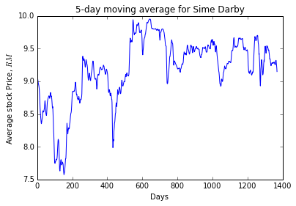

* The FTSEKLCI daily data was downloaded using DataReader for 5-years as well.
* The correlation of Sime Darby Bhd with FTSEKLCI was carried out usig function corr().