**PYTHON OPERATORS**

|  |  |  |  |  |  |  |
| --- | --- | --- | --- | --- | --- | --- |
| Arithmetic operators | | | | | | |
| + | - | * | ** | / | // | % |
| sum | Minus | Mult | Power | Div | Floor div | Remain |
| Relational operators | | | | | | |
| > | >= | < | <= | == | != | = |
|  |  |  |  |  |  | Assigning |
| Boolean operators | | | | | | |
| or | and | not |  |  |  |  |

**ORDER OF GROWTH**

**Time complexity:**

Recursive: usually O(n), total operations

Iteration: usually O(n), total steps

**Space complexity:**

Recursive: usually O(n), total pending operations

Iteration: usually O(1), total variables used

**LIST**

List is mutable.

lst = [1, 2, 3]

**Changing an element in a list:**

lst[0] = 5

return lst 🡪 [5, 2, 3]

**Deleting an element in a list:**

del lst[0]

return lst 🡪 [2, 3]

**Sorting a list:**

lst = [(‘a’, 2), (‘c’, 4), (‘b’, 6)]

lst.sort(key, reverse)

key = can be x:x[0], means sorted by ‘abc’

reverse = True 🡪 descending

**List operations**

|  |  |
| --- | --- |
| .append(n) | Append an element/list to a list  *n can be a list too  lst = [1,2,3]  lst.append([4, 5, 6])  return lst 🡪 [1, 2, 3, [4, 5, 6]] |
| .extend(n) | Append a list to a list  lst = [1,2,3]  lst.extend([4, 5, 6])  return lst 🡪 [1, 2, 3, 4, 5, 6] |
| .copy() | Returns a shallow copy of the list |
| .insert(n, p) | Inserts n to the position p in the list |
| .pop(p) | Removes the element in position p and returns that element  *if it’s lst.pop(), the last element will be removed |
| .remove(n) | Removes the first occurrence of n in the list, reports error if n is not found |
| .clear() | Removes all element in the list |
| .reverse() | Reverse the whole list |

**TUPLE**

|  |  |
| --- | --- |
| **Operations** | **Returns** |
| foo | the tuple foo |
| foo[0] | the first element |
| foo[‐1] | the last element |
| foo[1:] | rest of foo without 1st element |
| foo[a:b] | a tuple consisting elements from index a to b (no b) |
| foo[a:b:c] | a tuple consisting elements from  index a to b (no b), in steps of c |
| len(foo) | the number of elements in foo |

**DICTIONARY**

A dictionary is a sequence of key-value pairs, keys must be unique and immutable (ie. Can be tuple but no list!).

The order of the dictionary is not important.

d = {‘a’: 1, ‘b’: 2}

**To update an existing entry:**

d[‘a’] = 5 🡪 d = {‘a’: 5, ‘b’: 2}

**To add an entry:**

d[‘c’] = 0 🡪 d = {‘a’: 5, ‘b’: 2, ‘c’: 0}

**To retrieve all keys into a list:**

list(d.keys()) 🡪 [‘a’, ‘b’, ‘c’]

**To retrieve all values into a list:**

list(d.values ()) 🡪 [5, 2, 0]

**To clear the entries:**

d.clear() 🡪 {}

**OOP**

**Refer to a method defines previously**

we have to add a () behind. Eg. self.get_minutes()

**Refer back to a property defined previously**

we don’t have to add a () behind. Eg. self.minutes

**Inheritance**

super().__init__(name, age)

*where name and age is inherited from the parent class

**Check the item’s class**

isinstance(item, class)

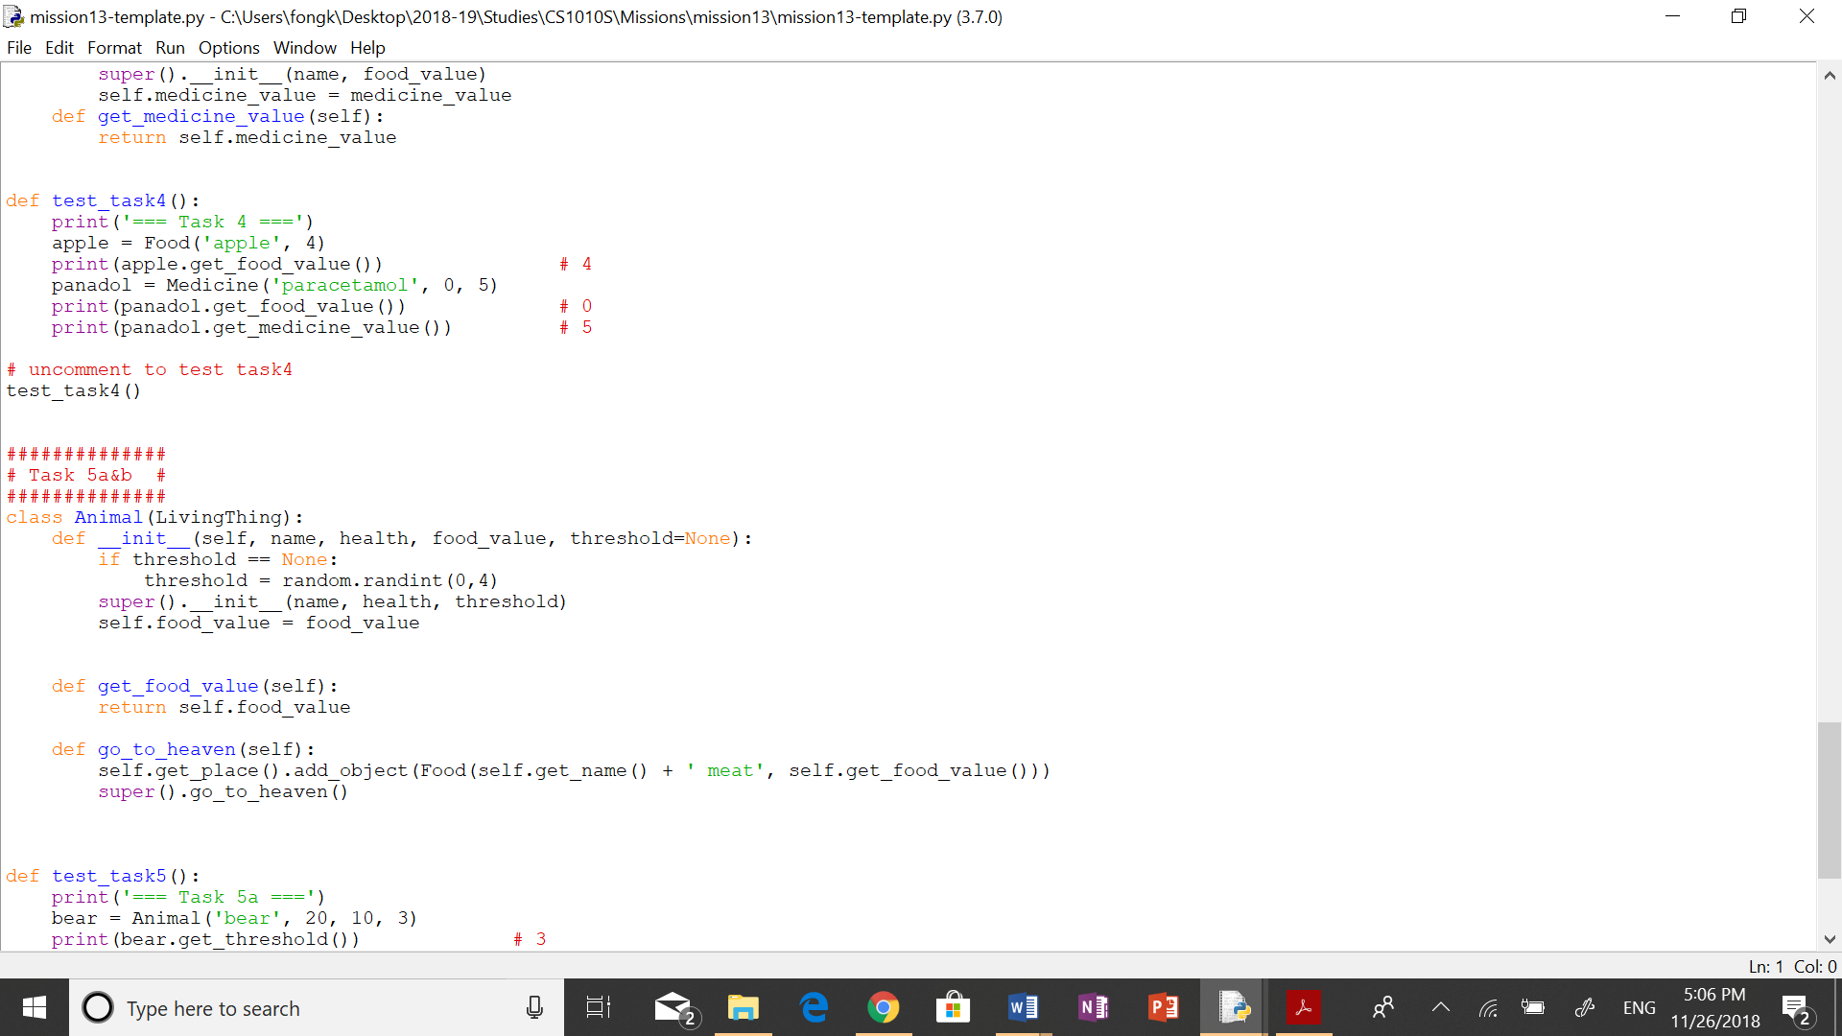**What if a property in a class is arbitrary?**

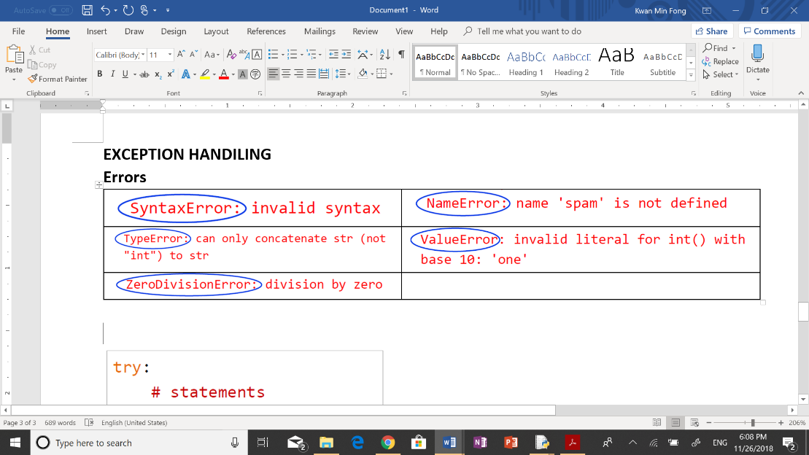**EXCEPTION HANDLING**

**EXCEPTION HANDING FORMAT**

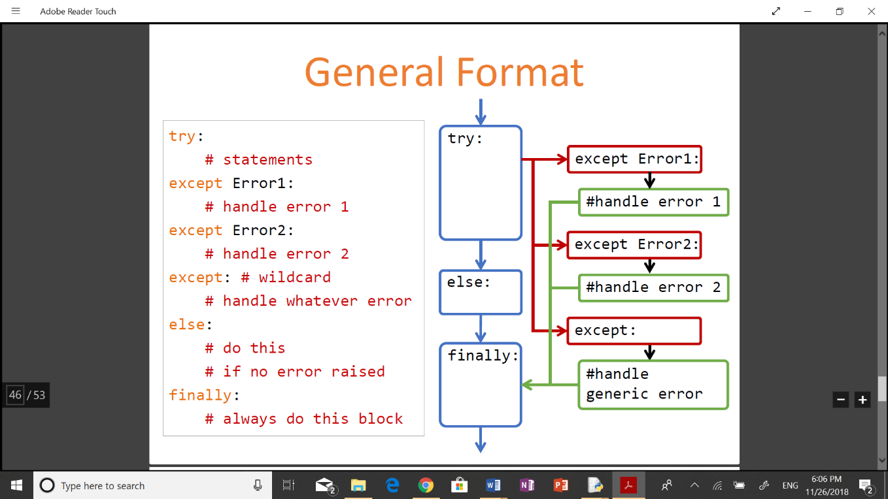

**TAKE NOTE**

1. Never return a list modification, eg. return lst.append(1), instead, use newlst = lst.append(1), return newlst
2. When a tuple only has one element, never forget to include ‘,’ behind.
3. Never forget the ‘return’
4. Never forget the ‘:’
5. Never operate on incompatible types. Eg. 5 + ‘1’
6. Check indentation in a loop to avoid infinite loops
7. If using while loop, remember to update the ‘i’
8. Never forget the * during multiplication
9. For OOP, never forget to put (object) behind the class
10. For OOP, never forget to include ‘self’.
11. Never reference a global variable inside a local frame.

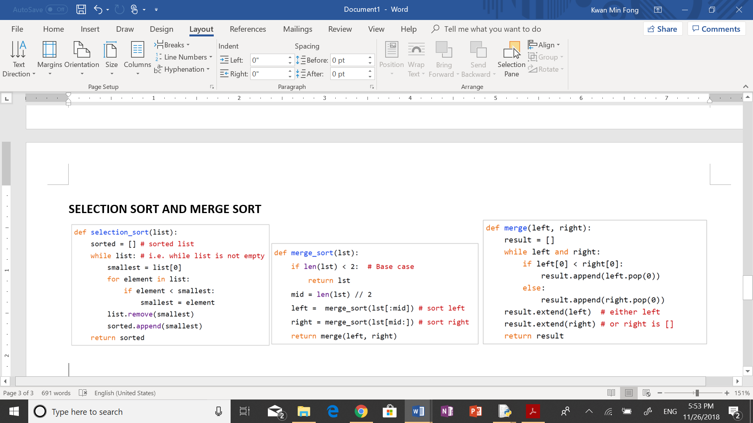

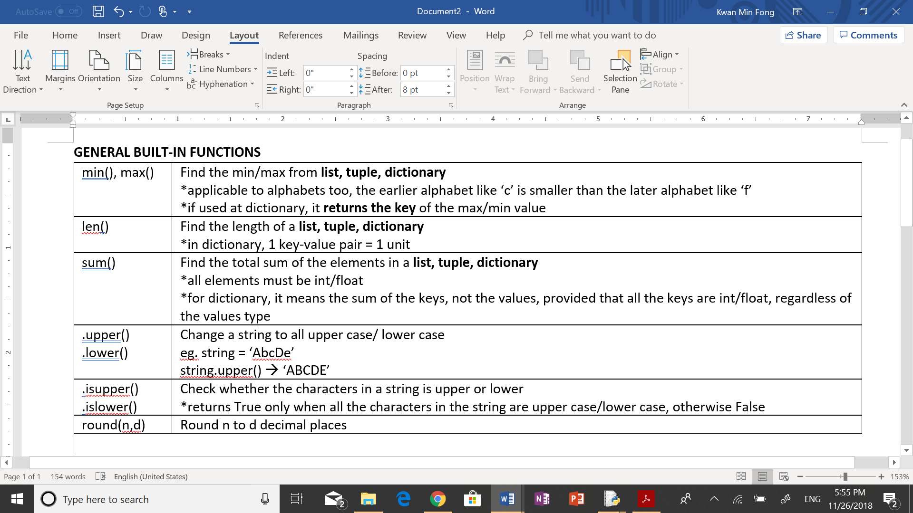

**OTHERS**

1. can use ‘in’ or ‘not in’ to check whether an element is in a **list, tuple, dictionary**

*for dictionary, it is used to check the key, not the value

2. Anonymous functions 🡪 lambda <input>: <output>

3. length of strings can be compared with ‘<’ and ‘>’

4. Counting leaves

def count_leaves(tree):

if tree == ():

return 0

elif is_leaf(tree):

return 1

else:

return count_leaves(tree[0]) + count_leaves(tree[1:])

def is_leaf(tree):

return type(tree) != tuple

5. Flattening tree

def enumerate_tree(tree):

if tree == ():

return ()

elif is_leaf(tree):

return (tree,)

else:

return enumerate_tree(tree[0]) +

enumerate_tree(tree[1:])

Example that will give error:

x = 10

def f(y):

x = x + y (return x will give error)

return x