CS3203 In-class Activities:   
Basic SPA Requirements

1. **AST**

Draw an AST for procedure main:

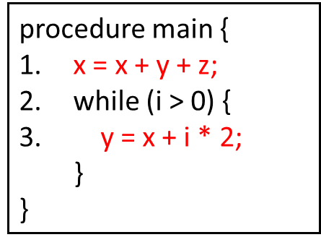

**2. Relationships and Queries in PQL**

Answer the questions in the slides with reference to the following SIMPLE program.

