

**GEH1070**

**Traditional Chinese Knowledge of Health and Well-Being**

**Bubble Tea Assignment**

**YAP DIAN HAO**

**A0184679H**

**Tutorial Group E6**

**11/11/2019**

**The Vital Elixir**

1. **Introduction**

The name “Vital Elixir” is inspired by the “Vital Qi” (生气). It comprises of several ingredients as follows:

* + - Jujube Fruit (大枣): Sweet in flavor, Warm in property, and targets the Stomach and Spleen (Wu JN, 2016, page 666).
    - Wolfberry Fruit (枸杞子): Sweet in flavor, Neutral in property, targets the Lung, Kidney and Liver (Wu JN, 2016, page 402).
    - Chrysanthemum (菊花): Sweet, bitter in flavor, Cold in property, targets the Lung and Liver (Wu JN, 2016, page 176).
    - Honey (蜂蜜): Sweet in flavor, Neutral in property, targets the Spleen, Lung, and Large Intestine (Wu JN, 2016, page 675).
    - Chinese Angelica Root (当归): Sweet and pungent in flavor, Warm in property, targets the Heart, Liver, and Spleen (Wu JN, 2016, page 84).
    - Brown sugar (赤砂糖): Sweet in flavor, Warm in property, targets the Spleen, Liver, and Stomach (TCM Wiki, 2016).

**2. Motivation and Diagnosis**

This drink is designed as an integration of the traditional TCM decoction and the modern bubble milk tea. The Vital Elixir is focused on healing individuals with **Qi Stagnation**. I found out that I am constantly depressed, suffering from anxiety, and sighs deeply all the time. Moreover, after some pulse diagnosis, I discovered that I have the short pulse at the Guan(关) position, and therefore reached a conclusion that I have Qi stagnation. As this tea not only is sweet, neutral in overall nature, but also is tasty when consumed and resembles closely to the modern bubble milk tea, therefore it could be a suitable decoction of this illness.

**3. Ingredients:**

* + - 6 - 8 wolfberries
    - 5 - 10 Jujube Fruit
    - 10 grams of dried chrysanthemum flowers
    - 1 tablespoon of honey
    - 6g of Dang Gui
    - 500 ml of water
    - 2 tablespoons of milk
    - 1 tablespoon of brown sugar

**4. Steps of Preparation**

* + - Prepare all the ingredients required.

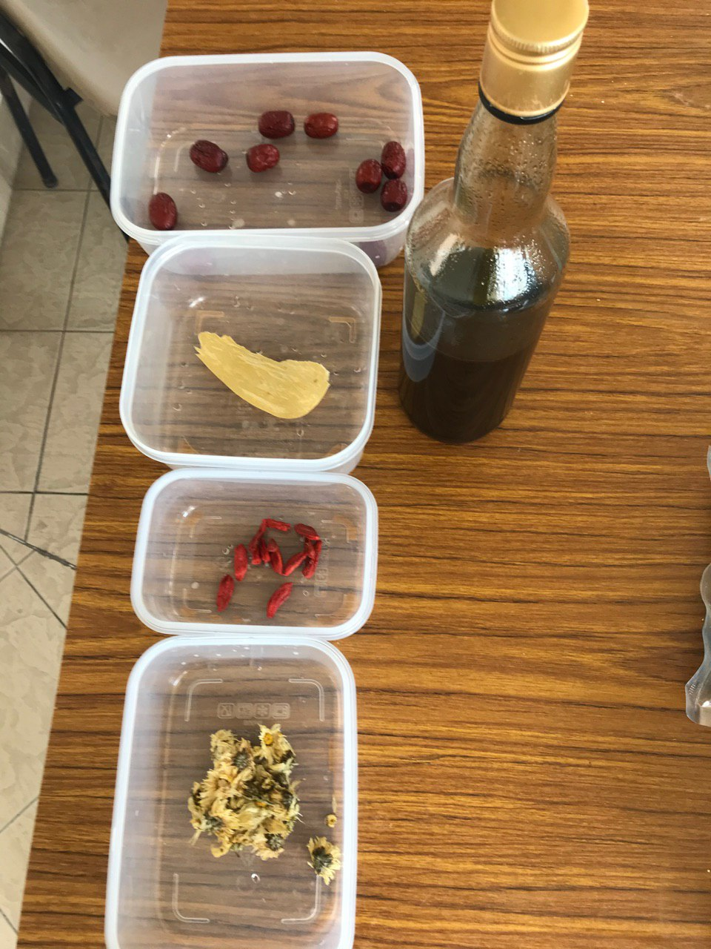

Jujube, dang gui, honey, wolf berry, chrysanthemum (top to Bottom)

* + - Boil 500 ml of water.

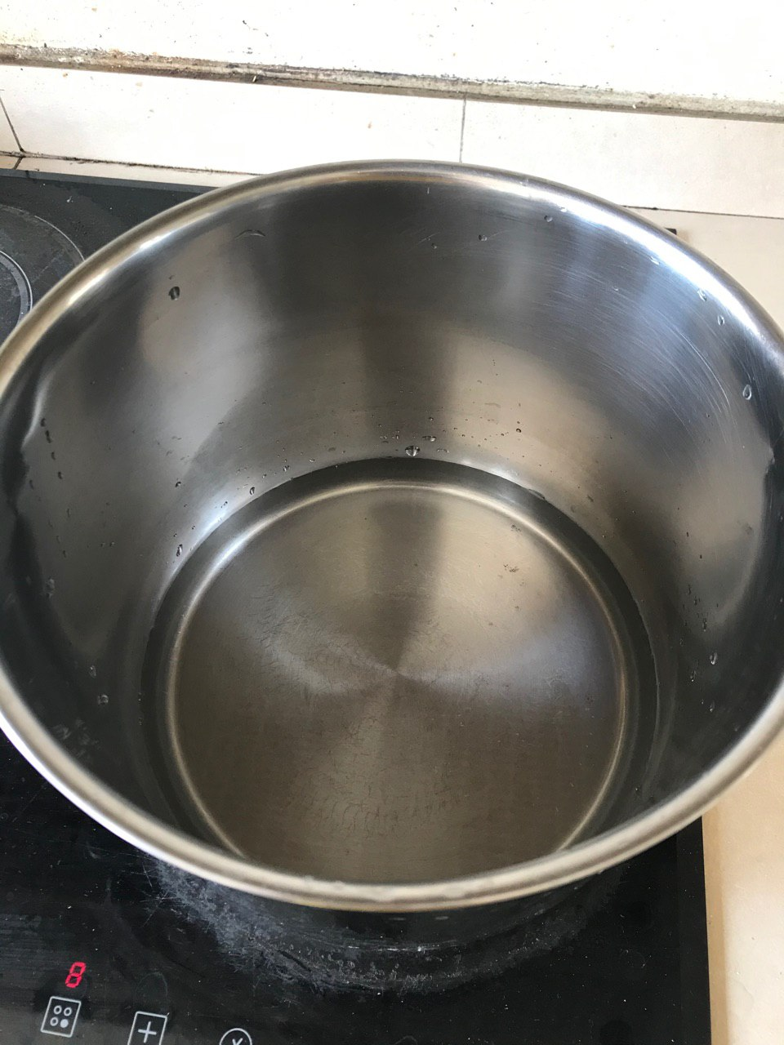

* + After the water simmers, add in the chrysanthemum, wolfberries, jujube fruits, and Dang Gui.

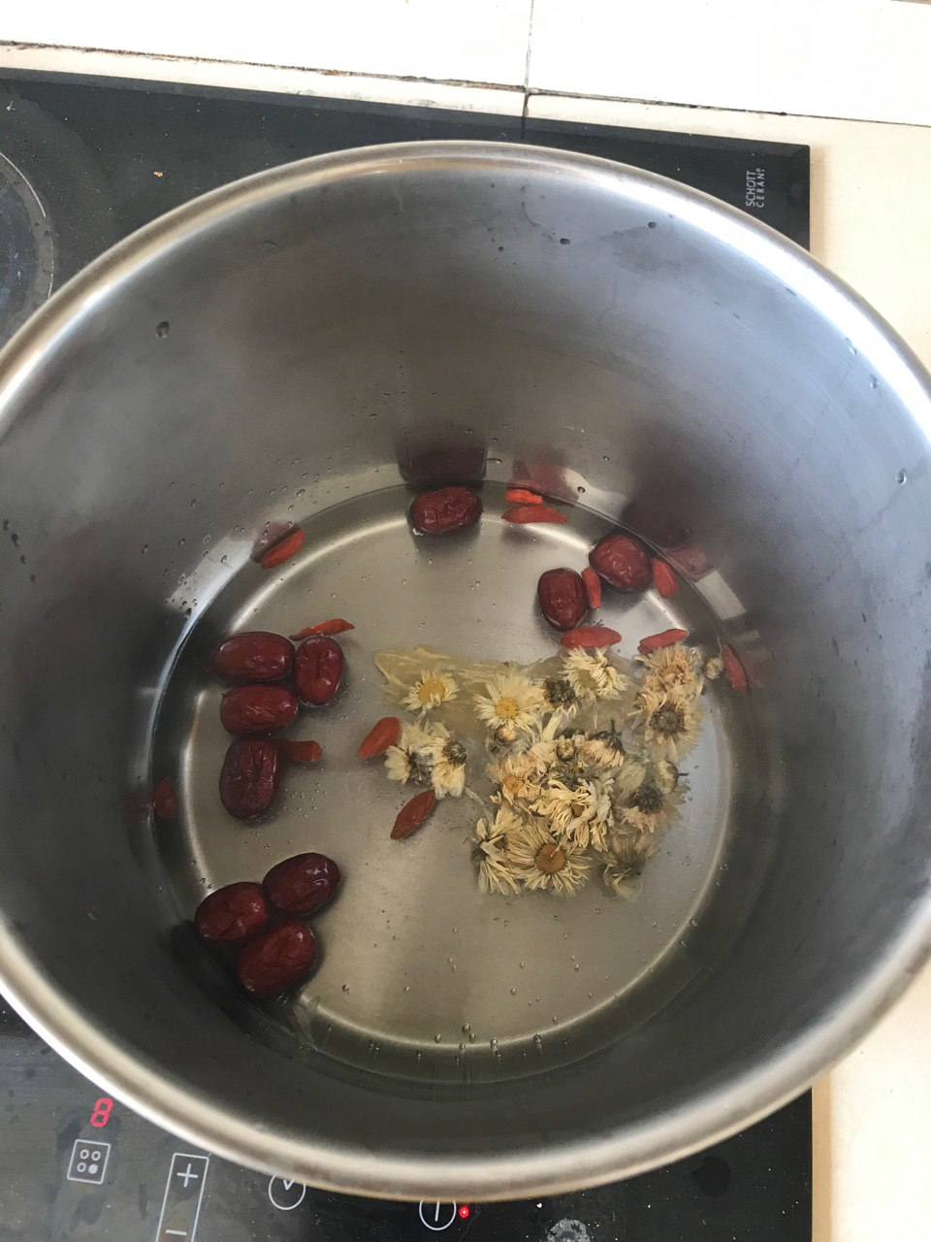

* + Add one teaspoon of brown sugar.

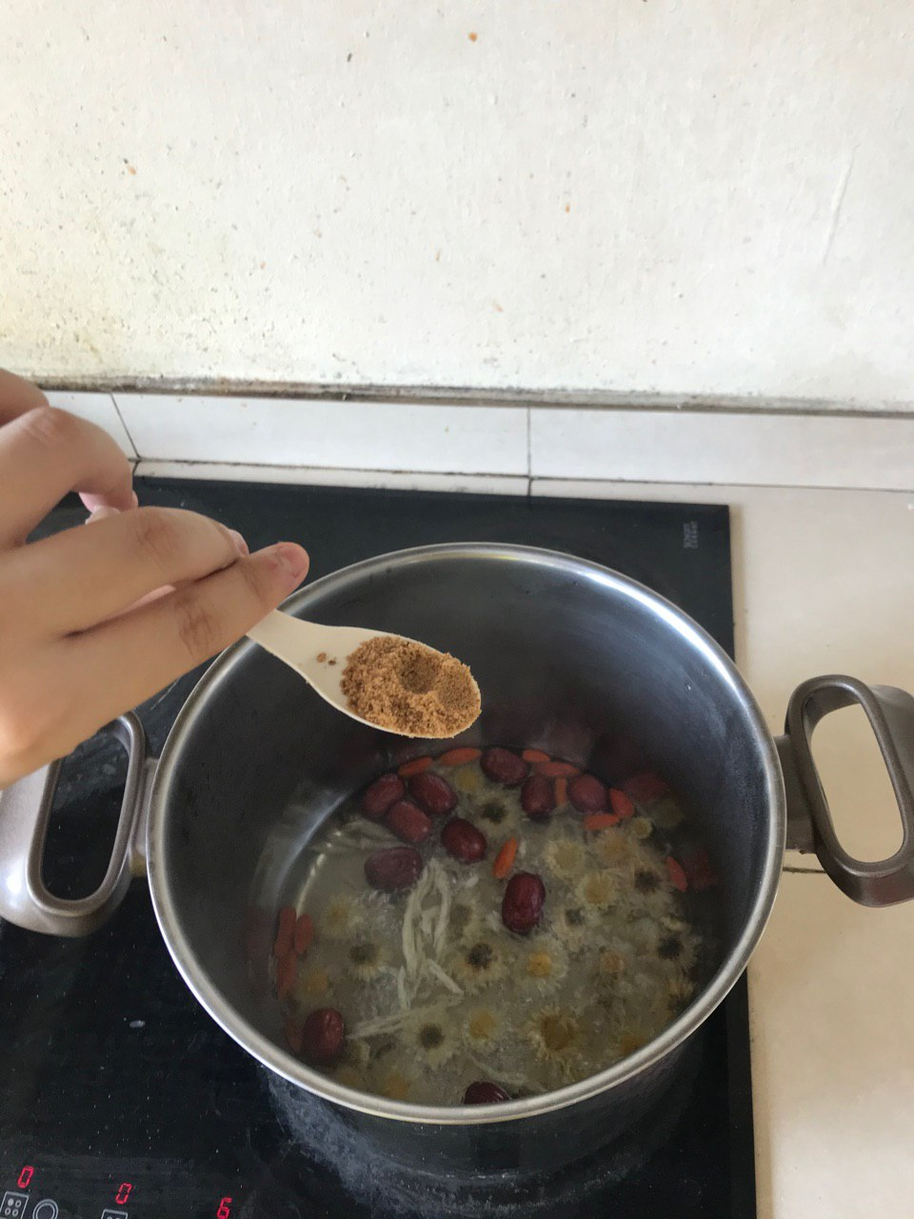

* + - Boil for 10 minutes.

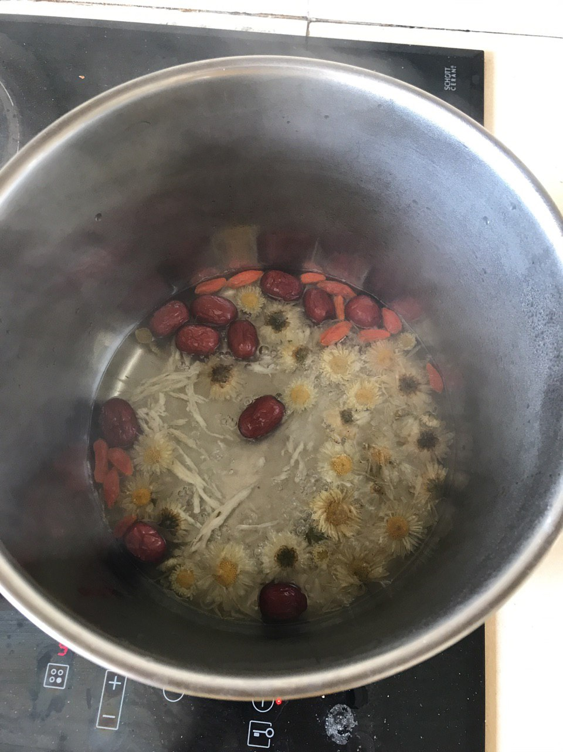

* + Pour the decoction into a bowl / cup. Add a tablespoon of honey.

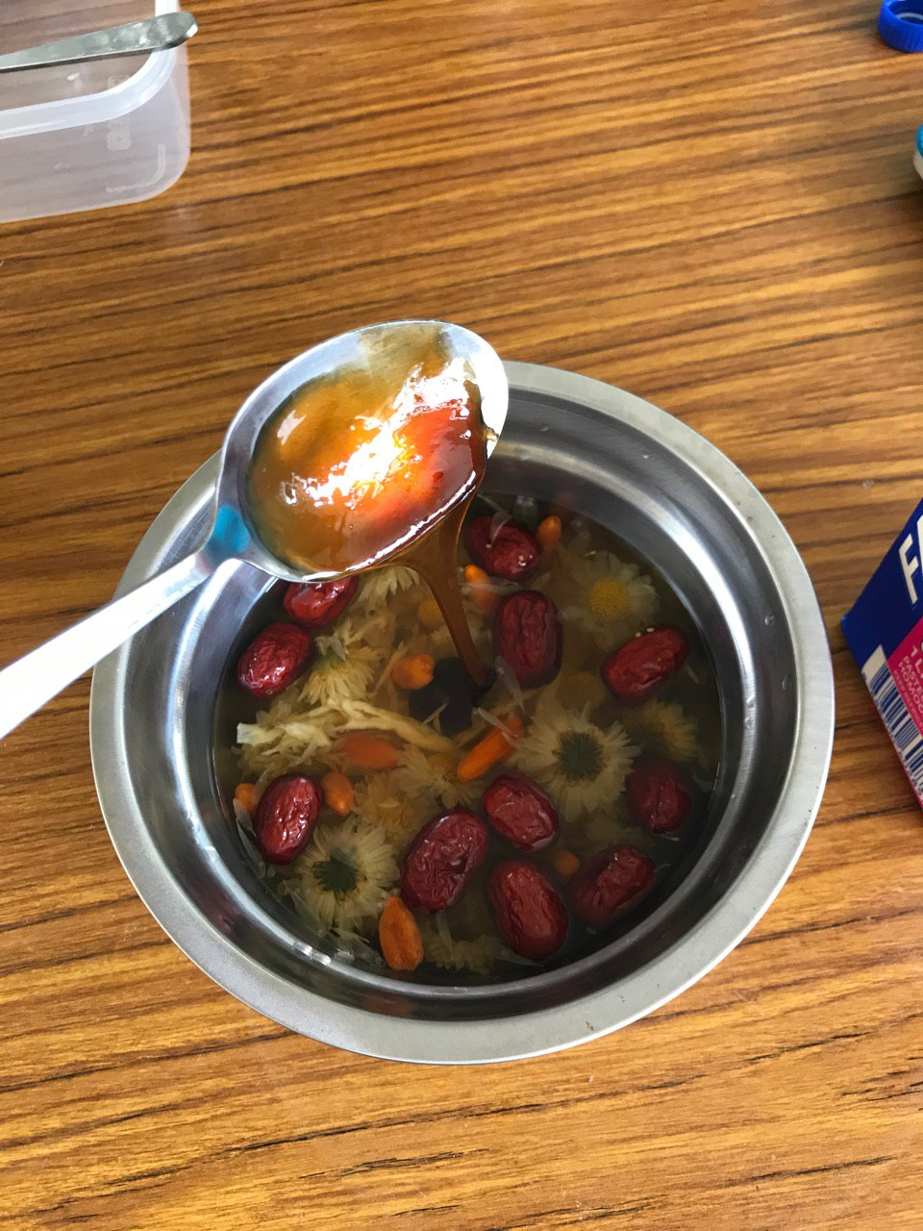

* + Add milk, and the milk tea is ready to serve.

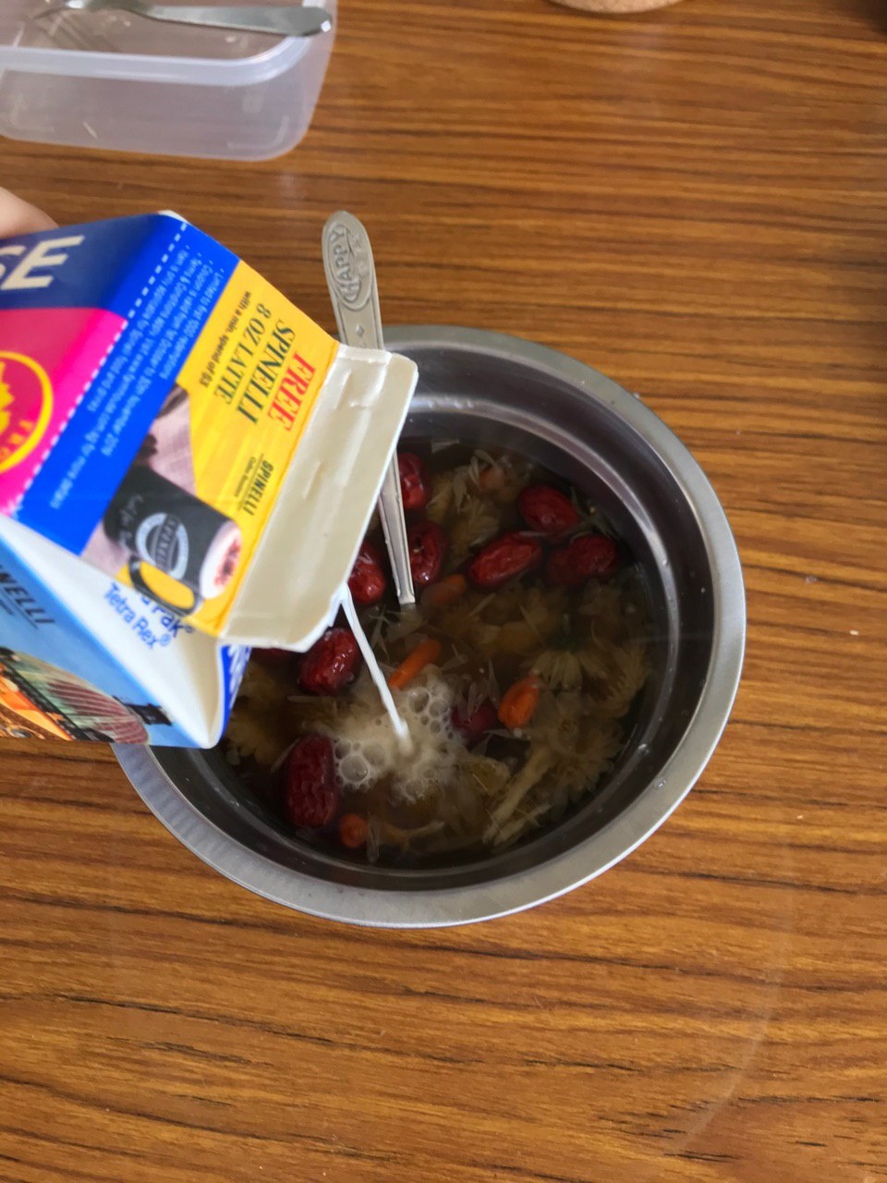

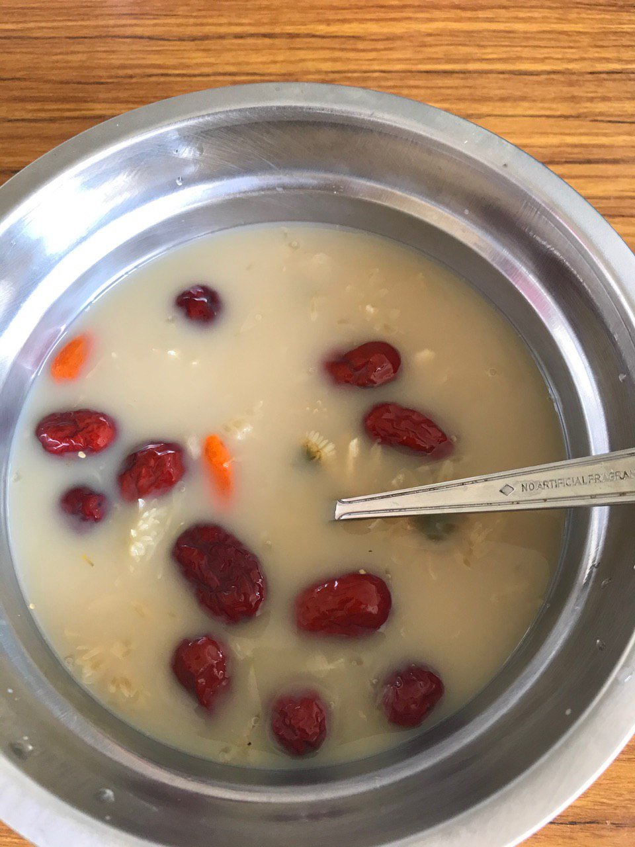

The vital elixir.

**5. Health Benefits**

According to the GEH1070 Tutorial 2 handout, Qi stagnation could be cured by promoting its flow and soothing the liver. This is because the Liver is considered the regulator of the flowing of Qi, (Me and Qi, 2019). Therefore, most of the ingredients are aimed at targeting the Liver. Besides, all of the ingredients in the Vital Elixir are sweet in flavor, which is able to remove toxic from the body. The Jujube fruit, apart from detoxification, also replenishes Qi and blood (Me & Qi, 2019). It targets the spleen, which is responsible for fluid metabolism, while fluid is also considered as a product of Qi. The wolfberries’ sweet flavor not only detoxifies, and also has the similar function of Jujube to replenish Qi (Me & Qi, 2019). It targets the Liver, which addresses Qi stagnation directly. Chrysanthemum, on the other hand, is cold in nature. This is crucial as it is the only cold herb in the decoction, and it counters the warm nature of other herbs. This is important because apart from Qi, the Yin Yang balance also cannot be neglected. The counteraction of Ju Hua and other substances restore the Yin Yang balance, therefore is a must ingredient in this decoction. It also targets the Liver, and the Lung which produces Qi (Me and Qi, 2019). It also has the effect of improving eyesight when consumed together with wolfberries. Meanwhile for honey, its sweetness allows it to replenish Qi, similar to that of wolfberries and Jujube fruit. It is also neutral in nature, which has little effect of disrupting the Yin and Yang balance (Me and Qi, 2019). As for Dang Gui, apart from its sweetness, it is pungent in flavor, which is the taste that promotes the circulation of Qi and Blood. It also targets the Liver, and Spleen, which is important for Qi circulation (Me and Qi, 2019). Finally for brown sugar, it is sweet in nature, and most importantly, it plays the role of soothing the Liver (TCM Wiki, 2016).

**6. Conclusion**

Bubble tea is a common drink in Singapore. However, different from any typical tea, it is unhealthy due to various reasons, such as high sugar contents, high calorie fillings known as “bubbles”, and high trans-fat (AA Singapore, 2019). Therefore, there is a crucial need in a special type of drink that is healthy, addresses body conditions, cure them, and is on par with current bubble milk tea in terms of tastiness. With the presented Vital Elixir, it not only has the tastiness that is required for common teenagers nowadays, but also directly addresses a specific type of illness - Qi stagnation. With the breakdown of its ingredients, the properties, flavors, and natures of its ingredients, not to mention its simplicity in preparing, it could very well serve to be a drink to overcome the current “bubble tea obsessiveness”.

**Reference List:**

1. Chrysanthemum flowers (Me and Qi, 2019). Retrieved from <https://www.meandqi.com/herb-database/chrysanthemum-flower>
2. Dong Quai (Me and Qi, 2019). Retrieved from <https://www.meandqi.com/herb-database/dong-quai>
3. Goji Berries (Me and Qi, 2019). Retrieved from <https://www.meandqi.com/herb-database/goji-berry>
4. Honey (Me and Qi, 2019). Retrieved from <https://www.meandqi.com/herb-database/honey>
5. Jujube Dates (Me and Qi, 2019). Retrieved from <https://www.meandqi.com/herb-database/jujube-dates>
6. Brown Sugar (TCM Wiki, 2016). Retrieved from <https://tcmwiki.com/wiki/brown-sugar>
7. Is Bubble Tea Bad For Health? (AA Singapore, 2019). Retrieved from <https://aa-highway.com.sg/is-bubble-tea-bad-for-health/>
8. An Illustrated Chinese Materia Medica (Wu, JN, 2005).