文档编号 | IAAS-DDS 002
文档版本 | 1.0
拟制人 | 杨方军
日期 | 2016.3.23

EayunCloud公有云业务管理平台
（安全）
概要设计说明书

变更说明
日期 | 版本 | 变更位置 | 变更说明 | 作者
2016．3．23 |  |  | 新建 | 杨方军

目 录
变更说明 2
目 录 3
1. 概述 5
1.1. 功能概述 5
1.2. 定义、缩略语 5
1.3. 参考资料 5
2. 业务分析 5
2.1. 关键业务用例 5
2.1.1. 安全组用例图 5
2.1.2. 防火墙用例图 6
2.2. 关键业务流程 6
2.2.1. 安全组流程图 6
2.2.2. 防火墙流程图 13
2.2.3. 防火墙策略流程图 19
2.2.4. 防火墙规则流程图 23
3. Controller设计 27
3.1. 模块规划 27
3.2. EcmcSecurityGroupController（/ecmc/virtual/securitygroup） 28
3.2.1. createSecurityGroup（/createSecurityGroup） 28
3.2.2. editSecrityGroup（/editSecrityGroup） 28
3.2.3. listDb（/listDb） 29
3.2.4. deleteFromDb（/deleteFromDb） 30
3.3. EcmcSecurityGroupRuleController(/ecmc/virtual/securitygrouprule) 30
3.3.1. createRule(/createRule) 30
3.3.2. getRulesBySecurityGroupIdFromDB(/getRulesBySecurityGroupIdFromDB) 31
3.3.3. deleteFromDb(/deleteFromDb) 32
3.4. EcmcFirewallController(/ecmc/virtual/firewall) 33
3.4.1. getFirewallList(/getFirewallList) 33
3.4.2. createFirewall(/createFirewall) 34
3.4.3. updateFirewall(/updateFirewall) 34
3.4.4. deleteFirewall(/deleteFirewall) 35
3.5. EcmcFirewallRuleController(/ecmc/virtual/firewallrule) 35
3.5.1. createFirewallRule(/createFirewallRule) 35
3.5.2. getFirewallRuleList(/getFirewallRuleList) 36
3.5.3. updateFirewallRule(/updateFirewallRule) 37
3.5.4. deleteFirewallRule(/deleteFirewallRule) 38
3.6. EcmcFirewallPolicyController(ecmc/cloud/firewallpolicy) 39
3.6.1. createFirewallPolicy(/createFirewallPolicy) 39
3.6.2. getFirewallPolicyList(/getFirewallPolicyList) 40
3.6.3. updateFirewallPolicy(/updateFirewallPolicy) 41
3.6.4. deleteFirewallPolicy(/deleteFirewallPolicy) 41
4. Model设计 42
4.1. 安全组 42
4.2. 防火墙 42
5. Service设计 43
5.1. 类设计 43
5.1.1. 模块类图 43
5.1.2. 关键逻辑时序图 44
5.1.3. 模块类说明 44
5.2. 安全组类（EcmcSecurityGroupService） 45
5.2.1. checkSecurityGroupName 45
5.2.2. findSecurityGroup 45
5.2.3. deleteSecurityGroup 45
5.2.4. addSecurityGroup 46
5.2.5. updateSecurityGroup 47
5.3. 安全组规则类(EcmcGroupRuleService) 47
5.3.1. deleteRule 47
5.3.2. findRule 47
5.3.3. addRule 48
5.4. 防火墙类(EcmcFireWallService) 48
5.4.1. getFirewallList 49
5.4.2. findFireWallById 49
5.4.3. addFirewall 49
5.4.4. updateFirewall 49
5.4.5. deleteFirewall 50
5.5. 防火墙策略类(EcmcFwPolicyService) 50
5.5.1. getFwPolicyList 50
5.5.2. deleteFwPolicy 50
5.5.3. updateFwPolicy 50
5.5.4. addFwPolicy 51
5.6. 防火墙规则类(EcmcFwRuleService) 51
5.6.1. checkFwRuleName 51
5.6.2. getRuleList 51
5.6.3. addRule 51
5.6.4. deleteRule 52
5.6.5. updateRule 52

概述

功能概述

定义、缩略语

参考资料
1.《公有云管理控制台V1.0.0原型2015.08.21》

业务分析

关键业务用例

安全组用例图
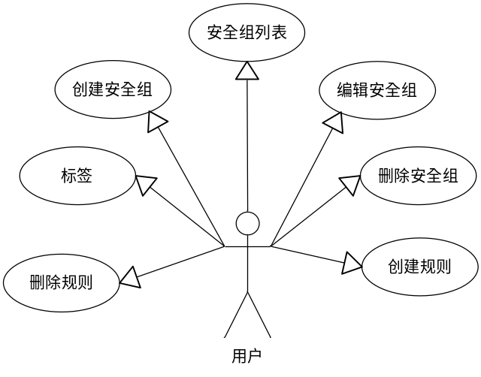

防火墙用例图
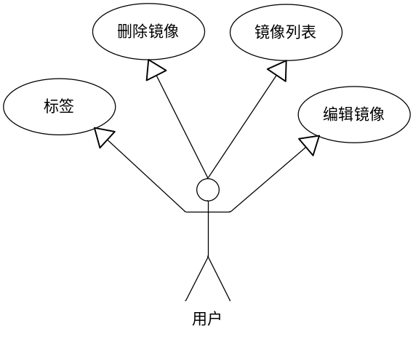

关键业务流程

安全组流程图

安全组列表
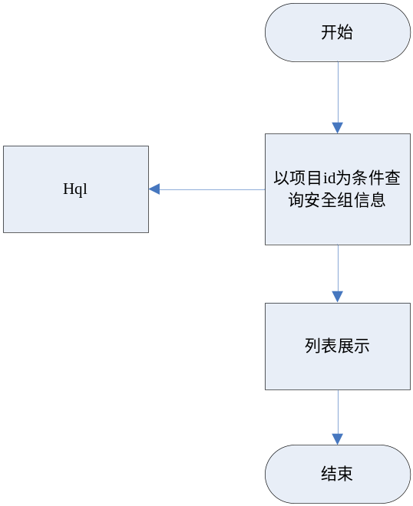

创建安全组
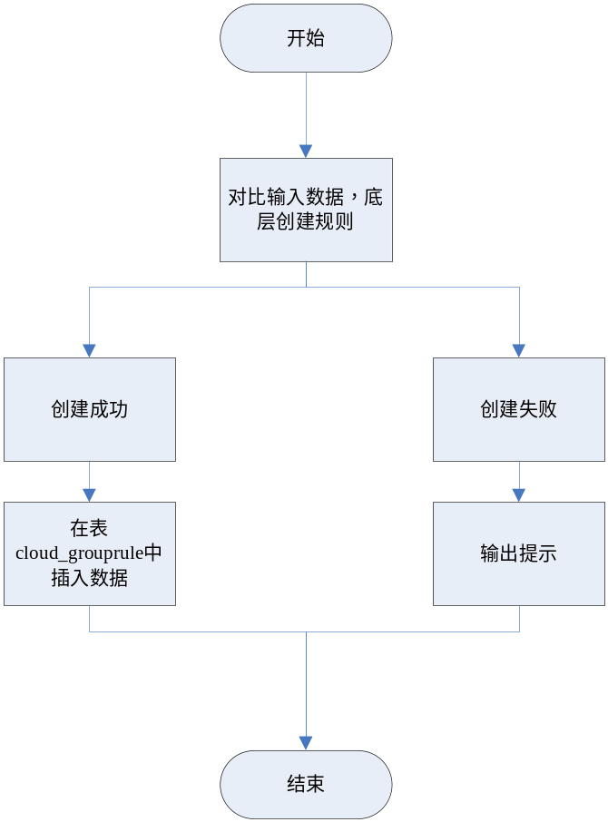

编辑安全组
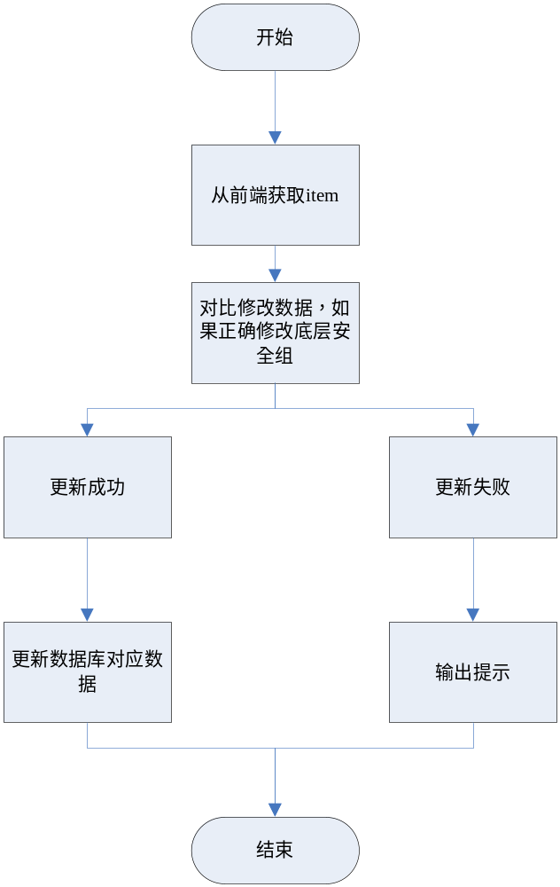

删除安全组
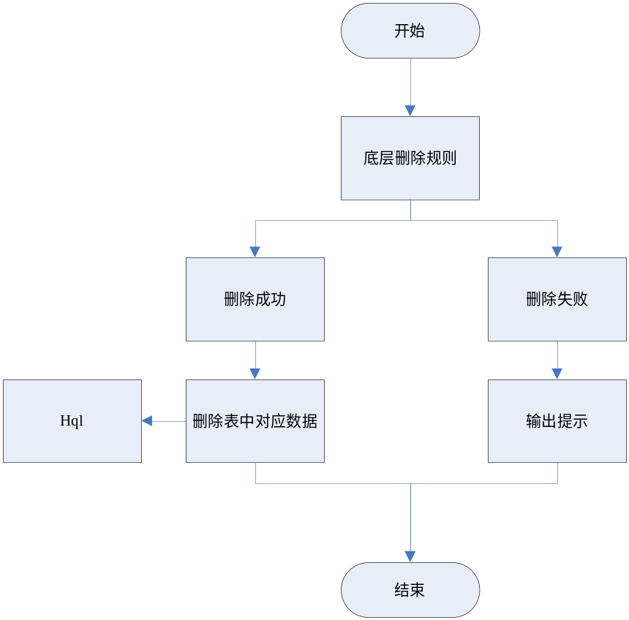

搜索安全组
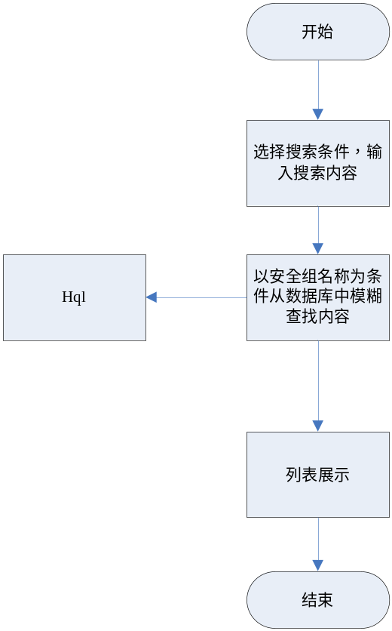

标签
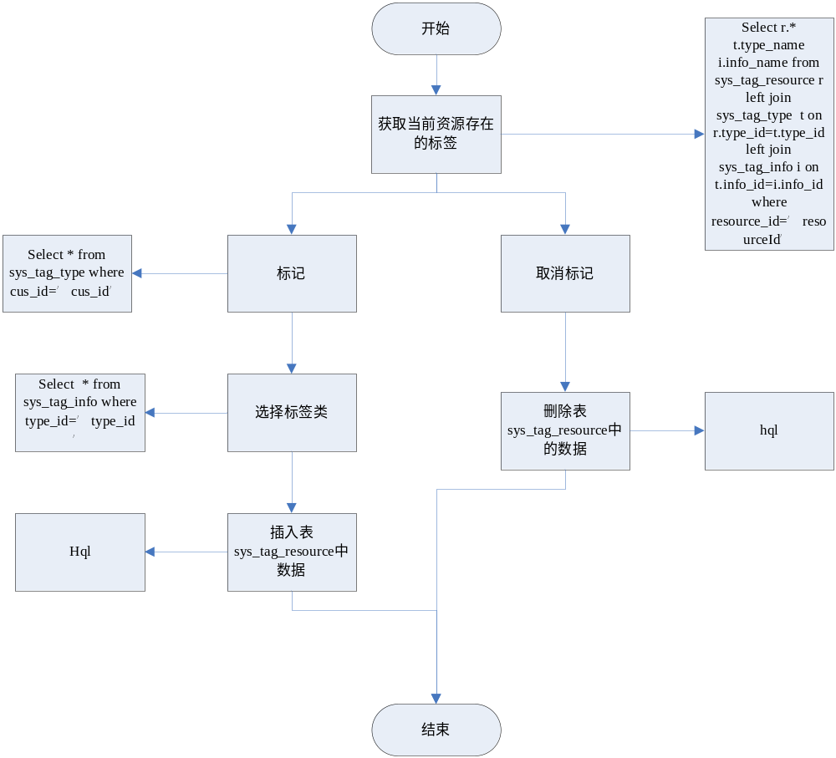

新建规则

删除规则

防火墙流程图

防火墙列表
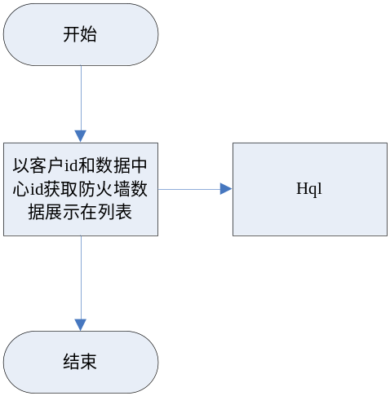

创建防火墙
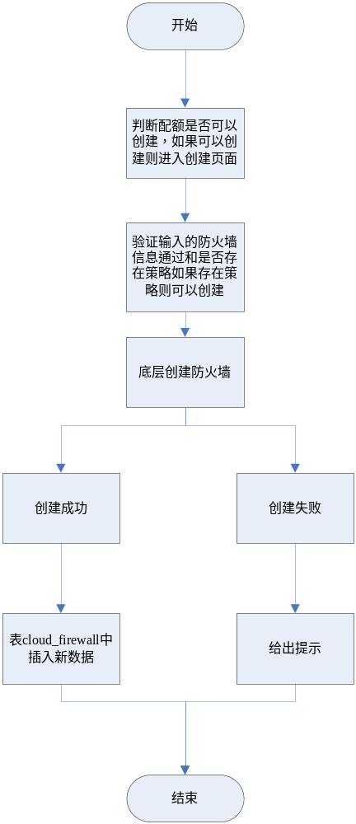

编辑防火墙
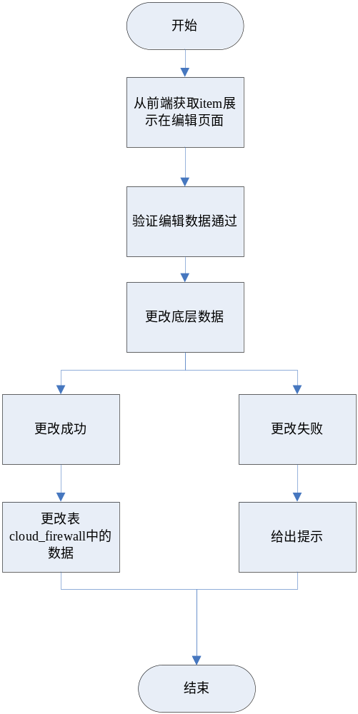

删除防火墙
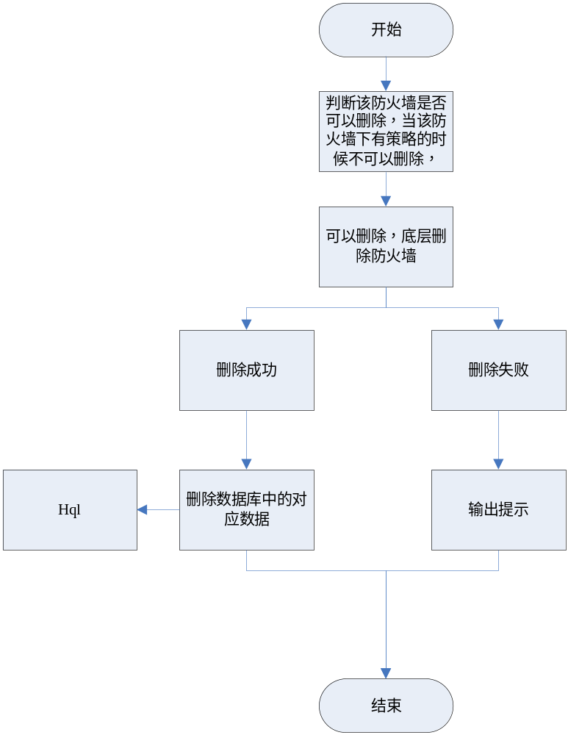

搜索防火墙
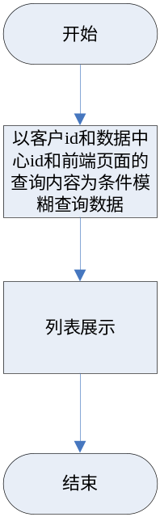

标签

防火墙详情
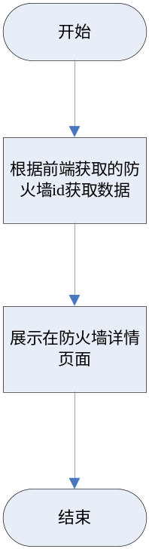

防火墙策略流程图

防火墙策略列表
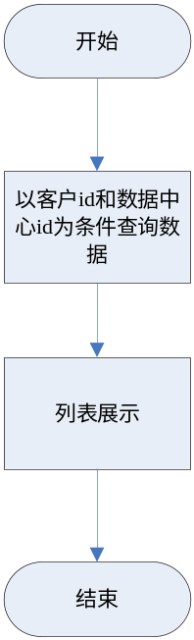

新建防火墙策略
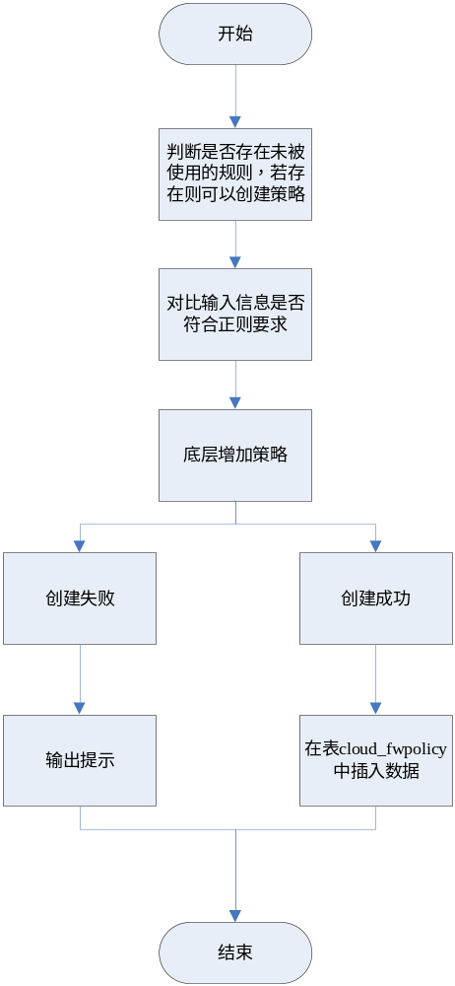

编辑防火墙策略
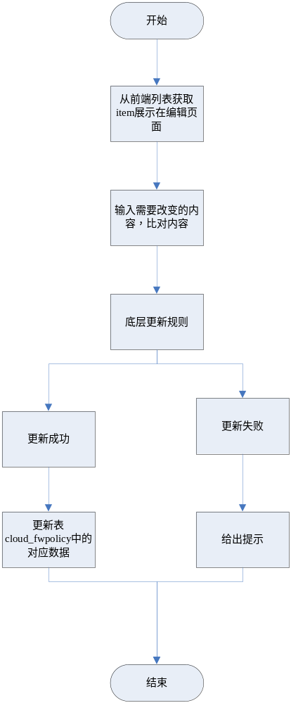

删除防火墙策略
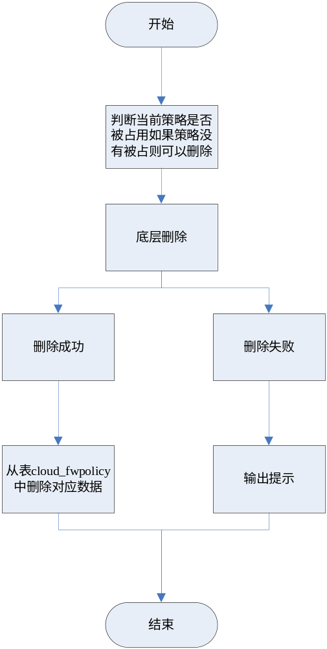

搜索防火墙策略

防火墙规则流程图

防火墙规则列表
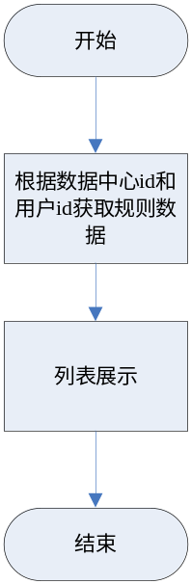

增加防火墙规则
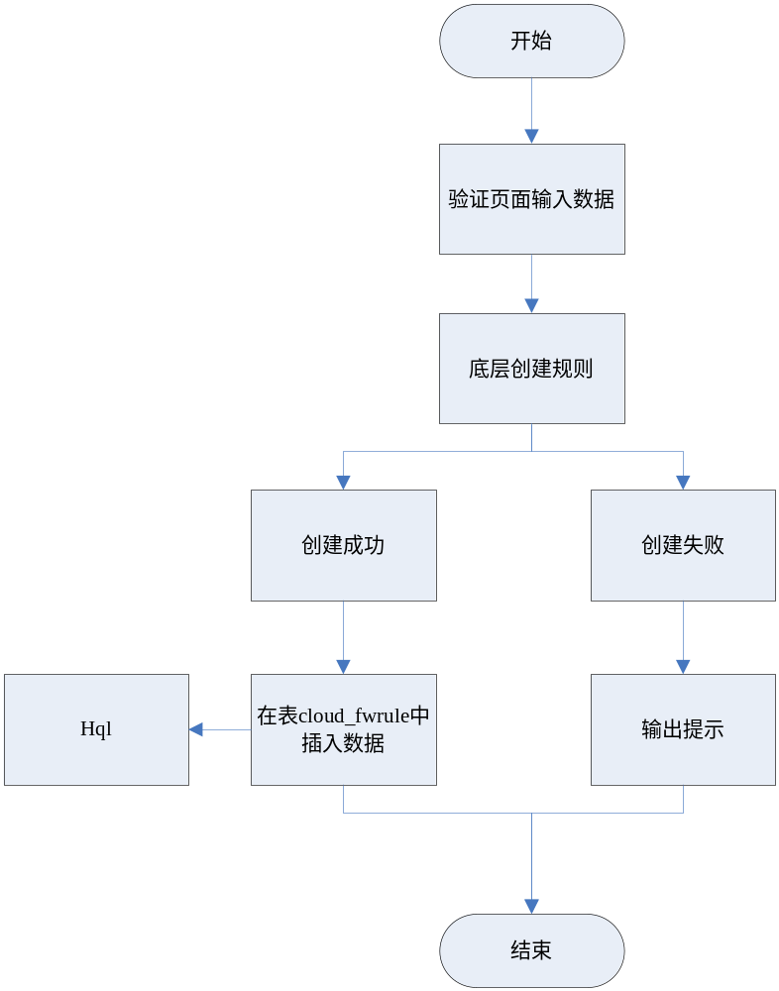

编辑防火墙规则
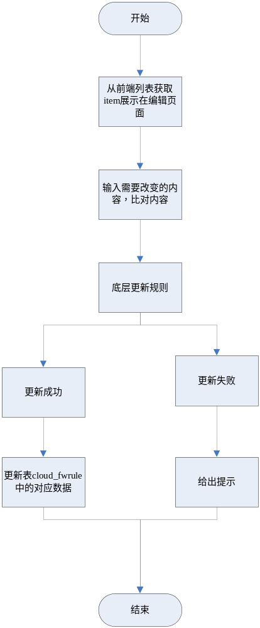

删除防火墙规则
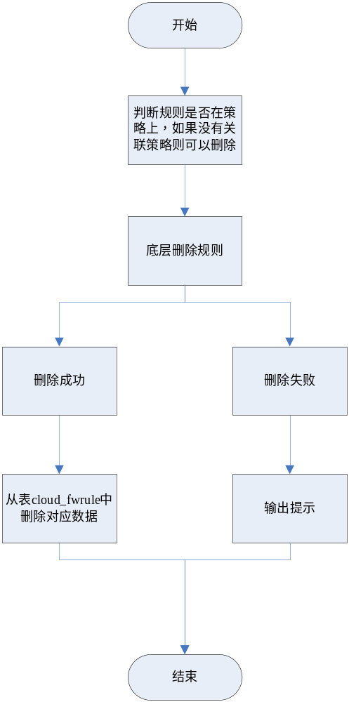

搜索防火墙规则

Controller设计

模块规划
菜单资源 | Controller类名 | 备注
安全组 | virtualization/ecmccontroller/EcmcSecurityGroupController
安全组规则 | virtualization/ecmccontroller/EcmcSecurityGroupRuleController
防火墙 | virtualization/ecmccontroller/EcmcFirewallController
防火墙规则 | virtualization/ecmccontroller/EcmcFirewallRuleController
防火墙策略 | virtualization/ecmccontroller/EcmcFirewallPolicyController

EcmcSecurityGroupController（/ecmc/virtual/securitygroup）

createSecurityGroup（/createsecuritygroup）
说明 | 修改安全组
URL | /ecmc/virtual/securitygroup/createsecuritygroup.do
方式 | POST
Post数据 | {  "dcId": "16022514134540",  "prjId": "1496a93fd6214b389762184f1df74229",  "sgName": "研发测试111",  "sgDescription": "研发测试1112"  }
返回Json | {  "code": "000000",  "resultData": {  "createName": "root",  "createTime": 1458701491821,  "dcId": "16022514134540",  "defaultGroup": "not",  "prjId": "1496a93fd6214b389762184f1df74229",  "sgDescription": "研发测试1112",  "sgId": "b96feef8-516e-4c49-a43e-6e08a39d8e1c",  "sgName": "研发测试111"  }  }

updateSecurityGroup（/updatesecuritygroup）
说明 | 创建安全组
URL | /ecmc/virtual/securitygroup/editSecrityGroup.do
方式 | POST
Post数据 | {  "dcId": "16022514134540",  "prjId": "1496a93fd6214b389762184f1df74229",  "sgDescription": "remark123",  "sgId": "d0faee76-fb1e-4d42-92b5-3fd70a264c32",  "sgName": "group123"  }
返回Json | {"code":"600000"}

querySecurityGroup（/querysecuritygroup）
说明 | 查询安全组
URL | /ecmc/virtual/securitygroup/querysecuritygroup.do
方式 | POST
Post数据 | {  "pageNumber": "1",  "pageSize": "10",  "params": {  "dcId": "16022514134540",  "prjName": "项目名称1,项目名称2",  "cusName": "客户名称1,客户名称2",  "name": "安全组名称，模糊查询"  }  }
返回Json | {  "items": [  {  "sgId": "e45e2cce-3458-449f-830d-b9f338fc9def",  "sgName": "default",  "createName": null,  "dcId": "1509211142230",  "createTime": 1460514079000,  "prjId": "e5b2d9f3d0c342b68a8b8af81113f4dc",  "sgDescription": "default",  "defaultGroup": "defaultGroup",  "prjName": "张帆_00",  "dcName": "研发32",  "tagName": null,  "vmCount": null,  "cusId": "4028b881540d697301540d6ae6680000",  "cusName": "张帆",  "isDeleting": "not"  }  ],  "pageNo": 1,  "pageNum": 1,  "pageSize": 10,  "queryParams": "{\"datacenterId\":\"16022514134540\",\"projectId\":\"1496a93fd6214b389762184f1df74229\"}",  "queryTimestamp": 1458701729310,  "queryUrl": "/bg/cloud/openstack/securitygroup/listDb.do",  "totalNum": 2  }

deleteSecurityGroup（/deletesecuritygroup）
说明 | 删除安全组
URL | /ecmc/virtual/securitygroup/deletesecuritygroup.do
方式 | POST
Post数据 | {  "id": "b96feef8-516e-4c49-a43e-6e08a39d8e1c",  "datacenterId": "1496a93fd6214b389762184f1df74229"  }
返回Json | {  "code": "100000",  "deleteCount": 0,  "deleteTotal": 1  }

checkSecurityGroupName（/checksecuritygroupname）
说明 | 检查安全组名称是否重复
URL | /ecmc/virtual/securitygroup/checksecuritygroupname.do
方式 | POST
Post数据 | {  "dcId": "16022514134540",  "prjId": "1496a93fd6214b389762184f1df74229",  "sgName": "研发测试111",  "sgId": "安全组Id(可空)"  }
返回Json | true

getSecurityGroupById（/getsecuritygroupbyid）
说明 | 根据安全组ID查找本地安全组
URL | /ecmc/virtual/securitygroup/getsecuritygroupbyid.do
方式 | POST
Post数据 | {  "sgId": "安全组Id"  }
返回Json | {  "sgId": "1ddc7eb8-83e9-475e-9aee-166067d8e006",  "sgName": "default",  "createName": null,  "dcId": "1509101341180",  "createTime": 1452505956000,  "prjId": "9d2510d3c5814cd485345caad016f782",  "sgDescription": "default",  "defaultGroup": "defaultGroup"  }

getRulesBySgId（/getrulesbysgid）
说明 | 根据安全组ID查找安全组规则
URL | /ecmc/virtual/securitygroup/getrulesbysgid.do
方式 | POST
Post数据 | {  "dcId": null,  "prjId": null,  "sgId": "1ddc7eb8-83e9-475e-9aee-166067d8e006"  }
返回Json | [  {  "sgrId": "06bc04bd-b5e0-49c3-afd3-c8f0cb6b7f8e",  "direction": "egress",  "ethertype": "IPv6",  "portRangeMax": "null",  "portRangeMin": "null",  "protocol": "null",  "remoteIpPrefix": "null",  "sgId": "1ddc7eb8-83e9-475e-9aee-166067d8e006",  "prjId": "9d2510d3c5814cd485345caad016f782",  "remoteGroupId": null,  "createTime": null,  "createName": null,  "dcId": "1509101341180",  "protocolExpand": "null",  "remoteGroupName": null  }  ]

listAllGroups（/listallgroups）
说明 | 未关联云主机的安全组列表
URL | /ecmc/virtual/securitygroup/listallgroups.do
方式 | POST
Post数据 | {  "dcId": "16022514134540",  "prjId": "1496a93fd6214b389762184f1df74229"  }
返回Json | [  {  "sgId": "e45e2cce-3458-449f-830d-b9f338fc9def",  "sgName": "default",  "createName": null,  "dcId": "1509211142230",  "createTime": 1460514079000,  "prjId": "e5b2d9f3d0c342b68a8b8af81113f4dc",  "sgDescription": "default",  "defaultGroup": "defaultGroup",  "prjName": "张帆_00",  "dcName": null,  "tagName": null,  "vmCount": null,  "isDeleting": "not"  }  ]

EcmcSecurityGroupRuleController(/ecmc/virtual/securitygrouprule)

createRule(/createrule)
说明 | 创建规则
URL | /ecmc/virtual/securitygroup/createrule.do
方式 | POST
Post数据 | {  "ipv4": "false",  "ipv6": "false",  "protocol": "TCP",  "direction": "ingress",  "port_range_min": "80",  "port_range_max": "8888",  "from": "SecurityGroup",  "ethertype": "IPv4",  "datacenterId": "16022514134540",  "projectId": "3bb60ae69ec746288630502d72eb8197",  "securityGroupId": "46325f90-c835-4524-ba58-48be015a2613"  }  //参考旧版，安全组ID统一用securityGroupId，不再传security_group_id
返回Json | {  "code": "000000",  "resultData": {  "direction": "ingress",  "ethertype": "IPv4",  "id": "023ad3af-4ed4-474b-9f18-3886d8be1107",  "port_range_max": "222",  "port_range_min": "80",  "protocol": "tcp",  "remote_ip_prefix": "192.168.1.0/24",  "security_group_id": "d0faee76-fb1e-4d42-92b5-3fd70a264c32",  "tenant_id": "1496a93fd6214b389762184f1df74229"  }  }

deleteRuleById(/deleterulebyid)
说明 | 删除安全组规则
URL | /ecmc/virtual/securitygroup/deleterulebyid.do
方式 | POST
Post数据 | {  "id": "023ad3af-4ed4-474b-9f18-3886d8be1107",  "datacenterId": "16022514134540"  }
返回Json | {  "code": "100000",  "deleteCount": 0,  "deleteTotal": 1  }

EcmcFirewallController(/ecmc/virtual/firewall)

getFirewallList(/getFirewallList)
说明 | 查询防火墙列表
URL | /ecmc/virtual/firewall/getFirewallList.do
方式 | POST
Post数据 | {  "id": "023ad3af-4ed4-474b-9f18-3886d8be1107",  "projectId": "1496a93fd6214b389762184f1df74229",  "datacenterId": "16022514134540"  }
返回Json | {  "items": [  {  "adminStateup": "是",  "dcId": "16022514134540",  "dcName": "研发32",  "cusId": "客户ID",  "cusName": "客户32"  "description": "",  "fwId": "8531ae9a-8aab-4001-aa73-cc2e10f50062",  "fwName": "1",  "fwStatus": "ACTIVE",  "fwpId": "36359edc-ff64-4e84-aa27-44002d8943cd",  "fwpName": "123",  "isDeleting": "not",  "prjId": "3bb60ae69ec746288630502d72eb8197",  "prjName": "chm_01"  }  ],  "pageNo": 1,  "pageNum": 1,  "pageSize": 10,  "queryParams": "{\"datacenterId\":\"16022514134540\",\"projectId\":\"3bb60ae69ec746288630502d72eb8197\"}",  "queryTimestamp": 1458809838137,  "queryUrl": "/bg/cloud/openstack/firewall/list.do",  "totalNum": 1  }

createFirewall(/createFirewall)
说明 | 创建防火墙
URL | /ecmc/virtual/firewall/createFirewall.do
方式 | POST
Post数据 | {  "admin_state_up": "1",  "shared": "1",  "policy": "2afcda97-ab62-4336-90af-d96c7d2a3621",  "datacenter": "16022514134540",  "project": "1496a93fd6214b389762184f1df74229",  "name": "firewall123",  "description": "remark123"  }
返回Json | {  "resultData": {  "admin_state_up": true,  "description": "remark123",  "firewall_policy_id": "2afcda97-ab62-4336-90af-d96c7d2a3621",  "id": "6855a9b2-d880-4c31-af73-a917e754bbce",  "name": "firewall123",  "shared": false,  "status": "PENDING_CREATE",  "tenant_id": "1496a93fd6214b389762184f1df74229"  }  }

updateFirewall(/updateFirewall)
说明 | 修改防火墙
URL | /ecmc/virtual/firewall/updateFirewall.do
方式 | POST
Post数据 | {  "adminStateup": "是",  "description": "remark123",  "fwId": "6855a9b2-d880-4c31-af73-a917e754bbce",  "fwName": "firewall123",  "fwStatus": "PENDING_CREATE",  "fwpId": "2afcda97-ab62-4336-90af-d96c7d2a3621",  "fwpName": "policy123",  "policy": "2afcda97-ab62-4336-90af-d96c7d2a3621",  "id": "6855a9b2-d880-4c31-af73-a917e754bbce",  "name": "firewall1232"  }
返回Json | 成功：  //TODO  失败：  {"code":"010120","message":"防火墙已被占用，不可以修改！"}

deleteFirewall(/deleteFirewall)
说明 | 删除防火墙
URL | /ecmc/virtual/firewall/deleteFirewall.do
方式 | POST
Post数据 | {  "id": "6855a9b2-d880-4c31-af73-a917e754bbce",  "projectId": "1496a93fd6214b389762184f1df74229",  "datacenterId": "16022514134540"  }
返回Json | {  "code": "100000",  "deleteCount": 0,  "deleteTotal": 1  }

EcmcFirewallRuleController(/ecmc/virtual/firewallrule)

createFirewallRule(/createFirewallRule)
说明 | 创建防火墙规则
URL | /ecmc/virtual/securitygroup/createFirewallRule.do
方式 | POST
Post数据 | {  "shared": "1",  "enabled": "1",  "protocol": "tcp",  "action": "allow",  "ip_version": "4",  "datacenter": "16022514134540",  "project": "1496a93fd6214b389762184f1df74229",  "source_port": "22",  "destination_port": "22",  "name": "rule123",  "source_ip_address": "192.168.1.11",  "destination_ip_address": "192.168.1.12",  "description": "remark"  }
返回Json | {  "code": "000000",  "resultData": {  "action": "allow",  "description": "remark",  "destination_ip_address": "192.168.1.12",  "destination_port": "22",  "enabled": true,  "id": "765ac5aa-f04b-485c-856a-5c1b90b2f9d7",  "ip_version": "4",  "name": "rule123",  "protocol": "tcp",  "shared": false,  "source_ip_address": "192.168.1.11",  "source_port": "22",  "tenant_id": "1496a93fd6214b389762184f1df74229"  }  }

getFirewallRuleList(/getFirewallRuleList)
说明 | 查询防火墙规则
URL | /ecmc/virtual/securitygroup/getFirewallRuleList.do
方式 | POST
Post数据 | {  "datacenterId": "16022514134540",  "projectId": "1496a93fd6214b389762184f1df74229"  }
返回Json | {  "items": [  {  "dcId": "16022514134540",  "dcName": "研发32",  "description": "remark",  "destinationIpaddress": "192.168.1.12",  "destinationPort": "22",  "fwrAction": "allow",  "fwrEnabled": "1",  "fwrId": "765ac5aa-f04b-485c-856a-5c1b90b2f9d7",  "fwrName": "rule123",  "ipVersion": "4",  "isActive": "是",  "isDeleting": "not",  "prjName": "123_17",  "protocol": "tcp",  "sourceIpaddress": "192.168.1.11",  "sourcePort": "22"  }  ],  "pageNo": 1,  "pageNum": 1,  "pageSize": 10,  "queryParams": "{\"datacenterId\":\"16022514134540\",\"projectId\":\"1496a93fd6214b389762184f1df74229\"}",  "queryTimestamp": 1458812214591,  "queryUrl": "/bg/cloud/openstack/firewallRule/list.do",  "totalNum": 1  }

updateFirewallRule(/updateFirewallRule)
说明 | 创建防火墙规则
URL | /ecmc/virtual/securitygroup/updateFirewallRule.do
方式 | POST
Post数据 | {  "description": "remark",  "destinationIpaddress": "192.168.1.12",  "destinationPort": "22",  "fwrAction": "allow",  "fwrEnabled": "1",  "fwrId": "765ac5aa-f04b-485c-856a-5c1b90b2f9d7",  "fwrName": "rule123",  "ipVersion": "4",  "protocol": "tcp",  "sourceIpaddress": "192.168.1.11",  "sourcePort": "22",  "id": "765ac5aa-f04b-485c-856a-5c1b90b2f9d7",  "name": "rule1234",  "protocol1": "tcp",  "sourcePortx": "22",  "sourceIpaddressx": "192.168.1.11",  "destinationPortx": "22",  "destinationIpaddressx": "192.168.1.12",  "action": "allow"  }
返回Json | {  "code": "200000",  "resultData": {  "createName": "root",  "createTime": 1458810080000,  "dcId": "16022514134540",  "description": "remark",  "destinationIpaddress": "192.168.1.12",  "destinationPort": "22",  "fwrAction": "allow",  "fwrEnabled": "1",  "fwrId": "765ac5aa-f04b-485c-856a-5c1b90b2f9d7",  "fwrName": "rule1234",  "ipVersion": "4",  "prjId": "1496a93fd6214b389762184f1df74229",  "protocol": "tcp",  "sourceIpaddress": "192.168.1.11",  "sourcePort": "22"  }  }

deleteFirewallRule(/deleteFirewallRule)
说明 | 创建防火墙规则
URL | /ecmc/virtual/securitygroup/deleteFirewallRule.do
方式 | POST
Post数据 | {  "id": "765ac5aa-f04b-485c-856a-5c1b90b2f9d7",  "datacenterId": "16022514134540"  }
返回Json | {  "code": "100000",  "deleteCount": 0,  "deleteTotal": 1  }

EcmcFirewallPolicyController(ecmc/cloud/firewallpolicy)

createFirewallPolicy(/createFirewallPolicy)
说明 | 创建防火墙策略
URL | /ecmc/virtual/securitygroup/createFirewallPolicy.do
方式 | POST
Post数据 | {  "audited": "1",  "shared": "1",  "datacenter": "16022514134540",  "project": "1496a93fd6214b389762184f1df74229",  "name": "policy123",  "description": "remark123",  "rules": "765ac5aa-f04b-485c-856a-5c1b90b2f9d7",  "rulesFormodify": "",  "rulesFormodify1": ""  }
返回Json | {  "code": "000000",  "resultData": {  "audited": true,  "description": "remark123",  "exist": false,  "firewall_rules": [  "765ac5aa-f04b-485c-856a-5c1b90b2f9d7"  ],  "id": "2afcda97-ab62-4336-90af-d96c7d2a3621",  "name": "policy123",  "shared": false,  "tenant_id": "1496a93fd6214b389762184f1df74229"  }  }

getFirewallPolicyList(/getFirewallPolicyList)
说明 | 查询防火墙策略
URL | /ecmc/virtual/securitygroup/getFirewallPolicyList.do
方式 | POST
Post数据 | {  "datacenterId": "16022514134540",  "projectId": "1496a93fd6214b389762184f1df74229"  }
返回Json | {  "items": [  {  "audited": "是",  "dcId": "16022514134540",  "dcName": "研发32",  "description": "remark123",  "fwpId": "2afcda97-ab62-4336-90af-d96c7d2a3621",  "fwpName": "policy123",  "isDeleting": "not",  "prjId": "1496a93fd6214b389762184f1df74229",  "prjName": "123_17",  "rulenum": "1"  }  ],  "pageNo": 1,  "pageNum": 1,  "pageSize": 10,  "queryParams": "{\"datacenterId\":\"16022514134540\",\"projectId\":\"1496a93fd6214b389762184f1df74229\"}",  "queryTimestamp": 1458811050053,  "queryUrl": "/bg/cloud/openstack/firewallPolicy/list.do",  "totalNum": 1  }

updateFirewallPolicy(/updateFirewallPolicy)
说明 | 修改防火墙策略
URL | /ecmc/virtual/securitygroup/updateFirewallPolicy.do
方式 | POST
Post数据 | {  "audited": "是",  "description": "remark123",  "fwpId": "2afcda97-ab62-4336-90af-d96c7d2a3621",  "fwpName": "policy123",  "prjId": "1496a93fd6214b389762184f1df74229",  "id": "2afcda97-ab62-4336-90af-d96c7d2a3621",  "name": "policy1234",  "tenant_id": "1496a93fd6214b389762184f1df74229",  "rules": "",  "rulesFormodify": "765ac5aa-f04b-485c-856a-5c1b90b2f9d7",  "rulesFormodify1": ""  }
返回Json | {  "code": "200000",  "resultData": {  "audited": false,  "description": "remark123",  "exist": false,  "firewall_rules": [  "765ac5aa-f04b-485c-856a-5c1b90b2f9d7"  ],  "id": "2afcda97-ab62-4336-90af-d96c7d2a3621",  "name": "policy1234",  "shared": false,  "tenant_id": "1496a93fd6214b389762184f1df74229"  }  }

deleteFirewallPolicy(/deleteFirewallPolicy)
说明 | 删除防火墙策略
URL | /ecmc/virtual/securitygroup/deleteFirewallPolicy.do
方式 | POST
Post数据 | {  "id": "2afcda97-ab62-4336-90af-d96c7d2a3621",  "projectId": "1496a93fd6214b389762184f1df74229",  "datacenterId": "16022514134540"  }
返回Json | {  "code": "100000",  "deleteCount": 0,  "deleteTotal": 1  }

Model设计

安全组
类名 | 说明 | 描述
com.eayun.cloud.model.BaseCloudSecurityGroup | 安全组实体类 | 表cloud_SecurityGroup
com.eayun.cloud.model.CloudSecurityGroup | 安全组类
com.eayun.cloud.model.CloudGroupRule | 安全组规则实体类 | 表cloud_grouprule
com.eayun.cloud.model.CloudGroupRule | 安全组规则类

防火墙
类名 | 说明 | 描述
com.eayun.cloud.model.BaseCloudFirewall | 防火墙实体类 | 表cloud_firewall
com.eayun.cloud.model.CloudFirewall | 防火墙类
com.eayun.cloud.model.BaseCloudFwPolicy | 防火墙实体类 | 表cloud_fwpolicy
com.eayun.cloud.model.CloudFwPolicy | 防火墙策略类
com.eayun.cloud.model.BaseCloudFwRule | 防火墙规则实体类 | 表cloud_fwrule
com.eayun.cloud.model.CloudFwRule | 防火墙规则类

Service设计

类设计

模块类图

安全组

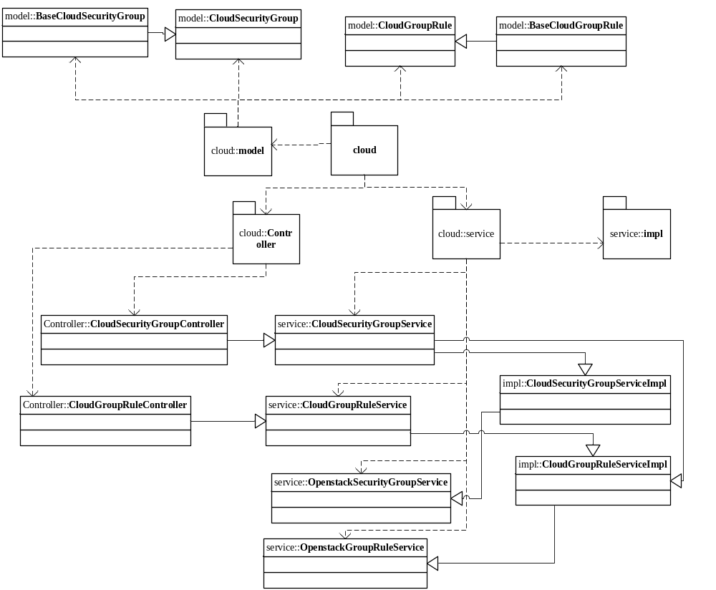

防火墙
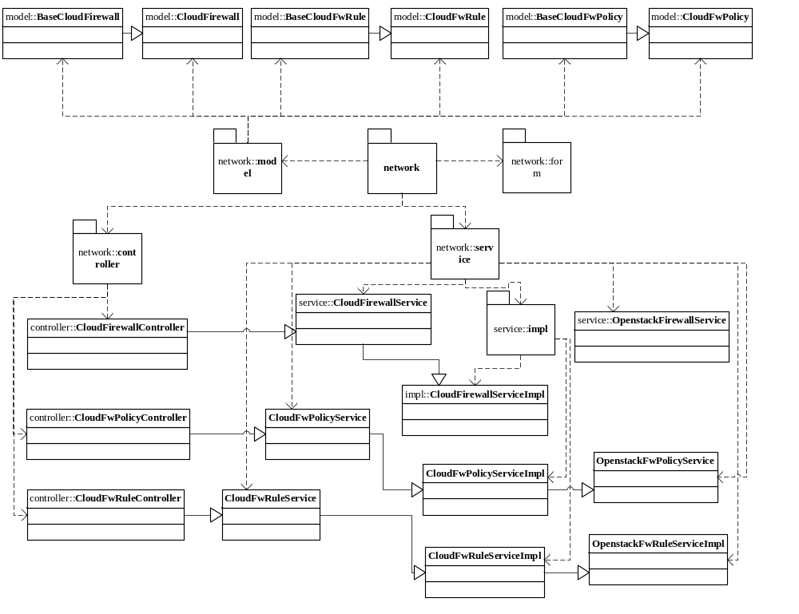

关键逻辑时序图

模块类说明
类名 | 说明 | 描述
com.eayun.cloud.ecmcservice.EcmcSecurityGroupService | 安全组Service接口类
com.eayun.cloud.ecmcservice.EcmcGroupRuleService | 安全组规则Service接口类
com.eayun.cloud.ecmcservice.EcmcFirewallService | 防火墙Service接口类
com.eayun.cloud.ecmcservice.EcmcFwPolicyService | 防火墙策略Service接口类
com.eayun.cloud.ecmcservice.EcmcFwRuleService | 防火墙规则Service接口类

安全组类（EcmcSecurityGroupService）

checkSecurityGroupName
public boolean checkSecurityGroupName(String datacenterId,String projectId,String groupName,String groupId) throws AppException{
判断安全组名称是否存在
}

findSecurityGroup
/**
* 安全组列表
* @param datacenterId 数据中心
* @param projectId 项目
* @param name 名称
* @return 安全组列表 CloudSecurityGroupVoe
* @throws Exception
*/
public List<CloudSecurityGroup> findSecurityGroup(String datacenterId,String projectId,String name) throws AppException{
1,用hql方法通过当前项目id从表cloud_securitygroup中查询数据
2，返回Page
}

deleteSecurityGroup
/**
* 删除安全组
* @param datacenterId 数据中心
* @param projectId 项目
* @param name 名称
* @return 安全组列表 CloudSecurityGroupVoe
* @throws Exception
*/
public boolean deleteSecurityGroup(String datacenterId,String id) throws AppException {
1，调用OpenstackSecurityGroupService中的delete方法删除安全组
2，接收返回结果并判断是否删除对应数据
3，返回Boolean值
}

addSecurityGroup
/**
* 添加安全组
*/

public boolean addSecurityGroup(String datacenterId, String projectId,HttpServletRequest request) throws AppException {
1，判断名称是否重复
2，拼接数据
3，调用OpenstackSecurityGroupService的add方法添加安全组
4，接收返回结果并判断是否插入对应数据
5，返回Boolean值
}

updateSecurityGroup
/**
* 编辑安全组方法,修改底层之后修改本地数据库。
*/
public boolean updateSecurityGroup(String datacenterId,String projectId,String id,HttpServletRequest request) throws AppException {
1，判断名称是否重复
2，拼接数据
3，调用OpenstackSecurityGroupService中的update方法更新安全组
4，接收返回结果并判断是否更新对应数据
5，返回Boolean值
}

}

安全组规则类(EcmcGroupRuleService)

deleteRule
public boolean deleteRule(String datacenterId, String id)
throws AppException {
1，调用OpenstackGroupRule方法删除底层规则
2，接收返回值并判断是否删除表中对应数据
3，返回Boolean值
}

findRule
public List<CloudGroupRule> findRule(String datacenterId,String projectId) throws AppException{
1，通过hql查询规则
2，查询条件项目id，数据中心id，安全组id
3，返回list
}

addRule
/**
* 创建安全组规则且保存到本地库
* @param request
* @return 返回指定安全组规则实体
*/
public Rule addRule(String datacenterId,String projectId,String securityGroupId,HttpServletRequest request) throws AppException {
1，拼接数据
2，如果选择的规则协议不是udp、tcp、icmp的类型，把其归属于tcp协议；
3，如果选择ICMP协议规则，设置类型、编码值；
4，如果选择任何协议规则

5，检查选择方向是否为空

6，port_range_min检查端口的值是否存在，有值给他put进去；

7，port_range_max检查端口的值是否存在，有值给他put进去；

8，security_group_id代表的是安全组自己 属性的id号；所属的那个项目下的这个安全组的id号；

9，这个属性是指在创建规则时，给这个规则赋予指向哪个安全组的id
10，调用OpenstackGroupRuleService中的addRule方法添加规则
11，接收返回值并判断是否需要在表中插入对应数据
12，返回Boolean值
}

防火墙类(EcmcFireWallService)

getFirewallList
public Page getFirewallList(String datacenterId,String projectId,String name) throws AppException{
1，hql
2，查询条件项目id，数据中心id，名称
3，返回Page对象
}

findFireWallById
public CloudFirewallVoe findFireWallById(String datacenterId,String projectId,String id) throws AppException{
CloudFirewallVoe cloudFirewallVoe=null;
查询防火墙
}

addFirewall
public Firewall addFirewall(String projectId,String datacenterId,HttpServletRequest request) throws AppException{
1，拼接数据
2，调用OpenstackFirewallService的addFirewall方法添加防火墙
3，接收返回结果并判断是否需要在表中插入对应数据
4，返回Boolean值
}

updateFirewall
public Firewall updateFirewall(String datacenterId,String id ,HttpServletRequest request) throws AppException{
1，拼接数据
2，调用OpenstackFirewallService中的updateFirewall方法更新防火墙
3，接收返回结果并判断是否需要更新表中对应信息
4，返回Boolean值
}

deleteFirewall
public boolean deleteFirewall(String datacenterId, String id) throws AppException {
try {
1，调用OpenstackFirewallService只给你的deleteFirewall方法删除防火墙
2，接收返回结果并判断是否需要删除对应数据
3，返回Boolean值
}

防火墙策略类(EcmcFwPolicyService)

getFwPolicyList
public List<CloudFwPolicyVoe> getFwPolicyList(String datacenterId,String projectId,String name) throws AppException{
查询防火墙策略
}

deleteFwPolicy
public boolean deleteFwPolicy(String datacenterId, String id) throws AppException {
1，调用OpenstackFwPolicyService中的deleteFwPolicy方法删除底层防火墙策略
2，接收返回值并判断是否需要删除对应数据
3，返回Boolean值
}

updateFwPolicy
public FirewallPolicy updateFwPolicy(String datacenterId,String id ,HttpServletRequest request) throws AppException{
1，拼接数据
2，调用OpenstackFwPolicyService中的updateFwPolicy方法更新底层策略
3，接收返回值并判断是否需要更新对应数据
4，返回Boolean值
}

addFwPolicy
public FirewallPolicy addFwPolicy(String projectId,String datacenterId,HttpServletRequest request) throws AppException{
1，拼接数据
2，调用OpenstackFwPolicyService中的addFwPolicy方法添加防火墙策略
3，接收返回结果并判断是否需要在表中插入对应数据
4，返回Boolean值
}

防火墙规则类(EcmcFwRuleService)

checkFwRuleName
public boolean checkFwRuleName(String datacenterId,String projectId,String fwrName,String fwrId) throws AppException{
判断防火墙规则名称是否存在
}

getRuleList
public Page getRuleList(String datacenterId,String projectId,String name) throws AppException{
查询防火墙规则列表
}

addRule
public FirewallRule addRule(String datacenterId,String projectId,HttpServletRequest request) throws AppException{
1，拼接数据
2，调用OpenstackFwRuleService中的addFwRule方法添加防火墙规则
3，接收返回值并判断是否在表中插入对应数据
4，返回Boolean值
}

deleteRule
public boolean deleteRule(String datacenterId,String id) throws AppException{
try {
1，调用OpenstackFwRuleService中的deleteFwRule方法删除规则
2，接收返回结果并判断是否删除表中对应数据
3，返回Boolean值
}

updateRule
public FirewallRule updateRule(String datacenterId, String projectId,
HttpServletRequest request,String id) throws AppException {
1，拼接数据
2，调用OpenstackFwRuleService中的updateFwRule方法更新规则
3，接收返回结果并判断是否更新表中对应数据
4，返回Boolean值
}

