文档编号 | IAAS-DDS 002
文档版本 | 1.0
拟制人 | 周海涛
日期 | 2016.3.21

EayunCloud公有云业务管理平台
（总览）
概要设计说明书

变更说明
日期 | 版本 | 变更位置 | 变更说明 | 作者
2016-03-21 | 1.0 |  | 新建 | 周海涛
2016-03-28 | 1.0 | 3.24 3.25 | 添加 | 周海涛
2016-03-29 | 1.0 |  | 修改requestMapping | 周海涛

目 录
变更说明 2
目 录 3
1 概述 4
1.1 功能概述 4
1.2 定义、缩略语 4
1.3 参考资料 4
2 业务分析 4
2.1 关键业务用例 4
2.2 关键业务流程 4
3 Controller设计 5
3.1 模块规划 5
3.2 EcmcOverviewController（/ecmc/overview） 5
3.2.1 getResourceTypeList（/listResourceType） 5
3.2.2 getDcResurceList（/listDcResource） 5
3.2.3 getPrjResourceList（/getPrjResourceList） 6
3.2.4 getAllCustomerList(/getAllCustomerList) 7
3.2.5 getAllProjectList(/getAllProjectList) 7
4 Model设计 8
5 Service设计 8
5.1 类设计 8
5.1.1 模块类图 8
5.1.2 关键逻辑时序图 9
5.1.3 模块类说明 9
5.2 总览类（EcmcOverviewService） 9
5.2.1 getDcResourceList 9
5.2.2 getPrjResourceList 12

概述

功能概述

定义、缩略语
- CCP-LQSM：CCP轻量级查询统计模块
- 数据集：也称数据来源，一个物理表或物理视图的业务定义
- 统计指标：也称统计项目，指作为统计对象的“数值型”字段，如销售额、利润等
- 维度：分为普通维度和时间维度，如年龄、行政区划、性别等
- 口径：口径必须定义在维度上，一个维度可允许定义多个口径
- 口径条目：口径的具体分类，如口径“地区”有“北京”、“上海”等口径条目

参考资料
- 《CCP-LQSM CCP轻量级查询统计模块愿景说明书》
- 《CCP-LQSM CCP轻量级查询统计模块需求规格说明书》
- 《CCP-LQSM CCP轻量级查询统计模块数据库设计说明书》

业务分析

关键业务用例
用例图和文字

关键业务流程
流程图和文字

Controller设计

模块规划
菜单资源 | Controller类名 | 备注
总览类 | EcmcOverviewController | ecmc总览页面中资源和项目的查询和统计

EcmcOverviewController（/ecmc/overview）

getResourceTypeList（/getresourcetypelist）
说明 | 获取总览页面资源统计中的资源类型
URL | /ecmc/overview/getresourcetypelist.do
方式 | post
Post数据 | {}
返回Json | {  “data”:[  {  参见SysDataTree  }  ……..  ]  }

getDcResurceList（/getdcresourcelist）
说明 | 查询总览页面中所有数据中心的资源配额和资源使用情况，以及所有数据中心的汇总数据（汇总数据放在列表的第一条）
URL | /ecmc/overview/getdcresourcelist.do
方式 | post
Post数据 | {  “resourceType”:”vmhost”,  “sortType”:”up”  }  注：  resourceType: 为资源类型列表的value  sortType为：up(从小到大)/down（从大到小）
返回Json | {  “data”:[  {  参见DcDataCenter  }  …………  ]  }

getPrjResourceList（/getprjresourcelist）
说明 | 查询项目下资源的配额及使用情况(分页)
URL | /ecmc/overview/getprjresourcelist.do
方式 | post
Post数据 | {  "pageSize":10,  "pageNumber":1,  "totalPage":1,  "params":  {  “prjName”:”徐的虚拟机2”,  “prjs”:”prjId1,prjId2,prjId3…..”  “customers”:”customerId1, customerId2, customerId3…….”  }  }
返回Json | {  “currentPageNo”:1,  “pageSize”:10,  “totalCount”:11,  “totalPageCount”:2  “result”:[  {  具体属性，参见CloudProject  }  ……….  ]  }

getAllCustomerList(/getallcustomerlist)
说明 | 查询系统中所有的客户列表
URL | /ecmc/overview/getallcustomerlist.do
方式 | post
Post数据 | {}
返回Json | {  [  {  custId:custId1,(客户ID)  custName:“xxx”（客户名称）  }  ……….  ]  }

getAllProjectList(/getallprojectlist)
说明 | 查询系统中所有的项目列表
URL | /ecmc/overview/getallprojectlist.do
方式 | post
Post数据 | {}
返回Json | {  [  {  projectId:custId1,(项目ID)  prjName:“xxx”（项目名称）  }  ……….  ]  }

Model设计

Service设计

类设计

模块类图
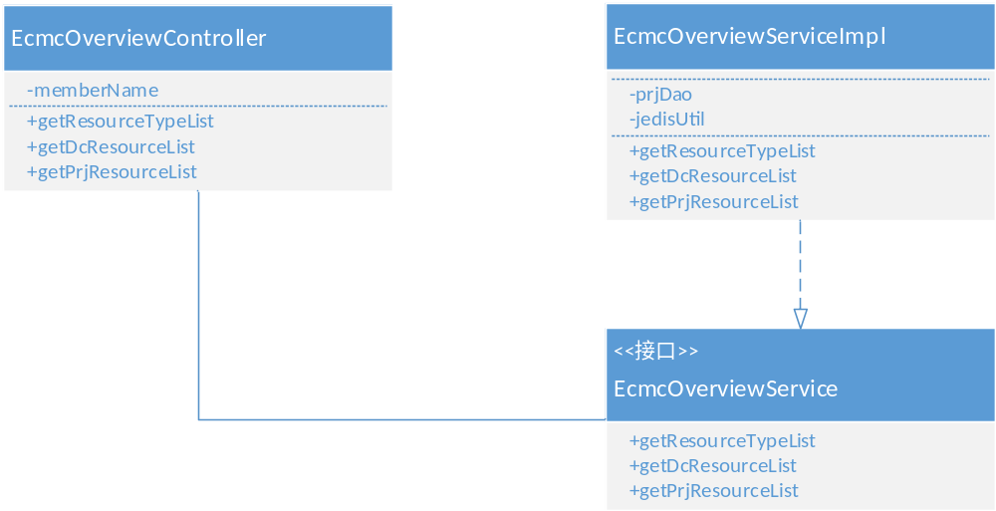

关键逻辑时序图
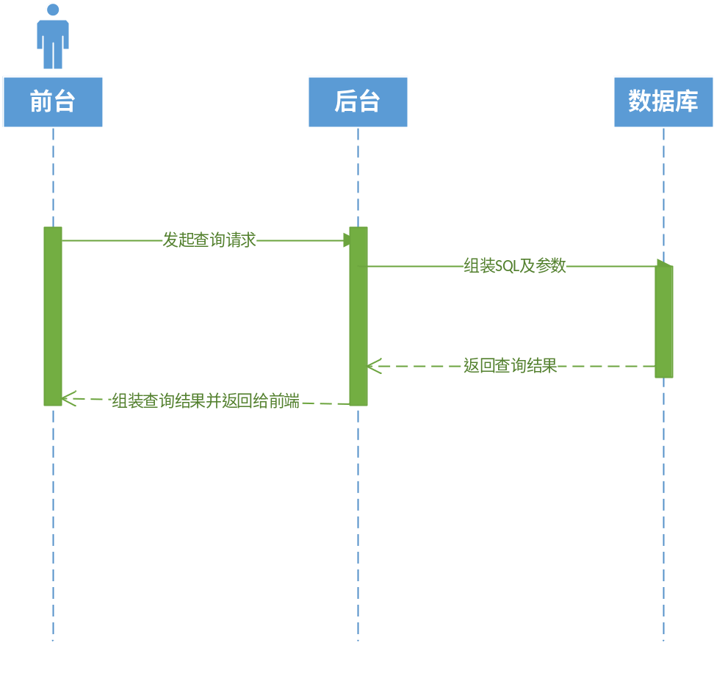

模块类说明
类名 | 说明 | 描述
ZcwhBO | 注师管理类

总览类（EcmcOverviewService）

getDcResourceList
public List<DcDatacenter> getDcResourceList(String resourceType, String sortType)
- 根据所选择的资源类型和排序规则，对所有数据中心的资源进行排序。参考的SQL如下：
SELECT
dcd.id,
dcd.dc_name,
cp.prjCount,
cp.countBand,
cp.hostCount,
cp.volumeCount,
cp.cpuCount,
cp.memory,
cp.diskCapacity,
cp.diskSnapshotCount,
cp.networkCount,
cp.subnetCount,
cp.safeGroupCount,
cp.ipCount,
cp.poolCount,
dcserver.serverCount,
cv.usedHostCount,
cv.usedMemory,
cv.usedCpu,
cvo.usedVolumeCapcity,
cf.usedFirewall,
ci.usedImageCount
FROM
dc_datacenter dcd
LEFT JOIN (
SELECT
count(*) AS prjCount,
sum(p.count_band) AS countBand,
sum(p.cpu_count) AS cpuCount,
sum(p.disk_count) AS volumeCount,
sum(p.host_count) AS hostCount,
sum(p.memory) AS memory,
sum(p.disk_capacity) AS diskCapacity,
sum(p.disk_snapshot) AS diskSnapshotCount,
sum(p.net_work) AS networkCount,
sum(p.subnet_count) AS subnetCount,
sum(p.safe_group) AS safeGroupCount,
sum(p.quota_pool) AS poolCount,
sum(p.outerip) AS ipCount,
p.dc_id
FROM
cloud_project p
GROUP BY
p.dc_id
) cp ON cp.dc_id = dcd.id
LEFT JOIN (
SELECT
count(*) AS serverCount,
datacenter_id AS dc_id
FROM
dc_server
GROUP BY
datacenter_id
) dcserver ON dcserver.dc_id = dcd.id
LEFT JOIN (
SELECT
cv.dc_id,
count(*) AS usedHostCount,
sum(cf.flavor_ram) AS usedMemory,
sum(cf.flavor_vcpus) AS usedCpu
FROM
cloud_vm cv
LEFT JOIN cloud_flavor cf ON cv.flavor_id = cf.flavor_id
AND cv.dc_id = cf.dc_id
WHERE
is_deleted = '0'
GROUP BY
dc_id
) cv ON cv.dc_id = dcd.id
LEFT JOIN (
SELECT
cv.dc_id,
sum(cv.vol_size) AS usedVolumeCapcity
FROM
cloud_volume cv
WHERE
cv.is_deleted = '0'
GROUP BY
cv.dc_id
) cvo ON cvo.dc_id = dcd.id
LEFT JOIN (
SELECT
dc_id,
count(*) AS usedFirewall
FROM
cloud_firewall
GROUP BY
dc_id
) cf ON cf.dc_id = dcd.id
LEFT JOIN (
SELECT
dc_id,
count(*) AS usedImageCount
FROM
cloud_image
where image_ispublic='2'
GROUP BY
dc_id
) ci ON ci.dc_id = dcd.id
order by countBand asc

getPrjResourceList
public List<CloudProject> getPrjResourceList(String prjName,List<String> prjIds, List<String> customerIds)
- 根据项目名称(模糊查询)或多个项目ID或客户ID查询满足条件的的项目配额及使用情况，参考SQL如下：
SELECT
cp.prj_name AS prjName,
cp.host_count AS hostCount,
cp.memory AS memory,
cp.cpu_count AS cpuCount,
cp.disk_count AS volumeCount,
cp.disk_snapshot AS diskSanpshotCount,
cp.disk_capacity AS diskCapacity,
cp.quota_pool AS poolCount,
cp.count_band AS countBand,
cp.net_work AS networkCount,
cp.subnet_count AS subnetCount,
cp.outerip AS ipCount,
cp.safe_group AS safeGroupCount,
cv.usedCpu,
cv.usedHostCount,
cv.usedMemory,
cvo.usedVolumeCount,
cvo.usedVolumeCapcity,
cd.usedSnapshotCount,
cn.usedNetworkCount,
cr.usedBandWidth,
cs.usedSubnetCount,
clp.usedPoolCount,
cse.usedSafeGroupCount,
cf.usedFloatIpCount,
ssc.cus_name
FROM
cloud_project cp
LEFT JOIN sys_selfcustomer ssc ON ssc.cus_id = cp.customer_id
LEFT JOIN (
SELECT
cv.prj_id,
count(*) AS usedHostCount,
sum(cf.flavor_ram) AS usedMemory,
sum(cf.flavor_vcpus) AS usedCpu
FROM
cloud_vm cv
LEFT JOIN cloud_flavor cf ON cv.flavor_id = cf.flavor_id
AND cv.dc_id = cf.dc_id
WHERE
is_deleted = '0'
GROUP BY
prj_id
) cv ON cv.prj_id = cp.prj_id
LEFT JOIN (
SELECT
cv.prj_id,
count(*) AS usedVolumeCount,
sum(cv.vol_size) AS usedVolumeCapcity
FROM
cloud_volume cv
WHERE
cv.is_deleted = '0'
GROUP BY
cv.prj_id
) cvo ON cvo.prj_id = cp.prj_id
LEFT JOIN (
SELECT
count(*) AS usedSnapshotCount,
prj_id
FROM
cloud_disksnapshot
GROUP BY
prj_id
) cd ON cd.prj_id = cp.prj_id
LEFT JOIN (
SELECT
sum(rate) AS usedBandWidth,
prj_id
FROM
cloud_route
GROUP BY
prj_id
) cr ON cr.prj_id = cp.prj_id
LEFT JOIN (
SELECT
count(*) AS usedNetworkCount,
prj_id
FROM
cloud_network
GROUP BY
prj_id
) cn ON cn.prj_id = cp.prj_id
LEFT JOIN (
SELECT
count(*) AS usedSubnetCount,
prj_id
FROM
cloud_subnetwork
GROUP BY
prj_id
) cs ON cs.prj_id = cp.prj_id
LEFT JOIN (
SELECT
count(*) AS usedPoolCount,
prj_id
FROM
cloud_ldpool
GROUP BY
prj_id
) clp ON clp.prj_id = cp.prj_id
LEFT JOIN (
SELECT
count(*) AS usedFloatIpCount,
prj_id
FROM
cloud_floatip
GROUP BY
prj_id
) cf ON cf.prj_id = cp.prj_id
LEFT JOIN (
SELECT
count(*) AS usedSafeGroupCount,
prj_id
FROM
cloud_securitygroup
GROUP BY
prj_id
) cse ON cse.prj_id = cp.prj_id
WHERE
cp.prj_name LIKE '%%'
AND cp.prj_id IN ('', '')
AND cp.customer_id IN ('', '')
order by cp.prj_name desc

