文档编号 | IAAS-DDS 002
文档版本 | 1.0
拟制人 | 杨方军
日期 | 2016.3.21

EayunCloud公有云业务管理平台
（网络）
概要设计说明书

变更说明
日期 | 版本 | 变更位置 | 变更说明 | 作者
2016．3．21 | 1.0 |  | 新建 | 杨方军

目 录
变更说明 2
目 录 3
1. 概述 7
1.1. 功能概述 7
1.2. 定义、缩略语 7
1.3. 参考资料 7
2. 业务分析 7
2.1. 关键业务用例 8
2.1.1. 私有网络用例图 8
2.1.2. 外部网络用例图 8
2.1.3. 弹性公网IP用例图 9
2.1.4. 负载均衡用例图 9
2.1.5. 路由用例图 12
2.2. 关键业务流程 12
2.2.1. 私有网络流程图 12
2.2.2. 私有网络子网流程图 17
2.2.3. 弹性公网IP 20
2.2.4. 负载均衡流程图 27
2.2.5. 路由流程图 52
3. Controller设计 61
3.1. 模块规划 61
3.2. EcmcNetworkController（/ecmc/virtual/network） 62
3.2.1. query（/query） 62
3.2.2. add（/add） 63
3.2.3. checkNetworkName(/checkNetworkName) 63
3.2.4. mod(/mod) 63
3.2.5. checkForDel(/checkForDel) 64
3.2.6. deleteNetwork(/deleteNetwork) 65
3.3. EcmcSubNetworkController（/ecmc/virtual/subnetwork） 65
3.3.1. checkSubNetWorkName（/checkSubNetWorkName） 65
3.3.2. addsub（/addsub） 66
3.3.3. getById（/getById） 67
3.3.4. mod（/mod） 67
3.3.5. deleteSubNetwork（/deleteSubNetwork） 68
3.4. EcmcOutNetworkController(/ecmc/virtual/networkout) 68
3.4.1. query（/query） 68
3.4.2. mod（/mod） 69
3.5. EcmcOutSubNetworkController(/ecmc/virtual/outsubnetwork) 70
3.6. EcmcRouteController(/ecmc/virtual/route) 70
3.6.1. queryRoute（/queryRoute） 70
3.7. EcmcFloatIpController(/ecmc/virtual/floatip) 71
3.7.1. list（/list） 71
3.7.2. allocateIp（/allocateIp） 72
3.7.3. bind（/bind） 72
3.7.4. //TODO 解绑（/） 73
3.7.5. deallocateFloatIp(/deallocateFloatIp) 73
3.8. EcmcPoolController(/ecmc/virtual/loadbalance/pool) 74
3.8.1. create(/create) 74
3.8.2. list(/list) 75
3.8.3. update(/update) 76
3.8.4. delete(/delete) 77
3.9. EcmcMemberController(/ecmc/virtual/loadbalance/member) 78
3.9.1. list(/list) 78
3.9.2. create(/create) 79
3.9.3. update(/update) 80
3.9.4. delete(/delete) 81
3.10. EcmcHealthMonitorController(/ecmc/virtual/loadbalance/healthmonitor) 81
3.10.1. listMonitor(/listMonitor) 81
3.10.2. createMonitor(/createMonitor) 82
3.10.3. updateMonitor(/updateMonitor) 83
3.10.4. delete(/delete) 85
3.11. EcmcVipController(/ecmc/virtual/loadbalance/vip) 85
3.11.1. listVip(/listVip) 85
3.11.2. create(/create) 86
3.11.3. updateVip(/updateVip) 87
3.11.4. deleteVip(/deleteVip) 88
4. Model设计 88
4.1. Model类规划 88
4.1.1. 私有网络、外部网络 89
4.1.2. 弹性公网IP 89
4.1.3. 负载均衡 89
4.1.4. 路由 90
5. Service设计 90
5.1. 类设计 91
5.1.1. 模块类图 91
5.1.2. 关键逻辑时序图 95
5.1.3. 模块类说明 95
5.2. 私有网络类（EcmcNetworkService） 96
5.2.1. getNetworkList 96
5.2.2. findNetworkById 96
5.2.3. addNetwork 96
5.2.4. updateNetwork 97
5.2.5. deleteNetworkById 97
5.2.6. findNetworkCountByPrjId 97
5.2.7. checkNetWorkName 97
5.3. 私有网络子网类(EcmcSubNetworkService) 97
5.3.1. addSubNetwork 98
5.3.2. updateSubNetwork 98
5.3.3. daleteSubNetwork 98
5.3.4. findSubNetworkById 98
5.3.5. getSubNetworkListByPrjId 98
5.3.6. getSubNetworkListByRouteId 99
5.3.7. checkSubNetworkName 99
5.4. 弹性公网IP类(EcmcFloatIpService) 99
5.4.1. getListByPrjId 99
5.4.2. allocateIp 99
5.4.3. deallocateFloatIp 100
5.4.4. getFloatIpList 100
5.4.5. bindToVm 100
5.4.6. unbindFromVm 100
5.5. 资源池类(EcmcPoolService) 100
5.5.1. getPoolList 101
5.5.2. findPoolById 101
5.5.3. bindToHealthMonitor 101
5.5.4. addPool 101
5.5.5. deletePool 101
5.5.6. updatePool 101
5.6. 成员类(EcmcMemberService) 102
5.6.1. findMember 102
5.6.2. addMember 102
5.6.3. updateMember 103
5.6.4. deleteMember 103
5.7. Vip类(EcmcVipService) 104
5.7.1. checkVipName 104
5.7.2. findVip 104
5.7.3. addVip 104
5.7.4. updateVip 106
5.7.5. deleteVip 106
5.8. 路由类(EcmcRouteService) 107
5.8.1. checkRouteName 107
5.8.2. findRoute 107
5.8.3. addRoute 108
5.8.4. updateRoute 108
5.8.5. setGateway 109
5.8.6. removeGateWay 110
5.8.7. bind 110
5.8.8. debind 111

概述

功能概述

定义、缩略语

参考资料
1.《公有云管理控制台V1.0.0原型2015.08.21》

业务分析

关键业务用例

私有网络用例图
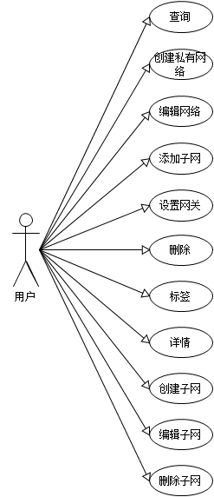

外部网络用例图
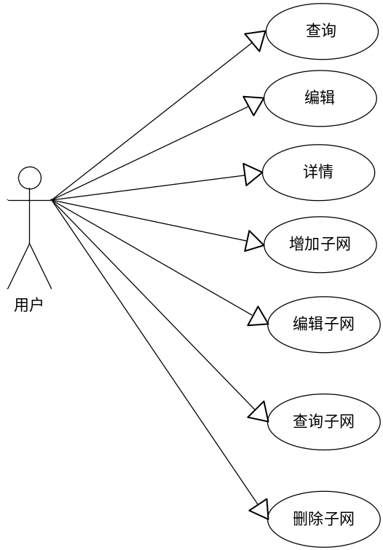

弹性公网IP用例图
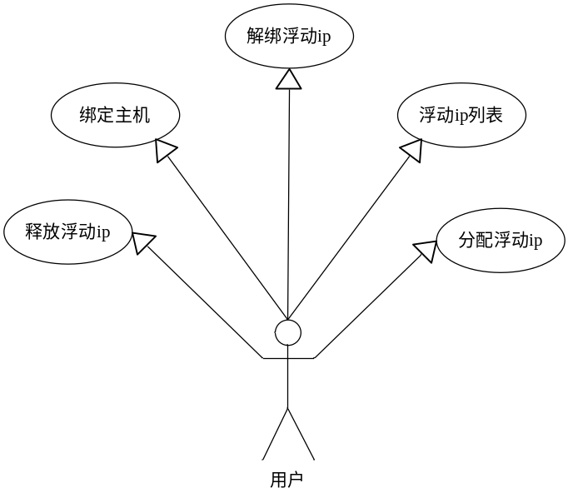

负载均衡用例图

资源池
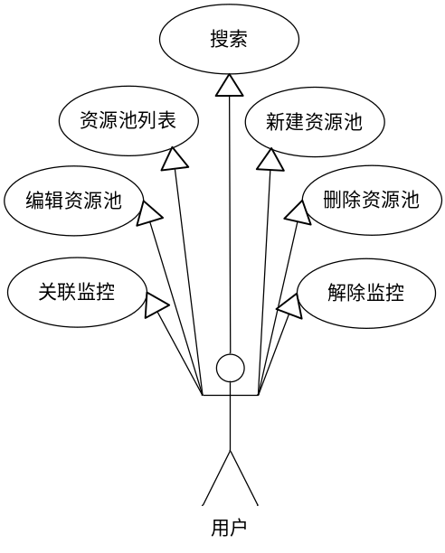

监控
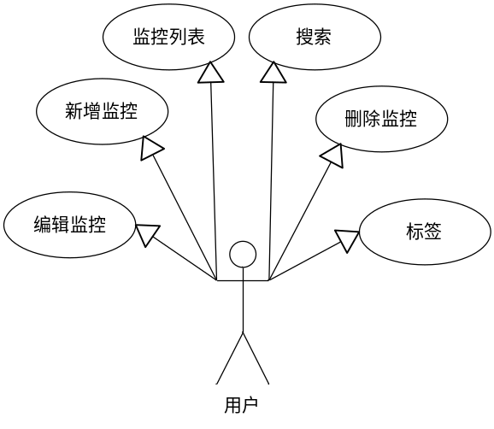

成员
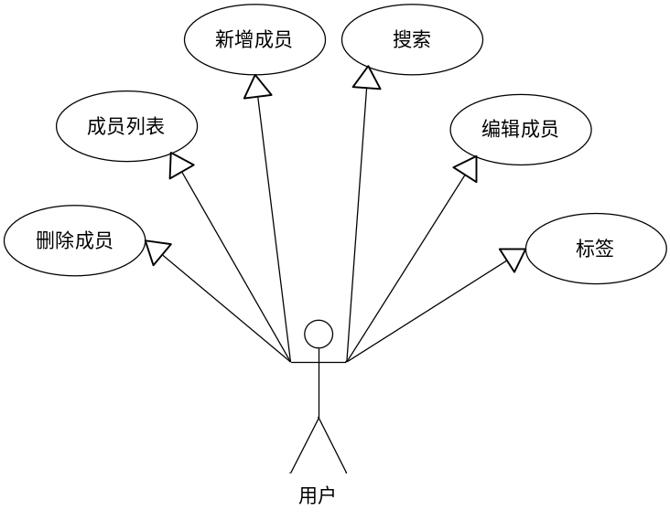

Vip
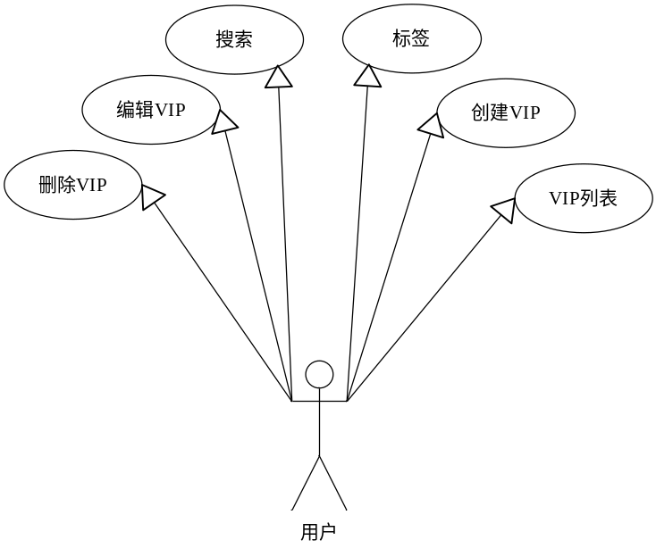

监听
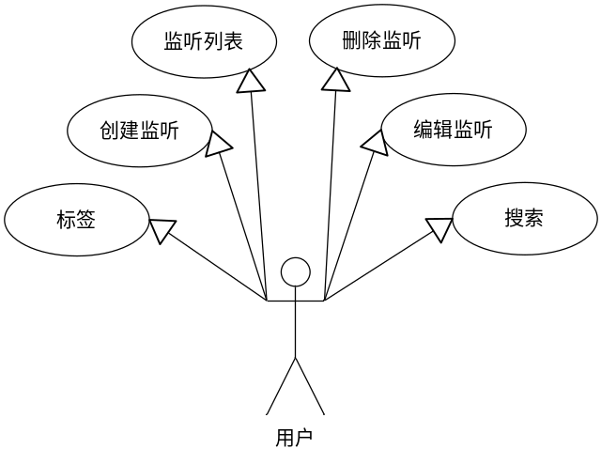

路由用例图
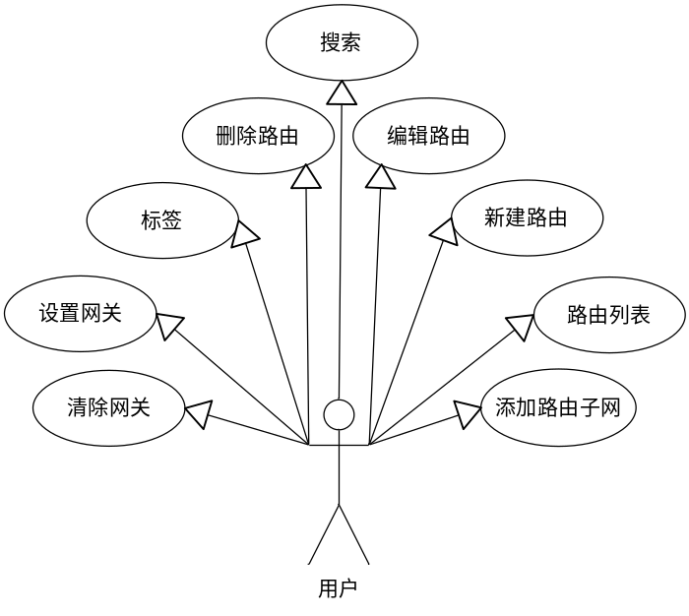

关键业务流程

私有网络流程图

网络列表
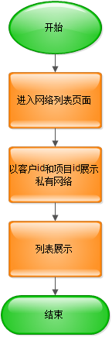

创建网络
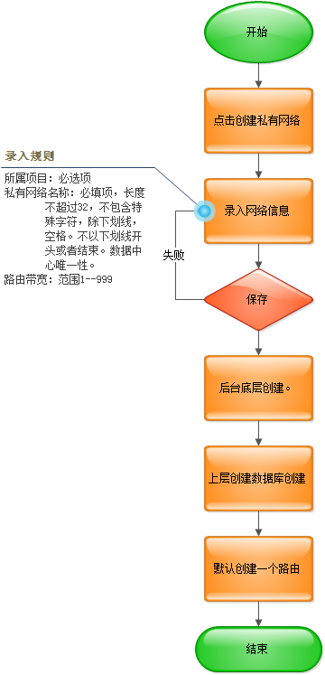

编辑网络
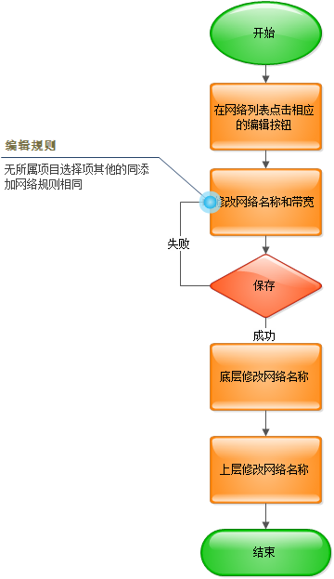

删除网络
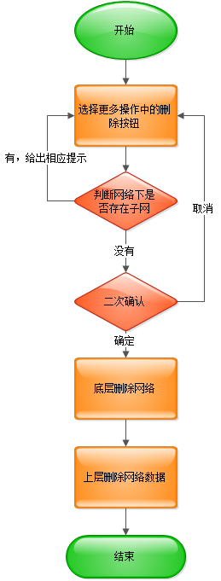

标签
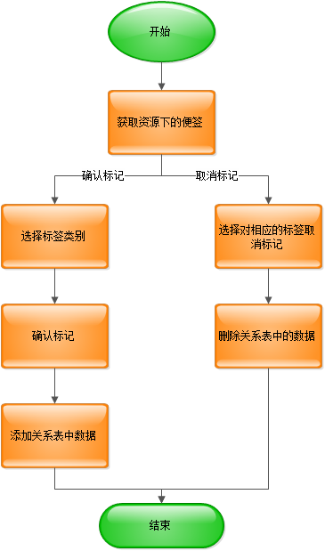

网络详情
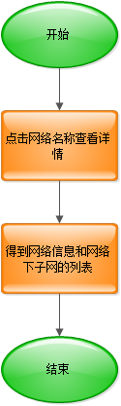

私有网络子网流程图

新建子网
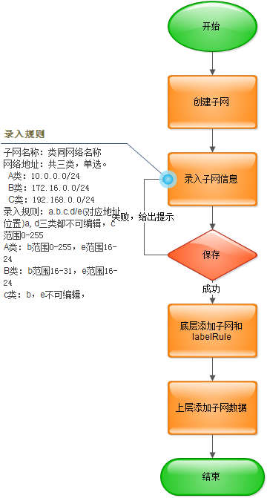

编辑子网
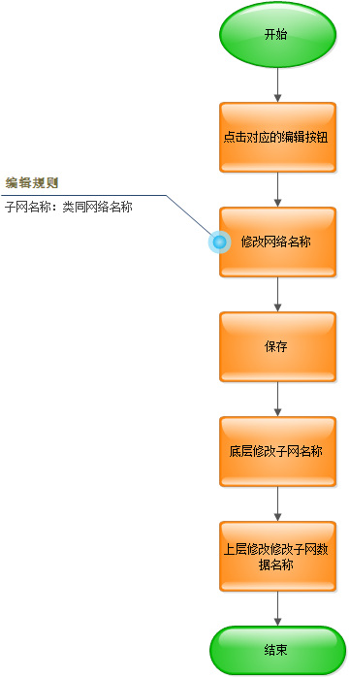

删除子网
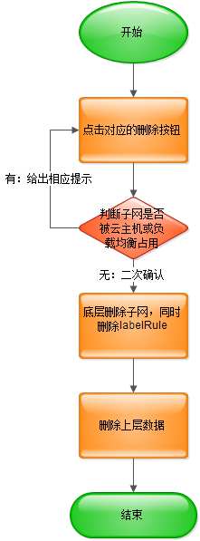

弹性公网IP

弹性公网ip列表
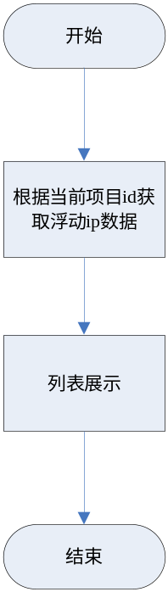

分配弹性公网ip
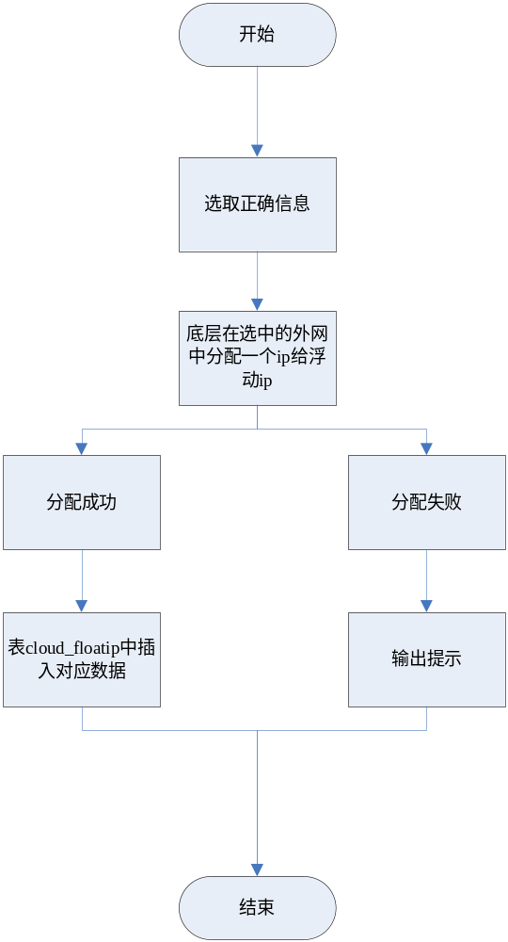

释放弹性公网ip
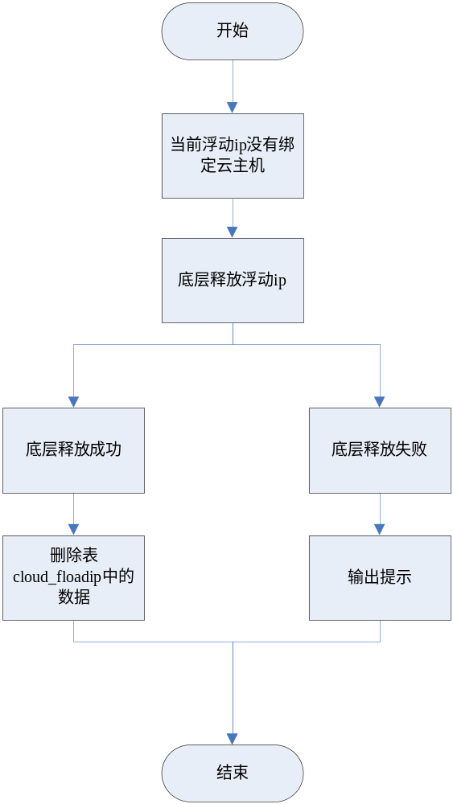

绑定弹性公网ip
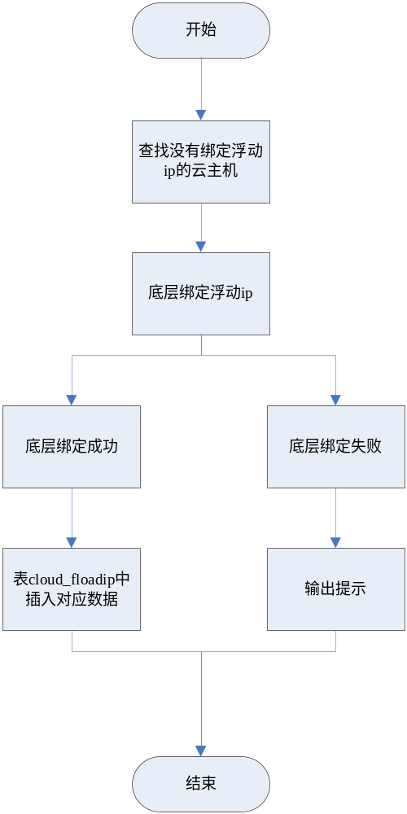

解绑弹性公网ip
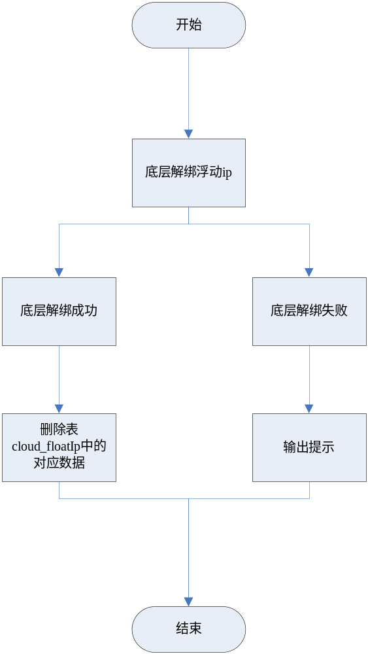

标签
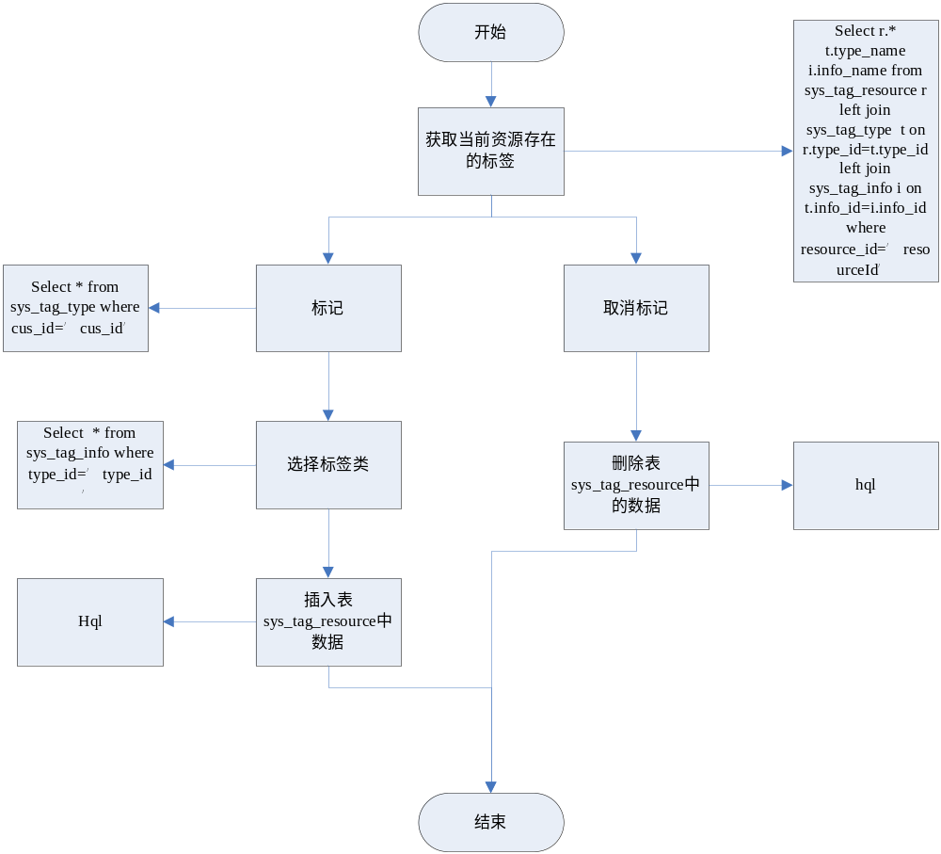

负载均衡流程图

资源池流程图

资源池列表
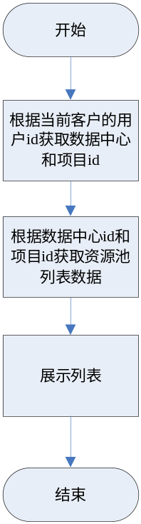

创建资源池
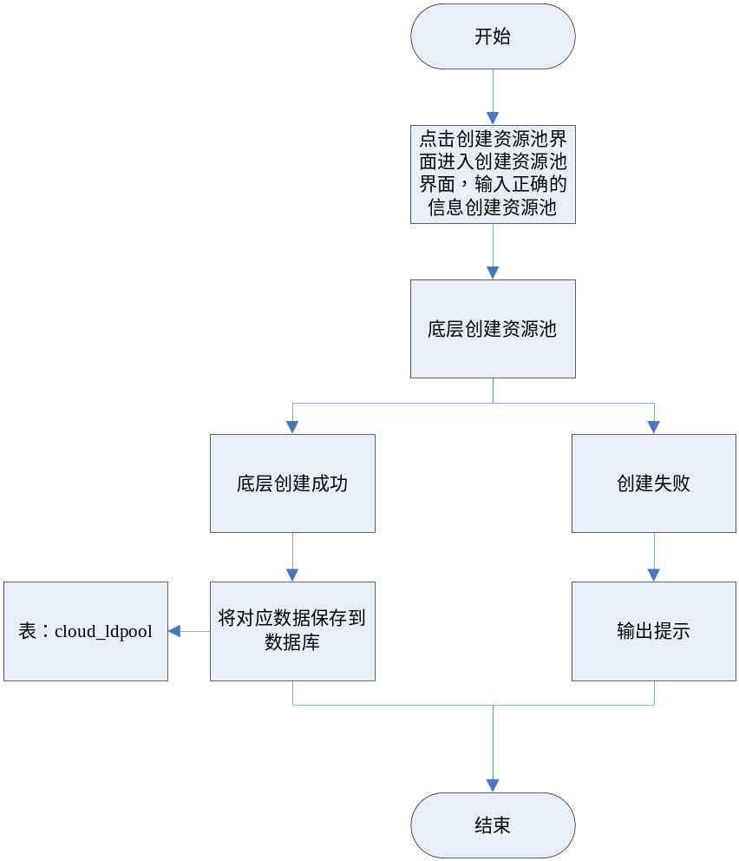

编辑资源池
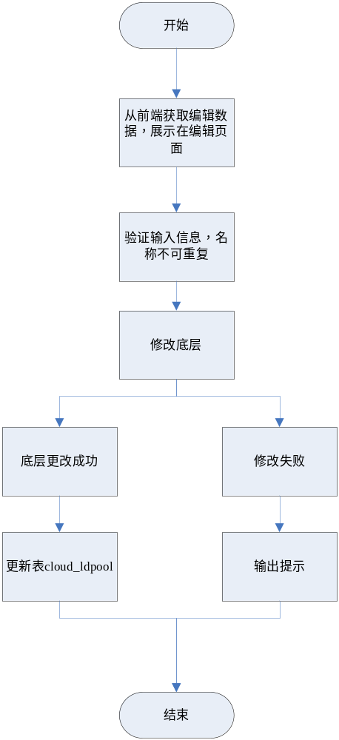

删除资源池
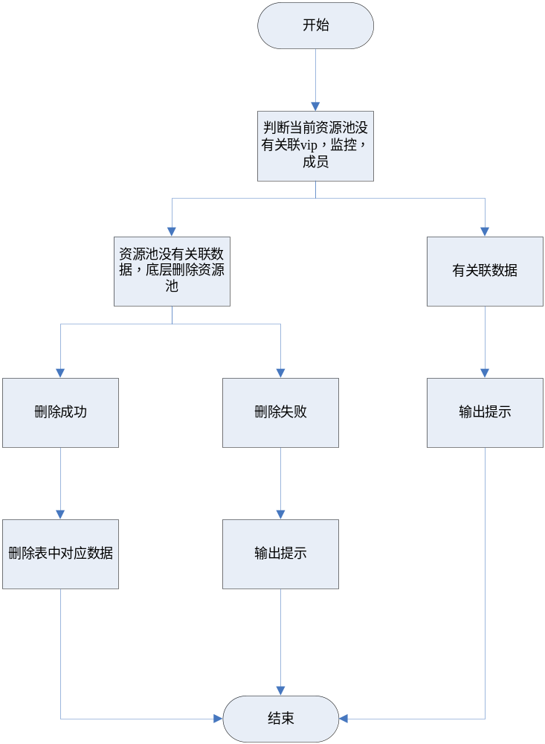

搜索资源池
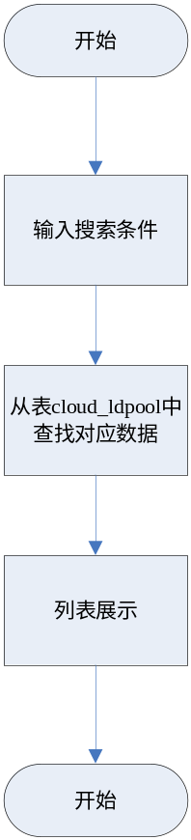

标签

资源池详情
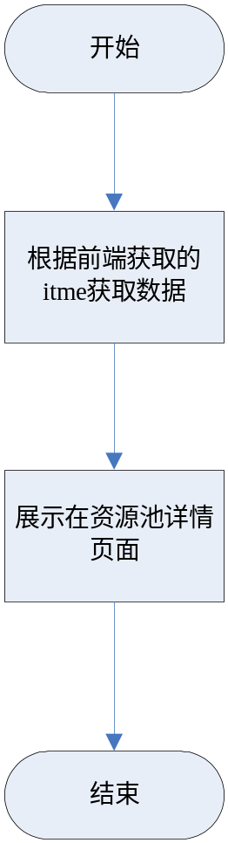

绑定监控
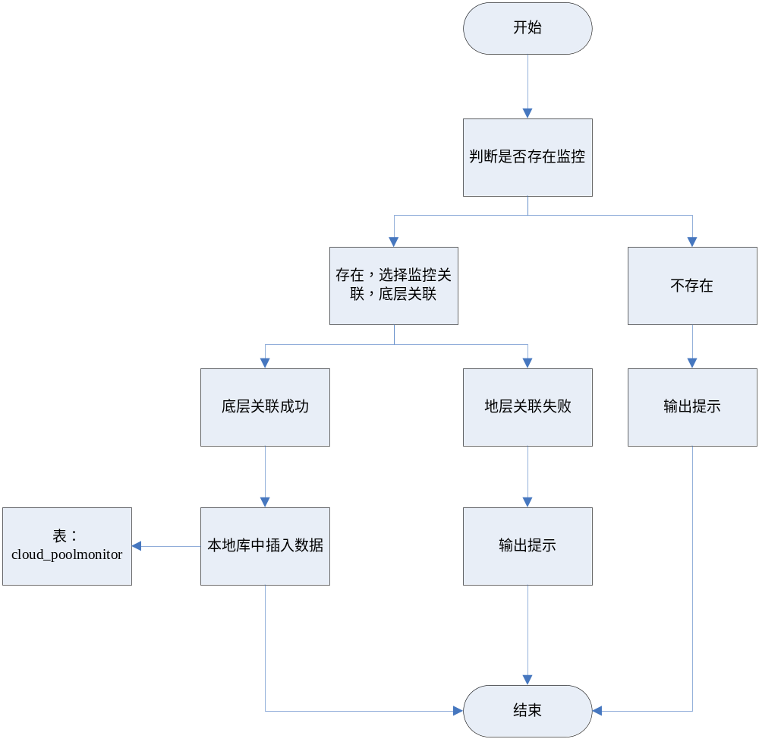

解除监控
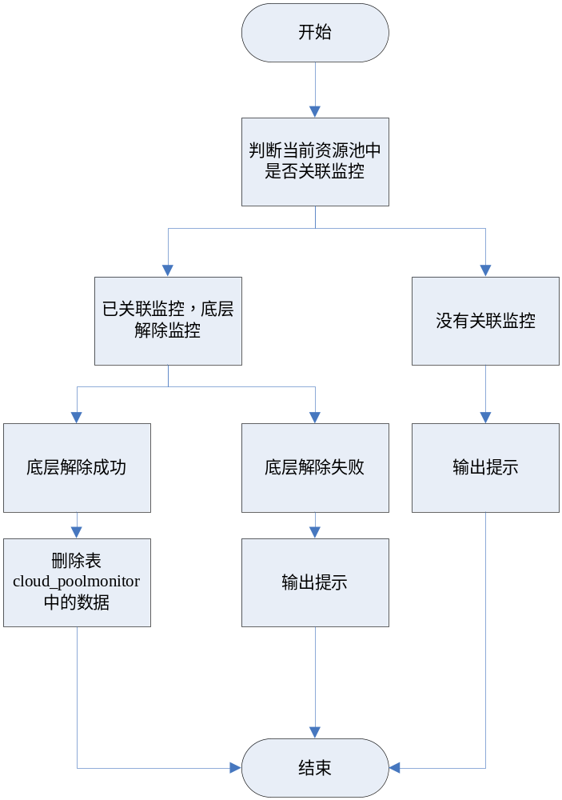

成员流程图

成员列表
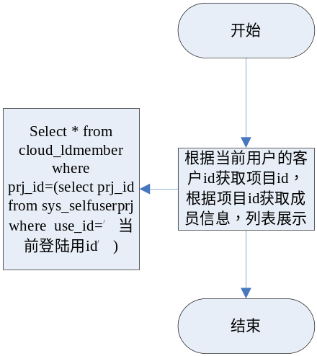

新建成员
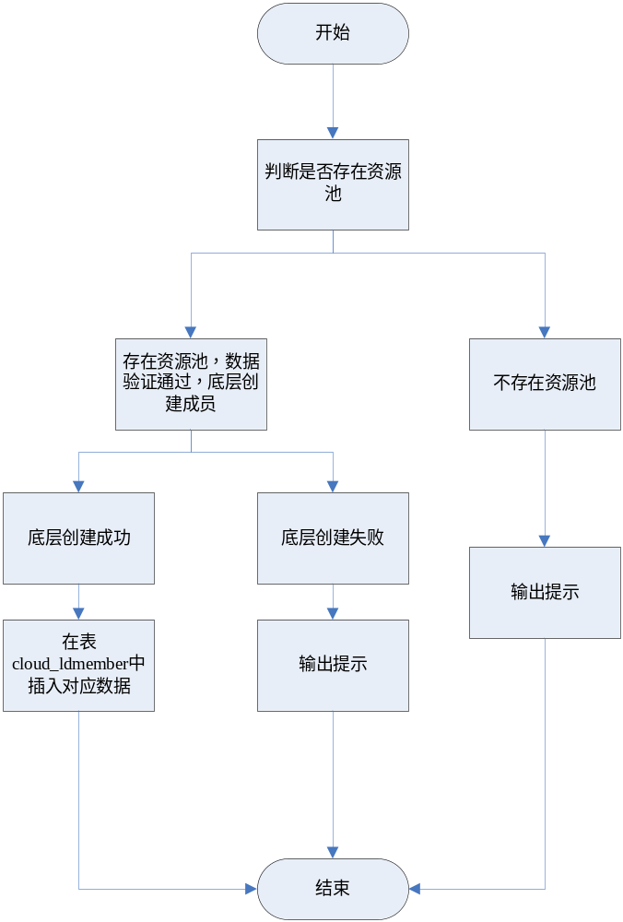

编辑成员
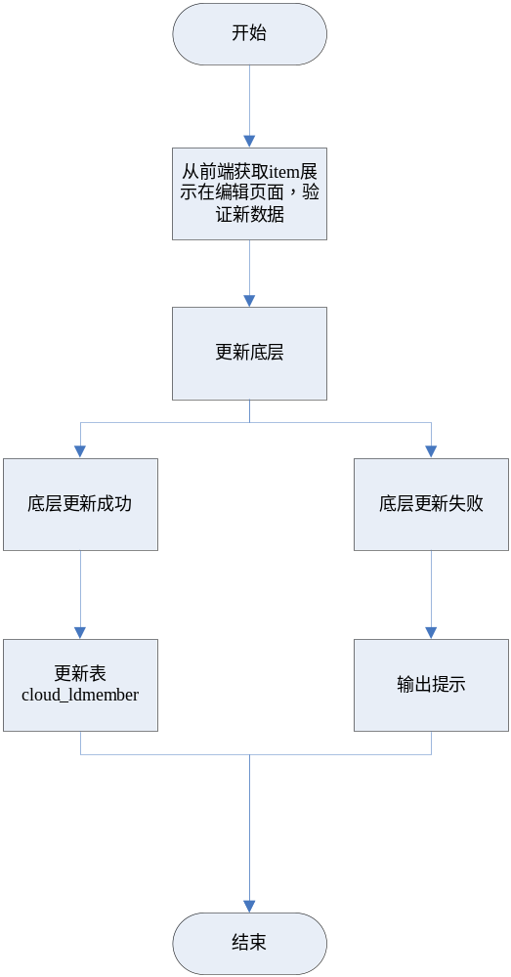

删除成员
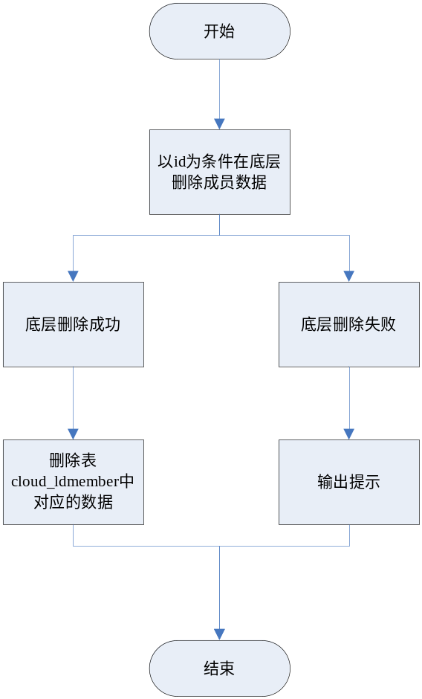

搜索成员
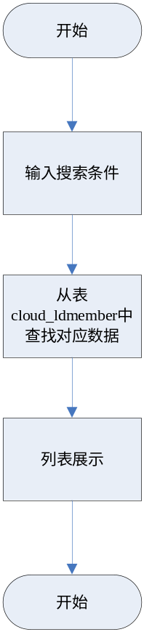

监控流程图

监控列表
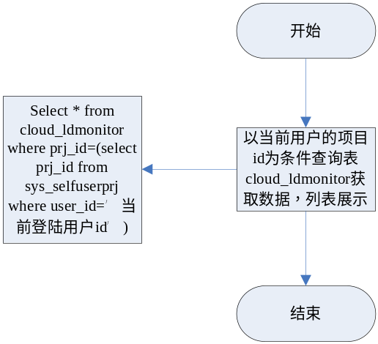

新建监控
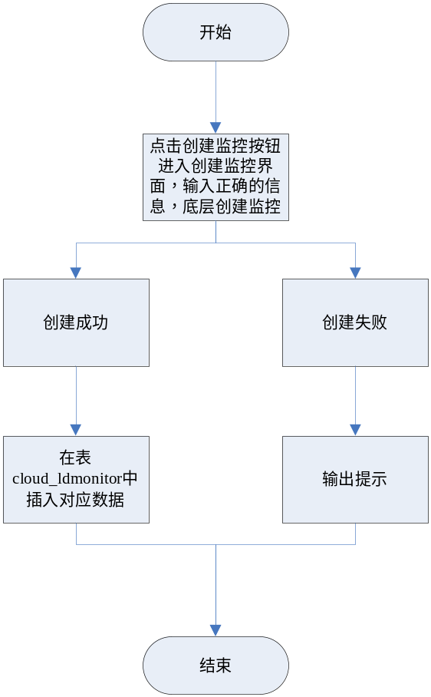

编辑监控
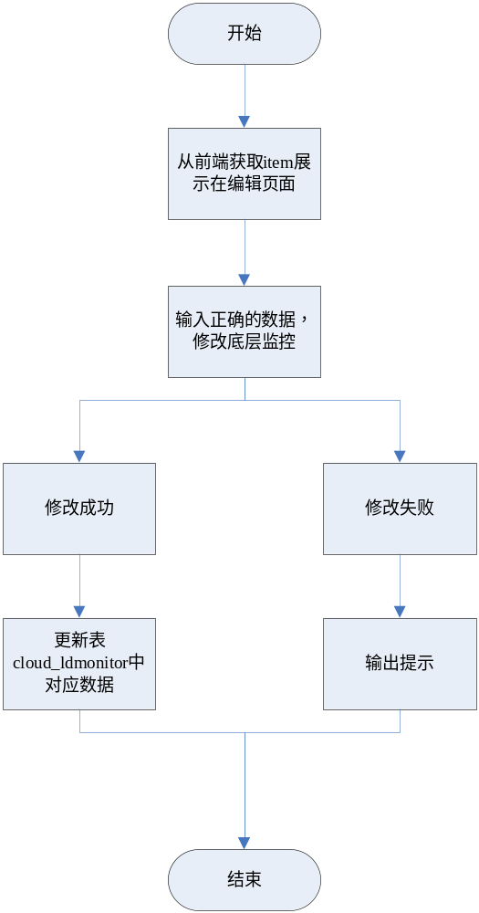

删除监控
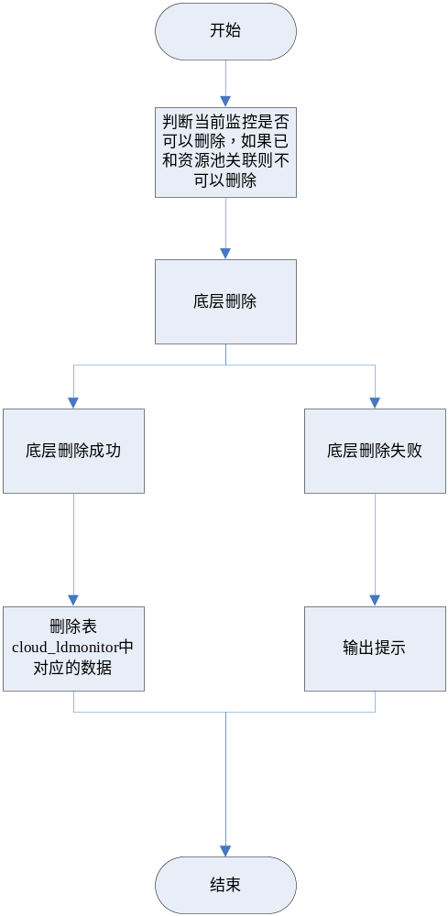

搜索监控
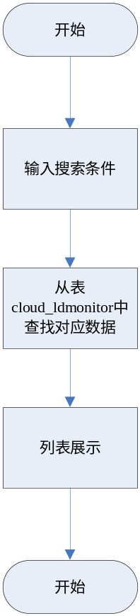

Vip流程图

Vip列表
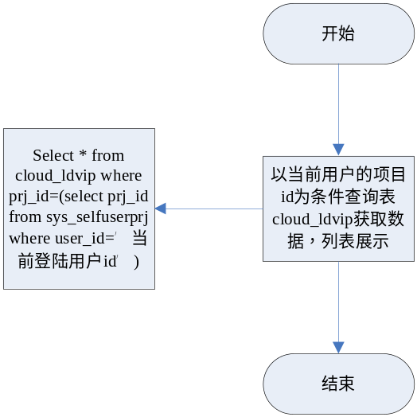

新建Vip
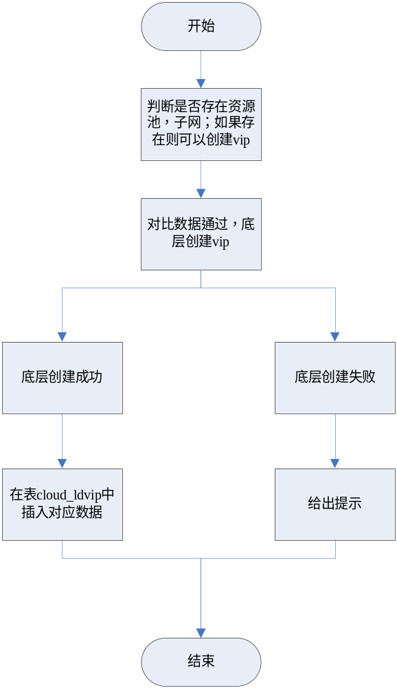

编辑Vip
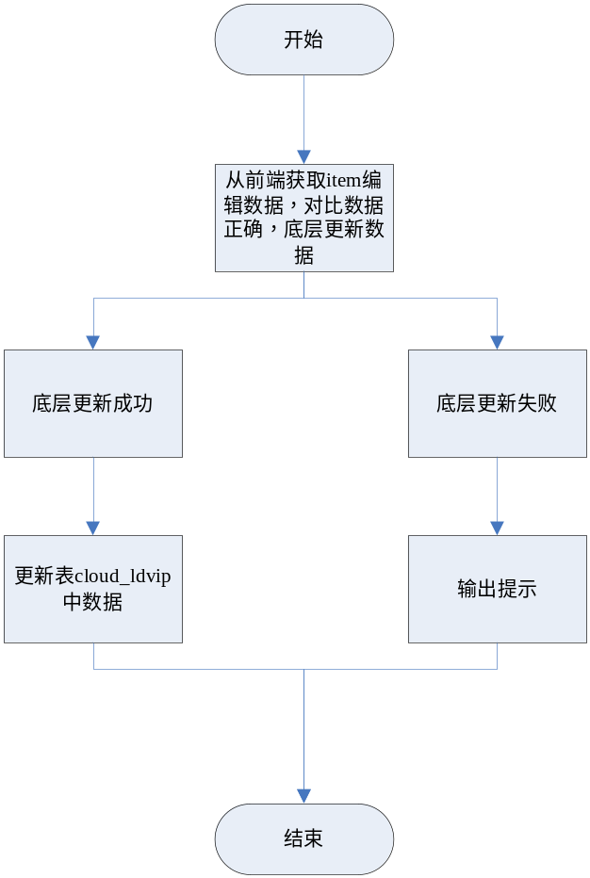

删除Vip
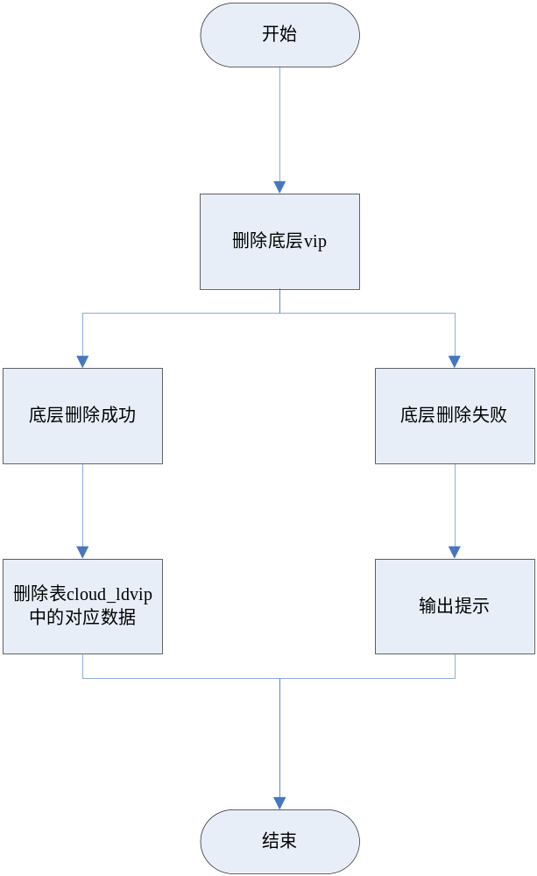

搜索Vip
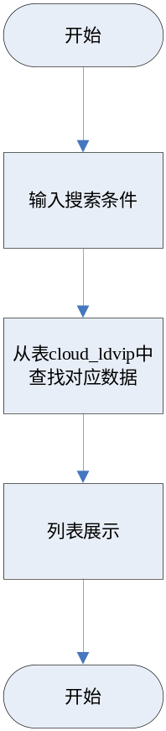

监听流程图

监听列表
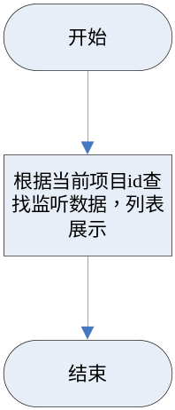

新建监听
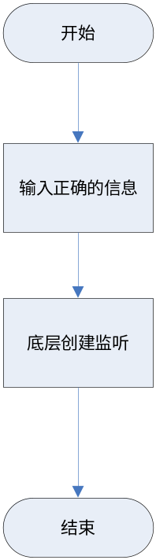

编辑监听
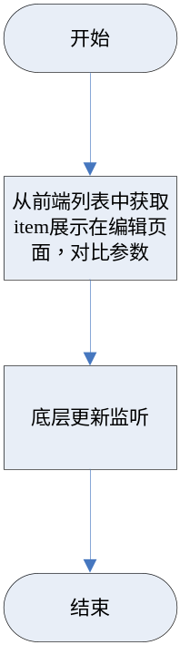

删除监听
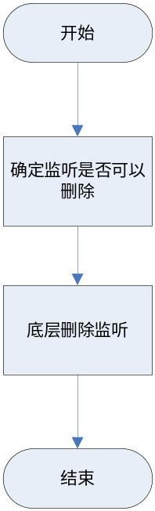

搜索监听
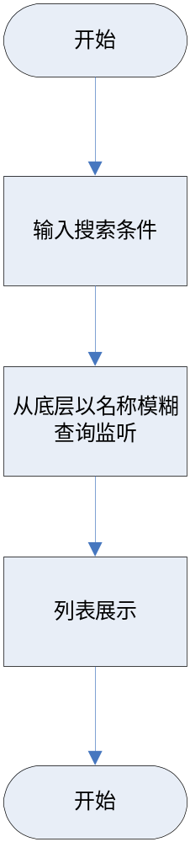

路由流程图

路由列表
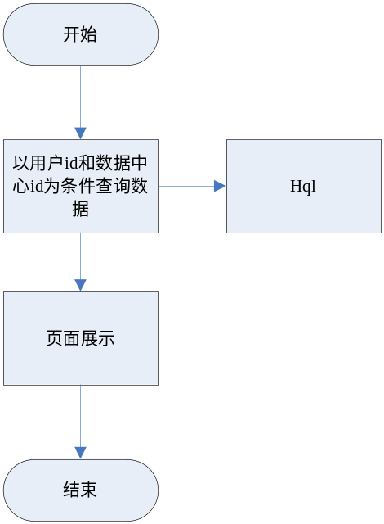

创建路由
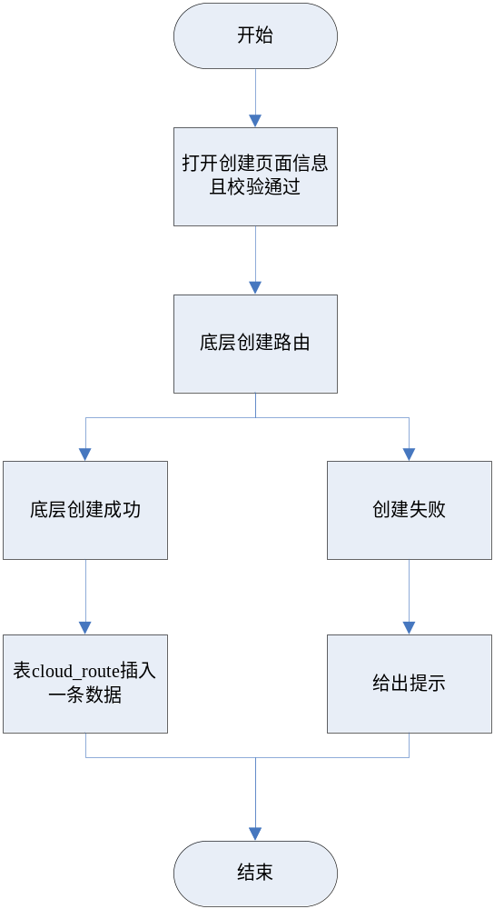

编辑路由
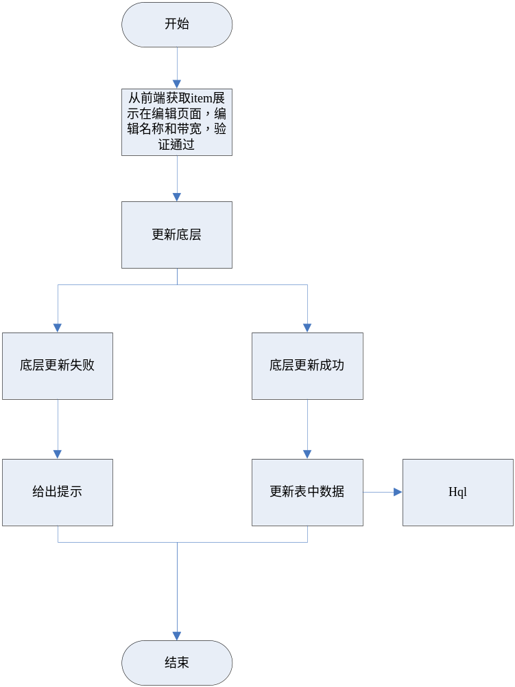

删除路由
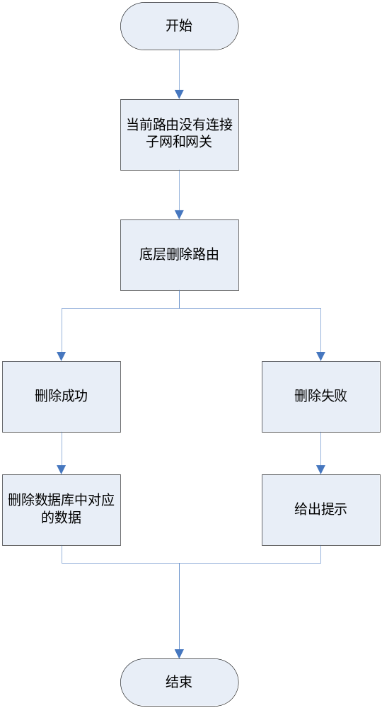

搜索路由
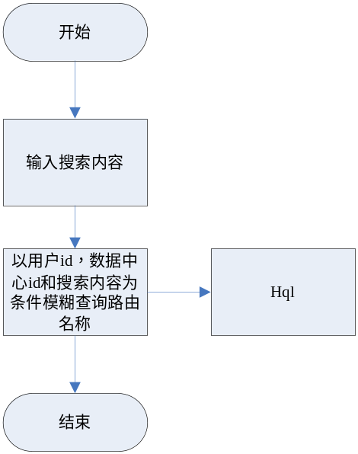

设置网关
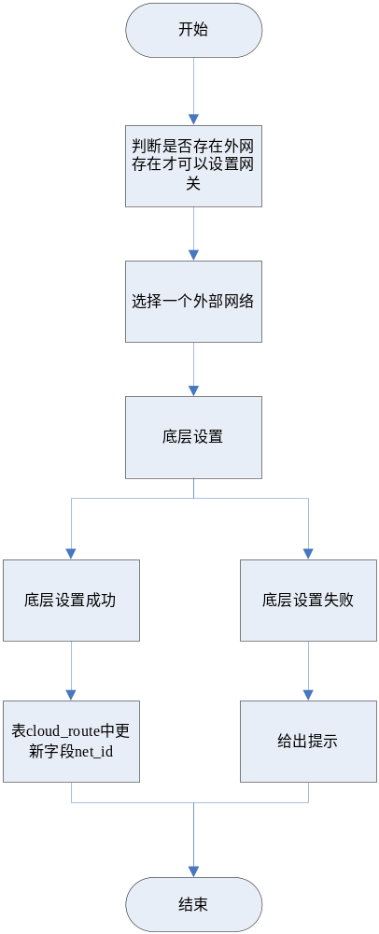

清除网关
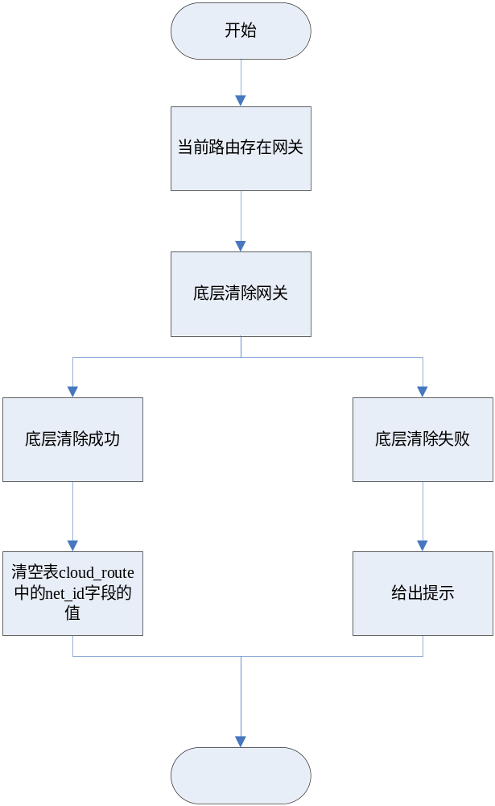

标签

路由详情
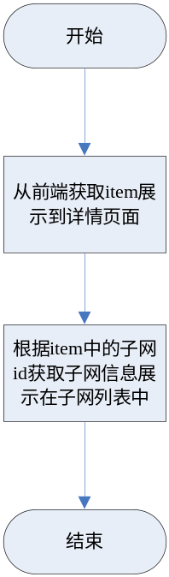

Controller设计

模块规划
菜单资源 | Controller类名 | 备注
私有网络 | virtualization/ecmccontroller/EcmcNetworkController
私有网络子网 | virtualization/ecmccontroller/EcmcSubNetworkController
外部网络 | virtualization/ecmccontroller/EcmcOutNetworkController
外部网络子网 | virtualization/ecmccontroller/EcmcOutSubNetworkController
路由 | virtualization/ecmccontroller/EcmcRouteController
弹性公网IP | virtualization/ecmccontroller/EcmcFloatIpController
资源池 | virtualization/ecmccontroller/EcmcPoolController
成员 | virtualization/ecmccontroller/EcmcMemberController
监控 | virtualization/ecmccontroller/EcmcHealthMonitorController
vip | virtualization/ecmccontroller/EcmcVipController

EcmcNetworkController（/ecmc/virtual/network）

queryNetwork（/querynetwork）
说明 | 查询网络
URL | /ecmc/virtual/network/querynetwork.do
方式 | POST
Post数据 | {  "pageNumber": "1",  "pageSize": "20",  "params": {  "cusName": "",  "prjName": "123_16",  "dcId": "1509101341180",  "netName": "545"  }  }
返回Json | {  "pageSize": 10,  "totalCount": 78,  "result": [  {  "netId": "aef71fb3-a195-4a01-8ec0-dfb4d93cbd63",  "netName": "net",  "createName": null,  "createTime": null,  "prjId": "e5b2d9f3d0c342b68a8b8af81113f4dc",  "dcId": "1509211142230",  "netStatus": "ACTIVE",  "adminStateup": "1",  "isShared": null,  "routerExternal": null,  "netStatusName": "正常",  "adminStaName": "UP",  "subNetCount": 1,  "prjName": null,  "dcName": null,  "extNetName": null,  "prjQuotaSubNet": 0,  "rate": 5,  "routeId": "42546fbc-c484-4b0c-b70a-d0dce9bddc90",  "routeName": "net20160413105244",  "cusId": "4028b881540d697301540d6ae6680000",  "cusName": "张帆"  },  ...  ],  "currentPageNo": 1,  "totalPageCount": 8  }

addNetwork（/addnetwork）
说明 | 创建网络
URL | /ecmc/virtual/network/addnetwork.do
方式 | POST
Post数据 | {  "ipversion": "IPv4",  "datacenter": 16022514134540,  "project": "1496a93fd6214b389762184f1df74229",  "name": "测试123"  }
返回Json | 成功：  {"code":"000000"}  失败：  {"code":"010120"}

checkNetworkName(/checknetworkname)
说明 | 验证网络名称
URL | /ecmc/virtual/network/checknetworkname.do
方式 | POST
Post数据 | {  "dcId": "16022514134540",  "netName": "%E6%B5%8B%E8%AF%951234",  "id": "a5287e58-172d-4b31-93d4-1217b9a1ac69"  }
返回Json | 成功：  {"code":"000000",  "exists":true}  失败：  {"code":"010120"}

modNetwork(/modnetwork)
说明 | 修改网络
URL | /ecmc/virtual/network/modnetwork.do
方式 | POST
Post数据 | {  "adminStateup": "true",  "dcId": "16022514134540",  "dcName": "研发32",  "isAdminStateup": "是",  "isDeleting": "not",  "netId": "a5287e58-172d-4b31-93d4-1217b9a1ac69",  "netName": "测试123",  "netStatus": "ACTIVE",  "prjId": "1496a93fd6214b389762184f1df74229",  "prjName": "123_17",  "subnetnum": "0",  "$$hashKey": "03U",  "datacenter": "研发32",  "netNamex": "测试1234"  }
返回Json | 成功：  {"code":"000000"}  失败：  {"code":"010120"}

checkForDel(/checkfordel)
说明 | 验证网络是否可删除
URL | /ecmc/virtual/network/checkfordel.do
方式 | POST
Post数据 | {  "networkId": "a5287e58-172d-4b31-93d4-1217b9a1ac69"  }
返回Json | 成功：  {"code":"000000",  "status":true}  失败：  {"code":"010120"}

deleteNetwork(/deleteNetwork)
说明 | 删除网络
URL | /ecmc/virtual/network/deleteNetwork.do
方式 | POST
Post数据 | {  "netId": "a5287e58-172d-4b31-93d4-1217b9a1ac69",  "dcId": "16022514134540"  }
返回Json | 成功：  {  "code": "000000",  "deleteCount": 0,  "deleteTotal": 1  }  失败：  {"code":"010120"}

EcmcSubNetworkController（/ecmc/virtual/subnetwork）

checkSubNetWorkName（/checksubnetworkname）
说明 | 验证子网名称是否重复
URL | /ecmc/virtual/subnetwork/checksubnetworkname.do
方式 | POST
Post数据 | {  "dcId": "16022514134540",  "prjId": "项目ID",  "subnetName": "子网123",  "subnetId": "子网123"//子网ID，非必传字段  }
返回Json | 成功：  {"code":"000000",  "exists":true}  失败：  {"code":"010120"}

checkSubNetIPByNet（/checksubnetipbynet）
说明 | 验证子网名称是否重复
URL | /ecmc/virtual/subnetwork/checksubnetipbynet.do
方式 | POST
Post数据 | {  "subnetIP": "192.168.1.0/24",  "netId": "f4bd7776-2c72-452d-9753-ee50f2e49d72"  }
返回Json | 成功：  true  失败：  {"code":"010120"}

addSubNetwork（/addSubNetwork）
说明 | 添加子网
URL | /ecmc/virtual/subnetwork/addSubNetwork.do
方式 | POST
Post数据 | {  "netId": "f4bd7776-2c72-452d-9753-ee50f2e49d72",  "dcId": "16022514134540",  "prjId": "1496a93fd6214b389762184f1df74229",  "ipVersion": "IPv4",  "datacenter": "研发32",  "subnetName": "subnet123",  "cidr": "192.168.1.0/24"  }
返回Json | 成功：  {  "code": "000000",  "resultData": {  "allocation_pools": [  {  "end": "192.168.1.254",  "start": "192.168.1.2"  }  ],  "cidr": "192.168.1.0/24",  "dns_nameservers": [  "114.114.114.114"  ],  "enable_dhcp": true,  "gateway_ip": "192.168.1.1",  "host_routes": [],  "id": "0eb4c7a2-8f89-4399-9be2-a5fa017918f4",  "ip_version": "4",  "name": "子网123",  "network_id": "84824adf-503a-4b7e-96cb-7afe5eadf81f",  "tenant_id": "1496a93fd6214b389762184f1df74229"  }  }  失败：  {"code":"010120"}

getSubNetworkById（/getsubnetworkbyid）
说明 | 查询单个子网
URL | /ecmc/virtual/subnetwork/getsubnetworkbyid.do
方式 | POST
Post数据 | {  "netid": "0eb4c7a2-8f89-4399-9be2-a5fa017918f4"  }
返回Json | 成功：  {  "cidr": "192.168.1.0/24",  "gatewayIp": "192.168.1.1",  "ipVersion": "4",  "isForbiddengw": "0",  "netName": "测试123",  "subnetId": "0eb4c7a2-8f89-4399-9be2-a5fa017918f4",  "subnetName": "子网123"  }  失败：  {"code":"010120"}

updateSubNetWork（/updatesubnetwork）
说明 | 修改子网
URL | /ecmc/virtual/subnetwork/updatesubnetwork.do
方式 | POST
Post数据 | {  "cidr": "192.168.1.0/24",  "gatewayIp": "192.168.1.1",  "ipVersion": "4",  "isForbiddengw": "0",  "netName": "测试123",  "subnetId": "0eb4c7a2-8f89-4399-9be2-a5fa017918f4",  "subnetName": "子网123",  "ipversion": "IPv4",  "subnetNamex": "子网1234",  "isforbidgateway": "false"  }
返回Json | 成功：  {"code":"000000"}  失败：  {"code":"010120"}

deleteSubNetwork（/deletesubnetwork）
说明 | 删除子网
URL | /ecmc/virtual/subnetwork/deletesubnetwork.do
方式 | POST
Post数据 | {  "id": "0eb4c7a2-8f89-4399-9be2-a5fa017918f4",  "datacenterId": "16022514134540"  }
返回Json | 成功：  {  "code": "100000",  "deleteCount": 0,  "deleteTotal": 1  }  失败：  {"code":"010120"}

getSubNetListByNetId（/getsubnetlistbynetid）
说明 | 获取指定网络下的子网
URL | /ecmc/virtual/subnetwork/getsubnetlistbynetid.do
方式 | POST
Post数据 | {"netId":"c627dc24-10ff-4153-965b-37fff0baab3f"}
返回Json | [  {  "subnetId": "003a4f51-c286-4e26-b8be-6a8c70d7b31f",  "subnetName": "北京易云捷迅有限公司北京易云捷迅有限公司",  "createName": null,  "createTime": null,  "prjId": "5724393f294a4e368966647bc1686016",  "dcId": "1511251732240",  "netId": "c627dc24-10ff-4153-965b-37fff0baab3f",  "routeId": "b6658c32-23a8-4bd8-998b-372444de485b",  "ipVersion": "4",  "cidr": "10.0.0.0/16",  "gatewayIp": "10.0.0.1",  "isShared": null,  "pooldata": "10.0.0.2,10.0.255.254",  "isForbiddengw": "0",  "inLabelRuleId": null,  "outLabelRuleId": null,  "prjName": null,  "netName": null,  "tagName": "{\"allTagsString\":\"\",\"twoTagsString\":\"\",\"gt2Tags\":false}",  "routeName": null  },  {  "subnetId": "5c15f42b-a6b5-44d8-baa4-249b96b76b2a",  "subnetName": "test_lihua",  "createName": null,  "createTime": null,  "prjId": "5724393f294a4e368966647bc1686016",  "dcId": "1511251732240",  "netId": "c627dc24-10ff-4153-965b-37fff0baab3f",  "routeId": "b6658c32-23a8-4bd8-998b-372444de485b",  "ipVersion": "4",  "cidr": "172.16.0.0/16",  "gatewayIp": "172.16.0.1",  "isShared": null,  "pooldata": "172.16.0.2,172.16.255.254",  "isForbiddengw": "0",  "inLabelRuleId": null,  "outLabelRuleId": null,  "prjName": null,  "netName": null,  "tagName": "{\"allTagsString\":\"\",\"twoTagsString\":\"\",\"gt2Tags\":false}",  "routeName": null  }  ]

EcmcOutNetworkController(/ecmc/virtual/networkout)

queryOutNetwork（/queryOutNetwork）
说明 | 外部网络列表
URL | /ecmc/virtual/networkout/queryOutNetwork.do
方式 | POST
Post数据 | {  "datacenterId": "16022514134540"  }
返回Json | {  "items": [  {  "adminStateup": "是",  "dcName": "研发32",  "isShared": "0",  "netId": "4052addb-4a89-466b-97bb-92c3832b68c2",  "netName": "net04_ext",  "netStatus": "ACTIVE",  "subnetnum": "1"  }  ],  "pageNo": 1,  "pageNum": 1,  "pageSize": 10,  "queryParams": "{\"datacenterId\":\"16022514134540\"}",  "queryTimestamp": 1458715190513,  "queryUrl": "/bg/cloud/openstack/networkout/query.do",  "totalNum": 1  }

modOutNetwork（/modOutNetwork）
说明 | 修改外部网络
URL | /ecmc/virtual/networkout/modOutNetwork.do
方式 | POST
Post数据 | {  "adminStateup": "是",  "dcName": "研发32",  "isShared": "0",  "netId": "4052addb-4a89-466b-97bb-92c3832b68c2",  "netName": "net04_ext1",  "netStatus": "ACTIVE",  "subnetnum": "1",  "$$hashKey": "04V",  "ipversion": "IPv4",  "netNamex": "net04_ext",  "datacenter": "研发32",  "adminStateupx": "true"  }
返回Json | {"code":"200000"}

selectOutNet（/selectoutnet）
说明 | 外部网络列表
URL | /ecmc/virtual/networkout/selectoutnet.do
方式 | POST
Post数据 | {  "datacenterId": "16022514134540"  }
返回Json | [  {  "text": "net04_ext",  "value": "4052addb-4a89-466b-97bb-92c3832b68c2"  }  ]

getOutNetworkDetail（/getoutnetworkdetail）
说明 | 外网详情
URL | /ecmc/virtual/networkout/getoutnetworkdetail.do
方式 | POST
Post数据 | {"netId":"7626643c-83c9-44e4-82d8-f80cad6e76b2"}
返回Json | {  "netId": "3ff86c74-3bbb-44e0-9587-3a9cfcd9f3e1",  "netName": "net",  "createName": null,  "createTime": null,  "prjId": "cab7cb18d6ed4260bb944302724d92f1",  "dcId": "1509101341180",  "netStatus": "ACTIVE",  "adminStateup": "是",  "isShared": "否",  "routerExternal": "1",  "subnetnum": null,  "prjName": "无",  "dcName": null,  "isDeleting": null,  "isAdminStateup": null  }

EcmcOutSubNetworkController(/ecmc/virtual/outsubnetwork)

addSubNetwork（/addSubNetwork）
说明 | 修改外部网络子网
URL | /ecmc/virtual/networkout/addSubNetwork.do
方式 | POST
Post数据 | {  "ipversion": "IPv4",  "subnetname": "subnet12311",  "subnetip": "192.168.33.0/24",  "gatewayip": "192.168.33.1"  }
返回Json | 成功：  {  "code": "000000",  "resultData": {  "cidr": "192.168.33.0/24",  "createName": "root",  "createTime": 1459134281334,  "dcId": "16022514134540",  "gatewayIp": "192.168.33.1",  "ipVersion": "4",  "isForbiddengw": "0",  "netId": "4052addb-4a89-466b-97bb-92c3832b68c2",  "subnetId": "7f3785a2-607a-486e-b8e1-9b821a7165d3",  "subnetName": "subnet12311"  }  }  失败：  {"code":"010120","message":"无效操作，与其他子网重叠！"}

updateSubNetwork（/updateSubNetwork）
说明 | 修改外部网络子网
URL | /ecmc/virtual/networkout/updateSubNetwork.do
方式 | POST
Post数据 | {  "cidr": "192.168.33.0/24",  "gatewayIp": "192.168.33.1",  "ipVersion": "4",  "isDeleting": "not",  "isForbiddengw": "0",  "netId": "4052addb-4a89-466b-97bb-92c3832b68c2",  "netName": "net04_ext",  "subnetId": "7f3785a2-607a-486e-b8e1-9b821a7165d3",  "subnetName": "subnet12311",  "$$hashKey": "04V",  "ipversion": "IPv4",  "subnetname": "subnet12312",  "gatewayIpx": "192.168.33.1",  "isforbidgateway": "false"  }
返回Json | 成功：  {"code":"200000","resultData":{}}  失败：  {"code":"010120","message":"无效操作，与其他子网重叠！"}

querySubNetwork（/querySubNetwork）
说明 | 查询外部网络子网
URL | /ecmc/virtual/networkout/querySubNetwork.do
方式 | POST
Post数据 | {  "networkid": "4052addb-4a89-466b-97bb-92c3832b68c2",  "datacenterId": "16022514134540"  }
返回Json | 成功：  {  "items": [  {  "cidr": "192.168.33.0/24",  "gatewayIp": "192.168.33.1",  "ipVersion": "4",  "isDeleting": "not",  "isForbiddengw": "0",  "netId": "4052addb-4a89-466b-97bb-92c3832b68c2",  "netName": "net04_ext",  "subnetId": "7f3785a2-607a-486e-b8e1-9b821a7165d3",  "subnetName": "subnet12312"  },  {  "cidr": "192.168.0.0/20",  "gatewayIp": "192.168.0.1",  "ipVersion": "4",  "isDeleting": "not",  "isForbiddengw": "0",  "netId": "4052addb-4a89-466b-97bb-92c3832b68c2",  "netName": "net04_ext",  "pooldata": "192.168.7.36,192.168.7.60",  "subnetId": "61f30b02-f695-4308-9b6c-7612762445d7",  "subnetName": "net04_ext__subnet"  }  ],  "pageNo": 1,  "pageNum": 1,  "pageSize": 10,  "queryParams": "{\"datacenterId\":\"16022514134540\",\"networkid\":\"4052addb-4a89-466b-97bb-92c3832b68c2\"}",  "queryTimestamp": 1459134422490,  "queryUrl": "/bg/cloud/openstack/outsubnetwork/query.do",  "totalNum": 2  }

deleteSubNetwork（/deleteSubNetwork）
说明 | 删除外部网络子网
URL | /ecmc/virtual/networkout/deleteSubNetwork.do
方式 | POST
Post数据 | {  "id": "7f3785a2-607a-486e-b8e1-9b821a7165d3",  "datacenterId": "16022514134540"  }
返回Json | 成功：  {  "code": "100000",  "deleteCount": 0,  "deleteTotal": 1  }  失败：  {"code":"010120","message":"系统繁忙！"}

EcmcRouteController(/ecmc/virtual/route)

queryRoute（/queryroute）
说明 | 路由列表
URL | /ecmc/virtual/route/queryroute.do
方式 | POST
Post数据 | {  "datacenterId": "16022514134540",  "projectId": "2980c0b81b7147978e9659a96b9fe83d"  }
返回Json | {  "items": [  {  "connectsubnetnum": "1",  "createTime": 1458699629000,  "dcId": "16022514134540",  "dcName": "研发32",  "isDeleting": "not",  "netId": "4052addb-4a89-466b-97bb-92c3832b68c2",  "netWorkId": "268d0c54-101b-47d4-9b5d-e6aea08c3bf6",  "netWorkName": "wangluo",  "prjId": "2980c0b81b7147978e9659a96b9fe83d",  "prjName": "lad_01",  "rate": 2,  "routeId": "c21ee763-5d30-443e-9e37-130dd152c2c0",  "routeName": "wangluo20160323102029",  "routeStatus": "ACTIVE"  }  ],  "pageNo": 1,  "pageNum": 1,  "pageSize": 10,  "queryParams": "{\"datacenterId\":\"16022514134540\",\"projectId\":\"2980c0b81b7147978e9659a96b9fe83d\"}",  "queryTimestamp": 1458716784604,  "queryUrl": "/bg/cloud/openstack/route/queryRoute.do",  "totalNum": 1  }

checkRouteName（/checkroutename）
说明 | 校验路由名称是否已经存在
URL | /ecmc/virtual/route/checkroutename.do
方式 | POST
Post数据 | {  "datacenterId": "16022514134540",  "projectId": "2980c0b81b7147978e9659a96b9fe83d"  }
返回Json | {  "items": [  {  "connectsubnetnum": "1",  "createTime": 1458699629000,  "dcId": "16022514134540",  "dcName": "研发32",  "isDeleting": "not",  "netId": "4052addb-4a89-466b-97bb-92c3832b68c2",  "netWorkId": "268d0c54-101b-47d4-9b5d-e6aea08c3bf6",  "netWorkName": "wangluo",  "prjId": "2980c0b81b7147978e9659a96b9fe83d",  "prjName": "lad_01",  "rate": 2,  "routeId": "c21ee763-5d30-443e-9e37-130dd152c2c0",  "routeName": "wangluo20160323102029",  "routeStatus": "ACTIVE"  }  ],  "pageNo": 1,  "pageNum": 1,  "pageSize": 10,  "queryParams": "{\"datacenterId\":\"16022514134540\",\"projectId\":\"2980c0b81b7147978e9659a96b9fe83d\"}",  "queryTimestamp": 1458716784604,  "queryUrl": "/bg/cloud/openstack/route/queryRoute.do",  "totalNum": 1  }

addRoute（/addroute）
说明 | 添加路由
URL | /ecmc/virtual/route/addroute.do
方式 | POST
Post数据 | {  "dcId": "16022514134540",  "prjId": "1496a93fd6214b389762184f1df74229",  "netWorkId": "559a177a-e7a8-4381-b465-74e0be018f83",  "routeName": "route123",  "rate": "1"  }
返回Json | {"code":"000000"}

checkRouteRate（/checkrouterate）
说明 | 检测路由带宽
URL | /ecmc/virtual/route/checkrouterate.do
方式 | POST
Post数据 | {  "prjId": "1496a93fd6214b389762184f1df74229"  }
返回Json | {  "countBand": 100,  "usedRate": 11  }

updateRoute(/updateroute)
说明 | 检测路由带宽
URL | /ecmc/virtual/route/updateroute.do
方式 | POST
Post数据 | {  "routeId": "0c548b9c-5748-40cf-9514-506fa3beed4e",  "dcId": "16022514134540",  "prjId": "1496a93fd6214b389762184f1df74229",  "netWorkId": "559a177a-e7a8-4381-b465-74e0be018f83",  "routeName": "route123",  "rate": "1"  }
返回Json | {"code":"200000"}

setGateWay(/setgateway)
说明 | 设置网关
URL | /ecmc/virtual/route/setgateway.do
方式 | POST
Post数据 | {  "routeId": "0c548b9c-5748-40cf-9514-506fa3beed4e",  "dcId": "16022514134540"  }
返回Json | {"code":"000000"}

removeGateway(/removegateway)
说明 | 清除网关
URL | /ecmc/virtual/route/removegateway.do
方式 | POST
Post数据 | {  "routeId": "0c548b9c-5748-40cf-9514-506fa3beed4e",  "dcId": "16022514134540",  "netWorkId": "559a177a-e7a8-4381-b465-74e0be018f83  }
返回Json | {"code":"000000"}

attachSubnet(/attachsubnet)
说明 | 绑定子网
URL | /ecmc/virtual/route/attachsubnet.do
方式 | POST
Post数据 | {  "routeId": "0c548b9c-5748-40cf-9514-506fa3beed4e",  "dcId": "16022514134540",  "subNetworkId": "559a177a-e7a8-4381-b465-74e0be018f83  }
返回Json | {"code":"000000"}

detachSubnet(/detachsubnet)
说明 | 解绑子网
URL | /ecmc/virtual/route/detachsubnet.do
方式 | POST
Post数据 | {  "routeId": "0c548b9c-5748-40cf-9514-506fa3beed4e",  "dcId": "16022514134540",  "subNetworkId": "559a177a-e7a8-4381-b465-74e0be018f83  }
返回Json | {"code":"000000"}

getRouteDetailById(/getroutedetailbyid)
说明 | 路由详情
URL | /ecmc/virtual/route/getroutedetailbyid.do
方式 | POST
Post数据 | {  "routeId": "0c548b9c-5748-40cf-9514-506fa3beed4e"  }
返回Json | {  "dcId": "16022514134540",  "isDeleting": "not",  "netWorkId": "559a177a-e7a8-4381-b465-74e0be018f83",  "netWorkName": "network1234",  "prjId": "1496a93fd6214b389762184f1df74229",  "prjName": "123_17",  "rate": 1,  "routeId": "0c548b9c-5748-40cf-9514-506fa3beed4e",  "routeName": "route1234",  "routeStatus": "ACTIVE"  }

queryRouteSubNetwork(/queryroutesubnetwork)
说明 | 路由子网列表
URL | /ecmc/virtual/route/queryroutesubnetwork.do
方式 | POST
Post数据 | {  "pageNumber": "1",  "pageSize": "10",  "params": {  "routeId": "0c548b9c-5748-40cf-9514-506fa3beed4e",  "dcId": "16022514134540"  }  }
返回Json | {  "pageSize": 10,  "totalCount": 1,  "result": [  {  "subnetName": "subnet",  "subnetId": "6e286c3b-6e82-447c-a321-d9edcf2ca4cb",  "netName": "net",  "gatewayIp": "172.16.0.1",  "cidr": "172.16.0.0/16",  "ipVersion": "4"  }  ],  "currentPageNo": 1,  "totalPageCount": 1  }

EcmcFloatIpController(/ecmc/virtual/floatip)

listFloatIp（/listFloatIp）
说明 | 弹性公网IP列表
URL | /ecmc/virtual/floatip/getFloatIpList.do
方式 | POST
Post数据 | {"pageSize":20,"pageNumber":1,"params":{“datacenterId”:”数据中心ID”,” projectId”:”产品ID”,” name”:”资源名称”,” ip”:”ip”,”prjName”:”项目1，项目2”}}
返回Json | {  "pageSize": 1,  "totalCount": 136,  "result": [  {  "floId": "e2867fe1-c7b3-43df-8c02-af14ebb4769e",  "floIp": "192.168.7.53",  "createTime": null,  "prjId": "1496a93fd6214b389762184f1df74229",  "dcId": "1509211142230",  "resourceId": "null",  "netId": null,  "reservepoolId": null,  "resourceType": "null",  "isDeleted": null,  "deleteTime": null,  "vmName": "null",  "netName": "net04_ext",  "prjName": "null",  "dcName": null,  "tagsName": null,  "tagName": null,  "subnetIp": null,  "portId": null  }  ],  "currentPageNo": 1,  "totalPageCount": 136  }

allocateIp（/allocateIp）
说明 | 分配弹性公网IP给项目
URL | /ecmc/virtual/floatip /allocateIp.do
方式 | POST
Post数据 | {"datacenter":"数据中心ID","project":"产品ID","network":"外网名称"}
返回Json | {  "code": "000000",  "date":  {  "floId": "e2867fe1-c7b3-43df-8c02-af14ebb4769e",  "floIp": "192.168.7.53",  "createTime": null,  "prjId": "1496a93fd6214b389762184f1df74229",  "dcId": "1509211142230",  "resourceId": "null",  "netId": null,  "reservepoolId": null,  "resourceType": "null",  "isDeleted": null,  "deleteTime": null,  "vmName": "null",  "netName": "net04_ext",  "prjName": "null",  "dcName": null,  "tagsName": null,  "tagName": null,  "subnetIp": null,  "portId": null  }  }

bindVm（/bindVm）
说明 | 绑定弹性公网IP到主机
URL | /ecmc/virtual/floatip/binDingVm.do
方式 | POST
Post数据 | Vm:{  "prjId": "1496a93fd6214b389762184f1df74229",  "dcId": "1509211142230",  "floIp": "192.168.7.53",  "resourceId": "vmId",--云主机ID  “resourceType”:”vm”  }  lb:{  "prjId": "1496a93fd6214b389762184f1df74229",  "dcId": "1509211142230",  "floIp": "192.168.7.53",  "resourceId": "lbId",---负载均衡ID  “resourceType”:”lb”,  }
返回Json | 成功：  {  "code": "000000",  "date": {  "floId": "e2867fe1-c7b3-43df-8c02-af14ebb4769e",  "floIp": "192.168.7.53",  "createTime": null,  "prjId": "1496a93fd6214b389762184f1df74229",  "dcId": "1509211142230",  "resourceId": "null",  "netId": null,  "reservepoolId": null,  "resourceType": "null",  "isDeleted": null,  "deleteTime": null,  "vmName": "null",  "netName": "net04_ext",  "prjName": "null",  "dcName": null,  "tagsName": null,  "tagName": null,  "subnetIp": null,  "portId": null  }  }  失败：  {  "code": "010120",  "message": "该云主机不存在！"  }

unBinDingVm 解绑（/unBinDingVm）
说明 | 解绑
URL | /ecmc/virtual/floatip/unBinDingVm.do
方式 | POST
Post数据 | Vm:{  “floId”:”flo_id”,---修改的ID  "prjId": "1496a93fd6214b389762184f1df74229",  "dcId": "1509211142230",  "floIp": "192.168.7.53",  "resourceId": "null",--云主机ID 为空  “resourceType”:”vm”  }  lb:{  “floId”:”flo_id”,---修改的ID  "prjId": "1496a93fd6214b389762184f1df74229",  "dcId": "1509211142230",  "floIp": "192.168.7.53",  "resourceId": "null",---负载均衡ID 为空  “resourceType”:”lb”,  }
返回Json | 成功：  {  "code": "000000",  "date": {  "floId": "e2867fe1-c7b3-43df-8c02-af14ebb4769e",  "floIp": "192.168.7.53",  "createTime": null,  "prjId": "1496a93fd6214b389762184f1df74229",  "dcId": "1509211142230",  "resourceId": "null",  "netId": null,  "reservepoolId": null,  "resourceType": "null",  "isDeleted": null,  "deleteTime": null,  "vmName": "null",  "netName": "net04_ext",  "prjName": "null",  "dcName": null,  "tagsName": null,  "tagName": null,  "subnetIp": null,  "portId": null  }  }  失败：  {  "code": "010120",  "message": "该云主机不存在！"  }

getUnBindFloatIp (/getUnBindFloatIp)
说明 | 查询未绑定云主机的浮动IP
URL | /ecmc/virtual/floatip/deallocateFloatIp.do
方式 | POST
Post数据 | {  "projectId": "1496a93fd6214b389762184f1df74229",  }
返回Json | 成功：  {  "code": "100000",  "date":[ {  "floId": "e2867fe1-c7b3-43df-8c02-af14ebb4769e",  "floIp": "192.168.7.53",  "createTime": null,  "prjId": "1496a93fd6214b389762184f1df74229",  "dcId": "1509211142230",  "resourceId": "null",  "netId": null,  "reservepoolId": null,  "resourceType": "null",  "isDeleted": null,  "deleteTime": null,  "vmName": "null",  "netName": "net04_ext",  "prjName": "null",  "dcName": null,  "tagsName": null,  "tagName": null,  "subnetIp": null,  "portId": null  },  {…}]  }  失败：  {  "code": "010120",  "message": "查询未绑定云主机的浮动IP失败！"  }

allocateIptonum (/allocateIptonum)
说明 | 批量分配浮动Ip给项目
URL | /ecmc/virtual/floatip/deallocateFloatIp.do
方式 | POST
Post数据 | {"datacenter":"数据中心ID","project":"产品ID","network":"外网名称",”num”:”4”}
返回Json | 成功：  {  "code": "100000",  "date":[ {  "floId": "e2867fe1-c7b3-43df-8c02-af14ebb4769e",  "floIp": "192.168.7.53",  "createTime": null,  "prjId": "1496a93fd6214b389762184f1df74229",  "dcId": "1509211142230",  "resourceId": "null",  "netId": null,  "reservepoolId": null,  "resourceType": "null",  "isDeleted": null,  "deleteTime": null,  "vmName": "null",  "netName": "net04_ext",  "prjName": "null",  "dcName": null,  "tagsName": null,  "tagName": null,  "subnetIp": null,  "portId": null  },  {…}]  }  失败：  {  "code": "010120",  "message": "批量分配浮动Ip给项目失败！"  }

checkeIpNow (/checkeIpNow)
说明 | 检查外部网络的可用公网IP数量是否小于填写数量
URL | /ecmc/virtual/floatip/checkeIpNow.do
方式 | POST
Post数据 | {  "prjId": "1496a93fd6214b389762184f1df74229",  “ipnum”:--输入的个数  }
返回Json | 成功：  {  "code": "000000",  "date":“true or false”  }  失败：  {  "code": "010120",  "message": "检查外部网络的可用公网IP数量是否小于填写数量失败！"  }

remainnum (/remainnum)
说明 | 查询剩余可用IP数
URL | /ecmc/virtual/floatip/ remainnum.do
方式 | POST
Post数据 | {"prjId": "1496a93fd6214b389762184f1df74229",}
返回Json | 成功：  {  "code": "000000",  "date":“10”  }  失败：  {  "code": "010120",  "message": "项目不存在，请核定prjId"  }

deallocateFloatIp (/deallocateFloatIp)
说明 | 释放浮动Ip
URL | /ecmc/virtual/floatip/ deallocateFloatIp.do
方式 | POST
Post数据 | {“datacenterId”:”数据中心ID”," projectId": "项目ID",”id”:”浮动ip的id”}
返回Json | 成功：  {  "code": "000000",  "date":“true”  }  失败：  {  "code": "010120",  "message": "释放浮动IP失败"  }

EcmcPoolController(/ecmc/virtual/loadbalance/pool)

createPool(/createPool)
说明 | 创建资源池
URL | /ecmc/virtual/loadbalance/pool/create.do
方式 | POST
Post数据 | {  "admin_state_up": "1",  "datacenterName": "研发32",  "provider": "haproxy(默认值)",  "protocol": "HTTP",  "lb_method": "ROUND_ROBIN",  "datacenter": "16022514134540",  "project": "1496a93fd6214b389762184f1df74229",  "subnet_id": "4f1ac240-a8a8-4566-8376-1cbb50bcc6b1",  "name": "pool123",  "description": "remark"  }
返回Json | {  "code": "000000",  "resultData": {  "adminStateup": "1",  "createName": "root",  "createTime": 1458720625405,  "dcId": "16022514134540",  "isDeleting": "not",  "lbMethod": "ROUND_ROBIN",  "poolDescription": "remark",  "poolId": "c338fd5b-d979-49bc-82f5-30fba9e41478",  "poolName": "pool123",  "poolProtocol": "HTTP",  "poolProvider": "haproxy",  "poolStatus": "PENDING_CREATE",  "prjId": "1496a93fd6214b389762184f1df74229",  "subnetId": "4f1ac240-a8a8-4566-8376-1cbb50bcc6b1"  }  }

queryPool(/queryPool)
说明 | 资源池列表
URL | /ecmc/virtual/loadbalance/pool/queryPool.do
方式 | POST
Post数据 | {  "pageNumber": "1",  "pageSize": "20",  "params": {  "cusName": "123",  "prjName": "123_17",  "dcId": "1509101341180",  "poolName": "545"  }  }
返回Json | {  "pageSize": 20,  "totalCount": 10,  "result": [  {  "poolId": "e01b4459-421a-47dc-b227-20a2bd0719f3",  "poolName": "12111111111",  "prjId": "1496a93fd6214b389762184f1df74229",  "dcId": "1509211142230",  "poolDescription": null,  "poolProvider": "haproxy",  "subnetId": "ae248baf-cca1-431f-87da-11ec6d10eeff",  "vipId": null,  "poolProtocol": "HTTPS",  "lbMethod": "LEAST_CONNECTIONS",  "poolStatus": "ACTIVE",  "adminStateup": "1",  "createName": "zhouhaitaoAdmin",  "createTime": 1460893751000,  "reserve1": null,  "reserve2": null,  "reserve3": null,  "reserve4": null,  "subnetName": "3",  "projectName": "123_17",  "vipName": null,  "isDeleting": "not",  "countNum": "0",  "adminStateupStr": "是",  "dcName": "研发32",  "cusId": "4028909551a8e5d30151a8e851e30009",  "cusName": "周"  }  ],  "currentPageNo": 1,  "totalPageCount": 1  }

updatePool(/updatePool)
说明 | 资源池修改
URL | /ecmc/virtual/loadbalance/pool/updatePool.do
方式 | POST
Post数据 | {  "adminStateup": "1",  "adminStateupStr": "是",  "createName": "root",  "createTime": "1458720625000",  "dcId": "16022514134540",  "isDeleting": "not",  "lbMethod": "ROUND_ROBIN",  "poolDescription": "remark",  "poolId": "c338fd5b-d979-49bc-82f5-30fba9e41478",  "poolName": "pool123",  "poolProtocol": "HTTP",  "poolProvider": "haproxy",  "poolStatus": "ACTIVE",  "prjId": "1496a93fd6214b389762184f1df74229",  "projectName": "123_17",  "subnetId": "4f1ac240-a8a8-4566-8376-1cbb50bcc6b1",  "subnetName": "subnet2",  "vipName": "",  "datacenterName": "研发32",  "id": "c338fd5b-d979-49bc-82f5-30fba9e41478",  "name": "pool1234",  "provider": "haproxy",  "subnet_id": "4f1ac240-a8a8-4566-8376-1cbb50bcc6b1",  "protocol": "HTTP",  "lb_method": "ROUND_ROBIN",  "admin_state_up": "1",  "description": "remark1"  }
返回Json | {  "code": "200000",  "resultData": {  "adminStateup": "1",  "createName": "root",  "createTime": 1458720625000,  "dcId": "16022514134540",  "isDeleting": "not",  "lbMethod": "ROUND_ROBIN",  "poolDescription": "remark1",  "poolId": "c338fd5b-d979-49bc-82f5-30fba9e41478",  "poolName": "pool1234",  "poolProtocol": "HTTP",  "poolProvider": "haproxy",  "poolStatus": "PENDING_UPDATE",  "prjId": "1496a93fd6214b389762184f1df74229",  "subnetId": "4f1ac240-a8a8-4566-8376-1cbb50bcc6b1"  }  }

deletePool(/deletePool)
说明 | 删除资源池
URL | /ecmc/virtual/loadbalance/pool/deletePool.do
方式 | POST
Post数据 | {  "id": "c338fd5b-d979-49bc-82f5-30fba9e41478",  "projectId": "1496a93fd6214b389762184f1df74229",  "datacenterId": "16022514134540"  }
返回Json | {  "code": "100000",  "deleteCount": 0,  "deleteTotal": 1  }

EcmcMemberController(/ecmc/virtual/loadbalance/member)

listMember(/listMember)
说明 | 成员列表
URL | /ecmc/virtual/loadbalance/member/listMember.do
方式 | POST
Post数据 | {  "datacenterId": "16022514134540",  "projectId": "3bb60ae69ec746288630502d72eb8197"  }
返回Json | {  "pageSize": 20,  "totalCount": 1,  "result": [  {  "memberId": "58fdbdfa-37f3-40d4-bd17-855ddb0a9ee7",  "memberName":"成员名称" ,  "poolId": "5f3240fd-24e7-4326-980a-5d20b5646462",  "prjId": "1496a93fd6214b389762184f1df74229",  "dcId": "1509211142230",  "createName": "root",  "memberAddress": "8.0.12",  "protocolPort": 4,  "memberWeight": 5,  "memberStatus": "ACTIVE",  "adminStateup": "1",  "createTime": 1460884711000,  "reserve1": null,  "reserve2": null,  "reserve3": null,  "isDeleting": "not",  "poolName": null,  "projectName": "123_17",  "adminStateupStr": "是",  "dcName": "研发32",  "cusId": "4028909551a8e5d30151a8e851e30009",  "cusName": "周"  }  ],  "currentPageNo": 1,  "totalPageCount": 1  }

createMember(/createMember)
说明 | 创建资成员
URL | /ecmc/virtual/loadbalance/member/createMember.do
方式 | POST
Post数据 | {  "admin_state_up": "1",  "datacenterName": "研发32",  "provider": "haproxy(默认值)",  "protocol": "HTTP",  "lb_method": "ROUND_ROBIN",  "datacenter": "16022514134540",  "project": "1496a93fd6214b389762184f1df74229",  "subnet_id": "4f1ac240-a8a8-4566-8376-1cbb50bcc6b1",  "name": "pool123",  "description": "remark"  }
返回Json | 成功：  //TODO  失败：  {"code":"000001"}

updateMember(/updateMember)
说明 | 成员修改
URL | /ecmc/virtual/loadbalance/member/updateMember.do
方式 | POST
Post数据 | {  "adminStateup": "1",  "adminStateupStr": "是",  "createName": "chmAdmin",  "createTime": "1458720868000",  "dcId": "16022514134540",  "isDeleting": "not",  "memberAddress": "192.168.45.3",  "memberId": "bde772e2-e560-4994-abd6-60c99a7b263e",  "memberStatus": "ACTIVE",  "memberWeight": "11",  "poolId": "39b034b0-5d70-4631-bca7-764c2d2c029d",  "poolName": "min_sdas",  "prjId": "3bb60ae69ec746288630502d72eb8197",  "projectName": "chm_01",  "protocolPort": "65535",  "id": "bde772e2-e560-4994-abd6-60c99a7b263e",  "pool_name": "39b034b0-5d70-4631-bca7-764c2d2c029d",  "weight": "11",  "protocol_port": "65535",  "admin_state_up": "1",  "flag": "false",  "rules": ""  }
返回Json | 成功：  {  "code": "200000",  "resultData": {  "isDeleting": "not"  }  }

deleteMember(/deleteMember)
说明 | 删除成员
URL | /ecmc/virtual/loadbalance/member/deleteMember.do
方式 | POST
Post数据 | //TODO
返回Json | //TODO

EcmcHealthMonitorController(/ecmc/virtual/loadbalance/healthmonitor)

listMonitor(/listmonitor)
说明 | 监听列表
URL | /ecmc/virtual/loadbalance/healthmonitor/listmonitor.do
方式 | POST
Post数据 | {  "pageNumber": "1",  "pageSize": "20",  "params": {  "dcId":"1509101341180",  "prjName":"root_04",  "cusName": "tests集团update",  "ldmName":""  }  }
返回Json | {  "pageSize": 20,  "totalCount": 2,  "result": [  {  "ldmId": "a67341e4-005c-4fd9-9c4b-2c14867c843f",  "prjId": "46b02452ecde465990309e3a7aa811ae",  "dcId": "1509101341180",  "createName": null,  "ldmType": "TCP",  "ldmDelay": 10,  "ldmTimeout": 10,  "maxRetries": 10,  "adminStateup": "1",  "urlPath": null,  "createTime": 1453967619000,  "reserve1": null,  "reserve2": null,  "ldmName": null,  "prjName": "root_04",  "isDeleting": null,  "text": null,  "dcName": "null",  "poolNum": "0",  "tagName": null,  "cusId": "cusid1",  "cusName": "tests集团update"  },  {  "ldmId": "0b2c8f6d-c9c0-4df8-acc6-36a484647459",  "prjId": "46b02452ecde465990309e3a7aa811ae",  "dcId": "1509101341180",  "createName": null,  "ldmType": "PING",  "ldmDelay": 20,  "ldmTimeout": 10,  "maxRetries": 1,  "adminStateup": "1",  "urlPath": null,  "createTime": 1453967607000,  "reserve1": null,  "reserve2": null,  "ldmName": null,  "prjName": "root_04",  "isDeleting": null,  "text": null,  "dcName": "null",  "poolNum": "0",  "tagName": null,  "cusId": "cusid1",  "cusName": "tests集团update"  }  ],  "totalPageCount": 1,  "currentPageNo": 1  }

createMonitor(/createMonitor)
说明 | 创建监听
URL | /ecmc/virtual/loadbalance/healthmonitor/createMonitor.do
方式 | POST
Post数据 | {  "admin_state_up": "1",  "datacenterName": "研发32",  "provider": "haproxy(默认值)",  "protocol": "HTTP",  "lb_method": "ROUND_ROBIN",  "datacenter": "16022514134540",  "project": "1496a93fd6214b389762184f1df74229",  "subnet_id": "4f1ac240-a8a8-4566-8376-1cbb50bcc6b1",  "name": "pool123",  "description": "remark",  "ldmName": "健康检查名称"  }
返回Json | 成功：  {  "code": "000000",  "resultData": {  "adminStateup": "1",  "createName": "root",  "createTime": 1458723165494,  "dcId": "16022514134540",  "ldmDelay": 240,  "ldmId": "45b9fd57-842b-42dd-8bac-9370019bd591",  "ldmTimeout": 120,  "ldmType": "PING",  "maxRetries": 10,  "prjId": "1496a93fd6214b389762184f1df74229"  },  "type": "PING"  }  失败：  {  "code": "010120",  "message": "延迟应大于等于超时！"  }

updateMonitor(/updateMonitor)
说明 | 监听修改
URL | /ecmc/virtual/loadbalance/healthmonitor/updateMonitor.do
方式 | POST
Post数据 | {  "adminStateup": "1",  "createTime": "1458723165000",  "dcId": "16022514134540",  "dcName": "研发32",  "isDeleting": "not",  "ldmDelay": "240",  "ldmId": "45b9fd57-842b-42dd-8bac-9370019bd591",  "ldmTimeout": "120",  "ldmType": "PING",  "maxRetries": "10",  "poolNum": "0",  "prjId": "1496a93fd6214b389762184f1df74229",  "prjName": "123_17",  "text": "PING延迟:240 重试:10 超时:120",  "$$hashKey": "0DU",  "id": "45b9fd57-842b-42dd-8bac-9370019bd591",  "delay": "241",  "timeout": "120",  "max_retries": "10",  "admin_state_up": "1"  }
返回Json | 成功：  {  "code": "200000",  "resultData": {  "adminStateup": "1",  "createName": "root",  "createTime": 1458723165000,  "dcId": "16022514134540",  "ldmDelay": 241,  "ldmId": "45b9fd57-842b-42dd-8bac-9370019bd591",  "ldmTimeout": 120,  "ldmType": "PING",  "maxRetries": 10,  "prjId": "1496a93fd6214b389762184f1df74229"  }  }  失败：  {  "code": "010120",  "message": "延迟应大于等于超时！"  }

deleteMonitor(/deleteMonitor)
说明 | 删除监听
URL | /ecmc/virtual/loadbalance/healthmonitor/deleteMonitor.do
方式 | POST
Post数据 | {  "id": "45b9fd57-842b-42dd-8bac-9370019bd591",  "projectId": "1496a93fd6214b389762184f1df74229",  "datacenterId": "16022514134540"  }
返回Json | 成功：  {  "code": "100000",  "deleteCount": 0,  "deleteTotal": 1  }

EcmcVipController(/ecmc/virtual/loadbalance/vip)

listVip(/listVip)
说明 | 成员列表
URL | /ecmc/virtual/loadbalance/vip/listVip.do
方式 | POST
Post数据 | {  "datacenterId": "16022514134540",  "projectId": "3bb60ae69ec746288630502d72eb8197",  "name": "333"  }
返回Json | {  "items": [  {  "adminStateup": "1",  "connectionLimit": 333333333,  "createTime": 1458703331000,  "gatewayIp": "192.168.45.1",  "isDeleting": "not",  "poolName": "12343245456587089987",  "prjId": "3bb60ae69ec746288630502d72eb8197",  "prjName": "chm_01",  "protocolPort": 333,  "subnetName": "4543534",  "vipAddress": "192.168.45.5",  "vipId": "6cc9d098-9e20-4d67-88a6-f79819fb0dac",  "vipName": "333",  "vipProtocol": "HTTPS",  "vipStatus": "ACTIVE"  }  ],  "pageNo": 1,  "pageNum": 1,  "pageSize": 10,  "queryParams": "{\"datacenterId\":\"16022514134540\",\"name\":\"333\",\"projectId\":\"3bb60ae69ec746288630502d72eb8197\"}",  "queryTimestamp": 1458724137101,  "queryUrl": "/bg/cloud/openstack/vip/listVip.do",  "totalNum": 1  }

createVip(/createVip)
说明 | 成员列表
URL | /ecmc/virtual/loadbalance/vip/createVip.do
方式 | POST
Post数据 | {  "admin_state_up": "1",  "subnet_id": "4f1ac240-a8a8-4566-8376-1cbb50bcc6b1",  "datacenter": "16022514134540",  "project": "1496a93fd6214b389762184f1df74229",  "pool_name": "446d4a9b-d95a-4b33-bb1b-6e2eabfe508c",  "name": "vip123",  "protocol_port": "2323",  "connection_limit": "3"  }
返回Json | {  "code": "000000",  "resultData": {  "adminStateup": "1",  "connectionLimit": 3,  "createName": "root",  "createTime": 1458724539794,  "dcId": "16022514134540",  "poolId": "446d4a9b-d95a-4b33-bb1b-6e2eabfe508c",  "prjId": "1496a93fd6214b389762184f1df74229",  "protocolPort": 2323,  "subnetId": "4f1ac240-a8a8-4566-8376-1cbb50bcc6b1",  "vipAddress": "172.16.0.3",  "vipId": "e93cab76-f0b3-4510-b05c-cff56459956f",  "vipName": "vip123",  "vipProtocol": "HTTP",  "vipStatus": "PENDING_CREATE"  }  }

updateVip(/updateVip)
说明 | 成员列表
URL | /ecmc/virtual/loadbalance/vip/updateVip.do
方式 | POST
Post数据 | {  "adminStateup": "1",  "connectionLimit": "3",  "createTime": "1458724539000",  "gatewayIp": "172.16.0.1",  "isDeleting": "not",  "poolName": "pool123",  "prjId": "1496a93fd6214b389762184f1df74229",  "prjName": "123_17",  "protocolPort": "2323",  "subnetName": "subnet2",  "vipAddress": "172.16.0.3",  "vipId": "e93cab76-f0b3-4510-b05c-cff56459956f",  "vipName": "vip123",  "vipProtocol": "HTTP",  "vipStatus": "ACTIVE",  "$$hashKey": "0FN",  "id": "e93cab76-f0b3-4510-b05c-cff56459956f",  "name": "vip123",  "protocol_port": "2323",  "connection_limit": "4",  "admin_state_up": "1"  }
返回Json | {  "code": "200000",  "resultData": {  "adminStateup": "1",  "connectionLimit": 4,  "createName": "root",  "createTime": 1458724539000,  "dcId": "16022514134540",  "poolId": "446d4a9b-d95a-4b33-bb1b-6e2eabfe508c",  "prjId": "1496a93fd6214b389762184f1df74229",  "protocolPort": 2323,  "subnetId": "4f1ac240-a8a8-4566-8376-1cbb50bcc6b1",  "vipAddress": "172.16.0.3",  "vipId": "e93cab76-f0b3-4510-b05c-cff56459956f",  "vipName": "vip123",  "vipProtocol": "HTTP",  "vipStatus": "PENDING_UPDATE"  }  }

deleteVip(/deleteVip)
说明 | 成员列表
URL | /ecmc/virtual/loadbalance/vip/deleteVip.do
方式 | POST
Post数据 | {  "id": "e93cab76-f0b3-4510-b05c-cff56459956f",  "datacenterId": "16022514134540"  }
返回Json | {  "code": "100000",  "deleteCount": 0,  "deleteTotal": 1  }

Model设计

Model类规划

私有网络、外部网络
类名 | 说明 | 描述
com.eayun.cloud.model.BaseCloudNetWork | 网络实体类 | 表cloud_network
com.eayun.cloud.model.NetWork | 网络类
com.eayun.cloud.model.BaseSubNetWork | 子网实体类 | 表cloud_subnetwork
com.eayun.cloud.model.SubNetWork | 子网类
com.eayun.cloud.model.voe.NetworkVoe | 网络VO

弹性公网IP
- private String floId; //主键id
- private String floIp; //浮动IP地址
- private Date createTime; //创建时间
- private String prjId; //项目id
- private String dcId; //数据中心id
- private String resourceId; //云主机id
- private String netId; //网络id
- private String reservepoolId; //保留vip的id字段
- private String resourceType; //资源类型（vm:云主机，lb:负载均衡）
- private String isDeleted; //是否删除
- private Date deleteTime; //删除时间
- private String vmName; //云主机名称
- private String netName; //网络名称
- private String prjName; //项目名称
- private String dcName; //数据中心名称
- private String vmIp; //内网IP
- private String tagsName;//已绑定标签名称

- private String tagName;//因加pop框增添字段
类名 | 说明 | 描述
com.eayun.cloud.model.BaseCloudFloatIp | 浮动ip实体类 | 表cloud_floatip
com.eayun.cloud.model.CloudFloatIp | 浮动ip类

负载均衡

类名 | 说明 | 描述
com.eayun.pool.model.BaseCloudPool | 资源池实体类 | 表cloud_ldpool
com.eayun.pool.model.CloudPool | 资源池类
com.eayun.pool.model.BaseCloudmemeber | 成员实体类 | 表cloud_ldmember
com.eayun.cloud.model.Cloudmember | 成员类
com.eayun.cloud.model.BaseCloudVip | Vip实体类 | 表cloud_ldvip
com.eayun.cloud.model.CloudVip | Vip类
com.eayun.cloud.model.BaseCloudMonitor | 监控实体类 | 表cloud_ldmonitor
com.eayun.cloud.model.CloudMonitor | 监控类
com.eayun.cloud.model.BaseCloudPoolMonitor | 资源池监控关联实体类 | 表cloud_poolmonitor
com.eayun.cloud.model.CloudPoolMonitor | 资源池监控关联类

路由
类名 | 说明 | 描述
com.eayun.cloud.model.BaseCloudRoute | 路由实体类 | 表cloud_route
com.eayun.cloud.model.CloudRoute | 路由类

Service设计

类设计

模块类图

网络
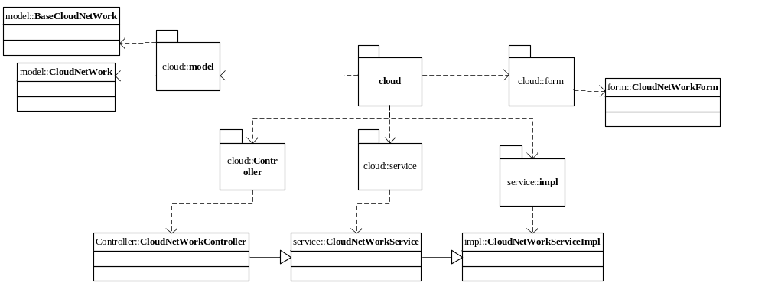

网络子网
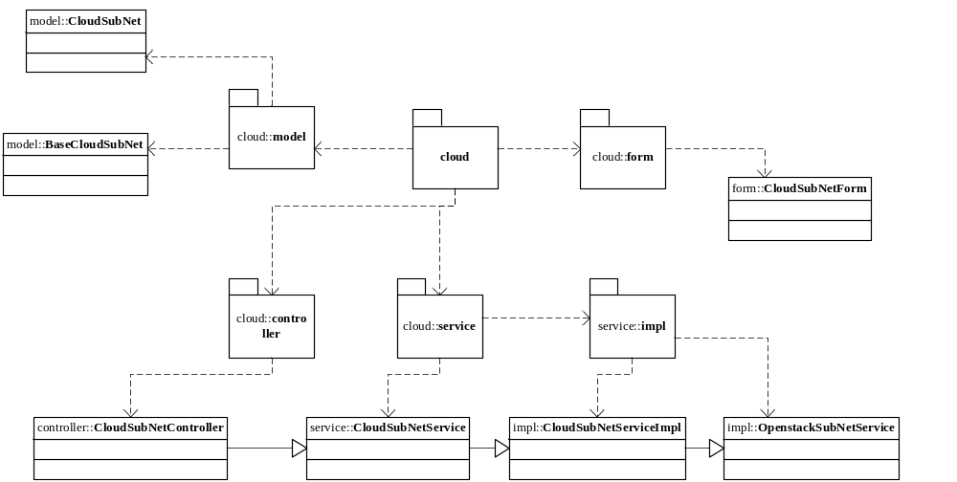

弹性公网IP

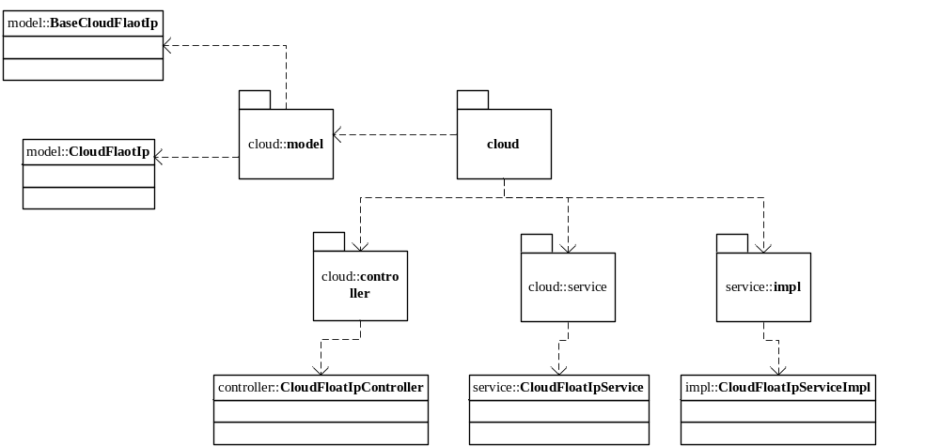

负载均衡

资源池

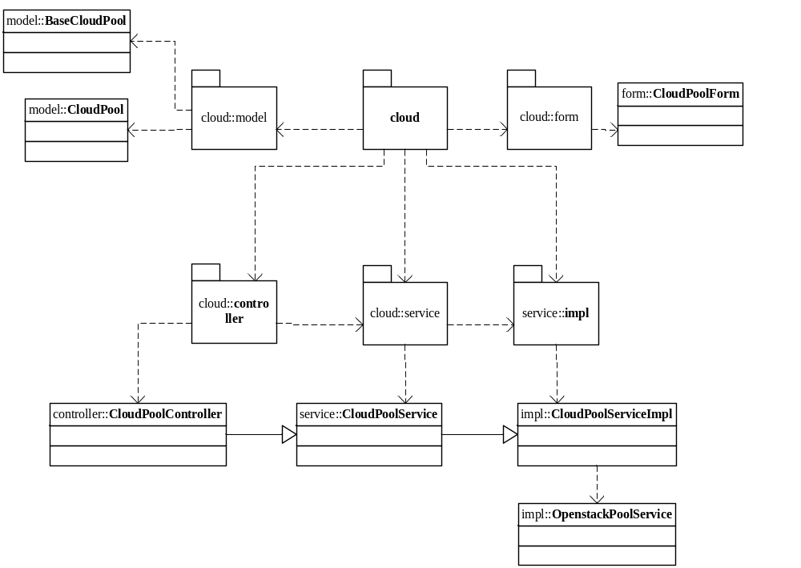

成员
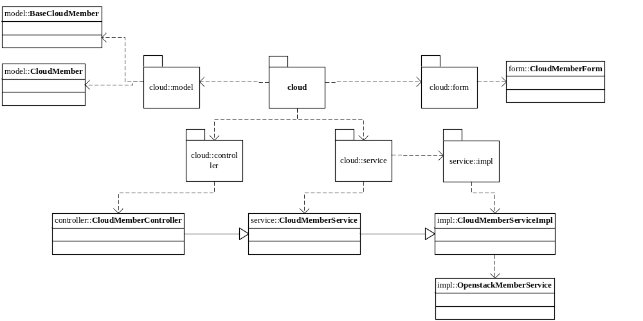

监控
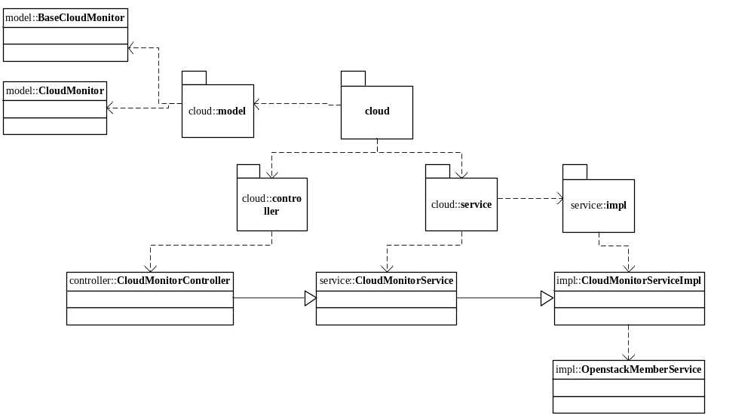

Vip
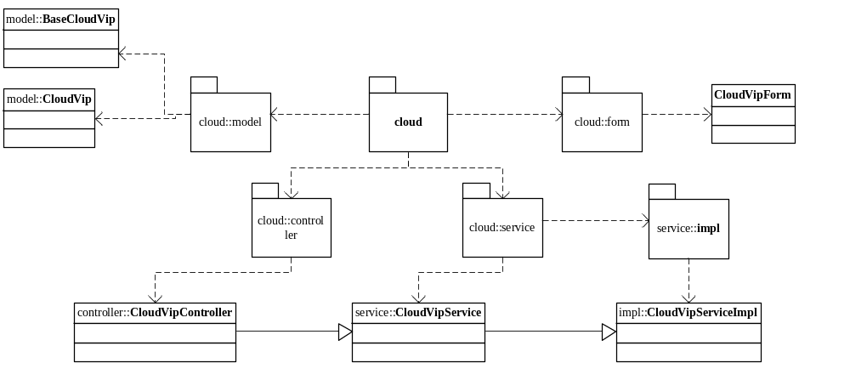

路由
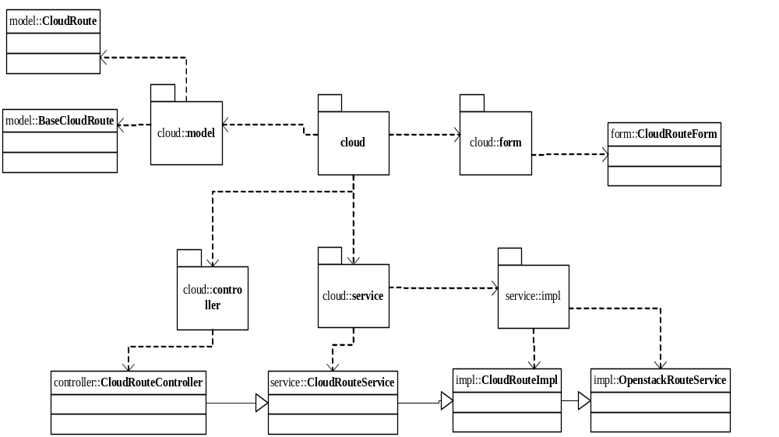

关键逻辑时序图

模块类说明
类名 | 说明 | 描述
com.eayun.virtualization.ecmcservice.EcmcNetworkService | 私有网络类
com.eayun.virtualization.ecmcservice.EcmcSubNetworkService | 私有网络子网类
com.eayun.virtualization.ecmcservice.EcmcFloatIpService | 弹性公网IP类
com.eayun.virtualization.ecmcservice.EcmcPoolService | 资源池类
com.eayun.virtualization.ecmcservice.EcmcMemberService | 成员类
com.eayun.virtualization.ecmcservice.EcmcVipService | Vip类
com.eayun.virtualization.ecmcservice.EcmcRouteService | 路由类

私有网络类（EcmcNetworkService）

getNetworkList
public List<Network> getNetworkList(String datacenterId,String projectId){
1.根据数据中心ID、项目ID查询私有网络
2.返回网络列表
}

findNetworkById
public Network findNetworkById(String id){
- 根据Id查询网络
- 放回网络
}

addNetwork
public CloudNetWork addNetwork(CloudNetWork cloudNetWork) {
- 数据校验
- 插入一条新数据到网络表
- 返回网络对象

}

updateNetwork
public CloudNetWork updateNetwork(CloudNetWork cloudNetWork) {
- 参数校验
- 修改网络
- 返回网络对象
}

deleteNetworkById
public boolean deleteNetworkById(CloudNetWork cloudNetWork) {
1.删除底层
2.删除数据库
3.返回结果
}

findNetworkCountByPrjId
public int findNetworkCountByPrjId(String prjId) {
1.查询项目下网络数量
2.返回数量
}

checkNetWorkName
public boolean checkNetWorkName(String netId,String netName,String dcId) {
验证并返回网络名称是否可用
}

私有网络子网类(EcmcSubNetworkService)

addSubNetwork
public CloudSubNetWork addSubNetwork(CloudSubNetWork cloudSubNetWork) {
1.创建子网
2.子网连接路由
3.返回子网对象
}

updateSubNetwork
public CloudSubNetWork updateSubNetwork(CloudSubNetWork cloudSubNetWork) {
1.数据校验
2.修改子网
3.返回子网对象
}

daleteSubNetwork
public boolean daleteSubNetwork(CloudSubNetWork cloudSubNetWork) {
- 解绑子网
- 删除子网
- 更新缓存
- 返回结果
}

findSubNetworkById
public BaseCloudSubNetWork findSubNetworkById(String subNetId){
根据ID查询子网并返回子网信息
}

getSubNetworkListByPrjId
public List<BaseCloudSubNetWork> getSubNetworkListByPrjId(String datacenterId,String projectId){
根据项目Id查询子网列表
}

getSubNetworkListByRouteId
public List<CloudSubNetWork> getSubNetworkListByRouteId(String dcId,String prjId,String routeId){
/*查询子网列表，根据route_id查询，左连杰网络表展示网络名称 */
}

checkSubNetworkName
public boolean checkSubNetworkName(String subnetId,String subNetName,String dcId) {
查询并返回子网名称是否可用
}

弹性公网IP类(EcmcFloatIpService)

getListByPrjId
public Page getListByPrjId(Page page , String projectId , QueryMap queryMap) {
查询项目Id下的弹性公网IP
}

allocateIp
public FloatIp allocateIp(String datacenterId, String projectId, String pool) throws AppException {
从公共网络中分配一个弹性公网IP并返回
}

deallocateFloatIp
public boolean deallocateFloatIp(String datacenterId, String id) throws AppException {
释放弹性公网IP
}

getFloatIpList
public List<FloatIp> getFloatIpList(String datacenterId, String projectId)throws AppException {
查询弹性公网IP列表
}

bindToVm
public void bindToVm(String datacenterId, String projectId, String vmId, String address)
绑定浮动IP到云主机
}

unbindFromVm
public void unbindFromVm(String datacenterId, String projectId, String vmId, String address)
解绑弹性公网IP和云主机的关系
}

资源池类(EcmcPoolService)

getPoolList
public List<Pool> getPoolList(String datacenterId, String projectId) throws AppException {
查询项目下的资源池并返回列表
}

findPoolById

public Pool findPoolById(String datacenterId,String projectId,String id) throws AppException {
根据资源池Id查询资源池
}

bindToHealthMonitor
public boolean bindHealthMonitor(String datacenterId, String projectId, String id,String healthId) throws AppException {
给资源池绑定监控
}

addPool
public Pool addPool(String datacenterId, String projectId,net.sf.json.JSONObject data) throws AppException{
添加资源池
}

deletePool
public boolean deletePool(String datacenterId, String projectId,String id) throws AppException{
删除资源池
}

updatePool
public Pool updatePool(String datacenterId, String projectId,net.sf.json.JSONObject data,String id) throws AppException{
修改资源池
}

成员类(EcmcMemberService)

findMember
public List<CloudLdmemberVoe> findMember(String datacenterId, String projectId,
String address) throws AppException {
1，用hql查询成员列表，查询条件为项目id，ip地址
2，返回page对象
}

addMember
/**
* 添加成员
*
* @param datacenterId
* @param projectId
* @param data
* @throws AppException
*/
public CloudLdmember addMember(String datacenterId,String projectId,HttpServletRequest request) throws AppException{
try {
1，处理数据

2，调用OpenstackMemberService中的addMember方法底层添加成员 并接收返回值
3，根据返回值在表中插入对应数据
4，返回Boolean值
}

updateMember
/**
* 修改成员
*
* @param datacenterId
* @param projectId
* @param data
* @param id
* @return
* @throws AppException
*/
public CloudLdmemberVoe updateMember(String datacenterId, String projectId,
HttpServletRequest request, String id) throws AppException {
1，拼接数据
2，调用OpenstackMemberService中的updateMember方法更新底层对应成员
3，更新对应表中数据
4，返回boolean值
}

deleteMember
/**
* 删除一条成员
*
* @param datacenterId
* @param projectId
* @param id
* @return
* @throws AppException
*/
public boolean deleteMember(String datacenterId, String projectId, String id)
throws AppException {
try {
1，调用OpenstackMemberService中的deleteMember方法删除 成员
2，根据返回值删除表中对应的数据
3，返回Boolean值

}

Vip类(EcmcVipService)

checkVipName
/**
* 检查是否重名
* @param datacenterId 数据中心
* @param imageType 镜像类型
* @param imageName 镜像名称
* @param vipId 对于更新时判断是否重名需要排除自身
* @return 已存在返回true，否则返回false
* @throws AppException
*/
public boolean checkVipName(String datacenterId,String projectId,String vipName,String vipId) throws AppException{
返回是否存在vip名称
}

findVip
/**
* 查询所有vip的信息
* @param request
* @return
* @throws AppException
*/
public Page findVip(String datacenterId,String projectId,String name) throws AppException{
try {
1，hql查询Vip信息
2，返回page
}

addVip
/**
* 添加vip
* @param datacenterId
* @param projectId
* @param data
* @throws AppException
*/
public CloudLdvip addVip(String datacenterId,String projectId,HttpServletRequest request) throws AppException{
CloudLdvip resultData= null;
try {
net.sf.json.JSONObject data=new net.sf.json.JSONObject();
net.sf.json.JSONObject temp=new net.sf.json.JSONObject();
/*创建VIP的时候根据选择的资源池给VIP设置属性“protocol”的值； 开始*/

1，拼接数据
if(pool_id!=null&&!pool_id.equals("")){
Pool pool=null;
pool=poolService.getById(datacenterId, projectId, pool_id);
temp.put("protocol",pool.getProtocol());
}
temp.put("name", request.getParameter("name"));
temp.put("tenant_id", request.getParameter("tenant_id"));
temp.put("description", request.getParameter("description"));
temp.put("subnet_id", request.getParameter("subnet_id"));
temp.put("address", request.getParameter("address"));
temp.put("protocol_port", request.getParameter("protocol_port"));
temp.put("pool_id", request.getParameter("pool_name"));
temp.put("session_persistence", request.getParameter("session_persistence"));
temp.put("connection_limit", request.getParameter("connection_limit"));
temp.put("admin_state_up", request.getParameter("admin_state_up"));
data.put("vip", temp);
2，判断是否重名
3，调用OpenstackVIPService中的create方法底层创建Vip
4，接收返回值，在表cloud_ldvip中插入对应数据
}

updateVip
/**
* 修改vip的信息
* @param datacenterId
* @param projectId
* @param data
* @param id
* @return
* @throws AppException
*/
public Boolean updateVip(String datacenterId,String projectId, HttpServletRequest request, String id) throws AppException {
1，拼接数据
CloudLdvip vip=null;
net.sf.json.JSONObject data=new net.sf.json.JSONObject();
net.sf.json.JSONObject temp=new net.sf.json.JSONObject();
temp.put("name", request.getParameter("name"));
temp.put("connection_limit", request.getParameter("connection_limit"));
temp.put("admin_state_up", request.getParameter("admin_state_up"));
data.put("vip", temp);
2，判断名称是否重复
3，调用OpenstackVIPService中的update方法底层更新vip
4，接收底层返回结果，更新对应信息
5，返回Boolean值
}

deleteVip
/**
* 删除一条vip
* @param datacenterId
* @param projectId
* @param id
* @return
* @throws AppException
*/
public boolean deleteVip(String datacenterId, String projectId,String id) throws AppException{
try {
1，执行openstack删除操作成功后，进行后续操作
2，接收底层返回数据判断是否删除数据库数据
3，删除对应数据
4，返回Boolean值
}

路由类(EcmcRouteService)

checkRouteName
/**
* 检查路由是否重名
* @param datacenterId 数据中心
* @param projectId 项目
* @param name 名称
* @return 已存在返回true，否则返回false
* @throws AppException
*/
public boolean checkRouteName(String datacenterId,String projectId,String routeName,String routeId) throws AppException{
判断是否存在路由名
}

findRoute
/**
* 获取路由的列表信息，用于在前端页面展示，从数据库中保存的信息
* @param datacenterId 数据中心id
* @param projectId 项目id
* @param name 前端页面输入的查询内容，用于过滤不匹配的记录
* @return
* @throws AppException
*/
public page findRoute(String datacenterId,String projectId,String name) throws AppException{

}

addRoute
/**
* 创建路由
* @param datacenterId
* @param projectId
* @param id
* @throws AppException
*/
public Boolean addRoute(String datacenterId,String projectId,HttpServletRequest request) throws AppException{
1，接收controller传递的对象
2，调用OpenstackRouteService中的addRoute方法并接收返回值
3，根据返回值在表cloud_route中插入对应数据
4，返回boolean
}

updateRoute
/**
* 修改路由
* @param datacenterId
* @param projectId
* @param id
* @throws AppException
*/
public Boolean updateRoute(String routeid,String datacenterId,HttpServletRequest request,String name) throws AppException{
1，拼装数据
net.sf.json.JSONObject net = new net.sf.json.JSONObject();
net.put("name", name);
net.sf.json.JSONObject resultData = new net.sf.json.JSONObject();
resultData.put("router", net);
2,调用OpenstackRouteService中的update方法更新底层路由，并接受返回结果
Route route = service.edit(datacenterId, routeid, resultData);
3，根据返回结果判断是否更新数据库中数据
4，返回Boolean值
}

setGateway
/**
* 设置网关方法
* @param datacenterId
* @param projectId
* @param id
* @throws AppException
*/
public CloudRouteVoe setGateway(String routeid,String datacenterId,String networkid) throws AppException{
CloudRouteVoe routeVoe = new CloudRouteVoe();
try {
1，调用OpenstackRouteService中的setgateway方法设置底层网关
Route route = service.setgateway(datacenterId, routeid, networkid);
2，判断底层是否设置成功，以更新数据库中对应数据
3，返回boolean值
}

removeGateWay
/**
* 清除网关
* @param datacenterId
* @param projectId
* @param id
* @throws AppException
*/
public CloudRoute removeGateWay(String routeid,String datacenterId) throws AppException{
CloudRoute cloudRoute = new CloudRoute();
try {
1，调用OpenstackRouteService中的removeGateway方法 清除网关
2，根据返回结果更新数据库中对应数据
3，返回Boolean值
}

bind
/**
* 路由连接子网
* @param datacenterId
* @param projectId
* @param id
* @throws AppException
*/
public Boolean bind(String routeid,String datacenterId,String subnetworkid) throws AppException{
try {
1，调用OpenstackRouteService中的bind方法绑定子网
2，根据返回结果更新数据库中对应数据
3，返回Boolean值

}

debind
/**
* 解绑子网
* @param datacenterId
* @param projectId
* @param id
* @throws AppException
*/
public Boolean debind(String routeid,String subnetworkid,String datacenterId) throws AppException{ 1，调用OpenstackRouteService中的debind方法解绑子网并接收返回值
2，根据返回值更新数据中对应数据
3，返回boolean值
}

/**
* 删除指定id的路由，包括两步删除操作，
* @param datacenterId
* @param projectId
* @param id
* @return
* @throws AppException
*/
Public boolean deleteRoute(String datacenterId,String id) throws AppException{
try{
1，调用OpenstackRouteService中的delete方法删除底层路由
2，根据返回结果确定是否删除数据库中对应数据
3，返回boolean值
}

