文档编号 | IAAS-DDS 002
文档版本 | 1.0
拟制人 | 曹翔宇
日期 | 2016.12.09

EayunCloud公有云业务管理平台
（包头数据中心-负载均衡）
概要设计说明书

变更说明
日期 | 版本 | 变更位置 | 变更说明 | 作者
2016.11.09 | 1.0.0 |  | 新建 | 曹翔宇

目 录
变更说明 2
目 录 3
1. 概述 4
1.1. 业务分析 4
1.1.1. 用例图 4
1.1.2. 时序图 5
1.1.3. 流程图 6
1.2. 定义、缩略语 10
1.3. 参考资料 10
2. 前台设计 10
2.1. 设置Api访问限制 10
2.2. Api访问限制次数默认值 11
3. Controller设计 12
3.1. EcmcCustomerController(/ecmc/customer) 12
3.1.1. getapitype 12
3.1.2. getrestrictrequestcount 13
3.1.3. updateapirequestcount 14
3.1.4. syncApiCount 15
3.2. EcmcApiCountController（/ecmc/system/apicount） 15
3.2.1. getdefaultapicount 15
3.2.2. updatedefaultapicount 16
4. Model设计 17
4.1. Model类规划 17
4.2. Api限制表 17
4.3. Api默认访问限制次数表 18
4.4. BaseApiCountRestrict 18
4.5. ApiCountRestrict 19
4.6. BaseApiDefaultCount 19
4.7. ApiDefaultCount 19
4.8. ApiRequestCount 19
4.9. Action设置 20
5. Redis设计 21
5.1. Api请求次数限制 21
5.2. Api请求次数限制默认值 22
6. Service接口 22
7. 后台设计 23
7.1. 类设计 23
7.1.1. ApiRestrictService 23
7.1.2. EcmcApiRestrictService 27

概述

业务分析
包头数据中心建设的网络，区别于传统数据中心只有一个运营商网络的情况，包头数据中心会存在以下几种不同的运营商网络：政务内网、政务外网、电信网络和联通网络等

用例图

Ecsc/Ecmc负载均衡
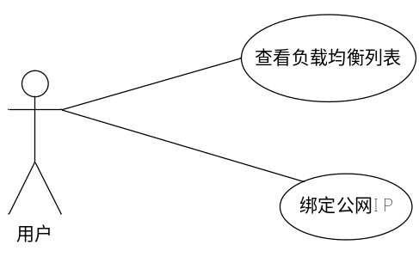.

流程图

获取负载均衡列表(ecmc)
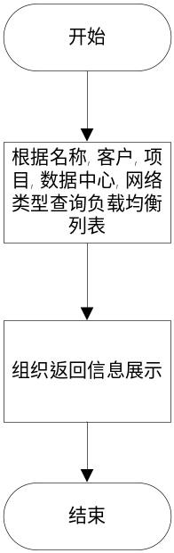

获取负载均衡列表(ecsc)
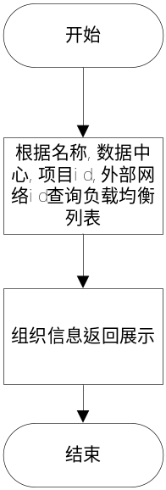

获取可绑定公网IP
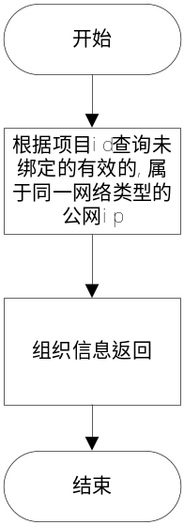

定义、缩略语

参考资料

前台设计

Ecsc负载均衡列表展示
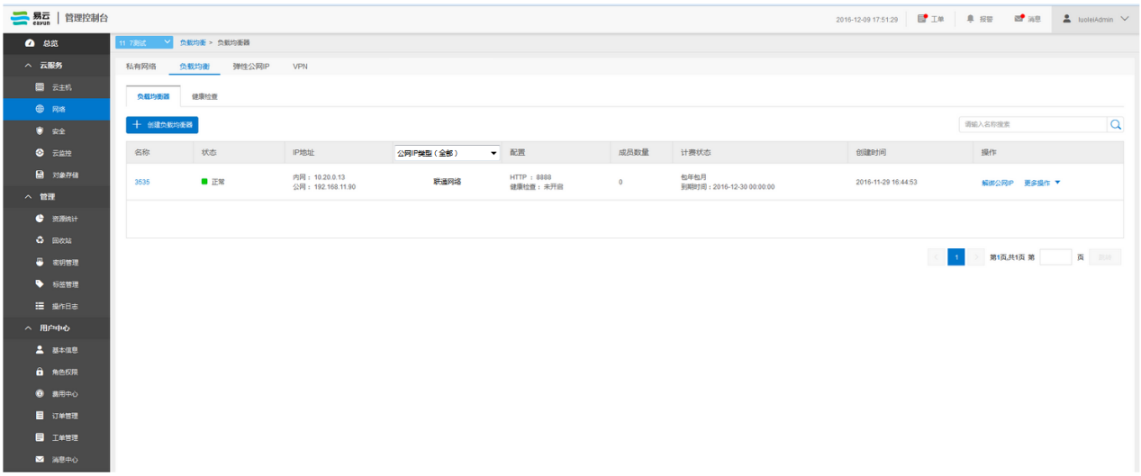

Ecmc负载均衡列表展示
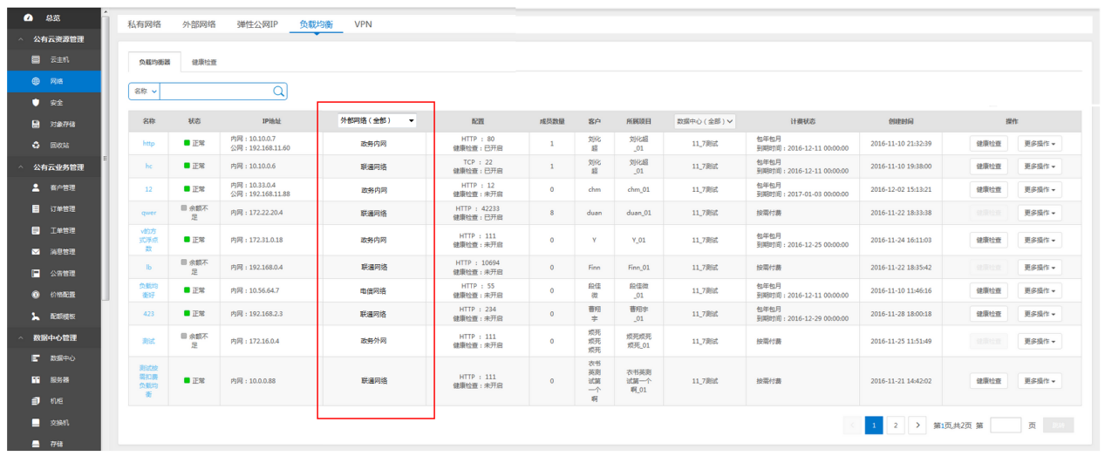

Controller设计
无新增,沿用之前的controller
类名 | 说明 | 描述
com.eayun.virtualization.controller.CloudFloatIpController | ecsc公网ip Controller
com.eayun.virtualization.ecmccontroller.EcmcCloudFloatIpController | ecmc公网ip Controller
com.eayun.virtualization.ecmccontroller.EcmcLBPoolController | ecmc负载均衡Controller
com.eayun.virtualization.controller.PoolController | ecsc负载均衡Controller

PoolController（/cloud/loadbalance/pool）

/ getPoolList
说明 | 查询所有资源池信息
URL | /cloud/loadbalance/pool/ getPoolList.do
方式 | post
Post数据 | {  Page:{},  dcId:”xxx”,  poolName:”xxxx”,  prjId:”xxxxxxxx”,  netoutId:”xxxxxxx” //新增 外部网络id  isBind:”” //是否绑定 不为空时表示未绑定公网ip  }
返回Json | 成功  Page:{}  "data":[  {  cloudLdPool  },  {  cloudLdPool  },  …..  ]  失败:{  “respCode”:”010120”  }

CloudFloatIpController (/cloud/floatip)

/ getUnBindFloatIp
说明 | 获取未绑定资源的公网ip
URL | /cloud/floatip/ getUnBindFloatIp.do
方式 | post
Post数据 | {  prjId:”xxxxxxxx”,  netoutId:”xxxxxxx” //新增 外部网络id  }
返回Json | 成功  [  {  cloudFloatIp  },  {  cloudFloatIp  },  …..  ]  失败:{  “respCode”:”010120”  }

EcmcLBPoolController（/ecmc/virtual/loadbalance/pool）

/ querypool
说明 | 查询所有资源池信息
URL | /ecmc/virtual/loadbalance/pool/ querypool.do
方式 | post
Post数据 | {  Page:{},  dcId:”xxx”,  poolName:”xxxx”,  cusOrg:”xxxx”,  prjName:”xxxxxxxx”,  netoutId:”xxxxxxx” //新增 外部网络id  isBind:”” //是否绑定 不为空时表示未绑定公网ip  }
返回Json | 成功  Page:{}  "data":[  {  cloudLdPool  },  {  cloudLdPool  },  …..  ]  失败:{  “respCode”:”010120”  }

EcmcCloudFloatIpController（/ecmc/virtual/floatip）

/ getUnBindFloatIp
说明 | 获取未绑定资源的公网ip
URL | /cloud/floatip/ getUnBindFloatIp.do
方式 | post
Post数据 | {  prjId:”xxxxxxxx”,  netoutId:”xxxxxxx” //新增 外部网络id  }
返回Json | 成功  [  {  cloudFloatIp  },  {  cloudFloatIp  },  …..  ]  失败:{  “respCode”:”010120”  }

Model设计

Model类规划
类名 | 说明 | 描述
com.eayun.virtualization.model.CloudLdPool | 负载均衡类 | 继承BaseCloudLdPool实体类

CloudLdPool
类名 |  | CloudLdPool
功能说明 |  | 继承自BaseCloudLdPool
序号 | 字段名称 | 中文名称 | 类型 | 说明
1 | netoutType | 网络类型 | String | 外部网络名称
2 | netoutId | 网络类型id | String | 外部网络id

Service接口
类名 | 说明 | 描述
com.eayun.virtualization.service.PoolService | 负载均衡接口类
com.eayun.virtualization.service.CloudFloatIpService | 浮动ip接口类

后台设计

类设计

PoolService
方法名 | 说明 | 描述 | 所需参数
getPoolList | 获取负载均衡列表 |  | //数据中心id  String dcId  //项目id  String prjId  //负载均衡名称  String name  //外部网络id  String netoutId  //是否绑定  String isBind
getLoadBalanceById | 获取负载均衡详情 |  | //负载均衡id  String poolId

getPoolList
/**
* 查询负载均衡器列表
* @throws Exception
*/
public Page getPoolList(Page page, String datacenterId, String projectId, String name, QueryMap queryMap,String netoutId,String isBind)
throws Exception {

SELECT
pool.dc_id,
dc.dc_name,
pool.prj_id,
pool.pool_id,
pool.pool_name,
pool.pool_status,
pool.pay_type,
pool.charge_state,
pool.create_time,
pool.end_time,
pool.subnet_id,
sub.subnet_name,
sub.cidr,
vip.vip_id,
vip.vip_address,
vip.port_id,
vip.vip_protocol,
vip.protocol_port,
vip.connection_limit,
floatip.flo_id,
floatip.flo_ip,
ldmem.memberCount,
CASE
WHEN ldpm.monitorCount > 0 THEN
'true'
ELSE
'false'
END AS isCheckMonitor,
net.net_name,
net.net_id
FROM
cloud_ldpool pool
LEFT JOIN dc_datacenter dc ON dc.id = pool.dc_id
LEFT JOIN cloud_ldvip vip ON vip.pool_id = pool.pool_id
LEFT JOIN cloud_subnetwork sub ON sub.subnet_id = pool.subnet_id
LEFT JOIN cloud_network net2 ON net2.net_id = sub.net_id
LEFT JOIN cloud_route rou ON rou.network_id = net2.net_id
LEFT JOIN cloud_network net ON net.net_id = rou.net_id
LEFT JOIN cloud_floatip floatip ON pool.pool_id = floatip.resource_id
AND floatip.resource_type = 'lb'
AND floatip.is_deleted = '0'
LEFT JOIN (
SELECT
count(1) memberCount,
pool_id
FROM
cloud_ldmember
GROUP BY
pool_id
) ldmem ON ldmem.pool_id = pool.pool_id
LEFT JOIN (
SELECT
count(1) AS monitorCount,
pool_id
FROM
cloud_ldpoolldmonitor
GROUP BY
pool_id
) ldpm ON ldpm.pool_id = pool.pool_id
WHERE
1 = 1
AND pool.is_visible = 1
AND pool.prj_id = ''
ORDER BY
pool.create_time DESC

}

getLoadBalanceById
/**
* 查询负载均衡器列表
* @throws Exception
*/
public Page getLoadBalanceById(String poolId)
throws Exception {
SELECT
pool.dc_id,
dc.dc_name,
pool.prj_id,
cp.prj_name,
pool.pool_id,
pool.pool_name,
pool.pool_status,
pool.lb_method,
vip.vip_id,
vip.vip_address,
vip.vip_protocol,
vip.connection_limit,
vip.protocol_port,
floatip.flo_ip,
subnet.net_name,
subnet.subnet_name,
subnet.subnet_id,
subnet.cidr,
pool.pay_type,
pool.charge_state,
pool.create_time,
pool.end_time,
CASE
WHEN ldpm.monitorCount > 0 THEN
'true'
ELSE
'false'
END AS isCheckMonitor,
net.net_name
FROM
cloud_ldpool pool
LEFT JOIN cloud_ldvip vip ON vip.pool_id = pool.pool_id
LEFT JOIN cloud_floatip floatip ON pool.pool_id = floatip.resource_id
LEFT JOIN cloud_network net ON floatip.net_id=net.net_id
AND floatip.resource_type = 'lb'
AND floatip.is_deleted = '0'
LEFT JOIN (
SELECT
sub.subnet_id,
sub.subnet_name,
sub.cidr,
net.net_name
FROM
cloud_subnetwork sub
LEFT JOIN cloud_network net ON net.net_id = sub.net_id
) subnet ON subnet.subnet_id = pool.subnet_id
LEFT JOIN (
SELECT
count(1) AS monitorCount,
pool_id
FROM
cloud_ldpoolldmonitor
GROUP BY
pool_id
) ldpm ON ldpm.pool_id = pool.pool_id
LEFT JOIN dc_datacenter dc ON dc.id = pool.dc_id
LEFT JOIN cloud_project cp ON cp.prj_id = pool.prj_id
WHERE
pool.pool_id = 'fc4db19b-1315-421a-92a1-90a2387d04b6'
}

CloudFloatIpService
方法名 | 说明 | 描述 | 所需参数
getUnBindFloatIp | 获取未被绑定的公网ip |  | //项目id  String prjId  //外部网络id  String outnetId

getUnBindFloatIp
public List<BaseCloudFloatIp> getUnBindFloatIp(String prjId,String outnetId) {
SELECT
flo.dc_id,
flo.prj_id,
flo.flo_id,
net.net_id,
net.net_name
FROM
cloud_floatip flo
LEFT JOIN cloud_network net ON net.net_id=flo.net_id
WHERE
flo.prj_id = '76381ea615d942ba8e457eec05fb5e0e'
AND flo.resource_id IS NULL
AND flo.resource_type IS NULL
AND flo.is_deleted = '0'
AND flo.charge_state = '0'
AND flo.is_visable = '1'
AND net.net_id='97536892-5019-4d21-adfd-22af91b0c12e';
}

EcmcLBPoolService
方法名 | 说明 | 描述 | 所需参数
getPoolList | 获取负载均衡列表 |  | //数据中心id  String dcId  //项目名称  String prjName  //负载均衡名称  String poolName  //外部网络id  String outnetId  //客户名称  String cusOrg  //是否绑定  String isBind

getPoolList
public Page getPoolList(String dcId, String poolName, String cusOrg, String prjName, QueryMap queryMap) throws Exception {
SELECT
pool.dc_id,
pool.prj_id,
pool.pool_id,
pool.pool_name,
pool.pool_status,
pool.subnet_id,
sub.subnet_name,
sub.cidr,
vip.vip_id,
vip.vip_address,
vip.port_id,
vip.vip_protocol,
vip.protocol_port,
vip.connection_limit,
floatip.flo_id,
floatip.flo_ip,
ldmem.memberCount,
CASE
WHEN ldpm.monitorCount > 0 THEN
'true'
ELSE
'false'
END AS isCheckMonitor,
cus.cus_org,
prj.prj_name,
dc.dc_name,
pool.pay_type,
pool.end_time,
pool.charge_state,
pool.create_time,
net.net_id,
net.net_name
FROM
cloud_ldpool pool
LEFT JOIN cloud_ldvip vip ON vip.pool_id = pool.pool_id
LEFT JOIN dc_datacenter dc ON dc.id = pool.dc_id
LEFT JOIN cloud_project prj ON pool.prj_id = prj.prj_id
LEFT JOIN sys_selfcustomer cus ON prj.customer_id = cus.cus_id
LEFT JOIN cloud_subnetwork sub ON sub.subnet_id = pool.subnet_id
LEFT JOIN cloud_network net2 ON net2.net_id = sub.net_id
LEFT JOIN cloud_route rou ON rou.network_id = net2.net_id
LEFT JOIN cloud_network net ON net.net_id = rou.net_id

LEFT JOIN cloud_floatip floatip ON pool.pool_id = floatip.resource_id
AND floatip.resource_type = 'lb'
AND floatip.is_deleted = '0'
LEFT JOIN (
SELECT
count(1) memberCount,
pool_id
FROM
cloud_ldmember
GROUP BY
pool_id
) ldmem ON ldmem.pool_id = pool.pool_id
LEFT JOIN (
SELECT
count(1) AS monitorCount,
pool_id
FROM
cloud_ldpoolldmonitor
GROUP BY
pool_id
) ldpm ON ldpm.pool_id = pool.pool_id
WHERE
1 = 1
AND pool.is_visible = '1'
ORDER BY
pool.dc_id,
pool.prj_id,
pool.create_time DESC
}

EcmcCloudFloatIpService
方法名 | 说明 | 描述 | 所需参数
getUnBindFloatIp | 获取未被绑定的公网ip |  | //项目id  String prjId  //外部网络id  String outnetId

getUnBindFloatIp
public List<BaseCloudFloatIp> getUnBindFloatIp(String prjId,String outnetId) {
SELECT
flo.dc_id,
flo.prj_id,
flo.flo_id,
net.net_id,
net.net_name
FROM
cloud_floatip flo
LEFT JOIN cloud_network net ON net.net_id=flo.net_id
WHERE
flo.prj_id = '76381ea615d942ba8e457eec05fb5e0e'
AND flo.resource_id IS NULL
AND flo.resource_type IS NULL
AND flo.is_deleted = '0'
AND flo.charge_state = '0'
AND flo.is_visable = '1'
AND net.net_id='97536892-5019-4d21-adfd-22af91b0c12e';
}

