文档编号 | IAAS-DDS 002
文档版本 | 1.0
拟制人 | 曹翔宇
日期 | 2016.07.14

EayunCloud公有云业务管理平台
（云资源到期、清理消息提醒）
概要设计说明书

变更说明
日期 | 版本 | 变更位置 | 变更说明 | 作者
2016.07.14 | 1.0 |  | 新建 | 曹翔宇

目 录
变更说明 2
目 录 3
1 概述 4
1.1 功能概述 4
1.2 定义、缩略语 4
1.3 参考资料 4
2 业务分析 4
2.1 关键业务用例 4
2.1.1 到期续费用例 4
2.1.2 资源过期提醒用例 5
2.2 关键业务流程 6
2.2.1 到期续费 6
2.2.2 资源过期 7
3 Job设计 8
3.1 到期续费通知 8
3.2 资源过期通知(ExpireNoticJob) 9
4 sql设计 10
4.1 获取云主机 10
4.2 获取云硬盘 11
4.3 获取私有网络 11
4.4 获取负载均衡 12
4.5 获取VPN 12
4.6 获取弹性公网IP 13

概述

功能概述
当客户购买的资源即将到期以及资源过期时,需要向客户发送短信提醒,我们采用通过计划任务的方式,定时查询需要发送短信提醒的资源,并向该资源的所属客户发送短信提醒.

定义、缩略语

参考资料

业务分析

关键业务用例

到期续费用例
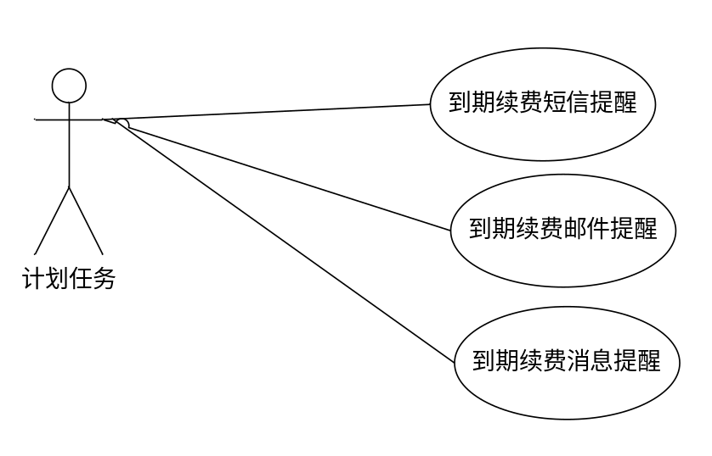

资源过期提醒用例
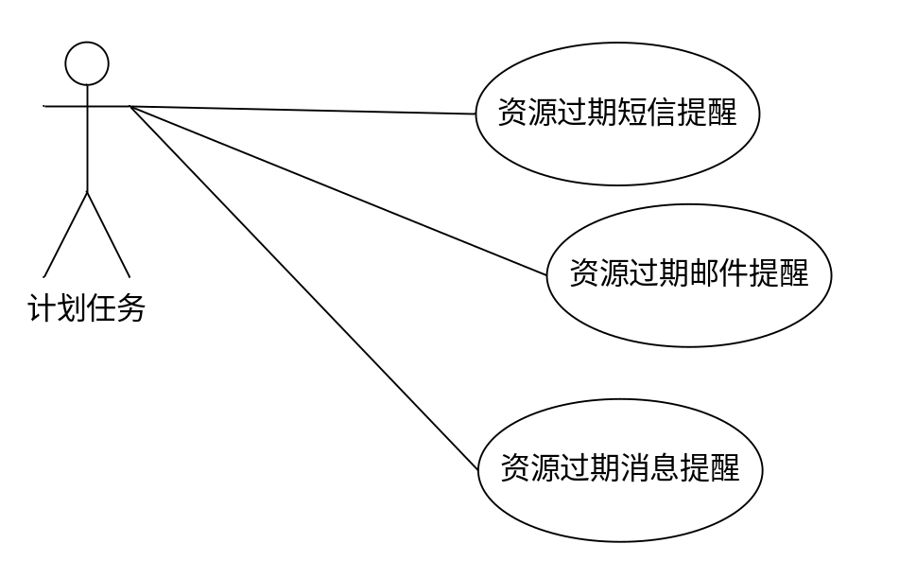

关键业务流程

到期续费
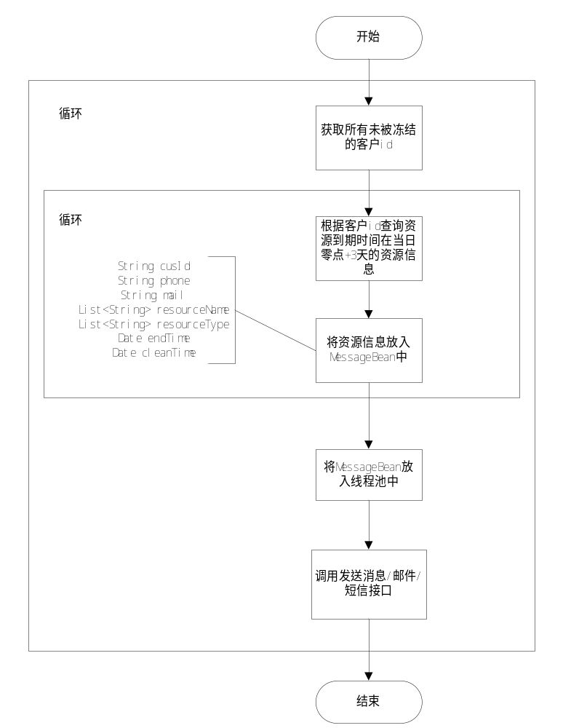
计划任务在每日早9点5分执行.获取所有未被冻结的有效客户id,通过客户id可以查询到该客户下的所有在使用的资源,根据资源的到期时间进行筛选,筛选出到期日期为当天零点+3天的资源信息,将该资源的资源类型和资源名称放入到同一个cusid的MessageBean中,最后将MessageBean传入线程池中,调用发送消息接口.
需要查询的资源:云主机;云硬盘;私有网络;VPN;负载均衡;弹性公网IP;

资源过期
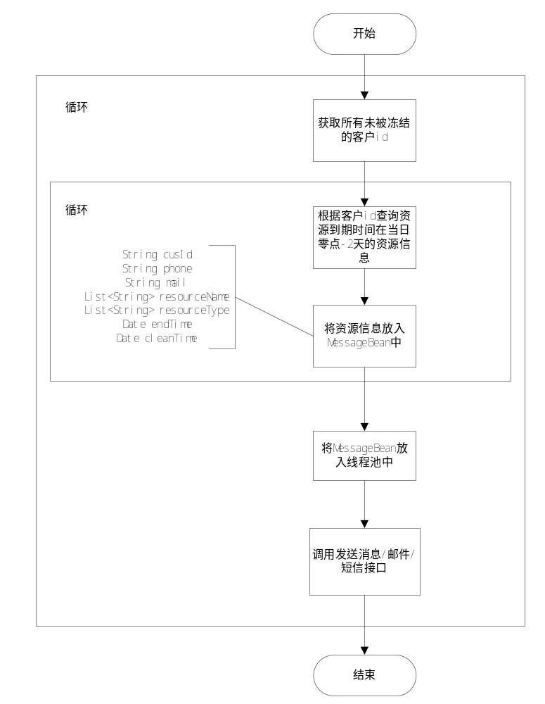
计划任务在每日早9点5分执行.获取所有未被冻结的有效客户id,通过客户id可以查询到该客户下的所有在使用的资源,根据资源的到期时间进行筛选,筛选出到期日期为当天零点-2天的资源信息,将该资源的资源类型和资源名称放入到同一个cusid的MessageBean中,最后将MessageBean传入线程池中,调用发送消息接口.
需要查询的资源:云主机;云硬盘;私有网络;VPN;负载均衡;弹性公网IP;

Job设计

到期续费通知
(eayun-virtualization/com/eayun/virtualization/notice/job/ContinuationNoticeJob)
(eayun-virtualization/com/eayun/virtualization/notice/thread/ContinuationNoticeThread)
(eayun-virtualization/com/eayun/virtualization/notice/thread/ContinuationNoticePool)
public class ContinuationNoticeJob extends BaseQuartzJobBean {
private static final Logger log = LoggerFactory.getLogger(NewsCountJob.class);

@Override
protected void executeInternal(JobExecutionContext context) throws JobExecutionException {
ApplicationContext applicationContext = getApplicationContext(context);
CustomerService customerService=(CustomerService)applicationContext.getBean("CustomerService");
ProjectService projectService=(ProjectService)applicationContext.getBean("ProjectService");
Date now=new Date();
Calendar c = Calendar.getInstance();
c.setTime(now);
c.set(Calendar.HOUR_OF_DAY,0);
c.set(Calendar.MINUTE,0);
c.set(Calendar.SECOND,0);
c.set(Calendar.MILLISECOND,0);
now=c.getTime();
Date endTime=DateUtil.addDay(now, new int[]{0,0,3});
List<BaseCustomer> allCustomers=customerService.getAllCustomerList();
for (BaseCustomer baseCustomer : allCustomers) {
String cusId=baseCustomer.getCusId();
List<CloudProject> prjList=projectService.getProjectListByCustomer(cusId);
MessageBean messageBean=new MessageBean();
for (CloudProject cloudProject : prjList) {
String prjId=cloudProject.getProjectId();
//根据项目id分别获取到期时间为now的云主机;云硬盘;私有网络;VPN;负载均衡;弹性公网IP;
//将资源名称与资源类型放入messageBean.getResourceNameList,和messageBean.getResourceTypeList中
}
ContinuationNoticeThread thread=new ContinuationNoticeThread(messageBean,sendMessageService);
ContinuationNoticePool.pool.submit(thread);
}
}

资源过期通知(ExpireNoticJob)
(eayun-virtualization/com/eayun/virtualization/notice/job/ExpirationNoticeJob)
(eayun-virtualization/com/eayun/virtualization/notice/thread/ExpirationNoticeThread)
(eayun-virtualization/com/eayun/virtualization/notice/thread/ExpirationNoticePool)
public class ExpirationNoticeJob extends BaseQuartzJobBean {
private static final Logger log = LoggerFactory.getLogger(NewsCountJob.class);

@Override
protected void executeInternal(JobExecutionContext context) throws JobExecutionException {
ApplicationContext applicationContext = getApplicationContext(context);
CustomerService customerService=(CustomerService)applicationContext.getBean("CustomerService");
ProjectService projectService=(ProjectService)applicationContext.getBean("ProjectService");
Date now=new Date();
Calendar c = Calendar.getInstance();
c.setTime(now);
c.set(Calendar.HOUR_OF_DAY,0);
c.set(Calendar.MINUTE,0);
c.set(Calendar.SECOND,0);
c.set(Calendar.MILLISECOND,0);
now=c.getTime();
Date endTime=DateUtil.addDay(now, new int[]{0,0,-2});
Date cleanTime=DateUtil.addDay(endTime,new int[]{0,0,3});
List<BaseCustomer> allCustomers=customerService.getAllCustomerList();
for (BaseCustomer baseCustomer : allCustomers) {
String cusId=baseCustomer.getCusId();
List<CloudProject> prjList=projectService.getProjectListByCustomer(cusId);
MessageBean messageBean=new MessageBean();
for (CloudProject cloudProject : prjList) {
String prjId=cloudProject.getProjectId();
//根据项目id分别获取到期时间为endTime的云主机;云硬盘;私有网络;VPN;负载均衡;弹性公网IP;
//将资源名称与资源类型放入messageBean.getResourceNameList,和messageBean.getResourceTypeList中
}
ExpirationNoticeThread thread=new ExpirationNoticeThread(messageBean,sendMessageService);
ExpirationNoticePool.pool.submit(thread);
}
}
}

sql设计

获取云主机
(添加索引idx_end_time,索引字段end_time)
select
vm.vm_id,
vm.create_time,
vm.end_time,
vm.create_name,
vm.dc_id,
vm.prj_id,
vm.sys_type,
vm.os_type,
vm.vm_name,
vm.vm_status,
vm.from_imageid,
vm.from_volumeid,
vm.flavor_id,
vm.net_id,
vm.vm_ip,
vm.host_id,
vm.host_name,
vm.vm_description,
vm.vm_from,
vm.is_deleted,
vm.delete_time,
vm.delete_user,
vm.resize_id,
vm.subnet_id,
vm.charge_model
from cloud_vm vm where vm.end_time='2016-07-18 00:00:00' and vm.charge_model='1' and vm.prj_id='cb6822654802410da4a45fa37f5ddaf9' and vm.is_deleted=’0’

获取云硬盘
(添加索引idx_end_time,索引字段end_time)
(添加索引idx_prj_id,索引字段prj_id)

select vol.vol_id,
vol.vol_name,
vol.create_name,
vol.create_time,
vol.prj_id,
vol.dc_id,
vol.vol_bootable,
vol.os_type,
vol.sys_type,
vol.disk_from,
vol.vm_id,
vol.from_imageid,
vol.form_snapid,
vol.vol_size,
vol.vol_description,
vol.vol_status,
vol.is_deleted,
vol.delete_time,
vol.delete_user,
vol.bind_point,
vol.end_time,
vol.buy_type from cloud_volume vol where vol.end_time='2016-07-18 00:00:00' and vol.buy_type='1' and vol.is_deleted='0' and vol.prj_id='cb6822654802410da4a45fa37f5ddaf9'

获取私有网络
(添加索引idx_end_time,索引字段end_time)
(添加索引idx_prj_id,索引字段prj_id)
select net.net_id,
net.net_name,
net.create_name,
net.create_time,
net.prj_id,
net.dc_id,
net.net_status,
net.admin_stateup,
net.is_shared,
net.router_external,
net.ent_time,
net.charge_model
from cloud_network net where net.prj_id='cb6822654802410da4a45fa37f5ddaf9' and net.end_time='2016-07-18 00:00:00' and net.charge_status=’1’

获取负载均衡
(添加索引idx_end_time,索引字段end_time)
(添加索引idx_prj_id,索引字段prj_id)

select pool.pool_id,
pool.pool_name,
pool.prj_id,
pool.dc_id,
pool.pool_desricption,
pool.pool_provider,
pool.subnet_id,
pool.vip_id,
pool.pool_protocol,
pool.lb_method,
pool.pool_status,
pool.admin_stateup,
pool.create_name,
pool.create_time,
from cloud_ldpool pool where pool.prj_id='cb6822654802410da4a45fa37f5ddaf9' and pool.end_time='2016-07-18 00:00:00' and pool.charge_status=’1’

获取VPN
(添加索引idx_end_time,索引字段end_time)

select vpn.id,
vpn.name,
vpn.status,
vpn.peer_address,
vpn.peer_id,
vpn.cidrs,
vpn.local_cidrs,
vpn.mtu,
vpn.dpt_action,
vpn.dpt_interval,
vpn.dpt_timeout,
vpn.psk_key,
vpn.vpnservice_id,
vpn.vpnservice_ipsecpolicy_id,
vpn.vpnservice_ikepolicy_id,
vpn.create_time,
vpn.end_time,
vpn.charge_status
from cloud_vpnconnection vpn
left join cloud_vpnservice service on vpn.vpnservice_id=service.tenant_id
where vpn.tenant_id='cb6822654802410da4a45fa37f5ddaf9' and vpn.end_time='2016-07-18 00:00:00' and vpn.charge_status=’1’

获取弹性公网IP
(添加索引idx_expriation_time,索引字段expriation_time)
(添加索引idx_prj_id,索引字段prj_id)

select flo.flo_id,
flo.flo_ip,
flo.create_time,
flo.prj_id,
flo.dc_id,
flo.resource_id,
flo.net_id,
flo.reservepool_id,
flo.resource_type,
flo.delete_time,
flo.is_deleted,
flo.expriation_time,
flo.paymeny_type from cloud_floatip flo where prj_id='cb6822654802410da4a45fa37f5ddaf9' and expriation_time ='2016-07-18 00:00:00' and paymeny_type =’1’ and is_deleted=’0’

