文档编号 | IAAS-DDS 002
文档版本 | 1.0
拟制人 | 段彬彬
日期 | 2016.7.14

EayunCloud公有云业务管理平台
（用户中心-总览）
概要设计说明书

变更说明
日期 | 版本 | 变更位置 | 变更说明 | 作者
2016.7.14 | 1.0.0 |  | 新建 | 段彬彬

目 录
变更说明 2
目 录 3
1. 概述 4
1.1. 功能概述 4
1.2. 参考资料 4
2. 业务分析 4
2.1. 关键业务流程图 5
2.1.1. 获取即将到期资源列表 5
3. Model设计 6
3.1. AboutToExpire 6
4. Controller设计 6
4.1. 模块规划 6
4.2. OverViewController(/sys/overview) 6
4.2.1. getValidDcList(getvaliddclist) 6
4.2.2. getToExpireResources(gettoexpireresources) 7
4.3. UserController(/sys/user) 8
4.3.1. getUserMessage(/getusermessage) 8
4.4. AccountOverviewController(/expensecenter/accountoverview) 8
4.4.1. getAccountMoney(/getaccountmoney) 8
4.5. LogController(/sys/log) 8
4.5.1. getLastLogs(getlastlogs) 8
4.6. OrderController(/order) 9
4.6.1. getToPayOrderPage(gettopayorderpage) 9
4.7. AlarmController(/monitor/alarm) 10
4.7.1. getUnhandledAlarmMsgList(getunhandledalarmmsglist) 10
4.8. NoticeController(/sys/notice) 10
4.8.1. getNoticeList(/getNoticeList) 10
4.8.2. getNoticePage(/getnoticepage) 11
4.8.3. getNoticeDetail(/getNoticeDetail) 11
5. Service设计 12
5.1. OverviewService 12
5.1.1. getValidDcList 12
5.1.2. getToExpireResources 12

概述

功能概述
总览页是用来展示用户的基本使用情况及提醒关键信息。在1.0.0版本中支持展示基本使用信息、资源到期情况、账户余额及订单等信息。

参考资料
《易云公有云用户中心模块V1.0.0需求规格说明书20160628.docx》
《07_用户中心V1.0.0原型20160707》
《02_ECSC日志记录信息_20160707.xlsx》

业务分析
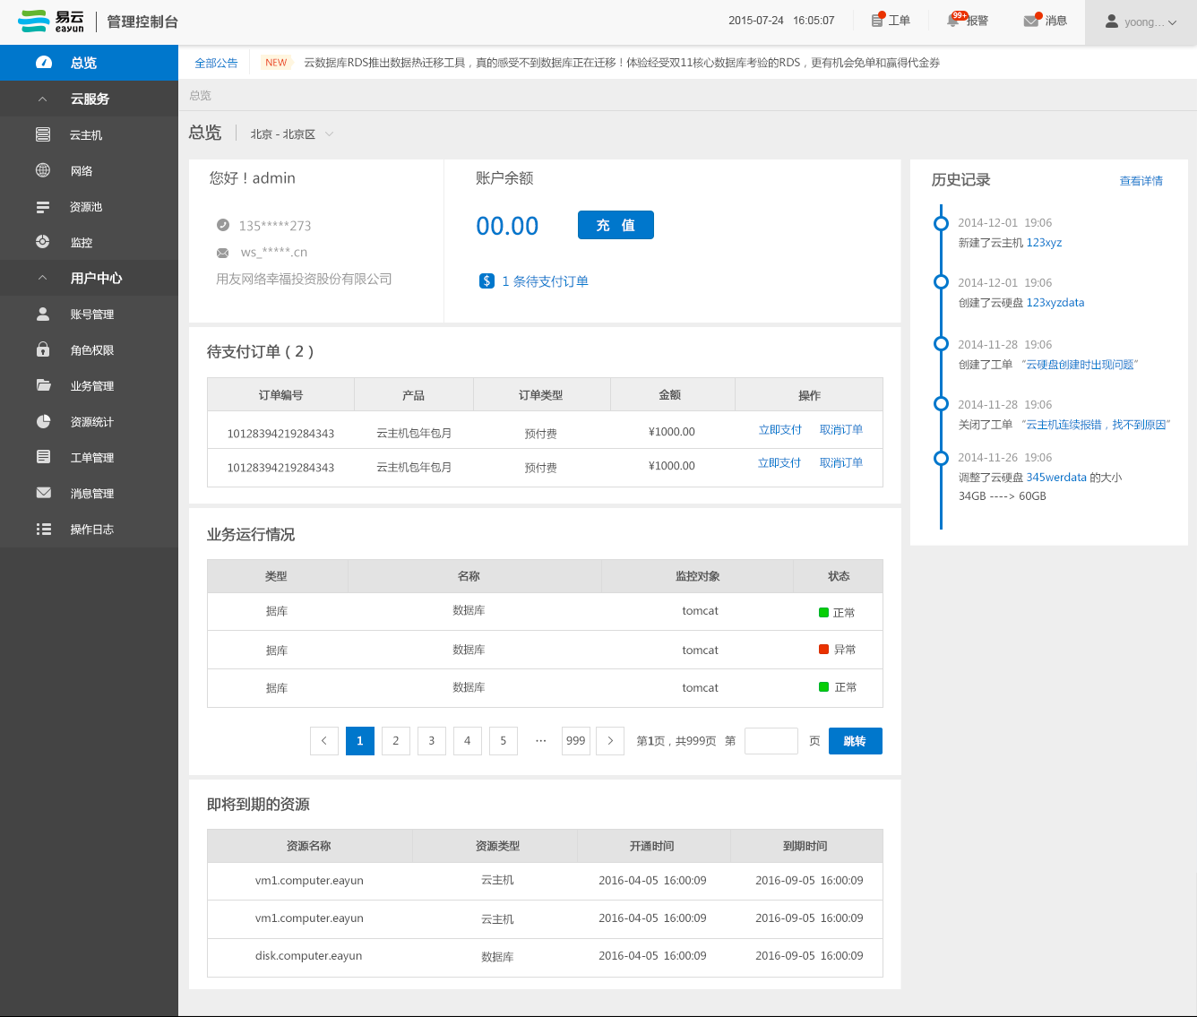
总览页面主要分为数据中心、基本信息、账户余额、待支付订单、业务运行情况、即将到期资源、公告和历史记录组成。
这里的数据中心显示用户在该数据中心下有项目的数据中心，然后，如果是普通用户登录，只显示该用户有权限的数据中心；与之相关，账号管理模块，原先的分配项目逻辑改为分配数据中心。切换数据中心受影响模块：业务运行情况（根据上一版逻辑定）、即将到期资源。
基本信息显示用户登录账号、手机号、邮箱、公司中文名称。这里的手机号和邮箱指的是当前登录用户的手机号和邮箱。
账户余额显示目前客户的账户余额，充值按钮，点击进入充值页面，待支付订单数，有待支付订单时，可点击进入待支付订单页面，没有时，置为灰色，不可点击。
待支付订单列表，5条一页，只有两个操作“立即支付”和“取消订单”。
业务运行情况与上一版保持一致，最多只展示三条，可点击去处理按钮。这里上一版其实只是写了一个固定的表头，新需求确认：展示最新三条未处理的云监控报警信息。
即将到期资源，列表展示资源名称、资源类型、创建时间、到期时间，5条一页；展示距离到期时间还有三个自然日的资源，按照最先到期的排在前面。这里只展示通过包年包月方式购买的资源，目前只有六种类型：云主机、云硬盘、私有网络、负载均衡、弹性公网IP、VPN。创建时间：资源创建时间。
公告，在页面上方滚动条区域展示公告，点击全部公告，弹出框内分页显示全部公告标题，时间倒序展示，点击标题，右侧显示详情。点击滚动区域弹出框显示该条公告详情。
如图所示：左侧显示所有公告标题，右侧显示详情。左右均使用滚动条
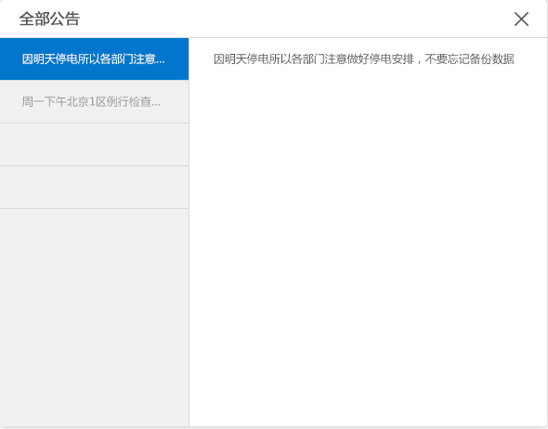
历史记录，展示ecsc日志，倒序显示五条，点击查看全部可跳转日志页面。这里需要根据新的ecsc日志记录信息展示内容。登录、退出日志不显示

关键业务流程图

获取即将到期资源列表
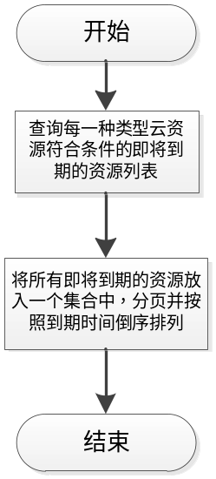

Model设计

AboutToExpire
AboutToExpire即将到期的资源
功能说明 | 用于总览页展现
字段类型 | 字段名称 | 字段含义 | 默认 | 备注
String | resourcesId | 资源id
String | resourcesName | 资源名称
String | resourcesType | 资源类型
Date | createTime | 创建时间
Date | endTime | 到期时间
String | prjId | 项目ID

原User对象增加字段cusCpname（公司中文名称）

Controller设计

模块规划
类名 | 说明 | 描述
com.eayun.virtualization.service.OverViewController
com.eayun.virtualization.service.OverviewService
com.eayun.virtualization.service.impl.OverviewServiceImpl
com.eayun.virtualization.bean. AboutToExpire

OverViewController(/sys/overview)

getValidDcList(getvaliddclist)
说明 | 查询有效的数据中心，有效是指，首先，该客户在此数据中心下有项目，其次，如果登录的是普通用户，需有此数据中心的权限
URL | /sys/overview/getvaliddclist.do
方式 | post
Post数据 | {}
返回Json | {  "respCode":"000000",  "data":{  "projectId ":"" //项目id  "dcId ":"" //数据中心id  "dcName":""//数据中心名称  参考CloudProject对象  }......  }  ----失败--------------------------------------------------  {  "respCode":"010120",  }

getToExpireResources(gettoexpireresources)
说明 | 获取即将到期的资源列表
备注 | 按照类别把所有即将到期的资源都查出来，5条一页
URL | /sys/overview/gettoexpireresources.do
方式 | post
Post数据 | {  "Page":""  "prjId":""  }
返回Json | {  Page:""  "data":[  "resourcesName ":""//资源名称  "resourcesType ":""//资源类型  ......  参考AboutToExpire对象  ]  }

getToPayOrderPage(gettopayorderpage)
说明 | 获取待支付订单列表
备注 | 分页显示，五条一页，与相关负责人协商。（曾波）
URL | /sys/overview/gettopayorderpage.do
方式 | post
Post数据 | {  "Page":""  }
返回Json | {  Page:""  "data":[  "orderId":"" //订单ID  "prodName":"" //产品名称  "payType":"" //支付类型  "paymentAmount":""//金额  ... ...参考orderInfo对象  ]... ...  }

UserController(/sys/user)

getUserMessage(/getusermessage)
说明 | 获取客户基本信息
备注 | 包含当前登录用户账户名称、手机号、邮箱和公司中文名称
URL | /sys/user/getusermessage.do
方式 | post
Post数据 | {}
返回Json | {  "userAccount ":""  "userPhone ":""  "userEmail ":""  "cusCpname":""  参考User对象  }

AccountOverviewController(/costcenter/accountoverview)

/getaccountbalance
说明 | 获取客户当前账户余额，与相关负责人协商。（翔宇）
URL | /costcenter/accountoverview /getaccountbalance.do
方式 | post
Post数据 | {}
返回Json | {  "money":"",//当前金额  }

LogController(/sys/log)

getLastLogs(getlastlogs)
说明 | 获取最新的5条日志信息展示，（新增方法）
URL | /sys/log/getlastlogs.do
方式 | post
Post数据 | {}
返回Json | {  "respCode":"000000",  "data":{  "actItem":"" //操作项  "actPerson":"" //操作者  ......参考SysLog对象  }......  }  ----失败--------------------------------------------------  {  "respCode":"010120",  }

AlarmController(/monitor/alarm)

getUnhandledAlarmMsgList(getUnhandledAlarmMsgList)
说明 | 获取最新的三条未处理的报警信息，（修改原方法）
URL | /monitor/alarm/getUnhandledAlarmMsgList.do
方式 | post
Post数据 | {  "prjId ":""  }
返回Json | {  "vmName ":"" //主机名称  "alarmType ":"" //报警类型  "time ":"" //报警时间  "detail ":"" //报警信息  参考AlarmMessage对象  }... ...

NoticeController(/sys/notice)

getNoticeList(/getNoticeList)
说明 | 滚动显示公告（使用原方法）
URL | /sys/notice/getNoticeList.do
方式 | post
Post数据 | {}
返回Json | {  "hasListOrNot ":"true"  "notice ":[  {  "memo ":""//标题  "validTime ":""//生效时间  ... ... 参考Notice对象  }  ]  }

getNoticeDetail(/getNoticeDetail)
说明 | 公告详情页（使用原方法）
URL | /sys/notice/ getNoticeDetail.do
方式 | post
Post数据 | {  "noticeId ":""  }
返回Json | {  "memo ":""//标题  "":""  ... ... 参考Notice对象  }

Service设计

OverviewService
改版后ECSC对用户隐藏了项目的概念，但底层逻辑不变，因此查询条件仍为项目ID

getValidDcList
查询客户有效的数据中心列表
List<Object> list = new ArrayList<Object>();
StringBuffer sql = new StringBuffer();
sql.append(" SELECT ");
sql.append(" cp.prj_id as prjId, ");
sql.append(" cp.prj_name as prjName, ");
sql.append(" cp.dc_id as dcId, ");
sql.append(" dc.dc_name as dcName ");
sql.append(" from ");
if(sessionUser.getIsAdmin()){
sql.append(" cloud_project ");
}
else{
sql.append(" ( ");
sql.append(" SELECT ");
sql.append(" s.project_id as prj_id,");
sql.append(" p.prj_name as prj_name,");
sql.append(" p.dc_id as dc_id ,");
sql.append(" p.customer_id as customer_id ");
sql.append(" from sys_selfuserprj s ");
sql.append(" left join cloud_project p ");
sql.append(" on s.project_id=p.prj_id ");
sql.append(" where s.user_id = ? ");
sql.append(" )");
list.add(sessionUser.getUserId());
}
sql.append(" cp");
sql.append(" join dc_datacenter dc on cp.dc_id = dc.id");
sql.append(" where cp.customer_id = ? ");
list.add(sessionUser.getCusId());

getToExpireResources
//获取即将到期资源
第一种方法先根据条件查出各自的数据，在联合查询
SELECT
vm.vm_id AS resources_id,
vm.vm_name AS resources_name,
vm.create_time AS create_time,
vm.end_time AS end_time,
'云主机' AS resources_type,
vm.prj_id AS prj_id
FROM
cloud_vm vm
WHERE
vm.pay_type = '1'
AND vm.is_deleted = '0'
AND vm.charge_state = '0'
AND vm.end_time < ?
AND vm.end_time >?
AND vm.prj_id = ?
UNION
SELECT
vol.vol_id AS resources_id,
vol.vol_name AS resources_name,
vol.create_time AS create_time,
vol.end_time AS end_time,
'云硬盘' AS resources_type,
vol.prj_id AS prj_id
FROM
cloud_volume vol
WHERE
vol.pay_type = '1'
AND vol.is_deleted = '0'
AND vol.charge_state = '0'
AND vol.end_time < ?
AND vol.end_time >?
AND vol.prj_id = ?
UNION
SELECT
net.net_id AS resources_id,
net.net_name AS resources_name,
net.create_time AS create_time,
net.end_time AS end_time,
'私有网络' AS resources_type,
net.prj_id AS prj_id
FROM
cloud_network net
WHERE
net.pay_type = '1'
AND net.charge_state = '0'
AND net.end_time < ?
AND net.end_time >?
AND net.prj_id = ?
UNION
SELECT
pool.pool_id AS resources_id,
pool.pool_name AS resources_name,
pool.create_time AS create_time,
pool.end_time AS end_time,
'负载均衡' AS resources_type,
pool.prj_id AS prj_id
FROM
cloud_ldpool pool
WHERE
pool.pay_type = '1'
AND pool.charge_state = '0'
AND pool.end_time < ?
AND pool.end_time >?
AND pool.prj_id = ?
UNION
SELECT
flo.flo_id AS resources_id,
flo.flo_ip AS resources_name,
flo.create_time AS create_time,
flo.end_time AS end_time,
'弹性公网IP' AS resources_type,
flo.prj_id AS prj_id
FROM
cloud_floatip flo
WHERE
flo.pay_type = '1'
AND flo.is_deleted = '0'
AND flo.charge_state = '0'
AND flo.end_time < ?
AND flo.end_time >?
AND flo.prj_id = ?
UNION
SELECT
vpn.vpn_id AS resources_id,
vpn.vpn _name AS resources_name,
vpn.create_time AS create_time,
vpn.end_time AS end_time,
'VPN' AS resources_type,
ser.prj_id AS prj_id
FROM
cloud_vpncon vpn
JOIN cloud_vpnservice ser ON vpn.vpnservice_id = ser.vpnservice_id
WHERE
vpn.pay_type = '1'
AND vpn.charge_state = '0'
AND vpn.end_time < ?
AND vpn.end_time >?
AND ser.prj_id = ?
ORDER BY
create_time DESC;
第二种方法，先联合查询所有，再根据条件筛选
SELECT
*
FROM
(
SELECT
vm.vm_id AS resources_id,
vm.vm_name AS resources_name,
vm.create_time AS create_time,
vm.end_time AS end_time,
'云主机' AS resources_type,
vm.prj_id AS prj_id,
vm.pay_type AS pay_type,
vm.charge_state AS charge_state
FROM
cloud_vm vm
UNION
SELECT
vol.vol_id AS resources_id,
vol.vol_name AS resources_name,
vol.create_time AS create_time,
vol.end_time AS end_time,
'云硬盘' AS resources_type,
vol.prj_id AS prj_id,
vol.pay_type AS pay_type,
vol.charge_state AS charge_state
FROM
cloud_volume vol
UNION
SELECT
net.net_id AS resources_id,
net.net_name AS resources_name,
net.create_time AS create_time,
net.end_time AS end_time,
'私有网络' AS resources_type,
net.prj_id AS prj_id,
net.pay_type AS pay_type,
net.charge_state AS charge_state
FROM
cloud_network net
UNION
SELECT
pool.pool_id AS resources_id,
pool.pool_name AS resources_name,
pool.create_time AS create_time,
pool.end_time AS end_time,
'负载均衡' AS resources_type,
pool.prj_id AS prj_id,
pool.pay_type AS pay_type,
pool.charge_state AS charge_state
FROM
cloud_ldpool pool
UNION
SELECT
flo.flo_id AS resources_id,
flo.flo_ip AS resources_name,
flo.create_time AS create_time,
flo.end_time AS end_time,
'弹性公网IP' AS resources_type,
flo.prj_id AS prj_id,
flo.pay_type AS pay_type,
flo.charge_state AS charge_state
FROM
cloud_floatip flo
UNION
SELECT
vpn.vpn_id AS resources_id,
vpn.vpn _name AS resources_name,
vpn.create_time AS create_time,
vpn.end_time AS end_time,
'VPN' AS resources_type,
ser.prj_id AS prj_id,
vpn.pay_type AS pay_type,
vpn.charge_state AS charge_state
FROM
cloud_vpncon vpn
JOIN cloud_vpnservice ser ON vpn.vpnservice_id = ser.vpnservice_id
) AS result
WHERE
result.pay_type = '1'
AND result.charge_state = '0'
AND result.end_time < ?
AND result.end_time >?
AND result.prj_id = ?
ORDER BY
result.create_time DESC;
经测试第二种方法比第一种方法慢3-5倍，因此采用第一种方法

