Task 1

**Simulating geometric Brownian motion**

dS(t) = 0.1 dt + 0.26 dB(t); S(0) = 39 ; ;

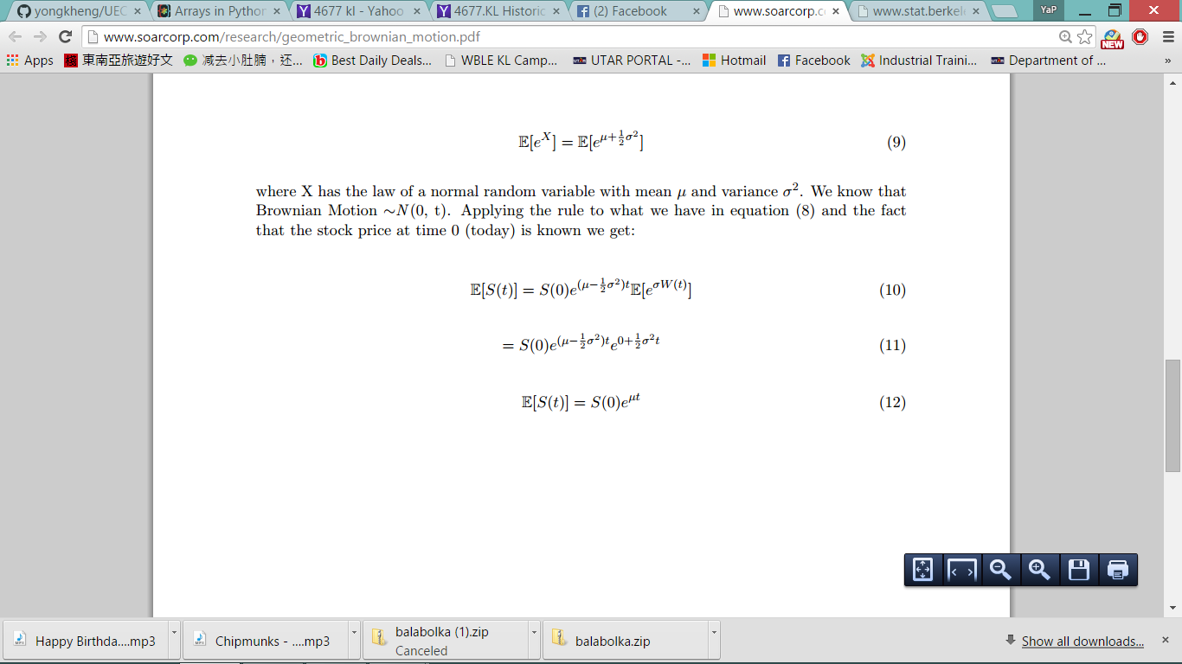

E[S(3)] = 39= 52.6444

Var[S(t)] =

Var[S(3)] =

1. Expectation value of S(3) is calculated by taking the sum of values from last column for each path and divide it by the total number of paths.
2. To calculate variance of S(3), we apply the formula . You need to use the stock prices - the expected value and squared it, use the sum of squared value divide by number of paths -1, you should be able to obtain the variance.
3. Calculate P[S(3) > 39].To calculate this, we use for loop and if statement here. Since we have 1000 paths, the loop will run five time *in range (1000)*. During each run, if the 1000th value (last value) of each path exceed 39, variable *count* will be updated from 0. So the probability can be obtain by using the count number divide by number of paths.
4. Calculate E[S(3) | S(3) > 39]. To calculate this, we use for loop and if statement here just like previous. For this not only variable *count* will be updated, the value of the price which exceed 39 will be sum up to the variable *total*. So the conditional expectation can be obtain by using the divide by count number.

#### Simulating mean reversal process

1. Calculate expectation value of R(1) is calculated by taking the sum of values from last column for each path and divide it by the total number of paths.
2. Calculate P[R(1) > 2]. To calculate this, we use for loop and if statement here. Since we have 1000 paths, the loop will run 1000 time *in range (1000)*. During each run, if the 1000th value (last value) of each path exceed 2, variable *count* will be updated from 0. So the probability can be obtain by using the count number divide by number of paths.

Task 2

1. Investigate the FTSE Bursa Malaysia KLCI Index

There are 30 component stocks in FTSEKLCI .

|  |  |  |  |  |  |
| --- | --- | --- | --- | --- | --- |
| Component stocks in FTSEKLCI index | | | | | |
| **Stock Name** | **Stock Code** | **Stock Sector** | **Weightage in FTSEKLCI (%)** | **PE Ratio** | **Net Market Capital (B)** |
| Public Bank Bhd | 1295 | Banks | 11.6 | 15.2 | 73.29 |
| Malayan Banking | 1155 | Banks | 9.32 | 12.39 | 87.75 |
| Tenaga Nasional | 5347 | Alternative Electricity | 9.28 | 9.31 | 69.76 |
| CIMB Group Holdings | 1023 | Banks | 5.76 | 17.51 | 46.52 |
| Axiata Group Bhd | 6888 | Mobile Telecommunications | 5.62 | 24.31 | 55.43 |
| Sime Darby Bhd | 4197 | Diversified Industrials | 5.51 | 20.8 | 52.09 |
| Digi.com | 6947 | Mobile Telecommunications | 4.16 | 20.81 | 42.06 |
| Genting | 3182 | Hotels | 3.68 | 16.5 | 30.86 |
| PETRONAS Chemicals Group Bhd | 5183 | Commodity Chemicals | 3.55 | 22.07 | 51.2 |
| Maxis Bhd | 6012 | Mobile Telecommunications | 3.45 | 29.73 | 48.88 |
| Petronas Gas | 6033 | Exploration & Production | 3.4 | 22.51 | 42.23 |
| IHH Healthcare | 5225 | Health Care Providers | 3.28 | 63.12 | 48.25 |
| IOI | 1961 | Farming & Fishing | 2.99 | 66.31 | 27.24 |
| Telekom Malaysia | 4863 | Fixed Line Telecommunications | 2.96 | 32.79 | 24.88 |
| Genting Malaysia Bhd | 4715 | Hotels | 2.5 | 20.14 | 23.99 |
| MISC | 3816 | Marine Transportation | 2.45 | 16.28 | 35.89 |
| AMMB Holdings | 1015 | Banks | 2.38 | 9.22 | 17.67 |
| Kuala Lumpur Kepong | 2445 | Farming & Fishing | 2.28 | 29.83 | 24.49 |
| SapuraKencana Petroleum | 5218 | Oil Equipment & Services | 1.98 | 11.97 | 14.15 |
| PBB Group | 4065 | Food Products | 1.8 | 17.74 | 17.83 |
| British American Tobacco (Malaysia) | 4162 | Tobacco | 1.7 | 20.67 | 19.02 |
| Hong Leong Bank | 5819 | Banks | 1.67 | 11.01 | 23.66 |
| YTL Corp | 4677 | Multiutilities | 1.63 | 14.81 | 16.67 |
| UMW Holdings | 4588 | Automobiles | 1.37 | 20.4 | 11.87 |
| Astro Malaysia Holdings | 6399 | Broadcasting & Entertainment | 1.22 | 28.41 | 15.81 |
| Petronas Dagangan Bhd | 5681 | Intrgrated Oil & Gas | 1.21 | 37.12 | 20.5 |
| RHB Capital | 1066 | Banks | 1.06 | 9.47 | 19.58 |
| Westports Holdings | 5246 | Transportation Services | 0.93 | 27.44 | 14.36 |
| Hong Leong Financial | 1082 | Banks | 0.64 | 10.21 | 16.62 |
| KLCC Prop & Reits - Stapled Sec | 5235SS | Real Estate Holding & Development | 0.63 | 26.42 | 12.64 |

1. Explanation on how to obtain the 5-day moving average.

After obtain the closing price, we use function of *movingaverage* to get the 5-day moving average value. Before using the formula we have to define the function, *movingaverage (values,window)* where parameter window refer to the number of day of moving average.