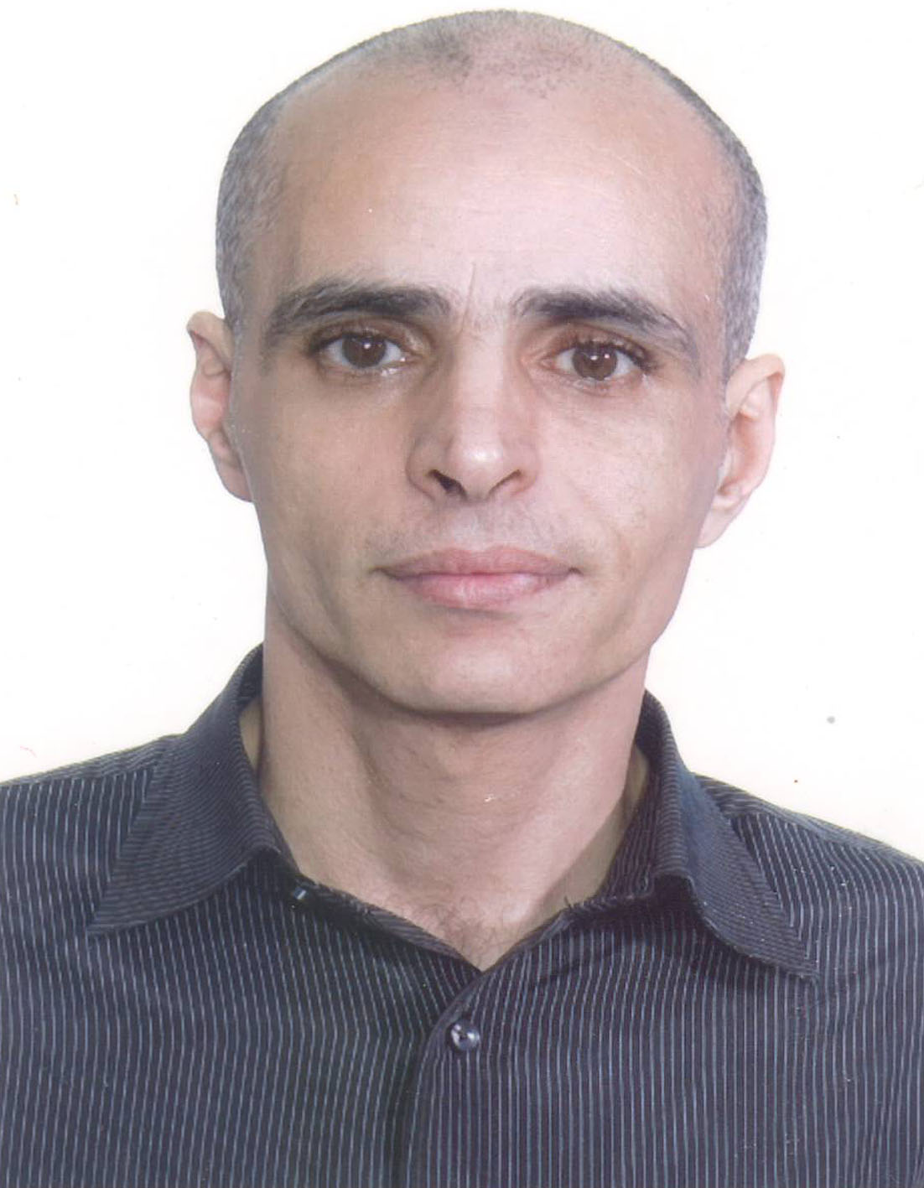
Sherif Barakat

20-years’ experience in IT, including 7 years working for an Oil & Gas industry. Wide technical knowledge in programming languages, databases, data analysis and business intelligence.

Birthdate | : 28/12/1977
Home Country | : Egypt
Country of Residence | : Malaysia
Cellphone | : +60 176439060
Languages | : English, Arabic
E-Mail | : sherifmagdy.barakat@yahoo.com
Education
- Currently, at last stage of PhD in computer science (Expected graduation in July 2021).
- Master degree in science of computing (Staffordshire University- APIIT- Malaysia) - June/2013.
- Postgraduate Diploma in Computing (Staffordshire University- APIIT- Malaysia) -November/2012.
- Certificate in Computing (Staffordshire University- APIIT- Malaysia) - May/2012.
- BCs. Agriculture from Cairo University (Botany and Genetics)- January/2002
Publications
- Journal of Education and Vocational Research
- Vol. 4, No. 3, pp. 60-68, Mar 2013 (ISSN 2221-2590)
- Title: Enhanced UML Methodology with New Hybrid Diagrams: An ATM Application
Certificates
- (MCT) Microsoft Certified Trainer October 11, 2017
- Microsoft Certified Solutions Expert: Data Management and Analytics Charter Member
- September 26, 2016
- Microsoft Certified Solutions Expert: Business Intelligence March 1, 2015
- Microsoft Certified Solutions Associate: SQL Server 2012/2014 October 31, 2014
- Microsoft Certified Professional August 29, 2014
- Microsoft Certified Professional November 30, 2005

Skills Profile
- Programming C++, C#, Java, Python.
- ASP.net MVC Core 3.1 (C#, HTML 5, CSS 3, Java script).
- Database MSSQL (Querying, data warehouse, encryption, SSIS, administration, development, high availability and performance Tuning).
- Design and implementation of ETL and big data project.
- Database Oracle (Querying, Administration and Data Warehouse).
- Database MYSQL (Querying, Administration, and Development).
- IBM DB2 database.
- Mongo DB.
- Analyzing Data with Power BI.
- Automotive administration with PowerShell.
- Developing cloud solutions in Azure.
- Advanced data analysis and business intelligence
Recent Working Experience
August 2017 – Up to date |  | Microsoft Certified Trainer  (Freelance)
November 2016 – August 2017 |  | Computer Science Lecturer  Thebes Academy-Egypt
September 2015 – October 2016 |  | Data Structure & Programming Trainer  Alex Library – Cairo Branch
December 2013 – July 2015 |  | IT programmer information system and technology  Bumi Armada Berhad - Malaysia
September 2008 – August 2013 |  | IT Specialist & Data Controller  Asian Geos Sdn Bhd - Malaysia

PREVIOUS RELEVANT EXPERIENCE
- Computer crime & advanced networking instructor in Ministry of Interior-Egypt (2005-2008-Full time).
- Trainer ICDL and Networks at ICI-Egypt (2005-2008-Part time).
- Installation and Maintenance Manager in Misria for computer systems -Egypt (2004-2005).
- Power House for generators as a IT technical support-Egypt ( 2003 – 2004).
- Modern Educational School as a technical support-Egypt (2002 – 2003).
- Morocco Embassy in Cairo as a technical support-Egypt (2002 – 2003).
- Trainer in Russian Culture Center-Egypt (2002 – 2003-Part time).
- Network Administrator and technical support at Diabetes Institute -Egypt (2000-2002 -Full Time).

Language Skills
- Arabic - Mother language
- English - Fluent
Hobbies
- Reading.
- Travelling.
- Gym

