**Project Name :** AmAccessBiz PC2  
**Test Script ID :** AABAA_QRPay_PayToP2P_06  
**Platform :** Windows 10  
**App Version :**   
**Run Date :** 02/27/2024  
**Run Started :** 12:37:02  
**Run Ended :** 12:39:36  
**Execution Time :** 00hrs 02mins 34secs   
**Execution Status :** Failed  
  
  
**Test Step 1(PASS) :** [CFO] Input [User ID]  
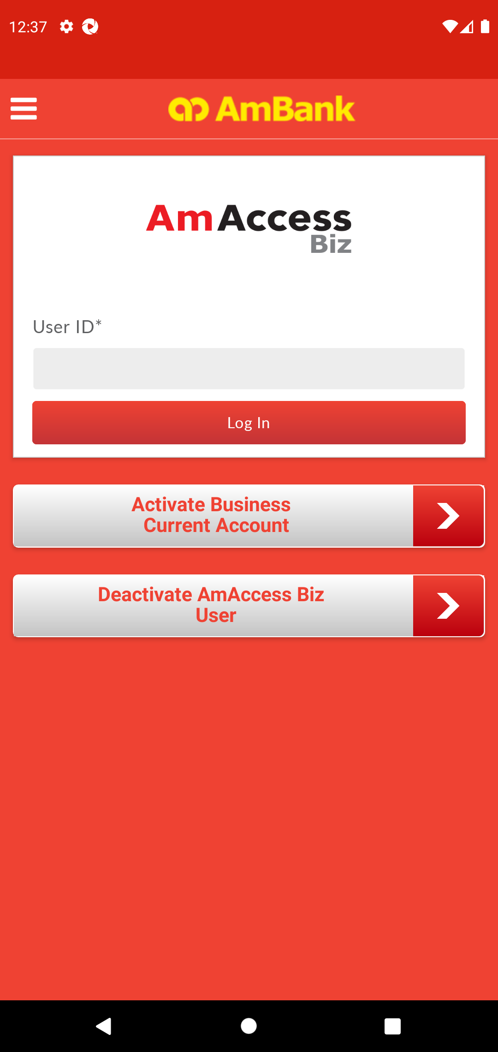  
  
**Test Step 2(PASS) :** [CFO] Click [Log In]  
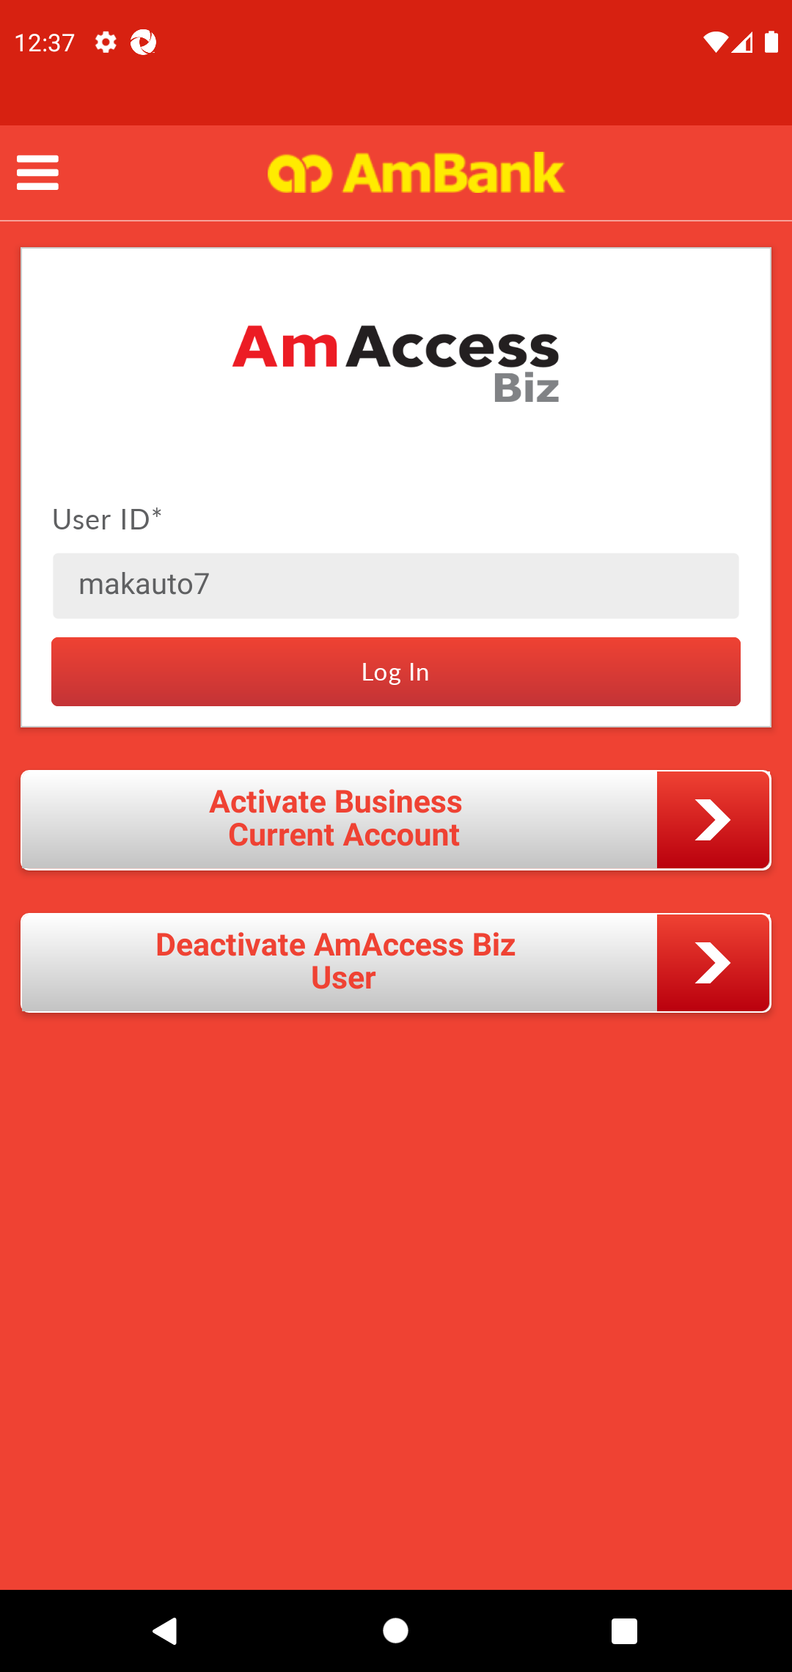  
  
**Test Step 3(PASS) :** [CFO] Click [Yes]  
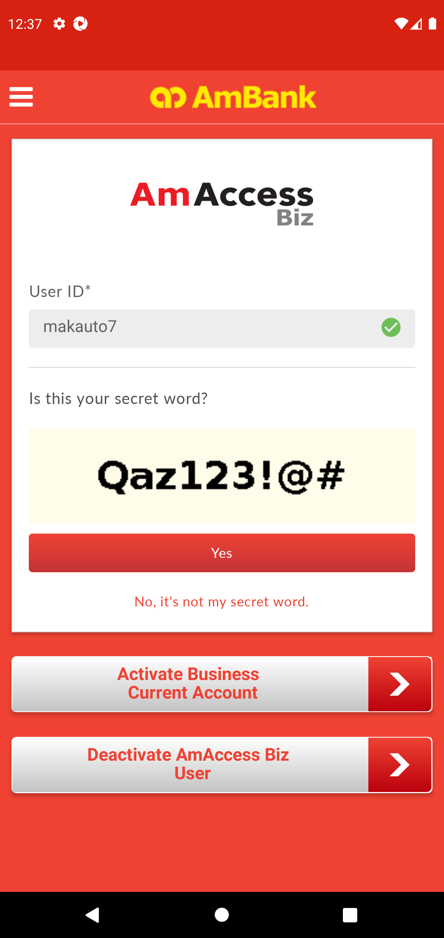  
  
**Test Step 4(PASS) :** [CFO] Input [Password]  
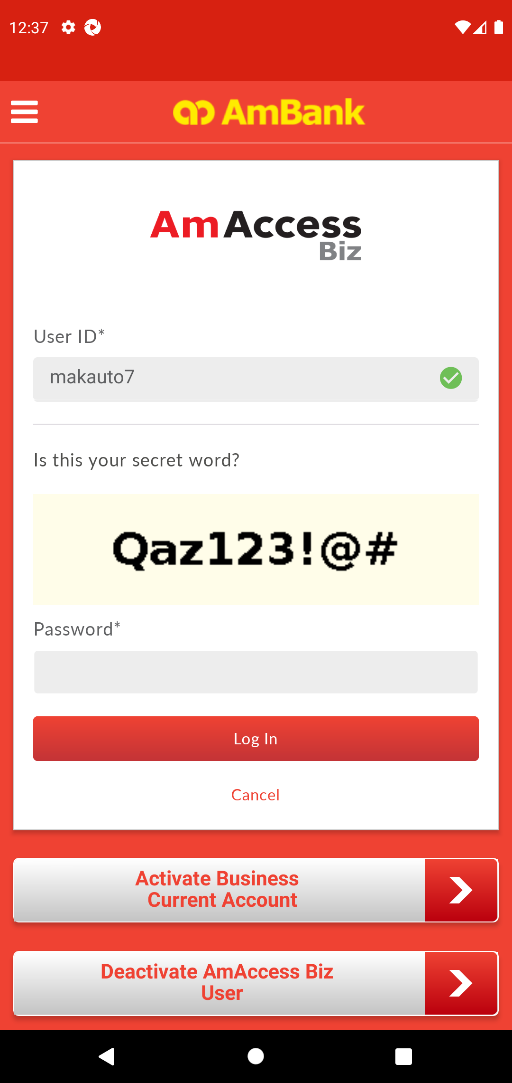  
  
**Test Step 5(PASS) :** [CFO] Click [Log In]  
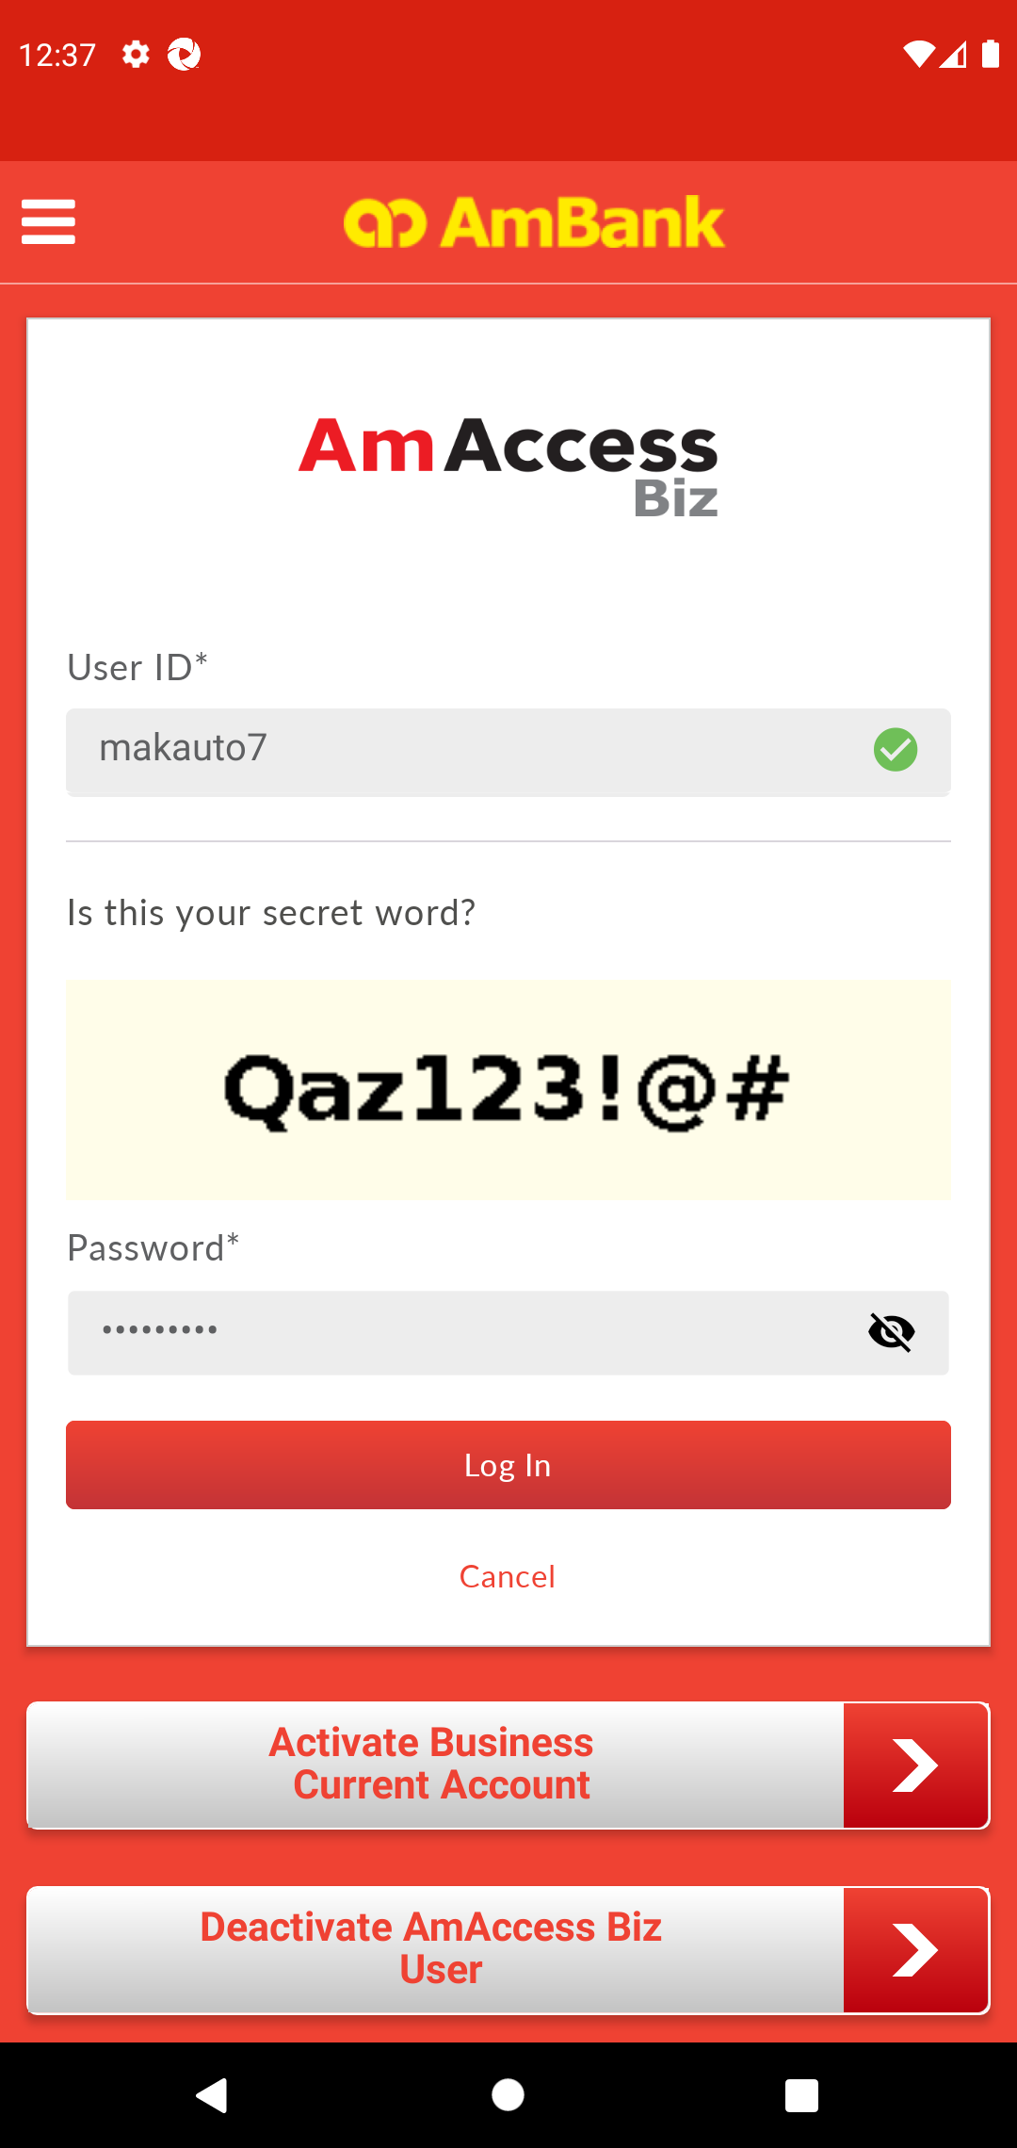  
  
**Test Step 6(PASS) :** [Home] Click [+] Button  
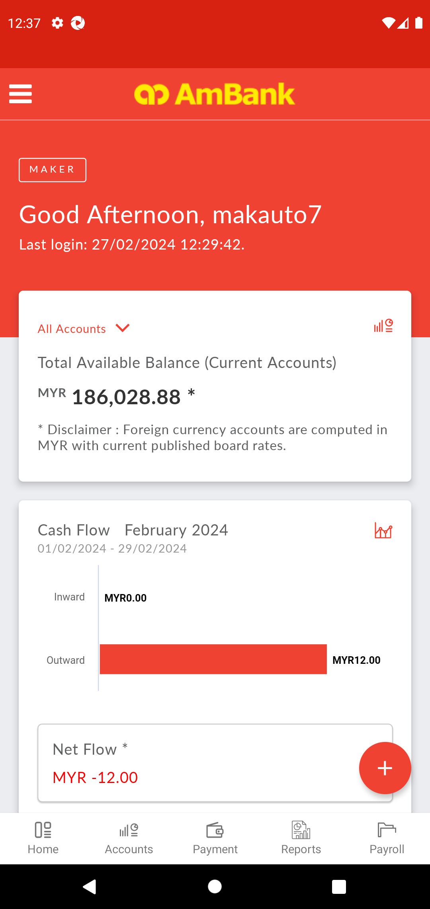  
  
**Test Step 7(PASS) :** Swipe Up  
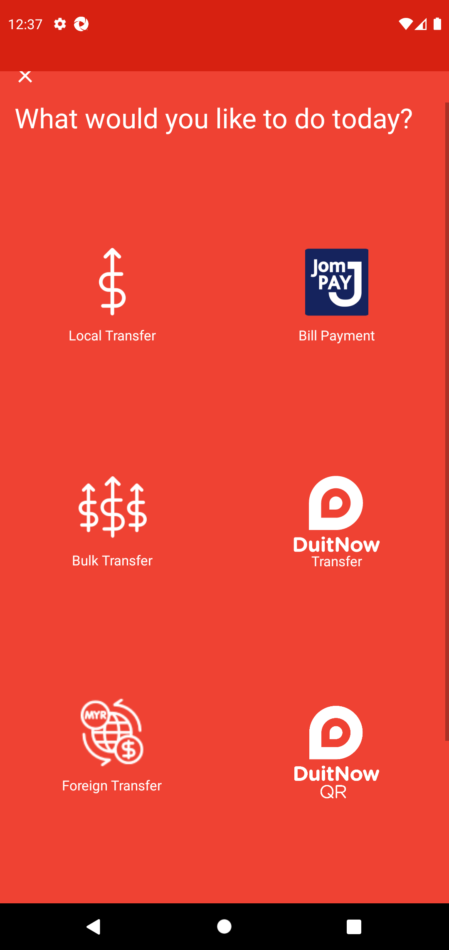  
  
**Test Step 8(PASS) :** [Home] Click [QR Pay] Button  
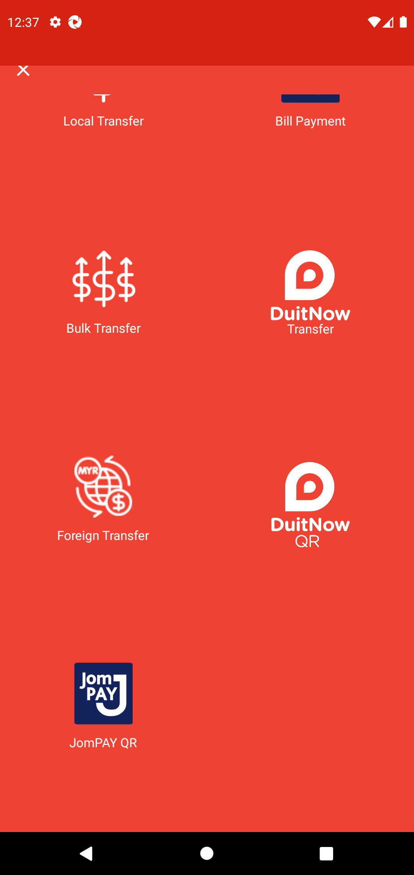  
  
**Test Step 9(PASS) :** screenshot  
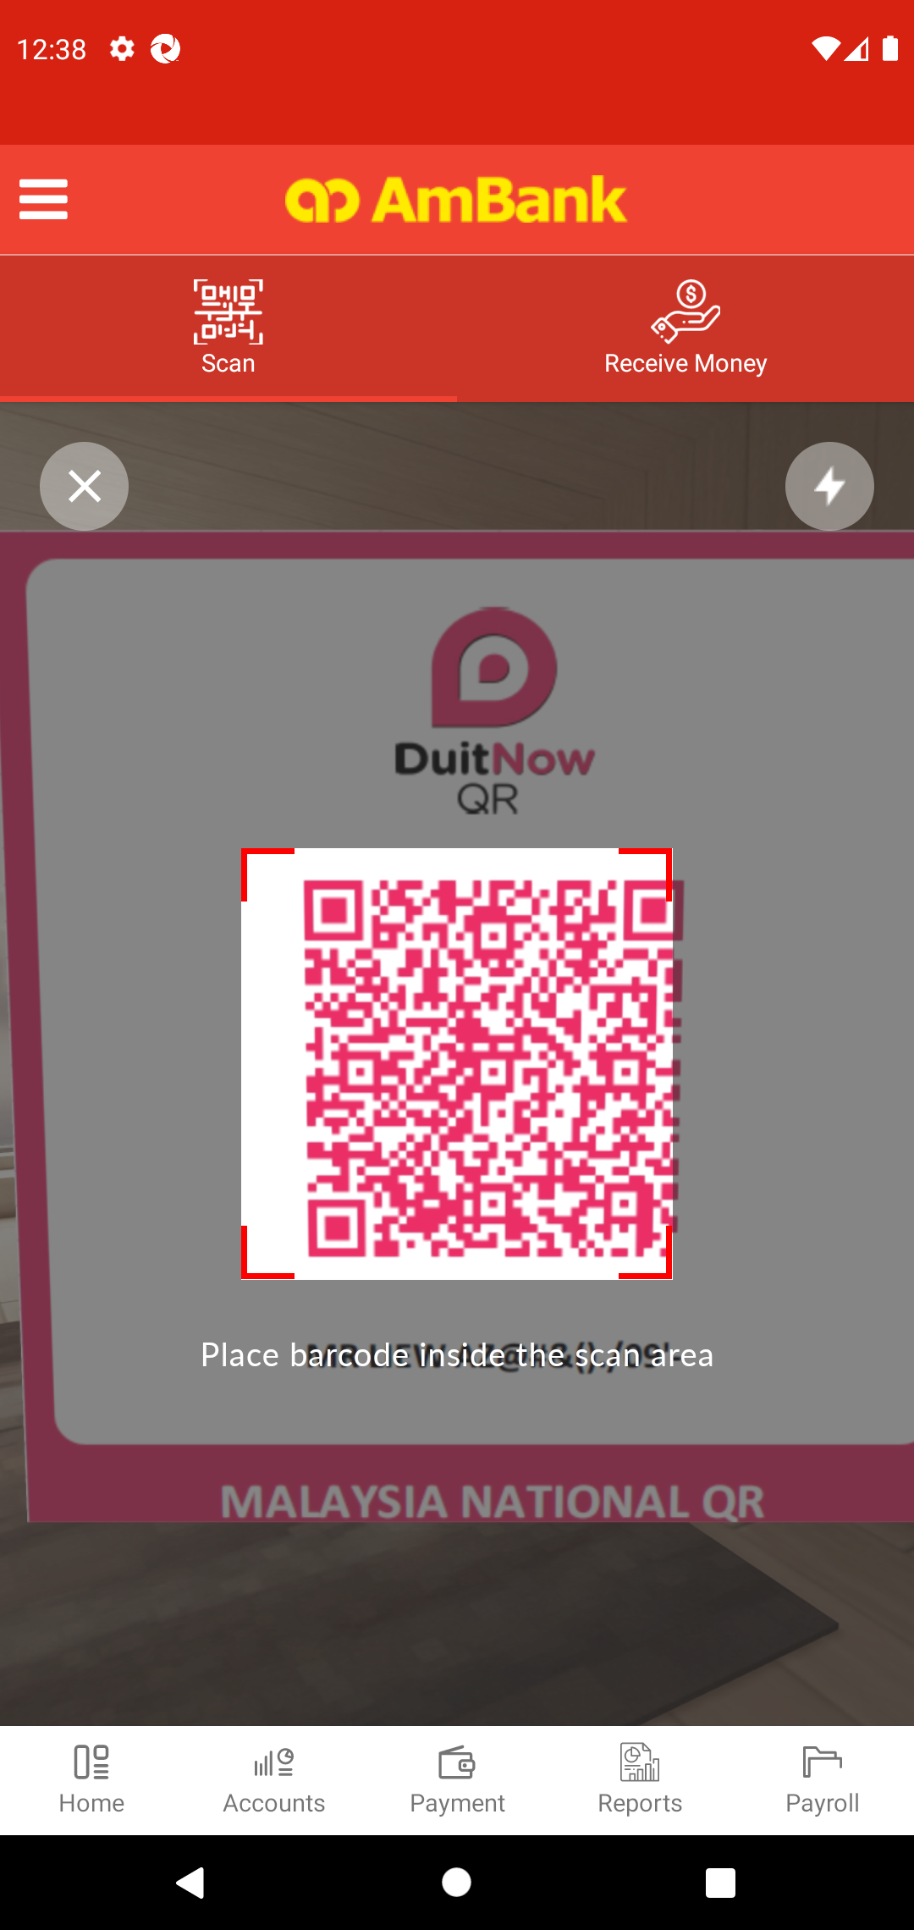  
  
**Test Step 10(FAIL) :** Swipe Up to Recipient Resident Status  
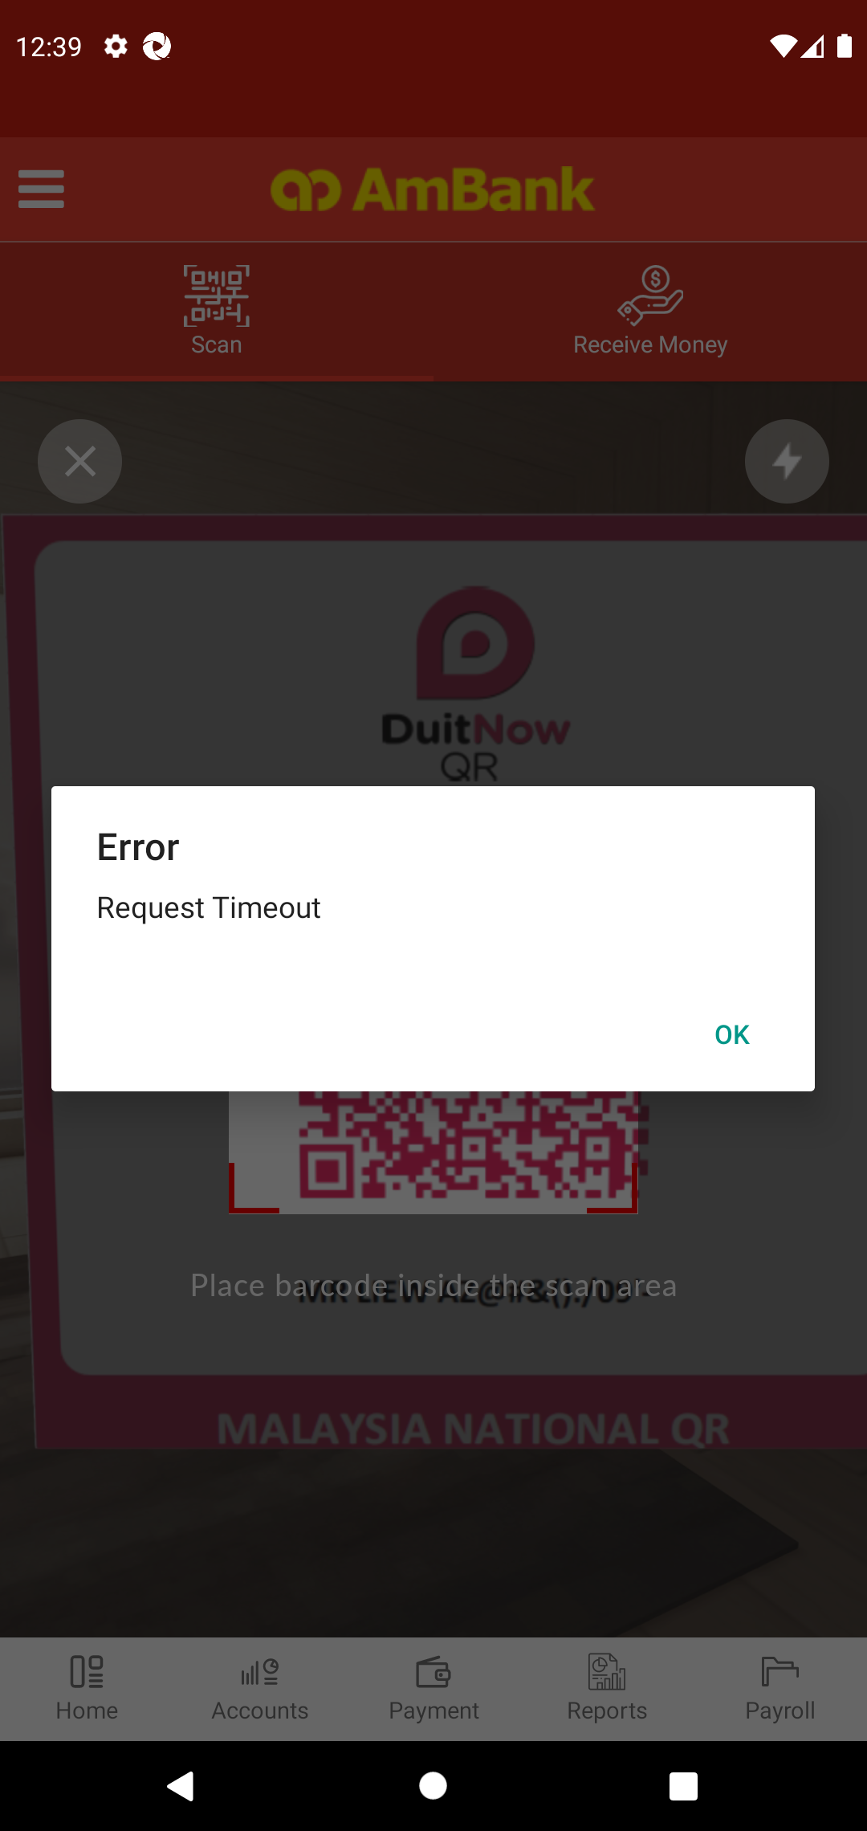  
  
**---------------------------------------- The End ----------------------------------------**