CRM Forms
Sales Managers - Create Lead Form
Lead Information
Field | What should be entered? | Required?
Lead Name | A short name that identifies the opportunity, e.g. “ABC Company CRM Development”. | Yes
Lead Source | How the company received the lead: Website, Referral, Email, Phone Call, social media, etc. | Yes
Lead Description | A short summary of what the opportunity is about. | Yes
Lead Status | The current stage of the lead, such as New. The system should normally set this automatically when the lead is created. | Auto-filled
Priority | How important or urgent the lead is: Low, Medium, or High. | Optional

Question based on Priority
Priority | What it means | Example
Low - No immediate action required. | The opportunity is not urgent, and there is no immediate action required. | A client is interested in a CRM but has not decided when they want to start.
Medium - Requires normal follow-up. | The opportunity is important, but there is no immediate deadline. | A client wants a CRM and expects to discuss the project within the next few weeks.
High - Requires urgent attention. | The opportunity needs attention quickly because of an urgent deadline, important client, or immediate business opportunity. | A client needs a proposal within three days because they are planning to start the project next month.
Organization / Client Information
Field | What should be entered? | Required?
Organization / Company Name | The name of the company is interested in the opportunity. | Yes
Industry | The company's business sector, e.g. IT, Healthcare, Finance. | Optional
Company Size | Approximate number of employees or company size category. | Optional
Website | The company's website address, if available. | Optional

Primary Contact Information
Field | What should be entered? | Required?
Contact Person Name | The name of the person who is interested in the service. | Yes
Job Title | Their position, e.g. Manager, Director, CEO. | Yes
Email Address | The email address used for communication. | Yes
Phone Number | The contact number, if available. | Optional
Preferred Contact Method | Email, Phone, Meeting, etc. | Optional

Initial Requirements
Field | What should be entered? | Required?
Client's Initial Requirement | What the client says they need. | Yes
Problem / Business Need | The problem the client wants to solve. | Optional
Expected Solution / Service | The product or service the client is interested in. | Optional
Expected Project Timeline | When the client expects the project to be completed. | Optional

Initial Commercial Information
Field | What should be entered? | Required?
Estimated Budget | The amount the client expects to spend, if known. | Optional
Currency | The currency used for the budget, e.g. LKR, USD. | Optional
Expected Deal Value | The estimated value of the opportunity to the company. | Optional

Additional Information
Field | What should be entered? | Required?
Additional Notes | Any extra information the Sales Manager wants to record. | Optional
Attach Documents | Upload any documents received from the client. | Optional
What happens?
- The Sales Manager saves the Create Lead Form.
- The system creates the lead with status New.
- The Sales Manager opens the newly created lead.
- The Sales Manager selects to Assign Lead to Sales Representative.
- The system displays a list of available Sales Representatives.
- The Sales Manager selects a Sales Representative.
- The Sales Manager confirms the assignment.
- The system assigns the lead to that Sales Representative.
- The Sales Representative receives notification.
- The lead status changes from New to Assigned
Assign Lead Form
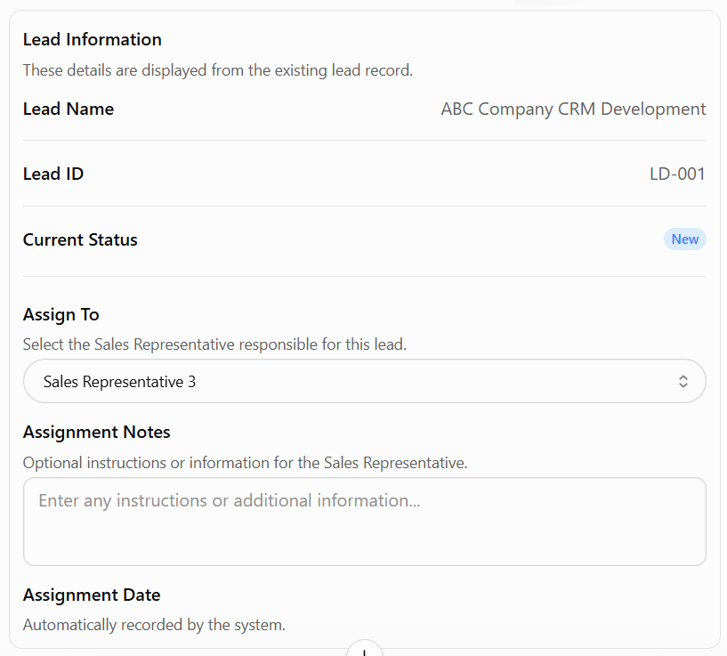
Now sales representative receives notification
Sales Rep should open the existing lead and use an Update Lead Details Form to add the information that was missing.

Sales Representative - Update Lead Details Form
Lead Information
Field | What should be entered? | Required?
Lead Name | A short name that identifies the opportunity, e.g. “ABC Company CRM Development”. | Yes
Lead Source | How the company received the lead: Website, Referral, Email, Phone Call, social media, etc. | Yes
Lead Description | A short summary of what the opportunity is about. | Yes
Lead Status | The current stage of the lead, such as New. The system should normally set this automatically when the lead is created. | Auto-filled
Priority | How important or urgent the lead is: Low, Medium, or High. | Optional

Question based on Priority
Priority | What it means | Example
Low - No immediate action required. | The opportunity is not urgent, and there is no immediate action required. | A client is interested in a CRM but has not decided when they want to start.
Medium - Requires normal follow-up. | The opportunity is important, but there is no immediate deadline. | A client wants a CRM and expects to discuss the project within the next few weeks.
High - Requires urgent attention. | The opportunity needs attention quickly because of an urgent deadline, important client, or immediate business opportunity. | A client needs a proposal within three days because they are planning to start the project next month.

Organization / Client Information
Field | What should be entered? | Required?
Organization Name | The name of the company is interested in the opportunity. | Yes
Industry | The company's business sector, e.g. IT, Healthcare, Finance. | Optional
Company Size | Approximate number of employees or company size category. | Optional
Website | The company's website address, if available. | Optional

Primary Contact Information
Field | What should be entered? | Required?
Contact Person Name | The name of the person who is interested in the service. | Yes
Job Title | Their position, e.g. Manager, Director, CEO. | Optional
Email Address | The email address used for communication. | Yes
Phone Number | The contact number, if available. | Optional
Preferred Contact Method | Email, Phone, Meeting, etc. | Optional

Detailed Project Requirements
Field | What should be entered?
Detailed Project Requirements | A full description of what the client wants.
Business Problem / Need | The actual problem the client wants to solve.
Expected Solution / Service | What the company is expected to provide.
Required Features | The specific features or services the client needs.
Number of Users / Scale | How many users, customers, or systems are involved.
Technical Requirements | Any preferred programming languages, frameworks, databases, software, or existing technologies mentioned by the client.
Platform Requirements | The type of platform the client expects, such as a web application, mobile application, desktop application, cloud-based system, or on-premises system.
Integration Requirements | Any existing systems, applications, APIs, or third-party services that the proposed solution must connect with.
Security Requirements | The client's security expectations, such as user authentication, role-based access, data encryption, secure document storage, or audit trails.
Performance Requirements | The client's expectations regarding system speed, availability, capacity, response time, or the number of users and transactions the system should support.
Other Technical Constraints | Any technical limitations or conditions, such as compatibility with existing infrastructure, required hardware, hosting restrictions, or software limitations.
Expected Project Timeline | The client's expected start date and completion date.
Additional Requirements | Any other important information collected from the client.

Example
Detailed Project Requirements: “The client requires a CRM system for approximately 100 users. The system should manage customers, leads, deals, and project information.”
Business Problem: “Customer information is currently scattered across spreadsheets and emails.”
Expected Solution: “A centralized CRM system.”
Required Features: “Lead management, customer management, deal tracking, and reporting.”
Technical Requirements: “Integration with the existing accounting system.”
Expected Timeline: “Six months.”
Commercial/ Financial Information
Field | What should be entered?
Estimated Budget | The budget the client expects to spend.
Currency | LKR, USD, etc.
Expected Deal Value | The estimated value of the opportunity.
Budget Confirmation | Whether the budget has been confirmed by the client.
Payment Terms | Any payment expectations discussed with the client.
Additional Financial Information | Any other financial details collected from the client.

Example
Estimated Budget: LKR 5,000,000 Currency: LKR Expected Deal Value: LKR 5,000,000 Budget Confirmation: Confirmed Payment Terms: Not discussed yet
Additional Information
Field | What should be entered?
Additional Notes | Any other information collected from the client.
Attach Documents | Upload requirement documents, quotations, emails, or other relevant files.

Record Client Interaction
Field | What it means | Required?
Interaction Type | Email / Phone Call / Meeting / Text Message | Yes
Date & Time | When the interaction happened | Yes
Contact Person | Who the Sales Rep communicated with | Yes
Subject / Purpose | Why they contacted the client | Yes
Interaction Summary | What was discussed | Yes
Client Requirements / Information Obtained | Important information learned from the client | Optional
Outcome | What was decided or achieved | Optional
Attachments | Meeting documents, email, quotation, etc. | Optional
Follow-up Required? | Yes / No | Yes

Interaction Type: Meeting
Date & Time: 08/09/2026 – 10:30 AM
Contact Person: John Silva
Subject: CRM Project Requirements Discussion
Summary: Discussed required CRM modules and number of users.
Information Obtained: Client requires approximately 100 users and integration with their accounting system.
Outcome: Client will provide the existing system documentation.
Follow-up Required: Yes

LEAD HISTORY

08 Sep 2026
Meeting
Sales Rep ↔ John Silva
Discussed CRM requirements.
Client requires 100 users and accounting integration.

05 Sep 2026
Phone Call
Sales Rep ↔ John Silva
Initial requirements discussed.

02 Sep 2026
Email
Requirement document received.

Schedule Follow Up
Field | What it means | Required?
Follow-Up Type | Call / Email / Meeting / Other | Yes
Date | When the follow-up should happen | Yes
Time | What time | Yes
Contact Person | Who needs to be contacted | Yes
Purpose / Subject | Why the follow-up is needed | Yes
Description / Notes | What needs to be discussed | Optional
Reminder | e.g. 1 day before / 1 hour before | Optional

Example
Follow-Up Type: Email
Date: 09/09/2026
Time: 2:00 PM
Contact Person: John Silva
Purpose: Request technical documentation
Notes: Follow up with client regarding the existing system documentation.
Reminder: 1 hour before
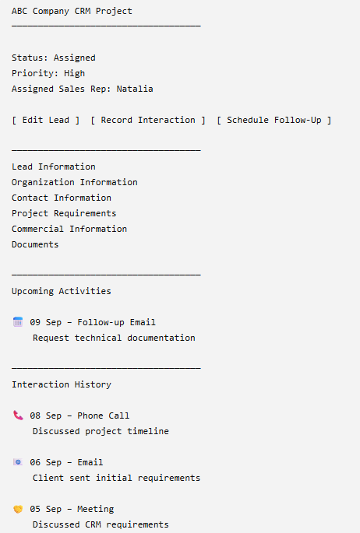

What does the Sales Manager see?
ABC Company — CRM Development
Lead Status: Assigned
Priority: High
Sales Representative: Natalia
Organization
- ABC Company
- IT Services
- 100 employees
Contact
- John Silva
- IT Manager
- john@abc.com
Requirements
- CRM for 100 users
- Customer management
- Lead management
- Accounting-system integration
- Six-month timeline
Commercial
- Estimated Budget: LKR 5,000,000
- Expected Deal Value: LKR 5,000,000
Documents
- Client Requirements.pdf
- Existing System.pdf
Interaction History
- Meeting — 08/09/2026
- Email — 06/09/2026
- Phone Call — 04/09/2026
Then the Sales Manager has an action:
[ Send for Assessment ]

Technical side
Technical Lead receives notification:
New Technical Assessment
Lead: ABC Company CRM Development
Submitted by: Sales Manager
Required by: [date]

Financial side
Financial Officer receives notification:
New Financial Assessment
Lead: ABC Company CRM Development
Submitted by: Sales Manager
Required by: [date]

Tech Lead sees
1. Opportunity Summary
- Lead / Opportunity Name
- Brief Description
- Priority
- Expected Timeline
2. Organization Context
- Organization Name
- Industry
- Approximate Company/System Size
- Expected Number of Users
3. Consolidated Project Requirements
- Business Need
- Expected Solution
- Detailed Requirements
- Required Features
- Expected Scope
4. Technical Requirements
- Technology Requirements
- Platform Requirements
- Integration Requirements
- Security Requirements
- Performance Requirements
- Other Technical Constraints
5. Relevant Documents
- Requirement specification
- Technical documents
- Existing system documentation
- Other documents specifically relevant to the technical assessment
Then:
[Start Technical Assessment]

1. Technical Assessment Form
The Technical Lead evaluates whether the client's requirements can be delivered technically.
Field | What should be entered?
Lead / Opportunity Name | The lead being assessed.
Technical Feasibility | Select whether the requirements are Technically Feasible, Feasible with Conditions, or Technically Not Feasible.
Requirement Assessment | Review each important requirement and state whether it is feasible.
Technology Assessment | Explain whether the required technologies, frameworks, databases, or software are suitable.
Platform Assessment | Confirm whether the proposed web, mobile, desktop, cloud, or on-premises platform is suitable.
Integration Assessment | Evaluate whether the required existing systems, APIs, or third-party services can be integrated.
Security Assessment | Evaluate whether the requested security requirements can be implemented.
Performance Assessment | Evaluate whether the system can support the expected number of users, transactions, speed, and availability requirements.
Resource Requirements | Identify the technical resources required, such as developers, testers, DevOps engineers, or specialists.
Technical Risks | Identify possible technical risks and their likelihood, impact, and mitigation.
Technical Constraints / Conditions | State any limitations, dependencies, or conditions that must be considered.
Technical Recommendation | Provide the final technical recommendation.
Technical Comments | Add explanations, assumptions, or additional information.
Supporting Documents | Upload any technical assessment documents if required.

Example
The Sales Representative records:
The client requires a web-based CRM for approximately 100 users with accounting-system integration and role-based access.
The Technical Lead then assesses:
The solution is technically feasible. Integration with the accounting system must be confirmed, and two backend developers and one integration specialist are required.

Financial Officer sees
1. Opportunity Summary
- Lead / Opportunity Name
- Brief Description
- Priority
- Expected Timeline
- Current Lead Status
2. Organization Context
- Organization Name
- Industry
- Approximate Company Size
- Expected Number of Users / Scale
3. Consolidated Project Requirements
- Business Problem / Need
- Expected Solution / Service
- Detailed Project Requirements
- Required Features
- Expected Scope
- Additional Requirements
4. Commercial and Financial Information
- Estimated Budget
- Currency
- Expected Deal Value
- Budget Confirmation
- Payment Terms
- Additional Financial Information
5. Resource and Cost-Related Information
- Required Resources
- Resource Type
- Required Quantity
- Required Skills
- Estimated Effort

- Estimated Resource Quantity
- Number of developers required
- Number of testers required
- Number of technical specialists required
- Other required team members

- Expected Project Duration
- Estimated Development Duration
- Estimated Testing Duration
- Estimated Deployment Duration
- Total Estimated Project Duration

- Infrastructure or Hosting Requirements
- Required Hosting Type
- Server Requirements
- Cloud Infrastructure Requirements
- Storage Requirements
- Additional Infrastructure Requirements

- Licensing or Software Requirements
- Required Software
- Required Tools
- Third-Party Services
- API or Platform Licences
- Estimated Licence Quantity

- Technical Conditions That May Affect Cost
- Additional Development Required
- Special Technology Requirements
- Integration Requirements
- Security Requirements
- Performance Requirements
- Infrastructure Conditions
- Technical Support Requirements

- Major Risks That May Increase Project Cost
- Integration Risk
- Security Risk
- Performance Risk
- Technology Risk
- Resource Risk
- Timeline Risk
- Risk Impact on Project Cost
- Proposed Risk Mitigation
6. Relevant Documents
- Client Budget or Quotation
- Proposed Contract
- Pricing Documents
- Payment Terms
- Cost Estimates
- Other Documents Specifically Relevant to the Financial Assessment
Then:
[Start Financial Assessment]

2. Financial Assessment Form
The Financial Officer evaluates whether the opportunity is financially viable.
Field | What should be entered?
Lead / Opportunity Name | The lead being assessed.
Estimated Budget | The budget provided or expected by the client.
Currency | The currency used for the budget and financial values.
Expected Deal Value | The expected revenue from the opportunity.
Estimated Project Cost | The estimated cost of delivering the project.
Estimated Resource Cost | The expected cost of developers, testers, project managers, and other resources.
Estimated Infrastructure Cost | Expected hosting, software, hardware, licensing, or cloud costs.
Other Estimated Costs | Any additional expenses related to the project.
Expected Profit | The estimated revenue remaining after project costs.
Profit Margin | The expected profitability of the opportunity.
Payment Terms | The client's expected payment schedule or conditions.
Budget Assessment | State whether the client's budget is sufficient for the proposed project.
Financial Risks | Identify risks such as insufficient budget, payment delays, unexpected costs, or uncertain scope.
Financial Conditions | State any conditions, such as requiring an advance payment or revising the project scope.
Financial Recommendation | Select Financially Viable, Viable with Conditions, or Not Financially Viable.
Financial Comments | Explain the financial assessment and recommendation.
Supporting Documents | Upload quotations, cost calculations, or other financial documents.
Example
The Sales Representative records:
Client budget: USD 25,000. Expected project duration: four months.
The Financial Officer assesses:
Estimated project cost is USD 20,000. The opportunity is financially viable, provided that the client agrees to a 30% advance payment.

3. Sales Manager makes the final decision
The Sales Manager opens the Final Deal Decision Form.
Field | What should be entered?
Technical Assessment Result | Automatically displayed from the Technical Lead's assessment
Financial Assessment Result | Automatically displayed from the Financial Officer's assessment
Final Decision | Accept, Reject, or Negotiate
Decision Reason | Explanation for the selected decision
Conditions / Negotiation Terms | Any conditions that must be fulfilled
Additional Comments | Other important decision information
Decision options
Accept
The opportunity is approved to proceed.
Reject
The opportunity is rejected. A rejection reason should be required.
Negotiate
The opportunity requires changes to the price, scope, timeline, payment terms, or other conditions before approval.
Then:
[Submit Final Decision]
4. System updates the lead
If the Sales Manager selects Accept
Lead status changes to Accepted
↓
Sales Representative receives notification
↓
Sales Representative confirms the deal with the client
↓
Sales Representative uploads the signed deal certificate
↓
Sales Manager verifies the signed certificate
↓
Accepted deal is transferred to the Project Queue
↓
Project Manager receives the deal

If the Sales Manager selects Reject
Lead status changes to Rejected
↓
Rejection reason is recorded
↓
Sales Representative receives notification
↓
Lead is closed

If the Sales Manager selects Negotiate
Lead status changes to Negotiation
↓
Sales Representative receives notification
↓
Sales Representative negotiates with the client
↓
Lead details are updated if necessary
↓
Sales Manager reviews the revised information
↓
Accept / Reject

