1. Approach

Student Number: 164789 & Kaggle Team Name: Yaqoob Matin
The approach that I have taken was created after I took a look into the data. The first thing that is noticeable is that the number of features was very big (4608). The first thing that came into my mind was to reduce the dimensionality, so the approach I took was rather simple.

- Extract and curate the data (replace missing values)
- Apply feature selection techniques on the features to reduce the dimensionality
- Scale the data
- Train multiple classifiers after splitting the data into a train-test set to check the results internally
- Predict the new testing to create the csv

2. Methodology
2.1 Data Preprocessing
The first thing that had to be done was to append the first dataframe that I created on my python environment with the other, I used the append method to combine the two dataframes (training and additional training sets) and I filled the missing values with the column mean to reduce the outliers, then I dropped the ‘ID’ and ‘prediction’ column to create my feature set and kept the ‘prediction’ column for my labels. Using the additional data is almost necessary in our occasion since the training set is small.

2.2 Feature Selection
For the feature selection part multiple approaches had to be considered. The first approach that I tried was to use a wrapper using sklearn’s RFE, but it was so computationally intensive that 12 hours were not enough to output any results on Jupyter Notebook. So that made me to use a filter method.
The method that was used was the Pearson [1] correlation coefficient which is one of the most popular and thankfully the “pandas” library is providing it using the “corr” method. Using this method I got the correlations of the features to the targeted value (“prediction”) and I picked those that had a higher coefficient than 0.2, which was selected after seeing that none of the features had more than 0.35. After using this technique I reduced the features from 4608 to 262. The next step was to scale my features to [-1, 1] which is commonly used in the field for making it easier for the classifier to train.

2.3 Training of the Classifier
After the feature selection and the scaling, the next step was to split the data and start training models to pick the best through trial and error. I used train test split from sklearn to create a training and a testing set so that I can start checking my results through that. Firstly, I tried to use MLPClassifier, I tweaked some parameters but I was not satisfied with the results. The next classifier that was tried was the popular Support Vector Classifier[2] with a linear kernel and C at 2e10, I got better results than the MLP so that made me notice that the problem that i am trying to solve is more linear than I imagined at first, when I used the rbf kernel I got even better results.
All these guided me into the “tree” based classifiers, the first one that I tried was the DecisionTreeClassifier and I got somewhat worse results than the svc but I still had the RandomForestClassifier in the back of my head. When I used Random Forest [3] I saw the best results till now. I tweaked the estimator parameter to 500 and got a 76% prediction accuracy on the testing set which was 20% of the whole dataset. This classifier got me a 70% accuracy on the private dataset on Kaggle, I also created a confusion matrix (Figure 1.) to check the validity of my results and I was satisfied from the output.

3. Results and Discussion
The results that I got from using the Random Forest classification algorithm were satisfying as they were but there is space for improvement in this type of problem. The thing that can be done and potentially give better results is to have a wrapper method applied for feature selection. I couldn’t do that because this process was so computationally intensive that it was crippling my personal computer. If this can be done a better set of features can be selected which creates less noise in the training process. The incomplete training data was very useful for me because without it the dataset would be very small and it wouldn’t give me any good results. The other thing that I noticed is that when I used the gini index as a measure of impurity the results had gotten worse than when I had used the entropy measure. The other thing that is also clear in Figure 2. (Learning Curve) is that overfitting the model on the data has been avoided because it’s clear that even though we are getting a 100% accuracy on the training data, we can still see that the validation accuracy does not drop, it’s good to note that the learning curve was created only to see if the model overfits on the data.
The thing that I understood from this project is the process of preprocessing and understanding the data before the use of a classifier and also the process of applying trial and error which I think is the most important part of Machine Learning. Below you can see all the graphs and the classifier performance array that I got from the process of trial and error.
Model | MLP | SVC(rbf) | DecTree | RandForest
Test Acc | 67% | 71% | 69% | 76%

Illustrations, graphs, and photographs
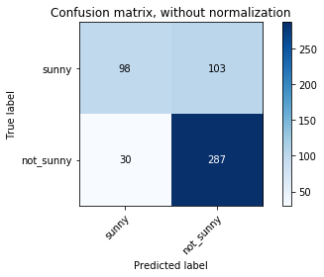
Figure 1. Confusion Matrix from Random Forest

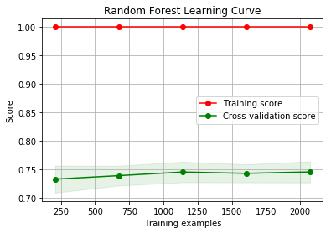
Figure 2. Learning Curve, Random Forest.

References
- A. G. Asuero, A. Sayago, and A. G. Gonz´alez, The Correlation Coefficient: An Overview.
- Vladimir N. Vapnik, Bernhard E Boser, Isabelle M. Guyon, A training algorithm for optimal margin classifier.
- Leo Breiman. Statistics Department, University of California Berkeley, CA94720. Random Forests

