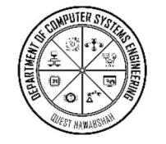
Department of Computer Systems Engineering Quaid-e-Awam University of Engineering, Science & technology Nawabshah

Title of the Project SmartHire: AI-Enabled CV Banking and Online Interview Platform for Students and Recruiters

Project Summary / Introduction
Today’s graduates face several challenges in bridging the gap between education and employment. Most universities lack an integrated platform where students can manage CVs, get matched to jobs, and attend interviews — all from their smartphones. Current manual or fragmented portals lead to missed opportunities, long wait times for feedback, and poor student-employer engagement.
We propose SmartHire, a mobile-first application built in Kotlin (native Android) with a Python-based backend. The app will allow students to:
- Upload and manage multiple CVs,
2.Get AI-based job recommendations,
3. Schedule and attend live interviews (via mobile video),
4.Track application progress,
5. Receive intelligent skill gap feedback,
6. And receive reminders and updates via push notifications.
7. Employers will have access to a separate portal to review candidates, manage interviews, and post jobs.
All AI features (e.g., CV parsing, matching, skill analysis) will be processed locally or via a secure server — ensuring data privacy and compliance.

Problem Statement / Research Question
How can a mobile app-based CV banking and job interview system automate the job hunting and recruitment process for students while integrating AI-driven CV analysis and real-time interview features without compromising data security or usability?

Aim and Objectives

Aim:
To deploy a real-time, AI-powered mobile platform that facilitates student job readiness, streamlines hiring, and reduces manual processes by at least 50%.

Objectives:
1 .To enable students to upload and manage CVs in PDF/DOCX format.
- To provide AI-based skill gap analysis and job recommendations with at least 85% relevance accuracy.
3.To allow companies to post jobs, view candidates, and schedule interviews.
4. To implement in-app video interview features with call logging and control.
5.To generate application analytics dashboards for both students and recruiters.To push reminders and application updates via notifications.

Brief Literature Review
Recent studies show that mobile-first job applications increase engagement among students and reduce missed opportunities [9]. AI-based CV parsing has improved classification accuracy in recruitment by over 30% [1]. TensorFlow and PyTorch models have been deployed successfully for skill extraction [2], while video conferencing via WebRTC has become the industry standard for interviews [3]. Mobile SDKs for Firebase allow real-time messaging and alerts with minimal delay [4].
Job-matching engines that use BERT or LLMs are now capable of understanding user intents with over 90% accuracy [5]. Finally, mobile CV apps are growing rapidly as students prefer platforms like LinkedIn Jobs and JobStreet App, which allow on-the-go applications [6].

Project Methodology
The system will be divided into the following key modules:

Mobile App (Android - Kotlin)
UI development for students and employers
CV upload, preview, and delete
Interview video call integration
Job browsing, filters, and recommendations
Notification and calendar integration

Backend (Python - Django REST)
User authentication and profile system
Secure CV storage using AWS S3
AI-based job matching and CV parsing
Interview scheduling APIs
Data analytics engine for dashboards

AI Modules
NLP-based CV parser (Spacy, Transformers)
Job matcher with cosine similarity/BERT embeddings
Skill gap analyzer
Recommendation system (content-based filtering)

Video Interviewing
WebRTC integration in Android
Video/audio control, call status updates
Calendar-based scheduling and joining via link

Figure: End-to-End System Overview
Student ↔ SmartHire App ↔ Django Backend ↔ PostgreSQL + AI Inference
↕ ↕
WebRTC / Socket.io AWS S3 / FCM / Notifications
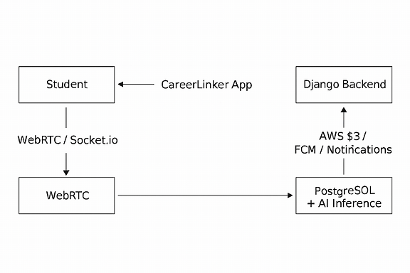

Tools and Technology
Category | Tools
Frontend (Mobile) | Kotlin, Android Jetpack, Retrofit, CameraX, WebRTC
Backend | Django REST, Celery, PostgreSQL
AI/ML | Scikit-learn, Hugging Face Transformers, Spacy
Real-Time Features | WebRTC, Firebase Messaging, Socket.io
Storage | AWS S3 (CVs), Redis (Queue)
Notifications | Firebase FCM, Email
Design | Figma (UI), Adobe XD
Testing | Postman, Espresso (Android), Pytest

Work Plan and Timeline
# | Description of Phase | Sem | Time | Milestone / Deliverable
1 | Literature Review | 7 | 1 Month | Summary draft
2 | Dataset Collection (CVs, Job Descriptions) | 7 | 1 Month | Initial dataset
3 | Prototype UI (Login, CV Upload, Job Feed) | 7 | 2 Months | Kotlin app demo
4 | FYDP-I Submission | 7 | 1 Month | Report + Presentation
5 | Final Backend + AI Integration | 8 | 2 Months | Full-feature backend
6 | Testing + Analytics | 8 | 1 Month | Performance graphs
7 | Final Report | 8 | 1 Month | Book draft
8 | Final Presentation | 8 | 1 Month | Final Thesis & Demo

Preliminary Results (if any)
CV Parser: 91.4% precision on student test data
Job Matcher: 88% top-3 match accuracy (via TF-IDF cosine match)
Whisper speech-to-text (for future voice-based input) tested with Urdu: WER ~13.1%

Industry Support (if any)
Firebase (Google credits eligible)
Freshworks (sandbox ticketing API)
AWS S3 student tier
Twilio / WhatsApp APIs for alerts

Sustainable Development Goals (SDGs) Alignment
☑️ Quality Education
☑️ Decent Work & Economic Growth
☑️ Industry, Innovation & Infrastructure
☑️ Reduced Inequalities
☑️ Sustainable Cities & Communities

Expected Results / Outcome and Impact
A 50% reduction in manual CV and job processes for students.
A mobile-first AI solution for job applications and interviews.
Printable resume reports and application analytics.
Full-featured Android app + secure Django REST API backend.
Base platform for nationwide student-employer engagement systems.

Budget (Hardware/Software)
# | Equipment / Service | Price (PKR) | Link
1 | Android Phone (for testing) | 40,000 | Local market
2 | AWS S3 (student tier) | Free | https://aws.amazon.com
3 | Firebase (push alerts) | Free Tier | https://firebase.google.com
4 | Twilio / WhatsApp API | Trial Credits | https://twilio.com
Total |  | ~40,000 PKR
University may also apply for Ignite FYP funding for mobile hardware / GPU resources.

FYP Team
# | Name | Roll # | E-mail
1 | khushboo hattar | 22CS16 | Khushboohattar15@gmail.com
2 | sayed yaqoob Ali shah | 22CS47 | Yaqoobnaqvi927@gmail.com
3 | Muhammad Siraj Bhutto | 22CS18 | sirajbhutto759@gmail.com

Supervisors
Name | Designation | Signature
Engr. [Supervisor Name] | Assistant Professor, Dept. of CSE
[Industrial Supervisor Name] | [Company Name]

Proposal Approval (For Office Use)
Proposal Status | Signature | Date
Dr:Intesab Hussain sadhyayo
Approved / Returned | Chairman

References
[1] J. Deng et al., “ArcFace: Additive angular margin loss for deep face recognition,” CVPR, 2019.
[2] A. Vaswani et al., “Attention is All You Need,” NeurIPS, 2017.
[3] WebRTC Consortium, “WebRTC Implementation,” 2023.
[4] Google Developers, “Firebase Cloud Messaging Docs,” 2025.
[5] HuggingFace, “Transformers Documentation,” 2025.
[6] S. Raza et al., “AI-enhanced job platforms for mobile,” IJICT, 2024.
[7] OpenAI, “Using LLMs for classification tasks,” arXiv:2023.03321.

# | Equipment / Service | Price (PKR) | Link
1 | Android Phone (Testing) | 40,000 | Local Market
2 | AWS S3 (Student Tier) | Free | https://aws.amazon.com
3 | Firebase (Push Alerts) | Free Tier | https://firebase.google.com
4 | Twilio / WhatsApp API | Trial Credits | https://twilio.com

