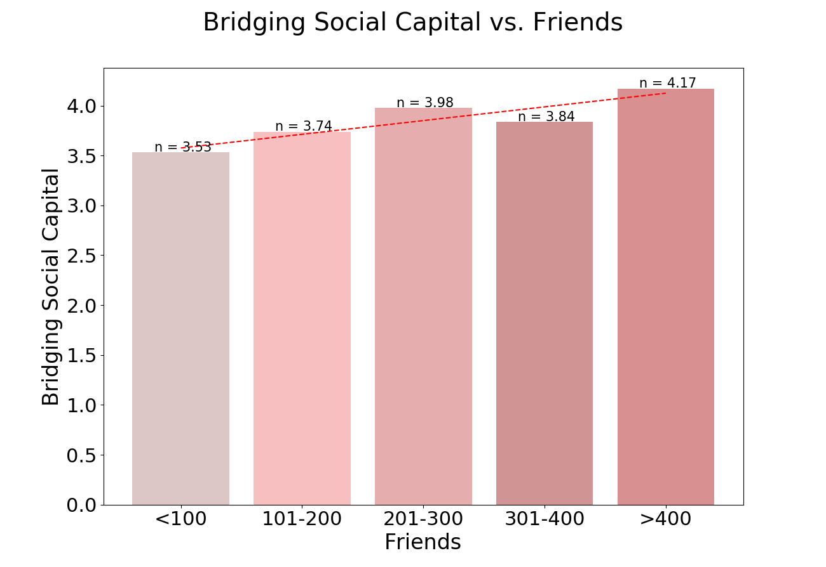

Created by: bridging_vs_friends.py

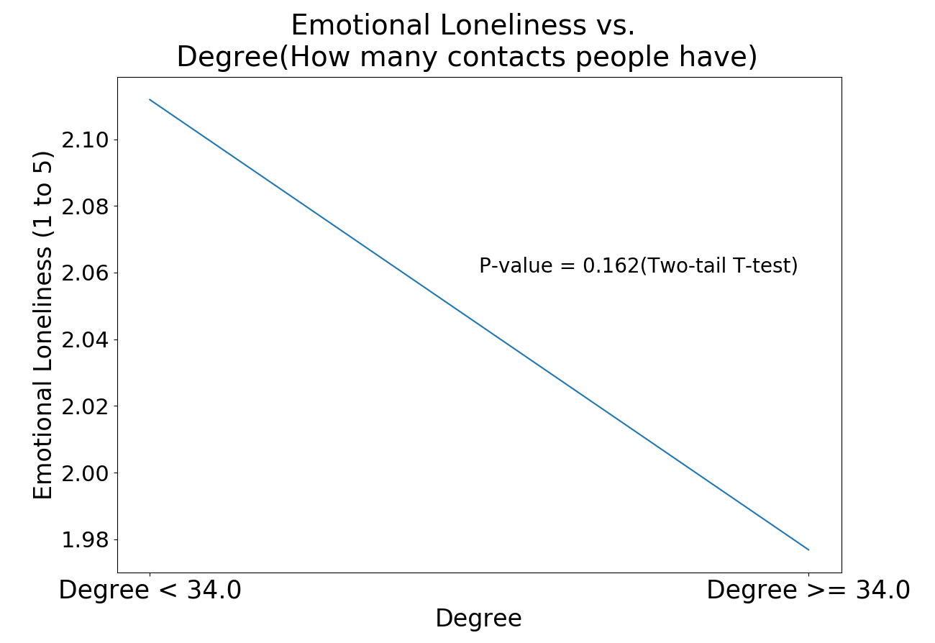

Created by: loneliness_vs_degree.py

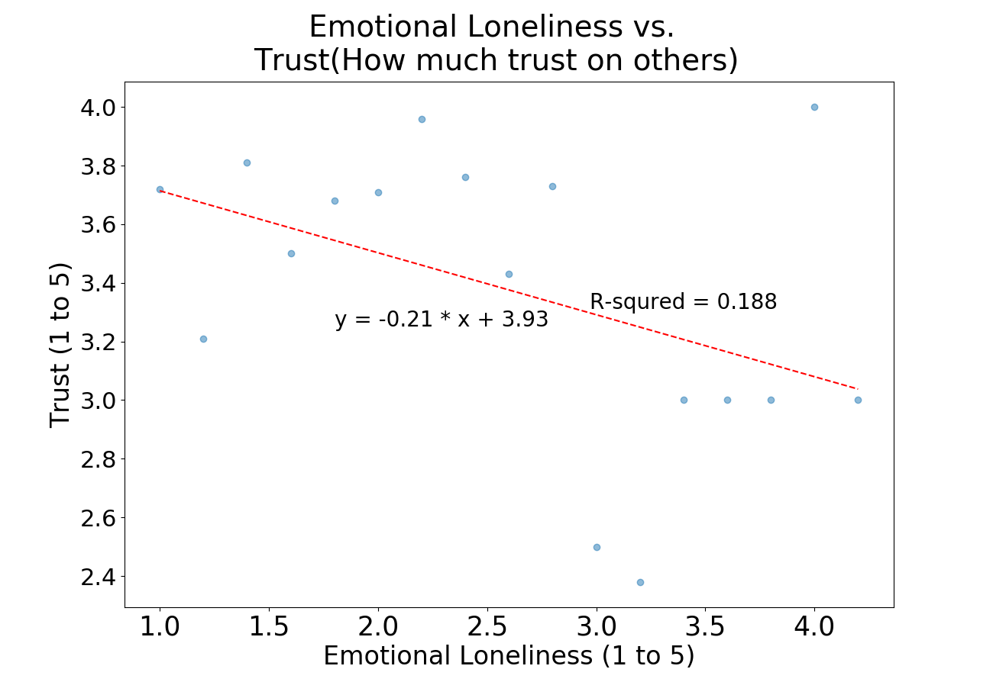

Created by: loneliness_vs_trust.py