BZ-Agent
Setup Roadmap
How the whole system was built — from an empty AWS account to two live, load-tested deployments

Contents

Build order at a glance
accounts/keys → scaffold → ODH + sanitize → agents + LangGraph → local verify → ECR + IAM → two images → Lambda + API Gateway → EC2 → custom VPC → features (weather / streaming / UI) → load test → report + Terraform.

Phase 0 — Accounts, access & local tools
AWS Free-plan account (~$120 credits). Enabled Amazon Bedrock model access for Anthropic Claude Sonnet 4.5 in eu-central-1 (a one-time console setting). Created IAM user bz-agent-dev with an access key, stored in ~/.aws/credentials so boto3 can authenticate.
Key fact: a Claude Pro subscription does NOT include API access — we use Bedrock (Claude via AWS/IAM), so there is one bill and no separate API key.
Local tools: Python, Docker Desktop, Node.js, Git. IAM permissions were attached reactively, per phase (least privilege):
Phase | Policies attached to bz-agent-dev
Run the agent | AmazonBedrockFullAccess, AmazonDynamoDBFullAccess
Deploy | ECR + Lambda + EC2 + IAM full access
API Gateway | AmazonAPIGatewayAdministrator

Phase 1 — Project scaffolding
A monorepo with a microservices boundary: shared/ (config, LLM factory, DynamoDB, JSON utils), odh/ (Open Data Hub clients + sanitization + weather), agents/ (Retriever, Reasoner, Generator, LangGraph), api/ (Lambda handler, FastAPI server, web UI), scripts/ (setup + deploy). The LLM provider is a one-line switch (Bedrock or Anthropic).

Phase 2 — Open Data Hub integration + sanitization
Built clients for Content (POIs, events), Mobility (parking, bike stations) and Weather (Bolzano district forecast). A sanitization layer strips raw ODH JSON to a few flat fields — the key defense against context overflow, cost blow-up, and hallucination.
Gotchas found by probing the live API: POI names live in Shortname / Detail.<lang>.Title; museum filtering needs tagfilter (not categorycodes); the old bike-availability dataset is dead (2016 data), so we switched to live ParkingStation + BikesharingStation.

Phase 3 — Agentic core
Retriever → Reasoner → Generator wired as a LangGraph state machine; state flows one way and each node writes its slice to the DynamoDB scratchpad. DynamoDB uses single-table design: PK = USER#<id>, SK = SESSION#<id>, on-demand billing.

Phase 4 — Local verification (against real AWS)
Created the table, then ran the pipeline end-to-end. Four real bugs were found and fixed:
Symptom | Fix
ODH ReadTimeout | 30s timeout + per-fetch resilience
DynamoDB rejects floats | convert floats → Decimal
Scratchpad document-path invalid | create skeleton + defensive init
Generator hallucinated (empty draft) | robust JSON extraction (Claude wrapped JSON in code fences)

Phase 5 — Containerize & deploy (two architectures)
Created ECR + IAM roles, built two images from one codebase (a uvicorn/FastAPI server image for EC2 and an AWS Lambda base image), and pushed them to ECR. Deployed Architecture A (Lambda from image, fronted by an HTTP API Gateway) and Architecture B (EC2 pulls the image and runs it).
Gotchas: Docker Desktop builds OCI manifests, which Lambda rejects → rebuilt with Docker v2 media types; the SSM AMI lookup was denied → switched to describe_images; the Lambda Function URL returned 403 (newer accounts block public Function URLs) → used API Gateway instead.

Phase 6 — Custom VPC (network isolation)
Built a custom VPC and migrated the EC2 workload into it: VPC 10.0.0.0/16, a public subnet 10.0.1.0/24, an internet gateway with a 0.0.0.0/0 route, a free DynamoDB gateway endpoint (state traffic stays on AWS's private network), and a security group allowing only inbound TCP 8080.
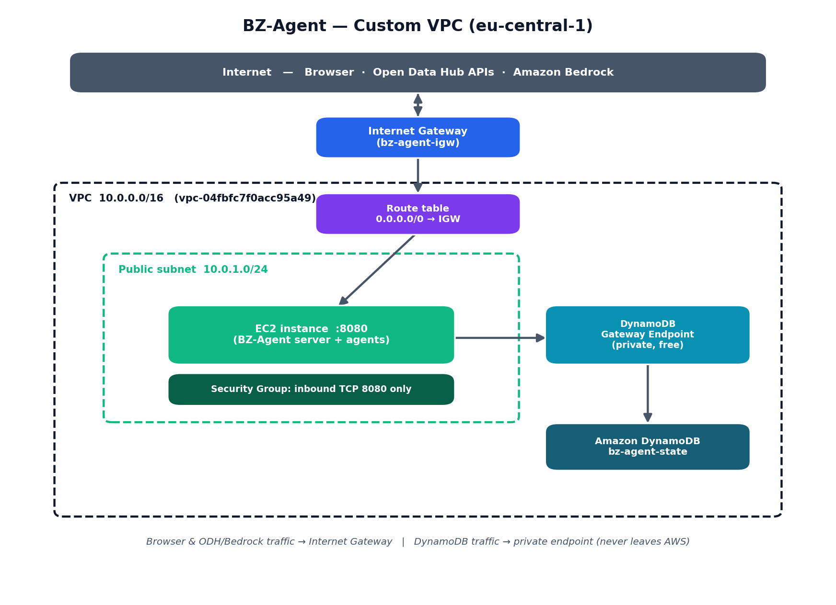

Phase 7 — Feature enhancements
- Weather-aware reasoning: rain/storm → indoor stops, clear → outdoor (verified).
- Geo-filtering: mobility data bounded to a Bolzano box (drops outliers).
- SSE progress streaming + a browser UI showing a live checklist as each agent finishes.

Phase 8 — Load testing & comparison
Measured per-request latency (~16.9 s) and ran an EC2 saturation sweep on the cost-free /health endpoint (25 → 400 concurrency): throughput peaks at ~25 (322 req/s), latency spikes at 150–200, and the instance is effectively broken by 300+ (p95 ≈ 15 s). Modelled the 50/200/1000-user case and analysed reliability, scalability, resource usage, and billing. Conclusion: Bedrock (the LLM) is ~95% of cost and identical for both architectures; at ~1000 users the Bedrock quota is the shared bottleneck.
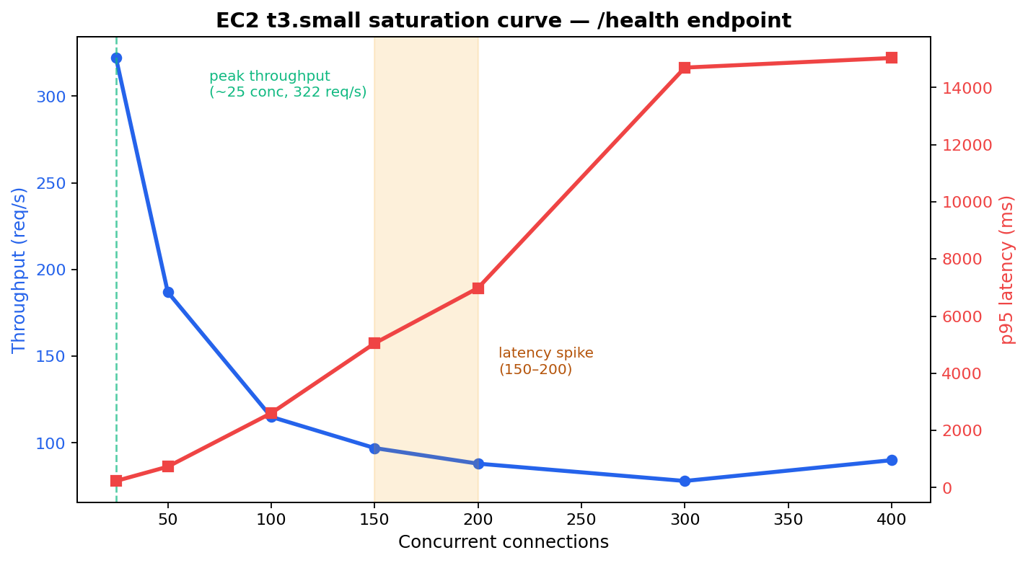

Phase 9 — Deliverables
- report/BZ-Agent_Report.docx — full project report with diagrams, comparison, and analysis.
- infra/ — Terraform codifying the whole stack (Infrastructure as Code).
- loadtest/ — k6 scripts, infra probe, methodology, results.
- All committed to Git; .env and secrets excluded via .gitignore.

