BZ-Agent
Smart-City Mobility & Event Orchestrator
A Cloud-Native, Multi-Agent AI System for Bolzano
Project Report & Technical Roadmap
Architecture: AWS (eu-central-1) · Amazon Bedrock · Lambda · EC2 · DynamoDB · API Gateway
Framework: LangChain / LangGraph · Data: NOI Techpark Open Data Hub

Table of Contents

1. Project Overview
BZ-Agent is a cloud-native, multi-agent AI system that acts as an autonomous smart-city orchestrator for Bolzano. It uses an Agentic RAG (Retrieval-Augmented Generation) architecture to fetch and process real-time mobility, weather, and tourism data from the local Open Data Hub (ODH) and turn a natural-language request (for example, “I want to visit a museum and find parking nearby”) into a validated, grounded itinerary.
The system follows a microservices design in which distinct agents handle specific tasks — data retrieval, constraint reasoning, and itinerary generation — orchestrated as a state graph. It is deployed on Amazon Web Services in two different ways, AWS Lambda (serverless) and Amazon EC2 (server), so the two compute models can be directly compared. The reasoning engine is Anthropic Claude, accessed through Amazon Bedrock; session state lives in Amazon DynamoDB; and Amazon API Gateway provides the public front door.

1.1 Objectives
- Demonstrate a complex, multi-agent backend workflow orchestrated and scaled on AWS.
- Ground every recommendation in live open data to avoid LLM hallucination.
- Compare two distributed compute architectures (serverless vs. server) for the same workload.
- Apply cloud-native principles: managed services, least-privilege IAM, pay-per-use, containerisation.

2. System Architecture
The diagram below shows the end-to-end architecture. A client request enters through one of two compute paths; both run the identical container image and the same LangGraph pipeline. The pipeline calls three backend services: the Open Data Hub for live data, Amazon Bedrock for reasoning, and DynamoDB for state.
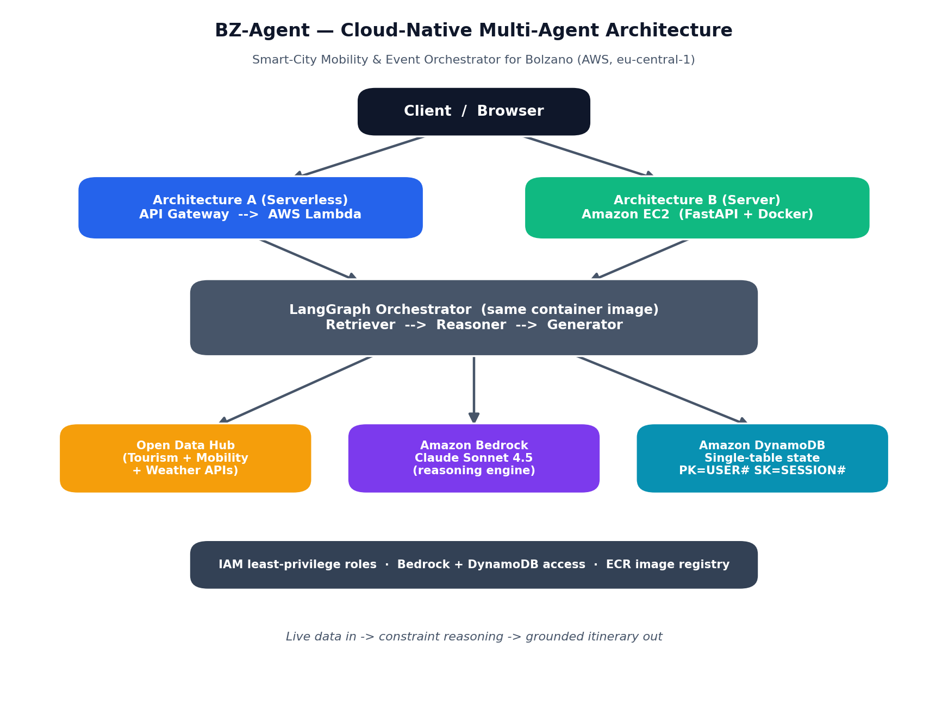
Data flow: live data in → constraint reasoning → grounded itinerary out. The compute layer (Lambda or EC2) only orchestrates; the intelligence is in Bedrock and the memory is in DynamoDB.

3. Cloud Components
Each AWS service was chosen to satisfy a specific role, applying the principle of using managed services rather than self-managed infrastructure.
Service | Role in BZ-Agent
Amazon Bedrock | Hosts the Claude Sonnet 4.5 model (reasoning engine). Accessed via IAM — no separate API key, billed through AWS.
AWS Lambda | Serverless compute for Architecture A; runs the agent pipeline on demand behind API Gateway.
Amazon EC2 | Server compute for Architecture B; a t3.small instance running the same container 24/7.
Amazon DynamoDB | Single-table NoSQL store for session state and the agent scratchpad (PK=USER#, SK=SESSION#).
Amazon API Gateway | Public HTTP front door (POST /plan-itinerary) that proxies to the Lambda.
Amazon ECR | Container registry holding the two image tags (server, lambda) pulled by EC2 and Lambda.
AWS IAM | Least-privilege roles for the Lambda and EC2 instance, granting only Bedrock + DynamoDB access.

4. The Agentic RAG Pipeline
The “brain” is a three-node LangGraph state machine. State flows strictly in one direction, and each node writes its output to the DynamoDB agent scratchpad, giving full traceability of how a plan was built.

4.1 Retriever
Maps the natural-language request to data needs, then calls the relevant ODH tools (points of interest, events, parking, bike stations) and always fetches today’s weather. A sanitisation layer strips the heavy raw JSON down to a few flat fields (name, coordinates, time, value) so the model context never overflows — the single most important safeguard against cost blow-up and hallucination.

4.2 Reasoner
Applies hard constraints to the sanitised data: geographic proximity, a ≥15-minute transit buffer, parking/bike availability, and weather (rain or thunderstorm → prefer indoor stops; warm and clear → outdoor routes are fine). It outputs a validated, ordered itinerary draft as structured JSON.

4.3 Generator
Renders the validated draft into a friendly, human-readable itinerary. It invents nothing — it only formats facts the Reasoner already validated — which keeps the final answer grounded in real data.

5. Architecture Comparison: Lambda vs. EC2
The same code was deployed two ways. This is the core of the “when to use which service” and “compare distributed architectures” analysis. Measurements are from live calls in eu-central-1.
Dimension | AWS Lambda (Arch A) | Amazon EC2 (Arch B)
Execution model | Serverless, per-request | Always-on server
Latency (warm) | ~13–15 s | ~13 s
Cold start | ~5–18 s first call | None
Cost when idle | $0 | Billed hourly (always)
Cost per request | Pennies per invocation | Included in hourly rate
Max execution time | 15 minutes (hard limit) | No limit
Scaling | Automatic, per-request | Manual / Auto Scaling group
Front door | API Gateway | Port 8080 (direct)
Best for | Spiky / occasional traffic | Steady traffic, long jobs
Conclusion: for an interactive planner with bursty, unpredictable usage, Lambda + API Gateway is the cost-efficient default (zero idle cost). EC2 becomes preferable only if traffic is steady enough to keep the instance busy, or if an agent run could exceed Lambda’s 15-minute ceiling.

6. Cloud Pricing Analysis
AWS follows a pay-per-use philosophy: you pay for what you consume, with no upfront cost. BZ-Agent illustrates three different billing models in one system.
Service | Pricing model & approximate cost
AWS Lambda | Per-request + per-GB-second. At 2048 MB and ~15 s/run, each itinerary costs well under one US cent; $0 when idle.
Amazon EC2 (t3.small) | Per-hour while running (~$0.021/hr in eu-central-1, ~$15/month if left on 24/7) regardless of traffic.
Amazon DynamoDB | On-demand (PAY_PER_REQUEST): pay per read/write. At this volume, effectively free.
Amazon Bedrock | Per input/output token of Claude. The sanitisation layer keeps prompts small, so each run is a few cents at most.
API Gateway | Per million requests; negligible at demo volume.
Cost-control measures applied: DynamoDB on-demand (no idle capacity charge), small prompts via sanitisation, and a recommended AWS Budgets alarm. Development to date has consumed only a few cents of the account’s credit.

7. Security & Compliance
Security measures implemented, illustrating defence-in-depth and least privilege:
- Least-privilege IAM: a dedicated bz-agent-dev user and separate execution roles for Lambda and EC2 grant only the permissions needed (Bedrock + DynamoDB), rather than AdministratorAccess.
- No long-lived model API key: Bedrock is reached through IAM role credentials, so there is no Anthropic key to leak; the LLM bill stays inside AWS.
- Secrets kept out of source control: a .gitignore excludes the .env file; only .env.example (no secrets) is committed.
- Encryption at rest: DynamoDB encrypts table data by default; ECR image scanning is enabled on push.
- Key rotation awareness: an access key accidentally exposed during setup was identified as a rotation risk (documented as a lesson in secure credential handling).

7.1 Hardening still recommended
- Move EC2 and Lambda into a custom VPC with private subnets and VPC endpoints for DynamoDB/Bedrock.
- Enable MFA on the root account; serve EC2 over HTTPS; store any future secret in AWS Secrets Manager.

8. Deployment Process
Deployment is scripted and reproducible (a step toward Infrastructure as Code):
- Provision: ECR repository + IAM roles created via boto3 (deploy_setup.py); DynamoDB table via create_table.py.
- Build: two Docker images from one codebase — a Lambda base image and a uvicorn/FastAPI server image — pushed to Amazon ECR.
- Deploy A: Lambda created from the image (deploy_lambda.py), fronted by an HTTP API Gateway (deploy_apigw.py).
- Deploy B: an EC2 instance launched with an instance profile and user-data that pulls the image from ECR and runs it (deploy_ec2.py).

9. Verification & Results
Both architectures were tested end-to-end against live AWS and live ODH data. Each returned HTTP 200 with a grounded itinerary referencing real Bolzano parking (e.g. “P07 - Mareccio, 144 spaces”) and real museums (e.g. Museum Eccel Kreuzer, Domschatzkammer Bozen).
The weather feature was confirmed to influence reasoning: on a clear 32 °C day the Reasoner produced an outdoor plan (city squares, the Etsch river bike path, a rooftop terrace) and explicitly cited the good weather.
Endpoint | Status
EC2 (Architecture B) | Live, browser UI + POST API, HTTP 200, ~13 s warm
Lambda via API Gateway (Architecture A) | Live public POST endpoint, HTTP 200
DynamoDB state | Scratchpad written per node (retriever/reasoner/generator)
Bedrock Claude Sonnet 4.5 | Reasoning + generation verified live

10. Mapping to Course Objectives
Course objective | Status | Where addressed
Define the main cloud components | Done | Section 3
Explain cloud architectural principles | Done | Sections 2, 4
Explain the cloud pricing philosophy | Done | Section 6
Describe security & compliance measures | Done | Section 7
Create and manage a VPC | Planned | Section 7.1 (next phase)
Principles of cloud-native applications | Done | Sections 2, 8
When to use EC2 vs Lambda vs Beanstalk | Done | Section 5
Compare distributed systems architectures | Done | Section 5

11. Future Work
- Custom VPC with private subnets and VPC endpoints (the remaining graded objective).
- Live SASA bus / GTFS schedules so the Reasoner can suggest exact departures.
- WebSocket streaming of progress (“Fetching weather… Calculating routes…”) to the UI.
- Infrastructure as Code (AWS CDK or Terraform) wrapping the deploy scripts.
- Multi-turn memory so follow-up questions reuse prior session context.

Appendix A. Project Structure & Endpoints
Repository layout: shared/ (config, LLM factory, DynamoDB, JSON utils), odh/ (Open Data Hub clients + sanitisation + weather), agents/ (Retriever, Reasoner, Generator, LangGraph), api/ (Lambda handler, FastAPI server, web UI), scripts/ (setup and deploy automation).
Region: eu-central-1 (Frankfurt). Model: Claude Sonnet 4.5 via Bedrock inference profile eu.anthropic.claude-sonnet-4-5-20250929-v1:0. DynamoDB table: bz-agent-state.

