Churn Analysis Report

Prepared By : Yarthem Muivah

Date Created: 16-11-2024

Executive Summary

This report provides an in-depth analysis of customer churn at **American Bank of Commerce(ABC)** **Bank**, aimed at identifying key factors contributing to attrition and offering actionable strategies to enhance customer retention. Drawing on data from 10,000 customers, the study examines demographic trends, product engagement, and customer behaviors, with a focus on understanding churn patterns.

**Key findings include:**

* **Age and Tenure**: Middle-aged customers (45–64) demonstrate the highest churn rates, with early-stage churn (first 1–2 years) also presenting significant challenges.
* **Geographic Disparities**: Germany has the highest churn rate (32.4%), suggesting potential issues with satisfaction or increased competition in that region.
* **Product Usage**: Customers using three products show an unusually high churn rate (82.7%), indicating dissatisfaction with specific service combinations.
* **Salary Influence**: While churned customers have slightly higher average salaries than retained ones, salary does not emerge as a major factor in churn behavior.

**Recommendations**

To address these issues, the report proposes:

* **Localized Strategies for Germany**: Tailor loyalty programs and address customer dissatisfaction through surveys and competitor analysis.
* **Retention for Middle-Aged Customers**: Offer specialized financial products and proactive advisory services for the 45–64 age group.
* **Improving Multi-Product Offerings**: Simplify and personalize service bundles to enhance satisfaction and reduce churn.
* **Enhancing On-Boarding**: Strengthen engagement during the first 1–2 years with personalized communication and support.

**Contents**

**Introduction**

keeping customers is crucial for long-term success in competitive banking industry. For American Bank of Commerce(ABC) Bank, losing customers, or “churn,” is a major issue, costing both lost revenue and the expense of finding new customers. The impact of churn goes beyond just money—it can hurt the bank’s reputation, market position, and customer satisfaction.

This project focuses on understanding why customers leave ABC Bank and what factors contribute to churn. By identifying the causes, we can come up with ideas to keep customers longer. High churn makes it harder for the bank to maintain steady revenue, as it’s typically more expensive to attract new customers than to keep existing ones. By analyzing churn, we can find areas where the bank can improve—whether it’s updating products, improving customer service, or addressing specific customer needs. This will help ABC Bank lower turnover and increase the value of each customer over time.

This report looks closely at customer details, how they use the bank's services, and their behavior. The goal is to find patterns in churn across different customer groups. The insights gained will help the bank make decisions that improve customer loyalty, increase engagement, and reduce the financial stress caused by losing customers. By using this information, ABC Bank can take steps to reduce churn and boost customer satisfaction, leading to stronger, sustainable growth in the future.

*Scope of Analysis:*

1. **Objectives:** To identify factors contributing to customer churn at ABC Bank and offer targeted strategies for retention.

**Data Sources:** The data set contains data on 10,000 customers of a bank, providing key information such as:

* **Demographics**: Age, Gender, and Country.
* **Banking Behavior:** Tenure, Balance, Number of Products, Credit Score, Active Membership, and Credit Card ownership
* **Financial Indicators:** Estimated Salary.
* **Outcome Variable:** Churn status (1: churned, 0: retained).

1. **Period:** The dateset does not specify a time frame but covers all customer types and transactions **.**
2. **Key Analytical Goals:**

* Examine customer characteristics linked to churn (e.g., demographics, tenure, product engagement).
* Quantify churn rates across categories like age, income, credit scores, and tenure.
* Identify significant patterns and correlations influencing churn behavior.

1. **Methodology:**

* Statistical techniques including segmentation, correlation analysis, hypothesis testing, and visualization to uncover insights.
* Feature engineering to group credit scores, age, and salaries for deeper segmentation.

1. **Insights Delivered:**

* Trends in churn across tenure, age groups, product usage, and country.
* Influence of demographic factors like gender and age.
* Assessment of product ownership and engagement's impact on churn.

**Methodology**

1. **Data Collection:**

The data for this analysis was sourced from Kaggle (link : <https://www.kaggle.com/datasets/gauravtopre/bank-customer-churn-dataset),> comprising 10,000 records of customers from a bank. The dataset includes essential attributes such as demographics, banking behavior, financial indicators, and churn status. This data provides a comprehensive view of customer characteristics to identify patterns linked to churn.

**Fields Include**:

* **Demographics**: Age, Gender, and Country.
* **Financial Information**: Balance, Estimated Salary, Credit Score
* **Behavioral Indicators**: Number of Products, Tenure, Credit Card Ownership, and Active Membership.
* **Outcome Variable**: Churn status (binary indicator).

1. **Methods:**
   1. **Data Segmentation:**

The data was segmented to focus on specific customer groups :

* **Churned vs. Retained Customers**: Examining differences in behavior and characteristics between churned (Churn = 1) and retained (Churn = 0) customers.
* **Active vs. Inactive Members:** Analyzing patterns based on customer engagement status.
* **Demographic Segments:** Grouping by gender, age ranges, and countries.
* **Behavioral Segments**: Grouping customers by the number of products used, tenure, and credit score levels.
  1. **Feature Engineering:**

1. **Credit Score Levels:**

Credit scores were grouped into predefined ranges (e.g., Poor, Fair, Good, Very Good, Exceptional) based on FICO standards.

**Reason**: To categorize customers by creditworthiness, making it easier to observe churn patterns linked to financial reliability. This helps identify whether customers with lower scores are at higher risk of churn.

1. **Age Groups:**

Customers were segmented into age brackets (e.g., 18–24, 25–34, etc.) based on life stages.

**Reason :** Different life stages might influence banking behavior and loyalty. For example, older customers may exhibit higher loyalty due to stability, while younger ones may churn more frequently due to financial mobility or dissatisfaction.

1. **Tools Used:**

* Python Libraries:
* **Pandas** for data manipulation and cleaning
* **Seaborn** and **matplotlib** for data visualization.
* **Scipy.stats** for statistical hypothesis testing

1. **Statistical Techniques:**

Each statistical method was selected based on the type of data, the relationships being examined, and the hypotheses tested. Below is a detailed rationale for each technique used:

* 1. **Chi-Square Test:**

The chi-square test is appropriate for analyzing relationships between categorical variables. For instance:

* Testing whether owning a credit card is associated with churn.
* Investigating if the number of products affects churn.
  1. **Point-Biserial Correlation:**

This correlation method is ideal for analyzing the relationship between one continuous variable (e.g., tenure, balance) and one binary variable (e.g., churn status).

Example: Examining if customers with longer tenures are less likely to churn.

* 1. **Spearman’s Rank Correlation:**

Unlike Pearson’s correlation, Spearman’s accounts for non-linear relationships and ranked data.

Example: Estimating the relationship between salary and churn where no linear trend is evident.

* 1. **Descriptive Statistics:**

Summarized key metrics such as mean, median, and variance for features like age, tenure, and credit scores.

Analyzed distributions to identify trends or anomalies among churned and retained customers.

* 1. **Visualization Techniques:**

Bar charts, histograms, and pie charts were used to highlight trends in customer churn across different segments.

Heatmaps to visualize correlations and age credit-score churn interactions.

**Data Analysis and Key Findings**

***1 ) Overview of findings***

* 1. **How do active and inactive membership rates vary across genders?**

There are **2,590** inactive and **2,867** active members, totaling **4,849**. In comparison, female members include **2,259** inactive and **2,284** active, totaling **4,543**.

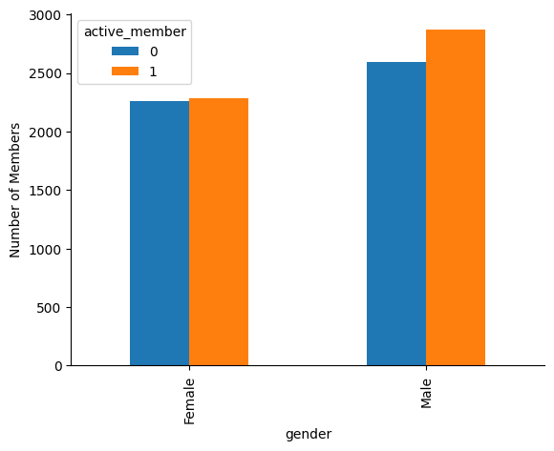

***Figure 1.1:***  *Active and inactive members based on the differences between male and female.*

**Table 1.1**: Active rate comparison between genders.

|  |  |  |  |
| --- | --- | --- | --- |
|  | ***Active*** | ***Inactive*** | ***Active Rate(%)*** |
| **Gender** |  |  |  |
| **Female** | 2259 | 2284 | 50.28 |
| **Male** | 2590 | 2867 | 52.54 |

This shows a slight difference in activity levels, with males having a marginally higher rate of active membership compared to females.

**1.2 Which country has the highest churn rate?**

Germany has the highest churn rate at **32.4%**, followed by Spain at **16.7%**, and France with the lowest churn rate at **16.2%**. This visual representation clearly highlights the disparity in churn rates between the three countries, with Germany experiencing significantly higher customer churn compared to France and Spain.

The significantly higher churn rate in Germany compared to France and Spain indicates a potential issue with customer satisfaction or retention strategies in that market.

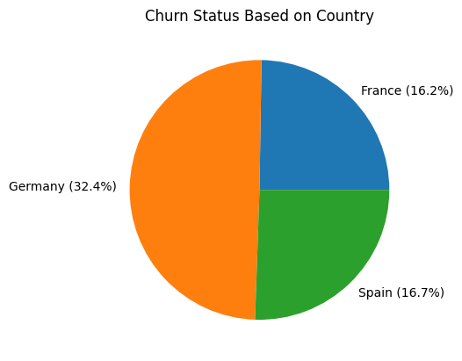

***Figure 1.2*** *: distribution of customer churn across three countries.*

***Table 1.2 :*** *Churn Rates by Geographic Region*

|  |  |  |  |
| --- | --- | --- | --- |
|  | ***Retained*** | ***Churned*** | ***Churn Status(%)*** |
| **Country** |  |  |  |
| **France** | 4204 | 810 | 16.15 |
| **Germany** | 1695 | 814 | 32.44 |
| **Spain** | 2064 | 413 | 16.67 |

Potential Reasons for High Churn in Germany's :

* Strong competition in the German market might be attracting customers away from the company.
* Customers in Germany might be experiencing problems with the products or services offered

**1.3 How does the age distribution of customers vary by gender?**

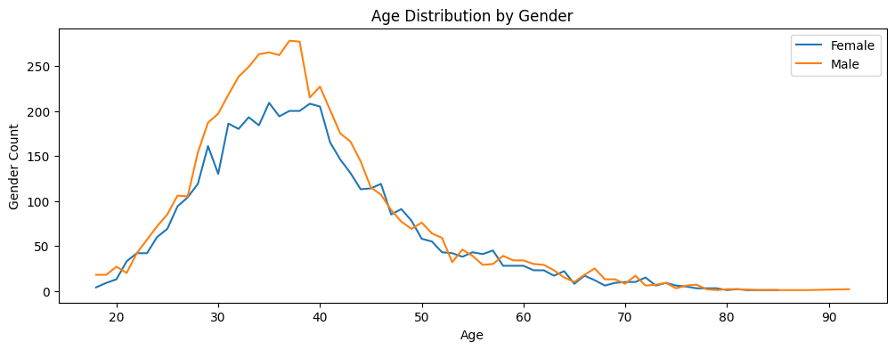

***Figure 1.3 :*** *Age distribution by gender*

|  |  |  |  |
| --- | --- | --- | --- |
|  | **Female** | **Male** | **Overall** |
| **count** | 4543.000000 | 5457.000000 | 10000.000000 |
| **mean** | 39.238389 | 38.658237 | 38.921800 |
| **median** | 38.000000 | 37.000000 | 37.000000 |
| **min** | 18.000000 | 18.000000 | 18.000000 |
| **max** | 85.000000 | 92.000000 | 92.000000 |

***Table 1.3:*** *Summary Statistics of Age Distribution by Gender*

The line chart with the data provided on the table display the distribution of customer age for male and female consists of **10,000** individuals, with **4,543 females** and **5,457 males**. The average median age of females is **39.24** years, slightly higher than the male average median of **38.66** years, resulting in an overall average median age of **38.92** years. The age range spans from **18 to 85** years for females and **18 to 92** years for males, with the maximum age overall being 92 years.

This distribution suggests a slightly broader age range among males compared to females.

Given the right-skewed distribution, the median provides a more representative measure of central age than the mean

### **1.4 Is there a specific age group that has the highest churn rate?**

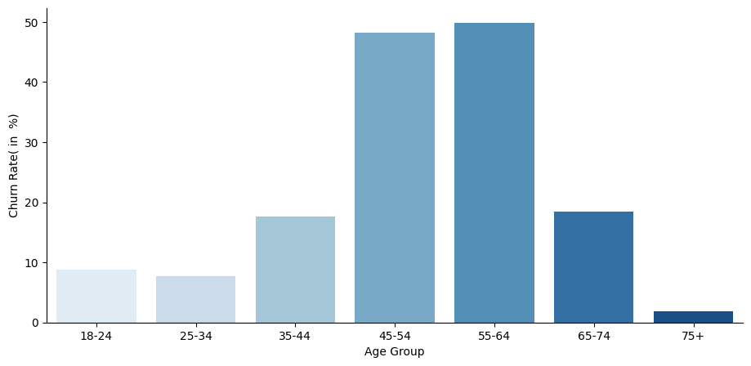

***Figure 1.4*** *: Churn rate by age group*

|  |  |  |  |
| --- | --- | --- | --- |
|  | ***Retained*** | ***Churned*** | ***Churn Rate(%)*** |
| ***Age Group*** |  |  |  |
| **18-24** | 397 | 38 | 8.740000 |
| **25-34** | 2972 | 250 | 7.760000 |
| **35-44** | 3278 | 703 | 17.660000 |
| **45-54** | 756 | 702 | 48.150000 |
| **55-64** | 301 | 299 | 49.830000 |
| **65-74** | 186 | 42 | 18.420000 |
| **75+** | 53 | 1 | 1.850000 |

**Table 1.4 :** *Churn rate by age group breakdown*

The chart and table highlight churn rates across various age groups, revealing a significant trend. The lowest churn rate is observed among the 18-24 age group (8.74%), gradually increasing to 7.76% for the 25-34 group and then surging to a peak of 49.83% for the 55-64 age group.

This age group, likely impacted by retirement and associated financial and lifestyle changes, appears most prone to discontinuing services. Factors such as reduced income or economic instability during this stage of life may drive these decisions.

After this peak, churn rates decline notably to 18.42% for the 65-74 group and drop further to 1.85% for customers aged 75 and older. Overall, churn rates are higher among middle-aged individuals compared to younger and older groups

**1.5 What is the churn rate among customers with specific credit score ranges?**

**Table 1.5:** Churn Breakdown by Credit Score Tier

|  |  |  |  |
| --- | --- | --- | --- |
|  | ***Retained*** | ***Churned*** | ***Churn Rate(%)*** |
| ***Credit Score Level*** |  |  |  |
| **300-579: Poor** | 1842 | 520 | 22.02 |
| **580-699: Fair** | 3597 | 893 | 19.89 |
| **679-739: Good** | 1025 | 244 | 19.23 |
| **740-799: Very Good** | 972 | 252 | 20.59 |
| **800-850: Exceptional** | 527 | 128 | 19.54 |

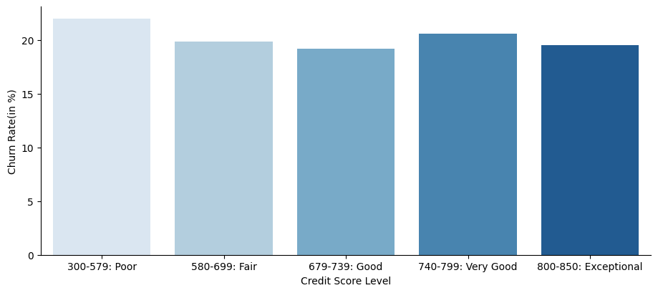

***Figure 1.5:*** *Churn Rate Based on Credit Score Range.*

* The bar chart shows that churn rates tend to increase with higher credit score ranges.
* Customers in the "Good," "Very Good," and "Exceptional" credit score categories have higher churn rates compared to those in the "Poor" and "Fair" ranges.
* The table reveals that churn rates remain relatively consistent, fluctuating between 19% and 22% across all credit score levels
* Credit score appears to influence churn, but it is not the only determining factor.

### **1.6 What is the distribution of the number of products used by customers?**

### **customerProductUsed**

*.*

***Figure 1.6 :*** *Frequency of product usage among customers.*

|  |  |  |
| --- | --- | --- |
|  | ***Number of Customers*** | ***Proportion(in%)*** |
| ***products_number*** |  |  |
| *1* | *5084* | 50.84 |
| *2* | *4590* | 45.90 |
| *3* | *266* | 2.66 |
| *4* | *60* | *0.6* |

***Table 1.6:*** *Breakdown of the number of products utilized by customers.*

The pie chart and table visualize the distribution of customers across different product numbers. The majority of customers (**5084**) have opted to used only product 1, constituting the largest segment of the pie chart. Customers using 2 products follows with **4590** customers, while using 3 and 4 products have significantly fewer customers, with **266** and **60** respectively.

This indicates a clear preference for using 1 or 2 products among the customer base.

.

**1.7 How does customer tenure impact churn rates, and what trends can be observed in churn behavior across different tenure levels?**

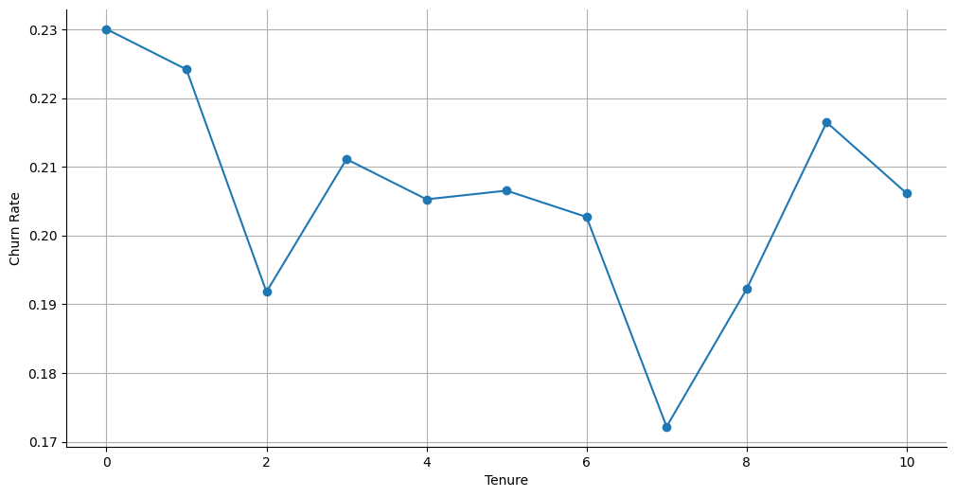

***Figure******1.7:*** *Distribution of churn status based on customer tenure.*

|  |  |  |  |
| --- | --- | --- | --- |
|  | ***Retained*** | ***Churned*** | ***Churn Rate(in %)*** |
| ***Tenure*** |  |  |  |
| **0** | 318 | 95 | 23.000000 |
| **1** | 803 | 232 | 22.420000 |
| **2** | 847 | 201 | 19.180000 |
| **3** | 796 | 213 | 21.110000 |
| **4** | 786 | 203 | 20.530000 |
| **5** | 803 | 209 | 20.650000 |
| **6** | 771 | 196 | 20.270000 |
| **7** | 851 | 177 | 17.220000 |
| **8** | 828 | 197 | 19.220000 |
| **9** | 771 | 213 | 21.650000 |
| **10** | 389 | 101 | 20.610000 |

From the illustration and the data on the table, the churn rate, or the percentage of customers who discontinue using the service, generally decreases as tenure (duration of service) increases.

At 0 tenure, the churn rate is **23%.** It drops to **22.42%** at 1 year of tenure, then further declines to **19.18%** at 2 years of tenure.

The churn rate remains around **20-21%** for customers with 3-6 years of tenure. It then drops to **17.22%** for those with 7 years of tenure, before fluctuating between **19-22%** for 8-10 years of tenure.

**Table 1.7** Customer churned trends over time

Overall, new customers may experience initial problems or dissatisfaction that lead to higher churn rates, while those with longer tenure have likely overcome such early challenges.

***2 ) Detailed Insights***

**2.1 Is there a correlation between tenure with the bank and churn rate?**

In this analysis, we explored whether the length of time a customer has been with the bank (tenure) affects their likelihood of churning (leaving the bank). We used a statistical method to check for any potential relationship between these two factors.

|  |  |
| --- | --- |
| **Point-Biserial Correlation Coefficient** | **P-Value** |
| −0.014 | 0.162 |

***Table 2.1 Correlation Test Results***

Our findings show that while there is a slight negative relationship between tenure and churn (meaning that longer-tenured customers may be slightly less likely to churn), the relationship is very weak.

The p-value **0.162** is greater than the typical significance level of **0.05**. This means that we fail to reject the null hypothesis that there is no correlation between tenure and churn.In other words, the observed correlation is not statistically significant, and cannot confidently conclude that tenure has an effect on churn.

The statistical test we conducted confirmed that the observed relationship is not strong enough to draw any meaningful conclusions. In other words, based on this analysis, we cannot confidently say that customers with longer tenure are any less likely to churn.

**2.2 How does the number of products a customer holds relate to churn rates?**

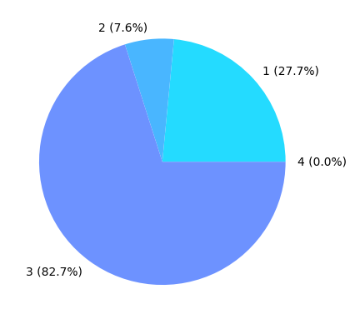

***Figure 2.1:*** *Distributions of churn rate as per number of products used by customer.*

***Table 2.2 :*** *Product Churn Breakdown.*

|  |  |  |  |
| --- | --- | --- | --- |
|  | ***Retained*** | ***Churned*** | ***Churn Rate(%)*** |
| ***Product number*** |  |  |  |
| **1** | 3675.0 | 1409.0 | 27.714398 |
| **2** | 4242.0 | 348.0 | 7.581699 |
| **3** | 46.0 | 220.0 | 82.706767 |
| **4** | 0.0 | 60.0 | 0.000000 |

The pie chart illustrates the distribution of churn rates across different number of product used by customer. The largest segment of the pie chart, representing **82.7%**, corresponds to using 3 product , indicating a significantly higher churn rate.

With 1 uses of product follows with a **27.7%** churn rate, while with 2 and 4 uses have significantly lower churn rates of **7.6% and 0%**, respectively.

This suggests that using 3 product might have specific issues leading to higher customer churn.

**2.4 Is there a threshold salary where customers are more likely to churn and does the estimated salary correlate with churn?**

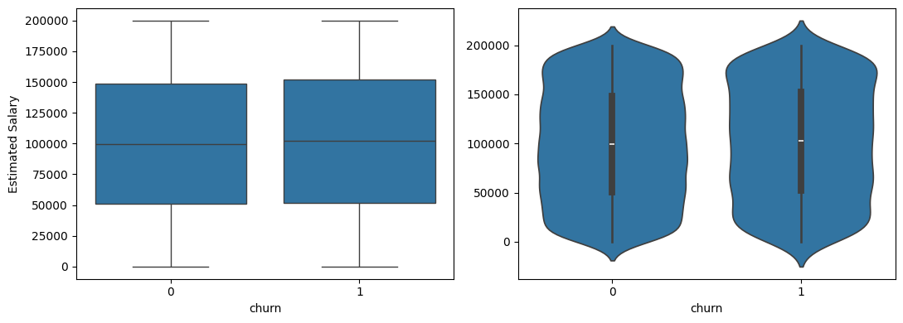

***Figure 2.2:*** *Boxplot and Violin plot for the estimated salary between churned and remained*

|  |  |  |  |  |  |  |
| --- | --- | --- | --- | --- | --- | --- |
|  | **Count** | **Mean** | **Median** | **Std** | **Min** | **Max** |
| **Churned** | 2037.0 | 101465.67 | 102460.84 | 57912.41 | 11.58 | 102460.84 |
| **Remained** | 7963.0 | 99738.39 | 99645.04 | 57405.58 | 90.07 | 199992.48 |

***Table 2.3:*** *Summary statistics of estimated salary between churned and remained*

The bar chart and the summary statistics table shows the distribution of churn status across the customer base.

The mean estimated salary for the churned customers is **$101,465.67**, which is slightly higher than the mean salary of **$99,738.39** for the retained customers. The median salary also follows a similar pattern, with the churned group having a median of **$102,460.84** compared to $**99,645.04** for the retained group.

This suggests that customers with higher estimated salaries tend to have a slightly elevated churn rate compared to those with lower salaries. However, the large standard deviations of around **$57,000** for both groups indicate significant overlap in the salary distributions between the churned and retained customers.

The data does not seem to reveal a clear salary threshold above which customers are significantly more likely to churn.

To gain deeper insights, we conducted a statistical test to see if salary is truly related to the likelihood of churning. The results showed that there is no significant difference in salary distribution between customers who churned and those who didn’t. In simple terms, salary does not seem to be a major factor in whether a customer stays or leaves.

**2.4 How does age group influence churn rate within different credit score levels?**

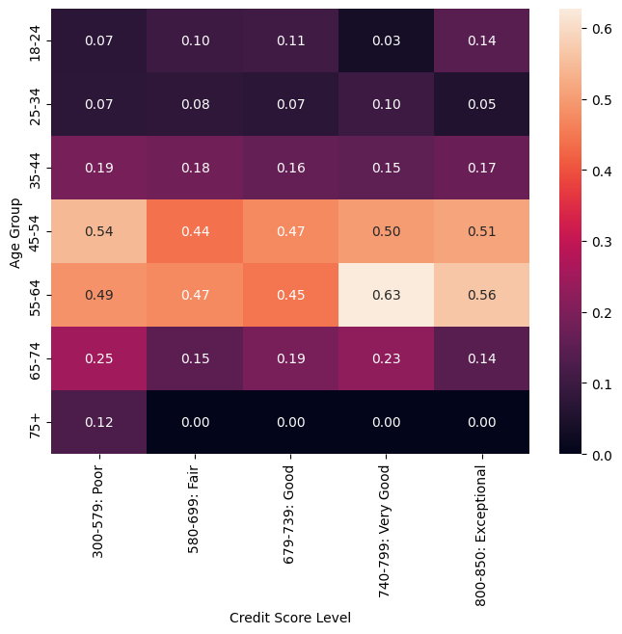

***Figure 2.3:*** *Churn Rate Variation by Credit Score and Age Group*



***Table 2.6 :*** *Impact of Age and Credit Score on Churn Rates*

The relationship between age groups and churn rates within different credit score levels reveals notable patterns.

Middle-aged customers, particularly those in the **45-54** and **55-64** age groups, exhibit higher churn rates across most credit score levels, with the highest concentration in the "Poor" (300-579) and "Fair" (580-699) credit score categories.

Younger age groups (**18-34**) tend to have lower churn rates across all credit levels, possibly reflecting less financial entanglement or shorter customer tenure.

Conversely, older age groups (**65+**) show lower churn rates in higher credit score levels, such as "Very Good" (**740-799**) and "Exceptional" (**800-850**), indicating more financial stability and loyalty among these customers.

This trend highlights that churn is not only influenced by credit scores but also by age-related financial behaviors and stability.

**Key Findings**

* **Germany has the highest churn rate (32.4%)**, compared to Spain (26%) and France (25%). This suggests potential regional challenges, such as increased competition or dissatisfaction with specific products or services offered in the German market. Further investigation into customer feedback and competitor analysis in this region would be valuable for understanding the root causes of this high churn rate.
* **Middle-aged customers (45-64) exhibit the highest churn rates (48-50%)**, particularly in the **"Poor" (300-579) and "Fair" (580-699) credit score categories.** One possible reason for this could be that many individuals in this age group are approaching or already in retirement, which may lead to changes in financial priorities and decreased engagement with the bank’s services. Targeting this group with tailored retention strategies could help address these challenges.
* **Customers using three products have the highest churn rate (82.7%)**, which could indicate dissatisfaction with the specific combination of services they have. This high churn rate may be a result of poor customer experience with multi-product offerings or issues related to service complexity. A closer look at the satisfaction levels of multi-product users and improvements to the service bundle could reduce this churn.
* **Early-stage churn (first 1–2 years) is high (~22–23%)**, highlighting difficulties in on-boarding and customer engagement during the initial relationship period. Customers in the early stages of their relationship with the bank may not fully understand the value of the bank’s services, which could lead to higher churn. Enhancing the on-boarding experience and providing more personalized engagement during these early years could help improve retention rates
* While churned customers have slightly higher average salaries than retained ones, the overlap in salary distributions suggests salary is not a key factor driving churn.

**Recommendation**

* **Localized Strategies for Germany:**  
  To address Germany's high churn rate (32.4%), We can conduct surveys and analyze competitor strategies to pinpoint areas of dissatisfaction. By tailoring loyalty programs, promotions, and outreach efforts to German customers, we can foster stronger relationships and reduce churn.
* **Tailored Retention for Middle-Aged Customers (45-64):**  
  Develop specialized financial products and services, such as retirement planning tools and low-risk investment options, to meet the needs of middle-aged customers. Personalized engagement and proactive financial advisory can reduce churn in this high-risk segment.
* **Improve Multi-Product Offerings:**  
  The high churn rate among three-product users (82.7%) indicates dissatisfaction with service combinations.We can simplify offerings, making them more intuitive and personalized. By actively seeking customer feedback and making necessary adjustments, we can enhance satisfaction and reduce churn.
* **Enhance Early-Stage Engagement:**  
  To mitigate high churn during the first 1–2 years (~22–23%), strengthen the on-boarding process with personalized touch-points, clear communication of service benefits, and regular check-ins during this critical period can boost retention.

**Conclusion**

This report has shed light on the key reasons why customers leave ABC Bank and offered practical steps to address these challenges. High churn rates in regions like Germany, as well as among middle-aged customers, stand out as significant concerns. Additionally, issues such as early-stage disengagement and dissatisfaction with multi-product bundles are major factors driving customer attrition.

While factors like salary have minimal impact, improving on-boarding, addressing regional concerns, and tailoring services to meet the needs of specific customer groups can make a big difference. The recommendations outlined in this report focus on creating a better customer experience, fostering stronger relationships, and keeping customers loyal.

By acting on these insights, ABC Bank has the opportunity to reduce churn, retain more customers, and build a stronger foundation for long-term success.