Day 3 — Set Up EF Core & Run Your First Migration
Hands-On Lab Documentation
Project: | Day3_TrainingManagementApi
Database: | TrainingManagementDB
Database Engine: | SQL Server LocalDB

Lab Objective
The objective of this lab was to set up Entity Framework Core in the ASP.NET Core Web API project, define the entity classes based on the Day 2 ERD, create and configure the database context, connect the project to SQL Server LocalDB, create the first migration, and verify the database structure.
1. Add the EF Core SQL Server and Tools NuGet Packages
The project was prepared to work with Entity Framework Core and SQL Server.
The EF Core CLI tool was installed successfully to allow the use of Entity Framework Core commands for managing migrations and the database.
The installed EF Core CLI version was 10.0.11. After installation, the tool was also verified successfully from the Terminal.
dotnet tool install --global dotnet-ef
Screenshot 1 — EF Core CLI Installation
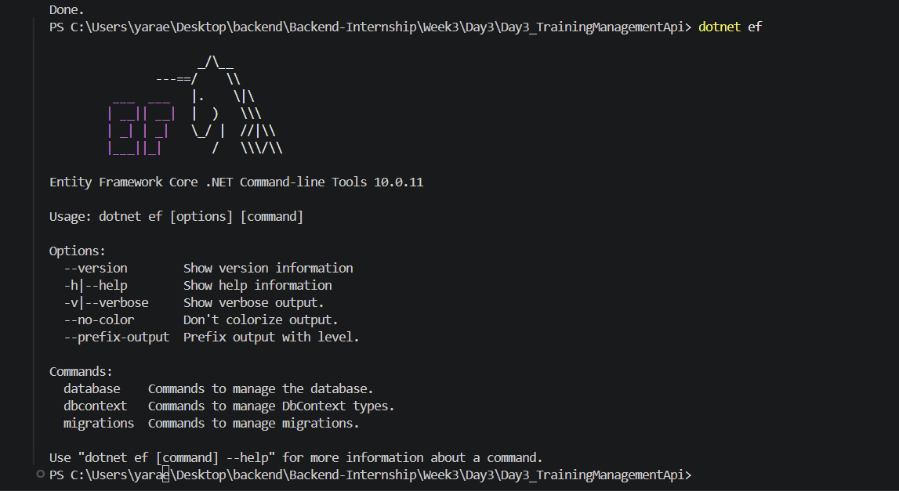
2. Define Entity Classes
The entity classes were created based on the tables defined in the Day 2 ERD.
The project includes entities representing participants, trainings, training days, trainers, companies, courses, instructors, universities, semesters, Islamic goals, tasks, skills, and the junction entities used for the many-to-many relationships.
Navigation properties were also added to represent the relationships between the entities.
For example, tasks can be associated with courses, trainings, and Islamic goals. Courses and trainings are also related to skills through their respective junction entities.
Screenshot 2 — Entity Classes
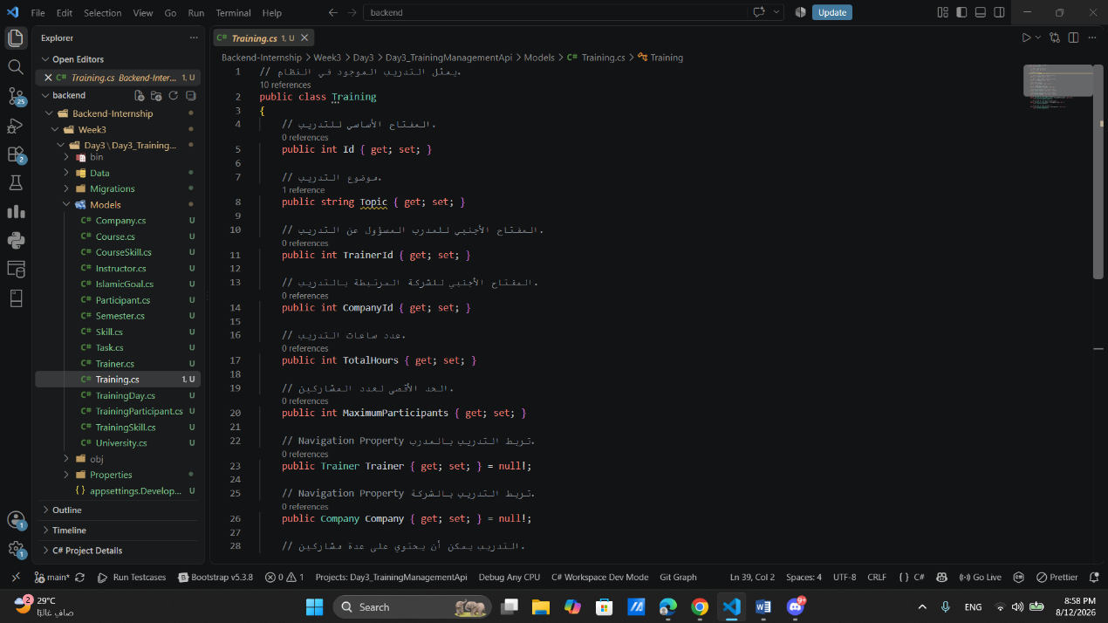
3. Create and Configure the DbContext
A TrainingManagementDbContext was created to manage the application's interaction with the database.
A DbSet was defined for each entity so that Entity Framework Core could represent the application's entities as database tables.
The relationships between the entities were configured in the DbContext. This included the composite primary keys used by the junction entities and unique indexes for participant emails, instructor emails, and course codes.
The DbContext was then registered in Program.cs and configured to use SQL Server with the connection string defined for the project.
The database connection was verified successfully using the EF Core DbContext information command.
The result confirmed:
• DbContext: TrainingManagementDbContext
• Provider: Microsoft.EntityFrameworkCore.SqlServer
• Database: TrainingManagementDB
• Data Source: (localdb)\MSSQLLocalDB
Screenshot 3 — DbContext Information
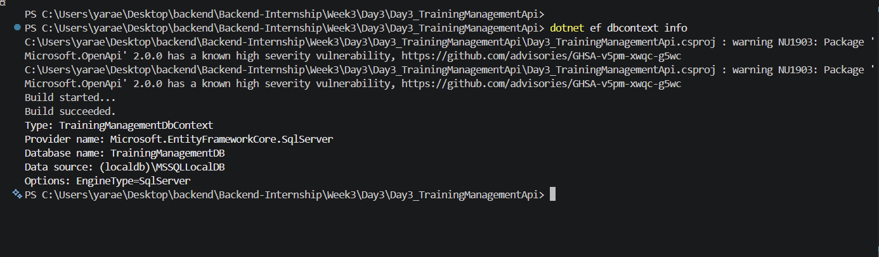
4. Create and Inspect the Initial Migration
After completing the entity and DbContext configuration, the first migration was created with the name InitialCreate.
The migration was generated successfully by Entity Framework Core.
The generated migration was then inspected to verify that Entity Framework Core had detected the required tables, primary keys, foreign keys, relationships, and indexes based on the configured model.
5. Update and Verify the Database
The database update command was executed to synchronize the database with the available migrations.
The command completed successfully, and EF Core reported that the database was already up to date.
The final message displayed in the Terminal was:
"No migrations were applied. The database is already up to date."
This confirmed that there were no pending migrations that needed to be applied.
6. Verify the Database Tables
The database was then accessed through the MSSQL extension in Visual Studio Code.
The TrainingManagementDB database was opened, and the Tables section was expanded to verify the database structure.
The expected tables were visible under the database, including tables for companies, courses, course skills, instructors, Islamic goals, participants, semesters, skills, tasks, training days, training participants, trainers, trainings, training skills, and universities.
Conclusion
The EF Core setup and first migration lab was completed successfully.
The project was configured to work with Entity Framework Core and SQL Server LocalDB. The required entities and relationships were defined, the DbContext was created and configured, and the InitialCreate migration was generated successfully.
Finally, the database was verified through the MSSQL extension in Visual Studio Code, where the database structure and tables were visible.

