Week 6 – Day 5: Sprint Review, API Demo & Retrospective
1. Day Overview
Day 5 focuses on closing and reviewing Sprint 1. The main goal is to demonstrate the API features implemented during the sprint, verify that the completed work behaves as expected, review the sprint against its acceptance criteria, identify any incomplete or improvable work, and prepare a retrospective for Sprint 2.
For the API demonstration, Swagger was used to execute the endpoints and show the results directly. The demonstration covered the catalog and read operations implemented in Day 3 and the medication order workflow implemented in Day 4.
Day 5 Activities
- Demonstrate the completed API features using Swagger.
- Demonstrate pagination, filtering, and sorting for the Patients catalog.
- Demonstrate medication order creation.
- Verify business logic such as stock validation and stock decrement.
- Review Sprint 1 against its acceptance criteria.
- Identify incomplete work or improvements for Sprint 2.
- Write a Sprint 1 retrospective.
- Prepare the Sprint 1 summary and supporting evidence.
2. Sprint 1 API Demonstration
2.1 Patients Catalog — Pagination
The Patients catalog endpoint was demonstrated using Swagger.
The request used:
GET /api/Patients?page=1&pageSize=2

The API returned 200 OK and returned two patients while showing that the total number of patients was four.
Evidence
Screenshot: Day5_Patients_Pagination_Demo.png
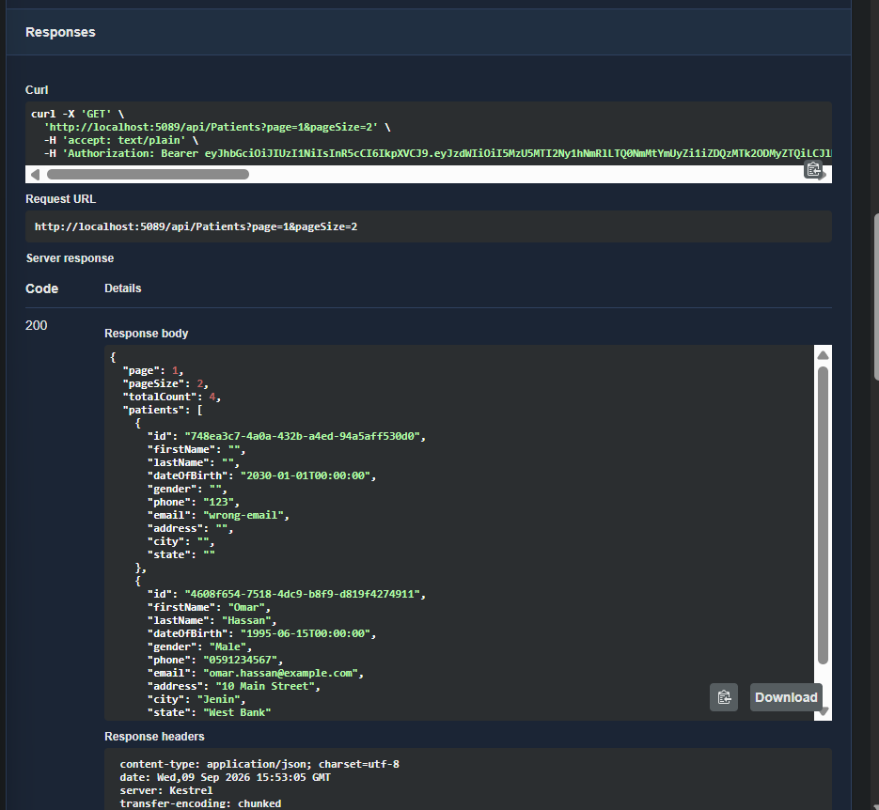
2.2 Patients Catalog — Gender Filtering
The Patients catalog endpoint was tested with a gender filter.
The request used:
GET /api/Patients?page=1&pageSize=10&gender=Male

The API returned 200 OK and returned only patients matching the requested gender. The response showed a total of three matching patients.
Evidence
Screenshot: Day5_Patients_Gender_Filter_Demo.png
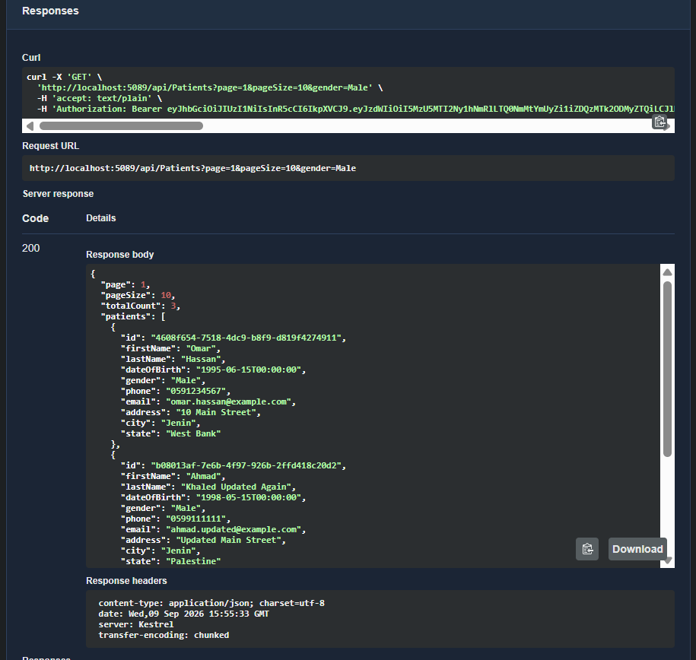
2.3 Patients Catalog — City Filtering
The Patients catalog endpoint was tested with a city filter using city=Jenin.
The API returned 200 OK and returned patients matching the requested city.
Evidence
Screenshot: Day5_Patients_City_Filter_Demo.png
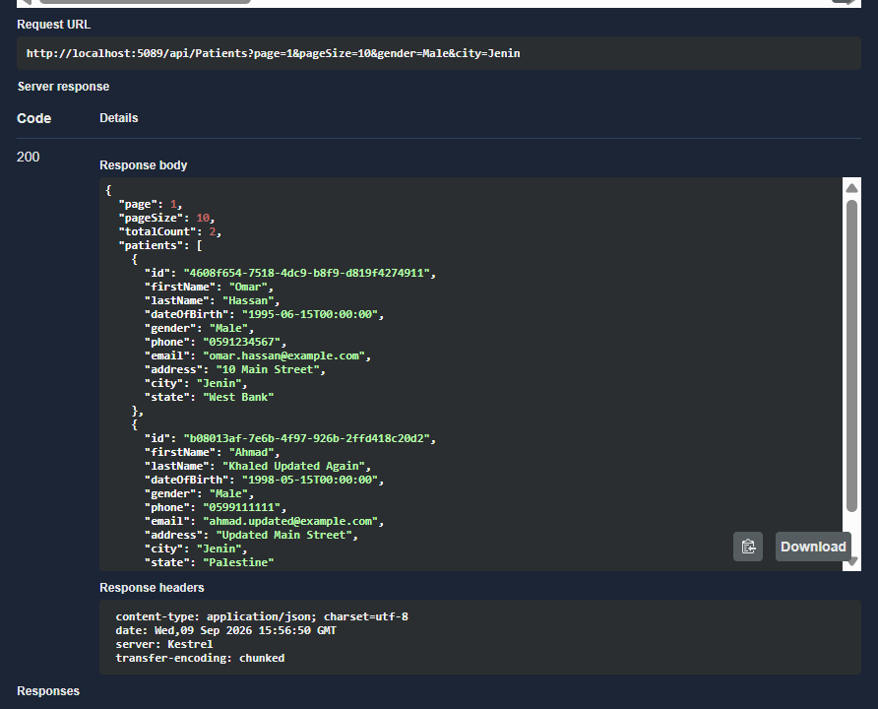
2.4 Patients Catalog — Sorting
The Patients catalog endpoint was tested using the sort=city query parameter.
The API returned 200 OK and demonstrated sorting the patient catalog by city.
Evidence
Screenshot: Day5_Patients_Sorting_City_Demo.png
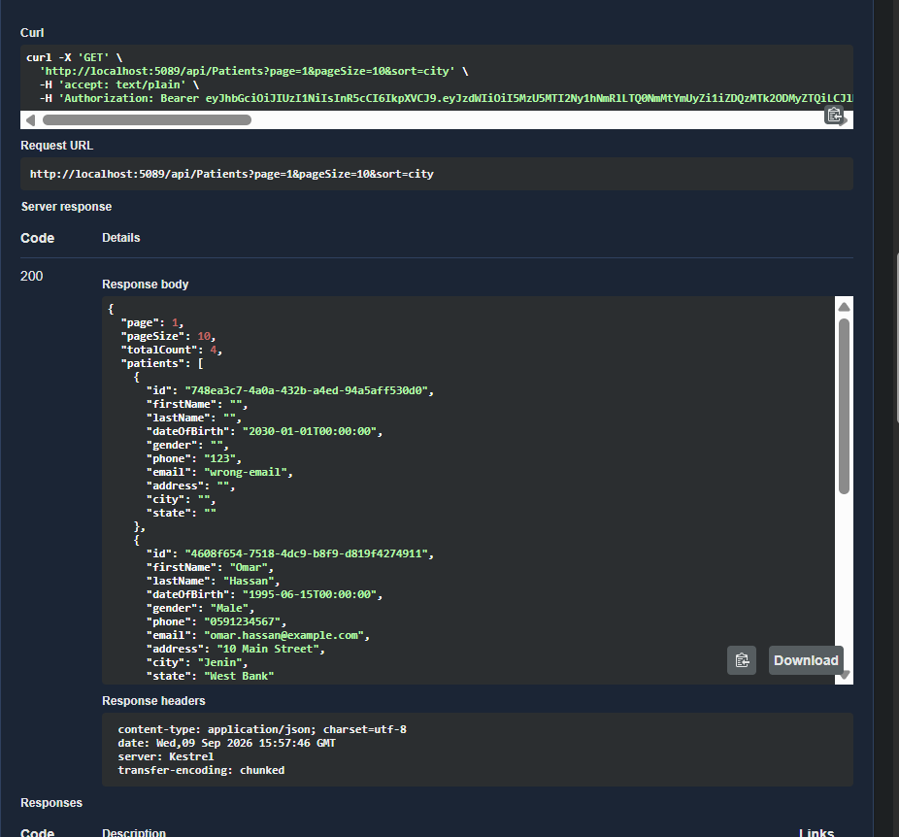
3. Medication Order Demonstration
The second part of the Sprint 1 demonstration focused on the medication order workflow implemented during Day 4.
The workflow contains business logic beyond simple CRUD. The system validates the patient and requested medication, checks stock availability, calculates the medication price and order total on the server side, creates the order and its items, and decreases the medication stock.
The demonstration was performed through Swagger using a real API request.
Request
POST /api/MedicationOrders

The request created an order for:
- Patient: Omar Hassan
- Medication: Metoprolol 25 mg
- Medication Catalog Item ID: 3
- Quantity: 1
Result
The API returned:
- Status: 200 OK
- Order ID: 5
- Unit Price: 7.75
- Line Total: 7.75
- Order Total: 7.75
This confirms that the API successfully created the medication order and calculated the price and totals on the server side.
Evidence
Screenshot: Day5_Create_Medication_Order.png
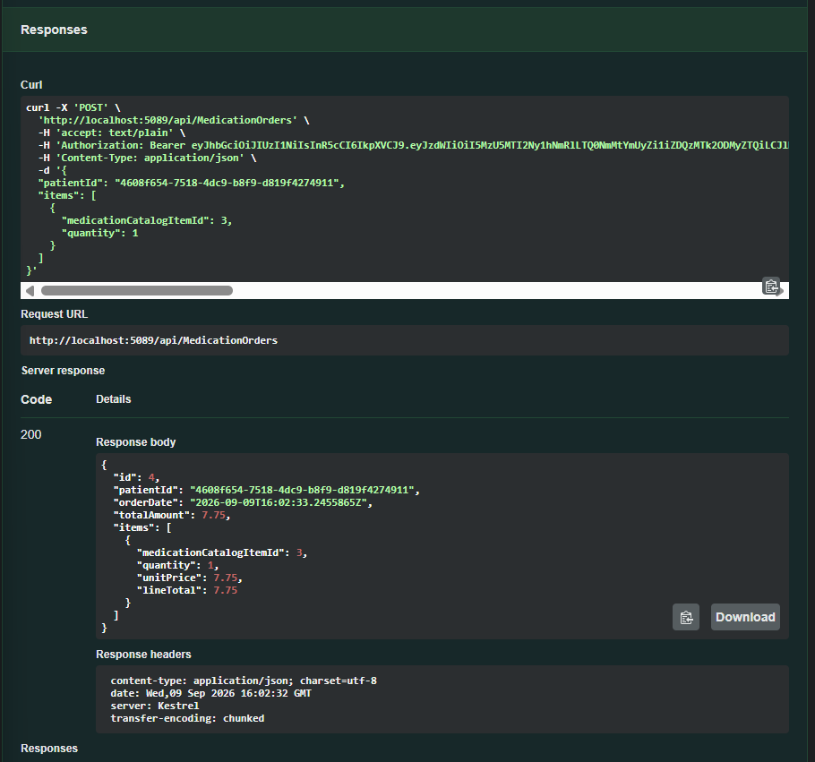
4. Stock Decrement Verification
To verify that the medication order also updates the inventory, the medication stock was checked in the database before and after creating the order.
Before Creating the Order
The stock of Metoprolol 25 mg was:
StockQuantity = 2

Evidence
Screenshot: Day5_Stock_Before_Order.png
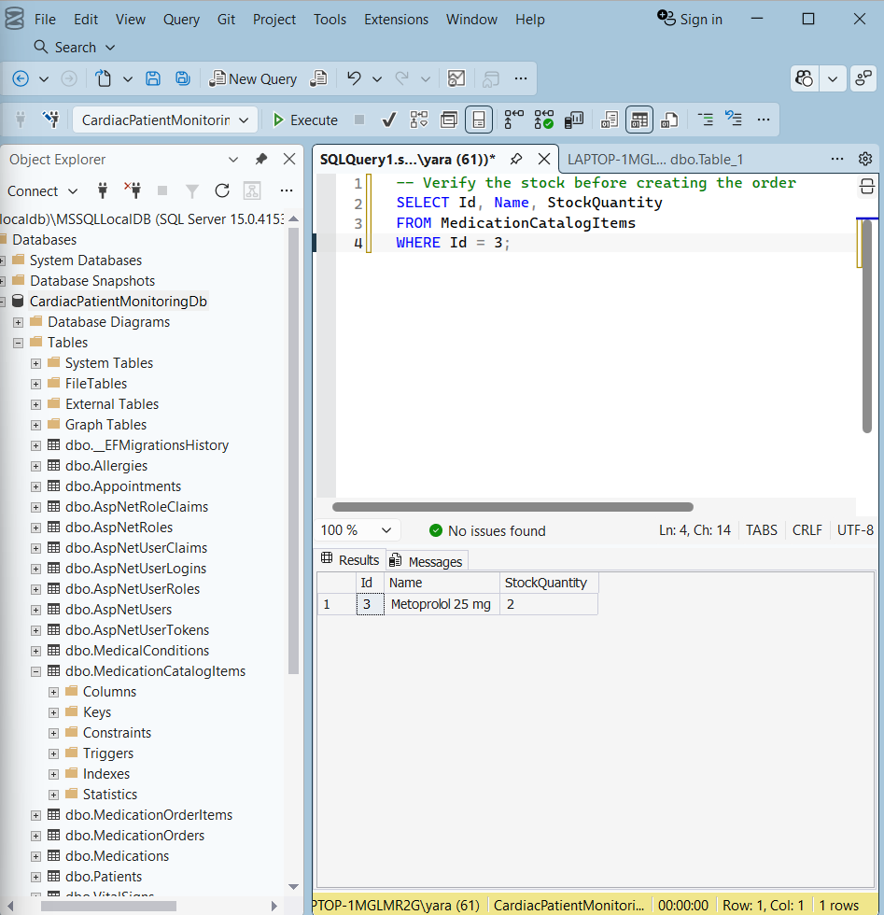
After Creating the Order
An order for quantity 1 was successfully created.
The stock was then checked again in the database and became:
StockQuantity = 1

This confirms that the medication stock was decreased by the ordered quantity after the successful order.
Evidence
Screenshot: Day5_Stock_After_Order.png
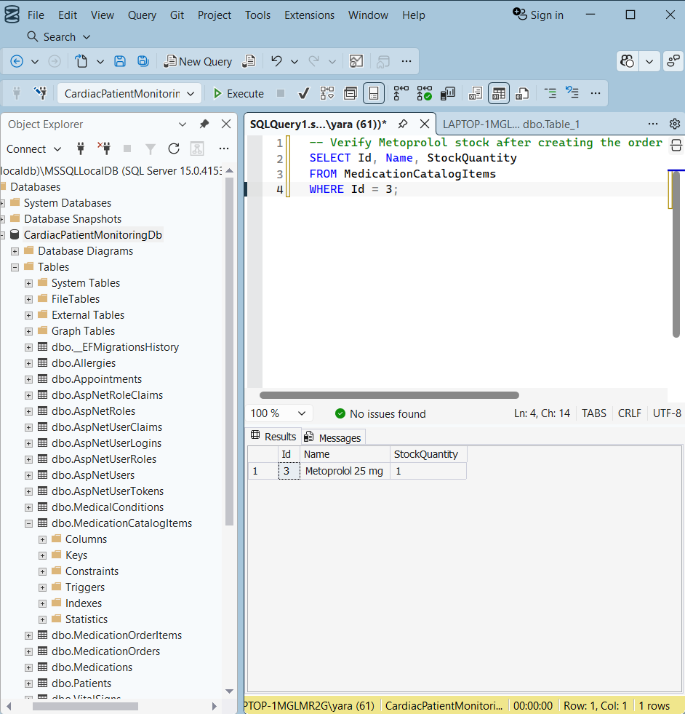
Verification Summary
The complete workflow was demonstrated as:
Stock = 2
↓
Create Order — Quantity = 1
↓
Order created successfully — 200 OK
↓
Stock = 1

This demonstrates that the medication order workflow does more than create database records. It also applies the required inventory business logic.
What to Say in the Discussion
"Before creating the order, the Metoprolol stock was 2. I then created an order for one unit through the API. The API returned 200 OK and created the order successfully. After that, I checked the database and the stock became 1. This confirms that the order workflow correctly updates the inventory."
5. Insufficient Stock Validation
The medication order workflow was also tested with a quantity greater than the available stock.
The API rejected the request instead of creating an invalid order. This confirms that the service checks stock availability before completing the transaction.
Evidence
Screenshot: Day5_Insufficient_Stock_Demo.png
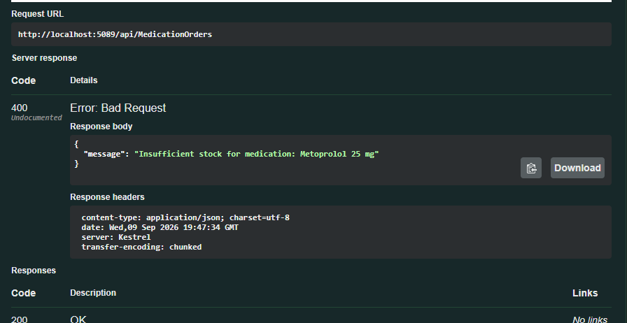
6. Transaction Rollback Verification
Transaction rollback was verified during Day 4 while testing the medication order workflow.
A temporary exception was added after the database changes were saved but before the transaction was committed. The API returned an error, and the transaction was rolled back successfully.
The temporary exception was then removed, and the application was built successfully.
Result
The test confirmed that the medication order operation is protected by a database transaction. If an error occurs before the transaction is committed, the changes are rolled back instead of leaving partial database changes.
7. Sprint Review
The completed Sprint 1 work was reviewed against the planned requirements.
Completed Work
- Patients catalog with pagination.
- Patients filtering by gender and city.
- Patients sorting by city.
- Medication order creation.
- Medication quantity validation.
- Insufficient stock validation.
- Server-side medication price calculation.
- Order total calculation.
- Stock decrement after a successful order.
- Transaction handling and rollback.
- Optimistic concurrency handling with RowVersion.
Review Result
The main Sprint 1 API requirements were completed and demonstrated through Swagger using both successful and error scenarios.
Remaining Work
Mentor code review and approval were not completed during Sprint 1. This will be carried forward to Sprint 2 together with any feedback received during the review.
8. Sprint 2 Backlog
The following items were carried forward to Sprint 2:
1. Complete Mentor Code Review
  - Review the Sprint 1 implementation with the mentor.
  - Address any feedback received during the review.
2. Improve Automated Tests
  - Add automated tests for the medication order business logic.
  - Cover successful order creation and insufficient stock scenarios.
  - Add coverage for transaction rollback behavior.
3. Continue API Improvements
  - Apply improvements identified during code review.
  - Continue validating the API through successful and error scenarios.

9. Sprint 1 Retrospective
What Went Well
- The Patients catalog features were implemented and tested successfully.
- Pagination, filtering, and sorting were demonstrated through Swagger.
- The medication order workflow included real business logic beyond basic CRUD.
- Stock validation and stock decrement were tested successfully.
- Transaction handling and rollback were verified.
- Both successful and error scenarios were tested during the Sprint 1 API demonstration.
What Could Be Improved
- Mentor code review was not completed during Sprint 1.
- More automated tests are needed for the medication order business logic.
- Code review should be included earlier in the development process.
Concrete Action for Sprint 2
Write automated tests for the medication order service before adding the next major write operation.
This will help detect business logic and transaction-related issues earlier and make the implementation easier to review.
10. Sprint 1 Summary
Sprint 1 focused on implementing and validating core API functionality for the Cardiac Patient Monitoring system.
Sprint 1 Deliverables
- Day 3: Implemented Patients catalog and read operations, including pagination, filtering, and sorting.
- Day 4: Implemented medication order write operations and business logic, including stock validation, server-side price calculation, stock decrement, transactions, and concurrency handling.
- Day 5: Demonstrated the completed API features through Swagger, tested successful and error scenarios, reviewed the Sprint 1 acceptance criteria, identified Sprint 2 backlog items, and completed the Sprint 1 retrospective.
Final Status
The main Sprint 1 API requirements were completed and demonstrated successfully.
Mentor code review and approval remain as follow-up work for Sprint 2.
Sprint 1 — Completed

