Day 5 — Securing the API: Rate Limiting, CORS & Security Headers
1. Day 5 Overview
Today we focused on protecting the API from some common issues, and applied them hands-on in the Day5 project.
We learned and applied:
- Rate Limiting
- CORS
- HTTPS Redirection
- HSTS
- SQL Injection Prevention
- Reviewing the API and testing security using Postman
2. Rate Limiting
What is Rate Limiting?
Rate Limiting means we define how many requests a Client can send within a specific time period.
The idea, simply:
Client
↓
Request
↓
Rate Limiter
↓
Exceeded the limit?
├── No → request is allowed
└── Yes → 429 Too Many Requests
We used it to protect the API from:
- Frequent, rapid Login attempts.
- Brute-force attacks.
- Some simple Denial of Service patterns.
2.1 Why does Login have a different Limit?
Not all Endpoints carry the same level of risk.
For example:
GET /api/participants/1
This can be a normal Endpoint.
But:
POST /api/auth/login
Someone could try hundreds of passwords against it.
That's why we gave the Login limit a stricter setting.
Our settings
General endpoints:
100 requests / minute
Login:
5 requests / minute
And the Queue:
0
This means that once the limit is reached, the extra request does not wait in a Queue — it is rejected immediately.
2.2 The code we implemented
In Program.cs:
// Configure ASP.NET Core's built-in rate limiting.
builder.Services.AddRateLimiter(options =>
{
// Return HTTP 429 when the request limit is exceeded.
options.RejectionStatusCode = StatusCodes.Status429TooManyRequests;

// General endpoints: allow up to 100 requests per minute.
options.AddFixedWindowLimiter("GeneralPolicy", limiterOptions =>
{
limiterOptions.PermitLimit = 100;
limiterOptions.Window = TimeSpan.FromMinutes(1);
limiterOptions.QueueLimit = 0;
});

// Login endpoint: allow only 5 requests per minute.
// This stricter limit helps reduce brute-force login attempts.
options.AddFixedWindowLimiter("LoginPolicy", limiterOptions =>
{
limiterOptions.PermitLimit = 5;
limiterOptions.Window = TimeSpan.FromMinutes(1);
limiterOptions.QueueLimit = 0;
});
});
What does FixedWindowLimiter mean?
We divided time into a Window that is one minute long:
1 minute
|-----------------------------|

Requests:
1 2 3 4 5 ❌
For Login, the first 5 requests are allowed, and after that we get:
429 Too Many Requests
3. Applying Rate Limiting to the Endpoints
We created a Policy for Login:
[EnableRateLimiting("LoginPolicy")]
[HttpPost("login")]
public async Task<IActionResult> Login(LoginRequest request)
{
// Login logic...
}
And we created a Policy for the General endpoint:
[EnableRateLimiting("GeneralPolicy")]
[HttpGet("{id}")]
public async Task<IActionResult> GetById(int id)
{
// Get participant...
}
Notice the difference:
Login
↓
LoginPolicy
↓
5 requests/minute
Compared to:
General endpoint
↓
GeneralPolicy
↓
100 requests/minute
4. Rate Limiting Test — Postman
Here is the Postman screenshot taken during testing.
Test 1 — Login Rate Limit
We used:
POST http://localhost:5030/api/auth/login
And sent repeated Login requests.
At first, the requests were accepted.
After exceeding the allowed limit:
429 Too Many Requests
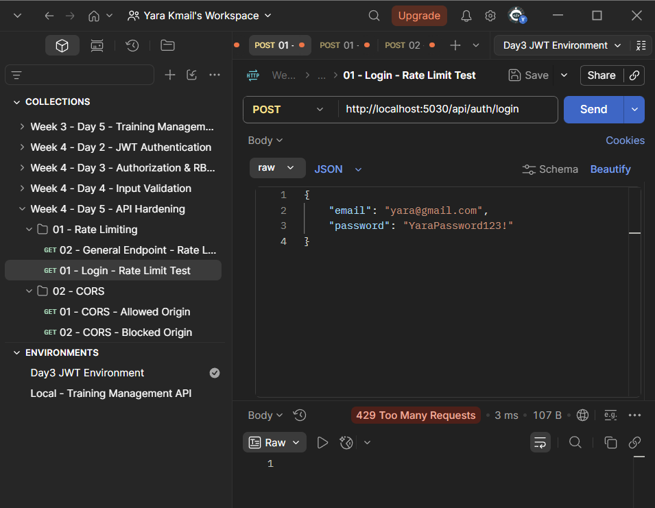
What did the test prove?
It proved that:
The Login endpoint has its own Rate Limit, and once we exceed 5 requests within the window, the request is rejected and HTTP 429 is returned.
5. General Endpoint Rate Limit
We also tested the General Policy on:
GET http://localhost:5030/api/participants/1
And this endpoint has:
[EnableRateLimiting("GeneralPolicy")]
And the policy allows:
100 requests / minute
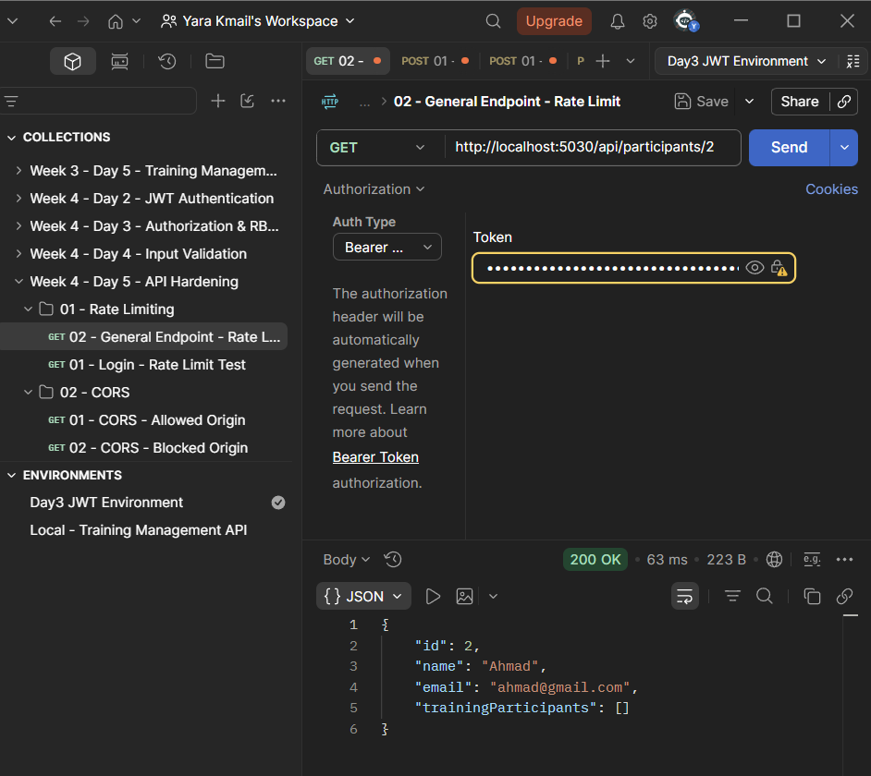
Important idea
Rate Limiting does not mean the entire API shares the same limit.
We can give each type of Endpoint a Policy that fits it.
6. CORS
What is CORS?
CORS stands for:
Cross-Origin Resource Sharing
It controls which Browser Origin is allowed to make requests directly to the API.
For example, our API is at:
https://api.myapp.com
And our Frontend is at:
https://myapp.com
We only want to allow the known Frontend.
6.1 The Policy we implemented
In Program.cs:
// Configure CORS and allow only our known frontend origin.
builder.Services.AddCors(options =>
{
options.AddPolicy("AllowFrontend", policy =>
{
// Only this frontend origin is allowed to call the API from a browser.
policy.WithOrigins("https://myapp.com")

// Allow the frontend to send normal HTTP headers.
.AllowAnyHeader()

// Allow the frontend to use GET, POST, PUT, DELETE, etc.
.AllowAnyMethod();
});
});
Instead of:
AllowAnyOrigin
We specified a particular Origin:
https://myapp.com
This is the right approach when we know the real frontend that will consume the API.
7. Enabling CORS in the Pipeline
After creating the Policy, we need to use it:
app.UseCors("AllowFrontend");
So now we have:
Request from Browser
↓
CORS
↓
Is the Origin allowed?
↓ ↓
Yes No
↓ ↓
Allow Reject
8. CORS Test — Postman
Here it's important to understand one point:
Postman is not a Browser.
CORS is a Browser security mechanism, so Postman does not behave like a Browser when it comes to CORS.
But we used Postman to add the Origin header and monitor the Response Headers during testing.
For example:
Origin: https://myapp.com
We compare it with the Origin allowed in the policy:
https://myapp.com
And for a disallowed origin:
Origin: https://evil.com
The Browser is supposed to prevent JavaScript from accessing the Response when the Origin is not allowed.
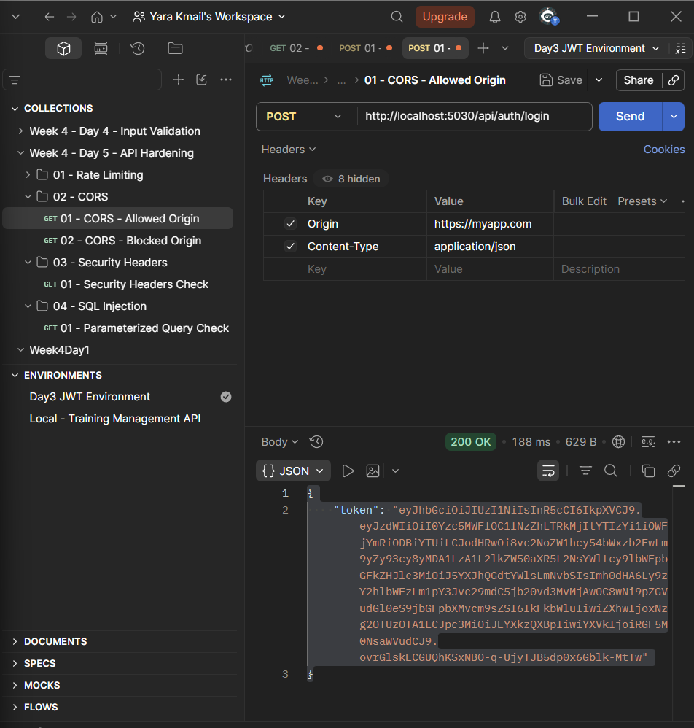
The point to remember
CORS does not mean:
"Blocking any Client from sending an HTTP request."
It mainly means:
Controlling cross-origin Browser requests, and whether the Browser will allow the page to read the response.
And that is a very important difference.
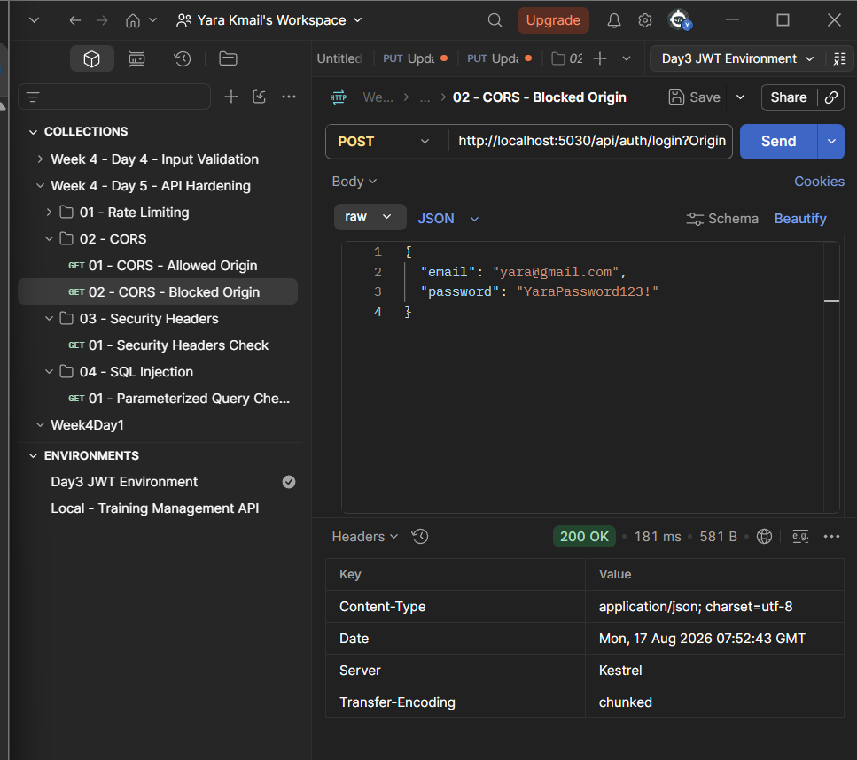
9. HTTPS Redirection
HTTPS protects the data while it travels between the Client and the API.
We added:
app.UseHttpsRedirection();
The idea:
HTTP Request
↓
HTTPS Redirection
↓
HTTPS
↓
API
This means that if a request arrives over HTTP, it gets redirected to HTTPS.
10. HSTS
We also added:
app.UseHsts();
HSTS stands for:
HTTP Strict Transport Security
The idea is that the Browser learns this site must be accessed using HTTPS.
This means that instead of the site relying on HTTP each time and then performing a Redirect, the Browser — after receiving the HSTS policy — can treat the site as HTTPS-only.
In our code:
app.UseHsts();
app.UseHttpsRedirection();
This fulfills what's required in the Hands-On Lab.
11. SQL Injection Prevention
The key point we learned:
When we use EF Core + LINQ, EF Core performs parameterization on the values in queries instead of concatenating user input directly into SQL.
For example, we use:
var participant = await _context.Participants
.FirstOrDefaultAsync(p => p.Id == id);
Here, we are not building the SQL string ourselves.
Why does this matter?
The problem occurs when a developer builds Raw SQL in an unsafe way, such as inserting a user value directly into SQL.
So caution is especially needed with:
FromSqlRaw
if it is used incorrectly with User Input.
12. How did we review the project?
We didn't just add Raw SQL to say we tested it.
We actually searched the project using:
Get-ChildItem -Recurse -Filter *.cs | Select-String -Pattern "FromSql|ExecuteSql|SqlQuery"
And the result was:
PS C:\...\Day5>
No results.
Result
We did not find in the project:
FromSql
ExecuteSql
SqlQuery
So we have no Raw SQL of these kinds that needs a parameterization review.
13. Final Security Pipeline
In the end, we ended up with a Pipeline containing the most important security parts we applied:
Incoming Request
↓
HTTPS / HSTS
↓
CORS
↓
Rate Limiting
↓
Authentication
↓
Authorization
↓
Controller
↓
Database through EF Core
And here, each part plays a different role:
Protection | Purpose
HTTPS | Encrypts the connection
HSTS | Makes the Browser treat the site as HTTPS-only
CORS | Restricts which Browser origins are allowed
Rate Limiting | Limits the number of requests
Authentication | Verifies the user's identity
Authorization | Determines what the user can access
EF Core parameterization | Reduces the risk of SQL Injection

14. What did we accomplish on Day 5?
Today we didn't just write configuration — we applied and tested the security:
Rate Limiting
We created a general Policy and a stricter Policy for Login, and tested requests reaching 429.
CORS
We created a Named Policy that only allows the specified Origin.
HTTPS + HSTS
We added:
app.UseHsts();
app.UseHttpsRedirection();
SQL Injection
We reviewed the project and did not find Raw SQL of the patterns we searched for.
Result
The API became more protected against:
- Brute-force login attempts
- Some request flooding patterns
- Disallowed Browser origins
- Unencrypted HTTP
- Some SQL Injection risks resulting from building Raw SQL unsafely

