Week 6 – Day 3 – Catalog & Read Operations

Hands-On Lab: Build the Catalog Endpoint

Objective
The goal of this lab was to implement a paginated catalog endpoint for the primary catalog resource, Patients, while supporting filtering, sorting, DTO projection, and efficient database querying.
The implemented endpoint is:
GET /api/Patients
The endpoint supports:
- Pagination using page and pageSize
- Filtering by gender
- Filtering by city
- Sorting by name
- Sorting by city
- Projection to PatientResponse DTO
- No-tracking queries using AsNoTracking()
- Pagination metadata including the total number of matching records

Endpoint Parameters
Parameter | Type | Default | Description
page | int | 1 | Page number
pageSize | int | 10 | Number of patients per page
sort | string | null | Sorting option: name or city
gender | string | null | Filters patients by gender
city | string | null | Filters patients by city

Example
GET /api/Patients?page=1&pageSize=2&sort=name&gender=Male&city=Jenin

1. Pagination
The endpoint uses Skip() and Take() to return only the requested page instead of loading all patients.
The total number of matching patients is calculated using CountAsync() before applying pagination.

Example
GET /api/Patients?page=1&pageSize=2

Result
The API returned:
- page: 1
- pageSize: 2
- totalCount: 4
- 2 patients in the current page
- HTTP status: 200 OK
Screenshot — Pagination Test:
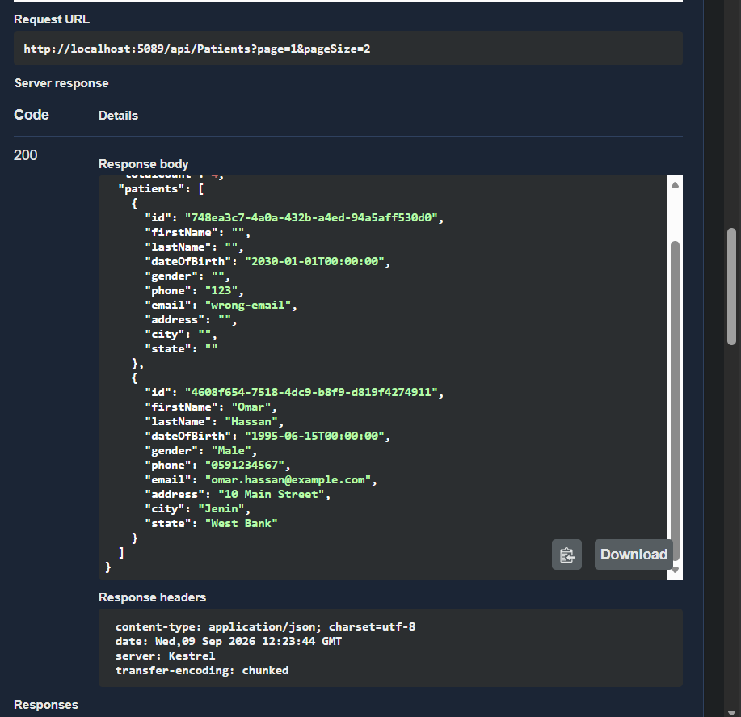

2. Sorting
Two sorting options were implemented:

Sort by Name
GET /api/Patients?sort=name
Patients are sorted by last name and then first name.

Sort by City
GET /api/Patients?sort=city
Patients are sorted by city and then last name.
Screenshot — Sorting by City:
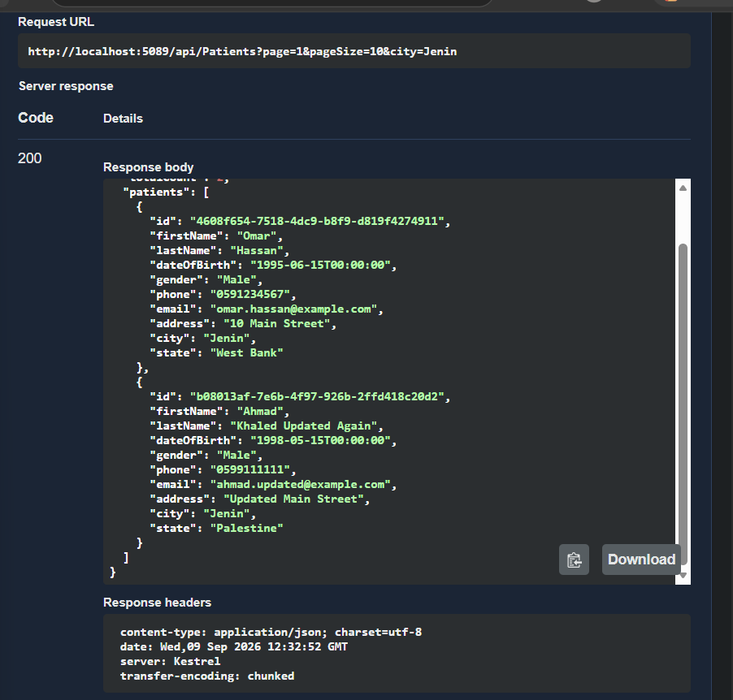

3. Filtering by Gender
An optional gender query parameter was added.
Example:
GET /api/Patients?gender=Male
When a gender value is provided, only patients matching that gender are returned.
Screenshot — Gender Filter:
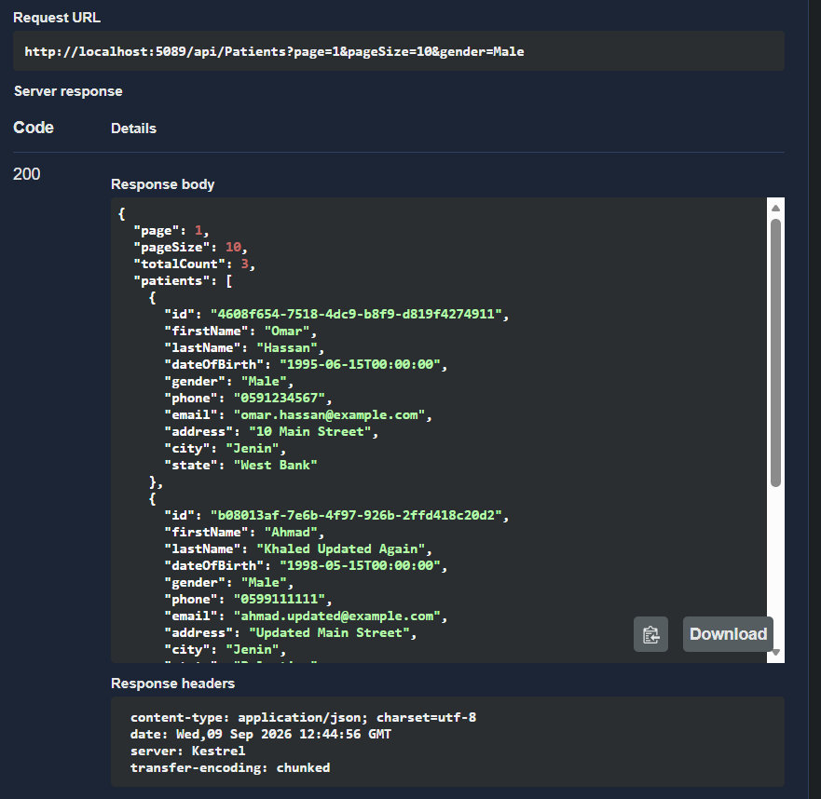

4. Filtering by City
An optional city query parameter was added.
Example:
GET /api/Patients?city=Jenin
When a city value is provided, only patients matching that city are returned.
Screenshot — City Filter:
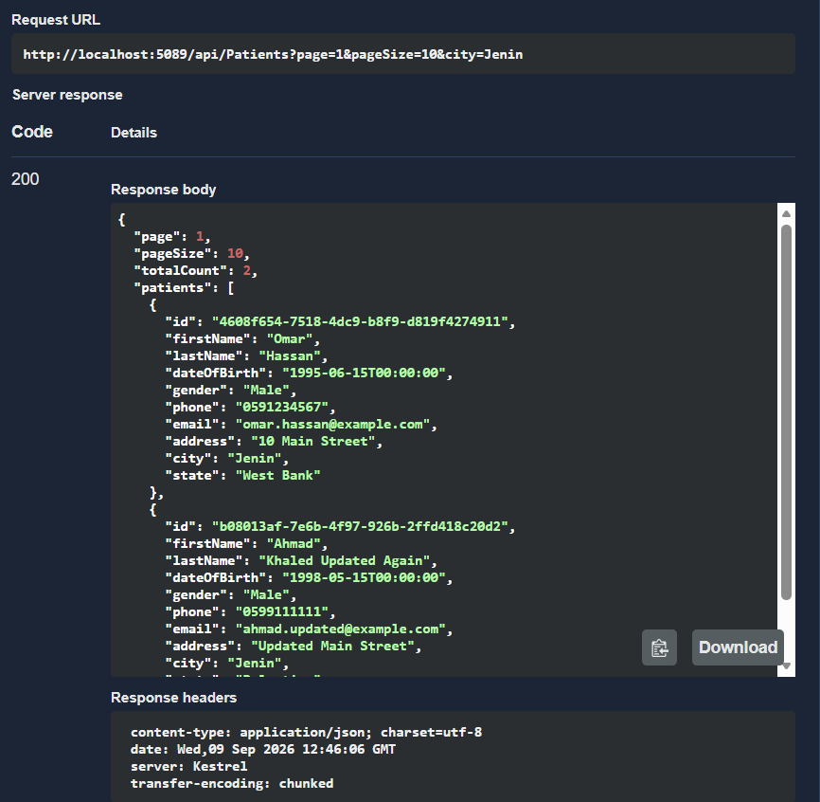

5. Combined Filtering, Sorting, and Pagination
The endpoint also supports using multiple query parameters together.
Example:
GET /api/Patients?page=1&pageSize=2&sort=name&gender=Male&city=Jenin
This test verifies that pagination, sorting, and both filters can work together in the same request.
The request returned HTTP 200 OK.
Screenshot — Combined Test:
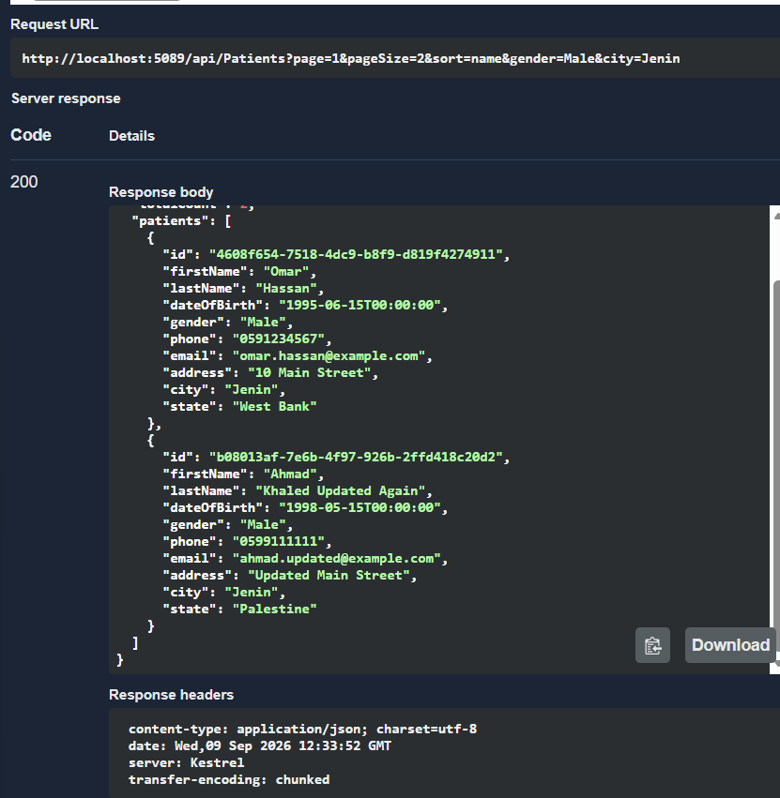

6. DTO Projection
The endpoint does not return the EF Core Patient entity directly.
Instead, the query uses Select() to project the required fields into PatientResponse.
This helps avoid exposing the database entity directly and prevents unnecessary data from being returned to the client.

7. No-Tracking Queries
AsNoTracking() is used because this endpoint only reads patient data and does not modify the returned entities.
This is appropriate for read-only operations.

8. Validation
The endpoint validates the pagination values.
If page or pageSize is less than 1, the API returns:
400 Bad Request
with the message:
Page and pageSize must be greater than 0.

9. Build Verification
After implementing Task 1, the project was built successfully using:
dotnet build .\Week6\Day3\CardiacPatientMonitoring.Api\CardiacPatientMonitoring.Api.csproj
The build completed successfully with no build errors.
Screenshot — Successful Build:
