HANDS-ON LAB
Design & Diagram a Normalized Schema
1. Executive Summary
This document presents the complete design of a normalized relational schema for the project's Day 1 API resources. The work covers entity identification, normalization through First, Second, and Third Normal Forms (1NF, 2NF, and 3NF), primary and foreign key definition, ERD construction, and the selection of appropriate SQL Server data types.
The design is project-specific: the entities were selected according to the project's own API/resource requirements rather than copied from a generic example. The resulting schema separates independent concepts, resolves many-to-many relationships through junction tables, and keeps relationship-specific attributes in the appropriate tables.
2. Task 1 — List Every Entity and Its Attributes
The first step was to identify all entities required by the project's Day 1 API resources and define the attributes associated with each entity. Each entity represents a distinct concept or business object in the application and is modeled as a separate relational table.
The following table summarizes the entities, their attributes, and their purpose within the system.
Entity | Attributes | Purpose
Participants | Id, Name, Email | Stores information about participants who can enroll in trainings.
Trainings | Id, Topic, TrainerId, CompanyId, TotalHours, MaximumParticipants | Stores training information, including its topic, trainer, company, duration, and participant capacity.
TrainingParticipants | TrainingId, ParticipantId, RegistrationDate, Completed | Junction table that represents the many-to-many relationship between participants and trainings and stores attributes specific to that relationship.
TrainingDays | Id, TrainingId, Date, StartTime, EndTime | Stores the individual scheduled sessions or days belonging to a training.
Trainers | Id, Name | Stores trainer information independently from training records.
Companies | Id, Name | Stores company information independently to avoid repeating company data across multiple trainings.
Courses | Id, CourseCode, Name, Description, CreditHours, InstructorId, UniversityId, SemesterId | Stores academic course information and its relationships with instructors, universities, and semesters.
Instructors | Id, Name, Email | Stores instructor information independently from course records.
Universities | Id, Name | Stores university information independently from course records.
Semesters | Id, Name | Stores semester information used by courses.
IslamicGoals | Id, Name, Description, StartDate, TargetDate, Status | Stores personal or Islamic goals tracked by the application.
Tasks | Id, Name, Description, StartDate, EndDate, Status, CourseId, TrainingId, IslamicGoalId | Stores actionable tasks that can be associated with their relevant course, training, or Islamic goal context.
Skills | Id, Name, Description | Stores reusable skills independently so that the same skill can be associated with multiple courses or trainings.
CourseSkills | CourseId, SkillId | Junction table that resolves the many-to-many relationship between courses and skills.
TrainingSkills | TrainingId, SkillId | Junction table that resolves the many-to-many relationship between trainings and skills.

Design Decisions
The following design decisions were made when identifying and structuring the entities:
• Each main entity has a unique Id primary key. Junction tables use composite primary keys because the combination of their foreign keys uniquely identifies each relationship.
• TrainingParticipants is modeled as a separate junction table because a participant can enroll in multiple trainings and a training can contain multiple participants.
• Relationship-specific attributes such as RegistrationDate and Completed are stored in TrainingParticipants because they describe a specific participant's enrollment in a specific training.
• Skills are modeled as an independent entity because the same skill may be associated with multiple courses and multiple trainings.
• Trainer, company, instructor, university, and semester information is separated into independent entities to avoid unnecessary duplication and improve data consistency.
• CourseSkills and TrainingSkills are used to represent many-to-many relationships without storing multiple skill values inside a single column.
• Tasks contain optional foreign keys that allow a task to be associated with the appropriate context within the application.
• The schema was designed specifically for the project's own API resources and business requirements rather than being copied from a generic database example.
Result: All entities required by the project's Day 1 API resources have been identified, their attributes have been defined, and their roles within the system have been documented.
Task 2 — Apply 1NF, 2NF, and 3NF
The proposed relational schema was evaluated against the first three normal forms: First Normal Form (1NF), Second Normal Form (2NF), and Third Normal Form (3NF).
The normalization review was performed during the schema design process to reduce unnecessary data duplication, avoid repeating groups, maintain clear entity boundaries, and prevent common data anomalies. The final structure was designed according to the project's own API resources and business requirements rather than being copied from a generic database example.
The following sections explain how the proposed schema satisfies each normal form.
3.1 First Normal Form (1NF)
The schema satisfies First Normal Form (1NF) by ensuring that each column contains a single atomic value and that repeating groups or lists are not stored inside a single column.
For example, a training should not store multiple participant IDs in one field such as 1,4,7. Instead, each participant–training relationship is stored as a separate row in the TrainingParticipants table.
The following design decisions support 1NF:
• Participant Name and Email are stored as separate attributes.
• Training Date, StartTime, and EndTime are stored as separate atomic attributes.
• Skills are not stored as comma-separated values. Instead, CourseSkills and TrainingSkills store individual relationships between entities.
• Each record can be uniquely identified through its primary key.
Result: The schema satisfies 1NF.
3.2 Second Normal Form (2NF)
Second Normal Form (2NF) requires the schema to be in 1NF and requires every non-key attribute to depend on the entire primary key. This is particularly important for tables that use a composite primary key.
The TrainingParticipants table uses the following composite primary key:
TrainingId + ParticipantId
The non-key attributes in this table are:
• RegistrationDate
• Completed
Both attributes describe the relationship between a specific participant and a specific training.
For example, RegistrationDate cannot be determined by ParticipantId alone because the same participant can register for multiple trainings. It also cannot be determined by TrainingId alone because a training can have multiple participants. Therefore, it depends on the combination of TrainingId and ParticipantId.
The same applies to Completed: we need to know both the participant and the training to determine whether that particular participant completed that particular training.
Other attributes are kept in their appropriate entity tables:
• Participant-specific attributes such as Name and Email are stored in Participants.
• Training-specific attributes such as Topic, TotalHours, and MaximumParticipants are stored in Trainings.
• CourseSkills and TrainingSkills contain the keys required to represent their respective many-to-many relationships.
Result: The schema satisfies 2NF.
3.3 Third Normal Form (3NF)
Third Normal Form (3NF) requires the table to be in 2NF and ensures that non-key attributes do not depend on other non-key attributes. In other words, each non-key attribute should depend directly on the primary key of its own table rather than describing another entity.
For example, a training does not store TrainerName and TrainerEmail directly. Instead, it stores TrainerId, which references the Trainers table. The trainer's descriptive information is therefore stored only once.
Similarly, a course stores UniversityId instead of repeating the university's name and other university information in every course record. This reduces redundancy and prevents inconsistent updates.
The following design decisions support 3NF:
• Trainer details are stored in Trainers and referenced from Trainings through TrainerId.
• Company details are stored in Companies and referenced from Trainings through CompanyId.
• Instructor details are stored in Instructors and referenced from Courses through InstructorId.
• University details are stored in Universities and referenced from Courses through UniversityId.
• Semester details are stored in Semesters and referenced from Courses through SemesterId.
• Goal details are stored in IslamicGoals and referenced from Tasks through IslamicGoalId.
• Skill details are stored in Skills and connected to courses and trainings through the CourseSkills and TrainingSkills junction tables.
By separating these independent entities, each table stores attributes that describe its own entity, while relationships between entities are represented using foreign keys.
Result: The schema satisfies 3NF for the modeled entities and relationships.
Normalization Summary
Normal Form | Applied Rule | How the Schema Satisfies It
1NF | Atomic values and no repeating groups | Each column stores a single value, and many-to-many data is represented using junction tables.
2NF | Every non-key attribute depends on the entire primary key | In TrainingParticipants, RegistrationDate and Completed depend on the complete composite key TrainingId + ParticipantId.
3NF | No transitive dependencies | Independent entity details such as trainers, companies, instructors, universities, semesters, goals, and skills are stored in their own tables and referenced using foreign keys.

4. Task 3 — Define Primary Keys and Foreign Keys
Primary keys uniquely identify each record within a table, while foreign keys establish relationships between related tables and maintain referential integrity.
Simple primary keys are used for the main entities. Junction tables use composite primary keys because the combination of their foreign keys uniquely identifies each relationship record.
Primary Keys
Table | Primary Key | Type
Participants | Id | Simple PK
Trainings | Id | Simple PK
TrainingParticipants | TrainingId + ParticipantId | Composite PK
TrainingDays | Id | Simple PK
Trainers | Id | Simple PK
Companies | Id | Simple PK
Courses | Id | Simple PK
Instructors | Id | Simple PK
Universities | Id | Simple PK
Semesters | Id | Simple PK
IslamicGoals | Id | Simple PK
Tasks | Id | Simple PK
Skills | Id | Simple PK
CourseSkills | CourseId + SkillId | Composite PK
TrainingSkills | TrainingId + SkillId | Composite PK

Foreign-Key Relationships
Foreign Key | Referenced Key | Relationship
TrainingParticipants.ParticipantId | Participants.Id | One participant can have many training participation records.
TrainingParticipants.TrainingId | Trainings.Id | One training can have many participant records.
TrainingDays.TrainingId | Trainings.Id | One training can contain many scheduled days.
Trainings.TrainerId | Trainers.Id | One trainer can conduct many trainings.
Trainings.CompanyId | Companies.Id | One company can be associated with many trainings.
Courses.InstructorId | Instructors.Id | One instructor can teach many courses.
Courses.UniversityId | Universities.Id | One university can have many courses in the modeled relationship.
Courses.SemesterId | Semesters.Id | One semester can contain many courses.
Tasks.CourseId | Courses.Id | One course can have many related tasks.
Tasks.TrainingId | Trainings.Id | One training can have many related tasks.
Tasks.IslamicGoalId | IslamicGoals.Id | One Islamic goal can have many related tasks.
CourseSkills.CourseId | Courses.Id | One course can have many CourseSkills records.
CourseSkills.SkillId | Skills.Id | One skill can appear in many CourseSkills records.
TrainingSkills.TrainingId | Trainings.Id | One training can have many TrainingSkills records.
TrainingSkills.SkillId | Skills.Id | One skill can appear in many TrainingSkills records.

Relationship Patterns
The foreign keys establish the following relationship patterns:
Pattern | Relationship
One-to-Many | Trainers → Trainings
One-to-Many | Companies → Trainings
One-to-Many | Trainings → TrainingDays
Many-to-Many | Participants ↔ Trainings through TrainingParticipants
Many-to-Many | Courses ↔ Skills through CourseSkills
Many-to-Many | Trainings ↔ Skills through TrainingSkills
One-to-Many | IslamicGoals → Tasks
One-to-Many | Courses → Tasks
One-to-Many | Trainings → Tasks

The many-to-many relationships are not stored directly between the two main entities. Instead, junction tables are used to represent each association as individual rows.
Task Context and Referential Integrity
The Tasks table contains three optional foreign keys:
• CourseId
• TrainingId
• IslamicGoalId
These foreign keys allow a task to be associated with its appropriate context within the application.
In the current DBML design, these columns are optional because the database structure alone does not yet enforce that exactly one of them must be populated. During the SQL Server implementation stage, a CHECK constraint or equivalent application-level validation can be added if the business rule requires every task to belong to exactly one context.
This validation should be considered a business-rule constraint rather than a primary-key or foreign-key requirement.
Task 4 — ERD (Entity Relationship Diagram)
The normalized relational schema was translated into an Entity Relationship Diagram (ERD) using DBML and dbdiagram.io.
The ERD provides a visual representation of the database structure and shows:
• All entities identified in Task 1.
• The primary key of each table.
• Foreign-key relationships between related tables.
• Composite primary keys used by junction tables.
• One-to-many relationships between entities.
• Many-to-many relationships resolved through junction tables such as TrainingParticipants, CourseSkills, and TrainingSkills.
The ERD was created after applying the normalization rules and defining the primary and foreign keys. This ensures that the diagram represents the final normalized schema rather than an earlier version of the design.
The diagram was reviewed to verify that the relationships between entities are correctly represented and that foreign keys reference the appropriate primary keys.
Final ERD
The following diagram represents the final normalized database schema for the project's Day 1 API resources.
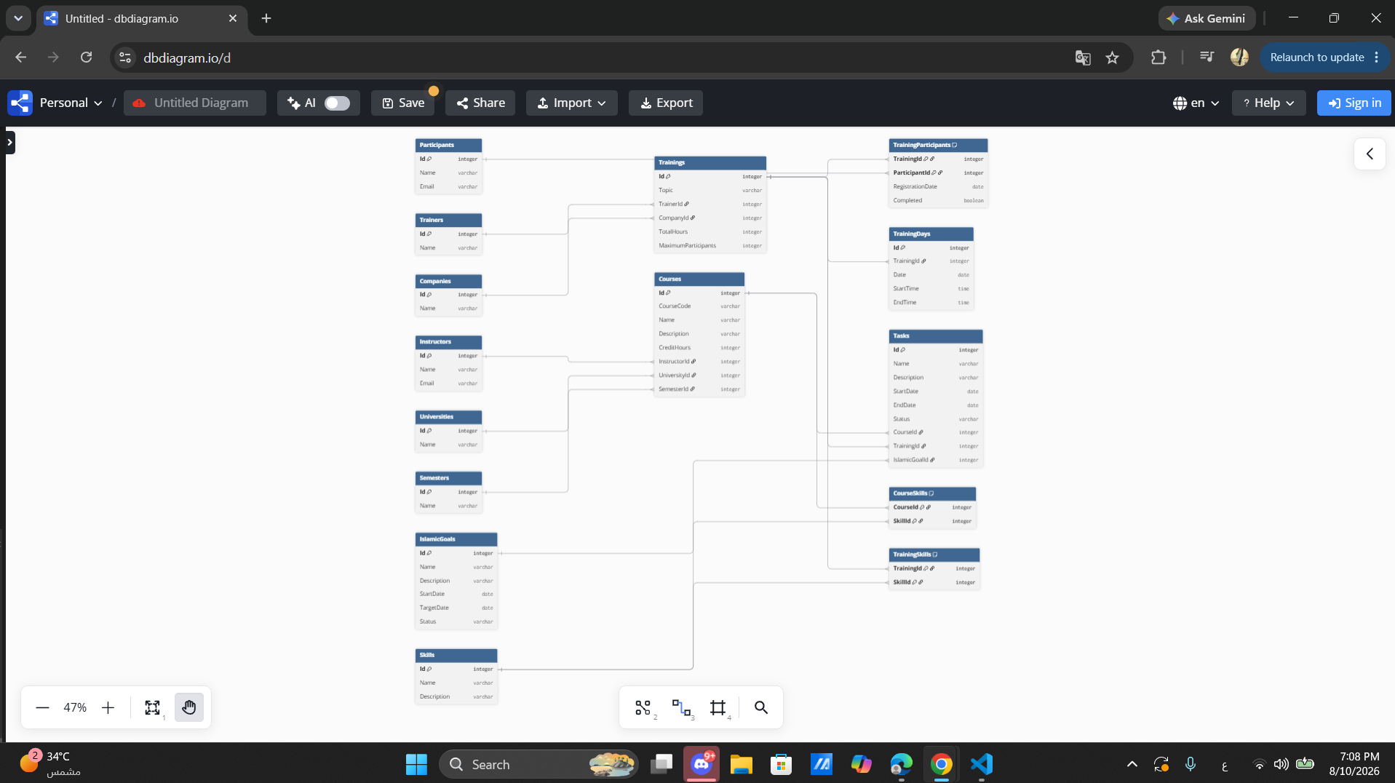

ERD Verification Checklist
• Every entity has a primary key.
• Every defined relationship is represented by the appropriate foreign key.
• Many-to-many relationships use junction tables.
• Relationship-specific attributes are stored in the appropriate relationship table.
• Trainer, company, instructor, university, semester, and skill details are stored independently and are not unnecessarily duplicated.
• The ERD matches the final DBML schema documented in this report.
• Composite primary keys are used for the junction tables where the combination of the foreign keys uniquely identifies the relationship.
• Optional task-context relationships are represented using nullable foreign keys in the Tasks table.
Result: The ERD accurately represents the final normalized relational schema and its defined relationships.
Task 5 — Choose Appropriate Column Types
The schema targets Microsoft SQL Server, so SQL Server-compatible data types were selected for every attribute.
The selected types were based on the nature of each attribute:
• INT is used for integer identifiers, counts, and whole-number values.
• NVARCHAR is used for textual attributes that may contain Unicode characters, including Arabic text.
• DATE is used when only the calendar date is required.
• TIME is used when only the time of day is required.
• BIT is used for Boolean-like values such as the training completion state.
• DECIMAL(p,s) is recommended for future monetary values that require exact decimal precision.
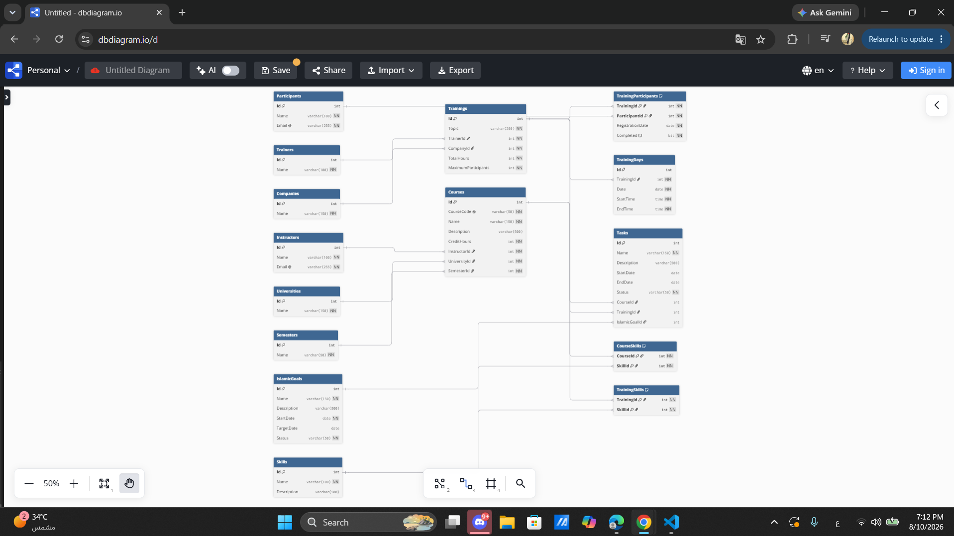
Column Type Selection
Table | Column | SQL Server Type | Reason
Participants | Id | INT | Integer identifier and primary key.
Participants | Name | NVARCHAR(100) | Participant name; supports Unicode text.
Participants | Email | NVARCHAR(255) | Email address; unique constraint applied.
Trainings | Id | INT | Integer identifier and primary key.
Trainings | Topic | NVARCHAR(200) | Training topic or title.
Trainings | TrainerId | INT | Foreign key referencing Trainers.
Trainings | CompanyId | INT | Foreign key referencing Companies.
Trainings | TotalHours | INT | Whole-number training duration in hours.
Trainings | MaximumParticipants | INT | Whole-number participant capacity.
TrainingParticipants | TrainingId | INT | Part of the composite primary key and foreign key.
TrainingParticipants | ParticipantId | INT | Part of the composite primary key and foreign key.
TrainingParticipants | RegistrationDate | DATE | Calendar date of registration.
TrainingParticipants | Completed | BIT | Boolean-like completion state represented as 0 or 1.
TrainingDays | Id | INT | Integer identifier and primary key.
TrainingDays | TrainingId | INT | Foreign key referencing Trainings.
TrainingDays | Date | DATE | Scheduled calendar date.
TrainingDays | StartTime | TIME | Session start time.
TrainingDays | EndTime | TIME | Session end time.
Trainers | Id | INT | Integer identifier and primary key.
Trainers | Name | NVARCHAR(100) | Trainer name; supports Unicode text.
Companies | Id | INT | Integer identifier and primary key.
Companies | Name | NVARCHAR(150) | Company name; supports Unicode text.
Courses | Id | INT | Integer identifier and primary key.
Courses | CourseCode | NVARCHAR(50) | Course identifier/code; unique constraint applied.
Courses | Name | NVARCHAR(150) | Course name.
Courses | Description | NVARCHAR(500) | Course description.
Courses | CreditHours | INT | Whole-number academic credit hours.
Courses | InstructorId | INT | Foreign key referencing Instructors.
Courses | UniversityId | INT | Foreign key referencing Universities.
Courses | SemesterId | INT | Foreign key referencing Semesters.
Instructors | Id | INT | Integer identifier and primary key.
Instructors | Name | NVARCHAR(100) | Instructor name.
Instructors | Email | NVARCHAR(255) | Instructor email; unique constraint applied.
Universities | Id | INT | Integer identifier and primary key.
Universities | Name | NVARCHAR(150) | University name.
Semesters | Id | INT | Integer identifier and primary key.
Semesters | Name | NVARCHAR(50) | Semester label.
IslamicGoals | Id | INT | Integer identifier and primary key.
IslamicGoals | Name | NVARCHAR(150) | Goal name.
IslamicGoals | Description | NVARCHAR(500) | Goal description.
IslamicGoals | StartDate | DATE | Goal start date.
IslamicGoals | TargetDate | DATE | Optional target date.
IslamicGoals | Status | NVARCHAR(50) | Goal status.
Tasks | Id | INT | Integer identifier and primary key.
Tasks | Name | NVARCHAR(150) | Task name.
Tasks | Description | NVARCHAR(500) | Task description.
Tasks | StartDate | DATE | Optional task start date.
Tasks | EndDate | DATE | Optional task end date.
Tasks | Status | NVARCHAR(50) | Task status.
Tasks | CourseId | INT | Optional foreign key referencing Courses.
Tasks | TrainingId | INT | Optional foreign key referencing Trainings.
Tasks | IslamicGoalId | INT | Optional foreign key referencing IslamicGoals.
Skills | Id | INT | Integer identifier and primary key.
Skills | Name | NVARCHAR(100) | Skill name.
Skills | Description | NVARCHAR(500) | Skill description.
CourseSkills | CourseId | INT | Part of the composite primary key and foreign key.
CourseSkills | SkillId | INT | Part of the composite primary key and foreign key.
TrainingSkills | TrainingId | INT | Part of the composite primary key and foreign key.
TrainingSkills | SkillId | INT | Part of the composite primary key and foreign key.

Monetary Values
The current project schema does not contain a monetary attribute such as Price, Cost, Salary, Fee, or Budget. Therefore, no monetary column is required in the current version of the schema.
If a future version introduces a monetary attribute, a fixed-precision DECIMAL(p,s) type is recommended when exact decimal precision is required. Microsoft documents decimal and numeric as fixed-precision and fixed-scale numeric types.
For example:
DECIMAL(12,2)
could be used for ordinary prices or costs that require two decimal places.
For financial values requiring exact decimal precision, DECIMAL(p,s) is preferred over approximate numeric types such as FLOAT.
The exact precision and scale should be selected according to the expected range of values and the number of decimal places required by the business rule.
Final DBML Implementation
The following DBML represents the final documented schema and can be used in dbdiagram.io to reproduce the ERD.
// Use DBML to define your database structure
// Docs: https://dbml.dbdiagram.io/docs
Table Participants {
Id int [primary key]
Name nvarchar(100) [not null]
Email nvarchar(255) [not null, unique]
}
Table Trainings {
Id int [primary key]
Topic nvarchar(200) [not null]
TrainerId int [not null]
CompanyId int [not null]
TotalHours int [not null]
MaximumParticipants int [not null]
}
Table TrainingParticipants {
TrainingId int [not null]
ParticipantId int [not null]
RegistrationDate date [not null]
Completed bit [not null, default: 0]
indexes {
(TrainingId, ParticipantId) [pk]
}
}
Table TrainingDays {
Id int [primary key]
TrainingId int [not null]
Date date [not null]
StartTime time [not null]
EndTime time [not null]
}
Table Trainers {
Id int [primary key]
Name nvarchar(100) [not null]
}
Table Companies {
Id int [primary key]
Name nvarchar(150) [not null]
}
Table Courses {
Id int [primary key]
CourseCode nvarchar(50) [not null, unique]
Name nvarchar(150) [not null]
Description nvarchar(500)
CreditHours int [not null]
InstructorId int [not null]
UniversityId int [not null]
SemesterId int [not null]
}
Table Instructors {
Id int [primary key]
Name nvarchar(100) [not null]
Email nvarchar(255) [not null, unique]
}
Table Universities {
Id int [primary key]
Name nvarchar(150) [not null]
}
Table Semesters {
Id int [primary key]
Name nvarchar(50) [not null]
}
Table IslamicGoals {
Id int [primary key]
Name nvarchar(150) [not null]
Description nvarchar(500)
StartDate date [not null]
TargetDate date
Status nvarchar(50) [not null]
}
Table Tasks {
Id int [primary key]
Name nvarchar(150) [not null]
Description nvarchar(500)
StartDate date
EndDate date
Status nvarchar(50) [not null]
CourseId int
TrainingId int
IslamicGoalId int
}
Table Skills {
Id int [primary key]
Name nvarchar(100) [not null]
Description nvarchar(500)
}
Table CourseSkills {
CourseId int [not null]
SkillId int [not null]
indexes {
(CourseId, SkillId) [pk]
}
}
Table TrainingSkills {
TrainingId int [not null]
SkillId int [not null]
indexes {
(TrainingId, SkillId) [pk]
}
}
// Relationships
Ref: TrainingParticipants.ParticipantId > Participants.Id
Ref: TrainingParticipants.TrainingId > Trainings.Id
Ref: TrainingDays.TrainingId > Trainings.Id
Ref: Trainings.TrainerId > Trainers.Id
Ref: Trainings.CompanyId > Companies.Id
Ref: Courses.InstructorId > Instructors.Id
Ref: Courses.UniversityId > Universities.Id
Ref: Courses.SemesterId > Semesters.Id
Ref: Tasks.CourseId > Courses.Id
Ref: Tasks.TrainingId > Trainings.Id
Ref: Tasks.IslamicGoalId > IslamicGoals.Id
Ref: CourseSkills.CourseId > Courses.Id
Ref: CourseSkills.SkillId > Skills.Id
Ref: TrainingSkills.TrainingId > Trainings.Id
Ref: TrainingSkills.SkillId > Skills.Id

