Week 3 — Day 5

Testing & Documenting the API with Postman

1. Overview
Day 5 focused on testing and documenting the Training Management API using Postman.
The practical work covered:
- Building an organized Postman Collection.
- Testing successful API requests.
- Testing error scenarios.
- Adding Postman test scripts.
- Creating and using an Environment.
- Using the {{baseUrl}} variable.
- Exporting the Postman Collection as a JSON file.
The API tested during this day was the Participants API created during Day 4.

2. API Used for Testing
The local API was running at:
http://localhost:5042
The main resource tested was:
/api/participants
The available CRUD operations were:
Method | Endpoint | Purpose
GET | /api/participants | Get all participants
GET | /api/participants/{id} | Get a participant by ID
POST | /api/participants | Create a participant
PUT | /api/participants/{id} | Update a participant
DELETE | /api/participants/{id} | Delete a participant

3. Building the Postman Collection
A new Postman Collection was created to keep all API requests organized and reusable.

Collection
Name:
Week 3 - Day 5 - Training Management API
Inside the collection, a Participants folder was created to organize the requests related to the Participants resource.

Collection Structure
Week 3 - Day 5 - Training Management API
│
└── Participants
├── Get All Participants - Success
├── Get Participant By ID - Success
├── Get Participant By ID - Not Found
├── Create Participant - Success
├── Create Participant - Error
├── Update Participant - Success
├── Update Participant - Not Found
├── Delete Participant - Success
└── Delete Participant - Not Found

📸 Screenshot 1 — Collection Setup
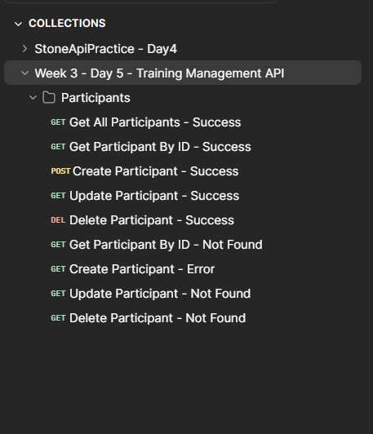
What this screenshot proves:
The Postman Collection was created and named according to the project.

📸 Screenshot 2 — Participants Folder

What this screenshot proves:
The API requests were organized according to the resource structure.

4. Testing Success Paths
The first stage of testing focused on successful requests.

4.1 Get All Participants

Request
GET {{baseUrl}}/api/participants
The request returned:
200 OK
This confirms that the API can successfully retrieve the participants collection.

📸 Screenshot 3 — Get All Participants
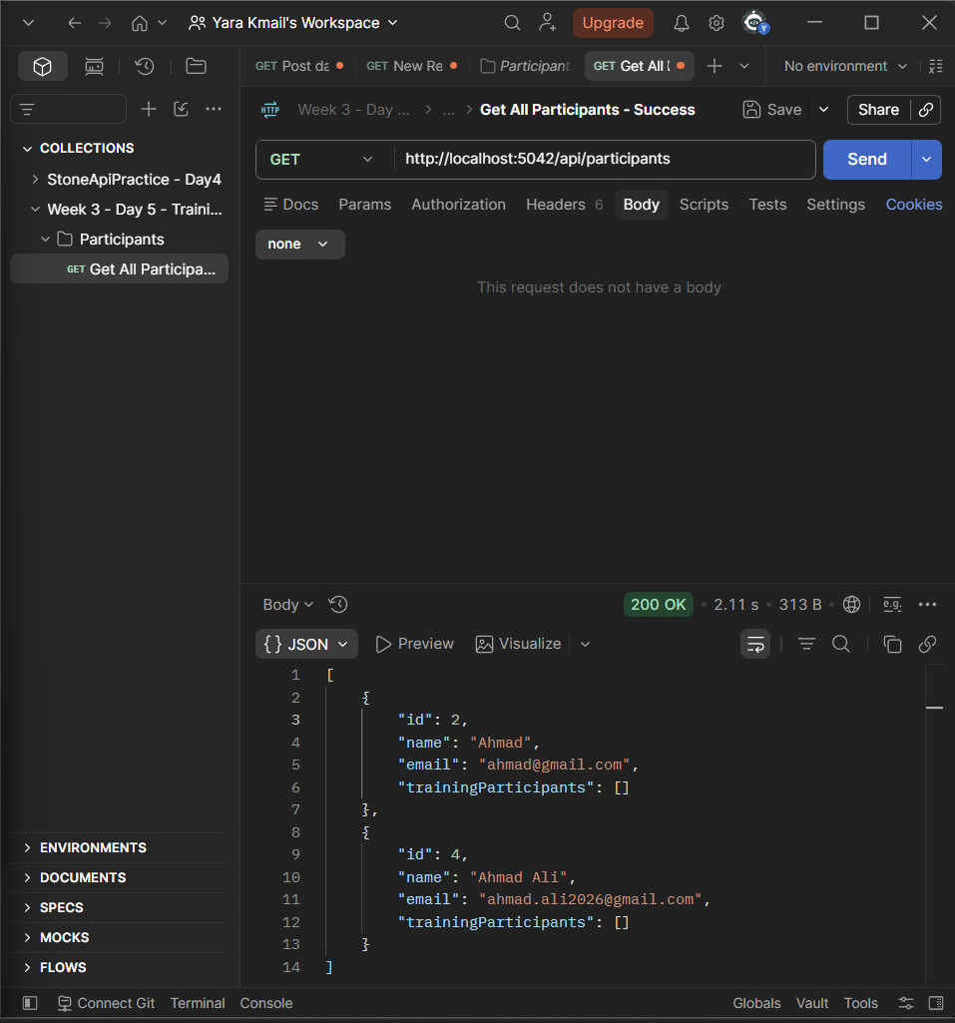

4.2 Get Participant by ID
A valid participant ID was used to retrieve one participant.

Request
GET {{baseUrl}}/api/participants/{id}
The request returned:
200 OK

📸 Screenshot 4 — Get Participant by ID
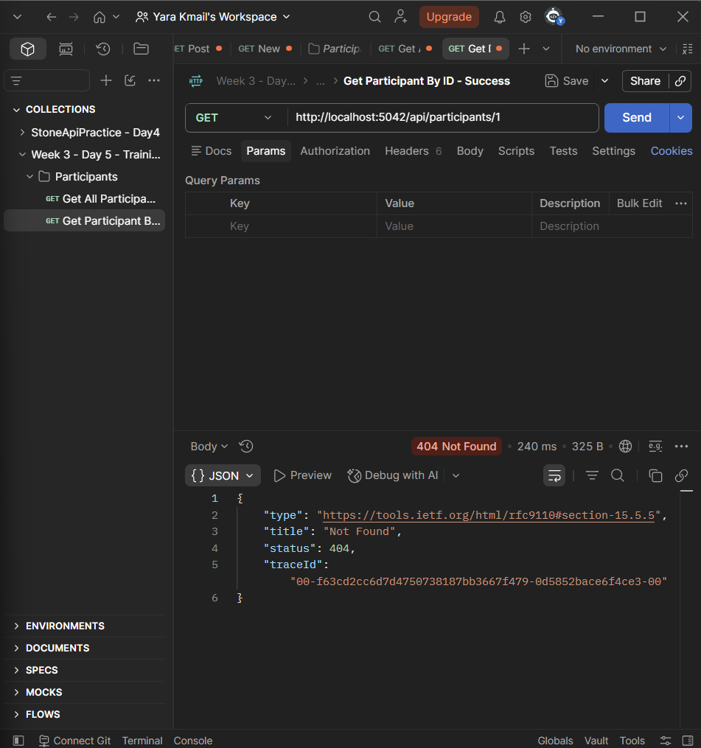

4.3 Create Participant
A new participant was created using a POST request.

Request
POST {{baseUrl}}/api/participants

Request Body
{
"name": "Test Participant",
"email": "testparticipant@gmail.com"
}
The API successfully created the participant and returned:
201 Created

📸 Screenshot 5 — Create Participant
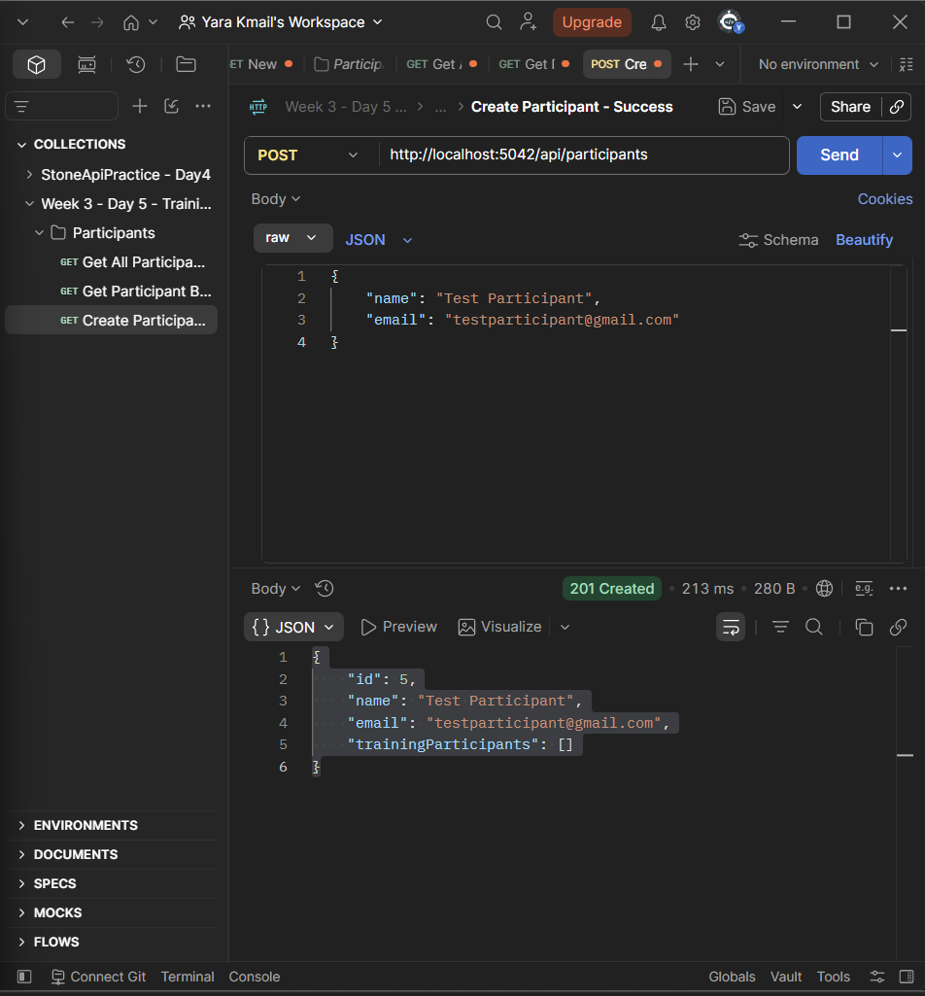

4.4 Update Participant
The participant created during testing was updated using a PUT request.

Request
PUT {{baseUrl}}/api/participants/{id}

Request Body
{
"name": "Updated Participant",
"email": "updatedparticipant@gmail.com"
}
The API returned:
200 OK

📸 Screenshot 6 — Update Participant
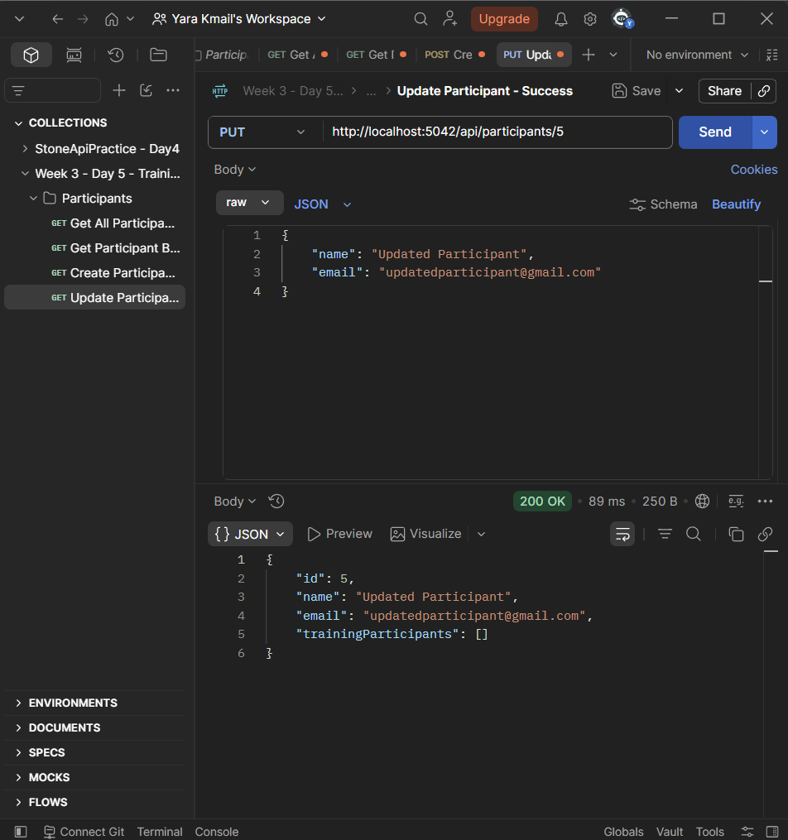

4.5 Delete Participant
The participant was deleted using a DELETE request.

Request
DELETE {{baseUrl}}/api/participants/{id}
The API returned:
204 No Content

📸 Screenshot 7 — Delete Participant

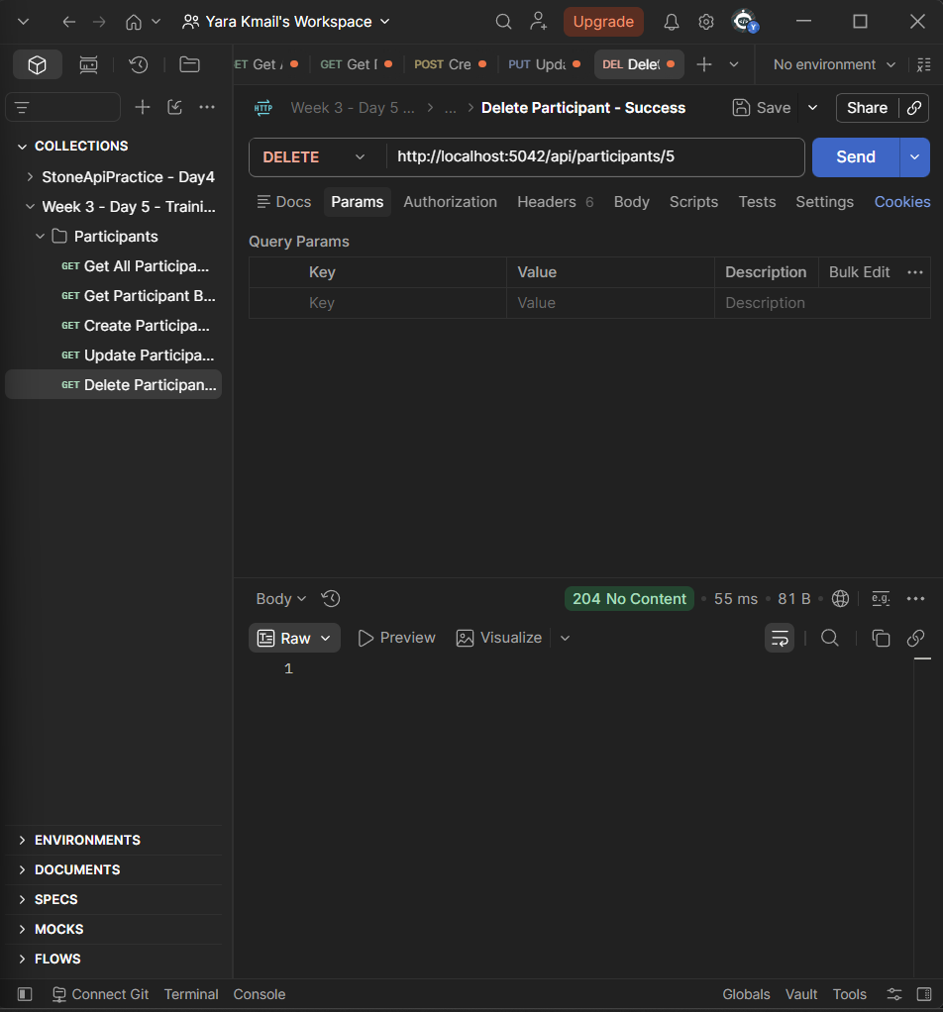

5. Testing Error Paths
After testing successful operations, realistic failure cases were tested.
The purpose was to verify that the API does not only work when valid data is provided.

5.1 Get Non-Existing Participant
A non-existing participant ID was requested.

Request
GET {{baseUrl}}/api/participants/99999
The API returned:
404 Not Found

📸 Screenshot 8 — GET Error Path
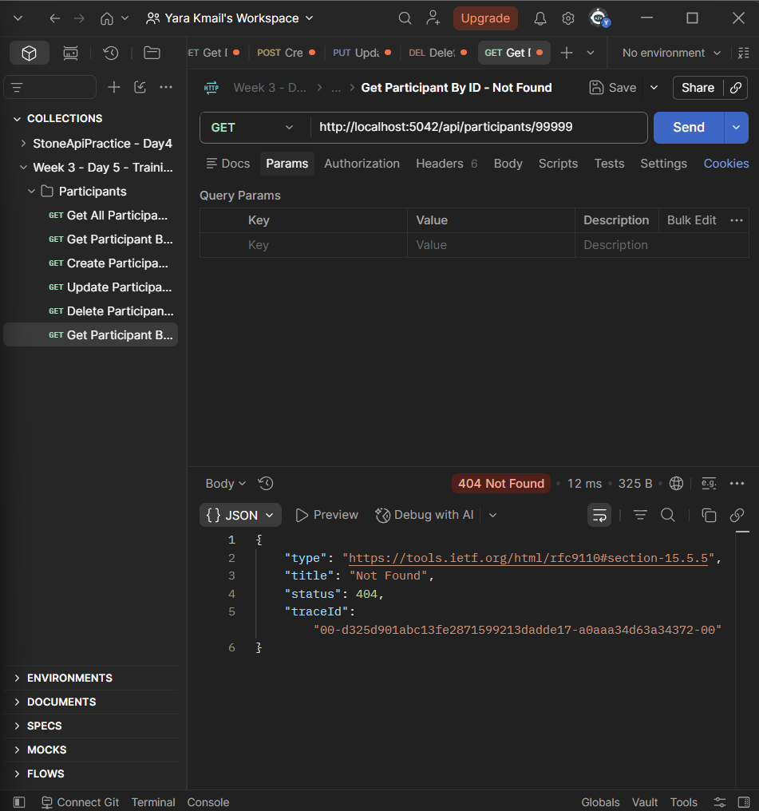

5.2 Create Participant with Invalid Input
An invalid request was sent with incomplete participant data.

Request
POST {{baseUrl}}/api/participants
The invalid request resulted in:
400 Bad Request

📸 Screenshot 9 — POST Error Path

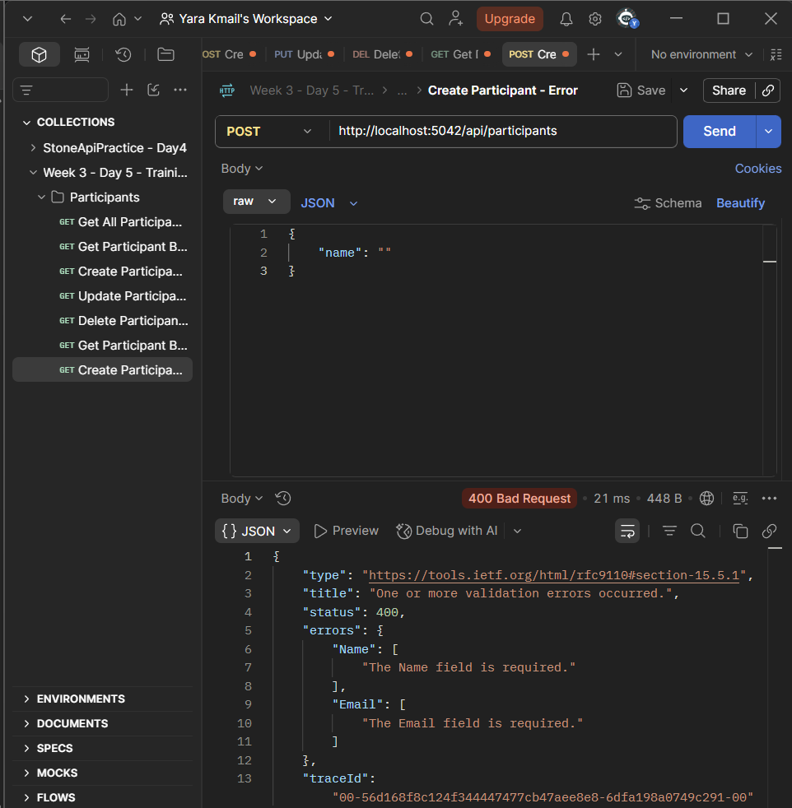

5.3 Update Non-Existing Participant
An update request was sent using a participant ID that does not exist.

Request
PUT {{baseUrl}}/api/participants/99999
The API returned:
404 Not Found

📸 Screenshot 10 — PUT Error Path

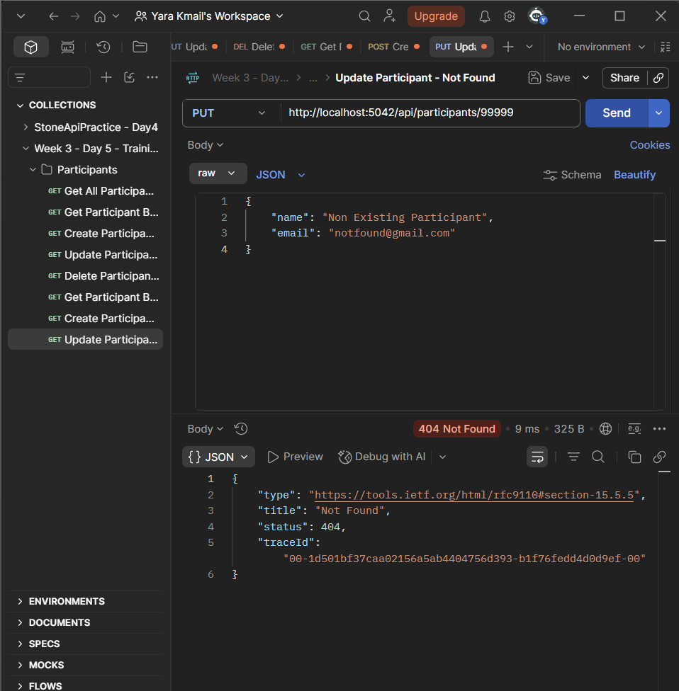

5.4 Delete Non-Existing Participant
A delete request was sent using a non-existing participant ID.

Request
DELETE {{baseUrl}}/api/participants/99999
The API returned:
404 Not Found

📸 Screenshot 11 — DELETE Error Path
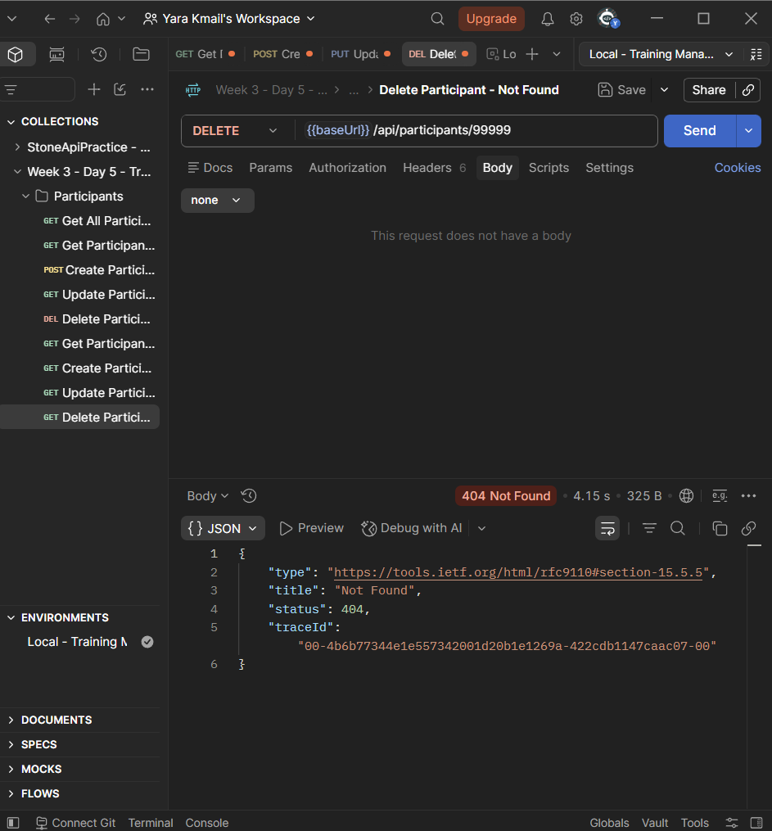

6. Postman Test Scripts
After validating the requests manually, basic automated tests were added using Postman's Post-response scripts.
The scripts check that the API returns the expected HTTP status code.

6.1 GET Test
The Get All Participants request was configured to verify that the response status is 200.
pm.test("Status code is 200", () => {
pm.response.to.have.status(200);
});

📸 Screenshot 12 — GET Test Script
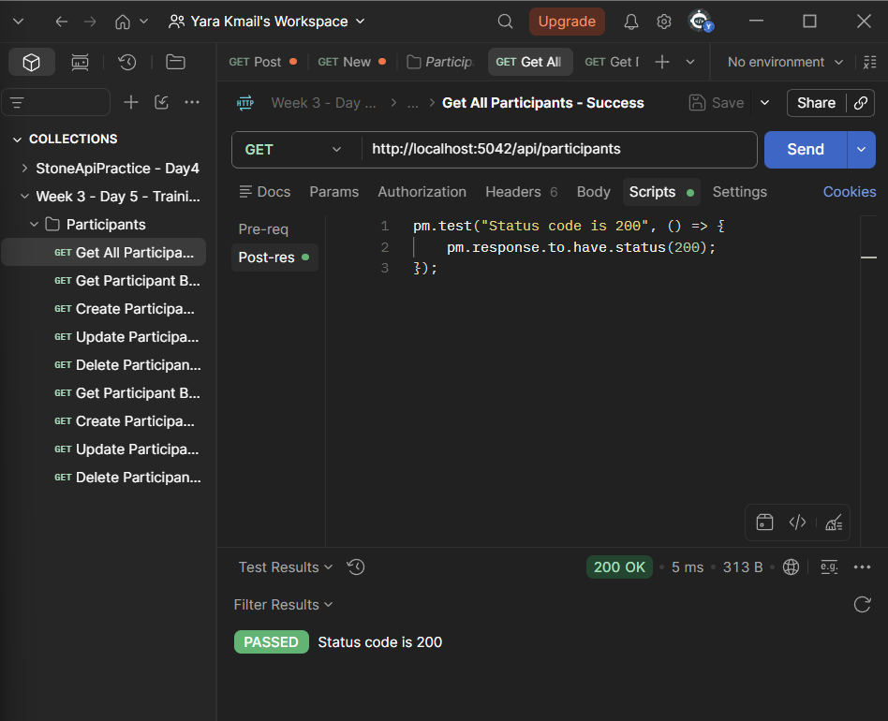

6.2 POST Test
The Create Participant request was configured to verify that the response status is 201.
pm.test("Status code is 201", () => {
pm.response.to.have.status(201);
});

📸 Screenshot 13 — POST Test Script
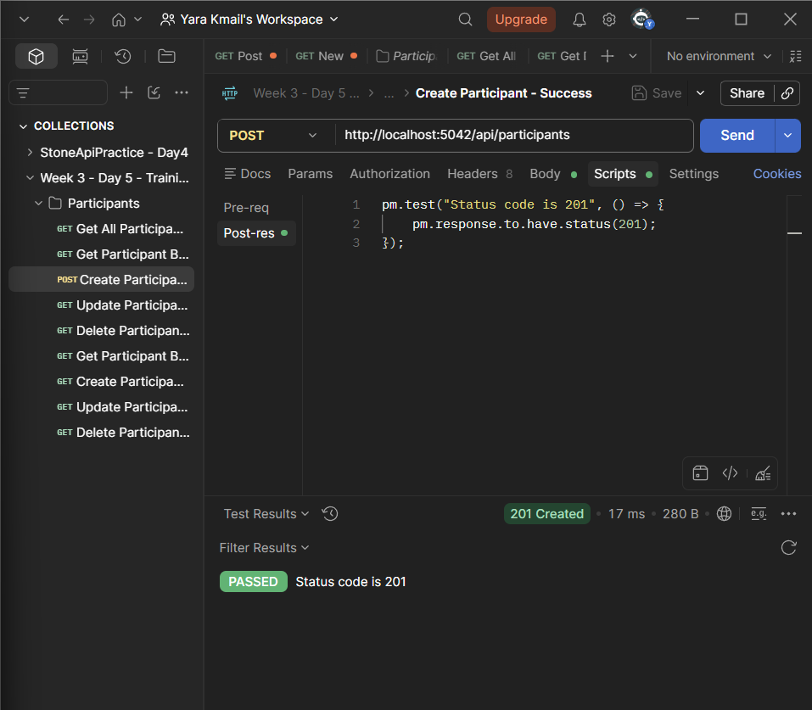

6.3 DELETE Test
The Delete Participant request was configured to verify that the response status is 204.
pm.test("Status code is 204", () => {
pm.response.to.have.status(204);
});

📸 Screenshot 14 — DELETE Test Script
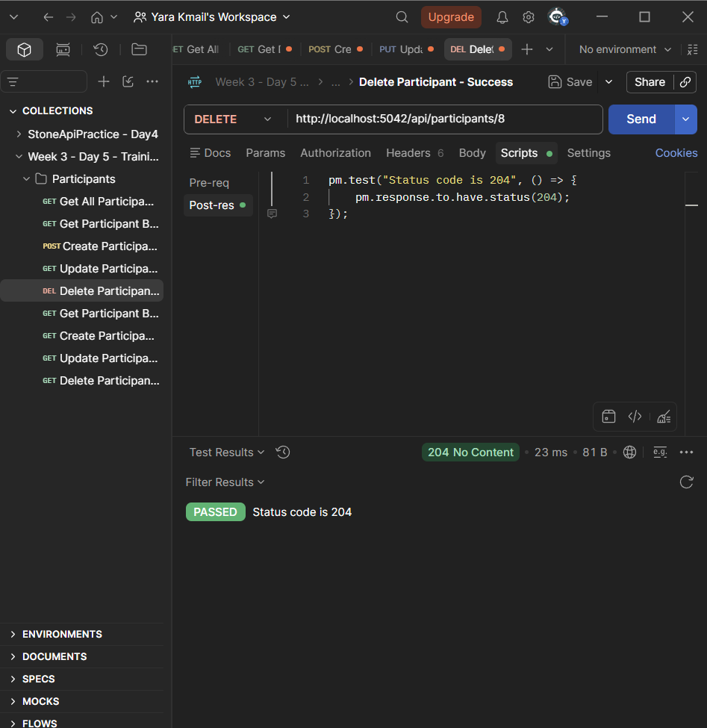

7. Postman Environment
A local Postman Environment was created to avoid repeating the API base URL in every request.

Environment
Name:
Local - Training Management API

Variable
baseUrl = http://localhost:5042

📸 Screenshot 15 — Environment
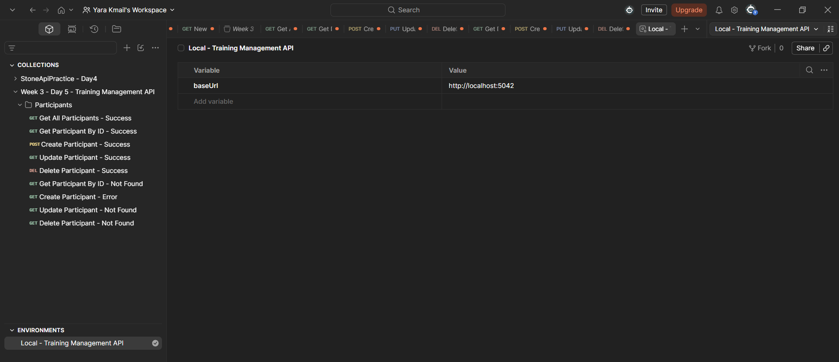

8. Using the {{baseUrl}} Variable
After creating the environment, the API requests were updated to use the variable instead of the complete local URL.
For example:
{{baseUrl}}/api/participants
instead of:
http://localhost:5042/api/participants
The same variable was used throughout the collection.

📸 Screenshot 16 — Using {{baseUrl}}
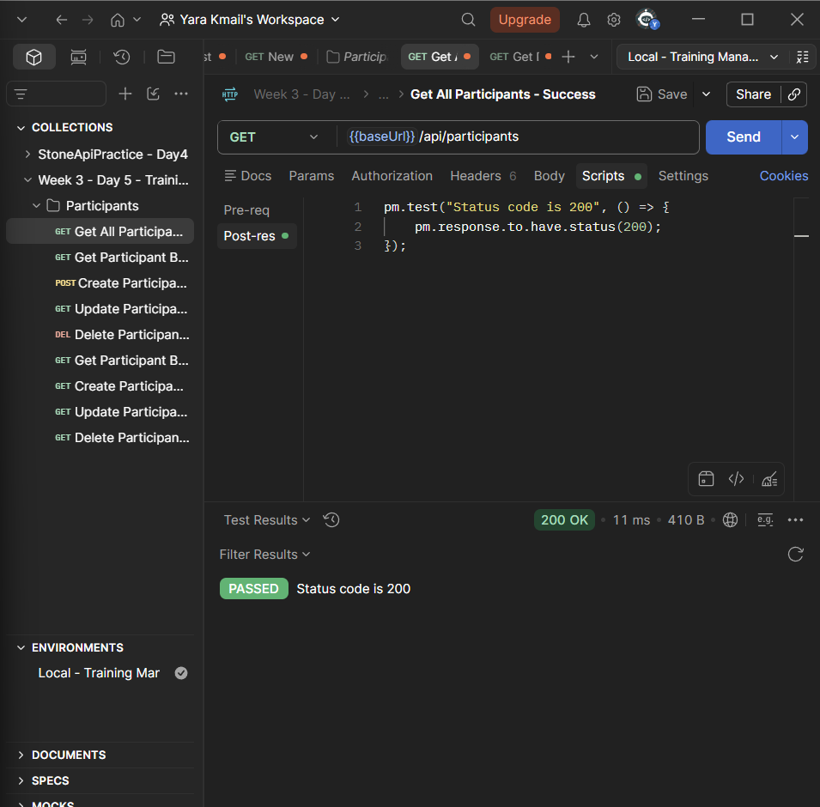

9. Exporting the Postman Collection
After completing the requests, error cases, tests, and environment configuration, the Postman Collection was exported as a JSON file.
The exported collection is stored in the project under:
Postman/
└── Week3_Day5_TrainingManagement_Postman.json

10. Final Testing Summary
The completed collection covers the main Participants CRUD operations and their tested success and error scenarios.
Operation | Success Case | Error Case
GET All | 200 OK | —
GET By ID | 200 OK | 404 Not Found
POST | 201 Created | 400 Bad Request
PUT | 200 OK | 404 Not Found
DELETE | 204 No Content | 404 Not Found
Three Postman requests also contain automated status-code tests:
- GET → 200
- POST → 201
- DELETE → 204

11. What I Learned
During Day 5, I practiced how to test an API systematically using Postman instead of testing requests individually without organization.
I learned how to:
- Create and organize a Postman Collection.
- Group requests by resource.
- Test successful API operations.
- Test realistic error cases.
- Add Postman test scripts.
- Use a Postman Environment.
- Store the API base URL in a variable.
- Use {{baseUrl}} across requests.
- Export a Postman Collection as JSON.
- Document API testing results.

12. Day 5 Outcome
By the end of Day 5, the Participants API had been tested through an organized Postman Collection covering its CRUD operations.
Both success and error scenarios were tested, three automated status-code checks were added, a local environment with baseUrl was configured, and the completed collection was exported as a JSON file.
The Day 5 work completed the practical API testing and documentation requirements for Week 3.

