Week 4 — Day 4: Input Validation with FluentValidation
Overview
This day focuses on implementing input validation in the existing Training Management API using FluentValidation.
The main goal is to validate incoming requests before they reach the controller logic and to return clear, structured validation errors when the input is invalid.
Learning Objectives
- Compare DataAnnotations and FluentValidation and understand when to use each approach.
- Create validators that enforce real business rules, not only basic data types.
- Integrate FluentValidation into the ASP.NET Core request pipeline.
- Return meaningful and structured validation errors.
- Test validation rules individually using Postman.
Project Setup
Day 4 was created as a continuation of the existing Day 3 Training Management API.
The existing project structure and functionality were carried over, including:
- Controllers
- Models
- Database Context
- Entity Framework Core migrations
- Authentication and JWT configuration
- Application settings
- Required NuGet dependencies
The project was then built successfully before starting the validation tasks.
Task 1 — Install FluentValidation
FluentValidation was added to the Day 4 project to provide a separate and scalable way of defining validation rules.
The following packages were installed:
- FluentValidation
- FluentValidation.AspNetCore
After installing the packages, the project dependencies were restored successfully and the project was successfully built.
The validation implementation uses FluentValidation instead of placing complex validation rules directly inside the request models.
Task 2 — Create a Validator
A separate CreateParticipantValidator class was created inside the Validators folder.
The validator inherits from:
AbstractValidator<CreateParticipantRequest>

This connects the validator to the CreateParticipantRequest model and allows FluentValidation rules to be defined using RuleFor.
Three validation rules were implemented:
1. Name must not be empty
- NotEmpty()
- Returns a custom message when the name is missing.
2. Name must not exceed 100 characters
- MaximumLength(100)
- Prevents excessively long participant names.
3. Email must have a valid email format
- EmailAddress()
- Returns a custom message when the email format is invalid.
Each rule uses WithMessage() to provide a clear validation message.
The project was successfully built after creating the validator.
Task 3 — Create an Update Validator
A separate UpdateParticipantValidator class was created inside the Validators folder.
The validator inherits from:
AbstractValidator<UpdateParticipantRequest>

Three validation rules were implemented:
1. Name must not be empty
- NotEmpty()
- Ensures that an update request contains a participant name.
2. Name must not exceed 100 characters
- MaximumLength(100)
- Prevents excessively long participant names.
3. Email must have a valid email format
- EmailAddress()
- Ensures that the provided email follows a valid email format.
Custom messages were added using WithMessage() so that validation failures provide clear information about the problem.
The project was successfully built after creating the update validator.
Task 4 — Integrating Validation into the Pipeline
FluentValidation was integrated into the ASP.NET Core application so that the validators can run automatically when incoming requests are validated.
First, the FluentValidation ASP.NET Core integration package was installed.
The validators were registered in Program.cs using:
builder.Services.AddValidatorsFromAssemblyContaining<Program>();

This allows FluentValidation to discover validator classes in the application assembly, including:
- CreateParticipantValidator
- UpdateParticipantValidator
Automatic validation was also enabled using:
builder.Services.AddFluentValidationAutoValidation();

This connects FluentValidation with ASP.NET Core's model validation process, allowing validation to happen automatically when a request reaches an API endpoint.
Therefore, an invalid request can be rejected automatically with a structured 400 Bad Request response instead of continuing into the controller logic.
The project was successfully built after completing the FluentValidation integration.
Build Verification
The final build completed successfully:
Day4 net10.0 succeeded

Although the project still displayed existing warnings, there were no build errors, and the application compiled successfully.
Task 5 — Test Validation Rules in Postman
After integrating FluentValidation into the request pipeline, the validation rules were tested individually using Postman.
The tests were performed separately so that each validation rule could be verified independently and its specific error message could be confirmed.
Create Participant — Validation Tests
Test 1 — Create - Name Required
A POST request was sent to the existing Create Participant endpoint with an empty Name.
The request intentionally violated the NotEmpty() rule.
The API returned:
400 Bad Request

with a structured validation response containing:
Name is required.

📸 Screenshot — Create - Name Required
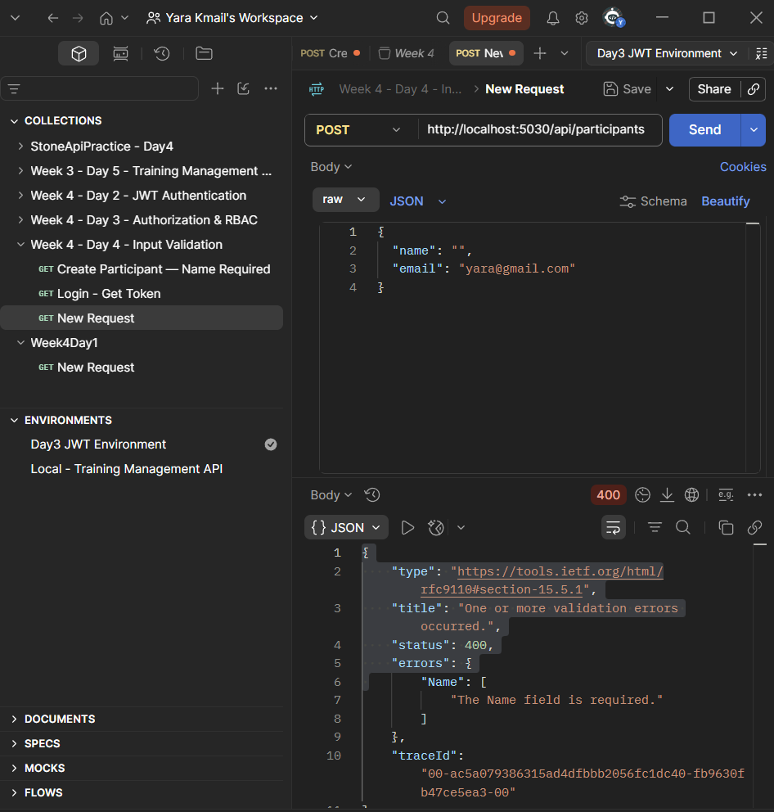
Test 2 — Create - Name Max Length
A POST request was sent with a participant name exceeding 100 characters.
This intentionally violated the MaximumLength(100) rule.
The API returned:
400 Bad Request

with the specific validation message:
Name must not exceed 100 characters.

📸 Screenshot — Create - Name Max Length
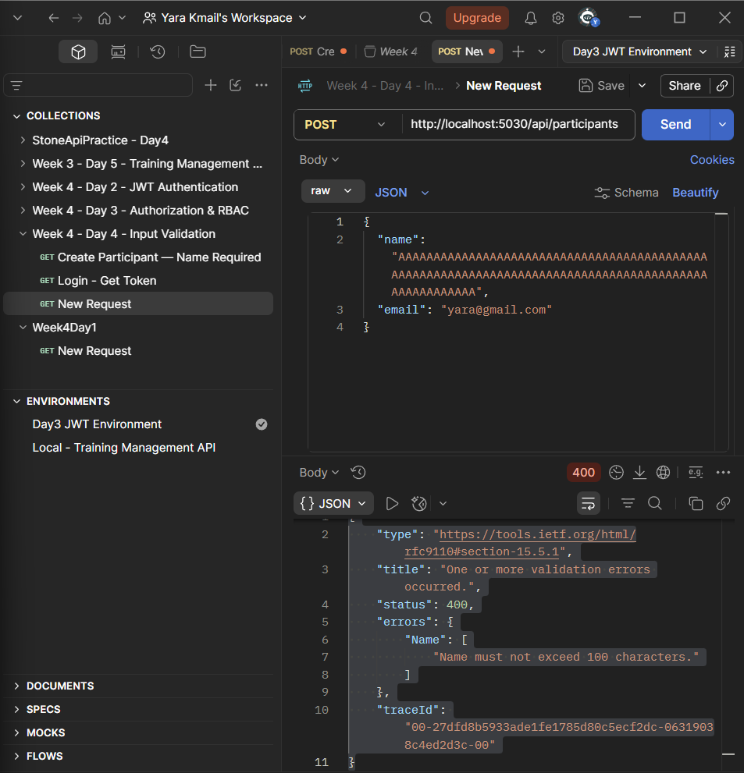
Test 3 — Create - Invalid Email
A POST request was sent with an invalid email format.
This intentionally violated the EmailAddress() rule.
The API returned:
400 Bad Request

with the specific validation message:
Email must be a valid email address.

📸 Screenshot — Create - Invalid Email
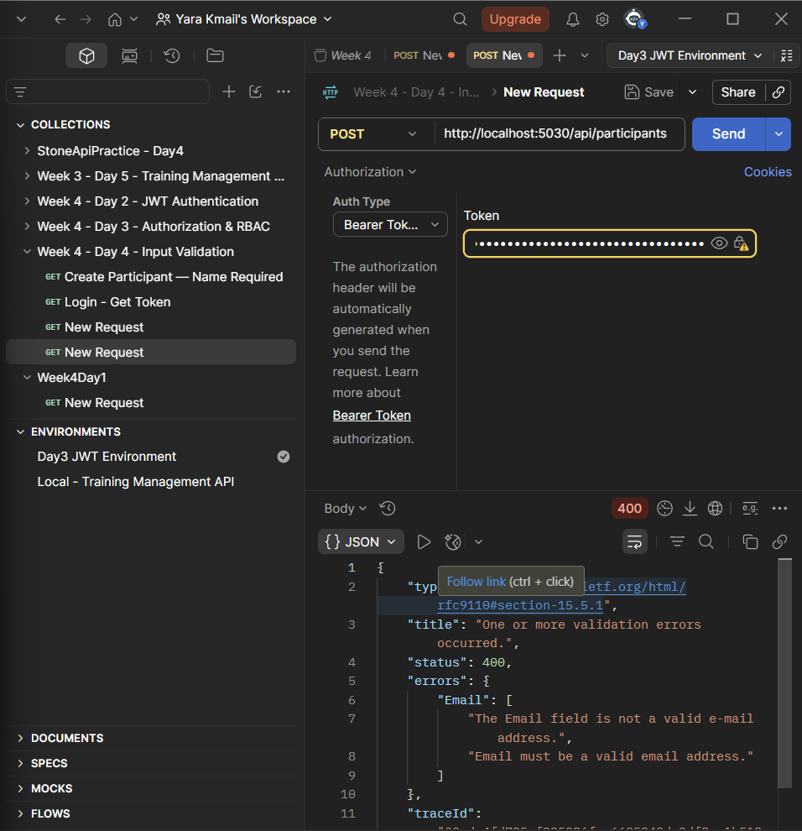
Update Participant — Validation Tests
The same validation rules were also tested against the existing Update Participant endpoint.
A valid participant ID was used for the update requests.
Test 4 — Update - Name Required
A PUT request was sent with an empty Name.
This intentionally violated the NotEmpty() rule.
The API returned:
400 Bad Request

with the specific validation message:
Name is required.

📸 Screenshot — Update - Name Required
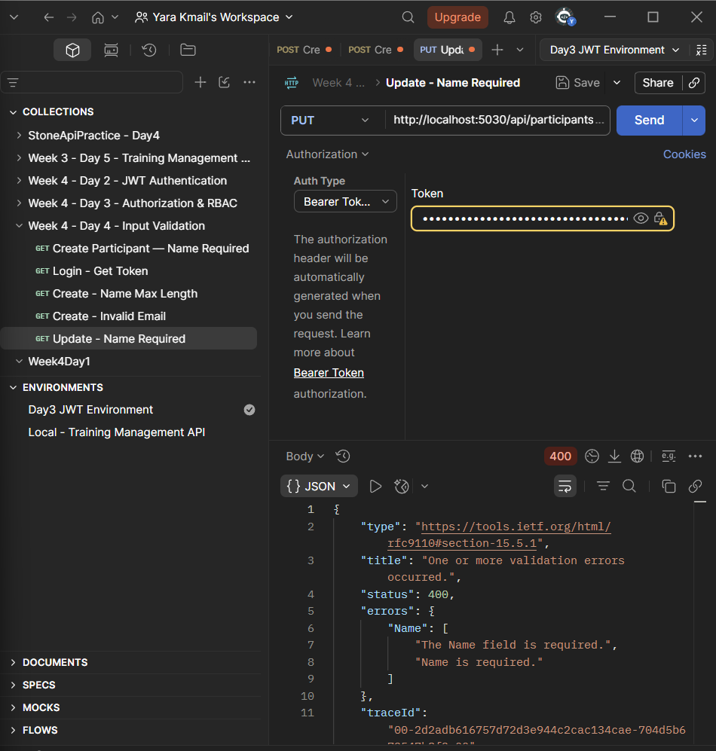
Test 5 — Update - Name Max Length
A PUT request was sent with a participant name exceeding 100 characters.
This intentionally violated the MaximumLength(100) rule.
The API returned:
400 Bad Request

with the specific validation message:
Name must not exceed 100 characters.

📸 Screenshot — Update - Name Max Length
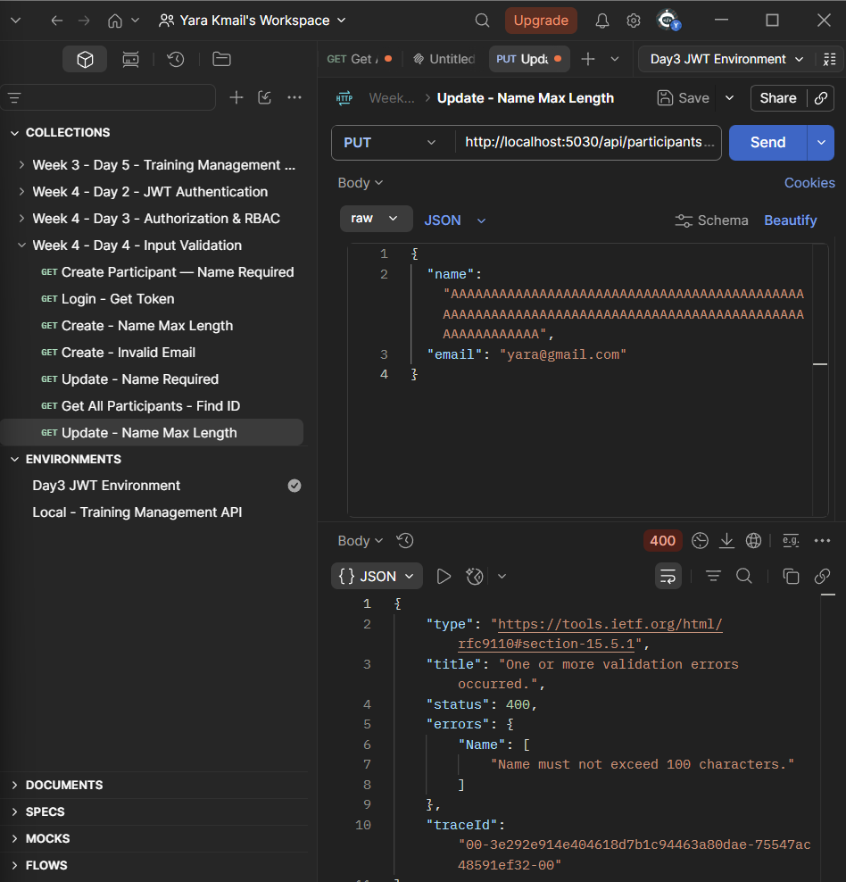
Test 6 — Update - Invalid Email
A PUT request was sent with an invalid email format.
This intentionally violated the EmailAddress() rule.
The API returned:
400 Bad Request

with the specific validation message:
Email must be a valid email address.

📸 Screenshot — Update - Invalid Email
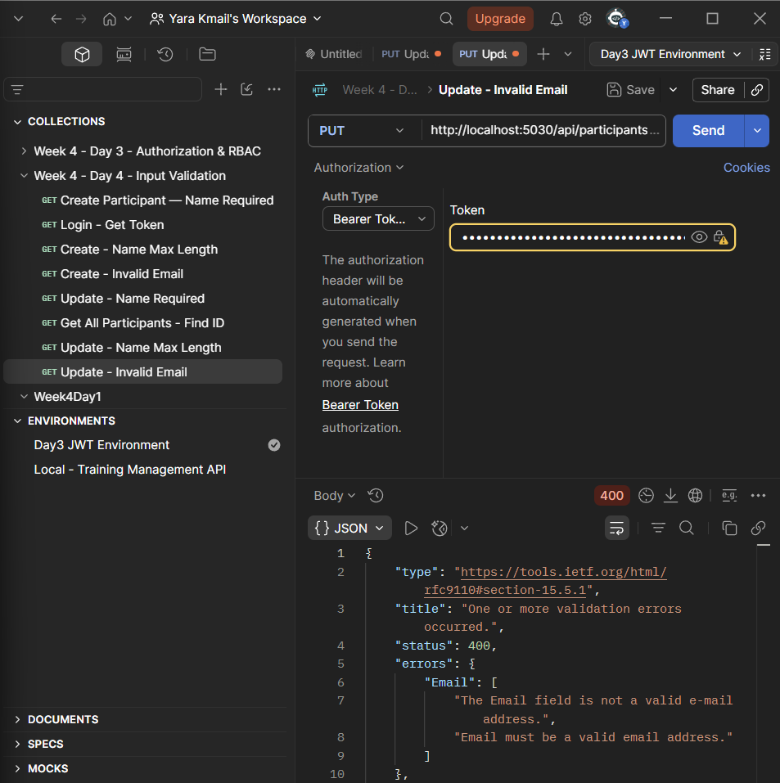
Validation Result
All validation rules were tested individually in Postman.
The tests confirmed that:
- Invalid input is automatically detected.
- The API returns 400 Bad Request.
- The response is structured by field.
- The specific validation message defined in the validator is returned.
- Both CreateParticipantRequest and UpdateParticipantRequest are validated automatically.
- Valid requests are allowed to continue through the normal API flow.
Therefore, the Hands-On Lab: Add Validators to Existing Endpoints was completed successfully.
Tools Used
- FluentValidation
- FluentValidation.AspNetCore
- ASP.NET Core Web API
- Postman

