Week 3 — Day 4 Documentation
Implementing CRUD Operations with Entity Framework Core
1. Day Overview
Day 4 Topic
Implementing CRUD Operations with EF Core
Objective
The goal of Day 4 was to implement and test complete CRUD operations for a primary API resource using:
• ASP.NET Core
• Entity Framework Core
• SQL Server
• Postman
The implementation was performed on the existing Training Management API created during Day 3.
For this day, the Participant resource was selected as the primary resource.
The following operations were implemented:
• Create a Participant
• Get all Participants
• Get a Participant by ID
• Update a Participant
• Delete a Participant
The implementation also covered:
• Validation
• Not-found handling
• EF Core Change Tracking
• SaveChangesAsync()
• Appropriate HTTP status codes
• Testing successful and error cases through Postman
2. Learning Objectives
By the end of this task, the following concepts were implemented and practiced:
Create and Read
• Creating new entities using EF Core.
• Saving entities using SaveChangesAsync().
• Reading data asynchronously using EF Core LINQ methods.
Update and Delete
• Finding an existing entity before modifying it.
• Updating a tracked entity.
• Deleting an existing entity.
• Persisting changes using SaveChangesAsync().
Error Handling
• Returning 404 Not Found when a Participant does not exist.
• Returning 400 Bad Request when request validation fails.
Testing
All CRUD endpoints were tested using Postman, including deliberate error cases.
3. Project Preparation
The Day 4 project was created based on the project developed during Day 3.
The existing database-related files, models, configuration, and project settings were carried into the Day 4 project so that we could continue working with the same Training Management database structure.
The project was then built and run successfully.
Build Verification
The following command was used:
dotnet build
The project successfully built.
There were warnings related to:
• The Microsoft.OpenApi package vulnerability warning.
• Nullable reference type warnings in some existing models.
These warnings did not prevent the project from building or running.
Run Verification
The application was started using:
dotnet run
The API started successfully on:
http://localhost:5001
4. Database Connection
The existing TrainingManagementDbContext from Day 3 was used in Day 4.
The DbContext represents the connection between the application and the SQL Server database.
The Participants table is represented by:
public DbSet<Participant> Participants { get; set; }
This allowed the controller to access the Participants table through:
_context.Participants
5. Participant Model
The Participant model represents a participant in the Training Management system.
// Represents a participant in the training management system.
public class Participant
{
// The primary key of the participant.
public int Id { get; set; }
// The participant's name.
public string Name { get; set; }
// The participant's email address.
public string Email { get; set; }
// Relationship between Participant and TrainingParticipant.
public ICollection<TrainingParticipant> TrainingParticipants { get; set; }
= new List<TrainingParticipant>();
}
The Participant contains:
Property | Purpose
Id | Primary key
Name | Participant name
Email | Participant email
TrainingParticipants | Relationship with trainings

6. Request Models
Instead of receiving the database entity directly for every request, request models were created for the operations that receive data from the client.
Two request models were used:
Models/
│
├── CreateParticipantRequest.cs
└── UpdateParticipantRequest.cs
6.1 CreateParticipantRequest
This model represents the data required when creating a new Participant.
using System.ComponentModel.DataAnnotations;
// Contains the data required to create a participant.
public class CreateParticipantRequest
{
// The participant name is required.
[Required]
public string Name { get; set; }
// The participant email is required.
[Required]
// The value must have a valid email format.
[EmailAddress]
public string Email { get; set; }
}
6.2 UpdateParticipantRequest
This model represents the data required when updating an existing Participant.
using System.ComponentModel.DataAnnotations;
// Contains the data required to update a participant.
public class UpdateParticipantRequest
{
// The participant name is required.
[Required]
public string Name { get; set; }
// The participant email is required.
[Required]
// The value must have a valid email format.
[EmailAddress]
public string Email { get; set; }
}
7. Participants Controller
A ParticipantsController was created to contain all CRUD operations for the Participant resource.
The controller receives the TrainingManagementDbContext through Dependency Injection.
// DbContext used to access the database.
private readonly TrainingManagementDbContext _context;
// ASP.NET Core provides the DbContext through Dependency Injection.
public ParticipantsController(TrainingManagementDbContext context)
{
_context = context;
}
The controller uses:
_context.Participants
to access the Participants table.
8. CRUD Endpoints
The final API contained five main endpoints:
Operation | HTTP Method | Endpoint
Create | POST | /api/participants
Get All | GET | /api/participants
Get By ID | GET | /api/participants/{id}
Update | PUT | /api/participants/{id}
Delete | DELETE | /api/participants/{id}

9. Create Operation
9.1 Endpoint
POST /api/participants
The purpose of this endpoint is to create a new Participant.
The process is:
Request
↓
Create Participant object
↓
Add to DbContext
↓
SaveChangesAsync()
↓
Return 201 Created
The Participant is first added to the DbContext:
_context.Participants.Add(participant);
At this point, the entity has been added to EF Core's tracking system, but the change has not yet been saved to the database.
The actual database operation occurs when:
await _context.SaveChangesAsync();
is executed.
The endpoint returns:
201 Created
and provides a Location header for the newly created Participant.
9.2 Postman — Successful Create
A POST request was sent from Postman with JSON data containing the Participant's name and email.
Example:
{
"name": "Ahmad Ali",
"email": "newemail@example.com"
}
The request returned:
201 Created
The response also contained the Location header.
Screenshot — Successful Create (POST)
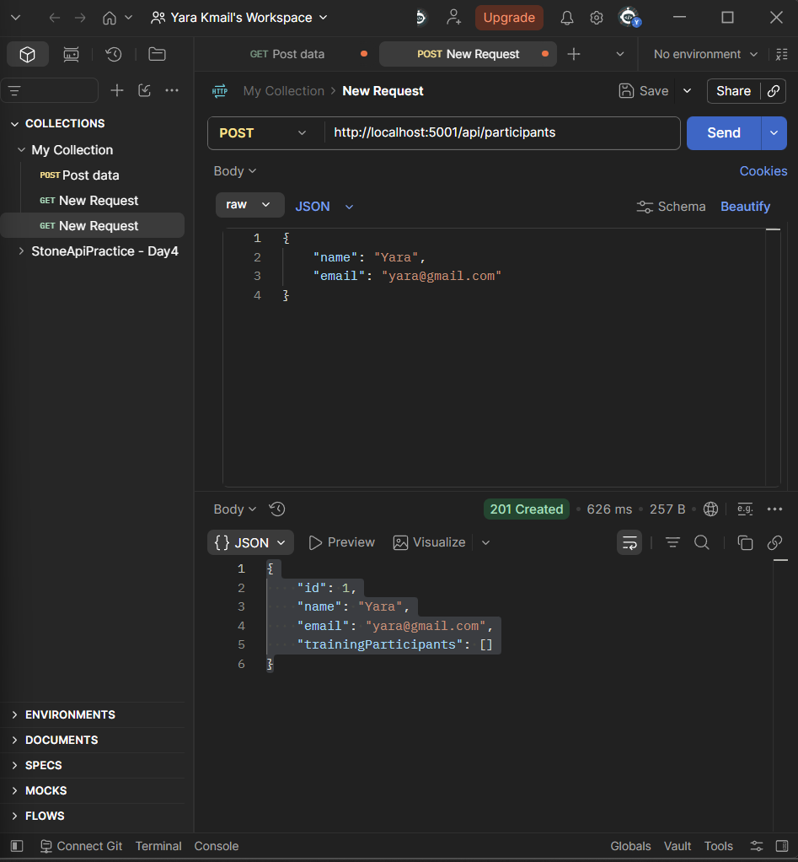
10. Get All Operation
10.1 Endpoint
GET /api/participants
This endpoint retrieves all Participants from the database.
EF Core's asynchronous method:
ToListAsync()
was used to retrieve the records.
The endpoint returns:
200 OK
when the request succeeds.
Process
GET Request
↓
ToListAsync()
↓
Retrieve Participants
↓
200 OK
Screenshot — Get All (GET)
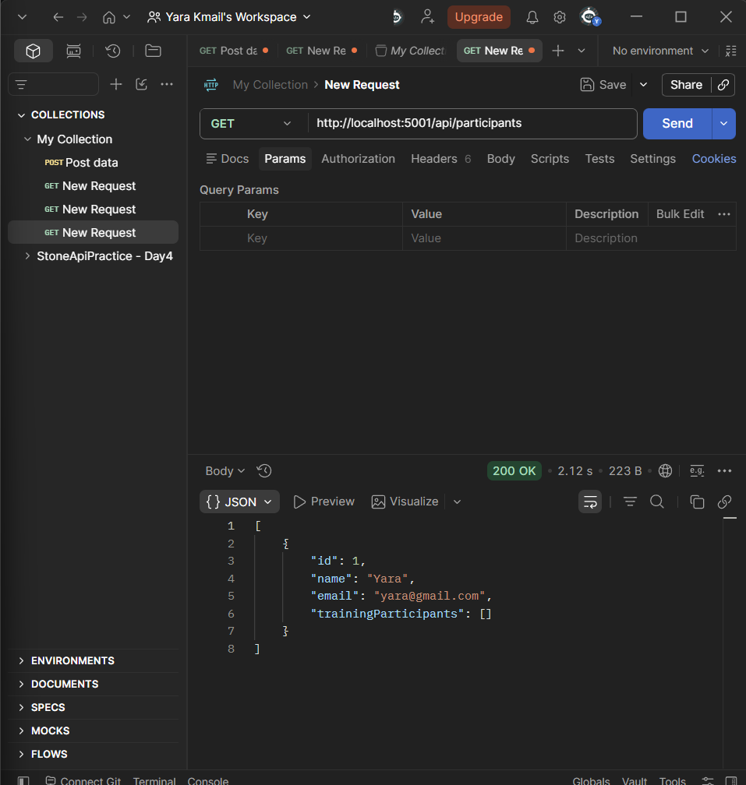
11. Get By ID Operation
11.1 Endpoint
GET /api/participants/{id}
This endpoint retrieves one Participant based on its ID.
The database is searched asynchronously using:
FirstOrDefaultAsync()
If the Participant exists:
200 OK
is returned.
If the Participant does not exist:
404 Not Found
is returned.
The logic is:
Search by ID
↓
Does Participant exist?
│
├── Yes → 200 OK
│
└── No → 404 Not Found
11.2 Postman — Existing ID
An existing Participant ID was tested using Postman.
The request returned:
200 OK
Screenshot — Existing ID
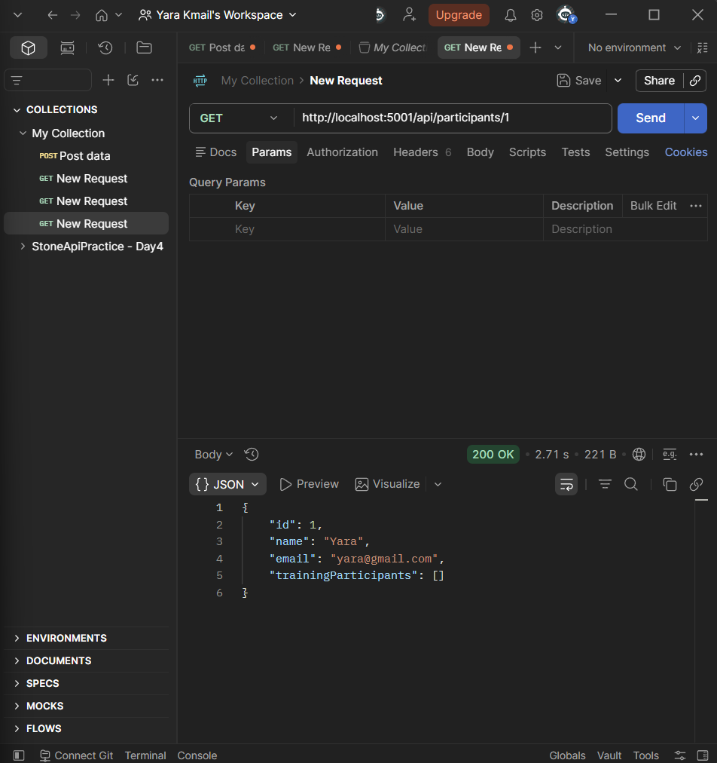
11.3 Postman — Non-existing ID
A non-existing ID was deliberately tested:
GET /api/participants/90
The API returned:
404 Not Found
This confirms that the API correctly handles requests for resources that do not exist.
Screenshot — Non-existing ID (404)
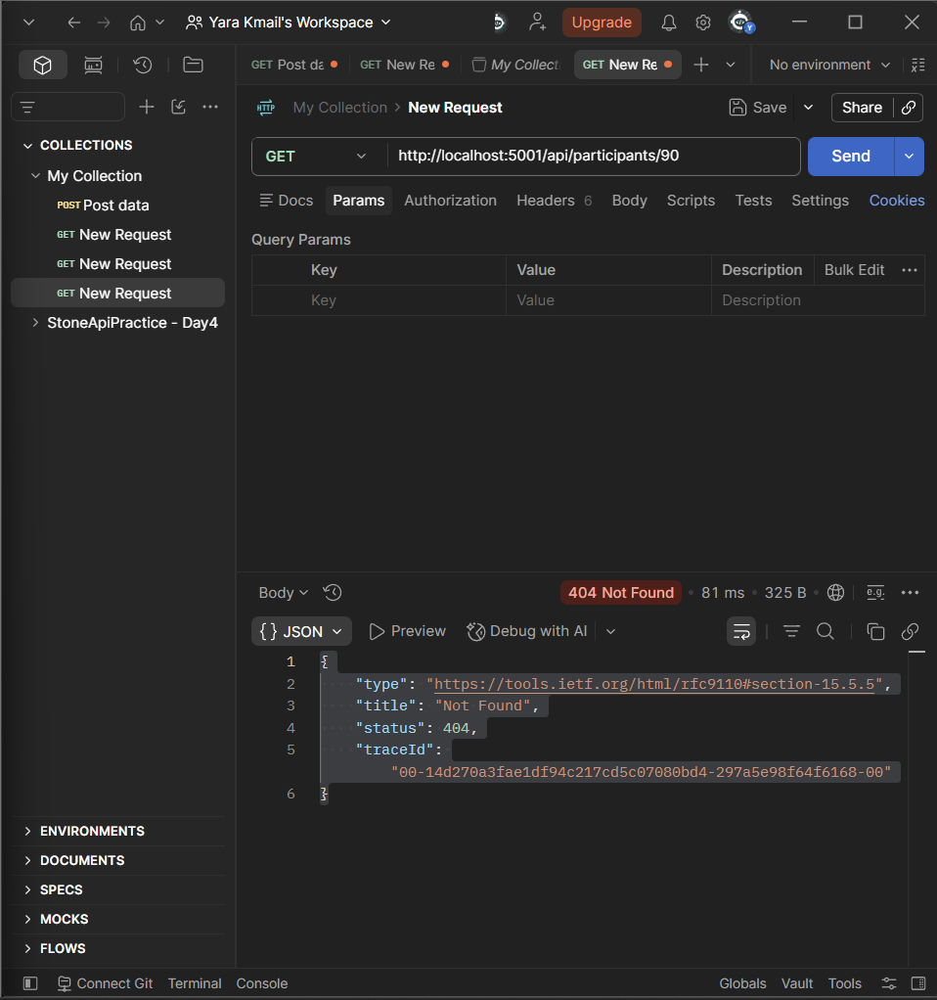
12. Update Operation
12.1 Endpoint
PUT /api/participants/{id}
The Update operation follows these steps:
Receive ID
↓
Find Participant
↓
Does it exist?
│
├── No → 404 Not Found
│
└── Yes
↓
Update properties
↓
SaveChangesAsync()
↓
200 OK
The Participant is retrieved first.
This is important because EF Core needs to track the existing entity.
After retrieving it, the properties are changed:
participant.Name = request.Name;
participant.Email = request.Email;
Then:
await _context.SaveChangesAsync();
is called to save the changes.
13. Change Tracking
Change Tracking was an important part of the Update operation.
When EF Core retrieves the Participant through the DbContext, EF Core tracks the entity.
For example:
Database:
Name = Ahmad
Email = ahmad@gmail.com
After changing the object:
Name = Ahmad Ali
Email = ahmad.ali@gmail.com
EF Core detects that the tracked values have changed.
Calling:
await _context.SaveChangesAsync();
then saves those changes to SQL Server.
This means we did not need to manually write an SQL UPDATE statement.
14. Update — Successful Test
A valid PUT request was tested using Postman.
The Participant's data was changed successfully.
The endpoint returned:
200 OK
Screenshot — Update Successful (PUT)
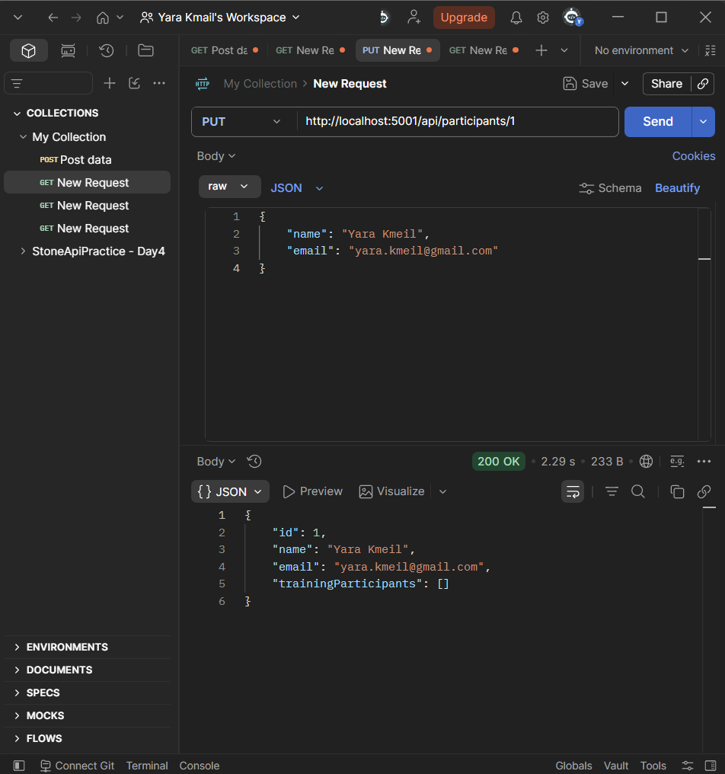
15. Update — Not Found Test
An Update request was deliberately sent using an ID that does not exist:
PUT /api/participants/90
The API first searches for the Participant.
Because the Participant does not exist, the operation stops and returns:
404 Not Found
No update is attempted.
Screenshot — Update Not Found (404)
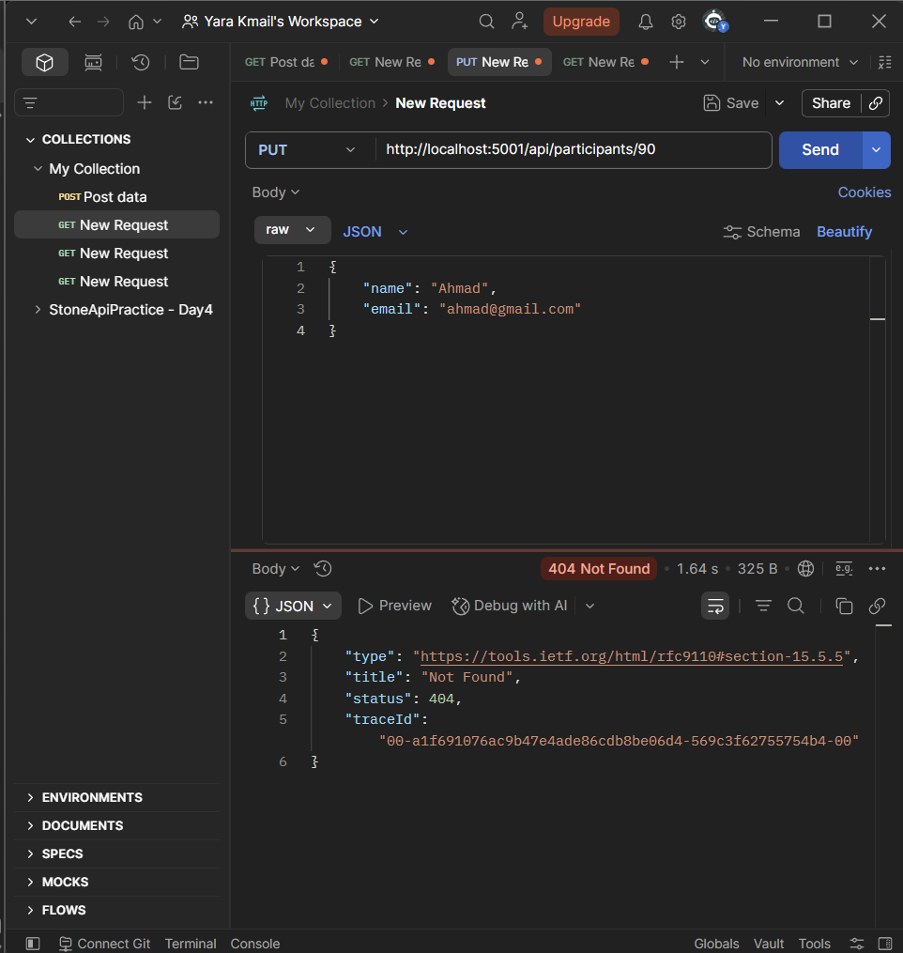
16. Validation
Validation was implemented using DataAnnotations.
The request models contain:
[Required]
and:
[EmailAddress]
The controller also uses:
[ApiController]
ASP.NET Core automatically checks the request model validation.
If the request contains invalid data, the request is rejected with:
400 Bad Request
before the normal database operation is performed.
16.1 Validation Test
An invalid request was deliberately tested in Postman.
For example, an invalid email format or missing required value was submitted.
The API returned:
400 Bad Request
Screenshot — Validation Failure (400)
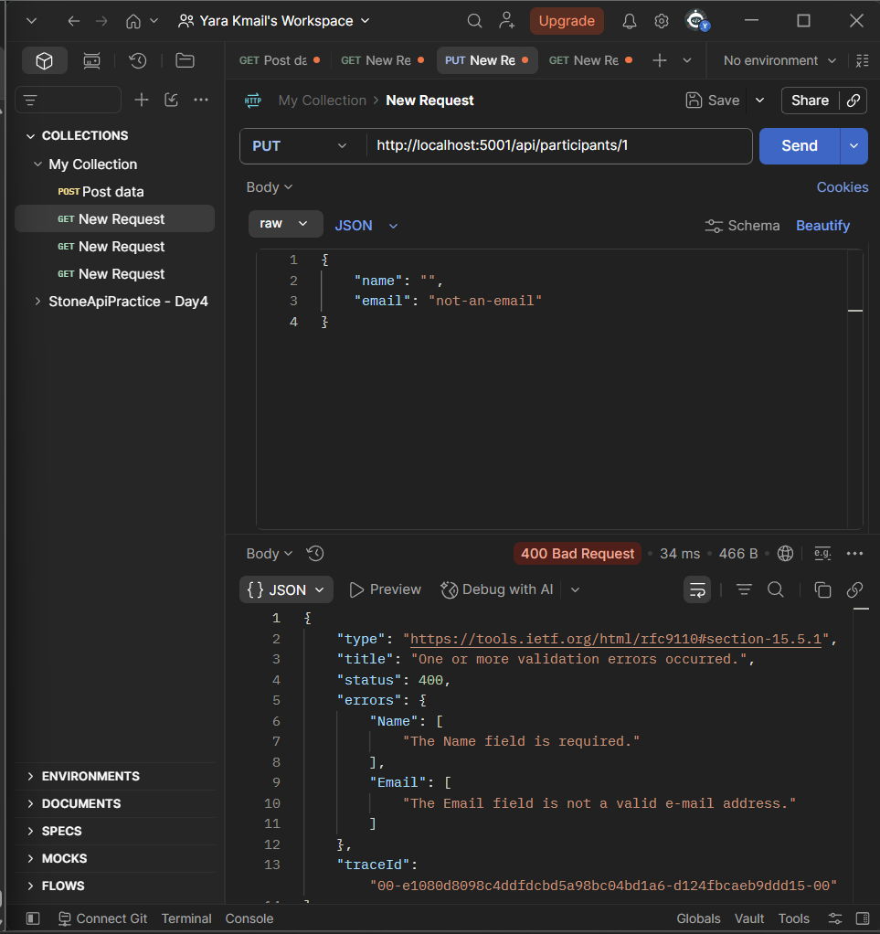
17. Delete Operation
17.1 Endpoint
DELETE /api/participants/{id}
The Delete operation first searches for the Participant.
If the Participant does not exist:
404 Not Found
is returned.
If it exists, it is marked for deletion using:
_context.Participants.Remove(participant);
Then the change is saved:
await _context.SaveChangesAsync();
Finally, the endpoint returns:
204 No Content
The complete process is:
DELETE Request
↓
Find Participant
↓
Does it exist?
│
├── No → 404
│
└── Yes
↓
Remove()
↓
SaveChangesAsync()
↓
204 No Content
18. Delete — Successful Test
A Participant that existed in the database was deleted using Postman.
The request returned:
204 No Content
This confirmed that the delete operation was successful.
Screenshot — Delete Successful (204)
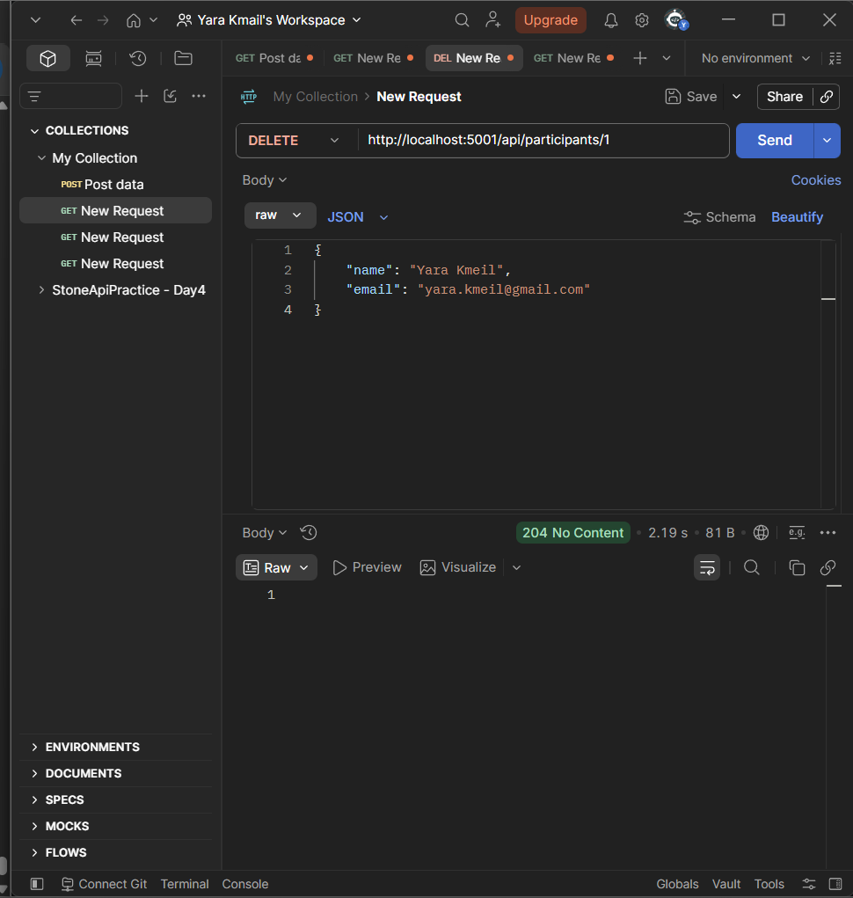
19. Delete — Not Found Test
A Delete request was deliberately sent using a non-existing ID:
DELETE /api/participants/90
The API returned:
404 Not Found
This confirms that the API checks whether the resource exists before trying to delete it.
Screenshot — Delete Not Found (404)
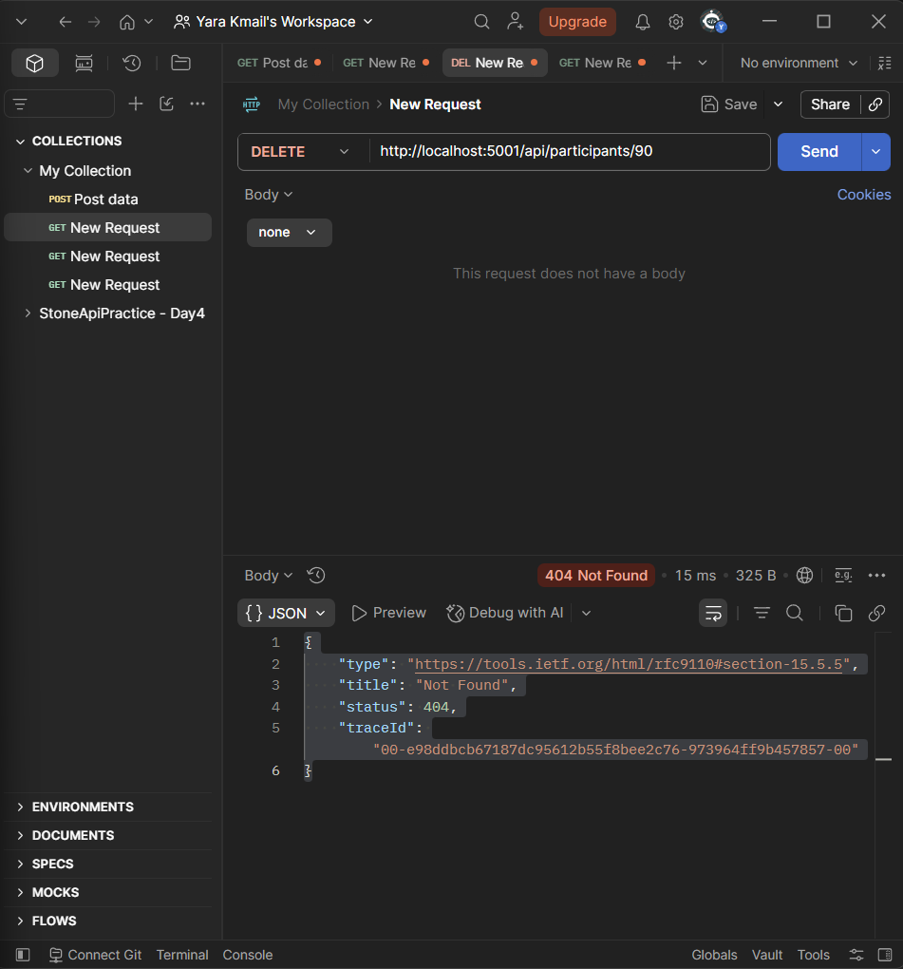
20. Duplicate Email Test
During Postman testing, an existing email was submitted again:
ahmad@gmail.com
The database rejected the operation because the Participant email was configured as unique.
The database returned a duplicate key error related to:
IX_Participants_Email
This happened because the email already existed in the Participants table.
After using a new email address, the Create operation succeeded and returned:
201 Created
Screenshot — Create with New Email (Success)
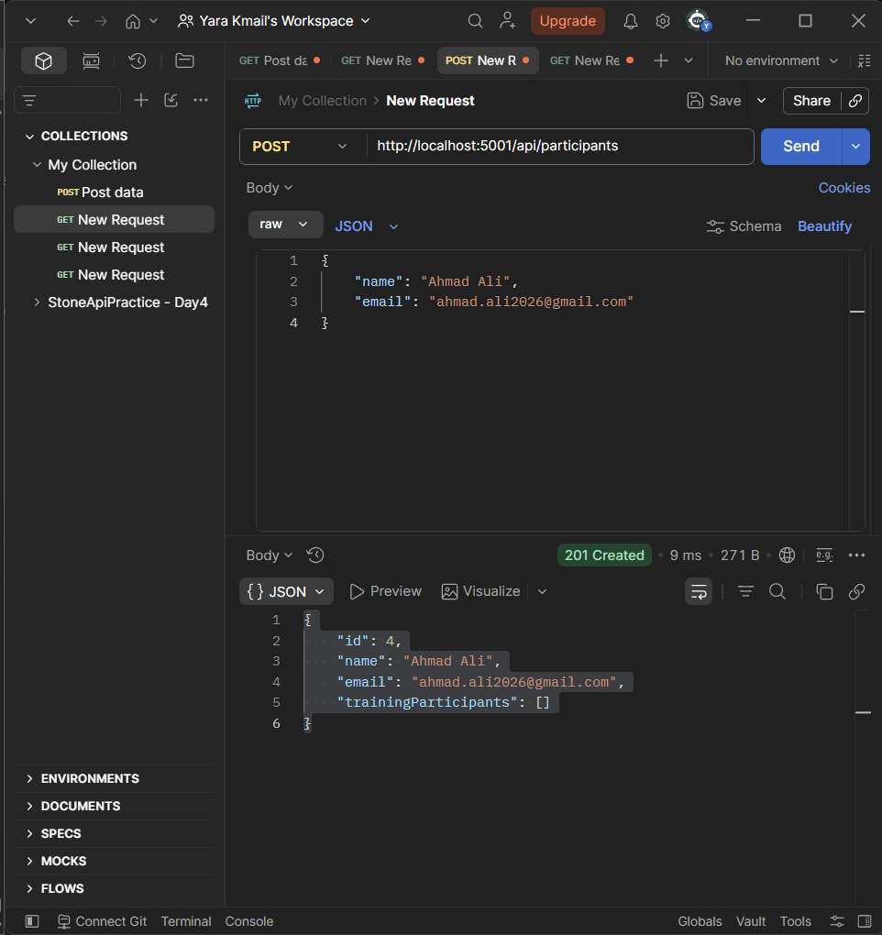
Result
This test confirmed that the unique email constraint configured in the database is being enforced.
21. Asynchronous EF Core Operations
All database operations that communicate with the database were implemented asynchronously.
Examples used during Day 4 include:
await _context.SaveChangesAsync();
await _context.Participants.ToListAsync();
await _context.Participants.FirstOrDefaultAsync(...);
Using the asynchronous versions allows the API to avoid blocking the request thread while waiting for database operations to complete.
22. HTTP Response Codes
The following response codes were used during Day 4:
Code | Meaning | Day 4 Usage
200 OK | Request completed successfully | GET / PUT
201 Created | New resource created | POST
204 No Content | Operation completed successfully without response body | DELETE
400 Bad Request | Request contains invalid data | Validation
404 Not Found | Requested resource does not exist | GET / PUT / DELETE

23. Postman Testing
Postman was used to test the complete CRUD implementation.
Successful Cases
POST /api/participants
GET /api/participants
GET /api/participants/{id}
PUT /api/participants/{id}
DELETE /api/participants/{id}
Error Cases
The following deliberate error cases were also tested:
GET /api/participants/90
PUT /api/participants/90
DELETE /api/participants/90
All returned:
404 Not Found
An invalid request was also tested and returned:
400 Bad Request
A duplicate email was tested and rejected by the database because of the unique constraint.
24. Final CRUD Flow
The complete implementation can be summarized as:
Participant API
│
┌─────────────────┼─────────────────┐
│ │ │
CREATE READ UPDATE
│ │ │
POST GET All / ID PUT
│ │ │
201 200 / 404 200 / 404
│
│
DELETE
│
DELETE
│
204 / 404
Validation is applied to incoming request data:
Invalid Request
↓
400 Bad Request
25. Day 4 Completion Checklist
Requirement | Status
Create endpoint | ✅ Completed
Return 201 Created | ✅ Completed
Return Location Header | ✅ Tested
Get All endpoint | ✅ Completed
Get By ID endpoint | ✅ Completed
Handle missing ID | ✅ 404 Not Found
Update endpoint | ✅ Completed
Handle missing resource during Update | ✅ 404 Not Found
Validate input | ✅ 400 Bad Request
Delete endpoint | ✅ Completed
Return 204 No Content | ✅ Completed
Handle missing resource during Delete | ✅ 404 Not Found
Use async EF Core methods | ✅ Completed
Use SaveChangesAsync() | ✅ Completed
Understand Change Tracking | ✅ Applied
Test endpoints in Postman | ✅ Completed
Test deliberate error cases | ✅ Completed

26. Conclusion
Day 4 extended the Training Management API by implementing a complete CRUD workflow for the Participant resource.
The implementation connected the API endpoints directly with the SQL Server database through Entity Framework Core.
The completed workflow is:
Client
↓
ASP.NET Core Controller
↓
EF Core DbContext
↓
SQL Server
The Participant API can now:
• Create Participants.
• Retrieve Participants.
• Retrieve a Participant by ID.
• Update existing Participants.
• Delete Participants.
• Validate incoming data.
• Handle non-existing resources.
• Persist changes asynchronously.
• Track modified entities through EF Core.
• Return appropriate HTTP status codes.
All implemented operations were tested through Postman, including successful requests and deliberate error cases.
Day 4 was therefore completed by implementing and testing the full CRUD lifecycle for the Participant resource.

