Week 6 – Day 4

Order Creation, Transactions, Rollback, and Stock Validation

1. Create Order – Successful Request
The first test verifies that a new order can be created successfully when all required information is valid and sufficient stock is available.
The request was sent through Swagger using valid order data. The API processed the request successfully and returned a successful response confirming that the order was created.
Screenshot – Create Order Success
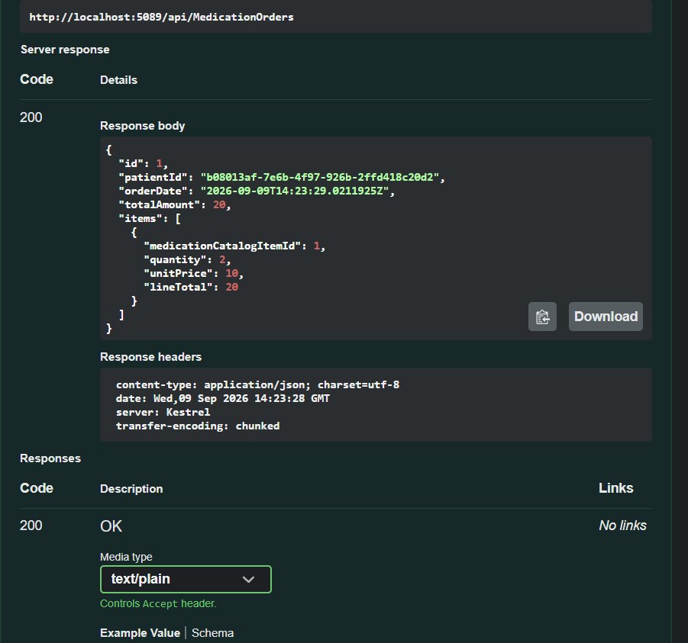

2. Transaction Rollback
The second test verifies that the transaction mechanism correctly rolls back changes when an error occurs during the order creation process.
A rollback scenario was intentionally triggered to verify that changes made during the transaction are not permanently saved when the operation fails.
The test confirmed that the transaction was rolled back successfully, preventing incomplete or invalid data from being persisted in the database.
Screenshot – Transaction Rollback
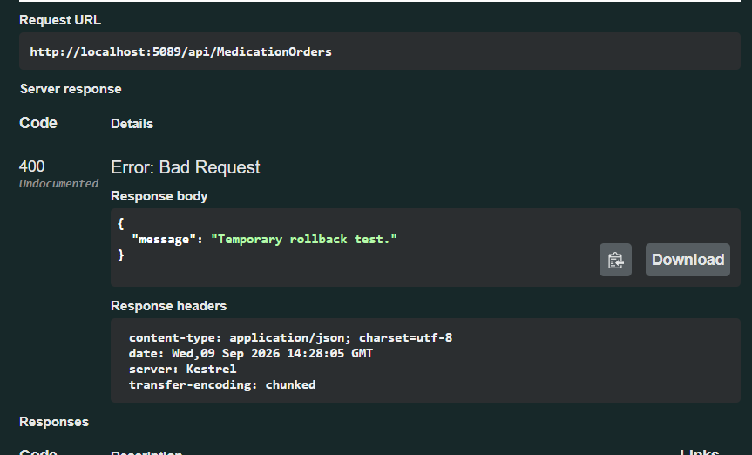

3. Create Order After Rollback
After verifying the rollback behavior, the order creation operation was tested again without the rollback condition.
The request was processed successfully, confirming that the previous failed transaction did not negatively affect subsequent operations and that the system was able to create a new order normally.
Screenshot – Create Order After Rollback
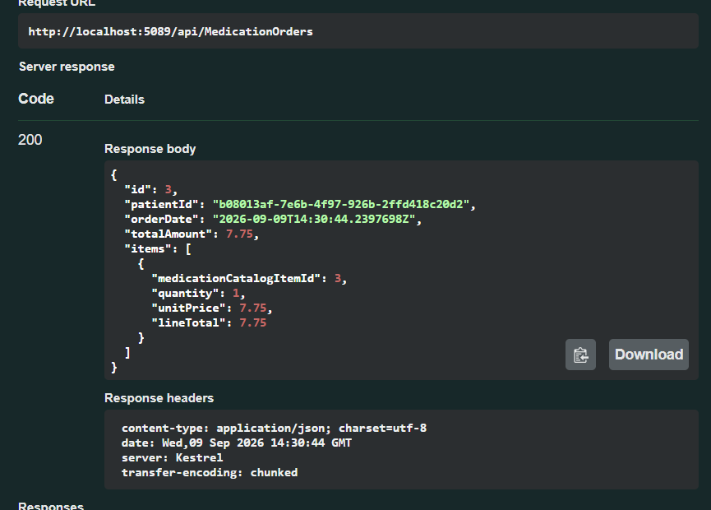

4. Insufficient Stock Validation
The final test verifies that the system prevents an order from being created when the requested quantity is greater than the available stock.
A request was submitted with a quantity exceeding the available inventory. The API rejected the request and returned an appropriate error response indicating that there was insufficient stock.
This confirms that the stock validation logic is working correctly and prevents orders from being created when the required inventory is unavailable.
Screenshot – Insufficient Stock
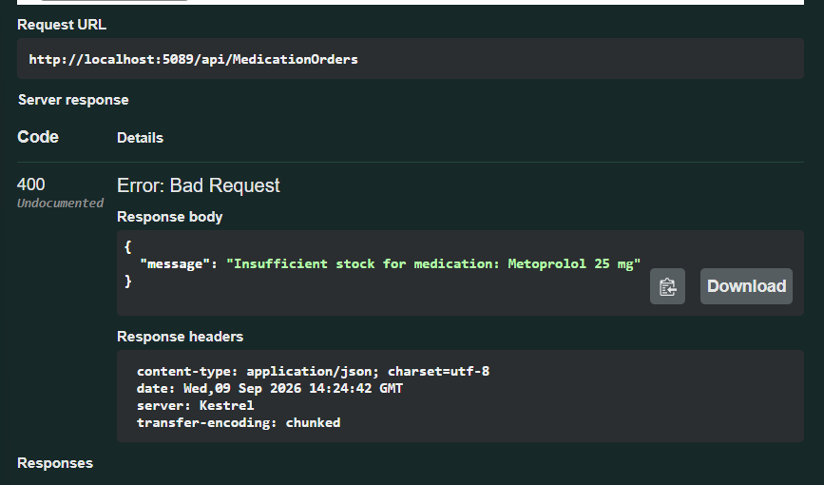

Conclusion
The Day 4 tests successfully verified the main order-processing scenarios, including successful order creation, transaction rollback, recovery after rollback, and insufficient-stock validation.
The results confirm that the API handles successful and failed order operations correctly while maintaining transaction integrity and enforcing stock availability rules.

