Day 4
ASP.NET Core Web API
Documentation

Project: StoneApiPractice
Author:yara kmail
Date: 2/8/2026

Table of Contents
Table of Contents
1. Project Setup and API Initialization
2. Creating a Controller with GET Endpoint
3. GET Endpoint with Route Parameter
4. Implementing Endpoints Using Minimal APIs
5. Testing API Endpoints Using Postman
6. Conclusion

Overview
This document presents a comprehensive report of the work completed during Day 4 of the ASP.NET Core Web API training program. The primary objective was to design, implement, and test a Web API application that manages a collection of books. Two distinct architectural approaches were explored: the traditional Controller-based API and the newer Minimal API approach introduced in ASP.NET Core 6.0. Each approach was implemented, tested using Postman, and documented to provide a clear understanding of their respective strengths and trade-offs.

1. Project Setup and API Initialization

Objective
The objective of this task was to create and initialize an ASP.NET Core Web API project and verify that the application was configured correctly and running successfully.

Implementation
The project was created using the ASP.NET Core Web API template. The application configuration was prepared using the minimal hosting model in Program.cs, where services and the application pipeline were configured. This included registering the necessary services (such as controllers and Swagger/OpenAPI documentation) and building the HTTP request pipeline with appropriate middleware.
The application was successfully built and executed using the .NET CLI with the command dotnet run. The running status of the API was verified by accessing the Swagger UI documentation interface available at the application URL.

Result
The API application started successfully on http://localhost:5200 and was ready for endpoint development and testing. The Swagger interface confirmed that the application was operational and configured correctly.


Figure 1.1: Application running successfully on localhost:5200 with Swagger UI accessible

2. Creating a Controller with GET Endpoint

Objective
The objective of this task was to create a Controller-based API endpoint that returns a predefined list of books from a domain model.

Implementation
A Book domain model was created to represent the data structure used by the API. The model includes three properties: Id (integer), Title (string), and Price (decimal). A BooksController was then implemented to handle HTTP GET requests and provide access to the available books stored in a static in-memory list.
The controller uses the [ApiController] attribute for automatic model validation and the [Route] attribute to define the base route as api/[controller]. A private static list of Book objects was initialized with three sample entries to simulate a data source.

Endpoint
GET /api/books

Testing
The endpoint was tested using Postman by sending a GET request to the API URL. The API successfully returned the list of books in JSON format with HTTP status code 200 OK.
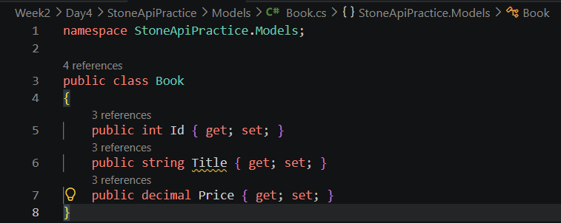

Figure 2.1: Book domain model implementation showing Id, Title, and Price properties

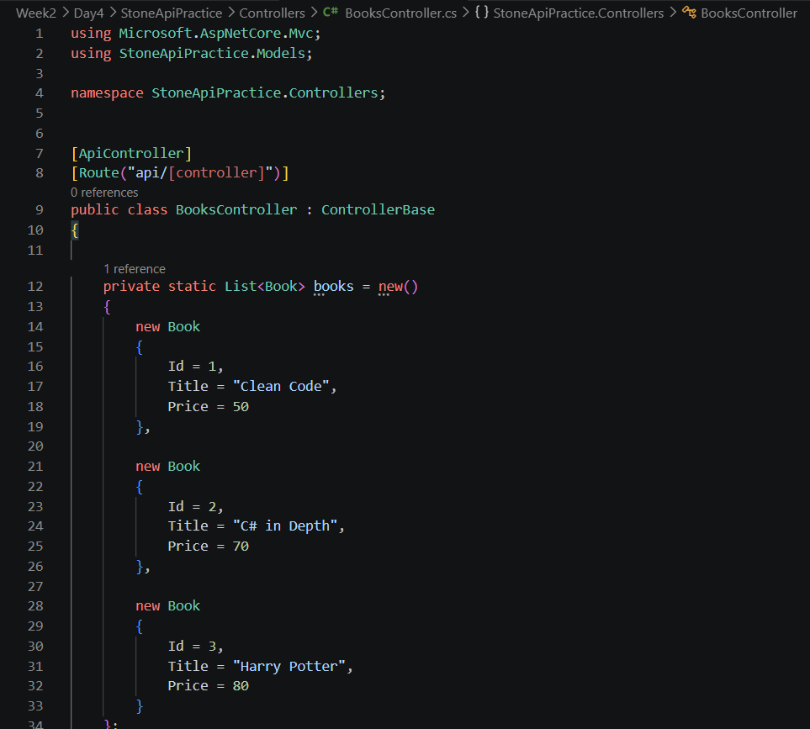

Figure 2.2: BooksController implementation with sample data and GET endpoint

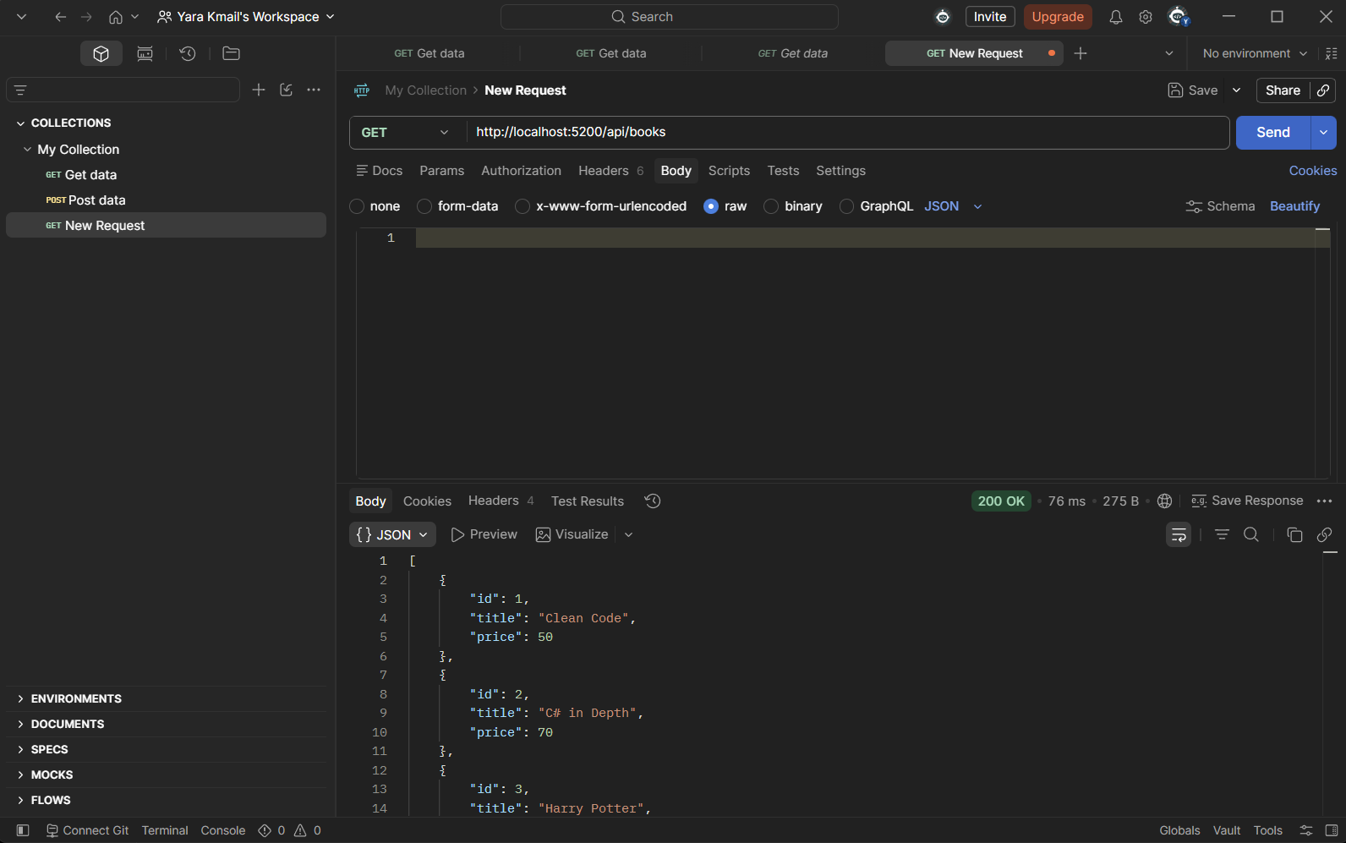

Figure 2.3: Testing the GET endpoint using Postman - returning all books in JSON format

3. GET Endpoint with Route Parameter

Objective
The objective of this task was to implement a GET endpoint that retrieves a specific book using its unique identifier as a route parameter.

Implementation
A new GET endpoint was added to the BooksController that accepts a route parameter representing the book ID. The endpoint uses the [HttpGet("{id}")] attribute to capture the ID from the URL path. The method searches the available books using LINQ's FirstOrDefault method and returns the matching item with an Ok response.
If the requested book exists, the API returns the book details with a 200 OK status. If no matching book is found, the API returns a 404 Not Found response, ensuring proper HTTP semantics for missing resources.

Endpoint
GET /api/books/{id}

Testing
The endpoint was tested using Postman by sending requests with different book IDs to verify both successful retrieval (existing ID) and not found scenarios (non-existent ID).
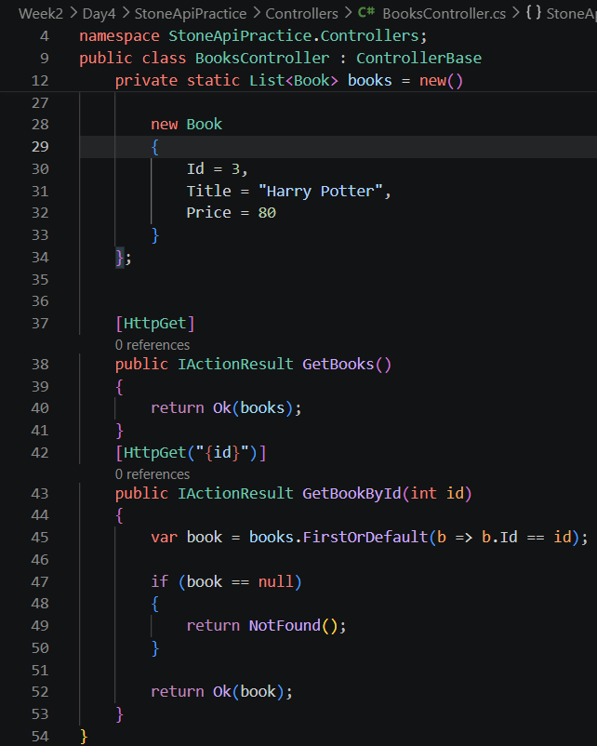

Figure 3.1: GetBookById endpoint implementation with route parameter and error handling

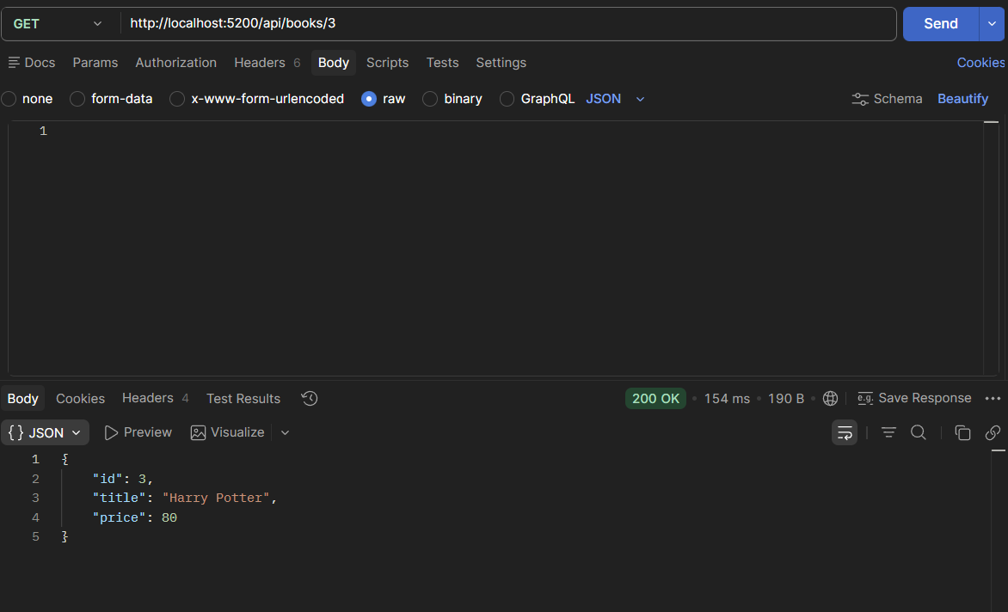

Figure 3.2: Postman test: GET /api/books/3 returns Harry Potter (200 OK)

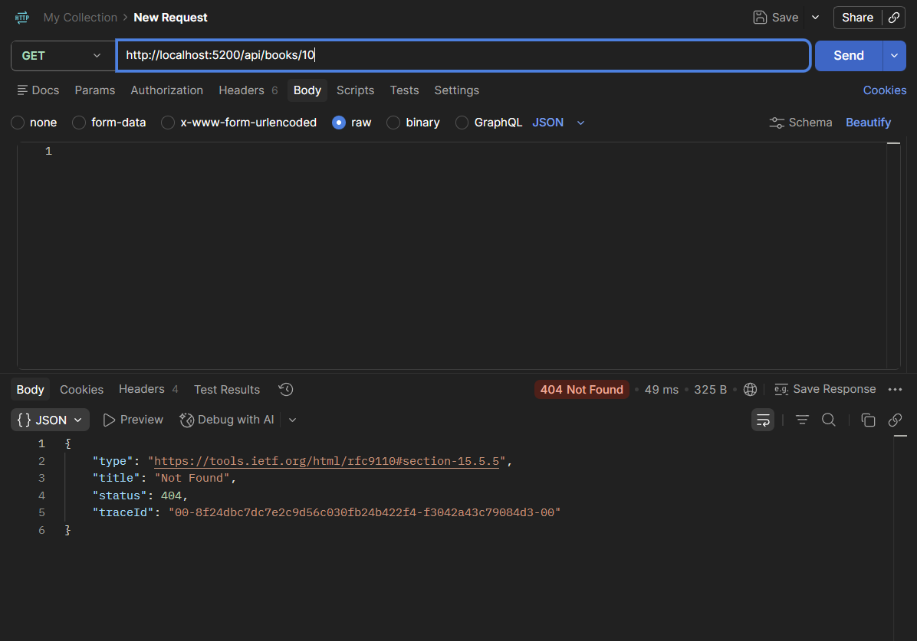

Figure 3.3: Postman test: GET /api/books/10 returns 404 Not Found for non-existent book

4. Implementing Endpoints Using Minimal APIs

Objective
The objective of this task was to implement API endpoints using ASP.NET Core Minimal APIs and compare this approach with Controller-based API development.

Implementation
In this task, the same book retrieval functionality was implemented using Minimal APIs directly inside the Program.cs file. Unlike Controllers, where endpoints are organized inside separate controller classes, Minimal APIs define routes directly using methods such as MapGet. This approach provides a simpler structure for small applications while reducing the amount of code required to create API endpoints.
Two endpoints were created:
- An endpoint to retrieve all books.
- An endpoint to retrieve a specific book using its ID.

Endpoints
GET /books
Get all books
GET /books/{id}
Get book by ID

Comparison Between Controllers and Minimal APIs
The following table summarizes the key differences between the two approaches:
Aspect | Controller-Based API | Minimal API
Structure | Endpoints are organized inside separate controller classes with attributes for routing, HTTP methods, and model binding. | Endpoints are defined directly in Program.cs using MapGet, MapPost, etc.
Best For | Large-scale enterprise applications requiring separation of concerns, complex routing, and maintainability. | Small services, microservices, and rapid prototyping where simplicity and minimal code are prioritized.

Summary
Both approaches can be used to create ASP.NET Core Web APIs. Controller-based APIs provide better structure and scalability for larger projects, while Minimal APIs provide a simpler solution for smaller applications and quick API development.

Testing
The Minimal API endpoints were tested using Postman to verify that the API returns the expected book data with correct HTTP status codes.
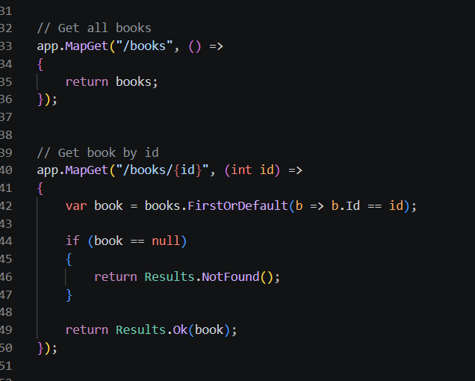

Figure 4.1: Minimal API implementation in Program.cs using MapGet

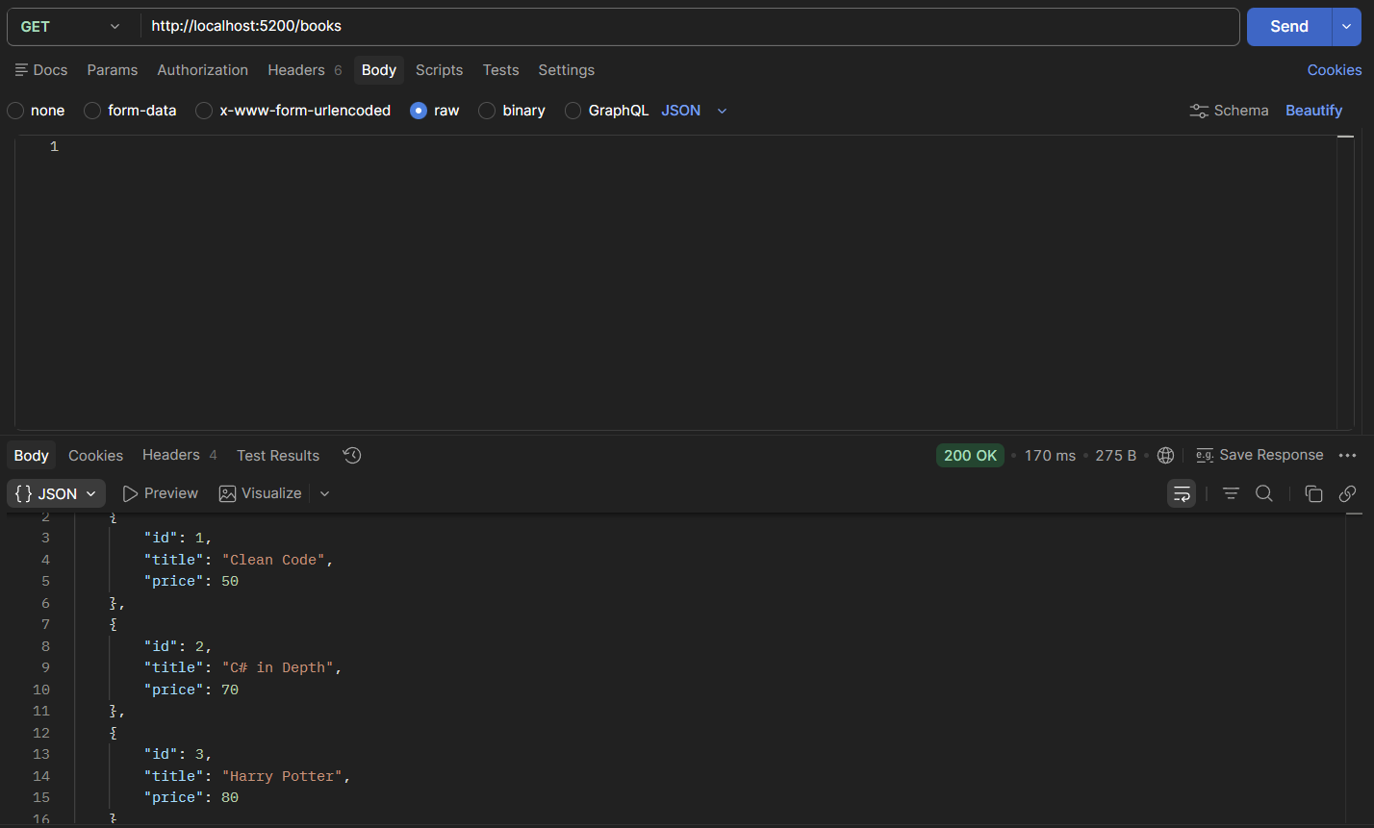

Figure 4.2: Postman test: GET /books returns all books (200 OK) via Minimal API

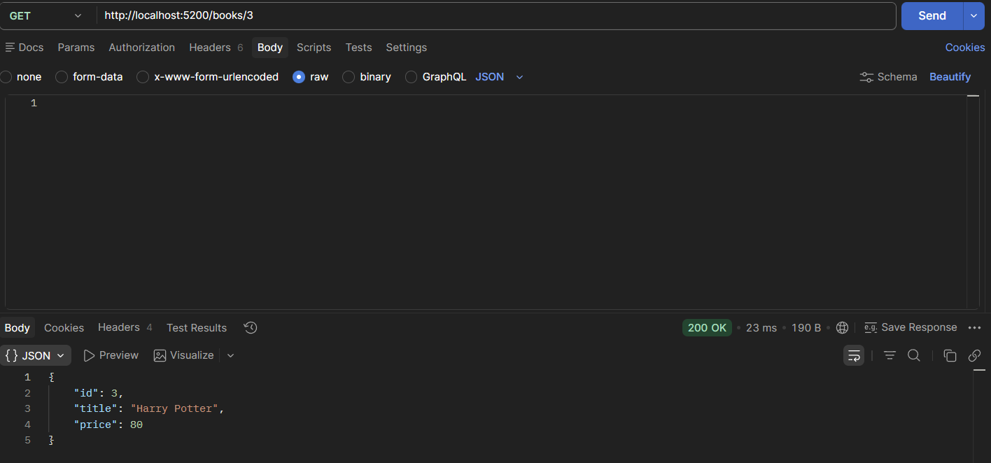

Figure 4.3: Postman test: GET /books/3 returns Harry Potter (200 OK) via Minimal API

5. Testing API Endpoints Using Postman

Objective
The objective of this task was to test all implemented API endpoints using Postman and organize them into a collection for easier management and future testing.

Implementation
All API endpoints developed during Day 4 were tested using Postman. A collection was created to group and organize the Controller-based endpoints and Minimal API endpoints into a single, manageable unit.

Postman Collection Structure
# | Request Name | HTTP Method & URL
1 | Controller - Get All Books | GET http://localhost:5200/api/books
2 | Controller - Get Book By ID | GET http://localhost:5200/api/books/{id}
3 | Minimal API - Get All Books | GET http://localhost:5200/books
4 | Minimal API - Get Book By ID | GET http://localhost:5200/books/{id}

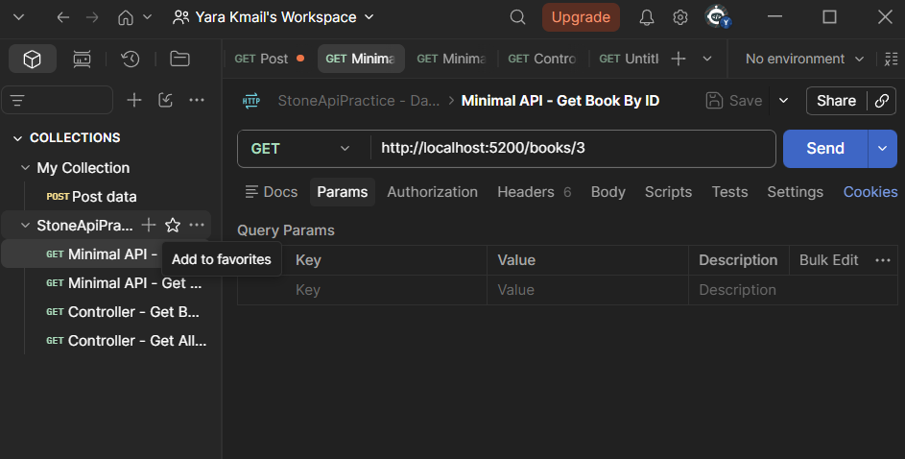

Figure 5.1: Postman collection containing all Day 4 API requests organized by approach

6. Conclusion
In Day 4, an ASP.NET Core Web API project was successfully created, configured, and tested. Both Controller-based APIs and Minimal APIs were implemented to understand the differences between the two approaches. The Controller-based approach demonstrated the benefits of structured organization and separation of concerns, while the Minimal API approach showcased the advantages of simplicity and reduced boilerplate code.
All developed endpoints were thoroughly tested using Postman, covering both successful retrieval scenarios and proper error handling for missing resources. The endpoints were organized into a Postman collection for better API management and future reference. This foundation provides a solid understanding of ASP.NET Core Web API development that can be built upon in subsequent tasks involving POST, PUT, DELETE operations, database integration, and authentication.

