Week 4 - Day 1
ASP.NET Core Identity & User Registration
Overview
Day 1 focused on setting up ASP.NET Core Identity with the existing Training Management project and implementing user registration.
Identity was connected to the existing Entity Framework Core DbContext and database, then registration was tested using Postman.
What We Learned
- What ASP.NET Core Identity provides for user management.
- How Identity works with Entity Framework Core.
- How IdentityDbContext adds Identity tables to the database.
- How UserManager and CreateAsync() are used for registration.
- How Identity handles password hashing and validation.
What We Implemented
1. Identity Setup
The existing Week 3 TrainingManagementDbContext was extended to:
IdentityDbContext<IdentityUser>

Identity was registered in Program.cs and connected to the same SQL Server database.
2. Identity Migration
A new AddIdentity migration was created and applied to the existing database.
The migration added the Identity tables such as:
AspNetUsers
AspNetRoles
AspNetUserRoles

3. User Registration
A registration endpoint was implemented:
POST /api/Auth/register

The endpoint uses UserManager<IdentityUser> and:
CreateAsync(user, password)

to create the account and let Identity handle password validation and hashing.
Postman Testing
Valid Registration
{
"email": "day1test@gmail.com",
"password": "StrongPassword123!"
}

Result:
200 OK
📸 Screenshot 4 — Successful Registration
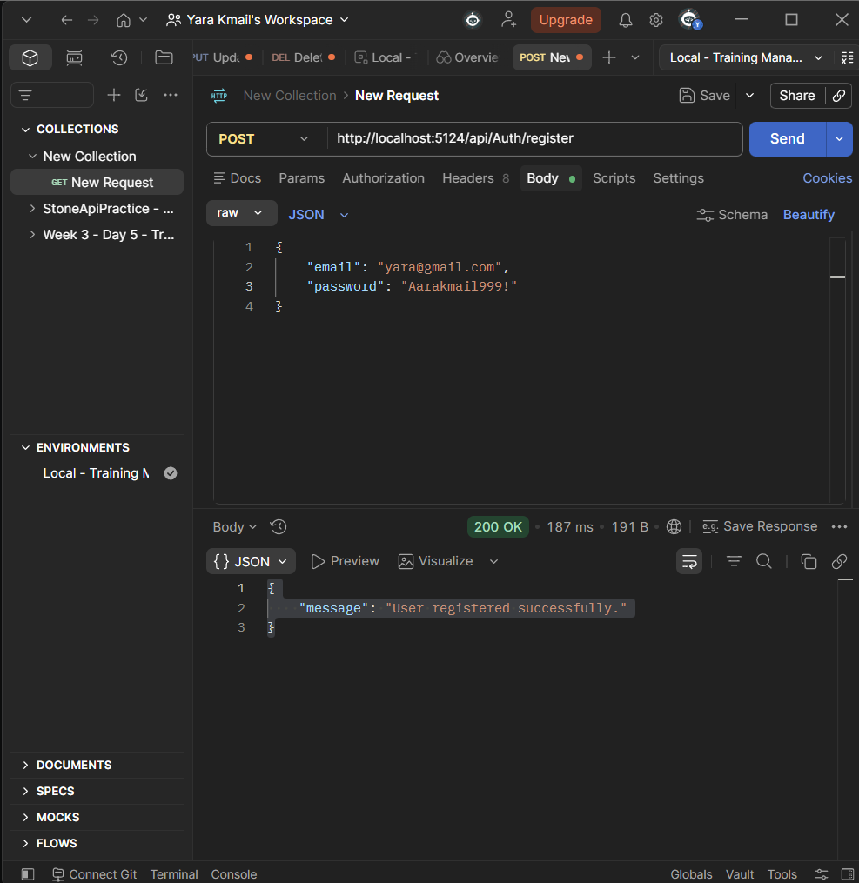
Weak Password
{
"email": "weaktest@gmail.com",
"password": "123"
}

Result:
400 Bad Request
Identity rejected the registration because the password did not meet the configured requirements.
📸 Screenshot 5 — Weak Password
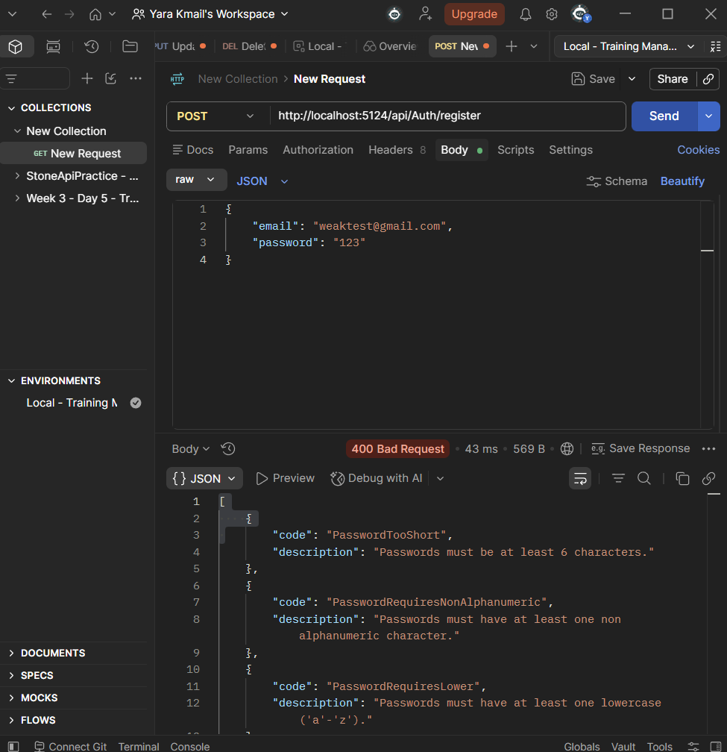
Final Result
Day 1 successfully added ASP.NET Core Identity to the Training Management backend and implemented user registration.
The registration endpoint was tested with both a valid password and a weak password, confirming successful registration and Identity validation behavior.

