Week 4 - Day 2
JWT Authentication & Token Issuance
Login, JWT Claims, Bearer Authentication, Protected Endpoints & Token Expiry
1. Day 2 Overview
Day 2 continued the authentication work from Day 1. After implementing user registration with ASP.NET Core Identity, the next step was to let an existing user log in and receive a JWT that can be used to access protected API endpoints.
2. The Story Behind JWT
In Day 1, a user could create an account. In Day 2, the user already has an account and wants to prove their identity.
The user sends their email and password to the Login endpoint. Identity verifies the credentials using SignInManager. If the credentials are correct, the API creates a JWT and returns it to the client.
The JWT acts like a digital access card. The client sends it with later requests using the Authorization header as:
Bearer <token>

ASP.NET Core then validates the token before allowing access to endpoints protected with [Authorize].
3. JWT Structure
A JWT contains three parts separated by dots:
- Header — describes the token type and signing algorithm, such as HS256.
- Payload — contains claims such as the user's ID, email, issuer, audience, and expiry.
- Signature — verifies that the token was signed correctly and helps detect whether the token has been modified.
The JWT payload is not encrypted. It can be decoded and read, so sensitive information such as passwords or secret keys must never be placed in the claims.
4. Claims, Issuer, Audience & Expiry
Term | Meaning
sub | The user's ID (subject).
Email claim | The email of the authenticated user.
Issuer (iss) | The application that issued the token.
Audience (aud) | The application/API for which the token is intended.
Expiry (exp) | The time after which the token is no longer valid.

5. Authentication vs Authorization
Authentication answers: "Who are you?"
In this Day, the JWT helps the API recognize the authenticated user.
Authorization answers: "What are you allowed to do?"
The [Authorize] attribute protects endpoints so that only authenticated requests can reach them.
6. What We Implemented
6.1 Login Endpoint
A LoginRequest model was created for the email and password sent by the client.
The AuthController was extended with a login endpoint that finds the user through Identity and verifies the password with:
SignInManager.CheckPasswordSignInAsync()

Endpoint:
POST /api/Auth/login

- Valid credentials → 200 OK + JWT
- Invalid credentials → 401 Unauthorized
6.2 JWT Creation
After successful login, the API creates claims containing the user's ID and email, signs the token with HMAC-SHA256, adds the configured issuer and audience, and sets a short expiry.
Final access-token expiry: 15 minutes.
6.3 JWT Bearer Authentication
Program.cs was configured with JWT Bearer authentication.
The API validates the issuer, audience, signing key, and token lifetime.
ClockSkew was set to:
TimeSpan.Zero

for the expiry test so that an expired token is rejected immediately.
6.4 Protected Endpoint
A protected GET endpoint was added with [Authorize].
A valid JWT allows access, while an expired token is rejected with 401 Unauthorized.
Endpoint:
GET /api/Auth/protected

7. Testing & Evidence
Screenshot 1 — Successful Login
POST /api/Auth/login with valid credentials.
Expected result: 200 OK and a JWT token.
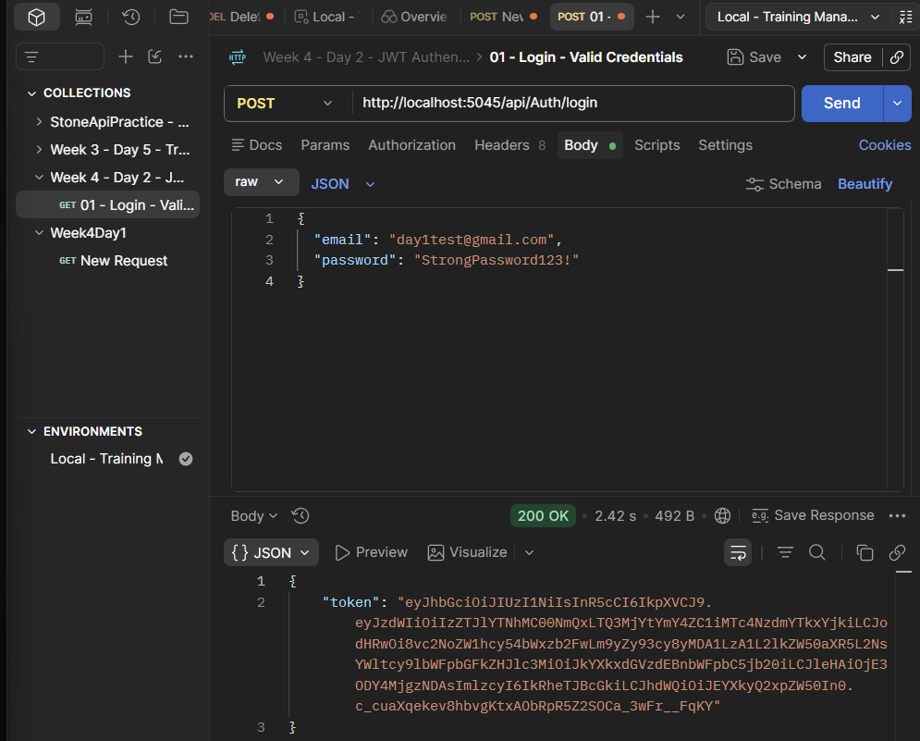
Screenshot 2 — JWT.io Claims Verification
The generated JWT was decoded using JWT.io to verify the claims contained in the token, including:
- sub
- Email claim
- exp
- iss
- aud
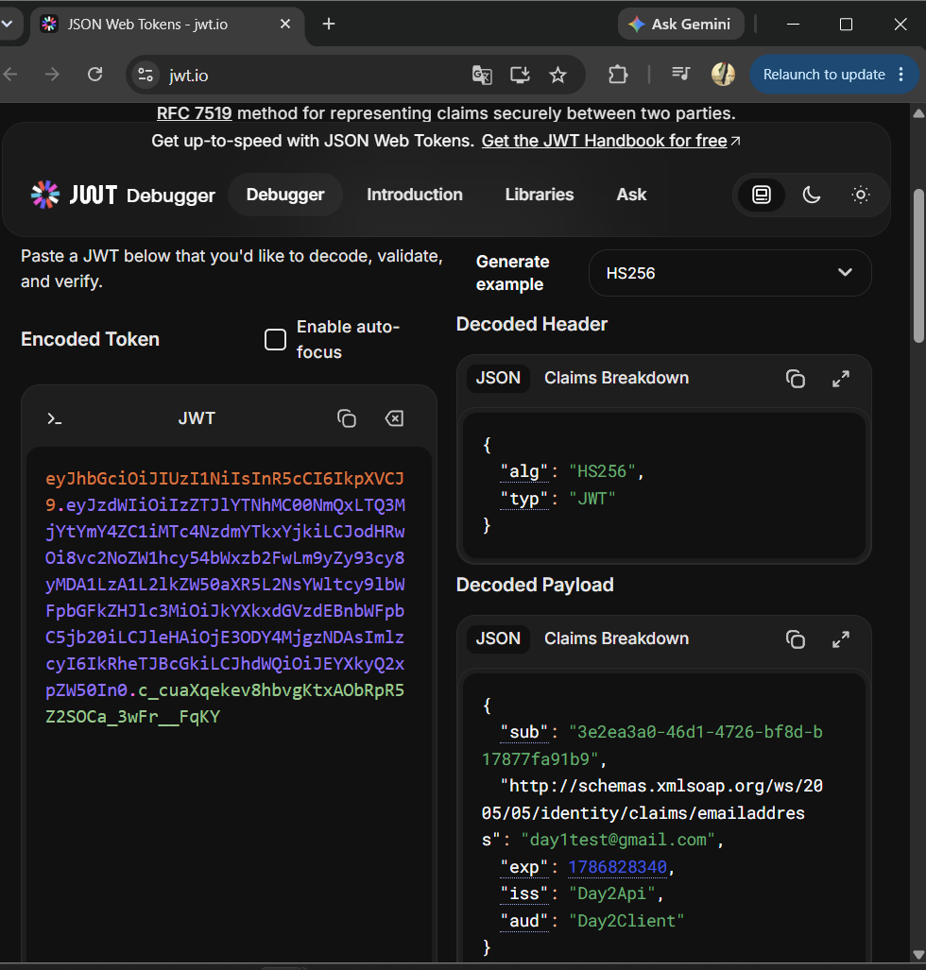
Screenshot 3 — Invalid Login
POST /api/Auth/login with an incorrect password.
Expected result: 401 Unauthorized.
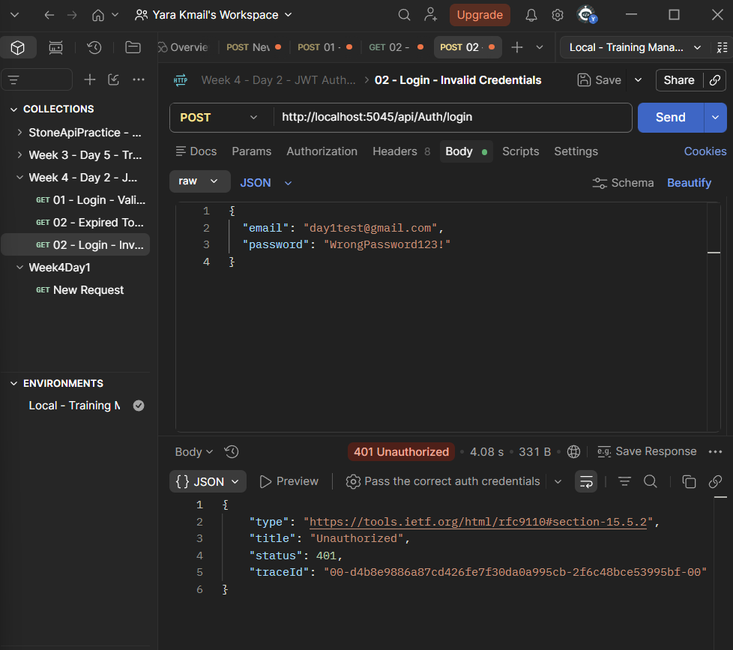
Screenshot 4 — Expired Token
GET /api/Auth/protected using an expired token.
Expected result: 401 Unauthorized.
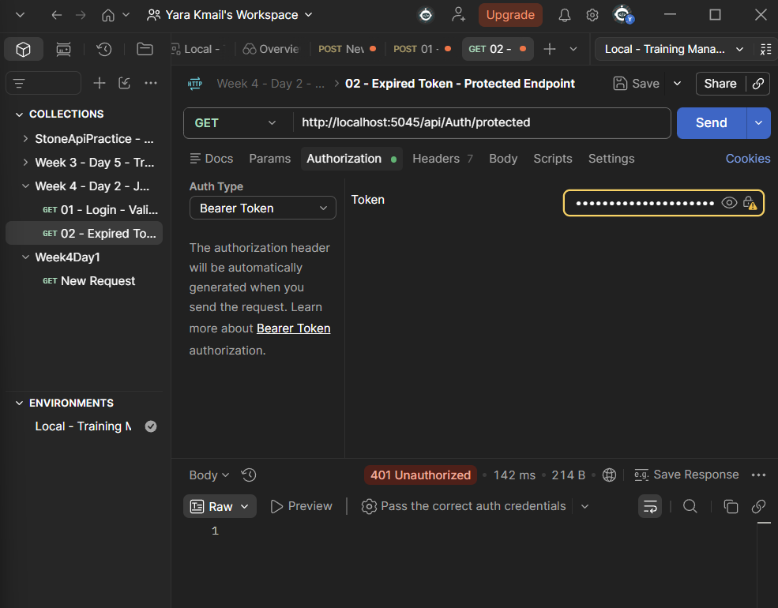
8. Final Result
Day 2 successfully added JWT-based authentication on top of ASP.NET Core Identity.
A user can log in, receive a signed JWT, send it as a Bearer token, and access protected endpoints while the token is valid.
Invalid credentials and expired tokens are rejected with 401 Unauthorized.
9. Main Concepts Practiced
JWT structure and claims • Login with SignInManager • JWT issuance • HMAC-SHA256 signing • Issuer and audience validation • JWT Bearer authentication • [Authorize] • Token expiry • Protected endpoints • Postman testing
10. Project Files
- Program.cs — JWT Bearer authentication and validation configuration
- Controllers/AuthController.cs — Register, Login, JWT creation, and protected endpoint
- Models/LoginRequest.cs — Login request model
- Data/TrainingManagementDbContext.cs — EF Core + Identity context
- Migrations/ — Existing database/Identity migration history

