Week 4 — Day 3: Authorization & RBAC
Hands-On Lab: Protect Routes & Add Roles
Objective
The goal of this lab was to protect the existing Week 3 CRUD API using ASP.NET Core Identity and JWT authentication, introduce User and Admin roles, restrict specific operations by role, define a named authorization policy, and configure Postman to automatically store and reuse the JWT.
The lab requirements were:
1. Add [Authorize] to the Week 3 CRUD controller and verify that requests without a token return 401 Unauthorized.
2. Create User and Admin roles and assign them to two different test users using UserManager.
3. Restrict the Delete endpoint to the Admin role and verify that a User token receives 403 Forbidden.
4. Define one named authorization policy beyond a simple role check and apply it to an endpoint.
5. Configure a Postman environment that captures the login token and reuses it automatically.
ASP.NET Core separates authentication from authorization: authentication establishes the user's identity, while authorization determines whether that authenticated user is allowed to perform an operation. ASP.NET Core supports both role-based and policy-based authorization.
1. Project Structure Used in Postman
During the lab, the Postman collection was organized into the following requests:
Week 4 - Day 3 - Authorization & RBAC

01 - Authentication
GET Login - Get JWT Token

02 - Authorization
GET Protected Participants - No Token - Expect 401

Create Roles
GET Create Roles
GET Assign Roles
POST Login - Yara Admin
GET Reset Password - Yara
GET Admin Only - Yara
GET Login - TestUser
GET Participants - GetAll - No Token
GET Participants - Delete - User - 403
GET Participants - GetAll - Policy - Admin

The following sections document these tests in the order used for the lab.
2. Login — Get JWT Token
The first step was to authenticate a user through the Login endpoint and obtain a JWT.
Endpoint
POST /api/Auth/login

The Login endpoint:
1. Finds the Identity user by email.
2. Checks the submitted password using SignInManager.
3. Retrieves the user's roles using UserManager.
4. Adds the user ID, email, and roles as claims.
5. Creates and signs the JWT.
6. Returns the JWT to the client.
The token therefore carries information that can later be used by the authorization system.
Expected Result
200 OK

The response contains:
{
"token": "eyJ..."
}

Screenshot
Screenshot 01 — Login - Get JWT Token
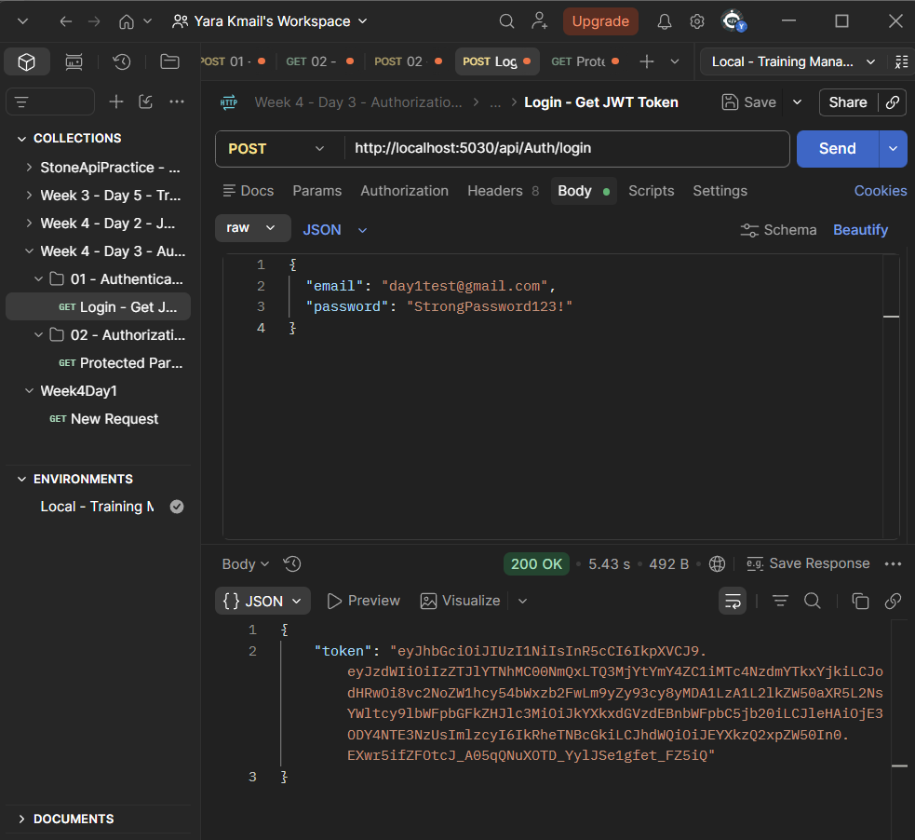
3. Protecting the Participants Controller
The Week 3 CRUD controller used in this lab was:
ParticipantsController

We added:
using Microsoft.AspNetCore.Authorization;

and protected the controller with:
[Authorize]
public class ParticipantsController : ControllerBase

This means that the CRUD endpoints require an authenticated user.
The controller contains:
POST /api/Participants
GET /api/Participants
GET /api/Participants/{id}
PUT /api/Participants/{id}
DELETE /api/Participants/{id}

Using [Authorize] without specifying a role or policy requires the caller to be authenticated.
4. Protected Participants — No Token → 401
We tested the protected Participants endpoint without sending a JWT.
Request
GET /api/Participants

No authentication token was provided.
Result
401 Unauthorized

This demonstrated that the [Authorize] attribute was working.
A 401 indicates an authentication problem, while a 403 is generally used when the user is authenticated but does not have sufficient permissions.
Screenshot
Screenshot 02 — Protected Participants — No Token — Expect 401
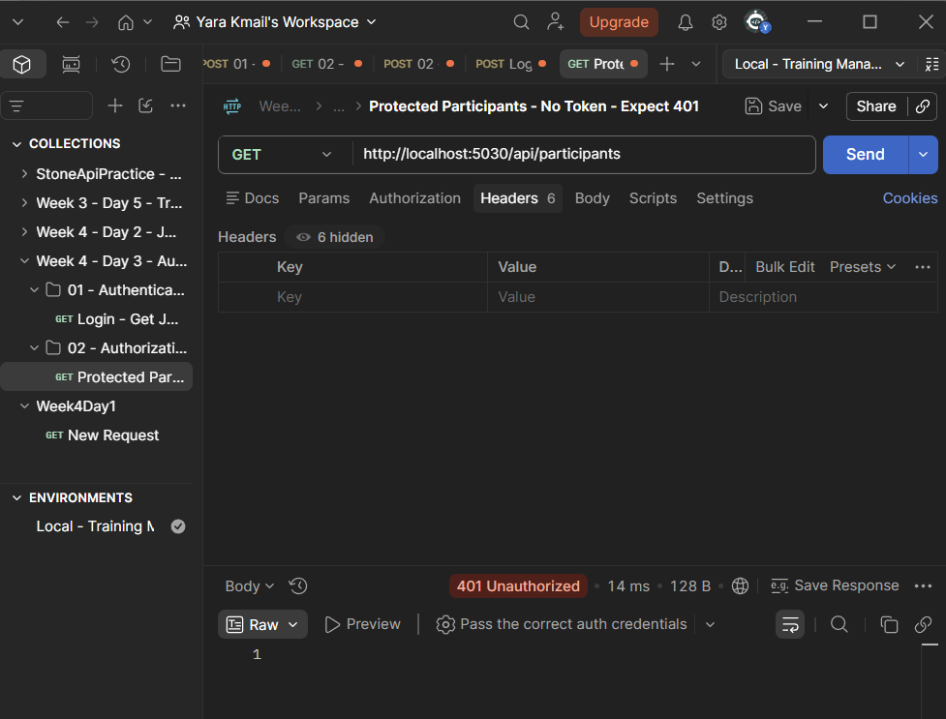
5. Creating the User and Admin Roles
The next requirement was to create two roles:
User
Admin

We used RoleManager<IdentityRole>.
The application checks whether each role already exists before creating it:
var roles = new[] { "User", "Admin" };

foreach (var role in roles)
{
if (!await _roleManager.RoleExistsAsync(role))
{
await _roleManager.CreateAsync(new IdentityRole(role));
}
}

This prevents duplicate role creation.
ASP.NET Core Identity provides built-in role management, and roles can be assigned to users programmatically through UserManager.
Result
{
"message": "User and Admin roles are ready."
}

Screenshot
Screenshot 03 — Create Roles
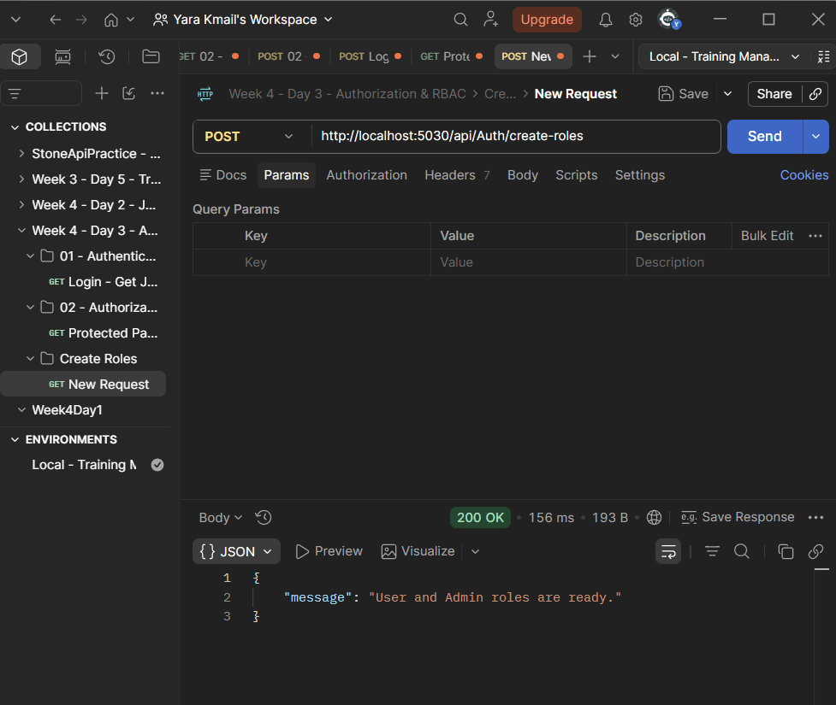
6. Assigning Roles to Test Users
After creating the roles, we assigned them to two existing Identity users.
The users were:
testuser@gmail.com
yara@gmail.com

We found the users using UserManager:
var user =
await _userManager.FindByEmailAsync("testuser@gmail.com");

var admin =
await _userManager.FindByEmailAsync("yara@gmail.com");

Then we assigned the roles:
await _userManager.AddToRoleAsync(user, "User");

await _userManager.AddToRoleAsync(admin, "Admin");

Therefore, our test accounts were:
Email | Role
testuser@gmail.com | User
yara@gmail.com | Admin

Result
{
"message": "Roles assigned successfully."
}

Screenshot
Screenshot 04 — Assign Roles
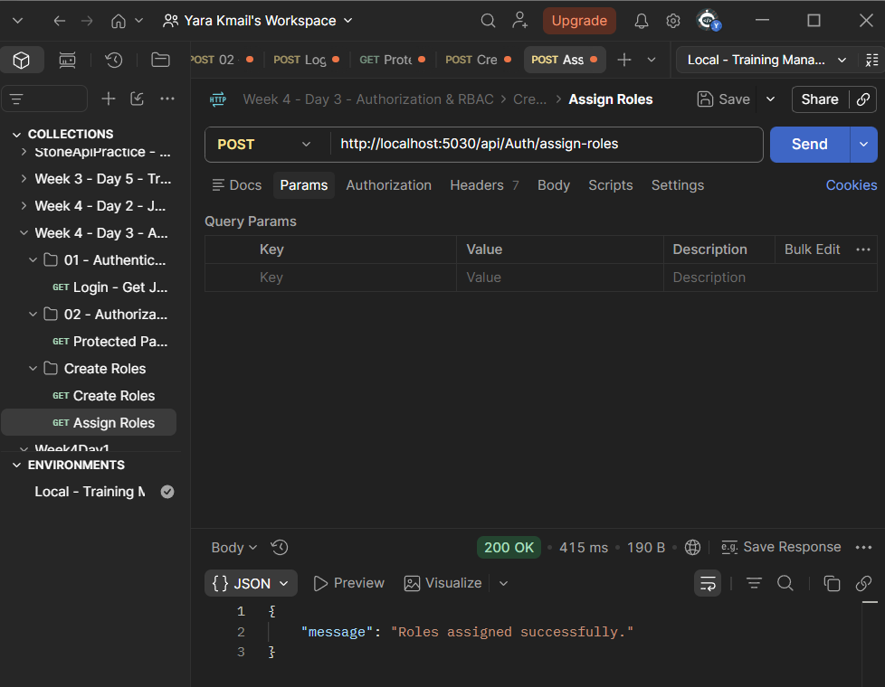
7. Reset Password — Yara
Before using Yara's Admin account for testing, we needed a password that we could use for login.
We therefore created a temporary Reset Password endpoint.
First, we found Yara's Identity user:
var user =
await _userManager.FindByEmailAsync("yara@gmail.com");

Then we generated a password-reset token:
var resetToken =
await _userManager.GeneratePasswordResetTokenAsync(user);

We defined the test password:
var newPassword = "YaraPassword123!";

Then we reset the password:
var result =
await _userManager.ResetPasswordAsync(
user,
resetToken,
newPassword);

If the operation succeeded, the API returned:
{
"message": "Password changed successfully."
}

This step allowed us to authenticate as Yara in the later Admin and policy tests.
Screenshot
Screenshot 05 — Reset Password — Yara
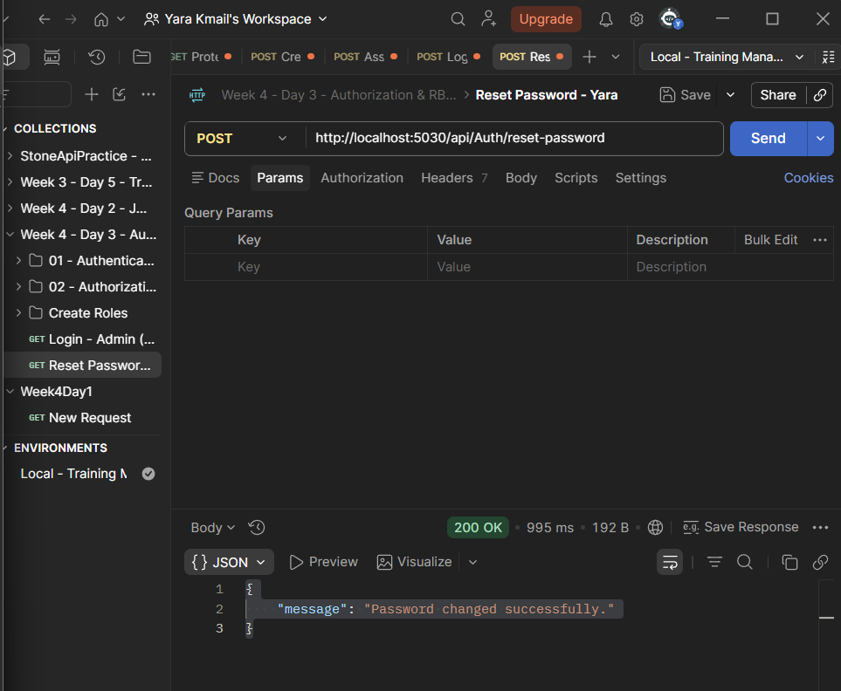
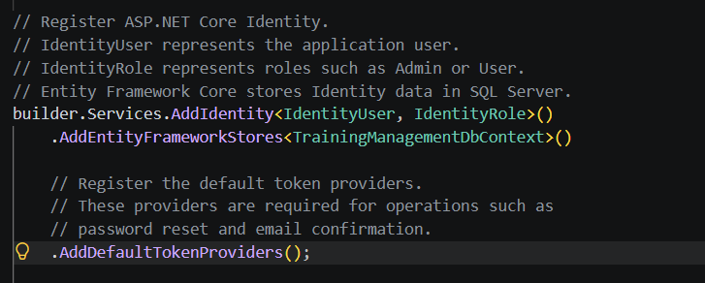
8. Login — Yara Admin
After resetting Yara's password, we logged in using:
yara@gmail.com

Yara had previously been assigned:
Admin

The Login endpoint verified the password and generated a JWT containing claims including the user's email and role.
The JWT we received represented:
Email = yara@gmail.com
Role = Admin

The Login request returned:
200 OK

Screenshot
Screenshot 06 — Login — Yara Admin
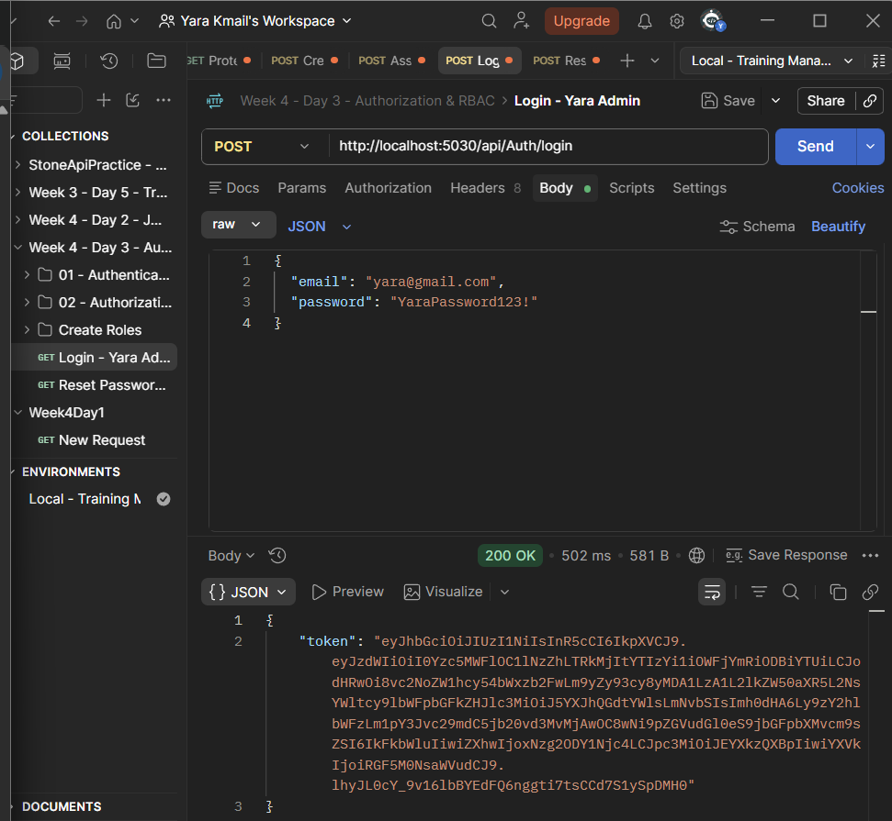
9. Admin Only — Yara
We then tested an endpoint restricted to the Admin role.
The Delete endpoint was changed from normal authentication to role-based authorization:
[Authorize(Roles = "Admin")]
[HttpDelete("{id}")]
public async Task<IActionResult> Delete(int id)

This means the caller must:
1. Be authenticated.
2. Have the Admin role.
ASP.NET Core supports role-based authorization by specifying the required role through the Roles property of [Authorize].
Yara's JWT contained:
Role = Admin

Therefore, the Admin authorization check succeeded.
Screenshot
Screenshot 07 — Admin Only — Yara
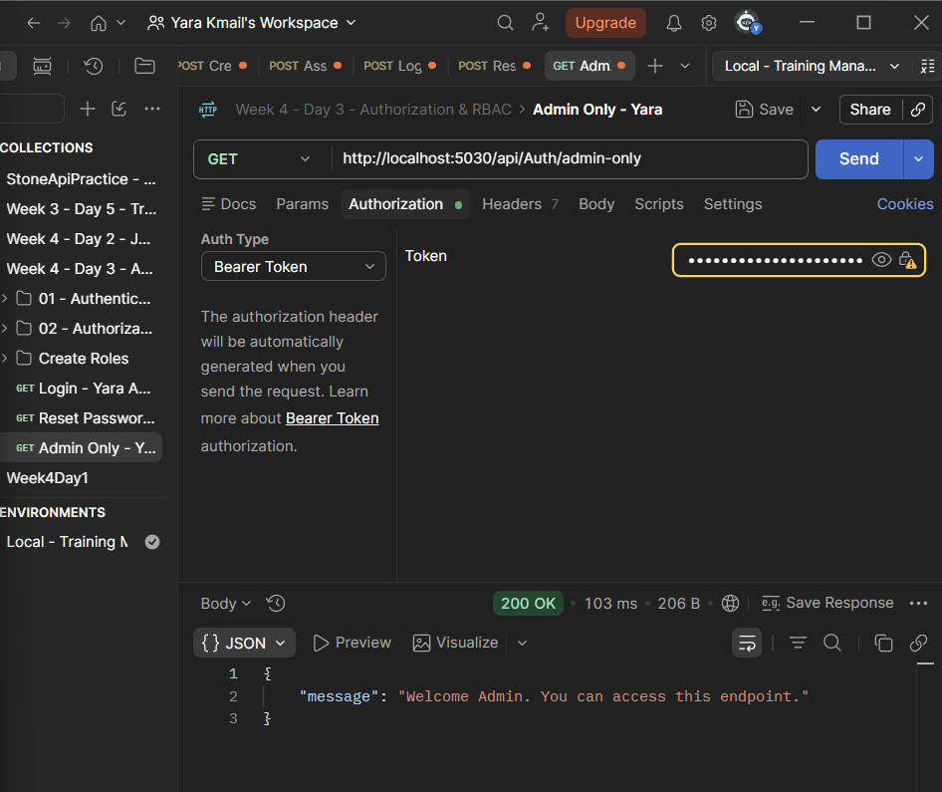
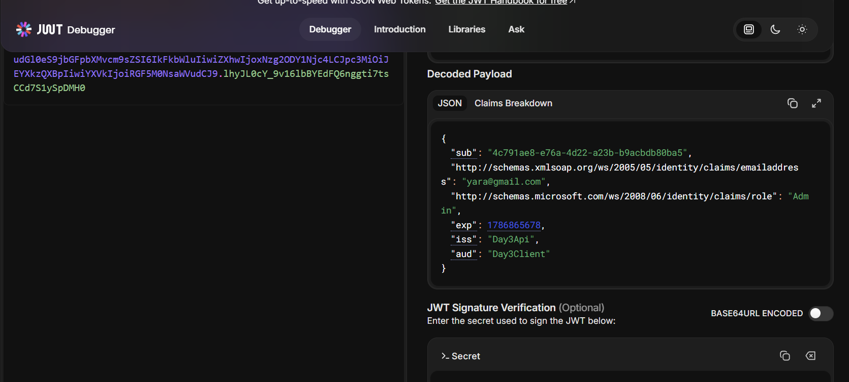
10. Login — TestUser
We also used the second test account:
testuser@gmail.com

This account had been assigned:
User

The Login endpoint generated a JWT for this account.
The important purpose of this login was to obtain a JWT containing the User role so that we could test whether a normal user could access an Admin-only operation.
Screenshot
Screenshot 08 — Login — TestUser
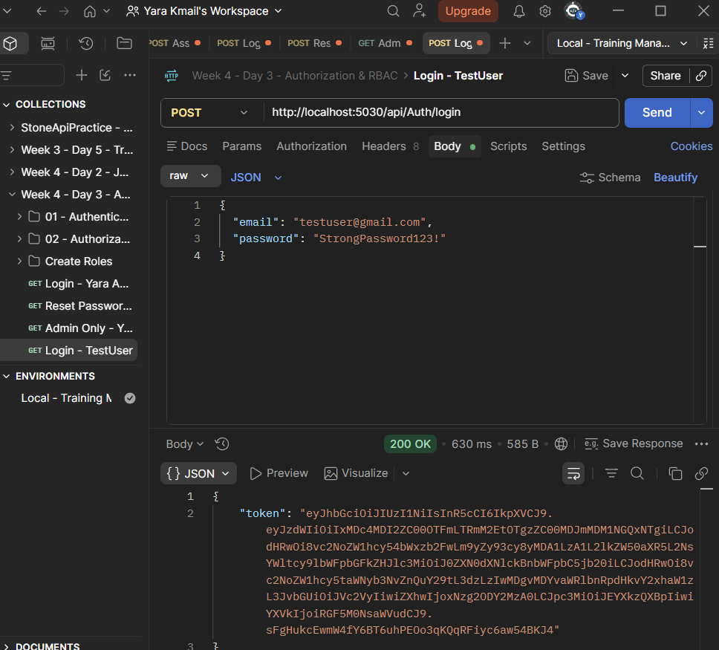
11. Participants — GetAll — No Token
We also tested the Participants GetAll endpoint without authentication.
Request
GET /api/Participants

The request was sent without a valid JWT.
Because the controller is protected by [Authorize], the request was rejected.
Result
401 Unauthorized

This test reinforced that the protected CRUD route cannot be accessed anonymously.
Screenshot
Screenshot 09 — Participants — GetAll — No Token
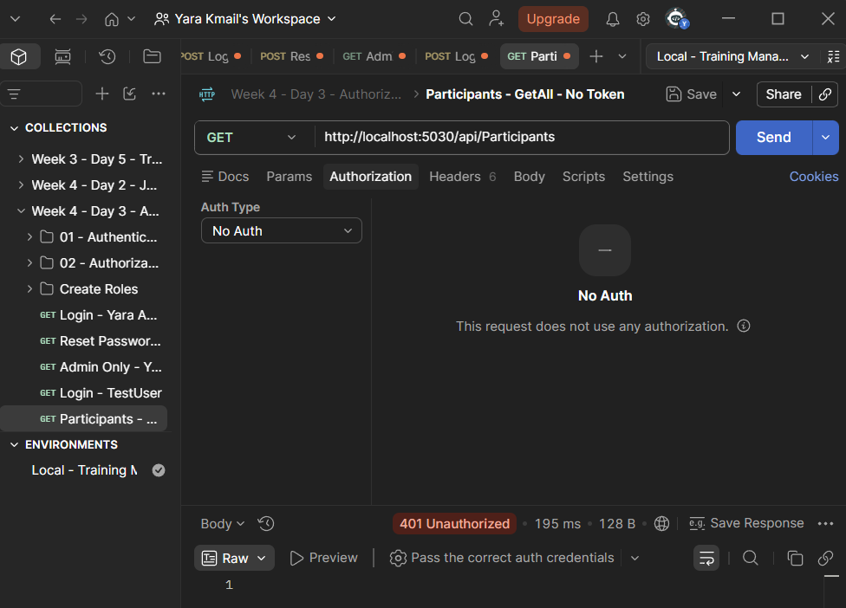
12. Participants — Delete — User → 403
We used the JWT belonging to:
testuser@gmail.com

The user had:
Role = User

We then attempted to call the Delete endpoint.
The endpoint requires:
[Authorize(Roles = "Admin")]

The JWT was valid, so authentication succeeded.
However, the user had the User role instead of Admin.
Therefore, authorization failed.
Result
403 Forbidden

This is the key difference:
Valid JWT
↓
Authentication succeeds
↓
Role = User
↓
Admin required
↓
403 Forbidden

A 403 Forbidden response typically indicates that the authenticated user does not have the permissions required for the requested resource.
Screenshot
Screenshot 10 — Participants — Delete — User — 403
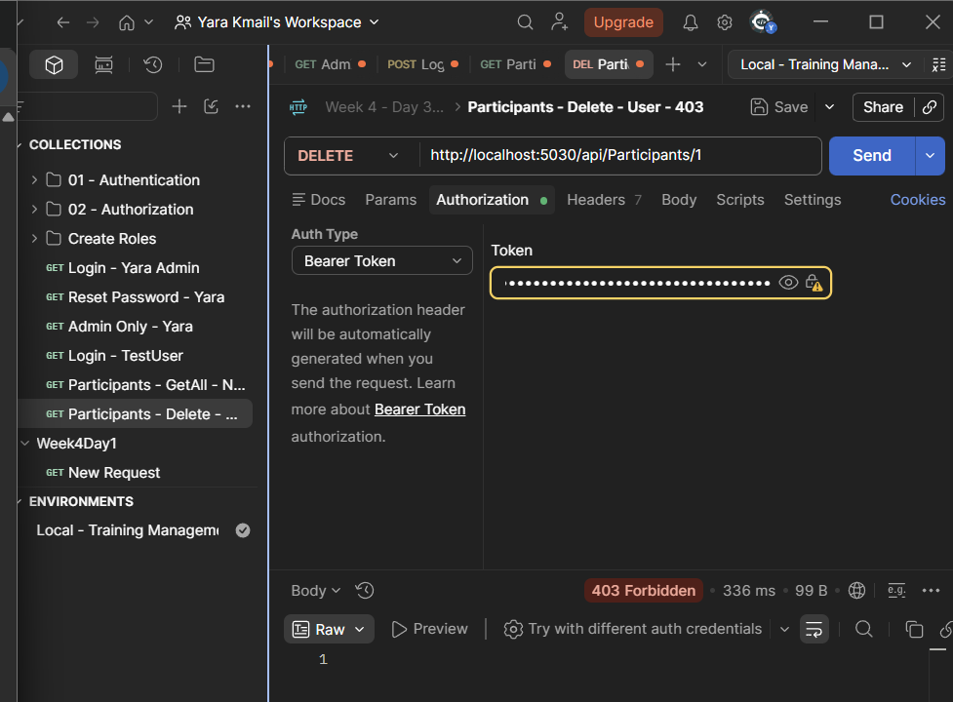
13. Named Authorization Policy
The lab also required one named authorization policy beyond a simple role check.
We created:
AdminWithEmailPolicy

The policy required both:
Admin role
AND
Email = yara@gmail.com

The policy configuration was:
builder.Services.AddAuthorization(options =>
{
options.AddPolicy("AdminWithEmailPolicy", policy =>
{
policy.RequireRole("Admin");

policy.RequireClaim(
ClaimTypes.Email,
"yara@gmail.com");
});
});

This is different from:
[Authorize(Roles = "Admin")]

because the named policy applies more than one requirement.
ASP.NET Core supports policy-based authorization, where a policy can evaluate requirements against the authenticated user's claims.
14. Applying the Policy
We applied the named policy to the Participants GetAll endpoint:
[Authorize(Policy = "AdminWithEmailPolicy")]
[HttpGet]
public async Task<IActionResult> GetAll()

The endpoint therefore requires the user to satisfy the named policy.
For Yara, the requirements were:
Role = Admin
✅

Email = yara@gmail.com
✅

Therefore, Yara satisfies the policy.
15. Participants — GetAll — Policy — Admin
We tested the policy using Yara's Admin JWT.
Request
GET /api/Participants

The request contained Yara's Bearer token.
The policy checked:
Admin role → PASS
yara@gmail.com → PASS

Therefore, authorization succeeded.
Result
200 OK

The endpoint returned the Participants data from the database.
Example response:
[
{
"id": 2,
"name": "Ahmad",
"email": "ahmad@gmail.com",
"trainingParticipants": []
},
{
"id": 4,
"name": "Ahmad Ali",
"email": "ahmad.ali2026@gmail.com",
"trainingParticipants": []
},
{
"id": 6,
"name": "Test Participant",
"email": "testparticipant@gmail.com",
"trainingParticipants": []
}
]

Important clarification
The participants in this response are database records.
They are not the users who were assigned the User and Admin roles.
The authorization check was performed against the authenticated user, which in this test was:
yara@gmail.com

Screenshot
Screenshot 11 — Participants — GetAll — Policy — Admin
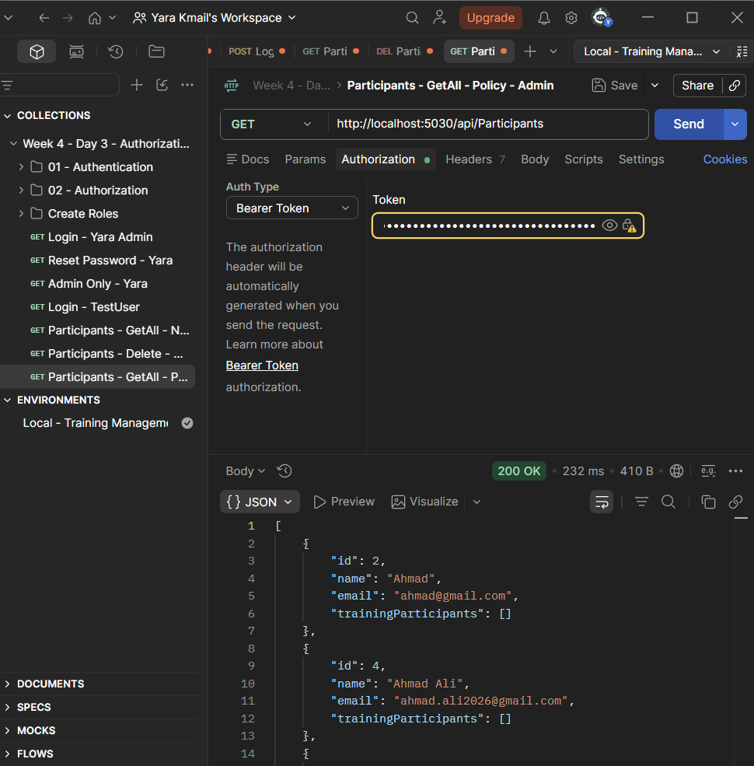
16. Postman Token Capture
After testing authentication and authorization, we configured Postman so that the JWT would be stored automatically.
The Login request used a Post-response script:
// Read the JSON response returned by the login endpoint.
const response = pm.response.json();

// Save the JWT token in the active Postman environment.
pm.environment.set("token", response.token);

Postman supports setting environment variables from scripts using pm.environment.set().
We also used the Postman Console to verify the token:
// Display the token returned by Login.
console.log("LOGIN TOKEN:", response.token);

// Display the token saved in the environment.
console.log(
"SAVED TOKEN:",
pm.environment.get("token")
);

The console showed:
LOGIN TOKEN: eyJ...
SAVED TOKEN: eyJ...

The two tokens matched.
This confirmed that the JWT returned by Login had been successfully stored in the Postman environment.
Screenshot
Screenshot 12 — Postman Console — LOGIN TOKEN / SAVED TOKEN
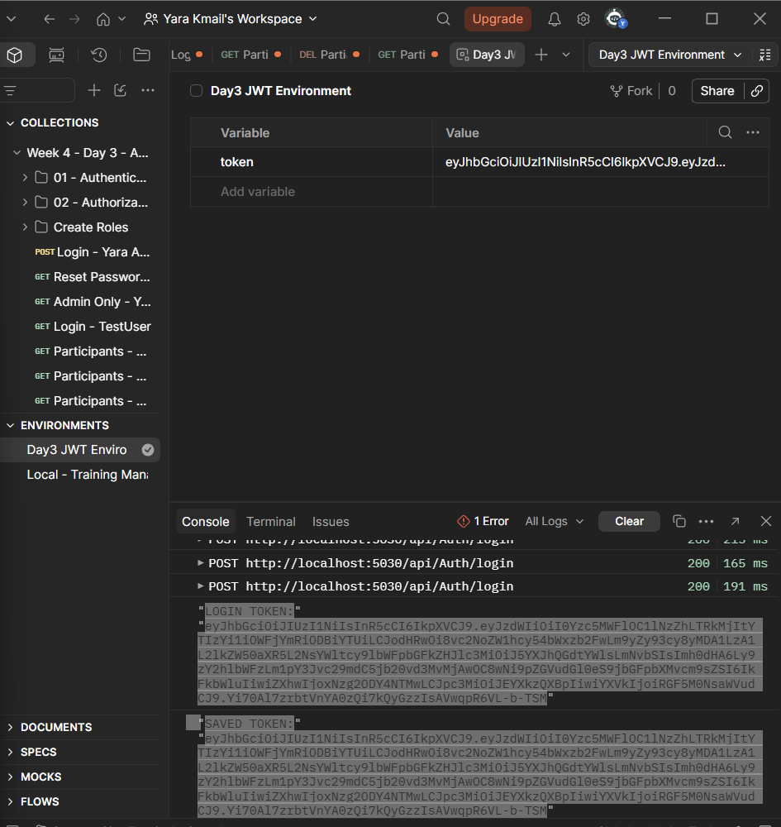
17. Postman Environment
We created a Postman environment and added the variable:
token

The purpose of this variable was to store the JWT returned by Login.
Postman environments group reusable variables, and those variables can be referenced in requests using the {{variable}} syntax.
The environment contained:
Variable | Purpose
token | Stores the JWT returned by Login

Screenshot
Screenshot 13 — Postman Environment

18. Reusing the Token Automatically
For protected requests, instead of manually copying the long JWT, we configured the Bearer Token to use:
{{token}}

Therefore, Postman resolves the variable to the JWT stored in the active environment.
The final setup was:
Login
↓
JWT returned
↓
Post-response script
↓
token environment variable
↓
{{token}}
↓
Bearer Token
↓
Protected endpoint

Postman supports referencing environment variables in request fields with double curly braces such as {{token}}.
Screenshot
Screenshot 14 — Protected Request Using {{token}}
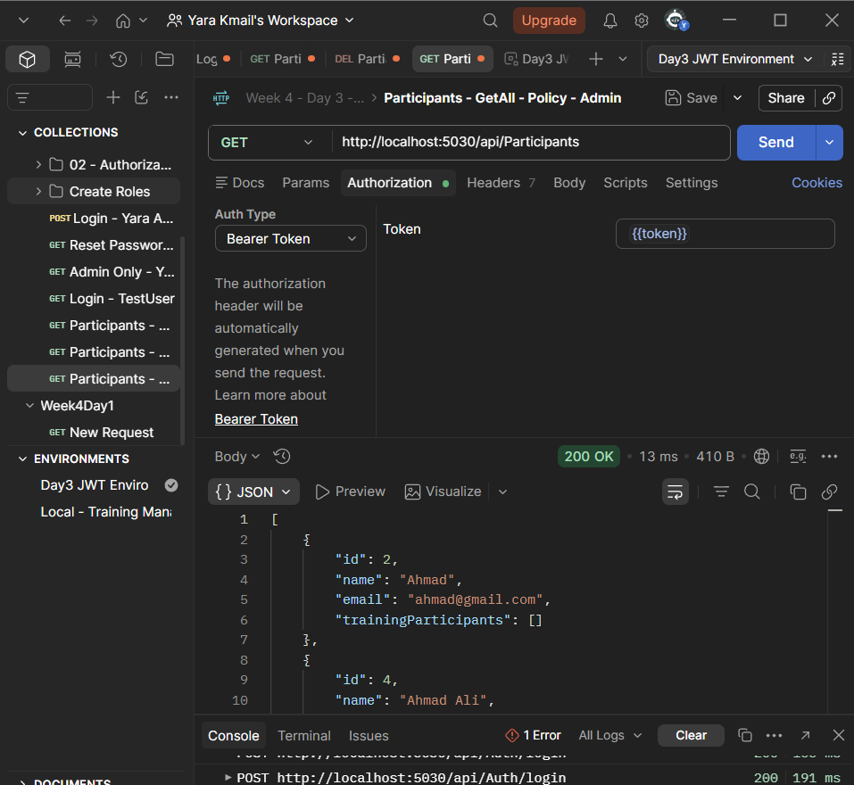
20. Authorization Flow
The final authentication and authorization flow was:
LOGIN
↓
ASP.NET Core Identity
↓
Verify Password
↓
Get User Roles
↓
Generate JWT
↓
JWT returned
↓
Postman saves JWT
↓
{{token}}
↓
Protected Request
↓
JWT Authentication
↓
Authorization
↓
┌──────────────┴──────────────┐
↓ ↓
Role Check Policy Check
↓ ↓
Admin only Admin + Email claim
↓ ↓
└──────────────┬──────────────┘
↓
Endpoint

