Day 5 – Middleware Pipeline & Dependency Injection
Task 1: Creating and Registering a Custom Middleware
Objective
The objective of this task was to understand how middleware works in the ASP.NET Core request pipeline by creating a custom middleware that logs each incoming request's HTTP method and request path to the console.
Implementation
A new ASP.NET Core Web API project named Day5Task was used for this task. A new folder called Middleware was created, followed by a custom middleware class named RequestLoggingMiddleware.
The middleware was designed to receive a RequestDelegate object through constructor injection, allowing it to forward the request to the next middleware in the pipeline after performing its own operation.
Inside the InvokeAsync() method, the request's HTTP method and request path were logged to the console using Console.WriteLine(). Finally, the middleware was registered in the request pipeline inside Program.cs using app.UseMiddleware<RequestLoggingMiddleware>().
Verification
The application was executed successfully using dotnet run. After sending a request through the browser, the middleware logged the request information in the terminal, confirming that it was executed correctly before the request continued through the pipeline.
RequestLoggingMiddleware.cs
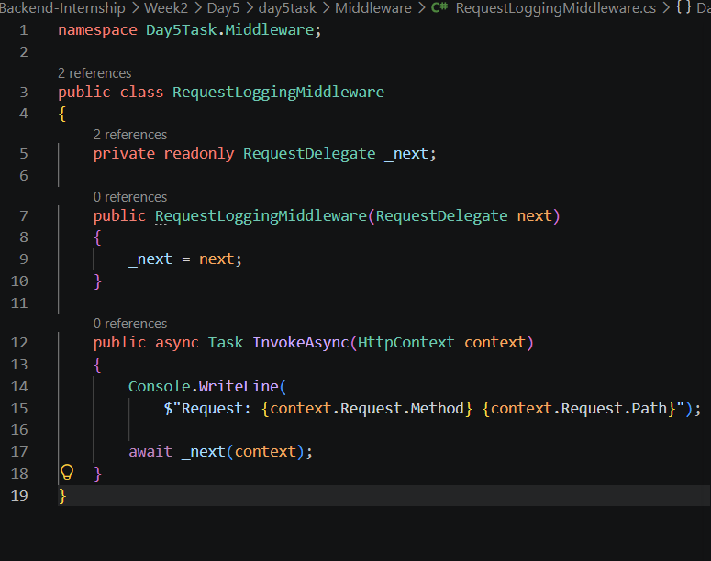
Program.cs
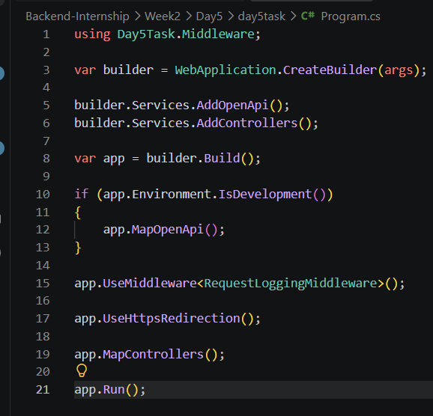
Application Output
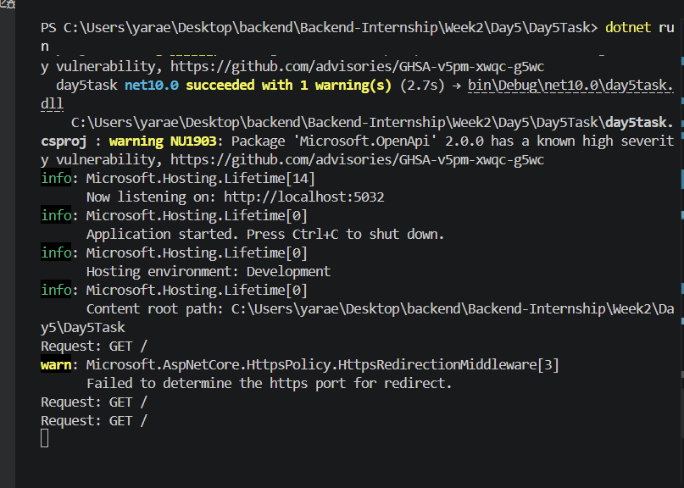
Result
The custom middleware was successfully created, registered, and executed. Every incoming HTTP request was logged to the terminal before being forwarded to the next middleware in the ASP.NET Core request pipeline.
Task 2: Testing Middleware Pipeline Order
Objective
The objective of this task was to understand the importance of middleware execution order in the ASP.NET Core request pipeline by intentionally placing the custom middleware in an incorrect position, observing the behavior, and then restoring the correct pipeline order.
Implementation
The custom RequestLoggingMiddleware was intentionally moved after app.MapControllers() to simulate an incorrect middleware pipeline configuration. This experiment demonstrated that middleware should be registered before endpoint mapping to ensure it executes as part of the request pipeline.
After observing the pipeline configuration, the middleware was moved back to its correct position before app.MapControllers(), following the recommended ASP.NET Core middleware order.
Screenshots
Incorrect Middleware Order
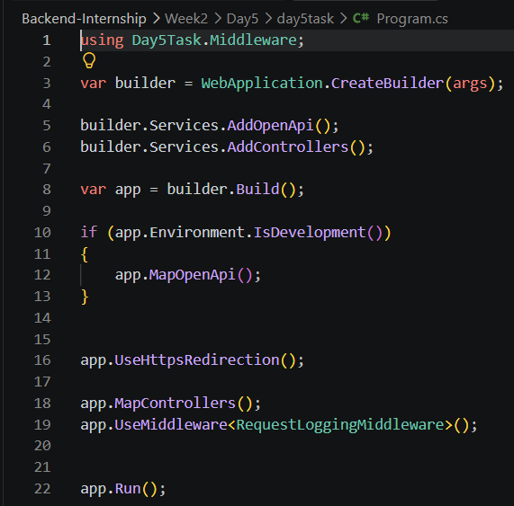
Screenshot 2
Correct Middleware Order


Result
The middleware pipeline was tested by placing the custom middleware in an incorrect position and then restoring it to the correct order. This task demonstrated that middleware execution order is an essential part of the ASP.NET Core request pipeline and should be configured carefully to ensure the expected application behavior.
Task 3: Creating and Registering a Service using Dependency Injection
Objective
The objective of this task was to create a service interface and its implementation, then register the service in the ASP.NET Core Dependency Injection container using the appropriate service lifetime.
Implementation
A new Services folder was created to organize the application's business logic. An interface named IProductService was created to define the service contract, followed by a ProductService class that implements the interface.
The service was then registered in the Dependency Injection container inside Program.cs using:
builder.Services.AddScoped<IProductService, ProductService>();
This configuration allows ASP.NET Core to automatically provide an instance of ProductService whenever an IProductService is requested.
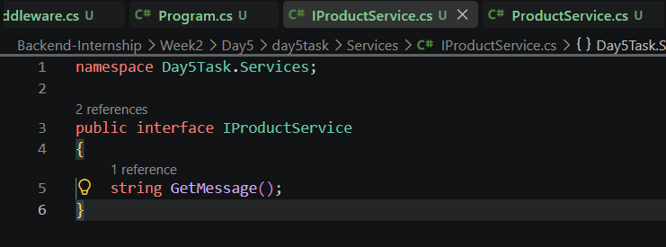

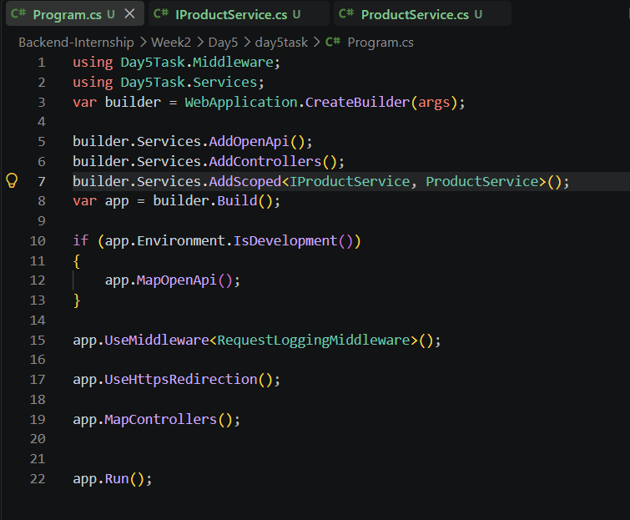
Result
The service interface and implementation were successfully created and registered in the Dependency Injection container. The service is now ready to be injected into controllers and used throughout the application.

Task 4: Injecting the Service into a Controller
Objective
The objective of this task was to inject a registered service into an ASP.NET Core controller using constructor injection and use the service to handle an HTTP request.
Implementation
A new controller named ProductsController was created inside the Controllers folder. The IProductService interface was injected into the controller through constructor injection. Instead of creating an instance manually, ASP.NET Core automatically provided the registered implementation (ProductService) from the Dependency Injection container.
A simple GET endpoint was implemented to call the service method GetMessage() and return its result as an HTTP response.
Screenshots
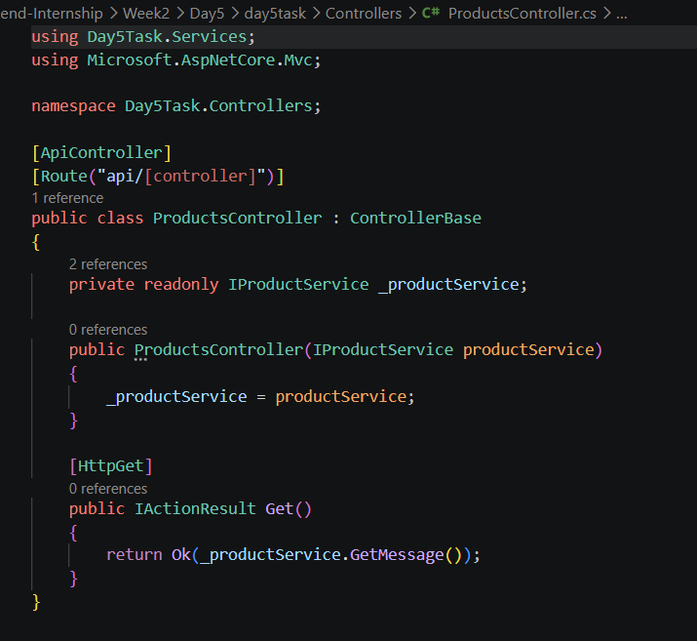

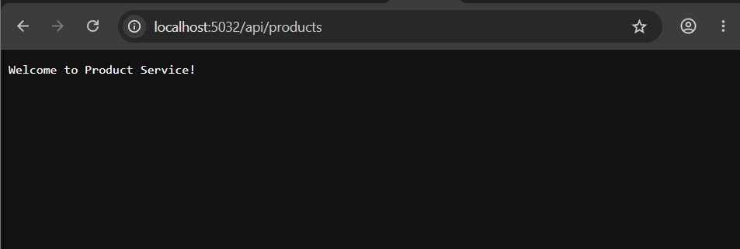
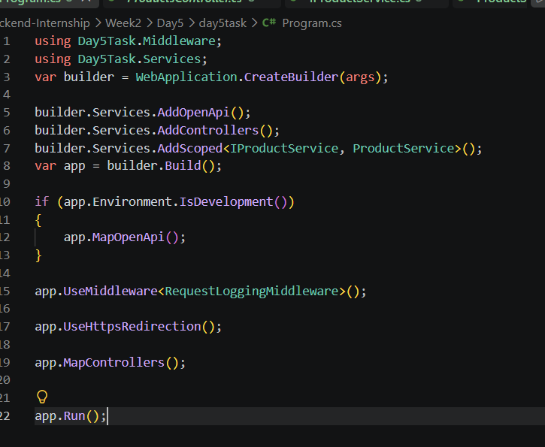
Result
The service was successfully injected into the controller using constructor injection. The application automatically resolved the dependency from the Dependency Injection container, and the endpoint returned the expected response successfully.

