TECHNICAL VALIDATION REPORT
Full-Upright MBB Beam
True 3D FEM screening of cubic infill at 15%, 25%, and 100% density
Document | Full-upright cubic infill FEM comparison
Prepared | 23 July 2026
Program | SURE Program, Alfaisal University
Laboratory | CM-ITAD Lab
Supervision | Libish Murugesan (@libishm1), ORCID 0009-0004-3238-4202

Executive Summary
This report compares three linear-elastic finite-element cases using one complete upright topology-optimized MBB beam. Geometry, loading, supports, material baseline, and mesh resolution are held constant so that infill density is the principal comparison variable.
KEY RESULT At 100 N, increasing cubic infill from 15% to 25% reduced mean load-point displacement by 16.5% and increased apparent stiffness from 255.83 to 306.30 N/mm.

The sparse cases are validated as comparative numerical screening models. They are not yet validated as printed-part strength or failure predictions because the cubic core is homogenized and requires coupon or representative-volume calibration.

1. Purpose and Scope
The purpose is to provide a reproducible comparison of cubic infill density for the recovered MBB beam while eliminating orientation and geometry differences between slicer archives. All accepted cases use the same full upright STL. The supplied 25% half-beam archive is used only to verify its cubic toolpath and pitch.

2. Model Definition
Geometry | Full upright original-mesh.stl
Envelope | Approximately 210.27 x 24.15 x 40.22 mm
Mesh | 134,566 first-order tetrahedra, nominal 2.4 mm
Dense PLA | E = 3.0 GPa; nu = 0.35; rho = 1240 kg/m3
Load | 100 N downward on a finite top-midspan patch
Supports | Left 3D bearing; right depth and vertical roller constraints

2.1 Sparse shell/core representation
The dense shell volume is matched to two slicer perimeter widths (0.42 + 0.45 mm). The core uses the screening relationship Ecore/EPLA = relative density squared. G-code inspection identified projected cubic pitches of 8.142 mm at 15% and 4.885 mm at 25%, with the expected 45, 105, and 165 degree road families.

3. Results
Case | Tetrahedra | Mean disp.  (mm) | Max. disp.  (mm) | Stiffness  (N/mm) | Mass  (g)
Cubic 15% | 134,566 | 0.39089 | 0.40766 | 255.83 | 40.93
Cubic 25% | 134,566 | 0.32648 | 0.33746 | 306.30 | 47.68
Dense 100% | 134,566 | 0.12432 | 0.12749 | 804.40 | 98.27
Table 1. Accepted fine-mesh results under the common 100 N load.
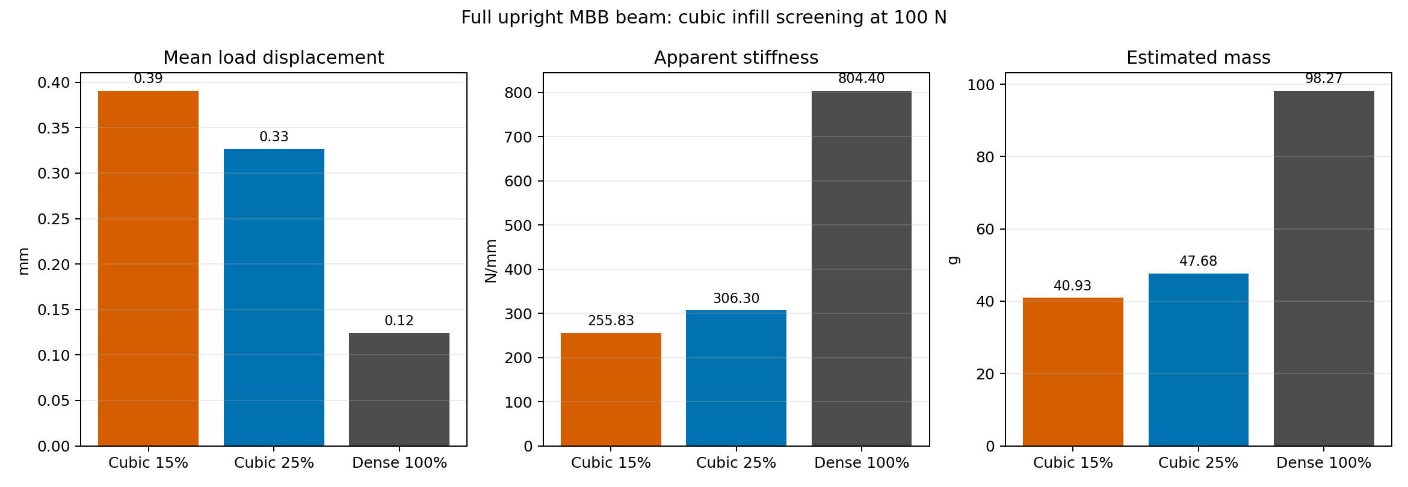
Figure 1. Full-upright displacement, apparent stiffness, and estimated mass comparison.

4. Numerical Verification
Case | Reaction error | Energy error | Status
Cubic 15% | 6.23e-09 | 1.08e-11 | PASS
Cubic 25% | 8.78e-09 | 8.34e-12 | PASS
Dense 100% | 1.63e-08 | 2.43e-11 | PASS
Table 2. Reaction-equilibrium and strain-energy identity checks.
All three solvers converged, total vertical reactions reproduce the 100 N applied load, and energy-identity errors are below 2.5e-11. No degenerate tetrahedra were reported.

4.1 Mesh sensitivity
Refining the sparse-case mesh from 3.0 to 2.4 mm changed mean displacement by 3.53% for 15% and 2.29% for 25%. The 15% result is close to, but slightly above, a provisional 3% convergence target.

5. Engineering Interpretation
The 25% case is 16.5% less compliant than the 15% case at the load point. Relative to the dense baseline, mean displacement is 3.14 times higher at 15% and 2.63 times higher at 25%.
The estimated mass rises by 6.75 g from 15% to 25%, while apparent stiffness rises by 50.47 N/mm. This quantifies the modeled stiffness-mass tradeoff but does not establish a safe working load.
USE OF RESULTS Use displacement and stiffness for comparative screening. Do not use the reported peak von Mises stress as a printed PLA failure criterion.

6. Limitations and Required Validation
Current limitation | Required next evidence
Homogenized isotropic cubic core | Printed cubic coupon or RVE elastic calibration
No layer-interface failure model | Upright tensile/shear interface characterization
Linear-elastic small strain | Physical three-point bending load-displacement test
Mesh-sensitive local stress | Local refinement and stress-convergence study
No print defects or porosity | Measured specimen mass, microscopy, and process record

7. Conclusion
Under the stated shell/core assumptions, cubic 25% provides a measurable stiffness improvement over cubic 15% while retaining less than half the estimated mass of the dense beam. The dense 100% beam remains substantially stiffer. Numerical balance checks pass for all accepted cases, supporting their use for comparative FEM screening.
The next defensible step is experimental calibration using full upright printed specimens with recorded slicer settings, measured mass, and three-point bending load-displacement data.

8. Reproducibility
Solver | src/fem/mbb_3d_cubic_shell_core.py
Dense baseline | src/fem/mbb_3d_dolfinx.py
G-code inspector | src/validation/inspect_cubic_gcode_3mf.py
Comparison data | outputs/fem/cubic_full_upright_comparison/comparison.json
Detailed validation | outputs/fem/cubic_full_upright_comparison/validation.md

References
1. DOLFINx documentation. https://docs.fenicsproject.org/dolfinx/main/python/
2. Wu, J., Clausen, A., and Sigmund, O. (2017). Minimum compliance topology optimization of shell-infill composites for additive manufacturing. Computer Methods in Applied Mechanics and Engineering, 326, 358-375. https://doi.org/10.1016/j.cma.2017.08.018
3. Project G-code validation and FEM result artifacts listed in Section 8.

