TECHNICAL VALIDATION REPORT
Full-Upright MBB Beam
True 3D FEM screening of cubic, gyroid, and honeycomb infill at 15% and 25%
Document | Full-upright six-case FDM infill FEM comparison
Prepared | 23 July 2026
Program | SURE Program, Alfaisal University
Laboratory | CM-ITAD Lab
Supervision | Libish Murugesan (@libishm1), ORCID 0009-0004-3238-4202

Executive Summary
This report compares three linear-elastic finite-element cases using one complete upright topology-optimized MBB beam. Geometry, loading, supports, material baseline, and mesh resolution are held constant so that infill pattern and density are the comparison variables.
KEY RESULT At 100 N, gyroid 25% is the stiffest sparse screening case at 314.92 N/mm. Its mean load-point displacement is 2.7% lower than cubic 25%.

The sparse cases are validated as comparative numerical screening models. They are not yet validated as printed-part strength or failure predictions because each sparse core is homogenized and requires coupon or representative-volume calibration.

1. Purpose and Scope
The purpose is to provide a reproducible comparison of cubic, gyroid, and honeycomb infill for the recovered MBB beam while eliminating orientation and geometry differences between slicer archives. All accepted cases use the same full upright STL. The supplied 25% half-beam archive is used only to verify their density-specific toolpaths.

2. Model Definition
Geometry | Full upright original-mesh.stl
Envelope | Approximately 210.27 x 24.15 x 40.22 mm
Mesh | 134,566 first-order tetrahedra, nominal 2.4 mm
Dense PLA | E = 3.0 GPa; nu = 0.35; rho = 1240 kg/m3
Load | 100 N downward on a finite top-midspan patch
Supports | Left 3D bearing; right depth and vertical roller constraints

2.1 Sparse shell/core representation
The dense shell volume is matched to two slicer perimeter widths (0.42 + 0.45 mm). Each core uses the screening relationship Ecore/EPLA = relative density squared. A pattern-specific correction uses the G-code axial fourth-orientation moment normalized to cubic at the same density.

3. Results
Case | Tetrahedra | Mean disp.  (mm) | Max. disp.  (mm) | Stiffness  (N/mm) | Mass  (g)
Cubic 15% | 134,566 | 0.39089 | 0.40766 | 255.83 | 40.93
Gyroid 15% | 134,566 | 0.38626 | 0.40255 | 258.89 | 40.93
Honeycomb 15% | 134,566 | 0.39057 | 0.40731 | 256.04 | 40.93
Cubic 25% | 134,566 | 0.32648 | 0.33746 | 306.30 | 47.68
Gyroid 25% | 134,566 | 0.31754 | 0.32790 | 314.92 | 47.68
Honeycomb 25% | 134,566 | 0.32270 | 0.33341 | 309.89 | 47.68
Dense 100% | 134,566 | 0.12432 | 0.12749 | 804.40 | 98.27
Table 1. Accepted fine-mesh results under the common 100 N load.
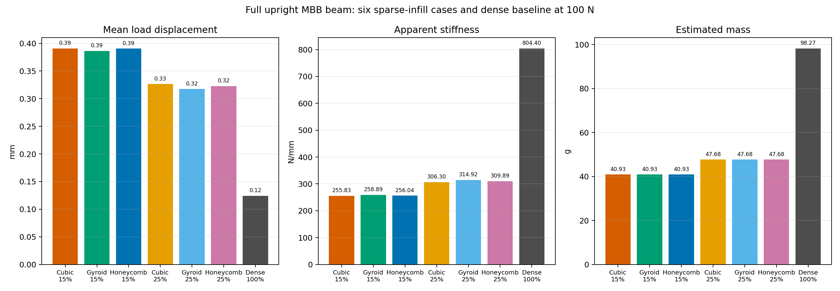
Figure 1. Full-upright displacement, apparent stiffness, and estimated mass comparison.

3.1 Engineering Comparison Matrix
Case | Infill | Mean disp.  (mm) | Apparent  stiffness  (N/mm) | Stiffness  vs. dense | Mass (g) | Specific stiffness  (N/mm/g) | Rank
Cubic 15% | 15% | 0.39089 | 255.83 | 31.8% | 40.93 | 6.25 | 7
Gyroid 15% | 15% | 0.38626 | 258.89 | 32.2% | 40.93 | 6.32 | 5
Honeycomb 15% | 15% | 0.39057 | 256.04 | 31.8% | 40.93 | 6.26 | 6
Cubic 25% | 25% | 0.32648 | 306.30 | 38.1% | 47.68 | 6.42 | 4
Gyroid 25% | 25% | 0.31754 | 314.92 | 39.1% | 47.68 | 6.61 | 2
Honeycomb 25% | 25% | 0.32270 | 309.89 | 38.5% | 47.68 | 6.50 | 3
Dense 100% | 100% | 0.12432 | 804.40 | 100.0% | 98.27 | 8.19 | 1
Table 2. Cross-case comparison under the common 100 N load. The blue row identifies the best sparse-case stiffness.
Dense stiffness reports each case as a percentage of the 100% solid baseline. Specific stiffness is apparent stiffness divided by estimated mass and is provided for comparative screening only. The sparse-core properties remain homogenized and require physical calibration.

4. Numerical Verification
Case | Reaction error | Energy error | Status
Cubic 15% | 6.23e-09 | 1.08e-11 | PASS
Gyroid 15% | 5.52e-09 | 9.23e-12 | PASS
Honeycomb 15% | 6.20e-09 | 1.07e-11 | PASS
Cubic 25% | 8.78e-09 | 8.34e-12 | PASS
Gyroid 25% | 1.08e-08 | 7.24e-12 | PASS
Honeycomb 25% | 1.09e-08 | 7.34e-12 | PASS
Dense 100% | 1.63e-08 | 2.43e-11 | PASS
Table 3. Reaction-equilibrium and strain-energy identity checks.
All three solvers converged, total vertical reactions reproduce the 100 N applied load, and energy-identity errors are below 2.5e-11. No degenerate tetrahedra were reported.

4.1 Mesh sensitivity
Refining the sparse-case mesh from 3.0 to 2.4 mm changed mean displacement by 3.43-3.53% for the 15% cases and 2.15-2.29% for the 25% cases. The 15% results are close to, but slightly above, a provisional 3% convergence target.

5. Engineering Interpretation
Gyroid is the stiffest sparse screening pattern at both densities. Pattern-to-pattern mean-displacement spread is only 1.2% at 15% and 2.8% at 25%, so the ranking should be treated as provisional until calibrated.
Estimated mass is 40.93 g at 15% and 47.68 g at 25% for every pattern because the common shell and nominal density are held fixed. Pattern differences therefore arise only from the G-code orientation correction in this model.
USE OF RESULTS Use displacement and stiffness for comparative screening. Do not use the reported peak von Mises stress as a printed PLA failure criterion.

6. Limitations and Required Validation
Current limitation | Required next evidence
Homogenized pattern cores | Pattern-specific printed coupons or RVE elastic calibration
No layer-interface failure model | Upright tensile/shear interface characterization
Linear-elastic small strain | Physical three-point bending load-displacement test
Mesh-sensitive local stress | Local refinement and stress-convergence study
No print defects or porosity | Measured specimen mass, microscopy, and process record

7. Conclusion
Under the stated shell/core assumptions, gyroid provides the highest sparse-case stiffness, followed by honeycomb and cubic at both densities. The differences are modest, while the dense 100% beam remains substantially stiffer. Numerical balance checks pass for all accepted cases, supporting their use for comparative FEM screening.
The next defensible step is experimental calibration using full upright printed specimens with recorded slicer settings, measured mass, and three-point bending load-displacement data.

8. Reproducibility
Solver | src/fem/mbb_3d_pattern_shell_core.py
Dense baseline | src/fem/mbb_3d_dolfinx.py
G-code inspector | src/validation/inspect_infill_gcode_3mf.py
Comparison data | outputs/fem/all_patterns_full_upright_comparison/comparison.json
Detailed validation | outputs/fem/all_patterns_full_upright_comparison/validation.md

References
1. DOLFINx documentation. https://docs.fenicsproject.org/dolfinx/main/python/
2. Wu, J., Clausen, A., and Sigmund, O. (2017). Minimum compliance topology optimization of shell-infill composites for additive manufacturing. Computer Methods in Applied Mechanics and Engineering, 326, 358-375. https://doi.org/10.1016/j.cma.2017.08.018

Appendix A. Inspected .3MF Infill Toolpaths
Each figure is reconstructed directly from sparse-infill extrusion moves in Metadata/plate_1.gcode. The 25% archives are pattern-calibration evidence only; all FEM cases use the same full upright beam.
Cubic 15% - full upright archive
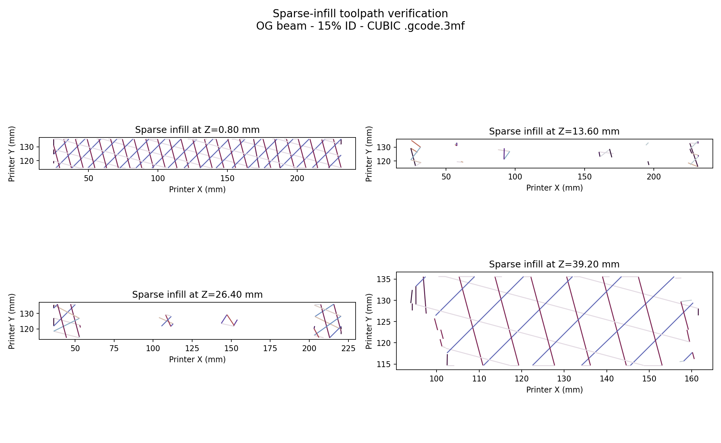
Figure A1. Inspected sparse-infill layers from the archived slicer .3mf file.
Cubic 25% - half-thickness calibration archive
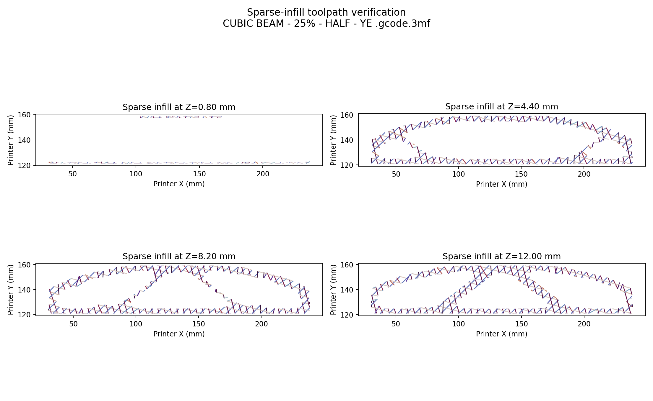
Figure A2. Inspected sparse-infill layers from the archived slicer .3mf file.
Gyroid 15% - full upright archive
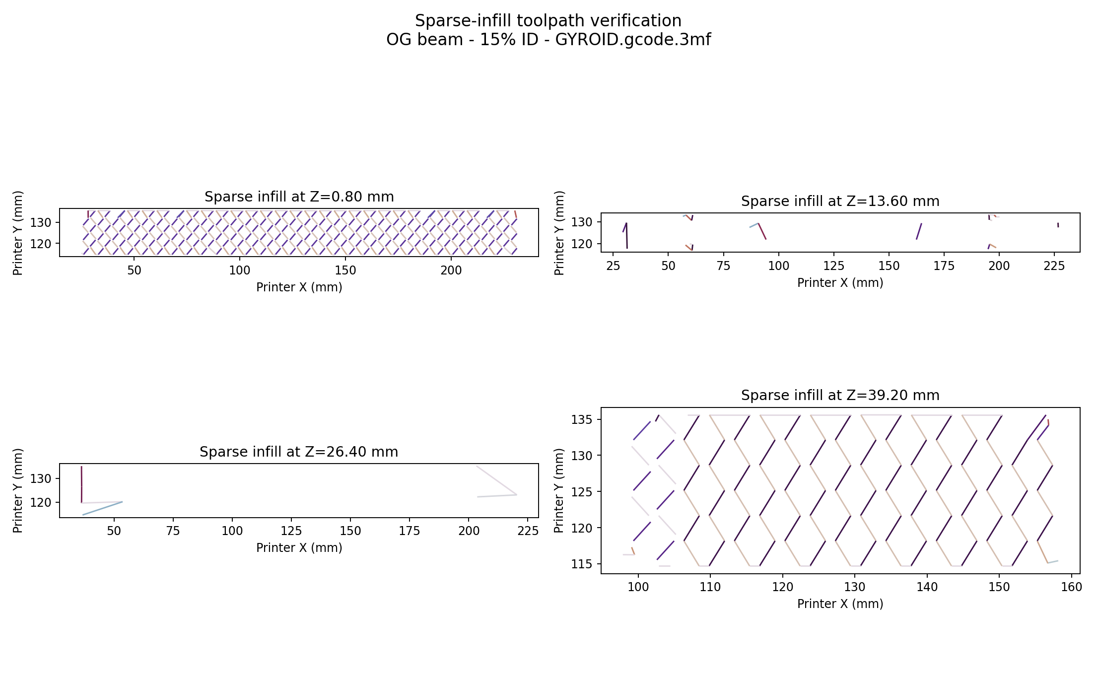
Figure A3. Inspected sparse-infill layers from the archived slicer .3mf file.
Gyroid 25% - half-thickness calibration archive
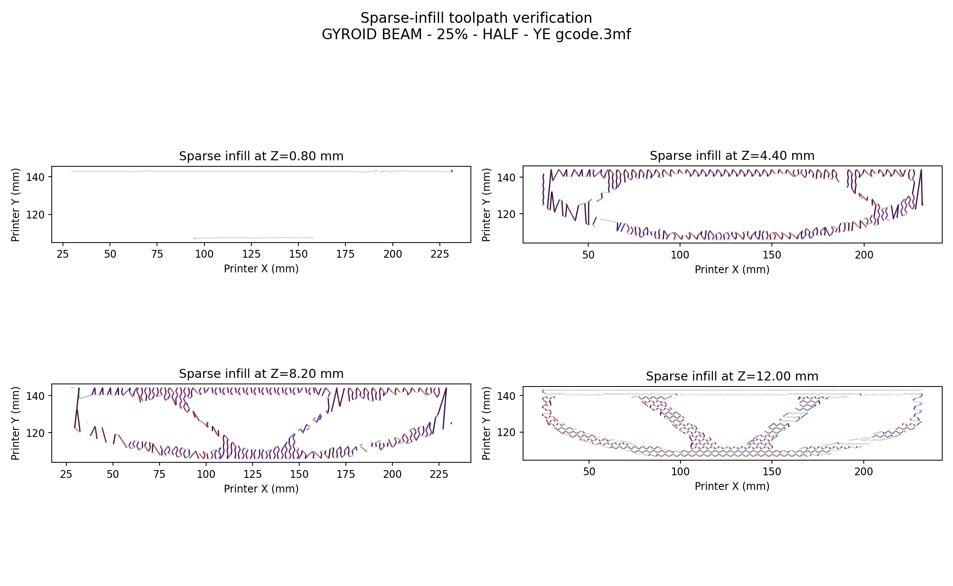
Figure A4. Inspected sparse-infill layers from the archived slicer .3mf file.
Honeycomb 15% - full upright archive
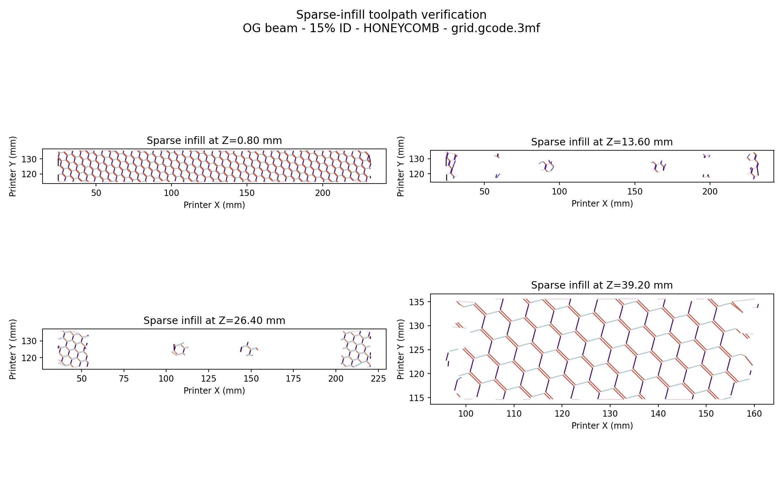
Figure A5. Inspected sparse-infill layers from the archived slicer .3mf file.
Honeycomb 25% - half-thickness calibration archive
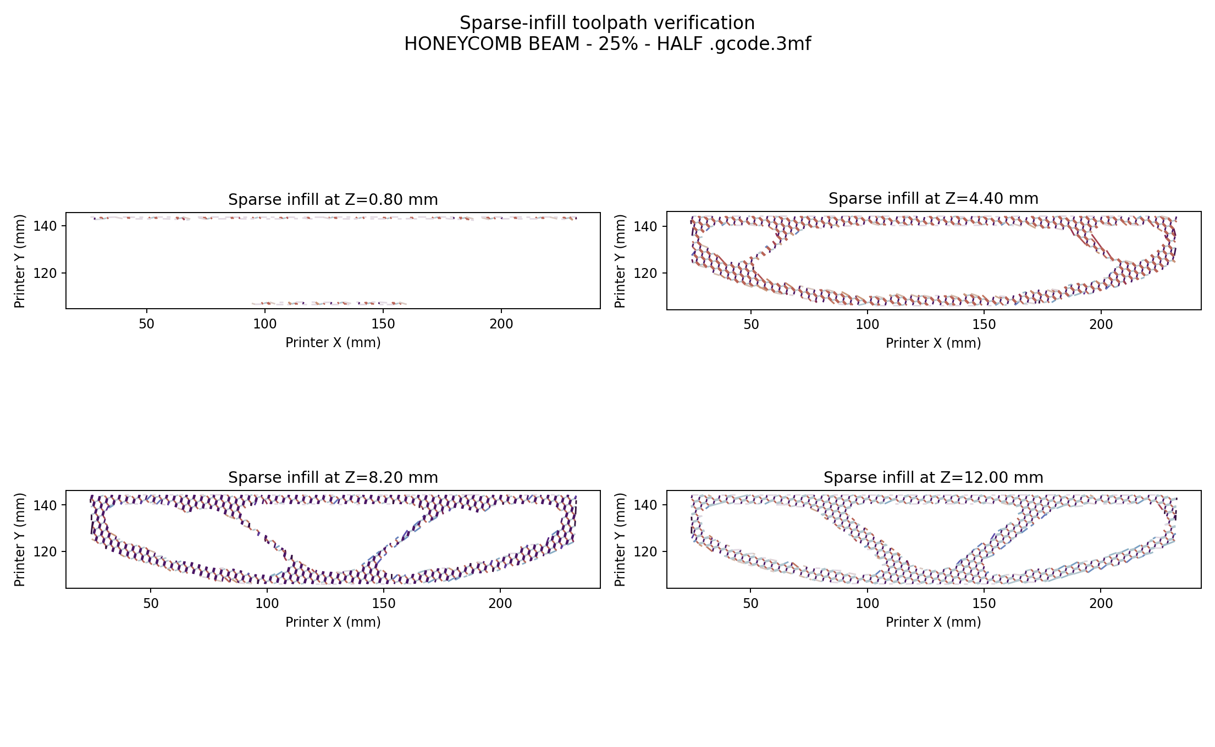
Figure A6. Inspected sparse-infill layers from the archived slicer .3mf file.

Appendix B. Three-Dimensional Meshes and FE Results
All six sparse material cases and the dense baseline use the same full-upright domain and 134,566-element tetrahedral discretization. The mesh view shows the exterior facets of that volume mesh; the result view shows displacement magnitude on the scaled deformed geometry.

Cubic 15%
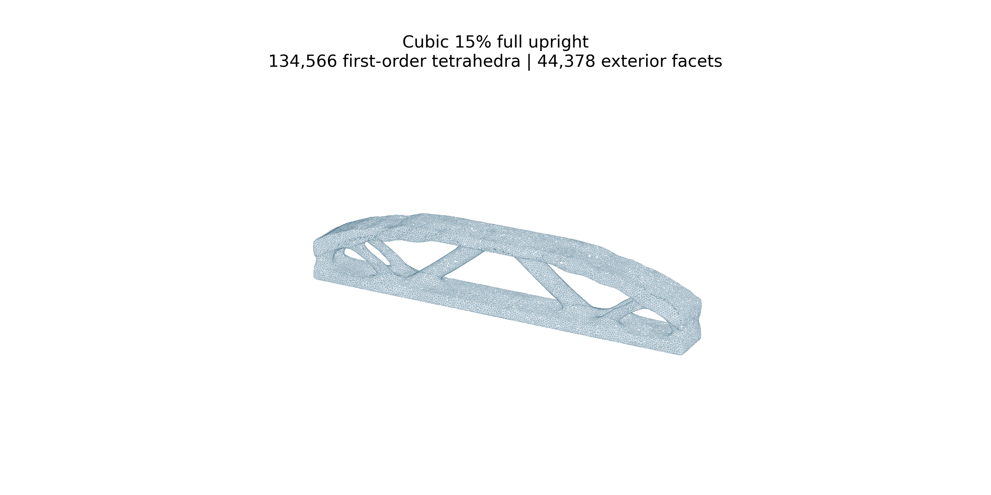
Figure B1. Cubic 15% 3D FE mesh: 134,566 first-order tetrahedra.
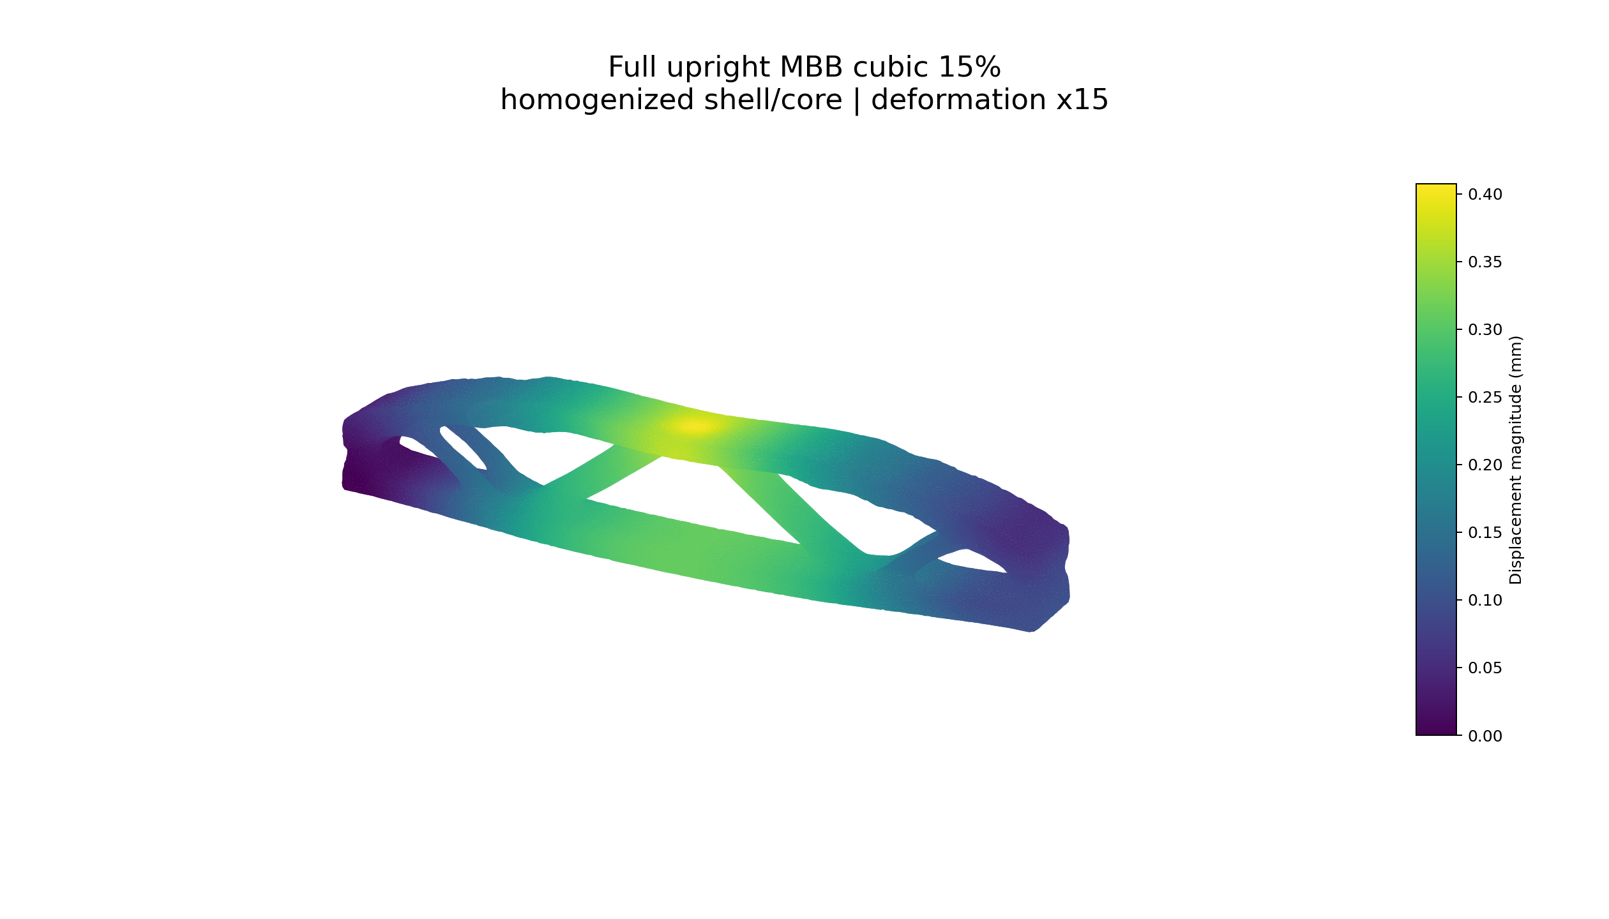
Figure B2. Cubic 15% FE displacement result: maximum displacement 0.4077 mm under the common 100 N load.

Cubic 25%
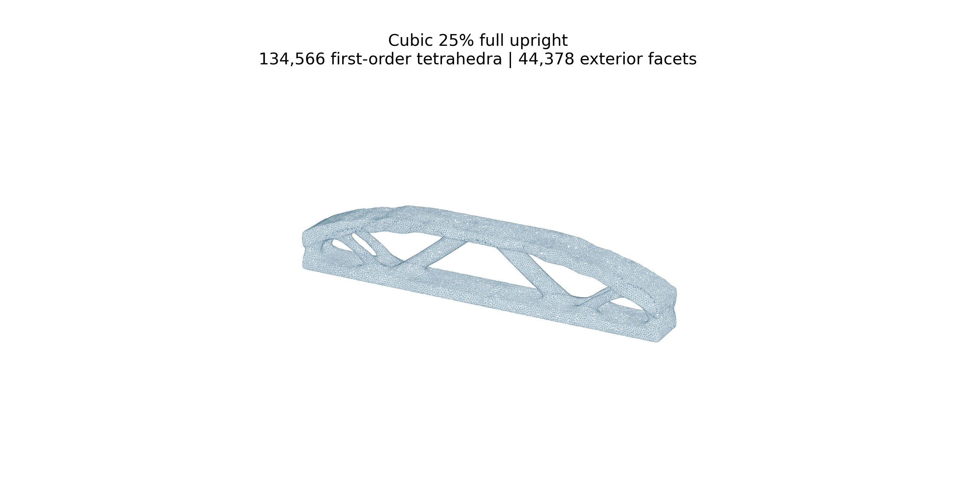
Figure B3. Cubic 25% 3D FE mesh: 134,566 first-order tetrahedra.
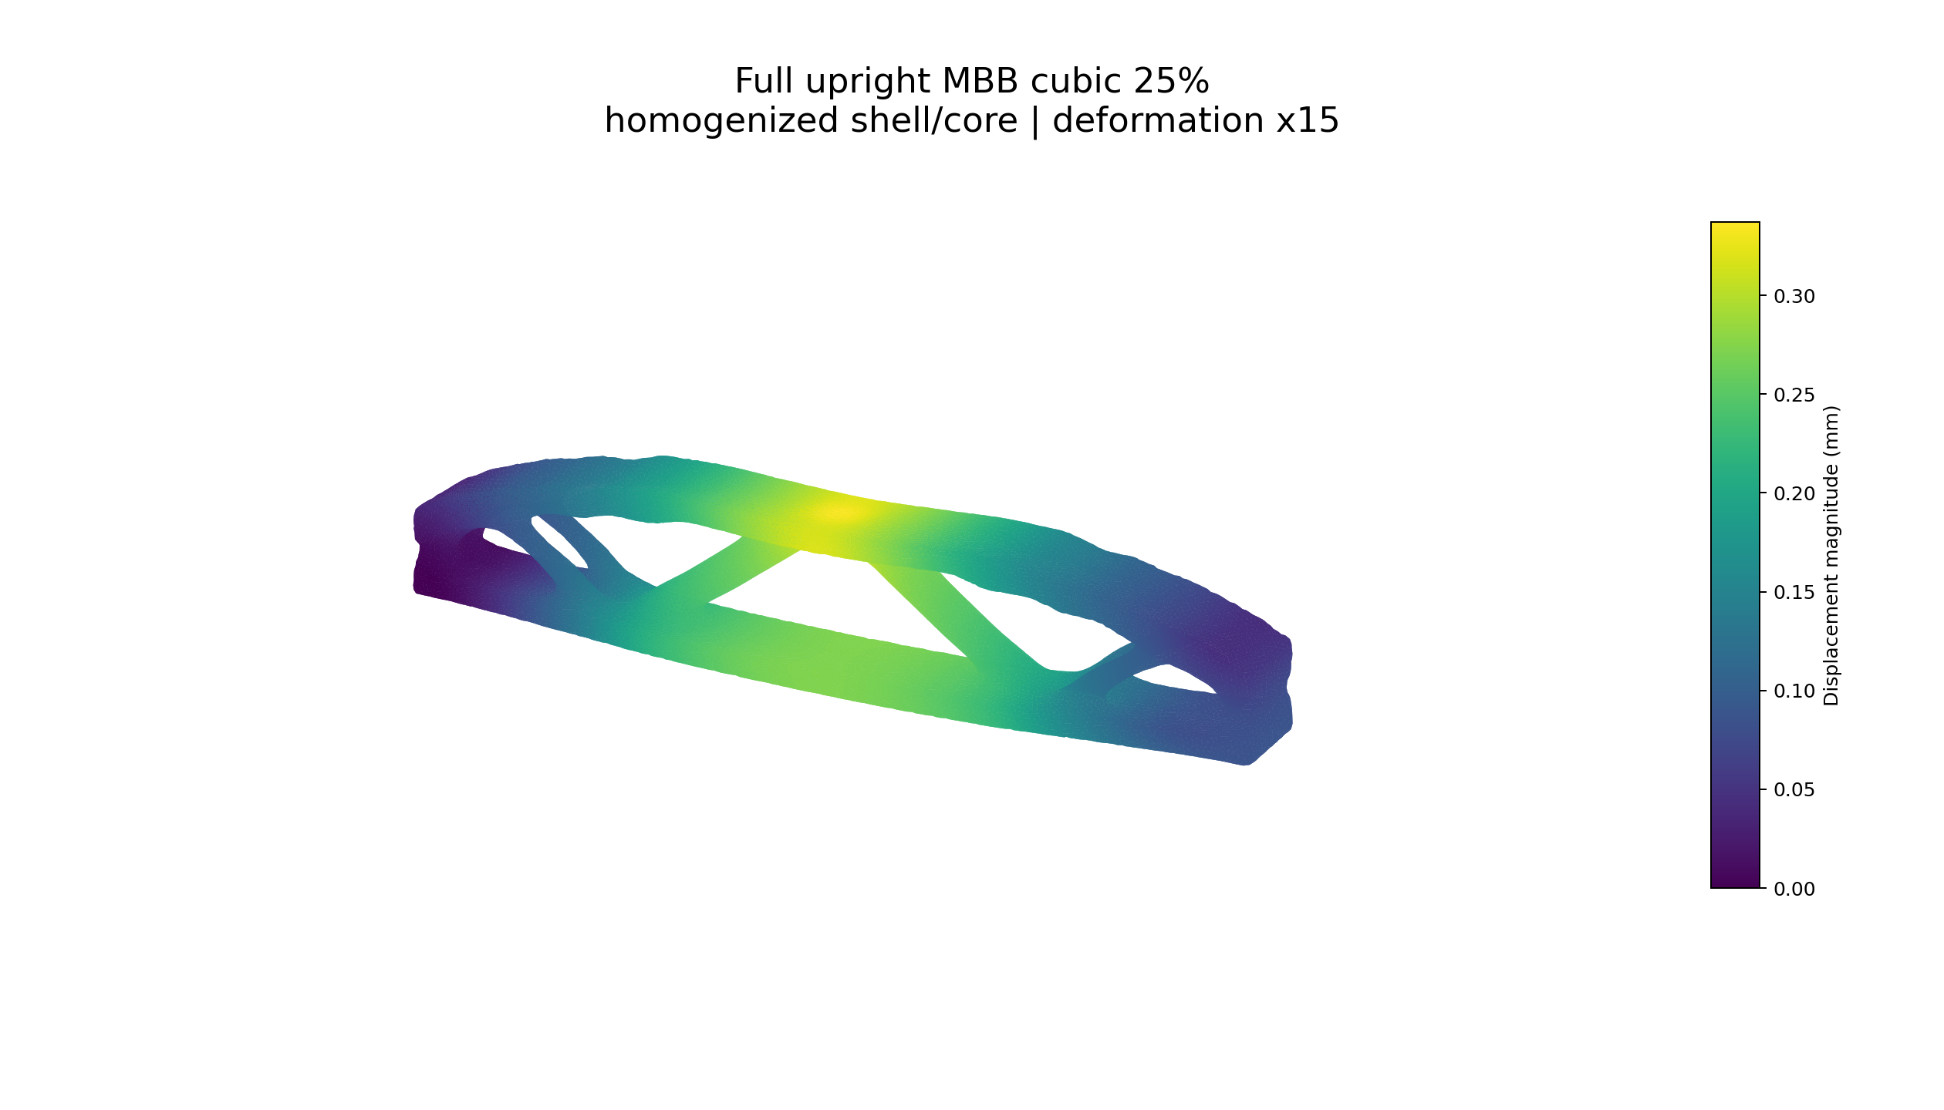
Figure B4. Cubic 25% FE displacement result: maximum displacement 0.3375 mm under the common 100 N load.

Gyroid 15%
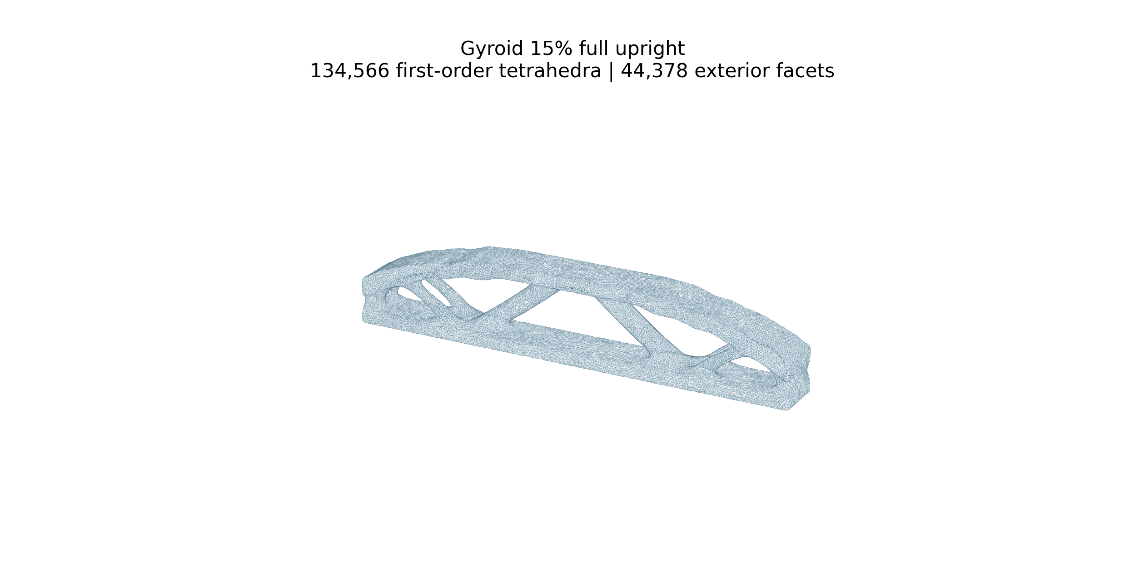
Figure B5. Gyroid 15% 3D FE mesh: 134,566 first-order tetrahedra.
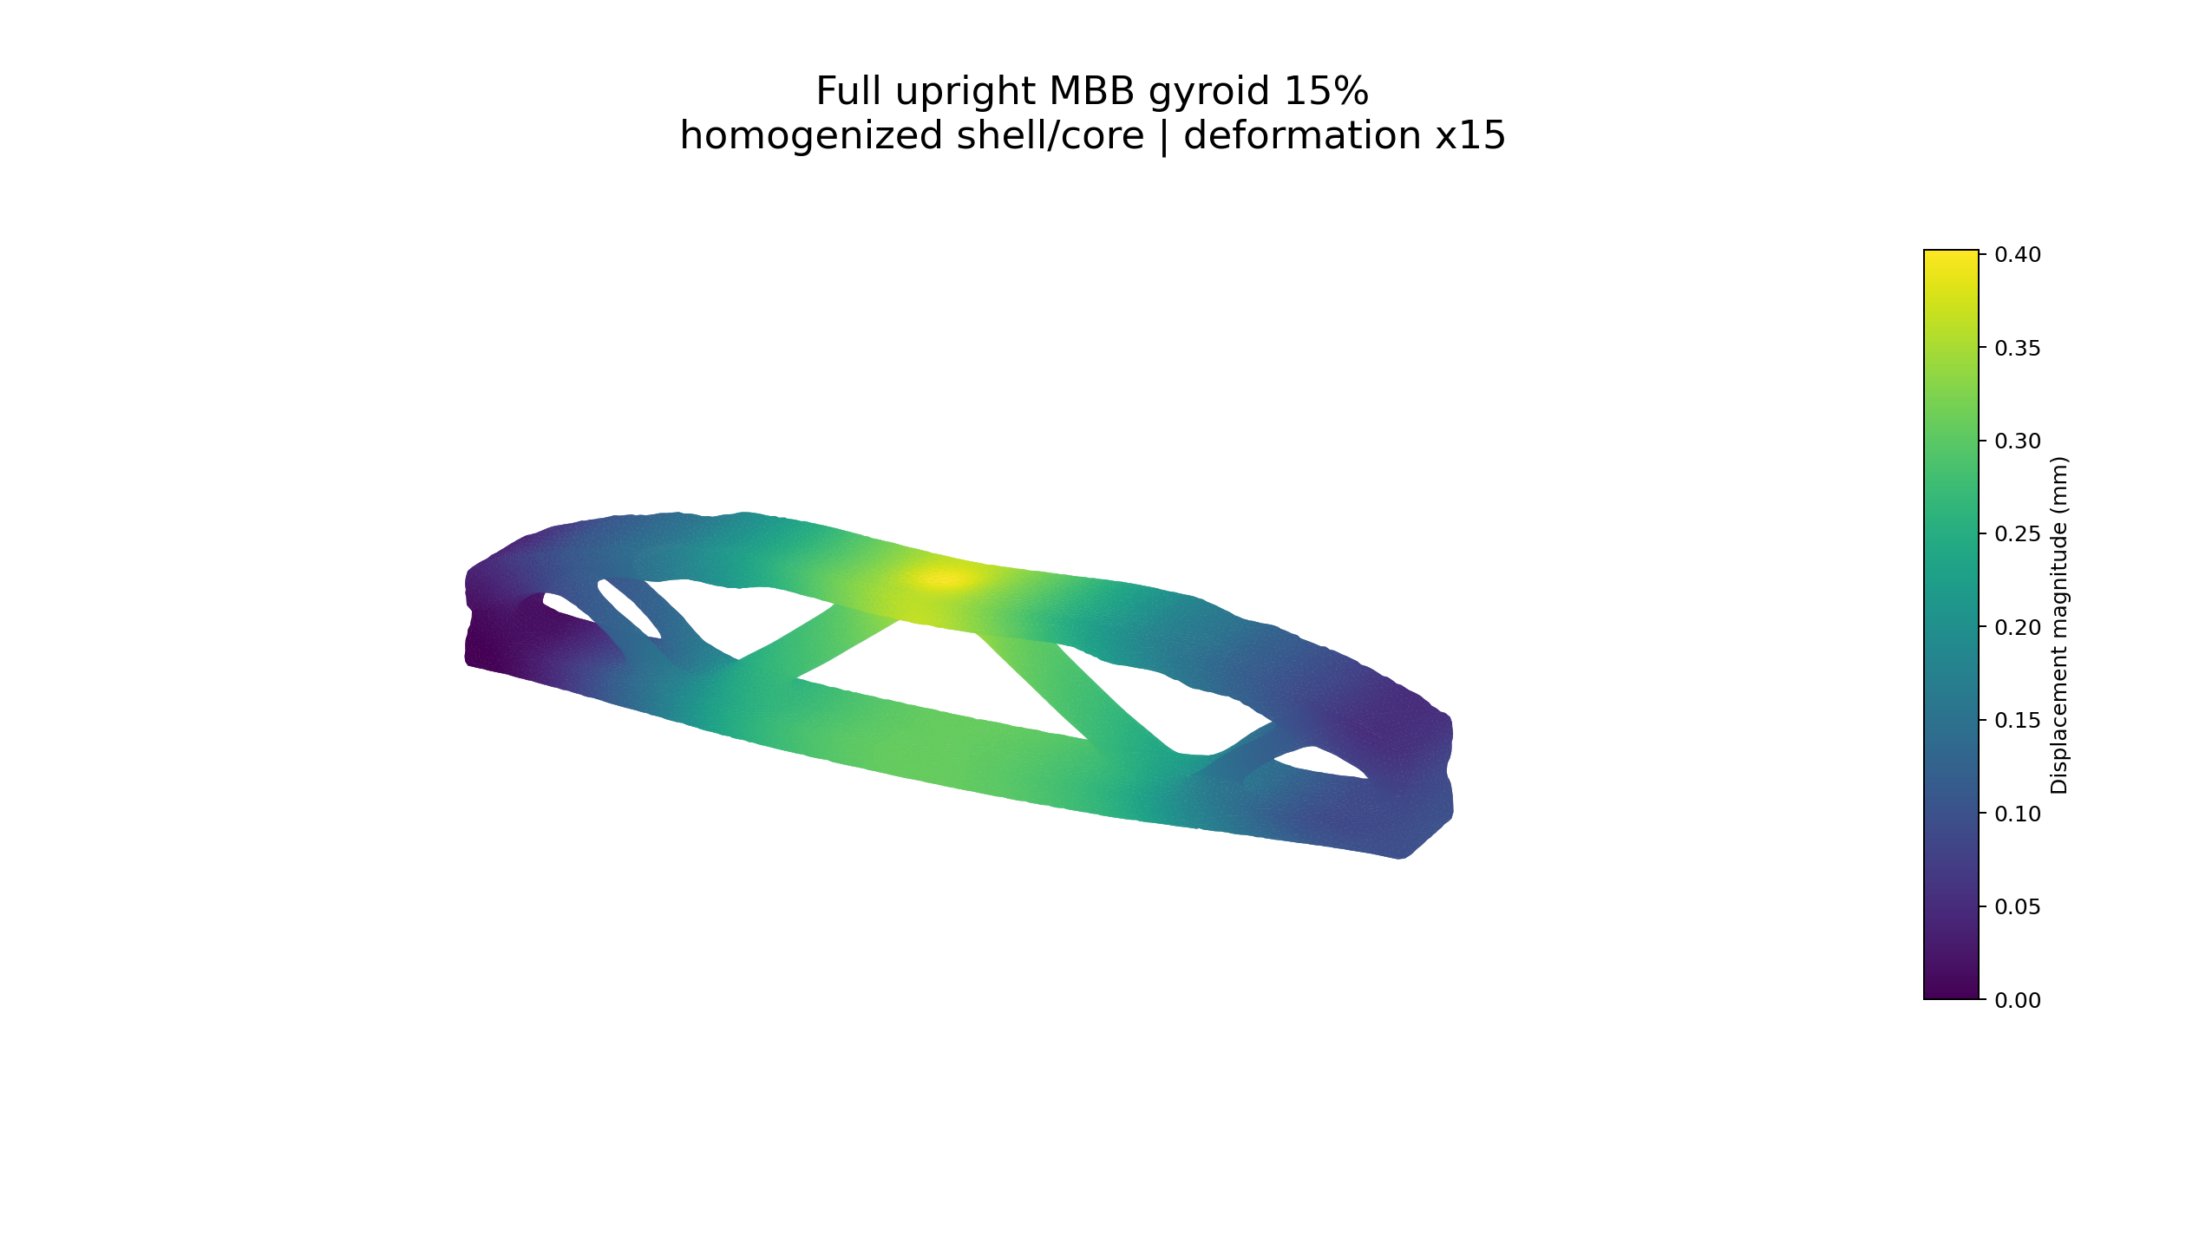
Figure B6. Gyroid 15% FE displacement result: maximum displacement 0.4025 mm under the common 100 N load.

Gyroid 25%
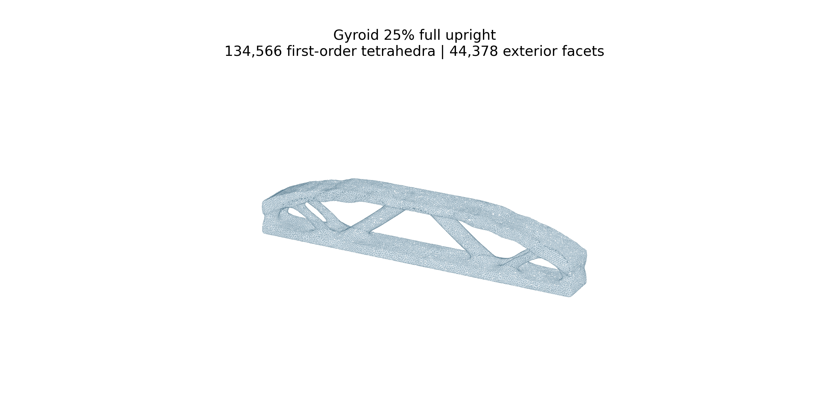
Figure B7. Gyroid 25% 3D FE mesh: 134,566 first-order tetrahedra.
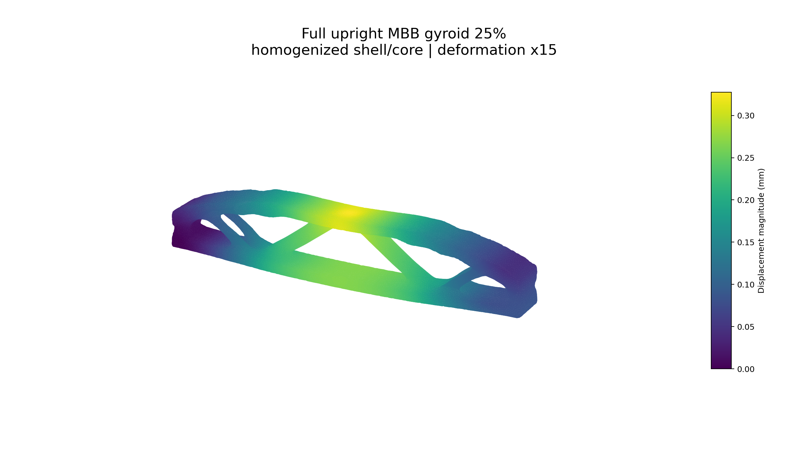
Figure B8. Gyroid 25% FE displacement result: maximum displacement 0.3279 mm under the common 100 N load.

Honeycomb 15%
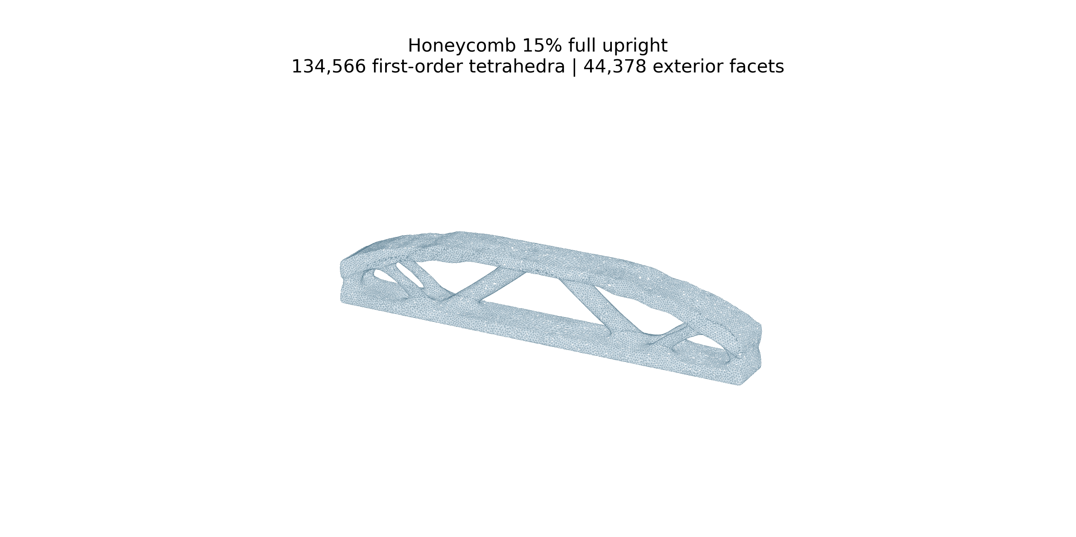
Figure B9. Honeycomb 15% 3D FE mesh: 134,566 first-order tetrahedra.
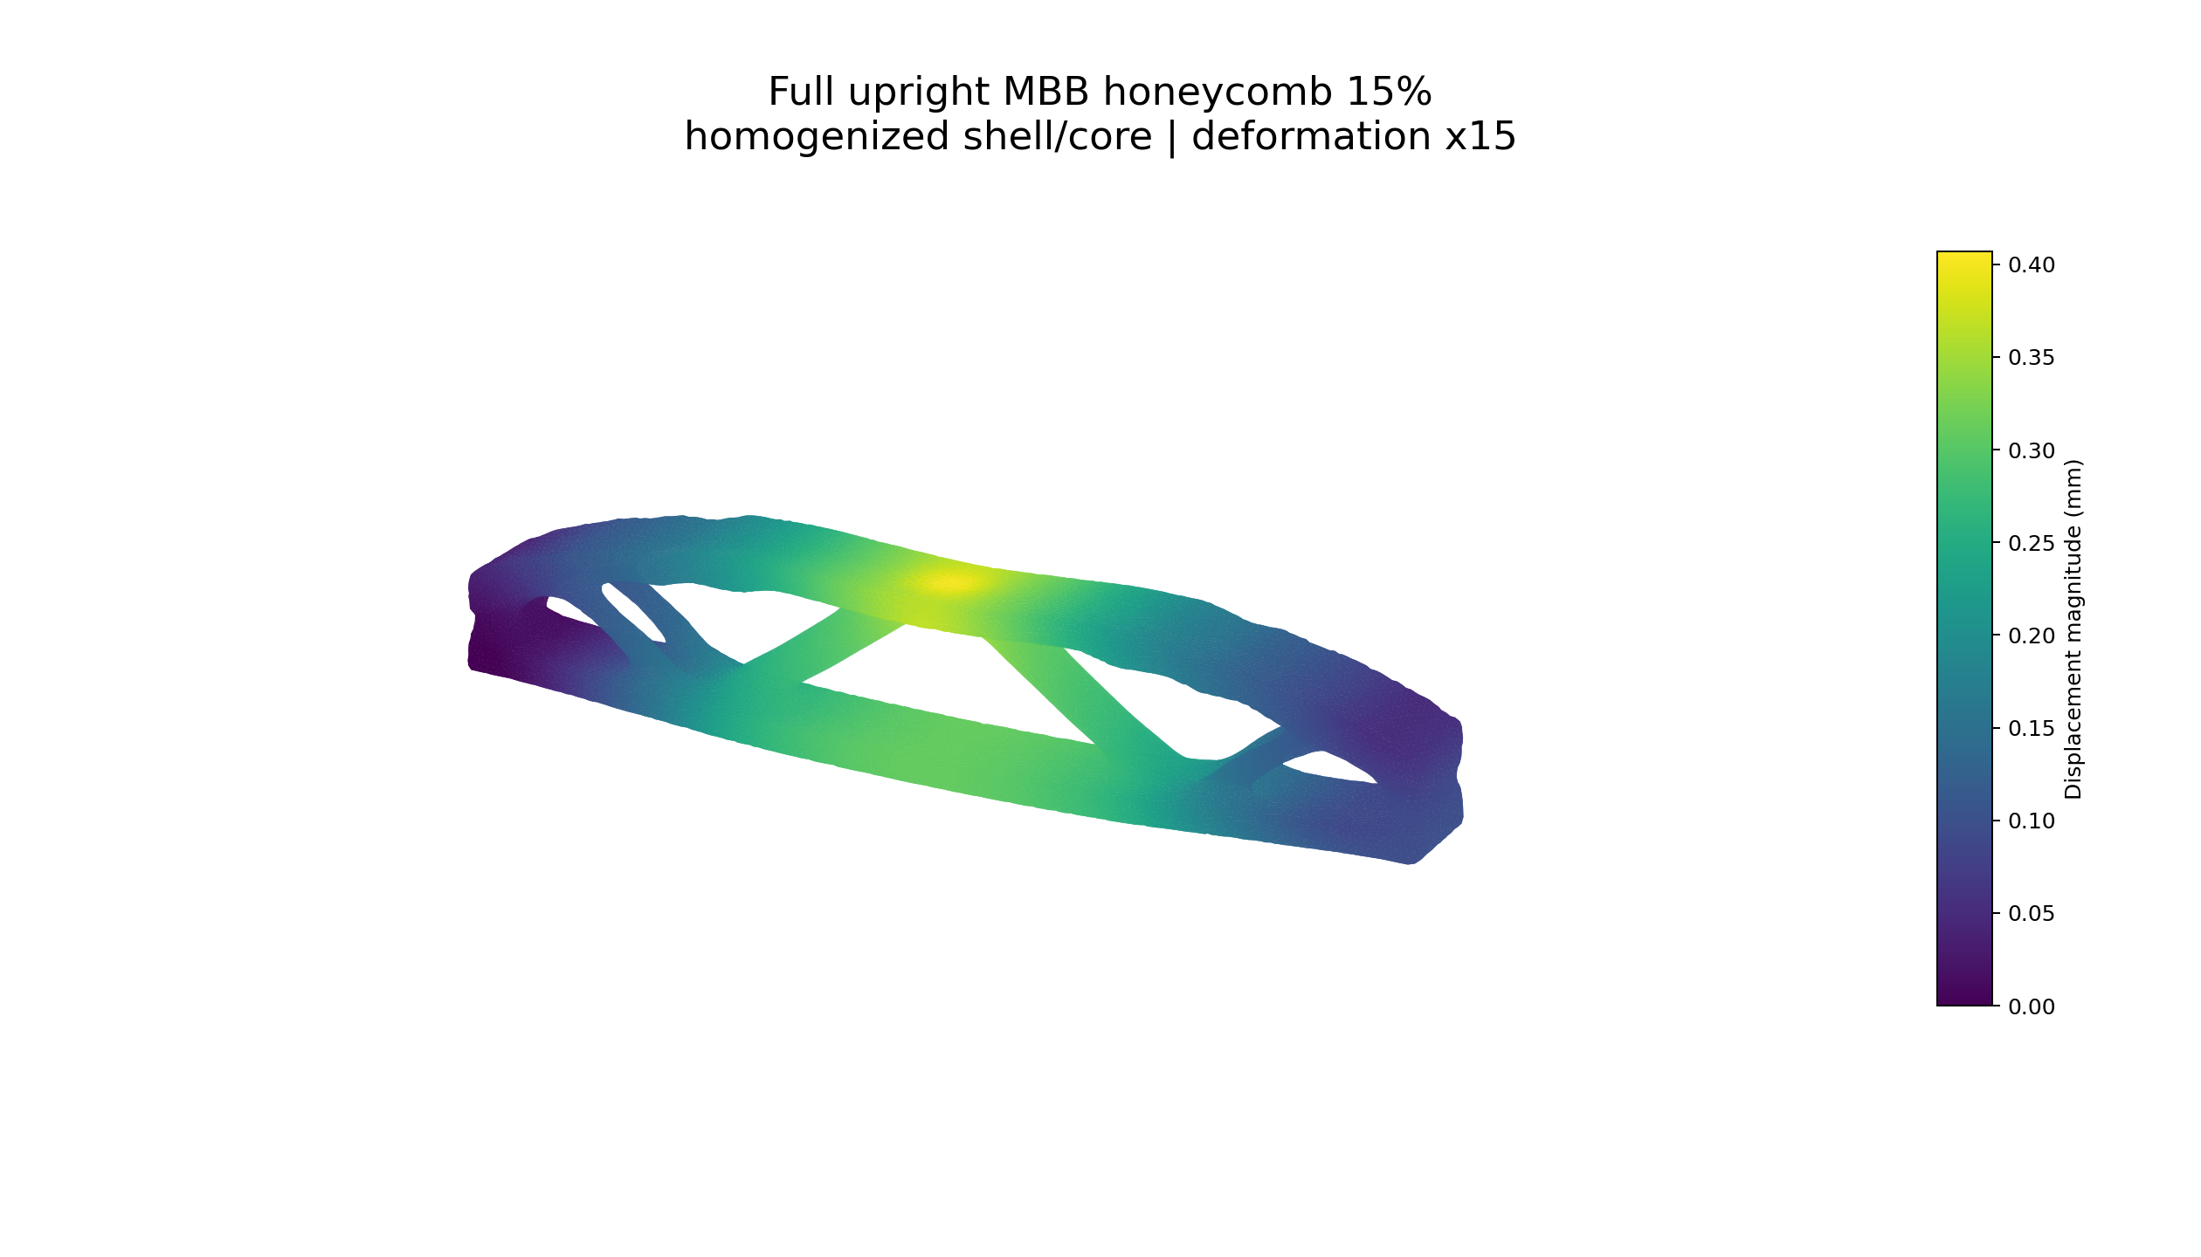
Figure B10. Honeycomb 15% FE displacement result: maximum displacement 0.4073 mm under the common 100 N load.

Honeycomb 25%
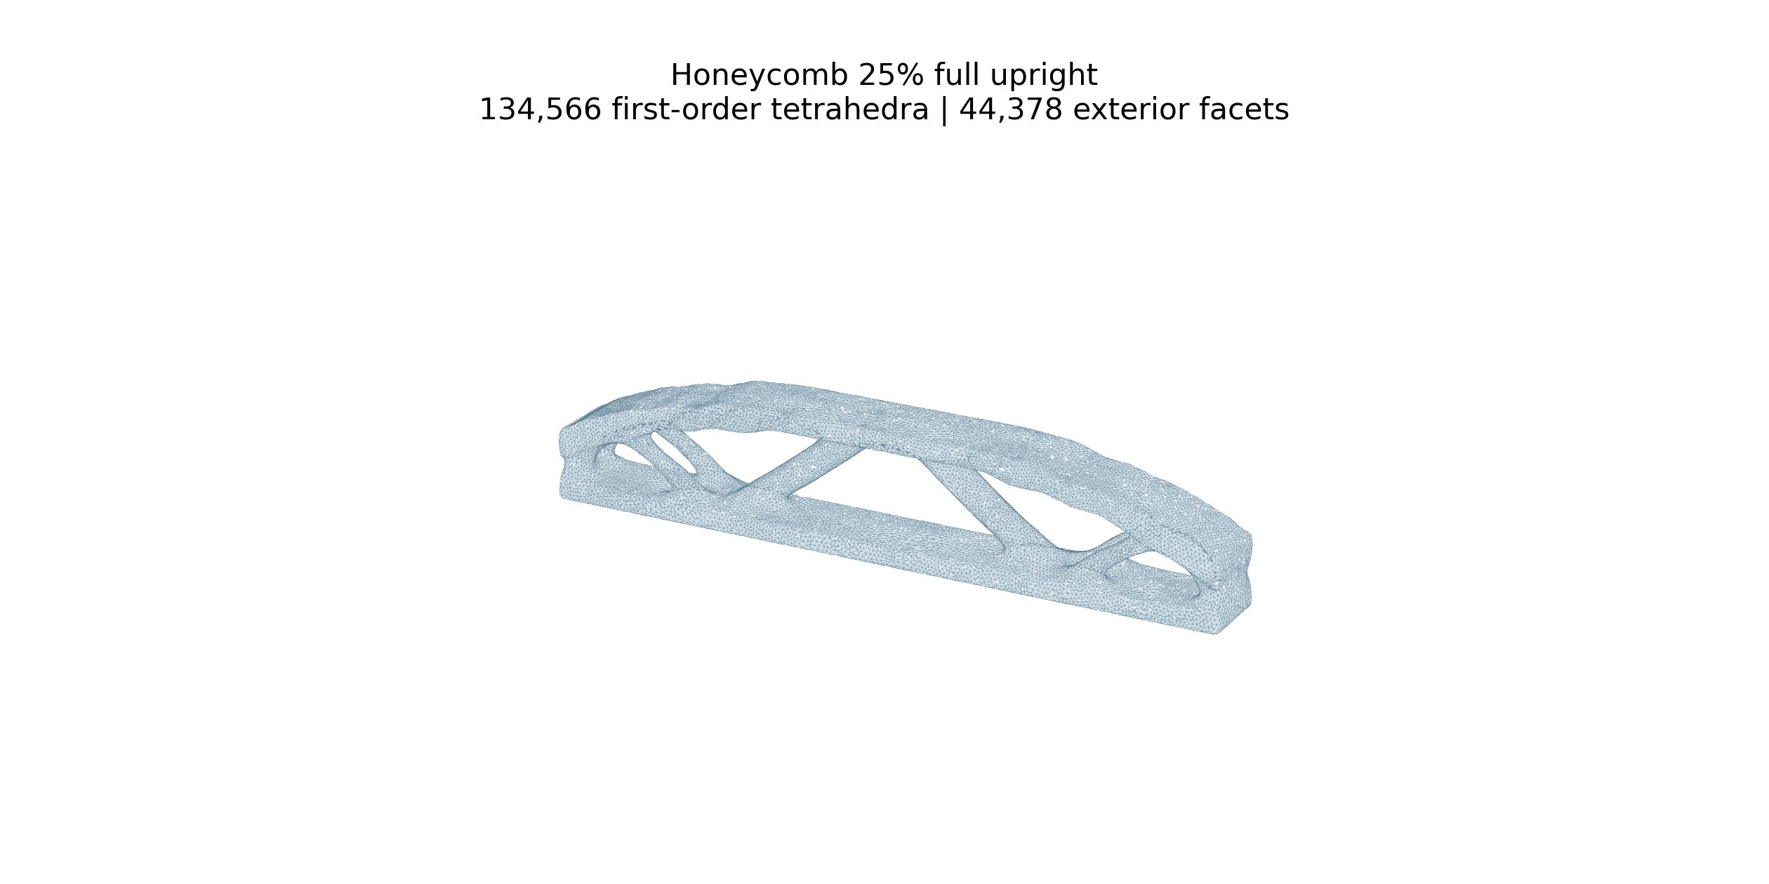
Figure B11. Honeycomb 25% 3D FE mesh: 134,566 first-order tetrahedra.
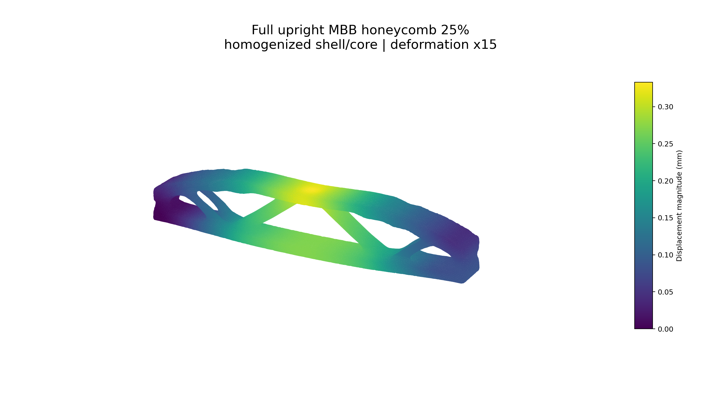
Figure B12. Honeycomb 25% FE displacement result: maximum displacement 0.3334 mm under the common 100 N load.

Dense 100% baseline
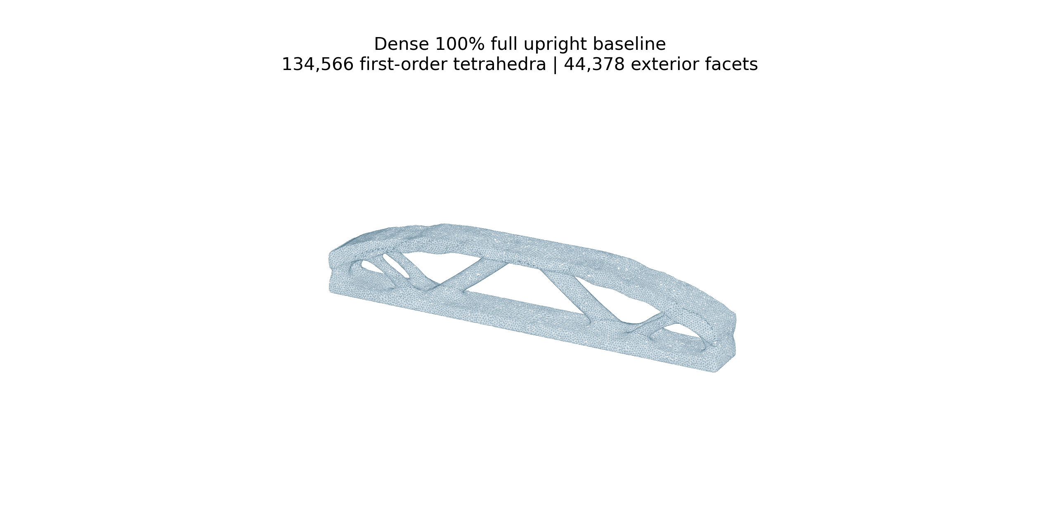
Figure B13. Dense 100% baseline 3D FE mesh: 134,566 first-order tetrahedra.
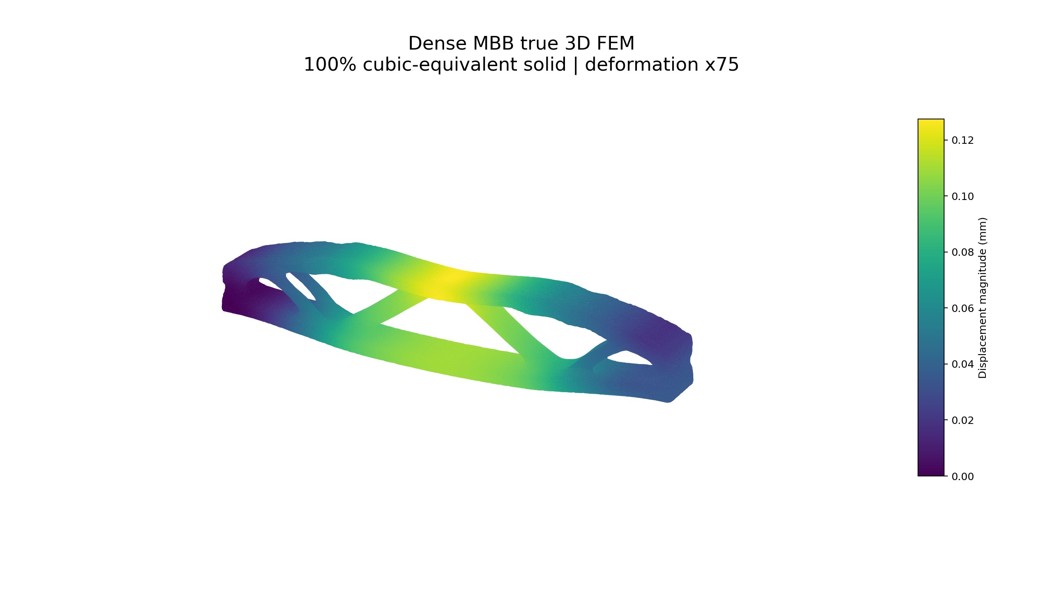
Figure B14. Dense 100% baseline FE displacement result: maximum displacement 0.1275 mm under the common 100 N load.

