Study Guide 1 - HTML and CSS - Chap. 1-5 Name – Yara Grassi Gouffon

Due: Start of class – second class of Week 2

Your HTML files must be zipped and handed in to the Study Guide 1 dropbox. This document should be submitted to the dropbox as well, but not zipped. Physical printouts will not be accepted.

Welcome to your first Study Guide! We have covered some, but not all, of the following concepts in class already. In either case, repetition, and writing things down, has been shown to improve retention of facts. Be sure to retain this document after it has been handed back to you. Many test questions will be pulled from these Study Guides. All of the questions are based on your reading of the textbook, chapters 1 through 5.

Introduction
Read it.

Chapter 1 - Structure

Structure is important in all kinds of documents as it helps the reader navigate your document and make sense of its content.

- What are some of the structural elements of a typical newspaper page?

There are headlines, text and (usually) images. Longer stories may be divided in smaller sections with subheadings, and there may also be quotes from involved people or authorities.

Another example given of a document with structure is a printed insurance form. Insurance forms often have headings, sections, questions, check boxes, and so on. An online insurance form will have a similar structure.

- MS Word documents often use headings and subheadings to present a hierarchy of information.

- HTML is a markup language that is used to create web pages that can be displayed in a web browser (or read out loud by screen reading software). HTML describes the structure of a page. An HTML page consists of many HTML elements.

- What does each HTML element tell the browser?

Each HTML element tells the browser information about the text contained within.

- How many tags are typically in an HTML element?

There are typically two tags: one to open, and one to close the element.

- Write an example of an HTML element below:
<p>This is a paragraph element.</p>

- Attributes provide additional information about the contents of an element. They appear in the opening tag and consist of a name and a value.

-Write an example of an element that has an attribute, and indicate both the
name and the value.

<a href=”www.google.com”>This is a link to Google.</a>
href is the name of the attribute, and www.google.com mis the value.

- Where does the information in the <body> tag appear in the browser?

Information inside the <body> tag appears inside the main browser window.

- Where does the information in the <title> tag appear in the browser?

Information in the <title> tag appears at the top of the browser, as the page title, and as the tab title if supported by the browser.

Note: The <head> section of a web page primarily contains the meta data (data about data) of a web page, and not text or other information that the user will directly see.

- Web pages are created with “plain text” text editors like Notepad++ (PC) or TextWrangler/BBEdit (Mac).

No answer required

- Which browser command allows you to see the HTML source code of a web page?

Selecting the 'View source' command (or similar, depending on the browser) from the View menu lets you see the HTML source of a web page.

Chapter 2 - Text

Adding tags to the contents of a pages is known as “marking up” the document. These tags add meaning to the content and allow the browser to structure the document properly.

- Give an example of Structural Markup

Headings (<h1>, <h2> and others) are an example of structural markup.

- Give an example of Semantic Markup

Block quotes (<blockquote>) are an example of semantic markup.

- Give an example of an appropriate tag for the following structural elements (we’ll give you the easy ones):

Headings <h1> through <h6>
<h1>Bob’s Home Page</h1>

Paragraphs <p>Hi There!</p>

Bold (or visually different) This is <b>bold</b>.

Italic (or a technical term) This is <i>italic</i>.

Superscript E = mc<sup>2</sup>

Subscript H<sub>2</sub>O

Line Break <br />

Horizontal Rule <hr />

- Semantic markup adds extra information to content without changing the structure of the document.

Important: As noted in the text, browsers often have a default style or appearance they apply to semantically marked up elements (which we can change). But the purpose of these tags is to describe your content more accurately.

GIve an example of an appropriate tag for the following semantic elements, and also note the typical default appearance if it is mentioned in the text.

“strong” text

This is the <strong>strong</strong> element.
Its default appearance is bold.

emphasized text

This is the <em>emphasis</em> element.
Its default appearance is italic.

long quotes

<blockquote><p>This is a looooong citation.</p></blockquote>
It is usually indented by the browser.

short quotes

<q>This is a short quotation.</q>
Some browsers add quotes around this element. Internet Explorer does not.

abbreviations and acronyms
This is an <abbr>IGM</abbr> course.

citations

This is in chapter 2 of <cite>HTML and CSS: Design and Build Websites</cite>.
Its default appearance is in italics.

definitions (defining instances)

A <dfn>structural element</dfn> is an element that can be used to describe headings and paragraphs.
The definition element is sometimes rendered in italics, though Safari and Chrome do not render it that way.

address

The main RIT campus is located at <address>1 Lomb Memorial Dr, Rochester</address>.
This element is usually rendered in italics.

inserted content

This is the <ins>new</ins> website for Company X.
The inserted content element is usually rendered as underlined.

deleted content

This is the <del>current</del> website for Company X.
The deleted content element is usually rendered as strikethrough.

content that is no longer accurate or relevant

Prices were just marked down! Game X now $30. <s>Was $50.</s>
The element is usually rendered as strikethrough.

- “White space” (page 47) - Placing extra spaces (more than 1), tabs, or multiple lines while marking up a document is commonly done to improve the readability of the raw HTML.

- What happens to this extra space when the browser renders the page?

Extra spaces are ignored by the browser. Only one space is displayed.

Lastly, look over the example HTML document at the end of the chapter

Chapter 3 - Lists

- Give an instance of when you would use an ordered list, and write an example in HTML below. (at least 3 list items please)

I would use an ordered list for recipe instructions, street directions or other things in which following a correct order is important.

<ol>
<li>Head west on Brooks Rd toward E River Rd</li>
<li>Turn right onto E River Rd</li>
<li>Turn right onto Ward Rd</li>
<li>Turn right onto Reynolds Dr</li>
</ol>

(Credits to Google Maps!)

- Give an example of when you would use an unordered list, and write an example in HTML below. (at least 3 items please)

I would use an unordered list for lists that are more like collections of items, for which order doesn't matter. For example, grocery lists or ingredient lists for a recipe.

<ul>
<li>Eggs</li>
<li>Bread</li>
<li>Yogurt</li>
<li>Broccoli</li>
<li>Milk</li>
</ul>

- Give an example of when you would use a definition list, and write an example in HTML below. (1 definition is fine)

I would use a definition list to make a glossary in a page with articles that use vocabulary the reader might not be familiar with.

<dl>
<dt>Bem-te-vi</dt>
<dd>A bird commonly found in Brazil. Also known as great kiskadee.</dd>
</dl>

- Note the example of nested lists - this is commonly done. Also look over the example at the end of the chapter.

No answer required

Chapter 4 - Links

- Write below the 5 types of links listed by the author.

Links from one website to another
Links from one page to another on the same website
Links from one part of a web page to another part of the same page
Links that open in a new browser window
Links that start up your email program and address a new email to someone

- Links are created with the very oddly named anchor tag - the <a> tag. Write an example of a link that will navigate to RIT’s home page when clicked. The clickable text should be “RIT Home”.

<a href=”http://www.rit.edu”>RIT home</a>

- What does URL stand for?

Uniform Resource Locator.

- What does an Absolute URL start with? Give an example of an absolute URL below:

An Absolute URL starts with the domain name.
http://www.rit.edu

- When are Relative URLs used? Give an example of a relative URL.

Relative URLs are used when linking to another page on the same website.
movies/list.html

For the following diagram:

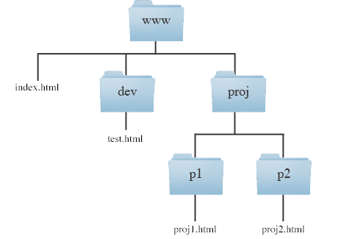

- write an <a> tag with a URL that connects proj1.html to proj2.html
<a href=”../p2/proj2.html”>link</a>

- write an <a> tag with a URL that connects index.html to proj1.html
<a href=”proj/p1/proj1.html”>link</a>

- write an <a> tag with a URL that connects proj1.html to index.html
<a href=”../../index.html”>link</a>

- If no filename is specified in the URL, what is the name of the file that the server will return by default? (page 81)
The server will return index.html by default.
8) Create a web page named sg1.html with the following in it:

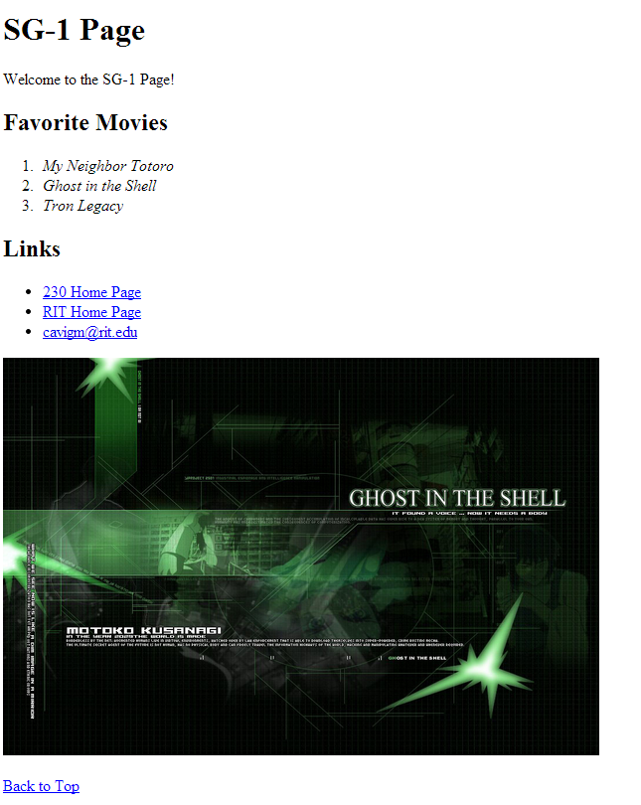
- A level-1 header that reads “SG-1 Page”

- A paragraph with the text “Welcome to the SG-1 Page!”

- A level-2 header with the text “Favorite Movies”

- An ordered list of 3 movies you enjoy. Use the correct semantic tag for titles of works (i.e. cited works - see chapter 2)

- A level-2 header with the text “Links”

- A link to our 230 class list page, as given in myCourses.

- A link to RIT’s home page: http://www.rit.edu in a new window

- An image in a web friendly format that is related to one of the movies in your list. Be sure that the image has height and width and alt attributes. Place the image tag inside of a paragraph tag. See chapter 5 if you don’t know how to do this yet.

- A Back to Top link that scrolls the browser back to the top of the page (note: you will have to make the browser window very small, or add more content to be to test the link)

- The title bar of the browser window/tab should also read “SG-1 Page”

L) Make sure that this page passes HTML validation at: http://validator.w3.org

*******************************************************************************************
Submission: ZIP up sg1.html and the image in one folder and post the ZIP to the dropbox before the due date.
*******************************************************************************************

Chapter 5 - Images

- If you are building a commercial web site that will be put out on the web, is it legal to use images that you find on the web, as long as they don’t have a copyright notice?

No. All images are subject to copyright, and it is best to assume permission is needed to use them even if there is no notice in order to avoid trouble.

- Images created by others that are legal to use on your web site are called?

They are called stock images.

3) How do most web browsers display the contents of the title attribute?

Most browsers display its contents in a tooltip if the user hovers their mouse over the picture.

4) Write the HTML for an image tag that will display an image named mugshot.jpg. The width of the image is 400 pixels, the height is 300 pixels, and the alternative text should be “mugshot!”, and the title attribute should be “Click me!”

Assuming the picture is in the same directory as the page:
<img src=”mugshot.jpg” height=”300” width=”400” alt=”mugshot!” title=”Click me!” />

- Page 102.

- Block elements always appear on a new line.

- Inline elements sit within a block level element and do not start a new line.

- Are <img> elements block or inline elements?

They are inline elements.

- What are the 3 rules for creating images?

1 – Save images in the right format – Usually jpg, gif or png.
2 – Save images at the right size – Always the same size they will appear on the website.
3 – Use the correct resolution – Usually 72 pixels per inch.

- According to the author, what image format should you use if an image has a lot of colors (like a photograph)?

You should use a JPEG.

- According to the author, what image format should you use if an image just a few colors, or large areas of the same color (like a logo)?

You should use GIF or PNG.

- Suppose you have an image file that is 1024 x 768 pixels, but then only display it at 100 x 70 pixels on your web site. Is this a good idea? Why or why not?

This is not a good idea, because it takes the image longer to load and the file size is larger than you would actually need.

- Suppose you have an image file that is 300 x 200 pixels, but then display it at 900 x 600 pixels on your web site. Is this a good idea? Why or why not?

This is not a good idea, because the resulting image would be of poor quality, probably blurry or blocky.

- What are the two web friendly image file formats that you can use if your image has transparency?

They are transparent GIFs (for transparent parts with straight edges that are 100% transparent) and PNGs.

- What are the two new HTML5 tags that can be used to group an image and a caption?

They are the <figure> tag, which contains the image and its caption, and the <figcaption> tag.

* Look over the example page and summary at the end of the chapter. *

Bring this to class on the due date. Don’t forget to post your zipped files to the dropbox BEFORE the due date.

