Study Guide 3 - HTML and CSS - Chap. 13 -15 Name Yara Grassi Gouffon

Due: Start of class - first day of week 5
Your HTML files must be zipped and handed in to the Study Guide 3 dropbox. This document should be submitted to the dropbox as well, but not zipped. Physical printouts will not be accepted.

Chapter 13 - Boxes
CSS treats each HTML element as if it sits in its own box.

- If you don’t set the height and width of a box, how big will it be?

It will be sized just big enough to hold its contents.

- Some page designs can expand and shrink to fit the size of the browser window. What are the two CSS properties that can be used to set a minimum and maximum size of a box (element)?

min-width and max-width.

Go check out the minimum width example on the book website:
http://htmlandcssbook.com/code-samples/chapter-13/

- What CSS properties are used to control the minimum height and maximum height of a box?

min-height and max-height,

- Imagine a paragraph is not big enough to hold its content, write a CSS rule (with a selector) that will hide this extra content.

p { overflow: hidden;}

- Now write another rule for the same paragraph that will instead cause scroll bars to appear when there is too much content to fit in the paragraph.

p { overflow: scroll;}

- What are the three properties available to boxes that can be adjusted to control their appearance?

Border, padding and margin.

7) True or False. If you add padding to a 400px box, the box won’t get any bigger. Instead the content area of the box will get smaller.

False.

- True or False. Margins sit outside of a box.

True.

9) True or False. Padding goes inside of a box and adds space between the content and the borders of the box.

True.

- Notice how using margin and padding to create white space and vertical margins makes this page:

http://htmlandcssbook.com/code-samples/chapter-13/white-space-vertical-margin.html

look better than this page:

http://htmlandcssbook.com/code-samples/chapter-13/white-space-vertical-margin-no-space.html

No answer required.

Borders
- Give the property used to control the width of borders.

border-width

12) List the 8 values for the border-style CSS property.

solid, dotted, dashed, double, groove, ridge, inset, outside and hidden/none.

13) Give the property used to control the color of borders.

border-color

Note that the border property can be used as as shorthand for the above 3 properties.

Padding

Note that the bottom box on page 313 has more padding and this makes the text easier to read.

- For the following shorthand padding declaration, label the left, right, top, and bottom padding:

padding: 10px 5px 20px 10px;

padding-top: 10px;
padding-right: 5px;
padding-bottom: 20px;
padding-left: 10px;

- “CSS margins collapse” - what does this mean? (page 314)

It means that if one box sits on top of another, only the larger of the two margins will be used.

- Note the trick of centering a box (page 315)

margin-left: auto;
margin:right: auto

If you want to center text (rather than the entire box), use text-align: center

No answer required.
display

- Describe what the following CSS properties do:

display : inline

Causes a block-level element to act like an inline element.

display: block

Causes an inline element to act like a block-level element.

display: inline-block

Causes a block-level element to flow like an inline element while still retaining other features of a block-level element.

display: none

Hides the element from the page.

18) How is visibility: hidden different from display: none?

visibility: hidden leaves a blank space where the element would have been, while display: none doesn't.

- Which CSS property is used to add drop shadows to a box?

box-shadow

- Which CSS property is used to add rounded corners to a box, or even to give it an elliptical shape?

border-radius

Look over the “The Analog Specialists” example at:
http://htmlandcssbook.com/code-samples/chapter-13/example.html#

Be sure to “View Source” to see the HTML and CSS. Note how display:inline has put the navigation links all on one line, and that margin:auto has centered the #page div.

**** HW-3 Part I ****

Give the recipe page’s unordered list of ingredients an elliptical border (something asymmetrical, it doesn’t have to look exactly like this), and a visible drop shadow. See pages 320 and 322 for how to do this. If the text doesn’t fit, that’s OK, we’ll fix it in the next section.

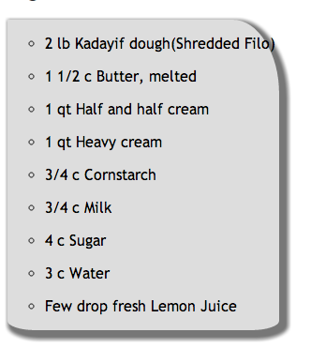
Chapter 14 - Lists, Tables & Forms

CSS for Lists

1) Read over the CSS list pages (331-366) and

**** HW-3 Part II ****

- Change the ingredients list style type to a square
- Change the list style position to inside

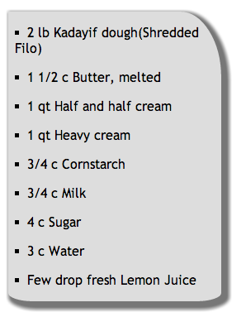

- Read over the rest of the chapter (HTML Table and HTML Form CSS)

No answer required.

- Note the CSS for styling the cursor on page 347. Write a CSS rule that turns the cursor into a question mark (help)

a { cursor: help; }

- Look over the List, Table and Forms examples at:
http://htmlandcssbook.com/code-samples/chapter-14/example.html

Be sure to “view source” to see the CSS.

No answer required.

Chapter 15 - Layout

Block-level elements start on their own line and act as the main building blocks of any layout, while inline boxes flow between surrounding text.

If one block-level element sits inside another block level element then the outer box is know as the containing or parent element.

There’s quite a bit to know in this area - we’ll be spending the next 2-3 weeks on this.

Be sure to view the examples (and the source) for this chapter at:
http://htmlandcssbook.com/code-samples/chapter-15/

Positioning Schemes
- Normal flow (the default, position:static) each block-level element sits on top of the next one.

No answer required.

- Relative Positioning (position:relative) moves an element in relation to where it would have been in normal flow.

- Absolute Positioning (position:absolute) causes a box to be taken out of normal flow and no longer affect the position of other elements on the page.

- Fixed Positioning (position:fixed) positions the element in relation to the browser window. When a user scrolls down the page the element stays in the same place.

- Overlapping elements - when using relative, fixed, or absolute positioning elements can overlap. Which CSS property is used to determine which element is on top?

z-index
- Floating Elements - the float property allows you to take an element in normal flow and place it to the left or right of the containing element.

- Which CSS property should be used with float so that it functions consistently?

width

- Floating allows boxes to site next to each other, but sometimes the results can be strange. clear is sometimes used as as solution. What does clear: left do?

It makes it so that no other element in the same containing element can touch the left side of the box clear was applied to.

- Note the Floated Elements: Problem and Solution.
Setting the parent element to overflow:auto and width:100% was the solution.

No answer required.

- Read over the multi-column layout with floats section - easy!

No answer required.

- Give 2 advantages and 2 disadvantages of using Fixed Width Layouts

Advantages:
- Greater control over appearance and position of items
- Size of image is always relative to the rest of the page

Disadvantages:
- If the user's resolution is high, the page may appear smaller and harder to read
- If the user increases font sizes, text might not fit into the allotted spaces

12) Give 2 advantages and 2 disadvantages of using Liquid Layouts.

Advantages:
- If the user has a small window, the page contracts to fit without the user having to scroll to the side
- The text will still fit even if the user increases font sizes

Disadvantages:
- Less control over the resulting appearance of the page and positioning of elements
- If the user has a large window, lines may become longer and harder to read

- Be sure to check out the Fixed Layout and Liquid Layout examples in the book and on the Web Site.
No answer required.

14) Designers commonly use a 960-pixel wide layout with 12 columns (60 pixels wide, 10 pixel margins). This 960 pixel grid allows a multitude of column layouts, which you can see on pages 389-390.

No answer required.

- Look over @import and the <link> tag and understand what they do.

No answer required.

16) Finally, look over the final chapter example, which uses 960.gs

No answer required.

Submission:
ZIP up the improved recipe page (Part I and II) and files and post to dropbox.

